1. **Write the Conceptual Dependency Representation of the following statements:**
2. **John killed Mary by throwing a rock at her.**

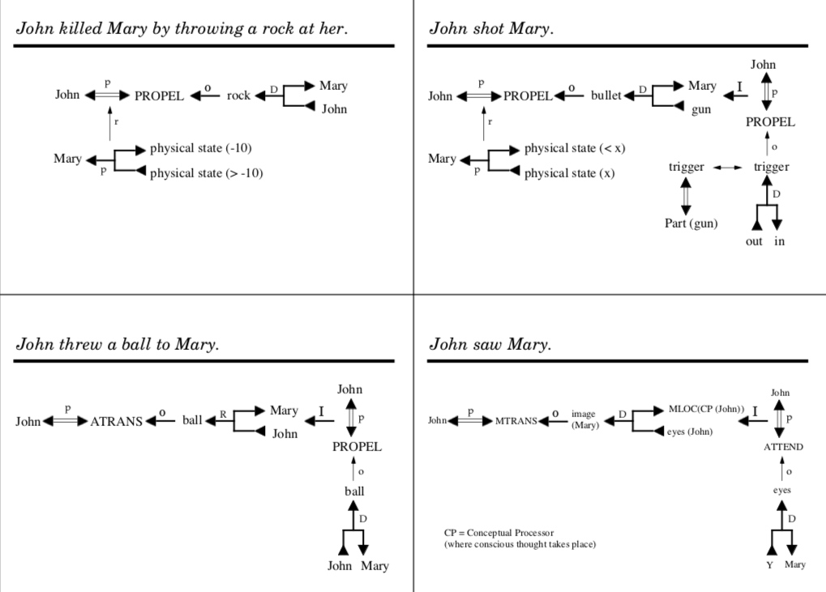

1. **John shot Mary.**



1. **John threw a ball to Mary.**



1. **John saw Mary**



1. **John ate a frog.**

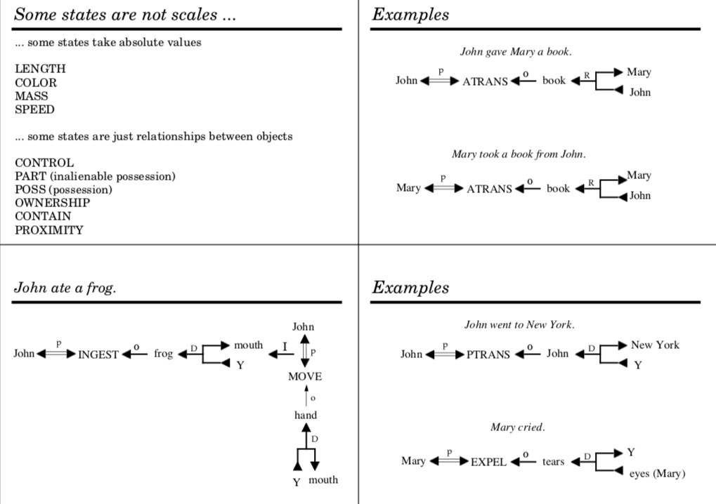

1. **John went to New York.**



1. **John sold his car to Bill.**

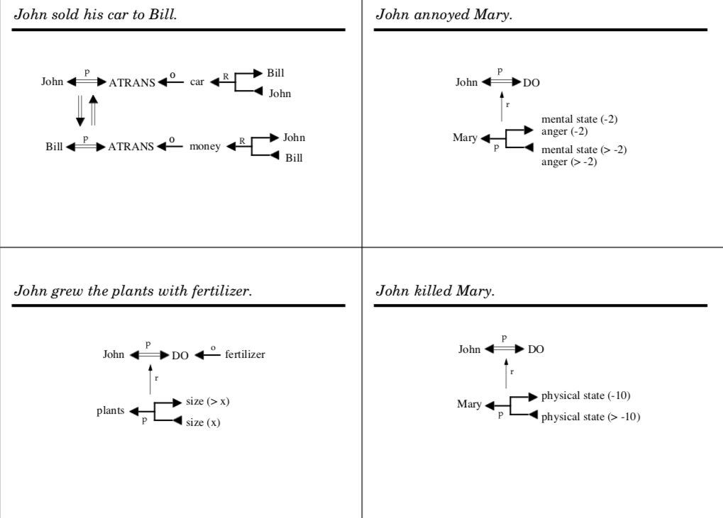

1. **John killed Mary.**



1. **John threw a ball to Mary.**



1. **John saw Mary.**



1. **The ball fell from the roof.**

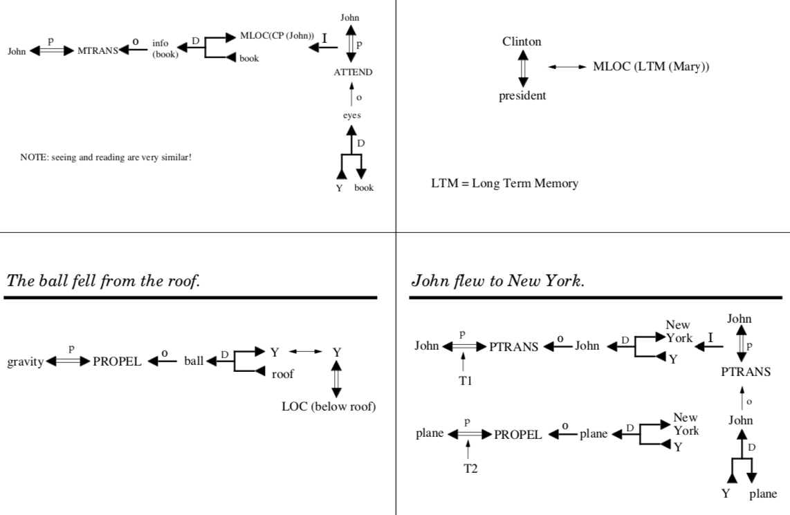

1. **Mary knows that Clinton is president.**



1. **John flew to New York.**



1. **John gave Mary a book by handing it to her.**

