Outputs :

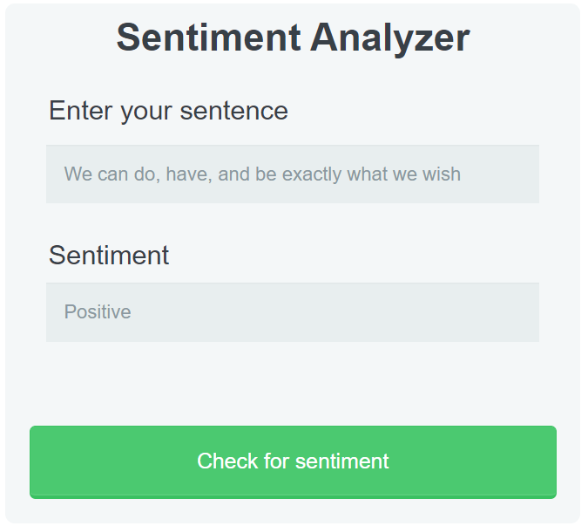

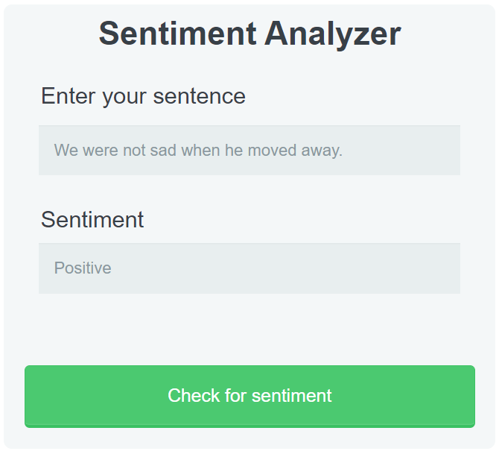

If no sentence is passed :

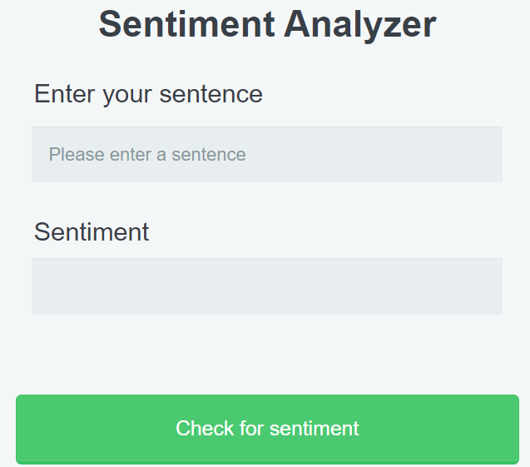

Sentence :

The most common mistake people make when it comes to growing as human beings is to **let other people around them dictate their future**. What actions you are going to take, as well as whether or not you are going to succeed doing it, is determined by one and one thing only: your belief regarding the outcome.

Outcome :

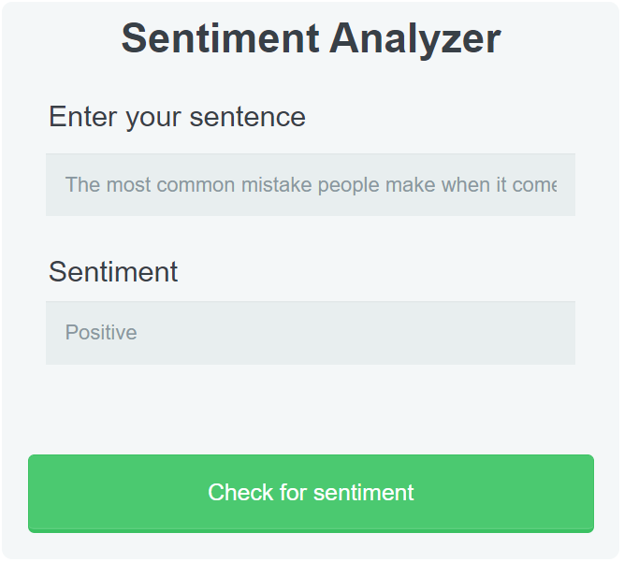

Sentence :

Being constantly around negative people will [always influence you](https://www.ncbi.nlm.nih.gov/books/NBK53409/) in one way or another, that’s why you will have to make a choice: you either have to live and go where these people aren’t, or you will have to toughen yourself up not to be affected that much by them.

Outcome :

