U P REFRIGERATION & SALES CO.

Refrigeration Systems for Cold Storages, Ice Plant, Dairies, Breweries, Chilling Plants, Frozen Food etc.

60 Neer Pioneer City Bithoor Road Kalyanpur Kanpur GSTIN-09DICPM0431G1ZK - mail: aj.kanpur@gmail.com

M/S-POORVAJ COLD STORE | UPR/656/2026-27
VILLAGE-BHAJEHTA | DATED. 05/05/2026
POST- KHURDA MADAR PUR PARGANA MALLAWAN
TEHSHIL -BILGRAM DISTRIC HARDOI (U.P. PIN. 241305)
NEERAJ SINGH JI

SUBJECT: TECHNO COMMERCIAL OFFER FOR 3000 MT COLD STORAGE

Dear Sir,

We like to congratulate on your venture for new Cold Storage & please to offer for the same. We assure you that we will do our best to make th 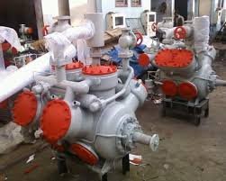is project an ideal one and would come up to your expectations.

Our Refrigeration system & Equipment are designed to give optimum performance and quality workmanship. Our refrigeration system ensures best possible energy savings and serves for longer period of time.

The detailed techno-commercial offer for the project is attached here with as per requirement of the project.

Should you need more details on the offer or technical details please feel free to contact us.

Regards,
For

U.P.REFRIGERATION SALES CO.
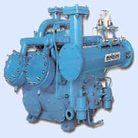
ANIL MISHRA

(SALS & MKTG.)

Mobile: +91-9412452844
U P REFRIGERATION & SALES CO.

Refrigeration Systems for Cold Storages, Ice Plant, Dairies, Breweries, Chilling Plants, Frozen Food etc.

List of Contents:

- Company Profile

- Basis of Design

- Details of Refrigeration Equipments

- Price Schedule

- Terms and Conditions

Company Profile:

We have pleasure in introducing ourselves as one of the leading company engaged in designing, installation & maintenance of Industrial Refrigeration Projects. Our company is established in 2018. Those were the time of imports & nothing was manufactured in India. Since then we are dealing in installation, maintenance &serving of Industrial Refrigeration plants such as Cold Storages, Ice Plants, Chilling Plants, Dairies and Breweries or any other plants which require Refrigeration in any of their processes.

We do undertake complete turnkey projects which include designing, supply, installation& commissioning of refrigeration plant. We deal in wide range of Refrigeration equipment such as Compressors, Air cooling units, PUF insulated panels, Ammonia liquid overfeed system, Ammonia valves & fittings, Pipes, Electrical Equipment & Gases. We have our Head office in Kanpur through which we cater to our thousands of prestigious clients spread across entire northern part India.

We have the privilege of having a long list of satisfied customers which are associated with us for decades. We take every step to look after their needs & provide them with best possible energy efficient design &solution & best of services every time.

We do undertake project for above 0 degree ‘C’ & sub 0 degree ‘C’ upto – 45 ‘C’. We can design refrigeration project for any product & application.

Our cold storage design has intangible number of advantages over the old methodology.

- The proper cooling of products loaded in chambers to the desire temperature and desired relative humidity levels.

- Proper air distribution in the cold chamber for uniform cooling and maintenance of desired conditions.

- System design to achieve the best possible energy efficiency since energy bills constitute the biggest component of running expenditure of the cold stores.

- Our systems have compressor capacity control to regulate the capacity in response to the load.

P a g e | 2

Kanpur Office:
U P REFRIGERATION & SALES CO.

Refrigeration Systems for Cold Storages, Ice Plant, Dairies, Breweries, Chilling Plants, Frozen Food etc.

,
- Our system also have, especially for larger units, provision for full or partial stand by compressor capacity, as failure of the system make cause huge product spoilage.

- For high humidly storage requirement, provision of external humidification or use of sprayed coil air handler are used.

- The space saving is one of the biggest result of our design.

- With our design we can prevent water loss of perishable products (weight loss).


BASIS OF DESIGN

SIZE OF CHAMBERS | : | AS PER LAYOUT
NO. OF CHAMBERS | : | 2
TOTAL CAPACITY | : | 3000MT
TYPE OF PRODUCT | : | POTATO
PRODUCT INCOMING TEMPERATURE | : | 30°C TO 35° C
STORAGE TEMPERATURE | : | 2°C TO 4°C
EVAPORATING TEMPERATURE | : | 2°C
CONDENSING TEMERATURE | : | 38°C

P a g e | 3

Kanpur Office:
U P REFRIGERATION & SALES CO.

Refrigeration Systems for Cold Storages, Ice Plant, Dairies, Breweries, Chilling Plants, Frozen Food etc.

REFRIGERATION EQUIPMENT

RECIPROCATING COMPRESSOR

KIRLOSKAR heavy-duty ammonia reciprocating open type compressor are built to meet all the industrial requirement for cold storage & food processing etc. and covers a wide range of applications. The reciprocating compressor is available in single stage and 2-stages designs. The compressor is complete with gas inlet and out let valves, safety valve, Suction side Filters, V-Belts, Motor Pulley, Flywheel, Base frame, sliding arrangement, shut off valve for suction & discharge line, electrical operated solenoid valve for capacity control, etc.
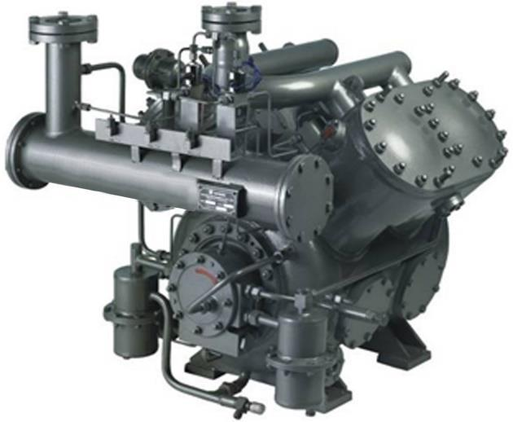
The Compressor base frame is of heavy MS structure which can take up the load of compressor and could easily uphold the shocks and vibrations.

SPIRAL FIN TYPE BUNKER COIL

Spiral Type Bunker Coil: Ammonia Cooling Coils fabricated from 1 Dia. M.S. Pipe and fully covered by continuous spiral G.I. Fins. This will increase total expansion area of cooling coil which leads to better heat transfer and proper utilisation of expanded Ammonia in coils.
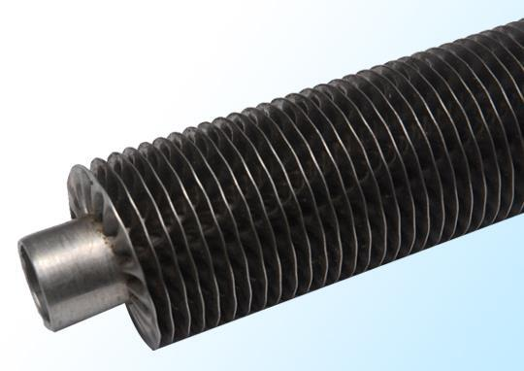
Adopting this technology not helps in lowering down temperature in lesser time but also ensures minimum liquid return back to compressor. So compressor also performs better with high suction pressure & performs upto the optimum capacity.

P a g e | 4

Kanpur Office:
U P REFRIGERATION & SALES CO.

Refrigeration Systems for Cold Storages, Ice Plant, Dairies, Breweries, Chilling Plants, Frozen Food etc.

ANNEXURE 1 (REFRIGERATION EQUIPMENT)

 | S. No. |  | Description of Equipment |  |  |  | Qty. |  |  |  | Rate |  | Amount
 | S. No. |  | Description of Equipment |  |  |  | Qty. |  |  |  | (Rs.) |  | (Rs.)

1. | COMPRESSOR UNIT
 | Kirloskar Reciprocating compressor (200), with | 1 Set | 5,30,000 | 5,30,000
 | Aciserise  karloskar Reciprocating compressor (300), with  Aciserise | 1 set | 6,30,000 | 6,30,000
 | Consisting of drive set fly wheel motor pulley and V belt, Sto
 | valves suction & discharge, HP/LP, OP cut out & HP, LP, OP
 | gauges, Base frame with foundation bolts & nuts, Tools &  gaskets,  Electric Moter induction brand ABB/Kirloskarac 440 voltage  IE3 75 HP | 1 nos | 2,50,000 | 2,50,000
 | Electric Moter induction brnd ABB/Kirloskar ac 440 voltage  IE 50 H P | 1 Nos | 1,90,000 | , 1,90,000

2. | ATMOSPHERIC AMMONIA CONDENSER
 | Made from 2” MS C class heavy pipes (12 Pipe high x 20’ long) | 12 Stands | 60,000 | 7,20,000
 | Total 12 x 20 x 24 stands (TATA Pipe)
3. | OIL SEPARATOR
 | Ammonia Oil separator made M.S. 10 mm MS sheet size | 1 Set | 28,000 | 28,000
 | 20”X60” with inlet & outlet connection, Oil drain
 | arrangement welded & tested hydraulically
4. | AMMONIA RECEIVER
 | Ammonia Receiver made M.S. sheet size 30” X 20 ft. with all | 1 Nos | 3,10,000 | 3,10,000
 | connections, Oil drain arrangement, welded & tested
 | hydraulically.
5. | AIR COOLING COIL
 | Cooling coil 25 mm tata pipe with fins |  |  | 0
 |  | 10,000 fit | 100/ | 10,00,000
6. | AMMONIA VALVES AND CONTROLS
 | Super make Valves, Flanges & Controls/ DANFOSS | 1 Lot | 4,90,000 | 4,90,000

P a g e | 5

U P REFRIGERATION & SALES CO.

Refrigeration Systems for Cold Storages, Ice Plant, Dairies, Breweries, Chilling Plants, Frozen Food etc.
-

 | 7. | MONOBLOCK PUMP FOR CONDENSER WATER
 |  | Kirloskar make Monoblock pumpset for condenser water | 2 Sets | 60,000 | 120,000
 |  | circulation & compressor jacket cooling 7.5 H.P.
 | 8. | MS PIPES & FITTINGS FOR REFRIGERANT
 |  | Ammonia Pipeline with fitting, bends, etc. to connect all | 1 Lot | 2,10,000 | 2,10,000
 |  | Refrigeration equipment
 | 9. | GI PIPES AND FITTING
 |  | G.I. pipeline / PVC pipes with Valves, Fittings & Controls for | 1 Lot | 2,10,000 | 2,10,000
 |  | inter connecting Condensers, Compressor jacket cooling and
 |  | drain water from Bunker Coil Tray.
 | 10. | STRUCTURE & SUPPORT MATERIAL
 |  | MS Angle, Channel, Nut Bolts, Framing etc. | 1 Lot | 2,90,000 | 2,90,000
 | 11. | ELECTRICAL PANEL WITH SWITCHGEARS
 |  | Cubical type MCC panel with Power factor90 KVR bus bars, Main | 1 Lot | 3,70,000 | 3,70,000
 |  | MCCB, Change for D.G., indicating lamps, push buttons,
 |  | switches, fuse, voltmeter, selector switch, ammeter, starter
 |  | for Compressor Motor, Condenser pump, starters for ceiling
 |  | fans, submersible pump, etc.
 | 12. | Liquid over Feed System
 |  | LPR with ammonia pump 7.5 hp | 1 Set | 6,50,000 | 6,50,000
 | 13. | EARTHING & CHAMBER LIGHT FITTINGS
 |  | EARTHING | 16SET | 4000 | 64,000
 | 14. | ELECTRIC TRANFORMER
 |  | Main Transformer 160 UPK ELECTRICALS PVT,LTD. COOPER | 1 Set | 1,80,000 | 1,80,000
 | 15. | SERVO STABILIZER
 |  | SERVO 340T0380 VOLTAGE MFG UPK ELECTRICALS PVT.LTD | 1 Set | 3,40,000 | 3,40,000
 | 16. | AUTOMATIC POWER FACTOR CONTROLAR
 |  | POWER FACTOR 100 KVAR L&T/BCH MAKE | 1 set | 1,30,000 | 1,30,000
 |  | MFG BY UPK ELECTRICALS PVT.LTD
 |  |  |  |  | P a g e | 6

U P REFRIGERATION & SALES CO.

Refrigeration Systems for Cold Storages, Ice Plant, Dairies, Breweries, Chilling Plants, Frozen Food etc.

17. POWER CABLING
Power and control cabling from Transformer to MCC Panel to | 1 Lot | 3,70,000 | 3,70,000
Motors & other equipment assuming that Panel is not more
than 5 meters away from Motors.

18. |  | AMMONIA GAS & COMPRESSOR OIL
 |  | First charge of Ammonia Gas & Compressor Oil.  100 liter oil 1500 kg Ammoniya gas | 1 Lot | 50,000 | 50,000
19. |  | OXYGEN, LPG & WELDING MATERIAL
 |  | Oxygen, LPG & Welding Rod for welding, cutting & fabrication | 1 Lot | 1,90,000 | 1,90,000
 |  | of total plant.
20. |  | ERECTION & COMMISSIONING
 |  | Total erection & commissioning of the entire refrigeration | 1 Job | 1,50,000 | 1,50,000
 |  | System of the plant.
 |  |  |  | Grand Total | Rs. 74,72,000/

1 TOTAL COST OF PROJECT (WITH GST PRICE) : Rs. 74,72,000/
2-CHAMBER LIGHT FITTING WITH 9 WATT LED VALVE Rs. 5,50,000/
3-BARAMDA LIGHT FITTING ONLY C/S FRONT SIDE SIGAL Rs 3,80,000/
4- AIR CARTAR UPR MAKE COOPER MOTOR Rs. 60,000/
5 THARMOCOL INSULLATION Rs. 20,00,000/

PRICE WITH GST 18% Rs. 1,04,62,000/

CIVIL WORK COSTOMAR SCOP UP REFRIGEARTION SCOP USE CIVIL WORK
- BRICK 3 LAKH Rs. 24,00,000/ WOODEN FITTING 4,50,000/
- MORANG 25000 FIT Rs. 12,50,000/
- GITTI 19 MM 15000 FIT Rs 7,50,000/ WINDOW 2 PCS 50,000/
- CEMENT 7000 BAG Rs, 21,00,000/
- IRON TMT 80 TON Rs. 32,00,000/ CIVIL WORK LEWOR 21,00,000/
- WOODEN 40 LAKH Rs. 20,00,000/
- ATHER EXP, 10 LAKH Rs. 10,00,000/
BARAMDA LEWOR 2,80,000/

Rs. 2,60,0,3000/

P a g e | 7

Kanpur Office
U P REFRIGERATION & SALES CO.

Refrigeration Systems for Cold Storages, Ice Plant, Dairies, Breweries, Chilling Plants, Frozen Food etc.

TERMS & CONDITIONS

VALIDITY

Our offer shall remain valid for your acceptance for 60 days from the date of this offer.

PRICE BASIS

Above Prices are ex-factory basis.

PRICE WITH GST

DELIVERY PERIOD & COMPLETE PROJECT
2-5 weeks ex- factory, Delivery commitment is from the date of receipt of advance payment.

3 months for installation & commissioning at site after receiving the purchase order along with the advance and subject to site clearance subject to force major clause of strike, fire, works dislocation due to circumstances beyond our control. Our responsibility ceases as per goods leave our works. Delivery shall be Pro rata basis

FREIGHT
Freight shall be extra at actual paid by the customer.

JURISDICTION
All matters are subject to Kanpur jurisdiction.

INSPECTION
Inspection if desired can be carried out at our works or at any other location prior to dispatch.

Company requires written Purchase Order along with payment as mentioned in payment schedule below on client’s letter head with acceptance of all terms & conditions mentioned in offer before commencement of any work.

TERMS OF PAYMENT

Please issue us two separate orders for Supply & Installation.

Terms of Payments for supply of Refrigeration Equipmen

P a g e | 8

Kanpur Office
U P REFRIGERATION & SALES CO.

Refrigeration Systems for Cold Storages, Ice Plant, Dairies, Breweries, Chilling Plants, Frozen Food etc.

- Terms of Payment for execution of Refrigeration Equipment

• Advance payment along with the order |  | 30 %
• | Against running Bills | 69 %
• | Balance against completion of job | 01 %

Page 9

U P REFRIGERATION & SALES CO.

Refrigeration Systems for Cold Storages, Ice Plant, Dairies, Breweries, Chilling Plants, Frozen Food etc.

WARRANTY CLAUSE

The warranty on Refrigeration equipments is manufacture’s specific & will be honoured by manufacturer as per his warranty terms. We stands warranty only for our quality workmanship & optimised plant design for better performance & energy savings will be for 12 months from date of commissioning or 18 months from date of shipment, ex works, whichever expires sooner.

The company’s warranty shall lapse when Purchaser opts for self-commissioning of the unit. In no event and under no circumstances shall the Company be liable for incidental or consequential damages, whether the theory be breach of this or any other warranty or negligence.

Thanking You,

Truly Yours,
U.P.REFRIGERATION SALES CO.
ANIL MISHRA

(SALS & MKTG.)

Refrigeration Division

Mobile: +91-9412452844

Our RTGS/NEFT Details Bank –
BANK OF BARODA SIGHPUR
CHAURHA KALYANPUR (KANPUR )
A/C 34420200000133
IFSC BARBOSINGHP
PIN. 208017

P a g e | 10

Kanpur Office:

