**SEO**

1 = On-Page SEO : A Content Written How much its weightage and importance (how to cover that topic )

2 = OFF-PAGE SEO : outside website linked

3 = TECHINICAL SEO : speed of our website ,load , responsive

Q :What is ON-PAGE SEO ?

A :

Q :Important elements to consider in ON-PAGE SEO?

A :

Q : KeyWORD Research

InBound Linking

OutBound Linking

Imp of META TAGS

Content Coverage ➡️ ( High Qulaity Pages/qulaity over quantity ) (keyword cannibalization)

Eg : Like in Pic

Make Different Pages which helps your Buiness

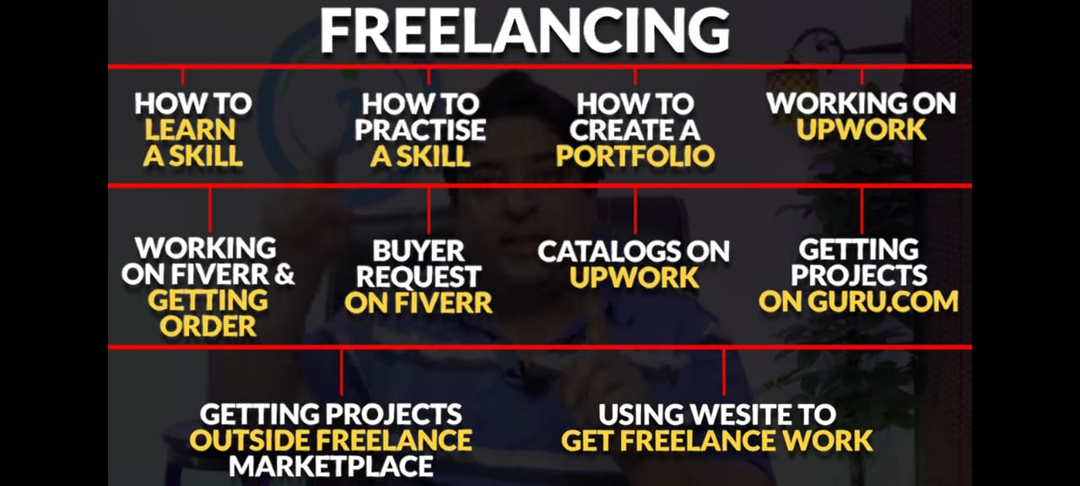

High Keyword density is a MYTH , Does not work

User Experience : Mtlb phone py b website sahi nazar ani chye (easy to read ho easy to understand ) Means on all GDGETS easy to fit .

Know your Audience : Content coverage k lie diversified topics kdr sy mily gy is website sy (website= answerthepublic.com )

Keywords Long Tail Vs Short Tail:

website Speed : agr website wordpress sy bni h to us mn sy un necessary plugins themes wgra dell kry or speed increase kry

Responsive Website

Link Building :

User Engagement Tactics : mtlb user ktni dair apki website py time spend krta h mtlb 1 page sy dusra 3sra utna e hmri website hamri rank hogi

Q : What is keyword research in ON-PAGE SEO ?

A :

Google Keyword Planner = SEMRUSH , ahrefs ,

or : ubersuggest (seo and keyword discovery )[chrome extension]

+

If we want to rank our website then goto neilpatil on chrome buy simple package and ranked.

Goto neilpatil keyword research then keyword ideas then search eg : freelancing

Select those jo green hon or phr excel file bana ly esy :

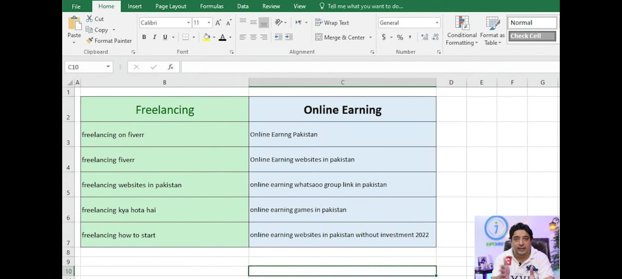

K in topics k lie knsy keywords achy rhy gy ye neilpatil sy aye h

Q: What is user search intent?

Q: How to know your competitors for the keywords?

Kssi b website ka data janny k lie website h : SIMILARWEB.COM udr search krna h

Better content , good keyword , engaging content

Keyword analysis , search intent

1 = Know your keywords 2 = understand search intent then 3rd = know your competitors

Google trends lazmi dekhna h it tells their key words popularity if it dip(drop ) to sup y kam krny ki zra b zururat nai h time waste krna h. or agr line consistent h upper nechy ho ri h to km kiya jaa skta h

1 TOPIC 1Blog Post sy zaidda nai hona chye

eg: how to get orders on fiver ? Then iska 1 hi topic hoga blog py mtlb a to z sb kch .

mtlb is qs k andr esy different topics aa skty h :

what is freelancing , skills in demand , market place , creating portfolio , win freelancing jobs , fiver ,upwark like in this picture .

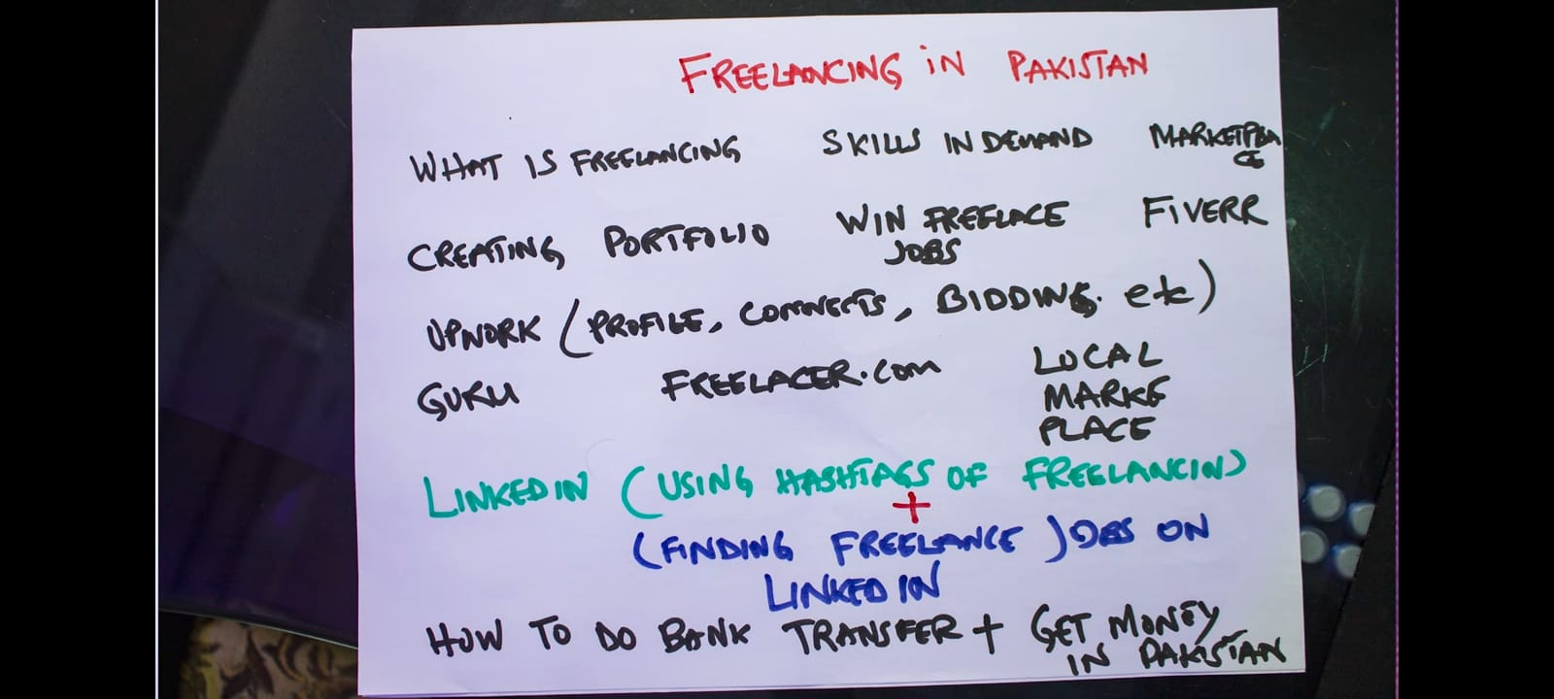

Then Know Your Pages Before you start writing the content different keywords ko different pages or different topics py cover kiya h.

How to get good seo traffic without spending a time = Engaging Content

How to find topics for your content on website?

Website h jdr sy search krna h = answer the public ye website khol k topic search krna h or circle mn qs / ans mill jaye gy . ya 1 or h QUORA.com search kr k qs section mn jaa k b qs ans mill jye gy.

Practically Start On-Page Seo

1 = Include main keyword in title

2 = Short URL

3 = Meta Description : title , description , or focus keywords.

4 = Inbound /Outbound Linking

5 = Image optimization

6 = User Readability Optimization

IMP role on on-page seo: title , description, sub-heading, text , font , Image Optimization

Title or url thora different hona chye eg= agr title h k top 10 freelancing websites in Pakistan

Variation lani h url or description(short ) mn hamesha

**Plugin = All in one seo Plugin (AIOSEO)**

Ey ye pic mn jesy title description

Then us k nechy URL jo k small hona chye

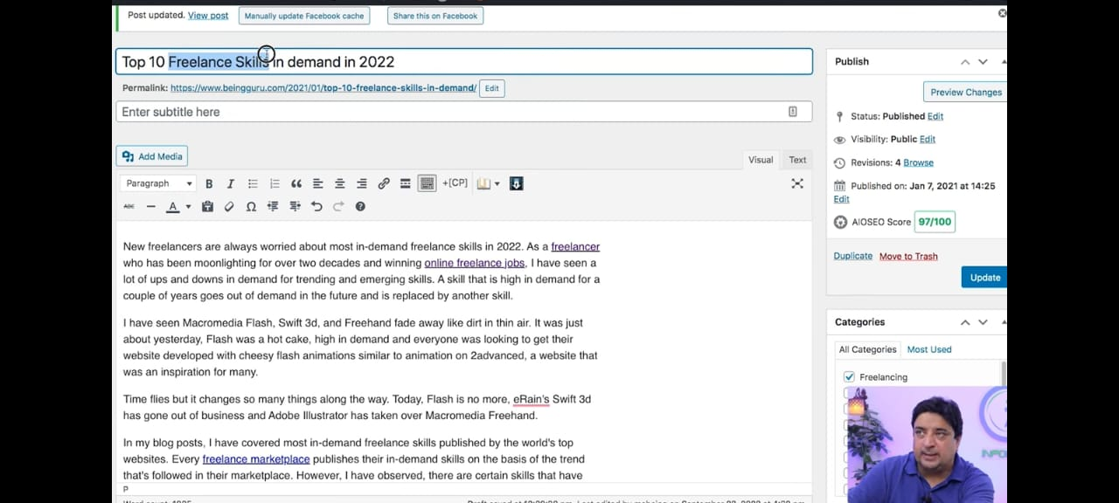

IMAGE Optimization: 1 = File Name of Image 2 = ALT Attribute (mtlb k google usko kesy prhta h )

3 = Optimized Image Size (1.2mB b bht bra size h pic k lie then usko km krny k lie goto CANVA.COM create a design then custom size like 550x330 and image ka name rkhna h jesy pic mn h upper like data entry job then share and download jpg file ) or usk agy ALT Text hota h udr lazmi likhna h relevant

Eg: Goto Pexel.com

Download images and use them in blog.

How to Write Content?

* Suggested keywords dekhny h phr unka volume check krna h volume jinka 100 sy upper ho usko uthana h or wo chk b krna h k green area mn fall k raha ho us py kam start krna h
* Or agr Uber suggest ka paid version liya h to goto our tool and start py click krna h or wo word dalna h or start sb kch wo khud kry ga like phly wo page title daly ga after title wo apko meta title py ly jaye ga or select krni h then goto heading jtni mrzi wo select krly then page ban Jaye ga then sara copy krna then goto our WordPress k dashboard.

Keyword research for free

What where why when how freelance / anything

Phly in dono sy search kro then 3rd sy uska volume nikal k use kr skty h or agr paid and best lena h to //neilpatil sy ly skty

Websie = keyword.io (<https://www.keyword.io/tool/google-longtail-finder?q=freelance&audience=en-us>)

2nd= <https://keywordsheeter.com/>

3rd= Keyword ka volume esy find krty h (<https://ahrefs.com/keyword-difficulty>) edr sy

Then Keyword ka trend mtlb line jo kb kb grow hui ya down hui lazmi chk krna h

4th = <https://trends.google.com/trends/explore?geo=PK&q=freelacing&hl=en-GB> (word apni mrzi ka )

OF-PAGE SEO

Get Recommendations from recommended sites:

Google sees that ap khud ktni authority hn (SUBJECT MATTER EXPERT) and 2nd k log apko ktna endorse kr rahy hn (mtlb recommend )kr rahy hn.

BACKLINKS: ka mtlb h k koi or blog post us content mn link py click krny sy ap ki trf traffic bhj ra h (mtlb k wo apko endorse(Appriciate) kr rahy hn ) agr apki back linking achi website sy aa rahi ho to good h .

Eg = 1 – 100 Ranking h aik jisko hm PAGE AUTHORITY khty hn DOMAIN AUTHORITY (PA ya DA ) 1 Parameter h wo parameter jtna high hoga utni hi bri site h like 70+ sites apko appreciate krdy means google smjhy ga k bri sites isko recommend kr rahi h isko rank kro. Backlinking high DOMAIN AUTHORITY sy aa rahi hoo to kam asan hoga .

1 website b h =BACKLINKO smjh a ski h.

Agr Hm Content ki bat kry to wo content ko link kiya jata h apki website sy

Anchor Text Types = Exact Match (Eg = Make Money Freelancing -> ye key word h is pury keyword ko as a anchor text dy dia h ), Partial Match (Eg = want to make money as a freelancer), Direct Brand Name(Eg = Amazon) , URL (Eg = Nicket link -> Url Direct provide krna ), Read More – Click Here

1st = Anchor Link =

2nd = Do Follow = means k ap google ko ye hint/Instruction dy rahy h k points forward krdo jab hm bat krty hn h PA ki to wo bht elements ko determine krta h ye jo authority 1-100 k drmiyan h un k number mn kaha jye gi. DoFollow Mtlb k hm points dy rahy h agli site ko ya points ly rahhy h us site sy Google isko ranking mn count krta h

3rd = No Follow Links = Reverse of DoFollow Link but it gives referral links

**Backlinking** mn 1st thing

**Guest Posting**: (free hoti h ye hmehsa)

Mtlb ksi ki website py ja k usk lie content likhna or us sy puch lena h k sir me apki site sy DoFollow (Backlink )link ly lu?

**2nd method = Goto Google Search : freelancing blogs “Submit a guest post ”**

Back link k lie ksi ko approach krny ka lie ya to website py ja k usk social icons sy usko msg kr do yar to 1 website h <https://hunter.io/> or udr usko mail kr deni h specific blog ko mention kr k .

2nd method = goto Contactout.com

Ab hmy janna h k site ka owner kon h usk lie site ka link copy krna h to google py ja k website ka name likhna h eg = propakistani.com owner esy likh dena h

How to get backlinking from forms -> 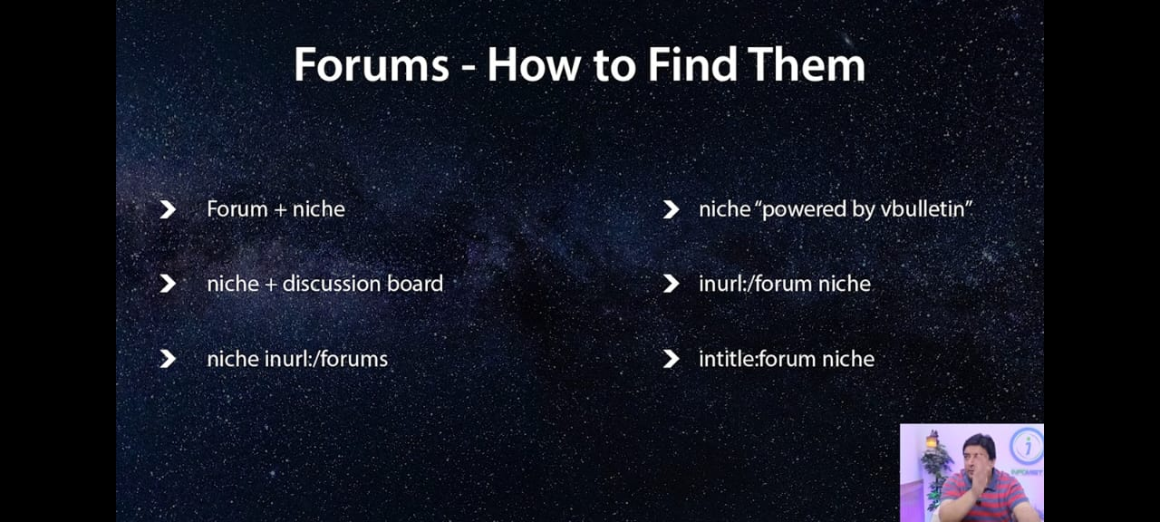

Jo b topic h hmra like esy likhna h

Freelancing “forum + niche”

Then websites kholo or udr sign up kr k discussion section mn jao or udr esy cmnt kr k bat start kro or phr us sy backlinking ki bat kro 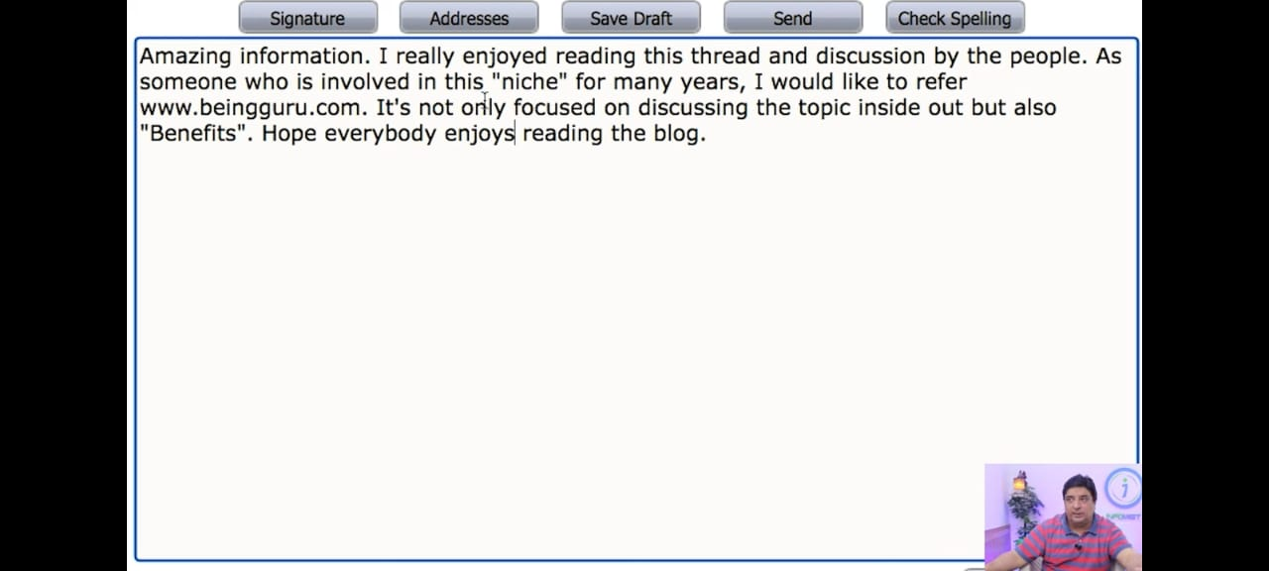

How to get backlinks from Resource Pages:

Or easy way to get broken backlinks =

1st step = our niche + useful links = eg = “freelancing ” + “useful/helpfull links ” (useful links mn hmny 1st chz jo dekhni h wo high domain authority honi chye)

Resource Pages =

Three Steps :

1st = Find relevant resource pages

2nd = find the best fit content

3rd = reach out

Esy jesy k ye 4th num py h to kaya or kesy search krna h = eg agr hm freelancing py km kr ry h to = freelance+”useful links” .

Jo b link khula or us bndy ko mail krni h to ye copy kr k kr do.

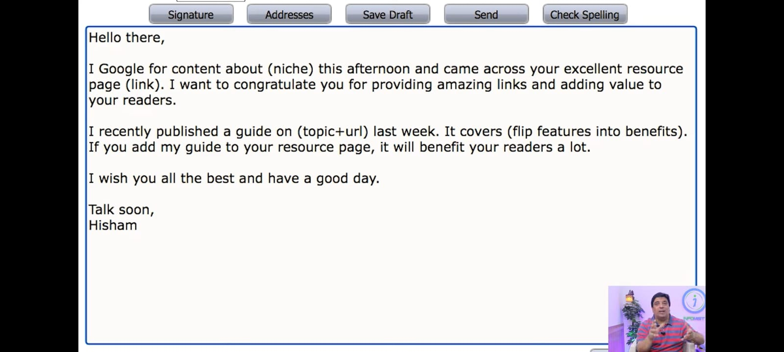

Add chrome extension = check my links

Eg = agr hm freelance +links search krty h or is extension ko use krty h to jo area red wala h wo hmra h hm usko use kr k broken links bhj skty h.

Best way of getting back links = Guest Posting

Link Building Strategy using sky scrapper:

Already jo popular website h ya jb hm google py jo kch b search krty h or search results sy jo hmy websites nazar ati hn agr usko achy backlinks Mily Huy h or agr hm us popular website k backlinks steal krly to popular ho jaye ga .

Ksi b website k words count krny k lie : = find website word count

Next = BLOG COMMENTING:

Relevant Blog Posting = search on google = our niche + blogs = eg= freelancing + blogs

Reverse image search = images.google.com ispy ja k agr ksi ny apki to udr sy sb show ho jata h kis kis ny apki apni images use ki hui h udr sy ya to unsy remove krwa skty h ya to backlink ly skty h

Blog commenting =

Social media profiles ko approach krny k 2 types hn= 1= jo hm daily use kr ry hn (like apni profiles py apni websites ka link dalna).

Which backlinks are not good?

There are 5 backlinks which are not good for our website.

1st = Link Exchange

2nd = Low Quality FORUMS Low Domain Authority

3rd = Social Bookmarking

4th = Directory Submission (that accept without verification). you can submit with software (Google does not give them any weightage) wee need to focus on lesser quantity and high quantity.

5th = Side Wide Links.

Imp:

SILO STRUCTURE =

Silo means(apni hirarchi mn reh k inbound linking krty h )

Agr hm SILO k Structure mn rhty h to we have a fair chance of making understand google that what we have done. Is pic ki best example ki website h propakistani.com

1 category k andr sub categories like eg = freelacing = Digital Products , then youtube , then blogging then in k andr insy relevant meterail add kry

**Summerize** form of Total SEO:

TECHNICAL SEO

Ismn hm sekhy gy k kesy website ko structure kry gy +responsiveness + website speed+ Domains ,SubDoamins

Categories wise then images k khayal rkhna h k images kesy rkhni h big,small,etc

Then Url + broken Images+ Double Domain Indexing +backlinking from websites (jinka spam xaida h )+ Google search Console +Google Analytics +Indexing +Fast Indexing

Google local business = lazmi hona chye chye wo kuch b ho like kch b sale kr ry ho ya kch b ho local business must h. search on google = google local business

**Three Elements Should be counted In Seo:**

**A=User Experience:**

**1=Bounce Rate 2=Exit Rate 3= Session Time**

**How to increase Session time and decrease bounce time ?**

B= Website Design:

Color , theme , pages , breadcrumb navigation , inner page linking

Search = Google speed insight test