1. STL Container Practice: Write a program using STL containers that:
   1. Uses vector<string> to store names
   2. Uses map<string, int> to store age against each name
   3. Implements functions to:
      1. Add new name-age pair
      2. Find all people above certain age
      3. Sort and display names alphabetically

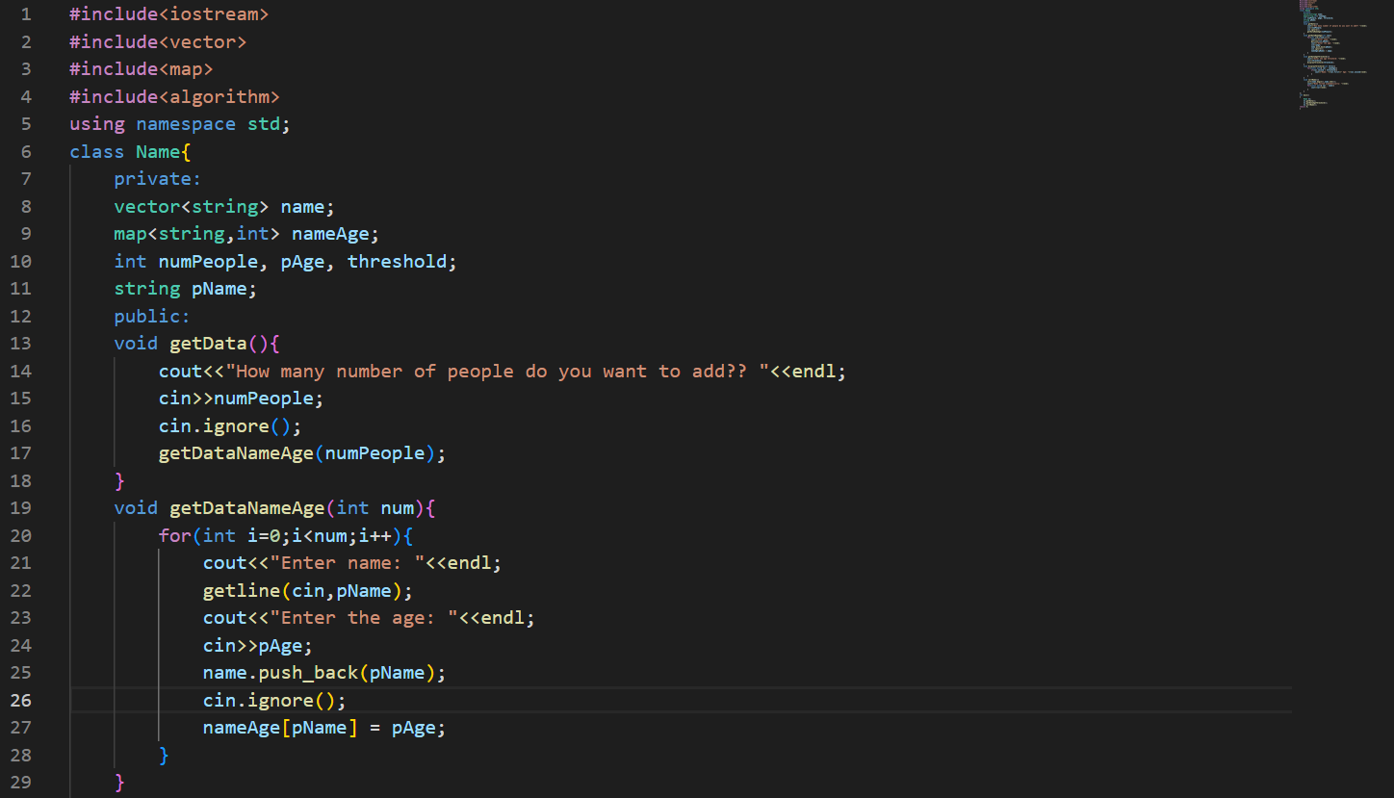

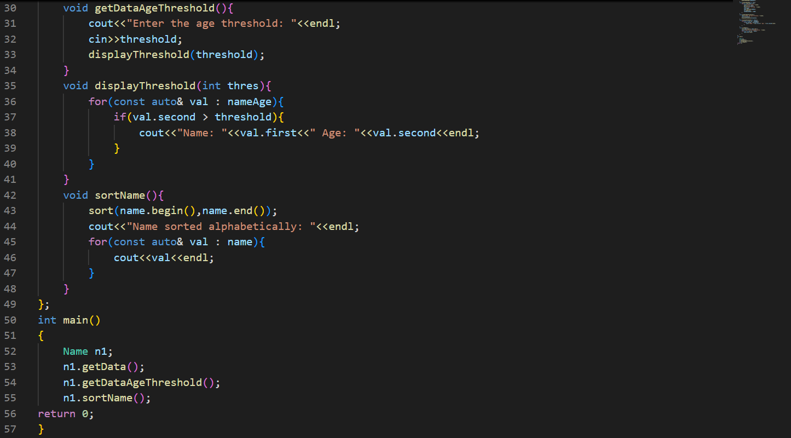

**Solution:**

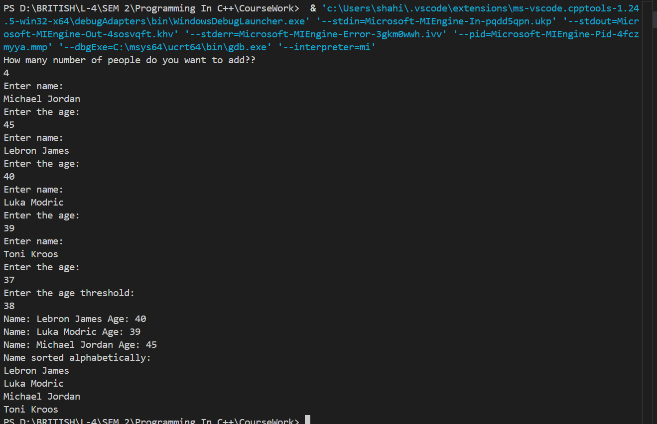

1. Stack Problem: Implement a stack using arrays (not STL) that:
   1. Has basic push and pop operations
   2. Has a function to find middle element
   3. Has a function to reverse only bottom half of stack
   4. Maintain stack size of 10

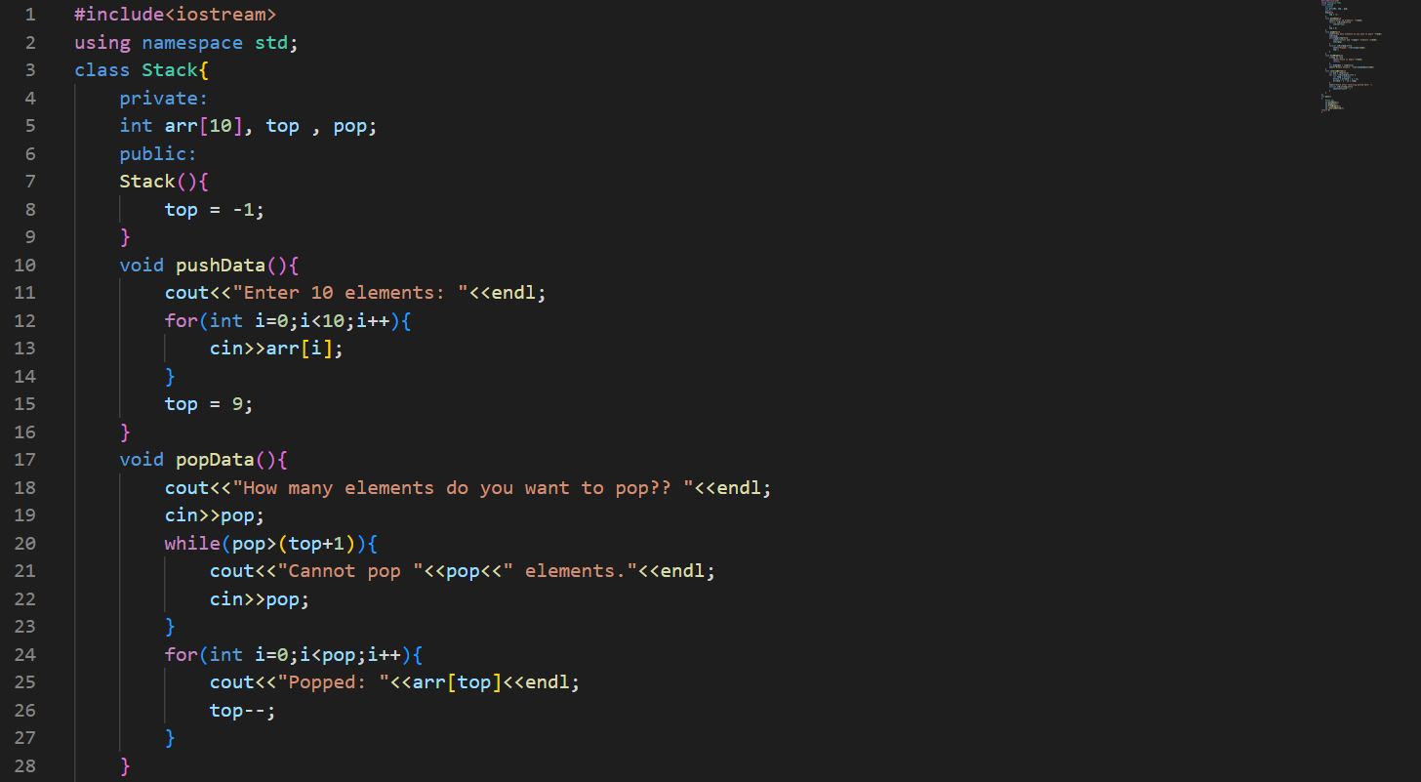

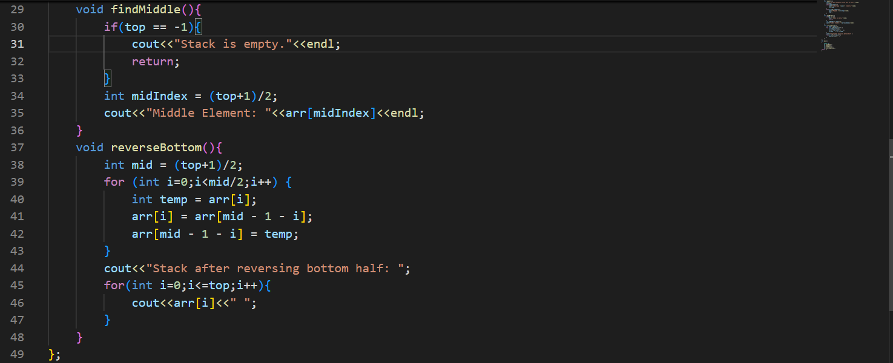

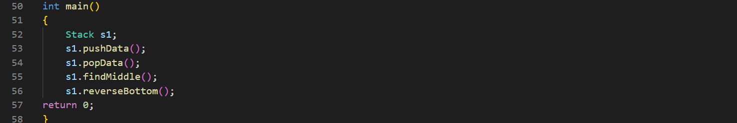

**Solution:**

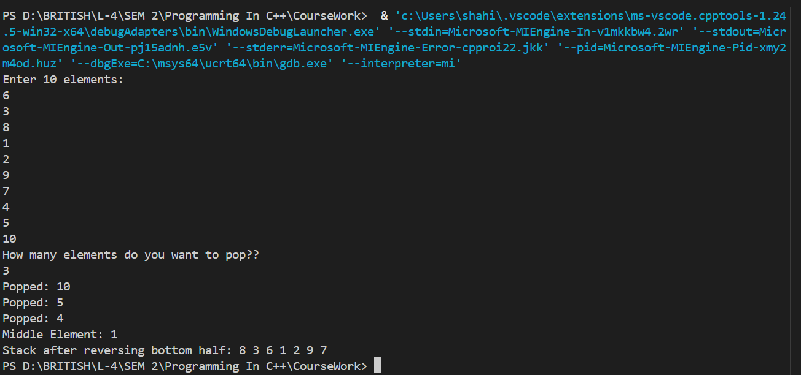

1. Queue Problem: Implement a queue using arrays (not STL) that:
   1. Has basic enqueue and dequeue operations
   2. Has a function to reverse first K elements
   3. Has a function to interleave first half with second half
   4. Handle queue overflow/underflow

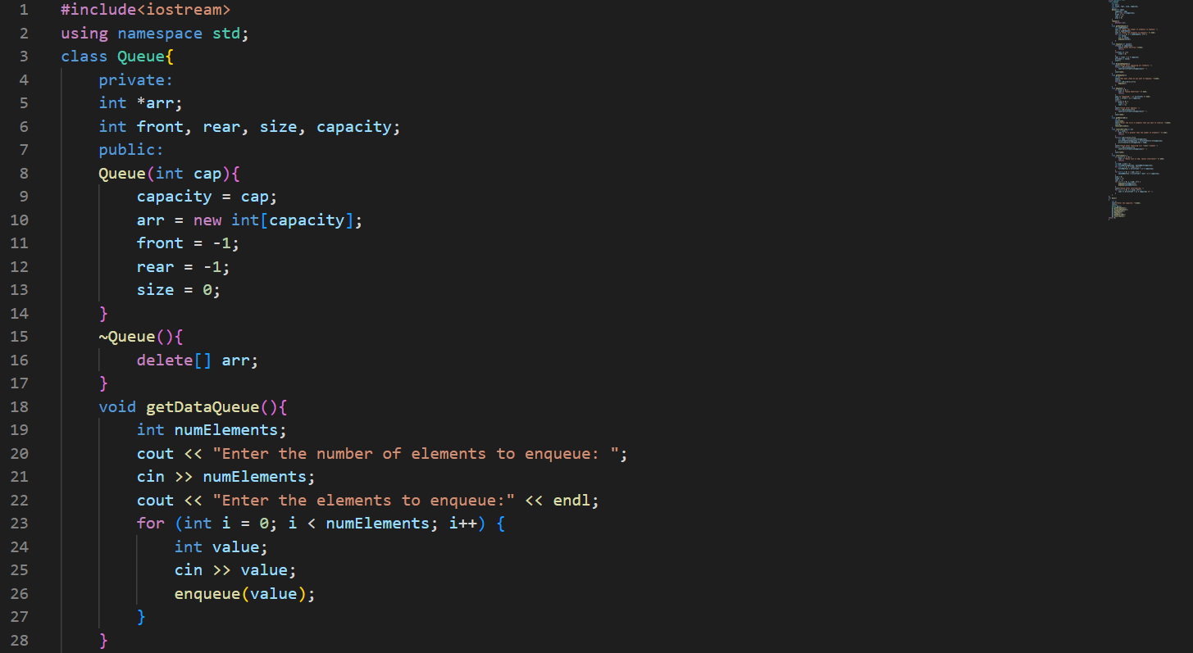

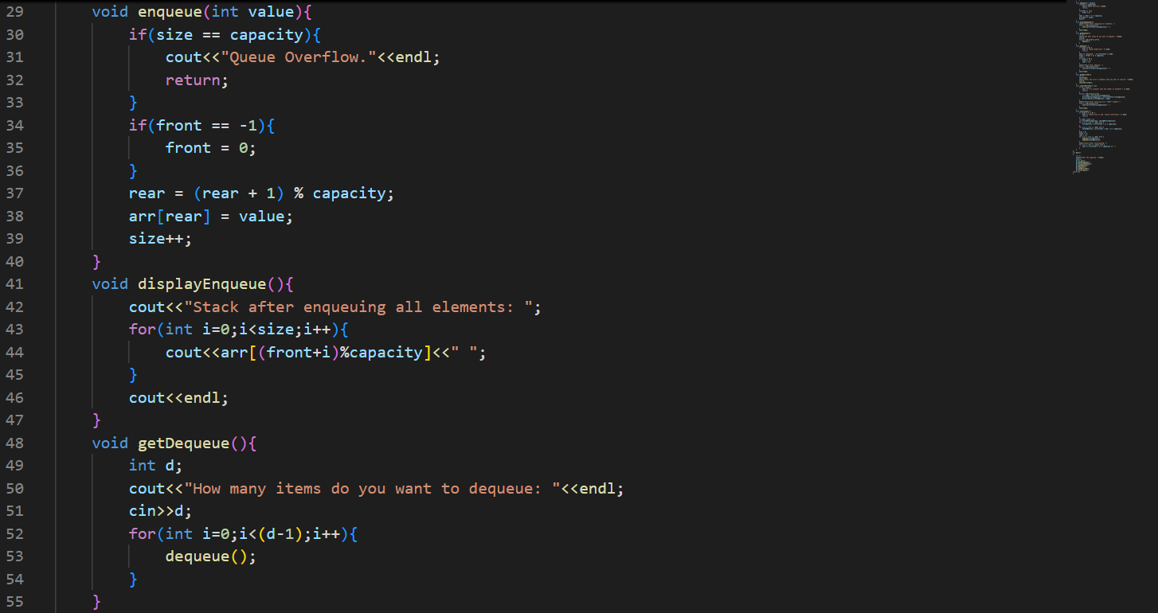

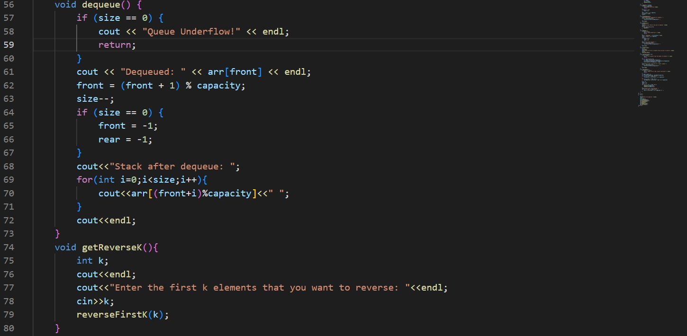

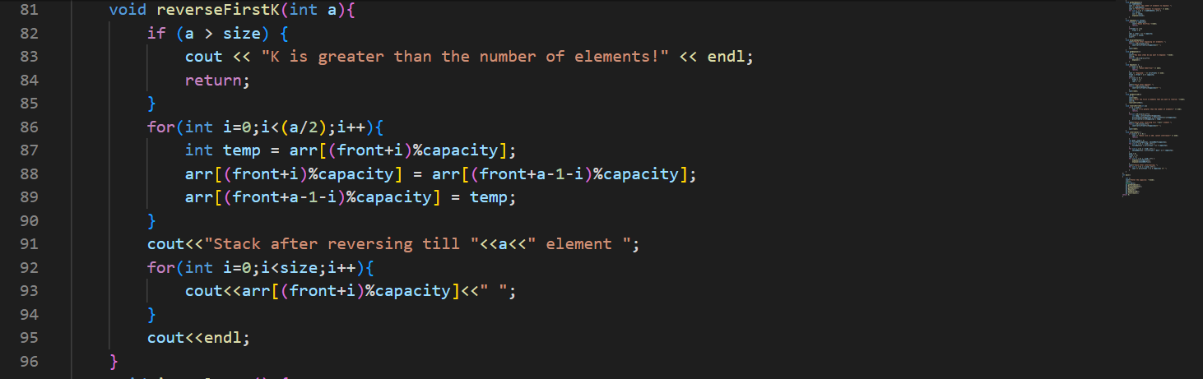

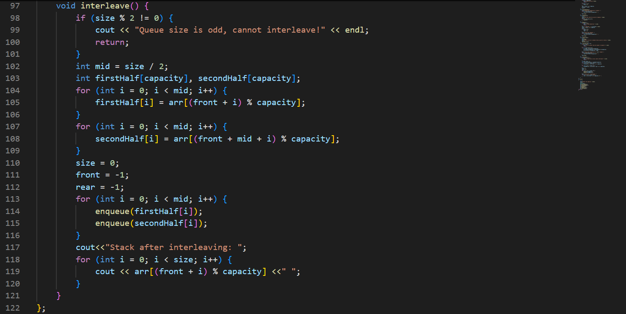

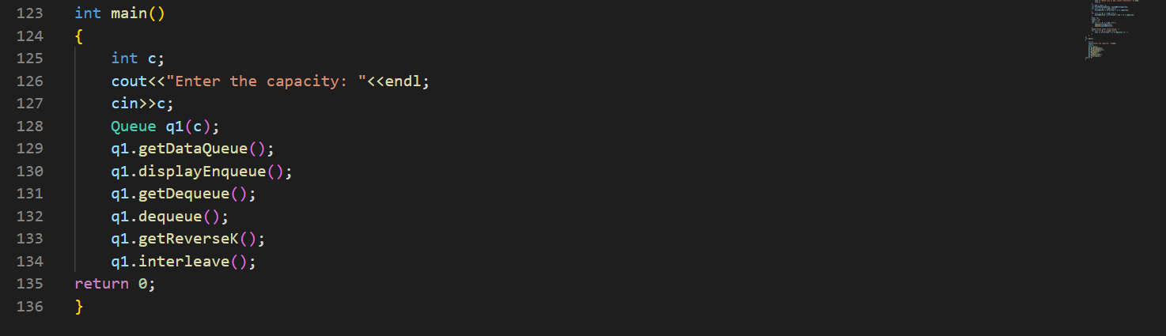

**Solution:**

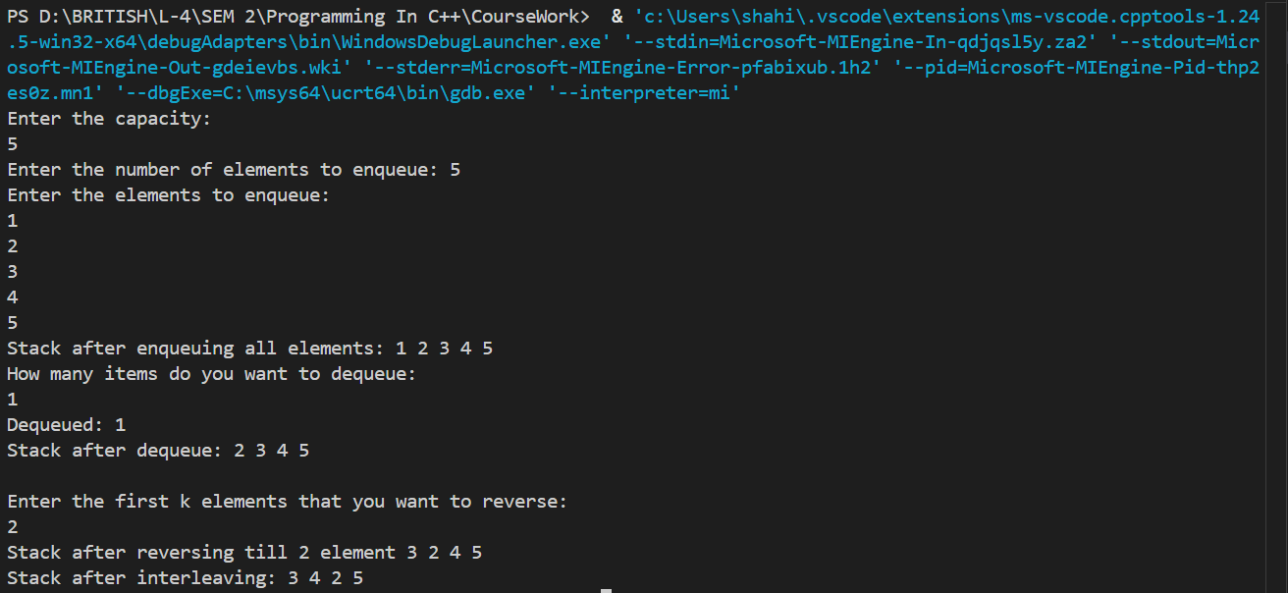

1. Linked List Problem: Create a singly linked list (not STL) that:
   1. Has functions to insert at start/end/position
   2. Has a function to detect and remove loops
   3. Has a function to find nth node from end
   4. Has a function to reverse list in groups of K nodes

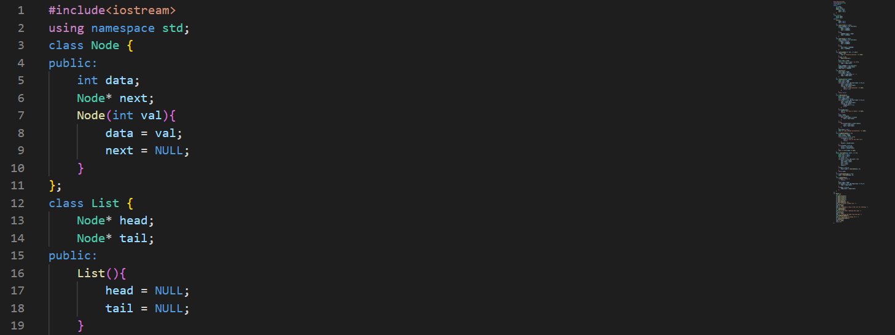

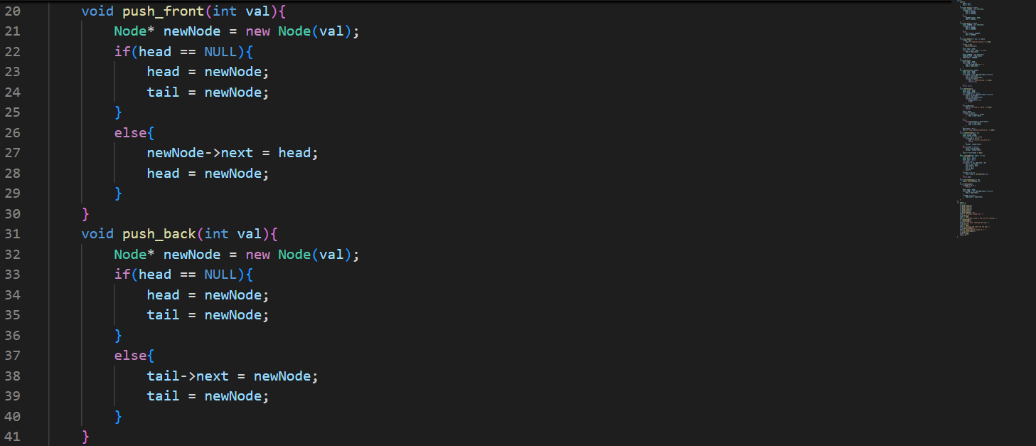

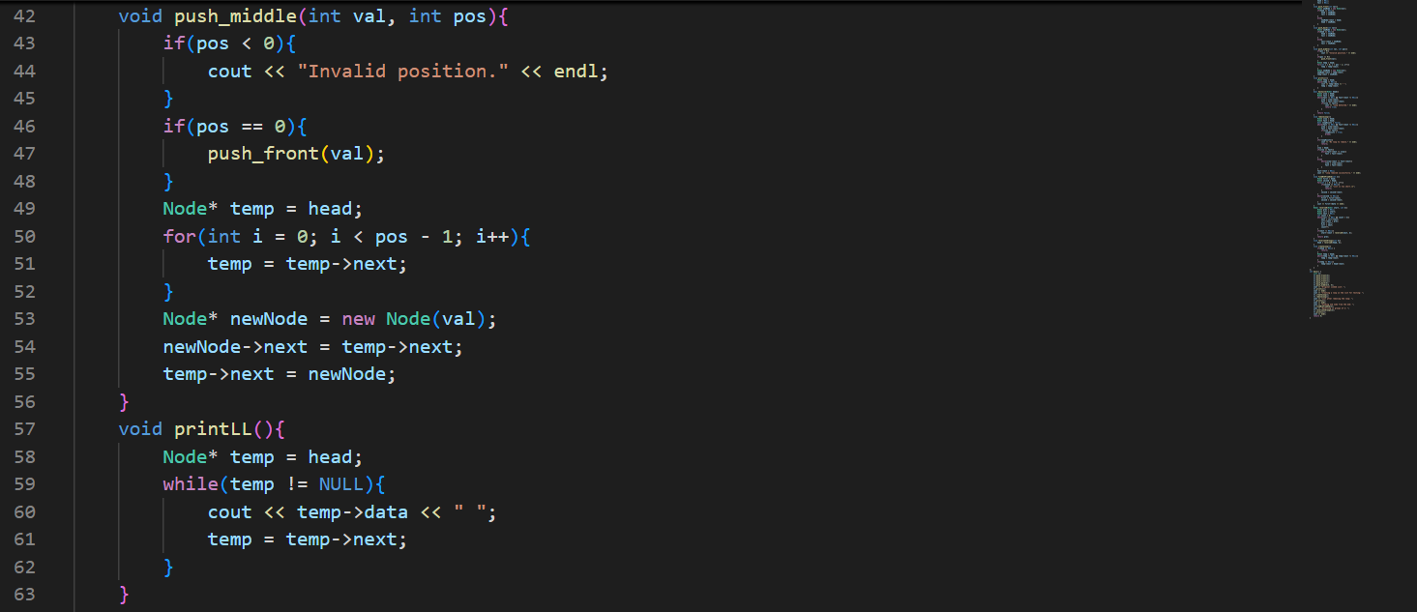

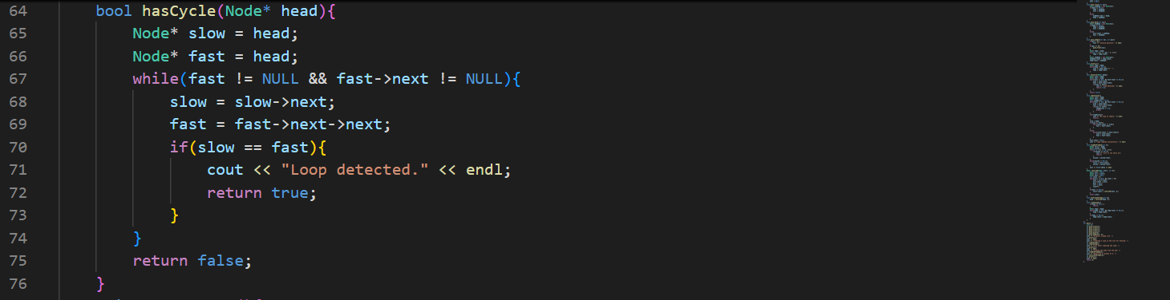

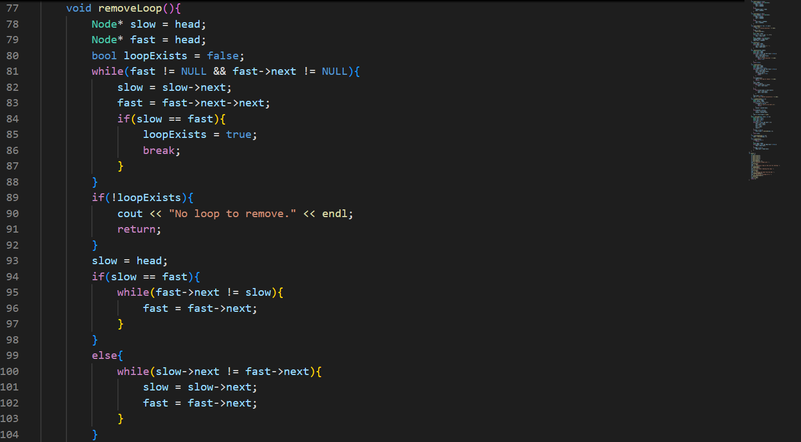

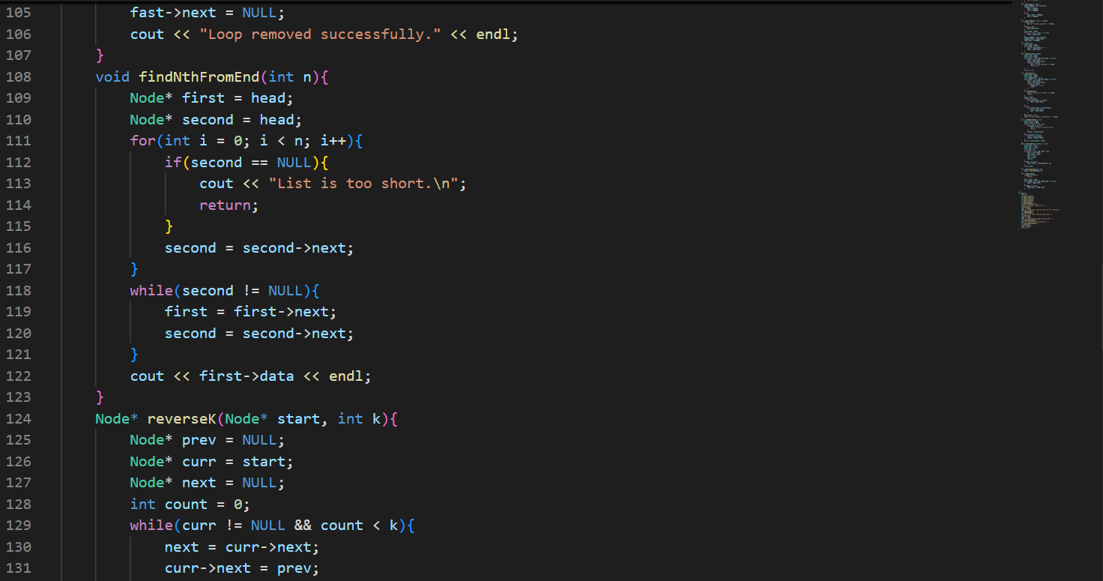

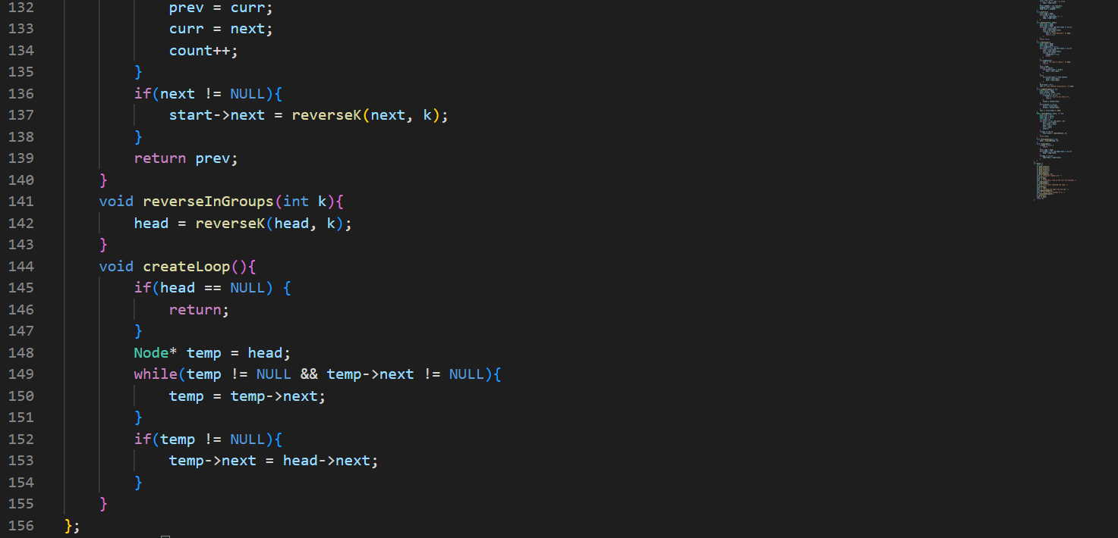

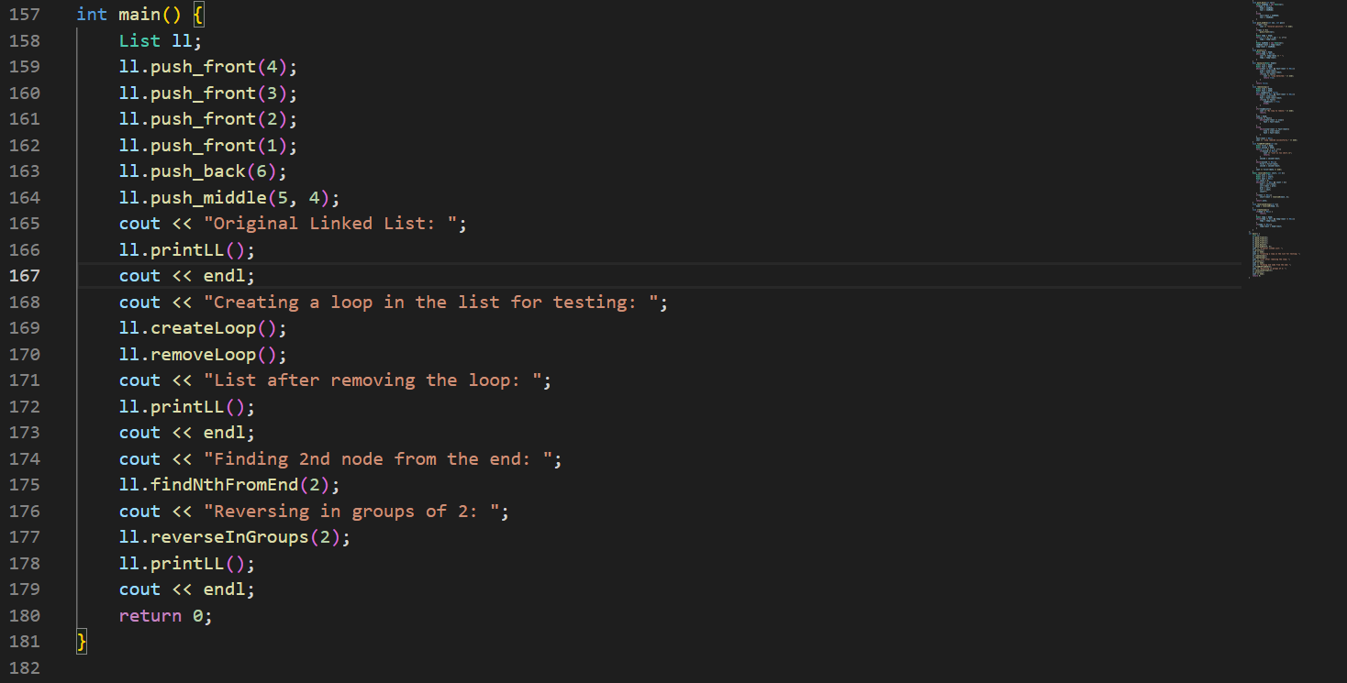

**Solution:**

