**Abstract**

**INTRODUCTION:** Travelling is considered to be one of the stress busters and hence people nowadays are becoming travel freaks. They like to explore more and know everything in detail in their own way. The source of information in a tourist place are of course the “tourist guides”. But the problem with them are: 1) they’re not easily accessible to everyone 2) one cannot be assured of their guidance to be authentic 3) they’re quite expensive sometimes. So, in order to solve this issue we’ve come up with a personalised application which will not only give authentic information about any place but also is cost effective.

**OVERVIEW**: We’re designing an android application that will replace the conventional travel guides. The user is supposed to download our application and sign up. There’ll be one package exclusively dedicated to each place. So, whenever the user wants to visit any place, he should search for the place in the search engine and download the convenient package. Each package will cost him some amount which will be sent to the tourism dept for the development and maintenance of the same place.

And now after downloading the package, all he has to do is, click a snap of any of the spot in that place about which he wants to know and our application will pop up a two-line info about the importance of that spot with the voice notes. if the user is still interested, he can now click on the pop up to know more about the same spot, and the application will give the entire info about that place and the relevant google links with the descriptive voice notes.

The key feature of this application is that the user can click any number of photos and he’ll get to hear and know more about it easily. All the pictures he’ll be clicking in and around that place will be saved in an exclusive folder with its name as the place name.

The user has to use the internet only to download the application and the package. Later on, the whole process doesn’t require internet.

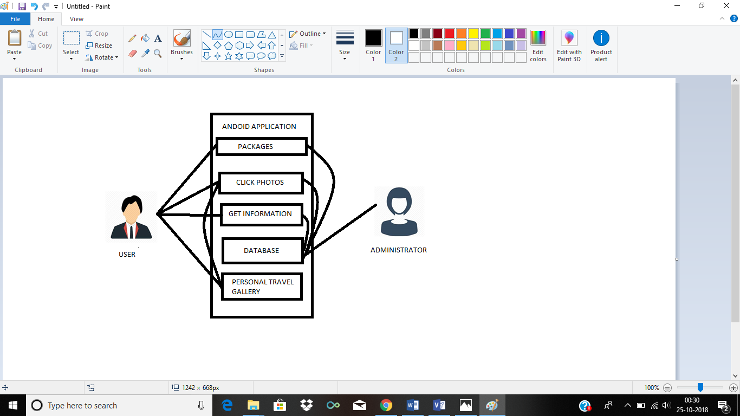

Data flow diagram

**CONCLUSION:** The quest has now become easy. The user does not have to google now to know about known and unknown places. Just click a snap of the place and our application will give all the information about it. And yes, it’s not just the text info, it has got voice notes as well for the user, which will make the quest more interesting.

This application is easily accessible and will give authentic information about any place to the user.

The traveller can have his own well organised personal travel gallery maintained in our application.

Cost effective and the amount donated by the user will contribute to the maintenance of the tourist spots, which will in turn attract more tourists.

[ANNAPOORNESHWARI.K - 1SI16TE003

SRIVIBHA. A. S - 1SI16TE039

ABHISHEK SHARMA - 1SI16TE047

UDHAV MOHATA - 1SI16TE045

V SEM TELECOMMUNICATION]