SHOPEZ – FULL STACK MERN E-COMMERCE PLATFORM

1. INTRODUCTION
Project Title : ShopEZ – Full Stack MERN E-Commerce Platform
Student Name: Anu Priya Pillalamarri
Role: Full Stack Developer

2. PROJECT OVERVIEW
Purpose
ShopEZ is a full-stack e-commerce web application developed using the MERN stack (MongoDB, Express.js, React.js, and Node.js). The main objective of this project is to provide users with a simple and secure online shopping platform where they can browse products, create an account, manage their cart, and place orders easily.
This project helped me understand how the frontend, backend, and database work together to build a complete web application.
Key Features
- User Registration and Login
- Secure JWT Authentication
- Browse Products by Category
- Search Products
- Shopping Cart Management
- Wishlist
- Checkout Process
- Order Management
- Responsive User Interface
- Admin Dashboard
- Product & Category Management
- MongoDB Database Integration

3. SYSTEM ARCHITECTURE
Frontend
The frontend is developed using React.js and Vite. It provides a clean and responsive user interface where users can browse products, manage their shopping cart, and place orders.
Backend
The backend is built using Node.js and Express.js. It handles all business logic, user authentication, product management, and communication with the database using REST APIs.
Database
MongoDB is used to store all application data, including users, products, orders, categories, cart details, and wishlist items.
Architecture Flow
React Frontend
↓
Express REST API
↓
Node.js Server
↓
MongoDB Database

4. SETUP INSTRUCTIONS
Software Requirements
- Node.js (v18 or above)
- npm
- MongoDB Community Server
- MongoDB Compass
- Visual Studio Code
- Git

5. PROJECT FOLDER STRUCTURE
Frontend
- assets
- components
- context
- layouts
- pages
- styles
- App.jsx
- main.jsx
Backend
- config
- controllers
- middleware
- models
- routes
- uploads
- utils
- server.js

6. RUNNING THE APPLICATION
Start Backend
cd backend
npm run dev
Start Frontend
cd frontend
npm run dev
Application URL
http://localhost:5173

7. API DOCUMENTATION
Authentication APIs
- POST /api/auth/register
- POST /api/auth/login
- GET /api/auth/me
Product APIs
- GET /api/products
- GET /api/products/:id
Cart APIs
- POST /api/cart
- GET /api/cart
- DELETE /api/cart/:id
Order APIs
- POST /api/orders
- GET /api/orders
Admin APIs
- GET /api/admin/products
- GET /api/admin/orders
- GET /api/admin/users

8. USER AUTHENTICATION
Authentication is implemented using JSON Web Tokens (JWT).
Features
- User Registration
- User Login
- Password Encryption using bcrypt.js
- JWT Token Generation
- Protected Routes
- Role-Based Access Control (User/Admin)

9. USER INTERFACE
The application consists of the following pages:
- Home Page
- Product Categories
- Product Listing
- Product Details
- Shopping Cart
- Wishlist
- Login Page
- Registration Page
- Checkout Page
- User Profile
- Admin Dashboard

10. TESTING
The application was tested to ensure all major functionalities work correctly.
Testing Performed
- User Registration
- User Login
- Product Search
- Product Filtering
- Add to Cart
- Remove from Cart
- Checkout Process
- Admin Dashboard
- Product Management
- API Testing

11. SCREENSHOTS
- Home Page
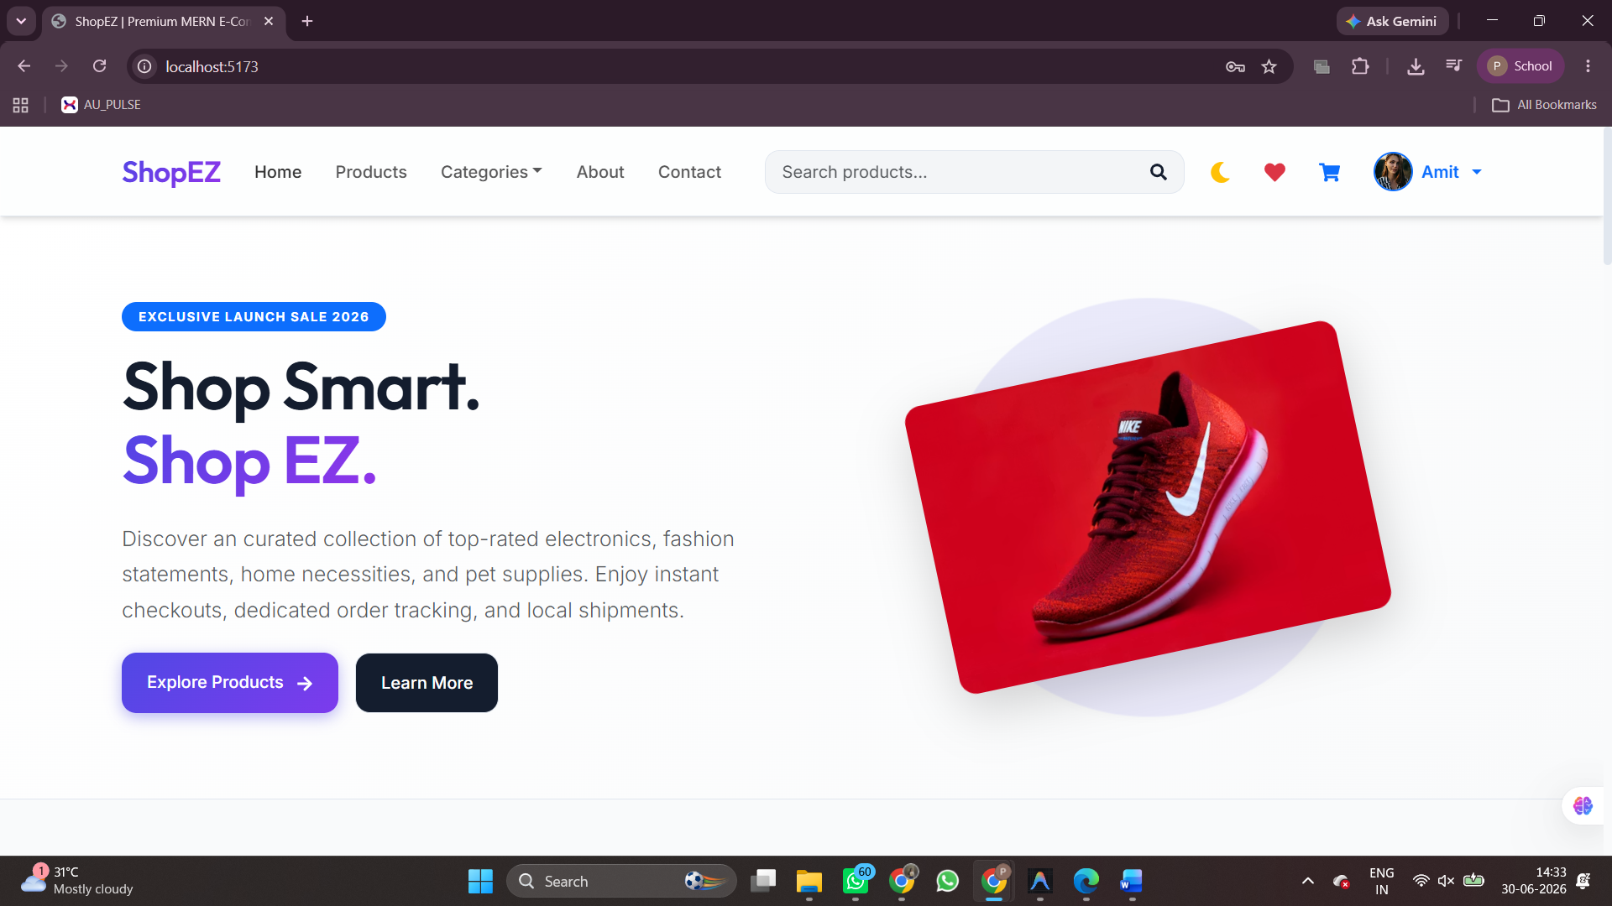

- Login Page
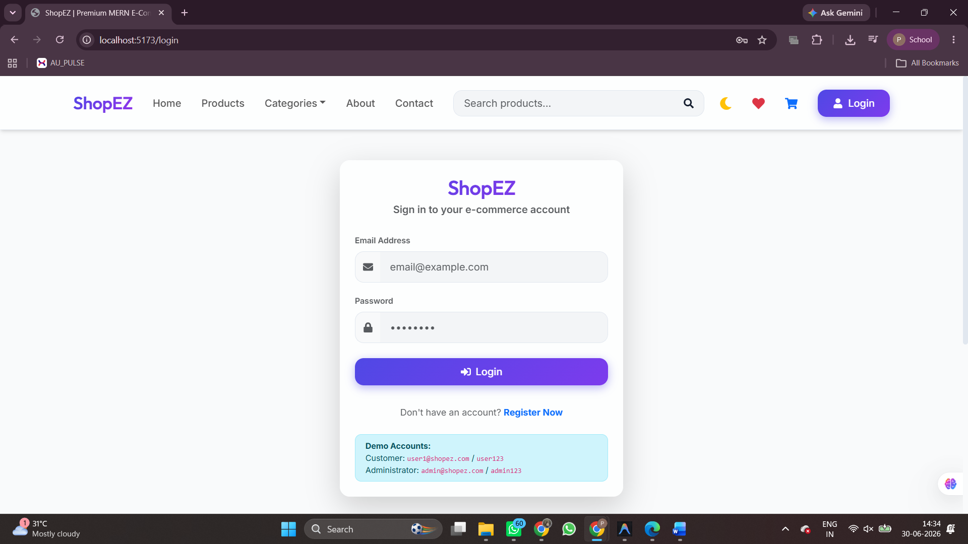

- Registration Page
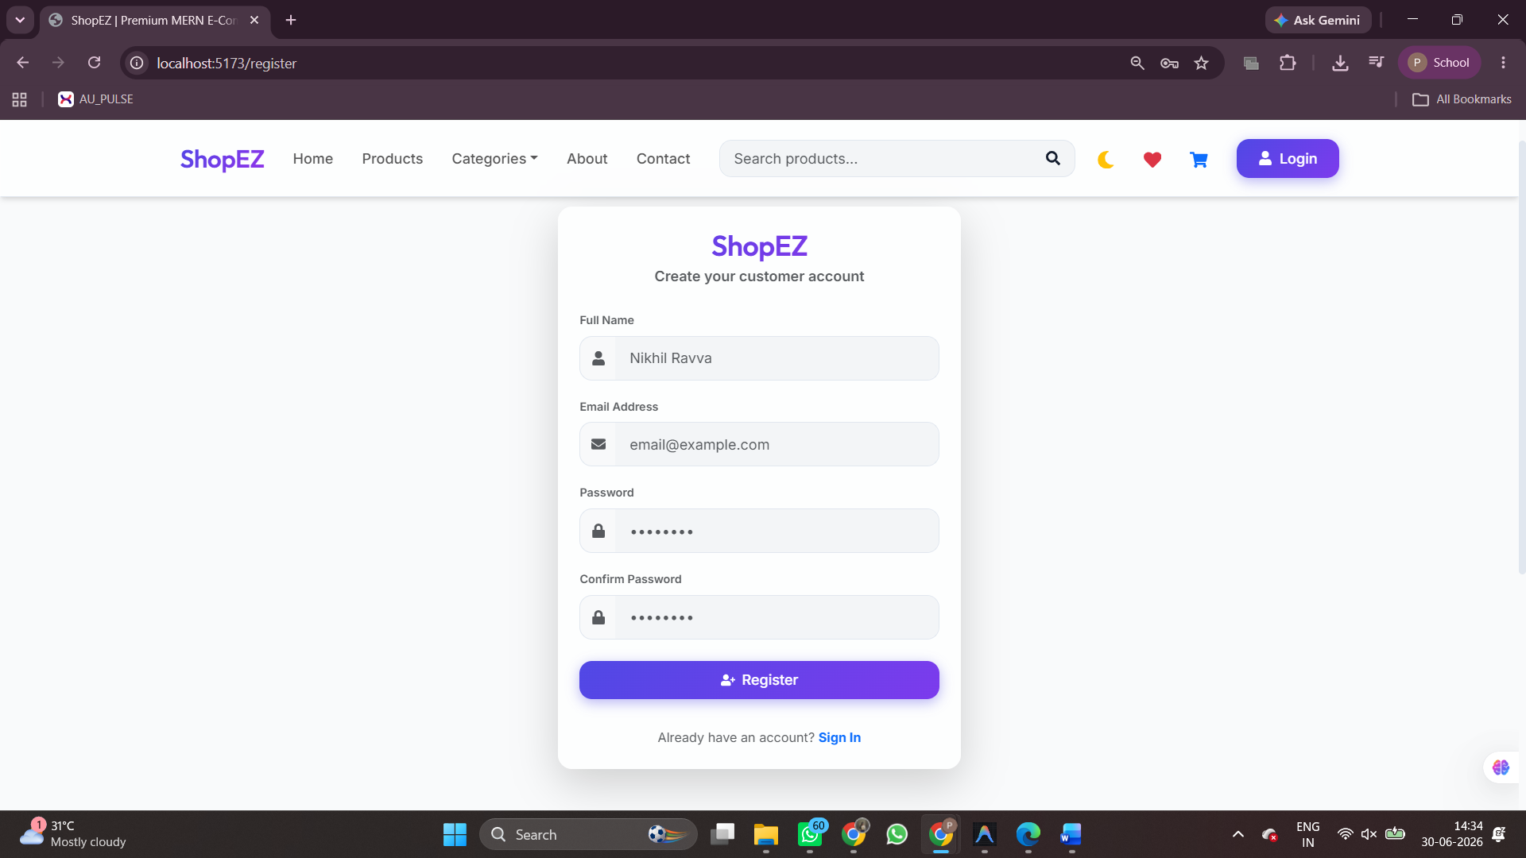

- Product Listing
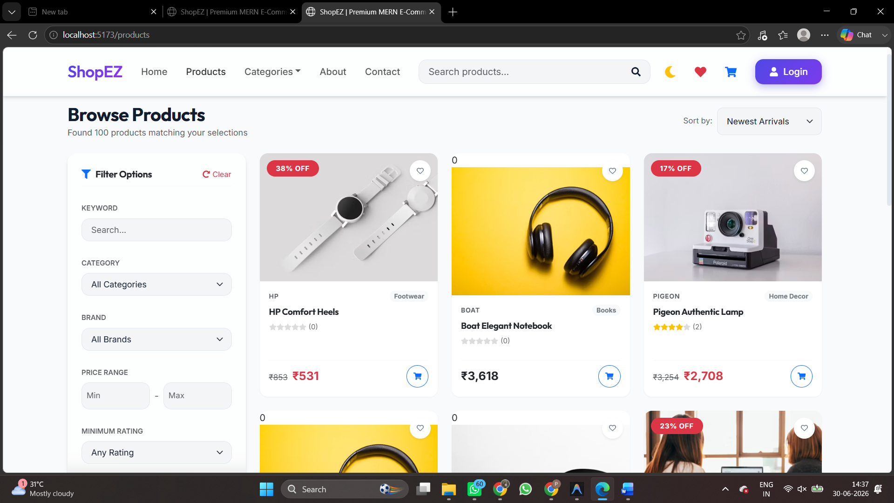

- Product Details
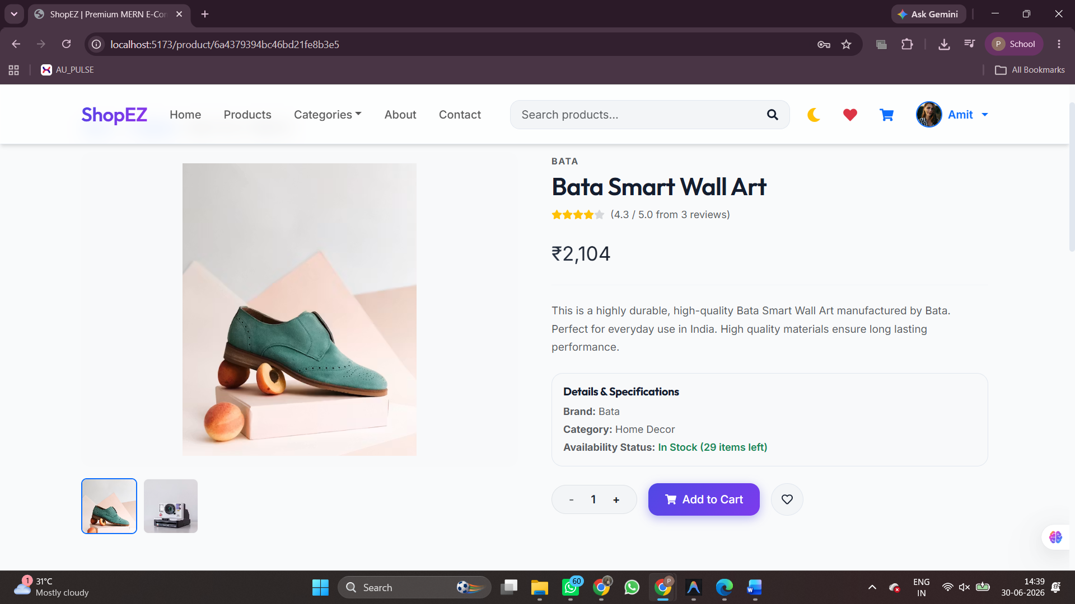

- Shopping Cart
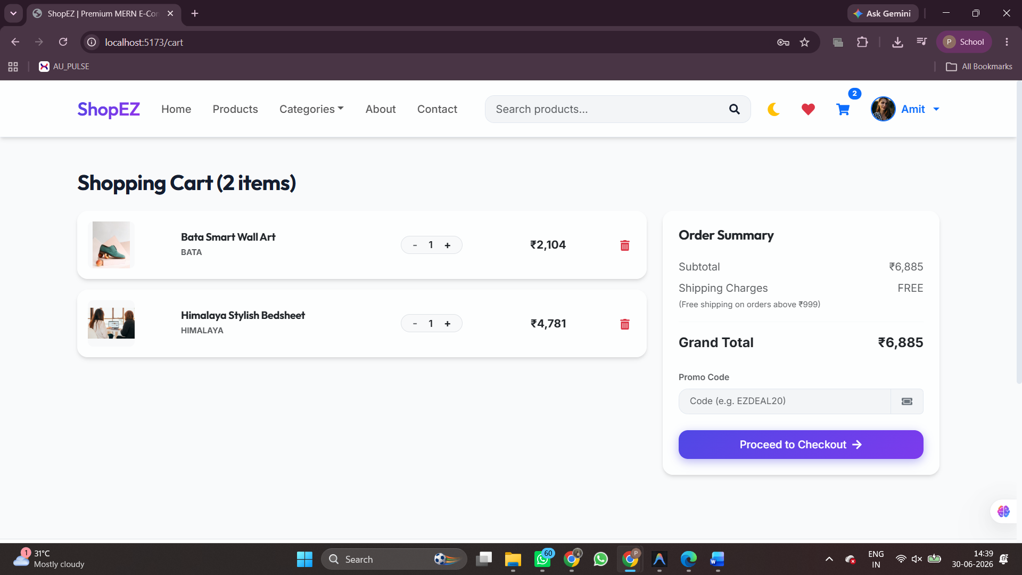

- Wishlist
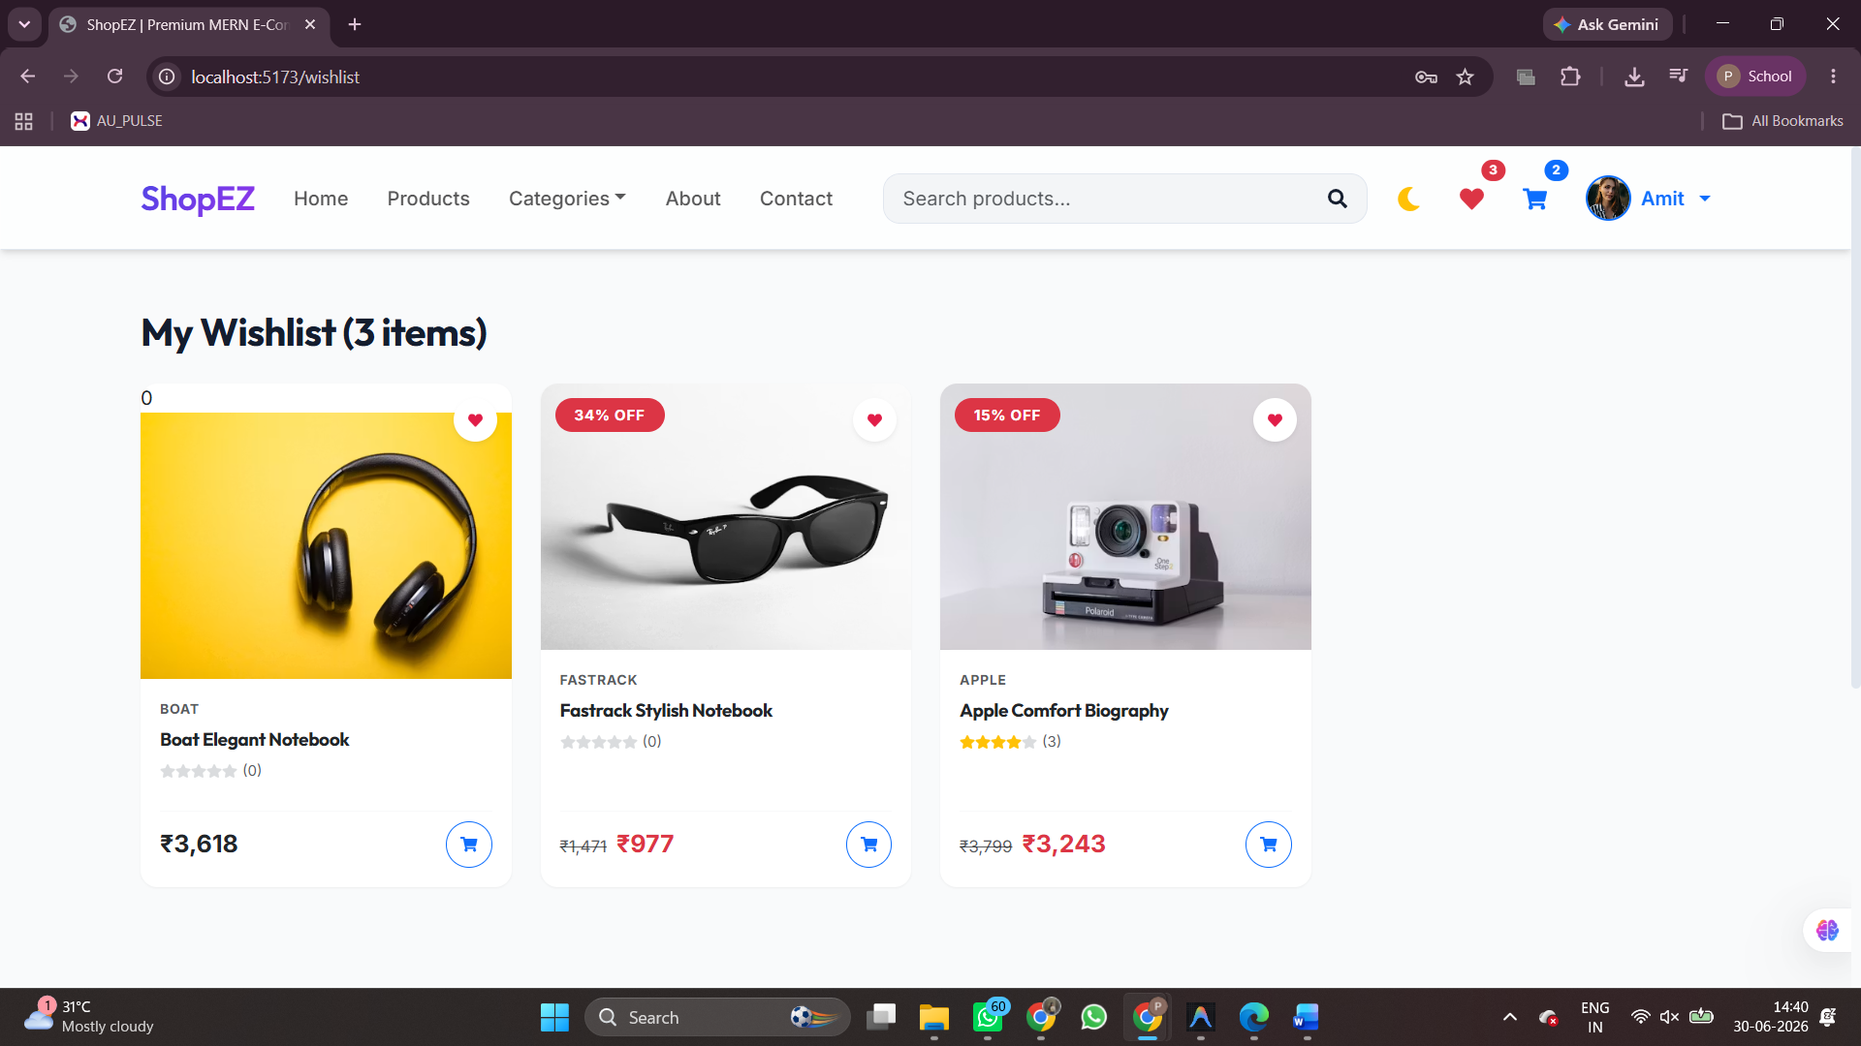

- Checkout Page
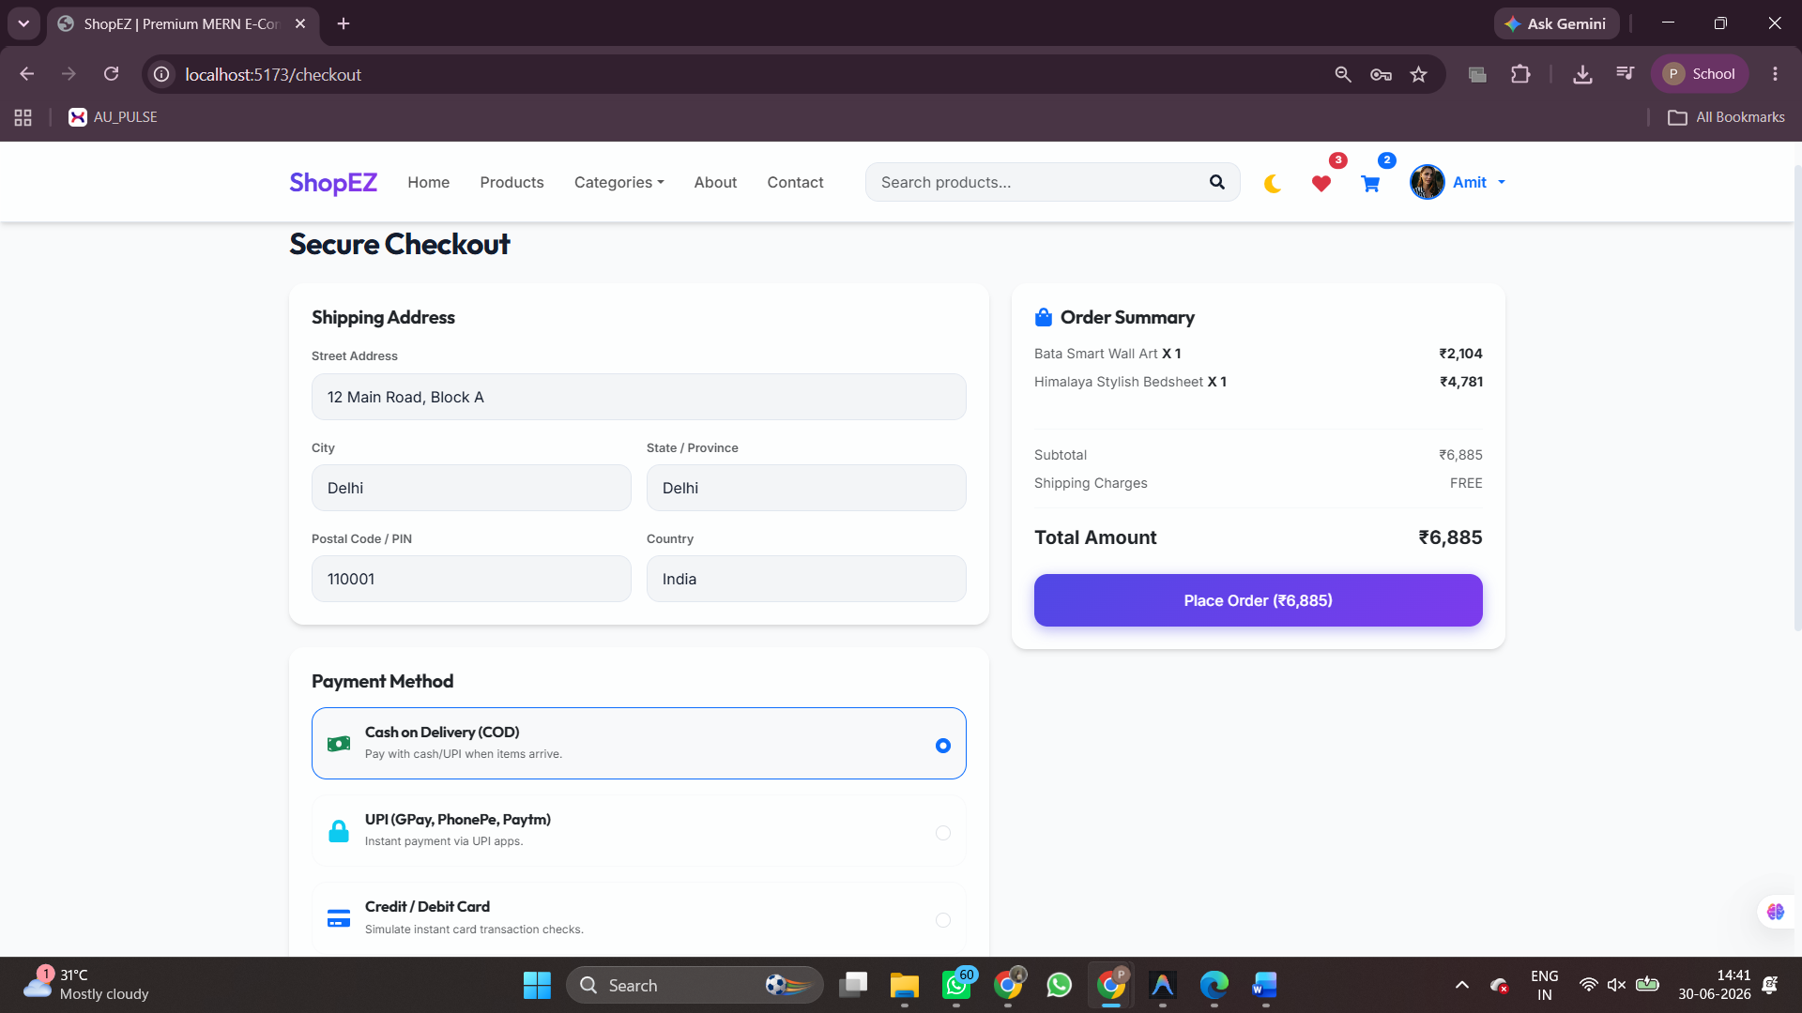

- User Profile
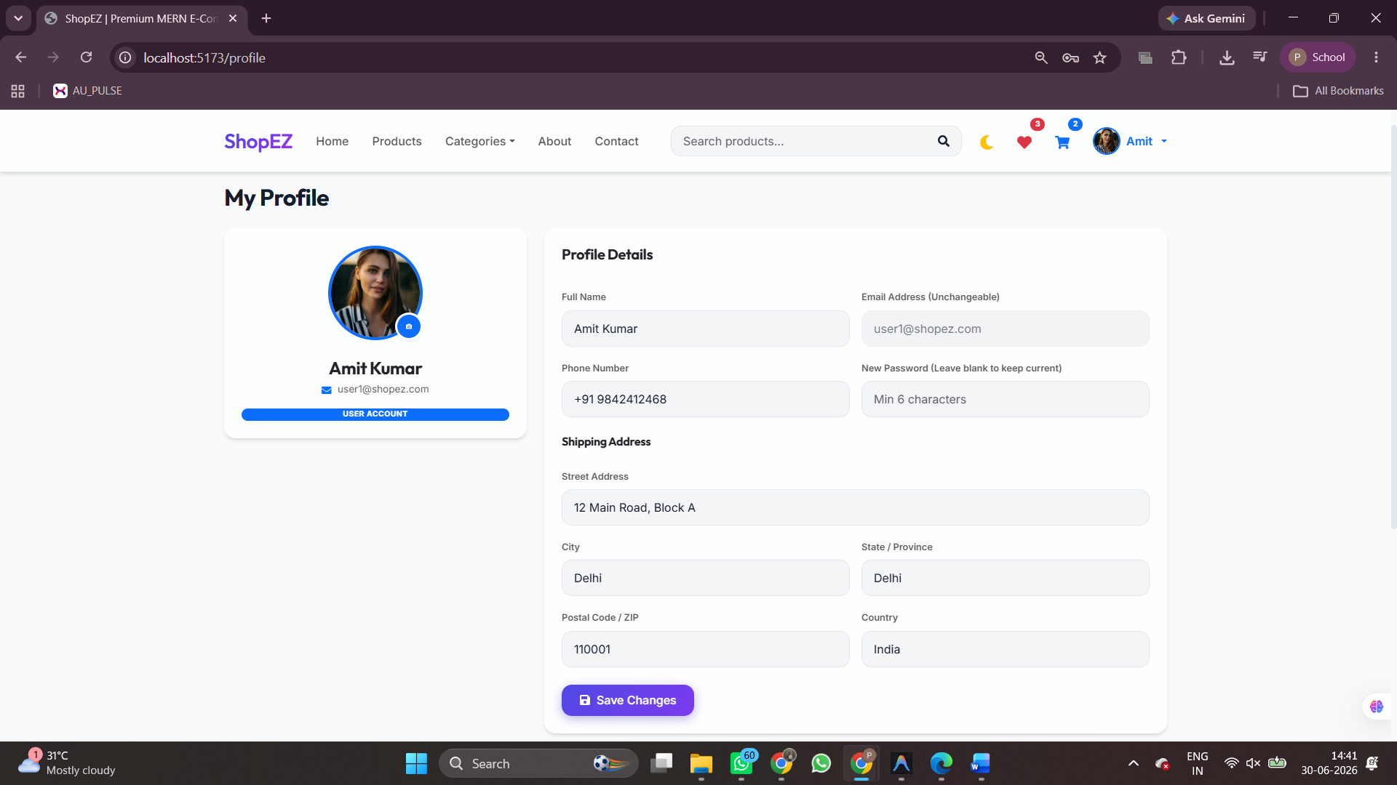

- Admin Dashboard
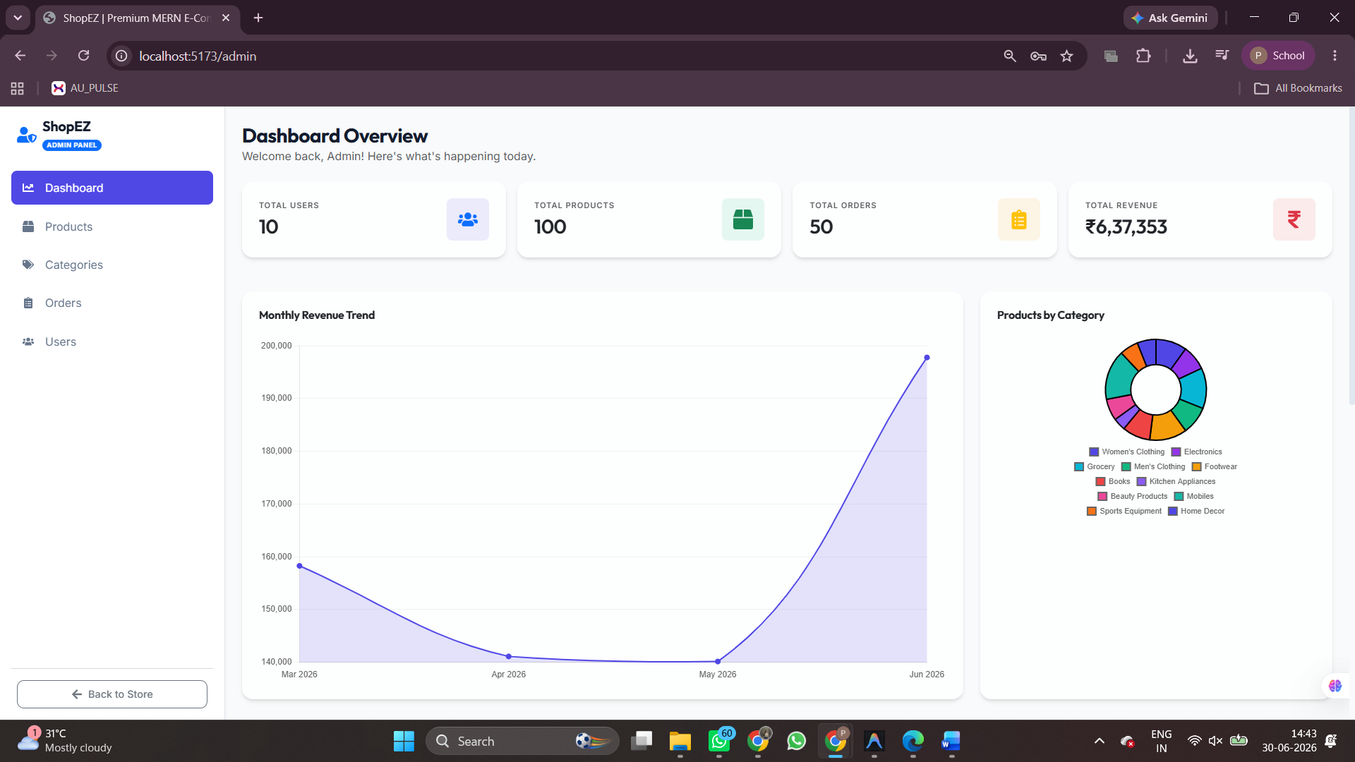

12. KNOWN ISSUES
- MongoDB must be running while using the project locally.
- Image loading may depend on internet connectivity.
- Online payment gateway is currently simulated.
- Some features require admin login.

13. FUTURE ENHANCEMENTS
The following features can be added in future versions:
- Razorpay Payment Integration
- Email Notifications
- Product Reviews & Ratings
- Live Order Tracking
- AI-based Product Recommendations
- Mobile Application
- Multi-language Support
- Advanced Sales Analytics
- Cloud Deployment using AWS or Azure

