SHOPEZ- FULLSTAK MRN E-COMMERCE PLATFORM
1.INTRODUCTION:
PROJECT TITTLE: ShopZ MERN E-Commerce Platform
TEAM MEMBER: PILLALAMARRI ANU PRIYA
ROLE: FULL STACK DEVELOPER
2. PROJECT OVRVIEW
ABSTRACT
The stock market has become one of the most popular investment options today. However, many beginners find it difficult to understand how trading works because investing real money involves financial risk. To address this problem, I developed TradeEZ, a virtual stock trading simulation platform that allows users to experience stock trading without using real money TradeEZ is a full-stack web application built using the MERN stack (MongoDB, Express.js, React.js, and Node.js). The platform allows users to register, log in, view stock information, buy and sell stocks using virtual money, track their portfolio, and monitor transaction history. The application also includes an admin panel for managing stocks and users. The main aim of this project is to provide a learning environment where users can understand stock market concepts and practice trading strategies safely. Through this project, I gained practical experience in full-stack development, database management, API integration, authentication, and responsive user interface design.
1. INTRODUCTION
Technology has transformed the way people learn and interact with financial markets. Nowadays, many individuals are interested in stock market investments, but beginners often hesitate to participate because they lack knowledge and fear losing money. TradeEZ was developed as a virtual trading platform to help users understand stock market operations in a risk-free environment. Instead of using real money, users receive virtual funds that can be used to buy and sell stocks. This enables them to learn trading concepts, portfolio management, and market analysis without financial consequences. The project was developed using the MERN stack, which is widely used for modern web application development. The platform provides a user-friendly interface with features such as stock search, portfolio tracking, transaction history, wallet management, and administrative controls. As a second-year Computer Science student, this project helped me understand how frontend and backend technologies work together to create a complete real-world application.
2. PROBLEM STATEMENT
Many students and beginner investors are interested in learning stock market trading but do not have access to practical learning platforms. Real trading involves financial risk, making it difficult for beginners to experiment and learn from their mistakes.
Therefore, there is a need for a virtual stock trading platform that simulates real trading activities and helps users gain experience without risking actual money.
3. OBJECTIVES OF THE PROJECT
The main objectives of TradeEZ are:
- To develop a web-based virtual stock trading platform.
- To provide users with a safe environment for learning stock trading.
- To implement secure user authentication and authorization.
- To allow users to buy and sell stocks using virtual funds.
- To maintain user portfolios and transaction records.
- To provide stock market analytics and performance tracking.
- To implement an admin dashboard for system management.
- To gain hands-on experience with MERN stack development.

4. TECHNOLOGY STACK

Frontend Technologies
- React.js: Used for building dynamic and responsive user interfaces.
- Vite: Provides fast development and optimized production builds.
- Bootstrap: Used for responsive layout and styling.
- Chart.js: Used for visualizing stock price movements and portfolio analytics.
- Axios: Facilitates communication between frontend and backend APIs.

Backend Technologies
- Node.js: Provides the server-side runtime environment.
- Express.js: Handles routing, middleware, and API development.
- JWT Authentication: Provides secure user authentication and authorization.
- Bcrypt: Used for password hashing and security.

Database
- MongoDB: Stores users, stocks, portfolios, and transactions.
- Mongoose: Provides schema-based modeling for MongoDB.

5. SCOPE OF THE PROJECT
The project focuses on simulating stock trading activities in a controlled environment. Users can perform most of the basic actions available in actual trading platforms, including stock purchases, sales, portfolio monitoring, and transaction tracking.
The current version of TradeEZ uses simulated stock prices and virtual money. In the future, the system can be expanded to integrate real-time market APIs, advanced analytics, mobile applications, and AI-based investment recommendations.

LOGIN PAGE:
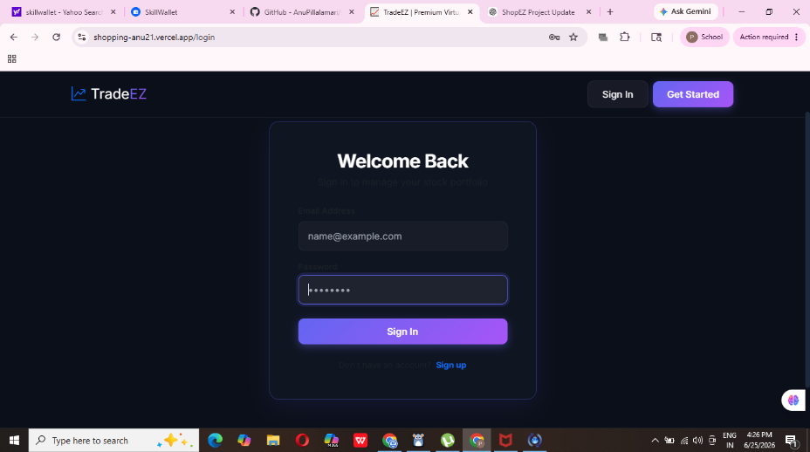
DASHBOARD:
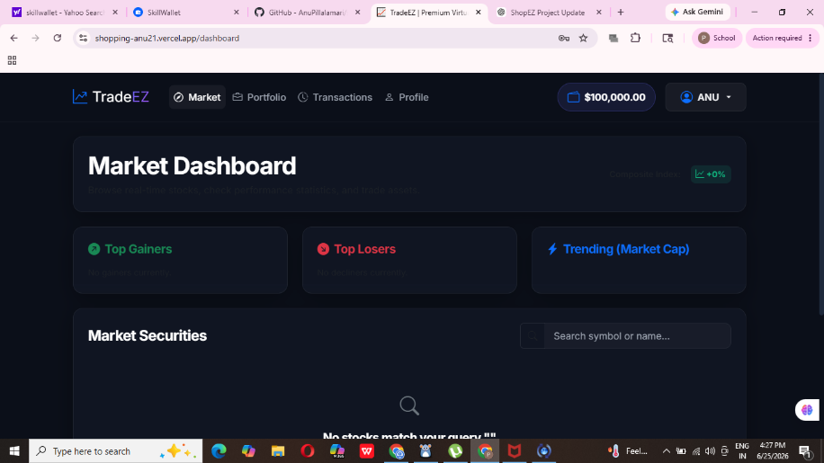
PORTFOLIO DASHBOARD:
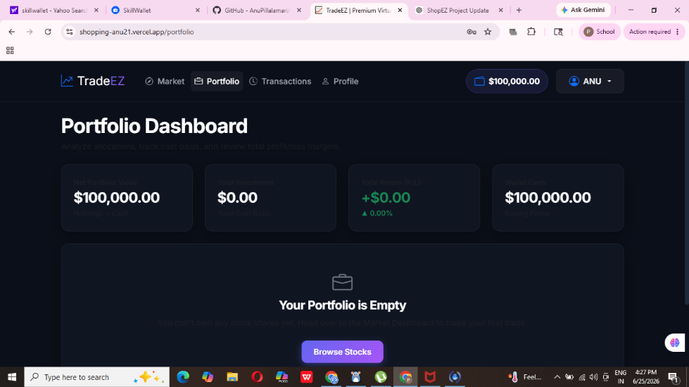

6. CONCLUSION
TradeEZ is a virtual stock trading platform developed using the MERN stack to help users understand stock market operations without financial risk. The platform provides features such as user authentication, stock trading, portfolio management, transaction tracking, and administrative controls.
Developing this project helped me improve my understanding of full-stack web development, REST APIs, database design, authentication systems, and frontend development. It also gave me practical experience in solving real-world problems through software solutions.
Overall, the project successfully achieved its objectives and serves as a useful learning tool for individuals who want to understand stock market trading in a safe and interactive environment.

