Supplementary Material
  - Beyond model complexity: a pre-registered evaluation of event-level alarm protocols for spacecraft telemetry anomaly detection
This file accompanies the manuscript. Every number is inserted from the study’s evidence file (thesis/evidence/evidence.json), which records the result file each value comes from. Section S4 reports the validation analyses of the second frozen plan (POSTHOC_PLAN_V2.md, SHA-256 prefix 217648e6805f, frozen 2026-10-25T12:14:37). Abbreviations: A0–A3, study arms; BH, Benjamini–Hochberg; ACI, adaptive conformal inference; M1, M2, Missions 1 and 2; FA, false alarms.

S1. Pre-registration, deviation log and validation plan
The following documents are provided as separate files in the repository and in the archived release:
- research_design/preregistration/PREREG_TELEMETRY_V1.md: the pre-registration, frozen as 09a98f5e160e, with 28 files hashed;
- research_design/preregistration/DEVIATIONS.md: every departure from the pre-registration, with its timing;
- research_design/preregistration/freeze_09a98f5e160e.json and freeze.json: the original freeze and the re-issued one (681cc7ddec86);
- research_design/preregistration/POSTHOC_PLAN_V2.md and posthoc_v2_freeze.json: the validation plan (P1–P8), frozen before any of its analyses was run.

S2. Results reported on ESA-ADB
Table S1. Results reported on ESA-ADB. Primary scores as published; the protocols differ, so the numbers are not comparable.
Study | Protocol | Method | Reported score
Kotowski et al. (2026) | official split; full and lightweight channels | TimeEval baselines, detector-specific thresholds | M1 full 0.061; M2 full 0.079; M1 lightweight 0.786
Şahin (2026) | official code; 24 / 19 channels; 16 seeds; pre-registered | telecommand conditioning; split, sliding and adaptive conformal thresholds | conditioning negative; point-level ACI collapses the event score
Nguyen et al. (2026) | own preprocessing; uncorrected event-wise metrics | supervised CNN and graph networks against unsupervised detectors | not comparable
Brancato et al. (2027) | Mission 1, hierarchical protocol (as stated in the abstract) | similarity search (SMED); quantile GP regression with retraining | M1 full 0.902 (SMED)
Alcarria et al. (2026) | monthly incremental retraining | LSTM autoencoder; PCA, k-means and LOF; adaptive thresholds | M1 0.700; M2 0.698
Allegrini and Pompei (2026) | Kaggle split of Mission 1, hidden test | supervised hierarchical ensemble | 0.853 (private leaderboard)
Heydari et al. (2026) | two missions, 77 shared channels | threshold transfer under alert budgets | policy diagnostics
This study | official split; full target channels; pre-registered | AR(8), XGBoost and TCN under one event-level layer | M1 0.428 (AR(8)), 0.544 (trees)
Note: GP, Gaussian process; LOF, local outlier factor; SMED, the similarity-search detector of Brancato et al.

S3. Models and pre-registered arms
Table S2. Model settings. No setting was tuned on test data; the supervised scorers received no hyperparameter search.
Model | Setting | Value
AR(8) | order; forecast horizon; maximum fitted rows | 8; 16 steps; 500,000
AR(8) | out-of-fold blocks; purge | 5 contiguous blocks; 1 d on either side
AR(8) | score | absolute forecast error / max(residual scale, 0.05)
XGBoost (A2) | trees; depth; learning rate | 400; 8; 0.1
XGBoost (A2) | row and column subsampling; minimum child weight | 0.8; 0.8; 5
XGBoost (A2) | training rows; classes; class weights | 2,000,000 (half labelled); 3; [1.0, 5.0, 5.0]
TCN (A3) | levels; kernel; width; receptive field | 8; 3; 64; 1021 steps
TCN (A3) | cross-channel mixing; parameters (M1) | every 2 levels; 220,739
TCN (A3) | optimiser; steps; learning rate; weight decay; dropout | AdamW, one-cycle; 1,500; 0.001; 0.0001; 0.1
TCN (A3) | batch; window; share of windows with a labelled sample | 8; 2,048 steps; 0.5
A2, A3 | per-step features | asinh z; log(1 + s); its EWMA over 1 h, 12 h, 3 d; deviation from trailing 1 d mean; forecast indicator

Table S3. Secondary metrics, Mission 1. Conformal-BH layer, test half, seed means.
Arm | Precision | Recall | Alarming precision | ADTQC | Affiliation | Rare-only runs | Channel | Subsystem
A0 | 0.061 | 0.462 | 0.276 | 0.821 | 0.564 | 81 | 0.219 | 0.308
A1 | 0.667 | 0.176 | 0.139 | 0.862 | 0.445 | 11 | 0.077 | 0.134
A2 | 0.627 | 0.415 | 0.213 | 0.732 | 0.627 | 136 | 0.248 | 0.348
A3 | 0.211 | 0.266 | 0.326 | 0.646 | 0.463 | 42 | 0.106 | 0.218
Note: ADTQC, alarm detection timing quality; affiliation, affiliation-based $F_{0.5}$; rare-only runs, alarm runs touching only rare events; channel and subsystem, channel- and subsystem-aware $F_{0.5}$.
Table S4. Secondary metrics, Mission 2. Conformal-BH layer, test half, seed means.
Arm | Precision | Recall | Alarming precision | ADTQC | Affiliation | Rare-only runs
A0 | 0.982 | 0.892 | 0.895 | 0.897 | 0.931 | 351
A1 | 1.000 | 0.580 | 0.857 | 0.930 | 0.733 | 238
A2 | 0.975 | 0.710 | 0.901 | 0.969 | 0.814 | 277
A3 | 0.958 | 0.676 | 0.885 | 0.779 | 0.791 | 268
Note: ADTQC, alarm detection timing quality; affiliation, affiliation-based $F_{0.5}$; rare-only runs, alarm runs touching only rare events.
Table S5. Alarm layers on identical scores. Test-half event-wise $F_{0.5}$, seed means.
Mission | Arm | Threshold | Conformal-BH | Rolling BH | ACI | ACI + events
1 | A1 | 0.428 | 0.428 | 0.101 | 0.0001 | 0.008
1 | A2 | 0.613 | 0.544 | 0.087 | 0.0000 | 0.046
1 | A3 | 0.282 | 0.205 | 0.323 | 0.0001 | 0.003
1 | A3, no residual inputs | 0.276 | 0.249 | 0.000 | 0.0001 | 0.005
1 | A3, two classes | 0.363 | 0.196 | 0.084 | 0.0001 | 0.000
1 | A1, lightweight | 0.350 | 0.025 | 0.130 | 0.0001 | 0.000
2 | A1 | 0.977 | 0.874 | 0.356 | 0.0007 | 0.000
2 | A2 | 0.819 | 0.904 | 0.244 | 0.0007 | 0.013
2 | A3 | 0.853 | 0.875 | 0.487 | 0.0014 | 0.005
2 | A1, lightweight | 0.978 | 0.978 | 0.529 | 0.0017 | 0.000
Note: ACI and ACI + events are the point-level comparator as pre-registered ($γ$ tuned to a point-wise rate).
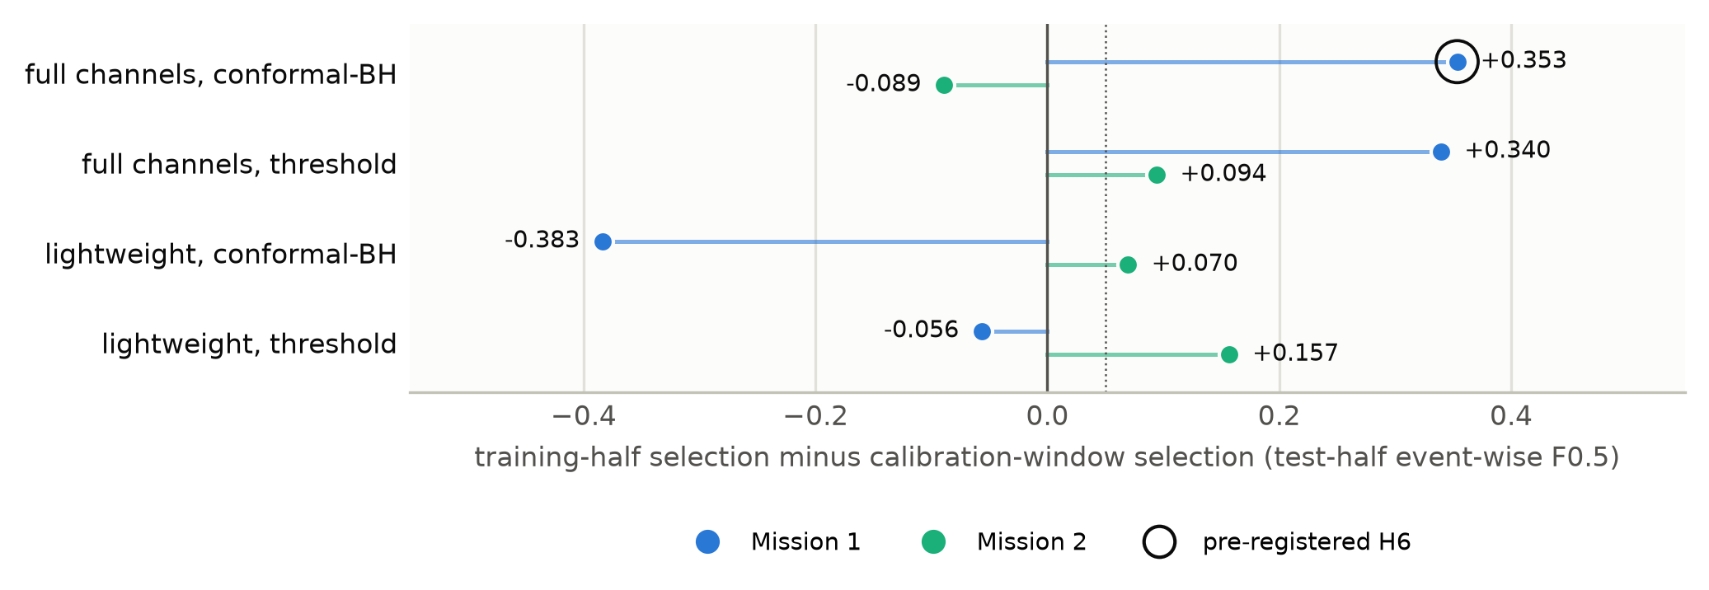
Fig. S1. Generality of the training-half protocol’s effect. Training-half protocol minus calibration-window protocol for AR(8), test-half event-wise $F_{0.5}$, by mission, channel set and alarm layer. The ringed point is the pre-registered H6 comparison; all other points are exploratory single runs.
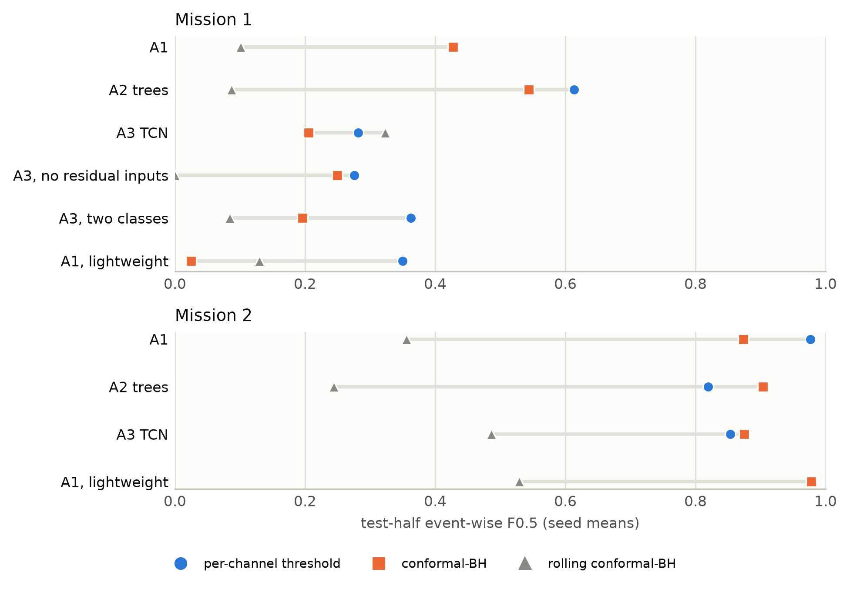
Fig. S2. Alarm layers on identical scores. Test-half event-wise $F_{0.5}$ of the same scores under the threshold, conformal-BH and rolling layers (seed means). Coinciding markers mean equal values; ACI is omitted because all its values are below 0.002.
Table S6. Per-seed results of the supervised arms. Mission 1, conformal-BH layer, test half (pre-registered seeds 0–4).
Seed | A2 $F_{0.5}$ | A2 FA / yr | A3 $F_{0.5}$ | A3 FA / yr
0 | 0.653 | 1.7 | 0.085 | 67.7
1 | 0.157 | 33.9 | 0.358 | 4.1
2 | 0.504 | 4.6 | 0.135 | 9.7
3 | 0.635 | 2.0 | 0.158 | 13.7
4 | 0.769 | 0.1 | 0.290 | 9.1

Table S7. Exploratory phase. AR(8) with the layer selected on the calibration window, and the label-free baselines; test-half $F_{0.5}$ (before the pre-registration).
Detector | M1 full | M1 lightweight | M2 full | M2 lightweight
AR(8), conformal-BH | 0.0744 | 0.408 | 0.962 | 0.908
AR(8), threshold | 0.0882 | 0.407 | 0.882 | 0.821
out-of-limit rule | 0.0007 | 0.202 | 0.894 | 0.965
GlobalSTD5 | 0.0029 | 0.253 | 0.063 | 0.075
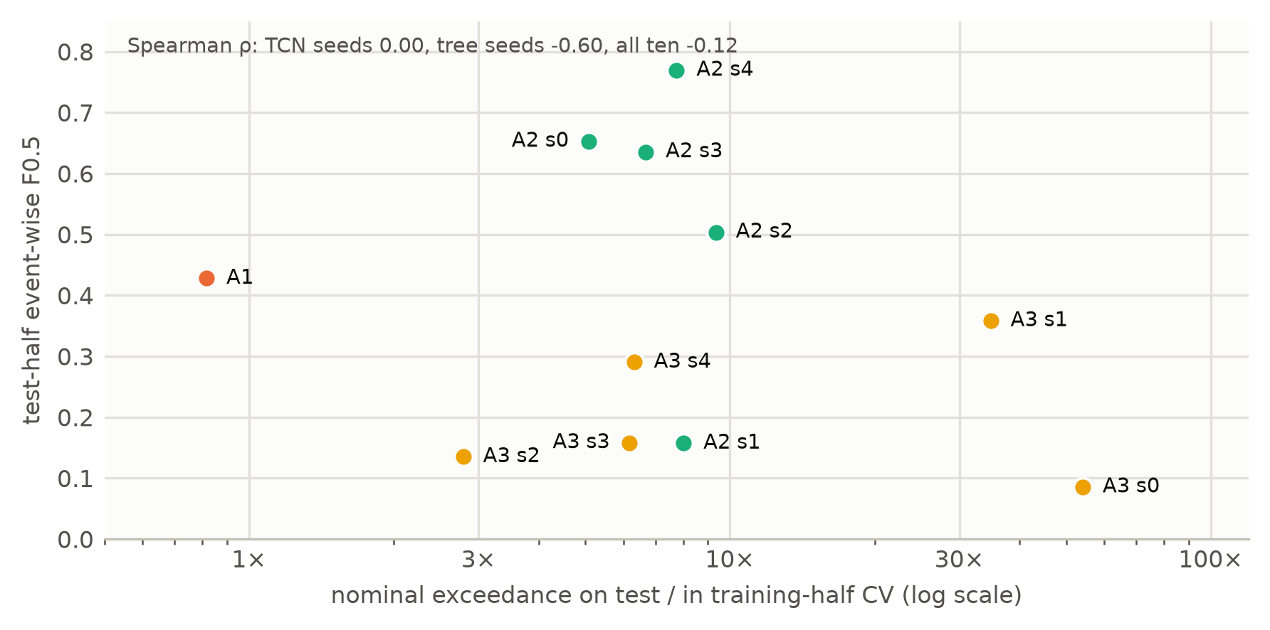
Fig. S3. Calibration shift against test score (exploratory). For each supervised run on Mission 1 (BH layer), the ratio of the nominal test exceedance rate to the cross-validation rate at the $1−{10}^{−4}$ quantile, against test-half event-wise $F_{0.5}$.

S4. Validation analyses (P1–P8)
All analyses in this section were specified and frozen before they were run, after the confirmatory analysis. They use test halves that had been used before.
P3, exact bootstrap. The block-decomposable metric of Appendix A was compared with the official value on 302 stored arm–metric pairs; the largest absolute difference was 2.1e-16 (criterion passed).
Table S8. P1 decomposition cells, Mission 1, target channels, conformal-BH layer. Each cell is a full protocol scored once on the test half. Reproduction of A0 and A1: passed.
Cell | Scores | Pool | Selection data | Grid | $F_{0.5}$​ | FA / yr | Level | $k$​
c0 | S0 | cal | cal | G0 | 0.074 | 91.6 | 0.01 | 10
c1 | S0 | cal | cal | G1 | 0.074 | 91.6 | 0.01 | 10
c2 | S½ | cal | cal | G1 | 0.084 | 52.0 | 0.001 | 10
c3 | S1 | cal | cal | G1 | 0.084 | 52.0 | 0.001 | 10
c4 | S1 | half | cal | G1 | 0.127 | 34.6 | 0.01 | 10
c5 | S1 | half | half | G1 | 0.428 | 1.1 | 0.0001 | 10
r1 | S1 | half | half | G0 | 0.493 | 1.6 | 0.0003 | 10
r2 | S1 | half | cal | G0 | 0.127 | 34.6 | 0.01 | 10
r3 | S1 | cal | cal | G0 | 0.084 | 52.0 | 0.001 | 10
r4 | S½ | cal | cal | G0 | 0.084 | 52.0 | 0.001 | 10
Note: Forward path c0 → c5 changes G, F, σ, P, D in turn; reverse path c5 → r1 → r2 → r3 → r4 → c0 changes G, D, P, σ, F. S½ is A1’s forecast errors on A0’s residual scale.
Table S9. P1 steps, Mission 1, target channels, conformal-BH layer. Change in test-half $F_{0.5}$ when one factor is switched, with exact block-bootstrap 95 % intervals, and the verdict of the pre-set rule.
Factor | Forward path | Reverse path | Verdict
grid | +0.000 [+0.000, +0.000] | -0.065 [-0.167, +0.014] | order-dependent
AR(8) fit data | +0.010 [-0.009, +0.035] | +0.010 [-0.009, +0.033] | not material
residual scale | +0.000 [+0.000, +0.000] | +0.000 [+0.000, +0.000] | not material
calibration pool | +0.043 [+0.015, +0.083] | +0.043 [+0.014, +0.081] | not material
selection data | +0.301 [+0.156, +0.436] | +0.366 [+0.234, +0.500] | material
Note: The rule defines material for gains only (≥ +0.05 on both paths); a factor that lowers the score on both paths is not material under it.
Table S10. P1 decomposition cells, Mission 1, target channels, threshold layer. Each cell is a full protocol scored once on the test half. Reproduction of A0 and A1: passed.
Cell | Scores | Pool | Selection data | Grid | $F_{0.5}$​ | FA / yr | Level | $k$​
c0 | S0 | cal | cal | G0 | 0.088 | 64.4 | 0.0001 | 10
c1 | S0 | cal | cal | G1 | 0.088 | 64.4 | 0.0001 | 10
c2 | S½ | cal | cal | G1 | 0.085 | 49.3 | 1e-05 | 10
c3 | S1 | cal | cal | G1 | 0.085 | 49.3 | 1e-05 | 10
c4 | S1 | half | cal | G1 | 0.231 | 13.1 | 0.0001 | 10
c5 | S1 | half | half | G1 | 0.428 | 1.1 | 0 | 10
r1 | S1 | half | half | G0 | 0.428 | 1.1 | 0 | 10
r2 | S1 | half | cal | G0 | 0.231 | 13.1 | 0.0001 | 10
r3 | S1 | cal | cal | G0 | 0.085 | 49.3 | 1e-05 | 10
r4 | S½ | cal | cal | G0 | 0.085 | 49.3 | 1e-05 | 10
Note: Forward path c0 → c5 changes G, F, σ, P, D in turn; reverse path c5 → r1 → r2 → r3 → r4 → c0 changes G, D, P, σ, F. S½ is A1’s forecast errors on A0’s residual scale.
Table S11. P1 steps, Mission 1, target channels, threshold layer. Change in test-half $F_{0.5}$ when one factor is switched, with exact block-bootstrap 95 % intervals, and the verdict of the pre-set rule.
Factor | Forward path | Reverse path | Verdict
grid | +0.000 [+0.000, +0.000] | +0.000 [+0.000, +0.000] | not material
AR(8) fit data | -0.003 [-0.021, +0.017] | -0.003 [-0.020, +0.016] | not material
residual scale | +0.000 [+0.000, +0.000] | +0.000 [+0.000, +0.000] | not material
calibration pool | +0.145 [+0.071, +0.263] | +0.145 [+0.070, +0.265] | material
selection data | +0.197 [+0.060, +0.327] | +0.197 [+0.063, +0.338] | material
Note: The rule defines material for gains only (≥ +0.05 on both paths); a factor that lowers the score on both paths is not material under it.
Table S12. P1 decomposition cells, Mission 1, lightweight channels, conformal-BH layer. Each cell is a full protocol scored once on the test half. Reproduction of A0 and A1: passed.
Cell | Scores | Pool | Selection data | Grid | $F_{0.5}$​ | FA / yr | Level | $k$​
c0 | S0 | cal | cal | G0 | 0.408 | 5.0 | 0.001 | 3
c1 | S0 | cal | cal | G1 | 0.408 | 5.0 | 0.001 | 3
c2 | S½ | cal | cal | G1 | 0.340 | 3.0 | 0.01 | 10
c3 | S1 | cal | cal | G1 | 0.340 | 3.0 | 0.01 | 10
c4 | S1 | half | cal | G1 | 0.191 | 20.6 | 0.01 | 3
c5 | S1 | half | half | G1 | 0.025 | 11.9 | 0.01 | 30
r1 | S1 | half | half | G0 | 0.025 | 11.9 | 0.01 | 30
r2 | S1 | half | cal | G0 | 0.191 | 20.6 | 0.01 | 3
r3 | S1 | cal | cal | G0 | 0.413 | 3.1 | 0.0003 | 3
r4 | S½ | cal | cal | G0 | 0.413 | 3.1 | 0.0003 | 3
Note: Forward path c0 → c5 changes G, F, σ, P, D in turn; reverse path c5 → r1 → r2 → r3 → r4 → c0 changes G, D, P, σ, F. S½ is A1’s forecast errors on A0’s residual scale.
Table S13. P1 steps, Mission 1, lightweight channels, conformal-BH layer. Change in test-half $F_{0.5}$ when one factor is switched, with exact block-bootstrap 95 % intervals, and the verdict of the pre-set rule.
Factor | Forward path | Reverse path | Verdict
grid | +0.000 [+0.000, +0.000] | +0.000 [+0.000, +0.000] | not material
AR(8) fit data | -0.068 [-0.159, +0.024] | +0.005 [-0.078, +0.083] | order-dependent
residual scale | +0.000 [+0.000, +0.000] | +0.000 [-0.017, +0.022] | not material
calibration pool | -0.150 [-0.258, -0.049] | -0.223 [-0.335, -0.110] | order-dependent
selection data | -0.166 [-0.243, -0.043] | -0.166 [-0.245, -0.042] | not material
Note: The rule defines material for gains only (≥ +0.05 on both paths); a factor that lowers the score on both paths is not material under it.
Table S14. P1 decomposition cells, Mission 2, target channels, conformal-BH layer. Each cell is a full protocol scored once on the test half. Reproduction of A0 and A1: passed.
Cell | Scores | Pool | Selection data | Grid | $F_{0.5}$​ | FA / yr | Level | $k$​
c0 | S0 | cal | cal | G0 | 0.962 | 3.4 | 0.01 | 30
c1 | S0 | cal | cal | G1 | 0.962 | 3.4 | 0.01 | 30
c2 | S½ | cal | cal | G1 | 0.965 | 2.9 | 0.01 | 30
c3 | S1 | cal | cal | G1 | 0.966 | 2.9 | 0.01 | 30
c4 | S1 | half | cal | G1 | 0.962 | 1.1 | 0.01 | 30
c5 | S1 | half | half | G1 | 0.874 | 0.0 | 0.001 | 30
r1 | S1 | half | half | G0 | 0.874 | 0.0 | 0.001 | 30
r2 | S1 | half | cal | G0 | 0.962 | 1.1 | 0.01 | 30
r3 | S1 | cal | cal | G0 | 0.966 | 2.9 | 0.01 | 30
r4 | S½ | cal | cal | G0 | 0.965 | 2.9 | 0.01 | 30
Note: Forward path c0 → c5 changes G, F, σ, P, D in turn; reverse path c5 → r1 → r2 → r3 → r4 → c0 changes G, D, P, σ, F. S½ is A1’s forecast errors on A0’s residual scale.
Table S15. P1 steps, Mission 2, target channels, conformal-BH layer. Change in test-half $F_{0.5}$ when one factor is switched, with exact block-bootstrap 95 % intervals, and the verdict of the pre-set rule.
Factor | Forward path | Reverse path | Verdict
grid | +0.000 [+0.000, +0.000] | +0.000 [+0.000, +0.000] | not material
AR(8) fit data | +0.003 [-0.004, +0.011] | +0.003 [-0.004, +0.011] | not material
residual scale | +0.001 [-0.000, +0.002] | +0.001 [-0.000, +0.002] | not material
calibration pool | -0.004 [-0.017, +0.015] | -0.004 [-0.018, +0.014] | not material
selection data | -0.088 [-0.134, -0.054] | -0.088 [-0.134, -0.055] | not material
Note: The rule defines material for gains only (≥ +0.05 on both paths); a factor that lowers the score on both paths is not material under it.
Table S16. P1 decomposition cells, Mission 2, target channels, threshold layer. Each cell is a full protocol scored once on the test half. Reproduction of A0 and A1: passed.
Cell | Scores | Pool | Selection data | Grid | $F_{0.5}$​ | FA / yr | Level | $k$​
c0 | S0 | cal | cal | G0 | 0.882 | 0.0 | 0 | 30
c1 | S0 | cal | cal | G1 | 0.882 | 0.0 | 0 | 30
c2 | S½ | cal | cal | G1 | 0.880 | 0.0 | 0 | 30
c3 | S1 | cal | cal | G1 | 0.884 | 0.0 | 0 | 30
c4 | S1 | half | cal | G1 | 0.977 | 1.7 | 0.001 | 30
c5 | S1 | half | half | G1 | 0.977 | 1.7 | 0.001 | 30
r1 | S1 | half | half | G0 | 0.977 | 1.7 | 0.001 | 30
r2 | S1 | half | cal | G0 | 0.977 | 1.7 | 0.001 | 30
r3 | S1 | cal | cal | G0 | 0.884 | 0.0 | 0 | 30
r4 | S½ | cal | cal | G0 | 0.880 | 0.0 | 0 | 30
Note: Forward path c0 → c5 changes G, F, σ, P, D in turn; reverse path c5 → r1 → r2 → r3 → r4 → c0 changes G, D, P, σ, F. S½ is A1’s forecast errors on A0’s residual scale.
Table S17. P1 steps, Mission 2, target channels, threshold layer. Change in test-half $F_{0.5}$ when one factor is switched, with exact block-bootstrap 95 % intervals, and the verdict of the pre-set rule.
Factor | Forward path | Reverse path | Verdict
grid | +0.000 [+0.000, +0.000] | +0.000 [+0.000, +0.000] | not material
AR(8) fit data | -0.002 [-0.011, +0.005] | -0.002 [-0.011, +0.005] | not material
residual scale | +0.005 [-0.001, +0.013] | +0.005 [-0.001, +0.012] | not material
calibration pool | +0.092 [+0.054, +0.142] | +0.092 [+0.055, +0.143] | material
selection data | +0.000 [+0.000, +0.000] | +0.000 [+0.000, +0.000] | not material
Note: The rule defines material for gains only (≥ +0.05 on both paths); a factor that lowers the score on both paths is not material under it.
Table S18. P1 decomposition cells, Mission 2, lightweight channels, conformal-BH layer. Each cell is a full protocol scored once on the test half. Reproduction of A0 and A1: passed.
Cell | Scores | Pool | Selection data | Grid | $F_{0.5}$​ | FA / yr | Level | $k$​
c0 | S0 | cal | cal | G0 | 0.908 | 9.2 | 0.01 | 30
c1 | S0 | cal | cal | G1 | 0.908 | 9.2 | 0.01 | 30
c2 | S½ | cal | cal | G1 | 0.913 | 18.3 | 0.001 | 10
c3 | S1 | cal | cal | G1 | 0.903 | 21.2 | 0.001 | 10
c4 | S1 | half | cal | G1 | 0.945 | 0.0 | 0.01 | 30
c5 | S1 | half | half | G1 | 0.978 | 0.6 | 0.001 | 10
r1 | S1 | half | half | G0 | 0.978 | 0.6 | 0.001 | 10
r2 | S1 | half | cal | G0 | 0.945 | 0.0 | 0.01 | 30
r3 | S1 | cal | cal | G0 | 0.903 | 21.2 | 0.001 | 10
r4 | S½ | cal | cal | G0 | 0.913 | 18.3 | 0.001 | 10
Note: Forward path c0 → c5 changes G, F, σ, P, D in turn; reverse path c5 → r1 → r2 → r3 → r4 → c0 changes G, D, P, σ, F. S½ is A1’s forecast errors on A0’s residual scale.
Table S19. P1 steps, Mission 2, lightweight channels, conformal-BH layer. Change in test-half $F_{0.5}$ when one factor is switched, with exact block-bootstrap 95 % intervals, and the verdict of the pre-set rule.
Factor | Forward path | Reverse path | Verdict
grid | +0.000 [+0.000, +0.000] | +0.000 [+0.000, +0.000] | not material
AR(8) fit data | +0.005 [-0.027, +0.035] | +0.005 [-0.027, +0.035] | not material
residual scale | -0.009 [-0.019, -0.002] | -0.009 [-0.019, -0.002] | not material
calibration pool | +0.042 [-0.022, +0.132] | +0.042 [-0.025, +0.135] | not material
selection data | +0.033 [+0.018, +0.052] | +0.033 [+0.018, +0.051] | not material
Note: The rule defines material for gains only (≥ +0.05 on both paths); a factor that lowers the score on both paths is not material under it.
Table S20. P2 forward chaining, Mission 1. Per fold: events of the fold, $F_{0.5}$ and false alarms per year for the calibration-window protocol W and the training-history protocol H.
Layer | Fold start | Events | W $F_{0.5}$ | H $F_{0.5}$ | H − W | W FA / yr | H FA / yr
conformal-BH | 2003-01-01 | 9 | 0.092 | 0.238 | +0.146 | 23.0 | 2.0
conformal-BH | 2004-01-01 | 10 | 0.013 | 0.000 | -0.013 | 271.4 | 0.0
conformal-BH | 2005-01-01 | 10 | 0.008 | 0.833 | +0.825 | 1172.8 | 0.0
conformal-BH | 2006-01-01 | 10 | 0.357 | 0.357 | +0.000 | 0.0 | 0.0
threshold | 2003-01-01 | 9 | 0.000 | 0.345 | +0.345 | 0.0 | 3.0
threshold | 2004-01-01 | 10 | 0.016 | 0.000 | -0.016 | 76.8 | 0.0
threshold | 2005-01-01 | 10 | 0.682 | 0.769 | +0.087 | 0.0 | 0.0
threshold | 2006-01-01 | 10 | 0.357 | 0.278 | -0.079 | 0.0 | 1.0
Note: Pooled over folds (BH): H − W = +0.455 [+0.189, +0.659]. Replication criterion met: no.
Table S21. P2 forward chaining, Mission 2. Per fold: events of the fold, $F_{0.5}$ and false alarms per year for the calibration-window protocol W and the training-history protocol H.
Layer | Fold start | Events | W $F_{0.5}$ | H $F_{0.5}$ | H − W | W FA / yr | H FA / yr
conformal-BH | 2001-01-01 | 29 | 0.917 | 0.929 | +0.012 | 0.0 | 0.0
conformal-BH | 2001-04-01 | 29 | 0.957 | 0.977 | +0.020 | 4.0 | 0.0
conformal-BH | 2001-07-01 | 26 | 0.941 | 0.960 | +0.020 | 7.9 | 4.0
threshold | 2001-01-01 | 29 | 0.917 | 0.940 | +0.023 | 0.0 | 0.0
threshold | 2001-04-01 | 29 | 1.000 | 0.985 | -0.015 | 0.0 | 0.0
threshold | 2001-07-01 | 26 | 0.960 | 0.951 | -0.009 | 4.0 | 4.0
Note: Pooled over folds (BH): H − W = +0.017 [-0.007, +0.044]. Replication criterion met: no.
Table S22. P4, ACI tuned on the event objective. Chosen $(α,γ,k)$ and test-half $F_{0.5}$ for the best setting overall, the best with $γ>0$, and $γ=0$ (a fixed per-channel conformal threshold).
Arm | Best: $α$, $γ$, $k$ | $F_{0.5}$​ | Best with $γ>0$ | $F_{0.5}$​ | $γ=0$ $F_{0.5}$
M1 A1 | 0.0001, 0.0001, 10 | 0.472 | 0.0001, 0.0001, 10 | 0.472 | 0.261
M1 A2 seed 0 | 0.0001, 0, 100 | 0.252 | 0.001, 0.0001, 100 | 0.407 | 0.252
M1 A2 seed 1 | 0.001, 0.0001, 100 | 0.535 | 0.001, 0.0001, 100 | 0.535 | 0.212
M1 A2 seed 2 | 0.0001, 0, 100 | 0.218 | 0.001, 0.0001, 100 | 0.513 | 0.218
M1 A2 seed 3 | 0.001, 0.0001, 100 | 0.453 | 0.001, 0.0001, 100 | 0.453 | 0.265
M1 A2 seed 4 | 0.0001, 0, 100 | 0.290 | 0.001, 0.0001, 100 | 0.510 | 0.290
M2 A1 | 0.001, 0, 30 | 0.977 | 0.01, 0.0001, 30 | 0.925 | 0.977

Table S23. P5, registered anomaly-score arm, Mission 1. Anomaly-only test-half $F_{0.5}$ with the layer selected on the anomaly-only objective.
Arm | Runs | Mean | sd | Min | Max | FA / yr
A1 | 1 | 0.336 | 0.000 | 0.336 | 0.336 | 1.1
A2 | 5 | 0.087 | 0.091 | 0.011 | 0.232 | 44.7
A3 | 5 | 0.097 | 0.072 | 0.034 | 0.211 | 18.5
Note: A1 is deterministic; A2 and A3 use their anomaly log-odds.
Table S24. P5, registered anomaly-score arm, Mission 2. Anomaly-only test-half $F_{0.5}$ with the layer selected on the anomaly-only objective.
Arm | Runs | Mean | sd | Min | Max | FA / yr
A1 | 1 | 0.000 | 0.000 | 0.000 | 0.000 | 0.0
A2 | 5 | 0.247 | 0.176 | 0.081 | 0.500 | 3.0
A3 | 5 | 0.005 | 0.010 | 0.000 | 0.023 | 6.6
Note: A1 is deterministic; A2 and A3 use their anomaly log-odds.
Table S25. P6, seed extension. Mission 1, conformal-BH layer: seed statistics with all available seeds, and the comparisons with the exact bootstrap (unadjusted, exploratory).
Arm or comparison | Seeds | Mean $F_{0.5}$ / difference | sd | Min / 95 % CI | Max / $p$
A2 | 10 | 0.488 | 0.195 | 0.157 | 0.769
A3 | 9 | 0.176 | 0.093 | 0.082 | 0.358
H4: A3 − A1 |  | -0.252 |  | [-0.402, -0.043] | p = 0.020
H5: A3 − A2 |  | -0.313 |  | [-0.457, -0.112] | p = 0.002
X1: A2 − A1 |  | +0.061 |  | [-0.138, +0.268] | p = 0.528

Table S26. P7, operational metrics. Test halves, conformal-BH layer; seed means for A2 and A3.
Mission | Arm | Detected / events | Anomalies | Rare events | Delay, median [IQR] (h) | Within 1 h | Within 24 h | Runs per detected event | FA per 1000 nominal h
1 | A0 | 42.0 / 91 | 17.0 | 25.0 | 0.35 [0.13, 6.54] | 0.67 | 0.86 | 2.0 | 11.749
1 | A1 | 16.0 / 91 | 8.0 | 8.0 | 0.33 [0.17, 3.73] | 0.62 | 0.88 | 1.0 | 0.147
1 | A2 | 37.8 / 91 | 11.8 | 26.0 | 1.07 [0.40, 2.52] | 0.47 | 0.95 | 1.4 | 1.085
1 | A3 | 24.2 / 91 | 11.8 | 12.4 | 2.02 [0.16, 5.75] | 0.43 | 0.92 | 1.6 | 2.680
2 | A0 | 323.0 / 362 | 1.0 | 322.0 | 0.16 [0.15, 0.19] | 0.97 | 1.00 | 1.0 | 0.411
2 | A1 | 210.0 / 362 | 0.0 | 210.0 | 0.16 [0.15, 0.19] | 0.95 | 1.00 | 1.0 | 0.000
2 | A2 | 257.2 / 362 | 0.8 | 256.4 | 0.07 [0.04, 0.10] | 0.98 | 1.00 | 1.0 | 0.425
2 | A3 | 244.8 / 362 | 0.8 | 244.0 | 0.27 [0.24, 0.30] | 0.97 | 1.00 | 1.0 | 0.918
Note: Delay is first-alarm time minus event start for detected events; IQR, interquartile range.
P8, provenance. Re-running the frozen selection for the A1 arms reproduced the saved choice and every grid value: Mission 1 passed (largest difference 0), Mission 2 passed (largest difference 0).

S5. Code, data and reproduction
The repository contains the frozen code of the pre-registered study, the validation scripts (scripts/posthoc_v2/), the evidence builder (thesis/tools/build_evidence.py) and the manuscript build (paper/journal_v2/tools/). The ESA Anomaly Dataset is obtained from Zenodo (DOI 10.5281/zenodo.12528696). Derived score and alarm arrays will be deposited with the archived release.

References
Alcarria, Ó., Sánchez, R., Sempere, J., Torrijos, P., Alfaro, J.C., Auñón, J.M., Gámez, J.A., Puerta, J.M., 2026. Structure-aware unsupervised anomaly detection for spacecraft telemetry with adaptive EVT thresholding. arXiv preprint arXiv:2609.10017. https://doi.org/10.48550/arXiv.2609.10017
Allegrini, L.R., Pompei, G., 2026. A hierarchical ensemble pipeline for anomaly detection in ESA satellite telemetry, in: Koprinska, I., Mendes-Moreira, J., Branco, P. (Eds.), Machine Learning and Principles and Practice of Knowledge Discovery in Databases. ECML PKDD 2025, Communications in Computer and Information Science. Springer, Cham, pp. 89–103. https://doi.org/10.1007/978-3-032-19105-2_7
Brancato, L., Lucchetti, A., Kimura, Y., Omata, N., Giglio, M., Tsutsumi, S., Cadini, F., 2027. Evaluating scalable similarity search and gaussian process regression for satellite telemetry anomaly detection on the ESA-ADB benchmark. Aerosp. Sci. Technol. 180, 113957. https://doi.org/10.1016/j.ast.2026.113957
Heydari, V., Mostafavi, P., Nyarko, K., 2026. Workload-constrained cross-mission deployment of spacecraft telemetry anomaly alerting: Policy-layer feasibility diagnostics and limits. IEEE Access 14, 113378–113402. https://doi.org/10.1109/ACCESS.2026.3714708
Kotowski, K., Haskamp, C., Andrzejewski, J., Ruszczak, B., Nalepa, J., Lakey, D., Collins, P., Martínez-Heras, J., De Canio, G., 2026. European Space Agency dataset and benchmark for real-world anomaly detection in spacecraft time series. Journal of Data-centric Machine Learning Research 3, 1–76. https://data.mlr.press/assets/pdf/v03-23.pdf
Nguyen, A., Rozenberg, D., Zhu, Y., Hu, P., 2026. Toward deployable satellite anomaly detection: A benchmark study on large-scale ESA-ADB telemetry. arXiv preprint arXiv:2607.07335. https://doi.org/10.48550/arXiv.2607.07335
[dataset] Şahin, F., 2026. TC-CAD: Preregistration, analysis code and per-seed results for a preregistered negative result on telecommand conditioning in ESA-ADB spacecraft telemetry. Zenodo. https://doi.org/10.5281/zenodo.23322711

