Reliability-gated mixture of experts with conformal calibration: an uncertainty-aware digital twin for orbital debris, atmospheric re-entry and satellite health
[Author name(s)]ª
ª[Affiliation, postal address, country]
Corresponding author: [name, e-mail]
Abstract
Contribution in artificial intelligence. A reliability-gated mixture of experts in which a learned gate weights a physics-based prior against recent tabular neural models, with distribution-free conformal calibration of every predictive interval and probability. Application in engineering. Forecasting the low-Earth-orbit debris environment: residual orbital lifetime, collision risk and spacecraft health.
Operational debris tools rely on physics propagators whose uncertainty is uncalibrated, and prior machine-learning lifetime studies used a few hundred to 1,800 objects, single-epoch predictions and only objects that had already decayed. The proposed digital twin holds one state per object and couples three learning modules through four explicit mechanisms. Evaluated on 64,516 catalogued objects across two forward-in-time test periods, a European Space Agency collision-avoidance benchmark and public spacecraft telemetry, the tabular foundation models reduced re-entry pinball loss 13 % below the strongest gradient-boosted baseline and 44 % below the physics expert for 2016–2021, yet were statistically tied with it for 2011–2015. Conformal intervals covered 72.6 %–90.6 % of decayed objects against 12.2 %–17.1 % for the operational ±20 % rule, and conditioning each area-to-mass ratio on catalogue history reduced 72-day over-prediction from 9.5-fold to 1.4-fold. Collision-risk forecasts improved 37 % over persistence, yet none beat the latest-risk baseline on the official metric, and zero-shot telemetry detection did not beat simple detectors. Calibrated learned fusion therefore improves debris forecasting wherever the full predictive distribution matters.
Keywords: Mixture of experts; Conformal prediction; Tabular foundation models; In-context learning; Uncertainty quantification; Digital twin; Space debris; Atmospheric re-entry prediction

1 Introduction
More than 30,000 tracked objects share low Earth orbit with the satellites that operators must keep healthy, steer clear of debris and eventually bring down. Three questions govern the resulting debris environment. How long does each object remain in orbit? How likely is a given encounter to become a collision? And which objects are still under control, and therefore not decaying freely at all? In operational practice each question is answered by a separate tool, and the uncertainty those tools report is rarely calibrated.
The three questions are not independent. A spacecraft that loses the ability to manoeuvre stops station-keeping and begins to decay; fragments of one breakup share an origin, and therefore a range of area-to-mass ratios that shapes how long they stay in orbit; and how long fragments remain aloft determines the population that conjunction assessment must screen. A digital twin of the tracked population, with one state per object that every function reads and updates, is the natural way to make these links explicit (Liu et al., 2024).
Building such a twin on public data meets a hard constraint: no public dataset follows the same object through telemetry, conjunction messages and re-entry. Telemetry benchmarks are anonymised (Hundman et al., 2018; Kotowski et al., 2026), conjunction messages are anonymised (Uriot et al., 2022), and catalogue data carry no telemetry. A credible twin therefore cannot be a single model trained over unpaired data. It must be a set of modules, each validated on its own real data, joined by couplings that are defined explicitly and tested wherever a real test exists.
This paper presents such a system. Its contribution in artificial intelligence is a reliability-gated mixture of experts with distribution-free calibration: a learned gate weights a physics-based prior against recent tabular neural models, and every interval and probability the system emits is calibrated by conformal prediction and isotonic regression. Its application in engineering is forecasting the low-Earth-orbit debris environment, across residual orbital lifetime, collision risk and spacecraft health.
The contributions are:
- A reliability-gated mixture-of-experts architecture for censored regression on an operational catalogue, evaluated against eight alternative fusion arms including the physics prior alone, each learned expert alone, an equal-weight average, a learned gate without reliability features, and a gradient-boosted baseline.
- A licence-clean, leakage-controlled benchmark of 64,516 catalogued objects with administrative censoring and two independent forward-in-time test periods.
- Four explicit cross-module couplings, three of which are tested on real data, with their measured contribution and their statistical significance reported.
- Evidence that conformal prediction’s marginal guarantee degrades under temporal drift, and that a catalogue covariate can leak the outcome through its availability rather than its value.
- An honest account of where learning helps and where it does not, including a central negative result: the learned gate never beat the best single expert.

2 Related work and the research gap

2.1 Physics-based lifetime and re-entry prediction
Semi-analytic decay theory (Frey et al., 2019; King-Hele, 1987) and numerical propagators with empirical atmospheres underpin operational tools such as the European Space Agency’s debris-risk suite (Braun et al., 2020). Assessments of the inter-agency re-entry campaigns report mean errors of about 10 % of the remaining lifetime, and a ±20 % window around the predicted epoch that covers roughly 90 % of true epochs in the final days before re-entry (Pardini and Anselmo, 2018); earlier assessments of propagator accuracy reach similar conclusions (Operti et al., 2017; Pardini and Anselmo, 2004). Thermospheric density is the dominant error source, and both its empirical modelling (Emmert et al., 2021; Licata et al., 2022b) and its uncertainty (Licata and Mehta, 2022; Pardini et al., 2012) are active subjects. Where orbital histories are available, the ballistic coefficient is fitted from tracking data (Gondelach et al., 2017; Pardini and Anselmo, 2008; Sang et al., 2013), which is the practice our state-estimation step approximates from two catalogue orbits.

2.2 Learning-based lifetime and re-entry prediction
Machine-learning studies predict the re-entry epoch or the orbital lifetime from orbital histories. Table 1 summarises those we could read in full. Salmaso et al. train a sequence model on 417 Space-Track bodies and test on 15 campaign objects (Salmaso et al., 2023); Lotti et al. fit a physics-informed convolutional network to 1,783 payloads and report that generalisation is “not yet fully satisfactory” (Lotti et al., 2025); Jung et al. use a recurrent network on altitude histories (Jung et al., 2021), and a physics-based backtest reports calibrated lifetime distributions for 1,283 objects but calibrates on the same backtest set (Shambaugh, 2026). Related learning work addresses density correction (Licata et al., 2022a), ballistic-coefficient estimation (Andaristiyan et al., 2025) and lifetime regression on orbital elements (Li et al., 2023; Peng and Bai, 2020).
Table 1. Prior machine-learning work on orbital lifetime, against this study. Cells are taken from our reading of each source; where a paper could not be read in full, the cell says so rather than guessing.
Study | Scale | Censoring | Output | Evaluation split | Cross-module couplings
Salmaso et al. (Salmaso et al., 2023) | 417 bodies; test 15 campaign objects | decayed only | point epoch | interleaved in time | none
Lotti et al. (Lotti et al., 2025) | 1,783 after filtering; 1,435 train | decayed only | point lifetime | random, stratified | none
Jung et al. (Jung et al., 2021) | not readable (closed access) | not readable | point epoch | not readable | none
Shambaugh (Shambaugh, 2026) | 1,283 objects | decayed only | distribution | backtest, calibrated on itself | none
This work | 64,516 objects, two periods | censoring-aware | seven quantiles + intervals | forward in time, two origins | three tested
Three properties are shared by every study we could read. The datasets are one to two orders of magnitude smaller than an operational catalogue; the output is a point epoch rather than a distribution; and the training population consists of objects that have already decayed, which discards the censored majority. Our Kaplan–Meier description (Section 12) shows that this majority is 46.7 % of one test cohort and 55.3 % of the other. None of these studies couples lifetime prediction to conjunction assessment or to spacecraft health.

2.3 Collision risk and the debris environment
The Kelvins collision-avoidance challenge released conjunction data messages with the final risk of each event (Uriot et al., 2022, 2021). The latest-risk baseline scored 0.694 on the official metric and only 12 of 97 teams beat it; the winning entry scored 0.556 (Uriot et al., 2022). Later entries report scores on the same split (Tulczyjew et al., 2021), and a pre-registered re-evaluation found that no model beats the latest-risk forecast with confidence (Vazquez, 2026). Other learning approaches to conjunction screening and risk include surrogate models of the encounter geometry (Acciarini et al., 2024, 2021), sequence models over message streams (Chu et al., 2026, 2024), and operational studies of alert handling (Lidtke et al., 2019; Stevenson et al., 2022). The debris environment itself is modelled from breakup statistics (Johnson et al., 2001; Kessler and Cour-Palais, 1978), and breakup families have been studied for origin attribution (Celletti et al., 2021; Wu and Rosengren, 2023); the Kelvins “space debris: the origin” data are simulated (Efthymiopoulos et al., 2021; European Space Agency, Advanced Concepts Team, 2021). We found no study that uses breakup-family membership as a predictor of fragment lifetime.

2.4 Spacecraft telemetry anomaly detection
The public spacecraft benchmarks are the Soil Moisture Active Passive and Mars Science Laboratory channels released with telemanom (Hundman et al., 2018), the European Space Agency anomaly-detection benchmark (De Canio et al., 2024; Kotowski et al., 2026) and the OPS-SAT set (Ruszczak et al., 2025). Metric design is a known hazard in this literature: point adjustment can make random detectors appear strong (Kim et al., 2022; Wu and Keogh, 2021), and range-based metrics were introduced to address it (Tatbul et al., 2018). Broad surveys of time-series anomaly detection make the same point about benchmark artefacts (Paparrizos et al., 2022; Schmidl et al., 2022; Sehili and Zhang, 2024). We therefore report event-wise and point-wise metrics without adjustment, alongside label-free references.

2.5 Methods from artificial intelligence
Tabular prediction has moved from gradient-boosted trees (Chen and Guestrin, 2016; Ke et al., 2017; Prokhorenkova et al., 2018), which remained competitive on tabular benchmarks (Grinsztajn et al., 2022), to parameter-efficient deep ensembles (Gorishniy et al., 2025) and to in-context foundation models that condition on the training set at inference time rather than fitting weights to it (Hollmann et al., 2025; NVIDIA, 2026; Qu et al., 2026, 2025). For time series, pretrained forecasters are used zero-shot (Ansari et al., 2025, 2024). These models are normally assessed on curated benchmark suites; we are not aware of an evaluation on an operational scientific catalogue with administrative censoring and forward-in-time drift.
Uncertainty is handled here by conformal prediction, which gives finite-sample, distribution-free coverage under exchangeability (Angelopoulos and Bates, 2023; Vovk et al., 2005). Conformalised quantile regression adapts interval width to the input (Romano et al., 2019), Mondrian variants condition coverage on groups (Vovk et al., 2005), and the behaviour of the guarantee under distribution shift has been studied directly (Barber et al., 2023; Candès et al., 2023; Gibbs and Candès, 2021). Conformal methods have been applied to space-surveillance tracking (Laxhammar and Falkman, 2015, 2010). Averaging quantile functions is a well-studied combination rule (Lichtendahl et al., 2013), and deep ensembles are a standard uncertainty baseline (Lakshminarayanan et al., 2017). Censored targets connect the problem to survival analysis (Barnwal et al., 2022; Harrell et al., 1982). Digital twins for space systems have been proposed mostly as architectures and reviews (Guimarães et al., 2023; Liu et al., 2024), or built for single functions such as orbit prediction (Xu et al., 2025) and physics-informed monitoring (EM et al., 2026).

2.6 The gap this paper addresses
Three gaps follow. First, no catalogue-scale, censoring-aware, forward-in-time evaluation of learned lifetime prediction with calibrated intervals exists. Second, recent tabular and time-series foundation models have not been tested on operational space-surveillance data, where the covariate distribution drifts with the solar cycle. Third, and most relevant to an integrated system, the couplings between health, debris and re-entry are asserted in digital-twin architectures but, as far as we can establish, never measured. This paper addresses all three, and reports the couplings that do not pay off as well as those that do.

3 Objectives and problem formulation

3.1 Objectives
- To build a shared-state digital twin in which orbital debris analysis is the primary function, and lifetime prediction and spacecraft health are sub-functions that feed it.
- To design a fusion architecture that combines a physics prior with recent tabular neural models and emits calibrated predictive distributions rather than point estimates.
- To measure what each learned component and each cross-module coupling contributes, against the operational practice it would replace, under forward-in-time evaluation.
- To report honestly where learning does not help.

3.2 Problem formulation
Residual lifetime. For object $i$ with state $s_{i}(t_{0})$ at prediction time $t_{0}$, let $T_{i}$ be the time from $t_{0}$ to natural atmospheric re-entry. $T_{i}$ is right-censored: an object still in orbit at the catalogue snapshot, or whose phase ended by a controlled de-orbit, landing or docking, contributes only the information $T_{i}>c_{i}$ for its censoring time $c_{i}$. With a five-year horizon the learning target is
$$z_{i}=\log_{10}min(T_{i}, 5 \text{yr}), δ_{i}=1[T_{i}≤c_{i}],$$ | $$(1)$$
and the estimand is the conditional distribution of $z_{i}$ given $s_{i}(t_{0})$, represented by the quantiles $q_{τ}(i)$ for $τ∈\{0.05,0.1,0.25,0.5,0.75,0.9,0.95\}$ and by the horizon probabilities $P(T_{i}≤H)$. Models are scored only on objects whose five-year outcome is known at the snapshot, so the five-year cap is a genuine point mass of the target rather than a censoring artefact.
Collision risk. For encounter $e$ with the sequence of conjunction data messages $C_{e}$ released at least two days before closest approach, the target is the risk $r_{e}$ of the final message, where $r_{e}=\log_{10}P_{c}$ is the base-ten logarithm of the collision probability, floored at $−30$. The estimand is the distribution of $r_{e}$ given $C_{e}$, and the derived decision quantity is $P(r_{e}≥−6)$.
Health. For channel $c$ of a spacecraft with nominal history $C_{c}$, a forecaster produces a non-conformity score $s_{c}(t)$, and the estimand is a calibrated alarm: a decision rule whose rate of alarm on nominal data is controlled.
What integration must mean. We require each coupling to be a function between module outputs and the shared state, with its inputs restricted to information available at the prediction time. A coupling counts as validated only if removing or replacing it changes a measured quantity on real data by an amount whose confidence interval we report. Architectural connections that cannot be tested on public data are labelled as demonstrations and excluded from every performance claim.

4 Architecture

4.1 Shared state
The system keeps one state per tracked object,
$$s_{i}(t)=\left(o_{i}(t), π_{i}, h_{i}(t), F_{i}(t), e(t), C_{i}(t)\right),$$ | $$(2)$$
holding the latest orbit $o_{i}$ (perigee, apogee, inclination), design properties $π_{i}$ (mass, dimensions, shape and a mass-uncertainty flag), health evidence $h_{i}$ (catalogue operational status, and an alarm state where telemetry exists), the debris family $F_{i}$ with sibling statistics restricted to events before $t$, space weather $e$ from observed days only, and a conjunction summary $C_{i}$ where messages exist. Three modules read and write this state, and every output written to it carries its model, its validation status and its own uncertainty. Figure 1 shows the modules and Figure 2 the couplings.
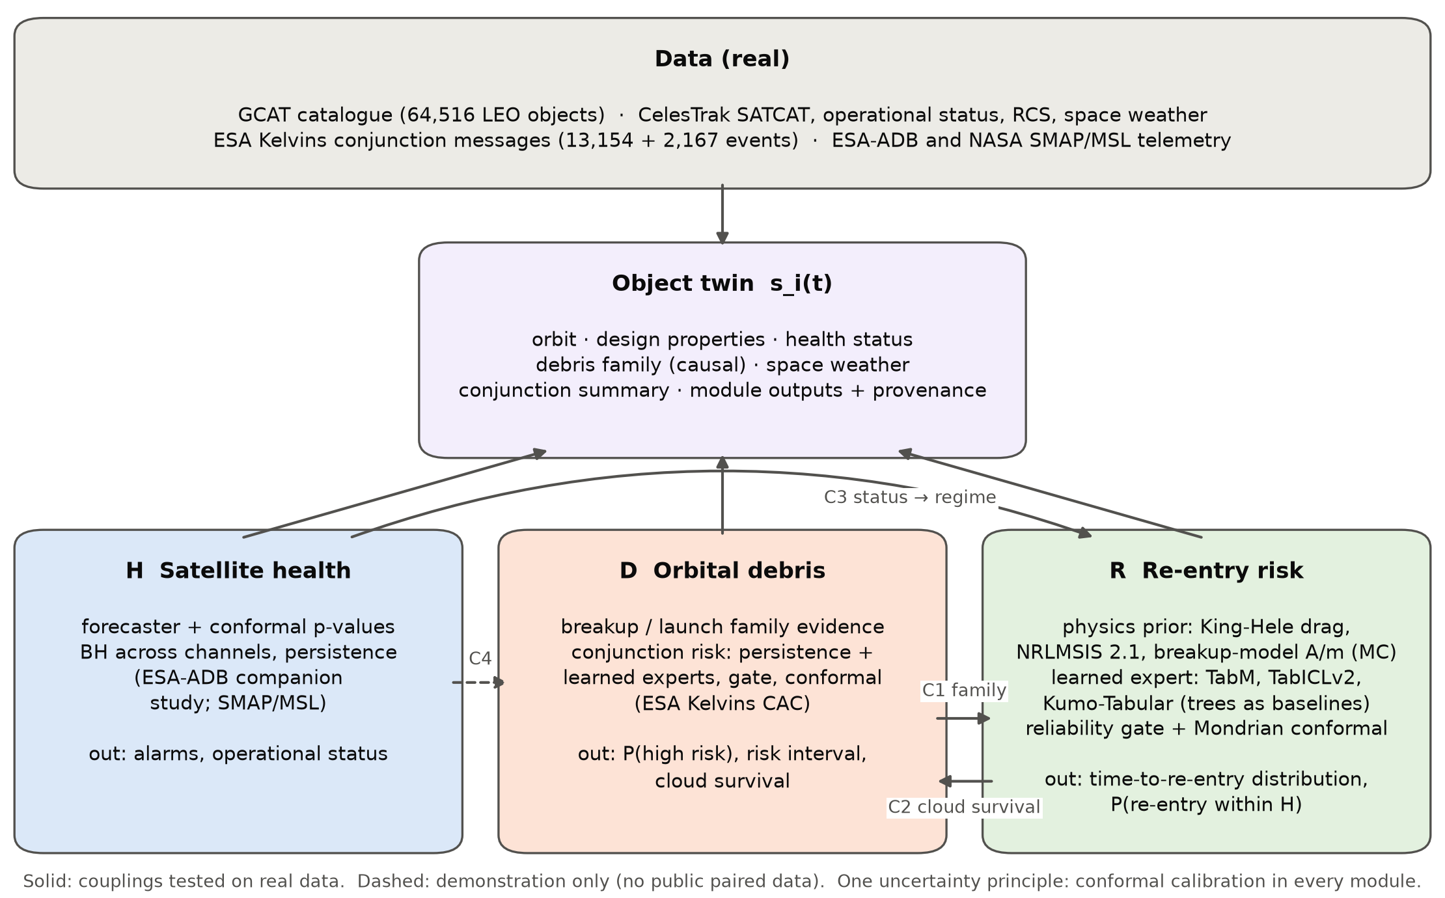
Fig. 1. System architecture. Three modules read and update one state per object. Solid arrows are couplings tested on real data; the dashed coupling has no public test data.
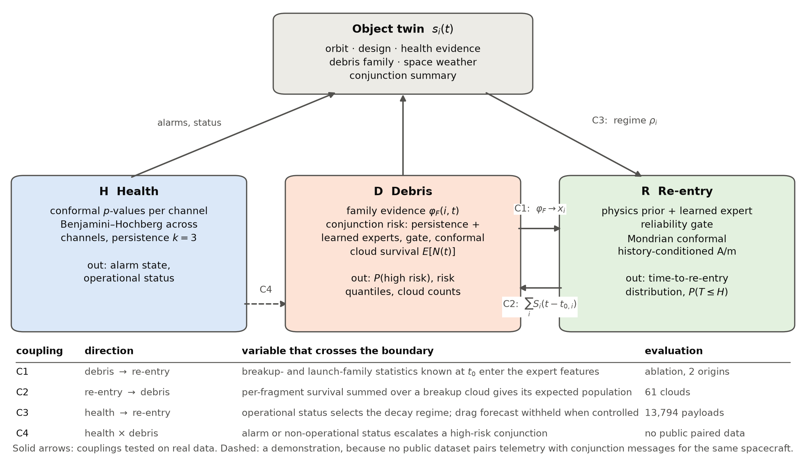
Fig. 2. Integration. The four couplings as a data flow, with the variable that crosses each boundary and how each is evaluated. Operational status reaches the re-entry module through the shared state, which is how it is implemented.

4.2 The artificial-intelligence contribution
The contribution is a two-expert mixture whose mixing weight is learned from descriptors of one expert’s own reliability, and whose output is calibrated without distributional assumptions. For object $i$,
$$q_{τ}(i)=g(r_{i}) q_{τ}^{\text{phys}}(i)+\left(1−g(r_{i})\right)q_{τ}^{\text{ml}}(i), g(r)=σ(w^{⊤}r+b),$$ | $$(3)$$
where $q_{τ}^{\text{phys}}$ are the quantiles of a Monte-Carlo physics prior, $q_{τ}^{\text{ml}}$ those of a learned expert, and $r_{i}$ collects reliability descriptors of the physics prior: the provenance of its area-to-mass ratio, the spread of its own Monte-Carlo distribution, eccentricity, a perigee band, the object class, and the probability it places at the five-year cap. Because a convex combination of monotone quantile functions is monotone, Eq. 3 returns a valid predictive distribution for any $g$; no sorting or post-hoc repair is required. The parameters $(w,b)$ minimise the mean pinball loss on out-of-fold predictions of the training period with an $L_{2}$ penalty, so the gate never sees a target that its experts were fitted on.
Two design choices distinguish this from a standard stacked ensemble. First, the gate input describes the prior’s trustworthiness, not the input in general, which makes the learned weights interpretable: a positive coefficient means “trust the physics more in this regime”. Second, mixing happens in quantile space rather than in expectation, so the fused object remains a distribution and can be conformalised directly.

4.3 Uncertainty layer
Two distinct calibrations are applied, and the distinction matters. Mondrian conformal prediction converts the fused quantiles into intervals with finite-sample coverage: on a calibration split disjoint from fitting and gating, the score $S=max(q_{\text{lo}}−z, z−q_{\text{hi}})$ is computed per object, and within group $k$ the correction ${\hat{Q}}_{k}$ is the $⌈(1−α)(n_{k}+1)⌉$-th smallest score, giving the interval $[q_{\text{lo}}−{\hat{Q}}_{k}, q_{\text{hi}}+{\hat{Q}}_{k}]$. Groups are object class crossed with perigee band, falling back to class and then to the pooled cohort when a group is too small. Isotonic regression is a separate, monotone recalibration of the horizon probabilities $P(T≤H)$ read off the same fused quantile function. Conformal prediction controls interval coverage and makes no assumption about the score distribution; isotonic regression corrects the probability scale and assumes only monotonicity. They are applied to different outputs and neither substitutes for the other. Because isotonic maps are piecewise constant and therefore tie scores, every ranking metric in this paper is computed on the raw probabilities and every calibration metric on the mapped ones.

5 Debris module: collision risk and cloud population

5.1 Family evidence
For object $i$ at time $t$ the module computes $φ_{F}(i,t)$: the number of siblings catalogued by $t$ in the same launch family and, for fragments, the same breakup family; the number and fraction of those siblings that decayed naturally before $t$; and their mean log-lifetime. Only events strictly before $t$ enter, so the feature is causal by construction. This is the quantity that coupling C1 passes to the re-entry module.

5.2 Collision risk
Inputs are the conjunction data messages of an encounter released at least two days before closest approach, reduced to one feature row per event: the latest risk; the minimum, maximum, mean and first risk; the change and the three-point slope; the last step; the logarithmic ratio of miss distance and of the covariance scales between the first and the last message; the message count; and the span. The target is the risk of the final message.
A persistence expert predicts the latest risk plus the training distribution of (final $−$ latest) changes within the same latest-risk bin, which is an honest persistence forecast with uncertainty rather than a bare point. The same learned experts as the re-entry module are applied to the event features, and the two are fused by Eq. 3. Learner selection, the gate, the conformal calibration, the isotonic map and the decision threshold are all driven by nested out-of-fold predictions over five event-hash folds, so no test message informs any choice. Quantiles within ${10}^{−4}$ of the risk floor are snapped to it, because most final risks lie exactly at the floor and the spacing of single-precision floats there is about $2×{10}^{−6}$.
Because the official metric scores a point forecast, a decision rule is also required: predict the latest risk when the calibrated $P(r≥−6)$ exceeds a threshold chosen on out-of-fold training events, and $−6.001$ otherwise.

5.3 Cloud population
Coupling C2 turns per-object survival into a debris-environment quantity. For a breakup cloud the expected number of catalogued fragments still in orbit at time $t$ is
E[N(t)]=i: t0,i≤t​Sit−t0,i, | $$(4)$$
where $S_{i}$ is the survival function of fragment $i$ read from the fused predictive distribution. It is read two ways: directly from the quantile function, and after isotonic maps of $P(T≤a)$ fitted on calibration fragments at 25 ages and interpolated in log-age. Reading it two ways is necessary because the two readings disagree, as Section 11 shows.

6 Re-entry module: physics prior and learned expert
Figure 3 shows the whole pipeline, including which cohort each component is fitted on.
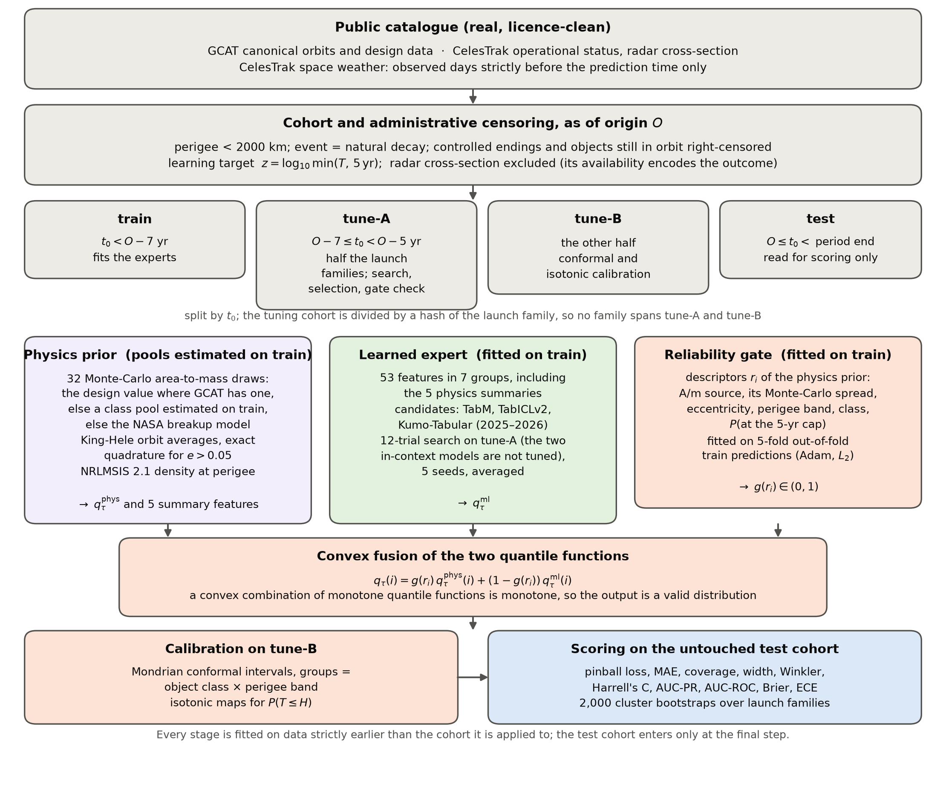
Fig. 3. Experimental design of the re-entry module. Every component is fitted on data strictly earlier than the cohort it is applied to, and the test cohort enters only at the final step.

6.1 Physics prior
The prior integrates the orbit-averaged drag equations for the semi-major axis $a$ and eccentricity $e$ with a thermospheric density from NRLMSIS 2.1 (Emmert et al., 2021) evaluated at perigee, and a ballistic coefficient $B=C_{D}A/m$. For $e≤0.05$ it uses King-Hele’s Bessel-function series (King-Hele, 1987); above that it integrates the same orbit averages exactly over the eccentric anomaly by 257-node quadrature, because the truncated series raises the perigee for $e$ above about 0.3, which is unphysical. Space weather is held at its value at $t_{0}$, using only days that ended before $t_{0}$.
The area-to-mass ratio is the dominant unknown, and it is sampled rather than assumed. Each object draws 32 Monte-Carlo values from one of three sources, which is recorded per object: its design value where the catalogue has one, modelled log-normally with a spread of 0.25 dex; a pool of design values of its class estimated on the training cohort, for intact payloads and rocket stages without one; or the NASA Standard Breakup Model (Johnson et al., 2001) with a characteristic length drawn from the training distribution of radar-derived sizes of its class, for fragments and components. Each object has its own random stream seeded from its catalogue identifier, so a draw is reproducible per object. The prior is therefore not free of fitted quantities: its class pools are estimated on the training cohort, and we say so rather than presenting it as purely a priori.

6.2 Learned expert
The expert performs quantile regression of $z$ on 53 features in seven groups: orbit, age at $t_{0}$, design properties, space weather, family evidence $φ_{F}$, five summaries of the physics prior’s Monte-Carlo distribution, and object class. Candidates are models published between 2022 and 2026: TabM, a parameter-efficient deep ensemble of multilayer perceptrons sharing most weights (Gorishniy et al., 2025); and two in-context foundation models, TabICLv2 (Qu et al., 2026, 2025) and Kumo-Tabular (NVIDIA, 2026), which condition on the training set at inference time instead of fitting weights to it. The candidate with the lowest pinball loss on the tuning split becomes the expert. Gradient-boosted trees (Chen and Guestrin, 2016; Ke et al., 2017; Prokhorenkova et al., 2018), a plain non-crossing quantile multilayer perceptron, and an accelerated-failure-time model trained on all objects including censored ones (Barnwal et al., 2022) are reported as reference baselines and are not eligible for selection. Each tuned learner receives the same budget of 12 random configurations scored on the tuning split and five seeds; the two in-context models are used with their default inference settings and are not tuned.
The deliberate exclusion is the radar cross-section. Whether the catalogue publishes one depends on how fast the object decayed, so its availability carries the outcome; Section 11 quantifies this and the paper keeps the covariate only as a labelled leak demonstration.

6.3 State estimation for objects already in orbit
The module is fitted at canonical-orbit epochs, but a twin must forecast objects that have been in orbit for years. Survival since the canonical orbit selects low area-to-mass ratios, which neither the class pools nor the learned expert know about. For each uncontrolled object the twin therefore conditions the area-to-mass distribution on the object’s catalogue history, a coarse two-orbit form of the ballistic-coefficient estimation used in practice (Gondelach et al., 2017; Pardini and Anselmo, 2008; Sang et al., 2013):
- 128 prior samples are propagated from the canonical orbit to the as-of date with the realised trailing space weather;
- samples that would already have re-entered receive zero weight;
- the remainder are weighted by a Gaussian likelihood of the current perigee and apogee, with $σ=10 \text{km}+0.3 |Δ|$ for an observed change $Δ$ since the canonical orbit;
- 32 posterior samples are drawn by systematic resampling; if the effective sample size falls below four, survival alone is used, and if no sample survives, the eight longest survivors are.
The physics prior then forecasts from the current orbit with these samples. This step is Bayesian rather than learned, and Section 13 returns to that point.

7 Health module
The health module converts a forecaster’s residuals into calibrated alarms. For channel $c$, a model fitted on nominal data produces a non-conformity score $s_{c}(t)$, which becomes a conformal $p$-value against that channel’s own calibration pool $C_{c}$,
$$p_{c}(t)=\frac{1+\#\{s^{′}∈C_{c}:s^{′}≥s_{c}(t)\}}{|C_{c}|+1},$$ | $$(5)$$
the $p$-values are aggregated across channels at each step with Benjamini–Hochberg control (Benjamini and Hochberg, 1995), and an alarm is raised causally at the third consecutive step with $p≤max({10}^{−3},1/(|C_{c}|+1))$. The level, the persistence and the window were fixed before any detector was scored, and no test label informs any choice. Calibration scores are computed out of fold in five contiguous blocks with a 30-step purge on each side, so no step is scored by a model that has seen it.
The detector compared in this paper is Chronos-2 (Ansari et al., 2025), a pretrained time-series foundation model used zero-shot: rolling eight-step forecasts from up to 512 past steps, scored by the absolute residual of the forecast median. It is set against three classic detectors — ridge autoregression, principal-component reconstruction and nearest-neighbour window distance — the published telemanom scores (Hundman et al., 2018), a random-score floor and an always-on alarm reference.
Two limitations of this evidence must be stated plainly. First, the Soil Moisture Active Passive and Mars Science Laboratory channels are real spacecraft telemetry, but they belong to an Earth-observation satellite and a planetary rover, not to the catalogue population whose debris risk the rest of the system forecasts; no public dataset provides telemetry for the objects in our catalogue cohort. The health module therefore transfers a method, not a fitted model, and its coupling to the debris modules runs through operational status rather than through telemetry. Second, the conformal alarm layer of this module was developed and tested in a separate pre-registered study on the European Space Agency benchmark (Kotowski et al., 2026) by the same authors; that study found the gain on one mission and a reversal on the other, and we treat the health module as the least validated of the three throughout.

8 Cross-module couplings
What separates this system from three models in one wrapper is that the modules exchange specific variables, and that each exchange is measured. Table 2 states each coupling, what crosses the boundary, and what the measurement shows.
Table 2. The four couplings and their measured effect. Confidence intervals are 2,000 cluster bootstraps over launch families (C1), clouds (C2) or launches (C3). A positive C1 effect means the features help; a negative C3 difference means the status-aware policy lowers the Brier score.
Coupling | Direction | What is measured | Measured effect | Verdict
C1 | debris $→$ re-entry | family features removed from the expert | +0.0056 [+0.0015, +0.0101] at 2016; +0.0024 [-0.0058, +0.0103] at 2011 | yes at 2016, not at 2011
C2 | re-entry $→$ debris | cloud population against catalogue counts | best mean absolute error 0.095 [0.068, 0.123] of a cloud (predcal_tabicl) | experts not separable
C3 | health $→$ re-entry | status-aware against status-blind Brier score | -0.0054 [-0.0120, +0.0006] | not significant
C4 | health $×$ debris | no public paired dataset | not evaluated | demonstration only
C1, debris to re-entry. Motivation: fragments of one breakup share an origin and therefore a range of area-to-mass ratios, so the fate of catalogued siblings is evidence about an object’s own lifetime. Formulation: $φ_{F}(i,t_{0})$ enters the feature vector $x_{i}$ of the learned expert. Evaluation: the feature group is removed and the expert refitted with identical settings and seeds, and the paired difference in test pinball loss is bootstrapped over launch families. Result: the features help at origin 2016, +0.0056 (+0.0015 to +0.0101), and the interval includes zero at origin 2011. Limitation: siblings are only informative once some of them have decayed, which is why the earlier origin gains less.
C2, re-entry to debris. Motivation: the debris environment is the sum of individual survival, so a lifetime model should reproduce the observed decline of a breakup cloud. Formulation: Eq. 4. Evaluation: predicted against catalogued fragment counts for every cloud with at least 30 fragments in a test cohort, at one to five years after its first catalogued fragment, with a bootstrap resampling whole clouds. Result: the best reading reaches a mean absolute error of about a tenth of a cloud’s size, but with 27 clouds the experts cannot be separated. Limitation: the number of clouds, not the number of fragments, sets the precision of this test.
C3, health to re-entry. Motivation: an operator that still controls a satellite determines its orbit, so drag physics does not predict its decay. Formulation: the status in $h_{i}$ selects a regime $ρ_{i}$; in the operator-controlled regime the drag forecast is withheld and the previous-window payload base rate is used instead. Evaluation: an as-of-date test on 13,794 payloads below 600 km with 182 decays in the following 72 days, comparing status-aware and status-blind policies that use only information available at the as-of date, with intervals resampling launches. Result: drag physics over-predicts for operational payloads (mean predicted 0.039 against an observed rate of 0.012) and under-predicts for non-operational ones (0.076 against 0.106). The status-aware policy lowers the Brier score, but the interval includes zero. Limitation: with 182 decays in one window the test shows the direction of the effect and not its size.
C4, health and debris to response. Motivation: a high-risk conjunction for a spacecraft that may be unable to manoeuvre warrants escalation. Formulation: an alarm state or a non-operational status raises the response level of a high-risk event. Evaluation: none is possible, because no public dataset pairs conjunction messages with telemetry or health status for the same spacecraft. This coupling is implemented and reported as a demonstration, and it supports no performance claim anywhere in this paper.

9 Datasets and preprocessing
All data are public and real; provenance, checksums and licences are recorded in a manifest released with the code. Table 3 lists what is used.
Table 3. Datasets. The class column follows the project’s own data audit, which separates real sources from derived and simulated ones. Simulated sets held on disk, such as the Kelvins debris-origin challenge data, are not used anywhere in this paper.
Role | Source | Class | Extent used | Licence
Catalogue (re-entry, debris) | General Catalog of Artificial Space Objects, release 1.8.8; CelesTrak catalogue and space weather | real | 64,516 objects below 2000 km perigee; 32,970 natural decays | Creative Commons Attribution 4.0 / CelesTrak policy
Conjunctions (debris) | European Space Agency Kelvins collision-avoidance challenge | real, anonymised | 8,293 training and 2,167 official test events | Creative Commons Attribution 4.0
Telemetry (health) | National Aeronautics and Space Administration Soil Moisture Active Passive and Mars Science Laboratory | real | 81 channels, 68 and 36 labelled sequences | as stated by the authors
Thermospheric density | NRLMSIS 2.1 via pymsis, tabulated | derived | density table used by the physics prior | open source
Catalogue. The General Catalog of Artificial Space Objects (McDowell, 2022, 2020) gives, for each object, one canonical orbit representative of early operations with its epoch, design mass and dimensions, the parent object for fragments, and the end of the current phase with a status code that distinguishes natural decay from controlled de-orbit, landing or docking. The CelesTrak catalogue (Kelso, 2026) adds operational status, and the CelesTrak space-weather file provides the solar and geomagnetic indices; only observed rows for days that ended before the prediction time are read. The cohort holds 64,516 objects whose canonical orbit has perigee below 2000 km, of which 32,970 decayed naturally. Figure 4 shows the cohort’s orbits, its distribution in time with the cohorts of both forecast origins, the observed lifetimes with their censoring, and the space-weather record.
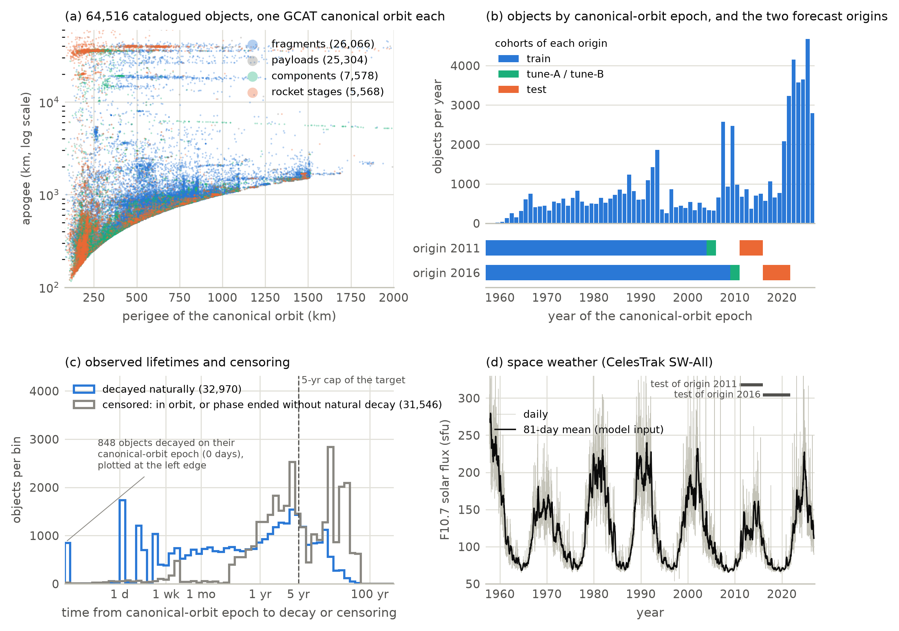
Fig. 4. The catalogue dataset. (a) Canonical orbits by object class; the classes overlap heavily at these densities, and the largest is drawn first. (b) Objects per year of canonical-orbit epoch, with the training, tuning and test cohorts of both origins. (c) Observed time to natural decay, and to censoring for objects still in orbit or whose phase ended otherwise. (d) Solar flux; its 81-day mean is the model input, and the bars mark the two test periods.
Conjunctions. The Kelvins collision-avoidance challenge data (European Space Agency, Advanced Concepts Team, 2019; Uriot et al., 2021) contain anonymised conjunction data messages received by the European Space Agency between 2015 and 2019. Following the challenge, inputs are the messages released at least two days before closest approach and the target is the risk of the final message. Training events are filtered to mirror the test inputs, leaving 8,293 training events, of which 66 are high risk, and the official 2,167 test events, of which 150 are high risk. Figure 5 shows the breakup clouds of the catalogue and the structure of the message data.
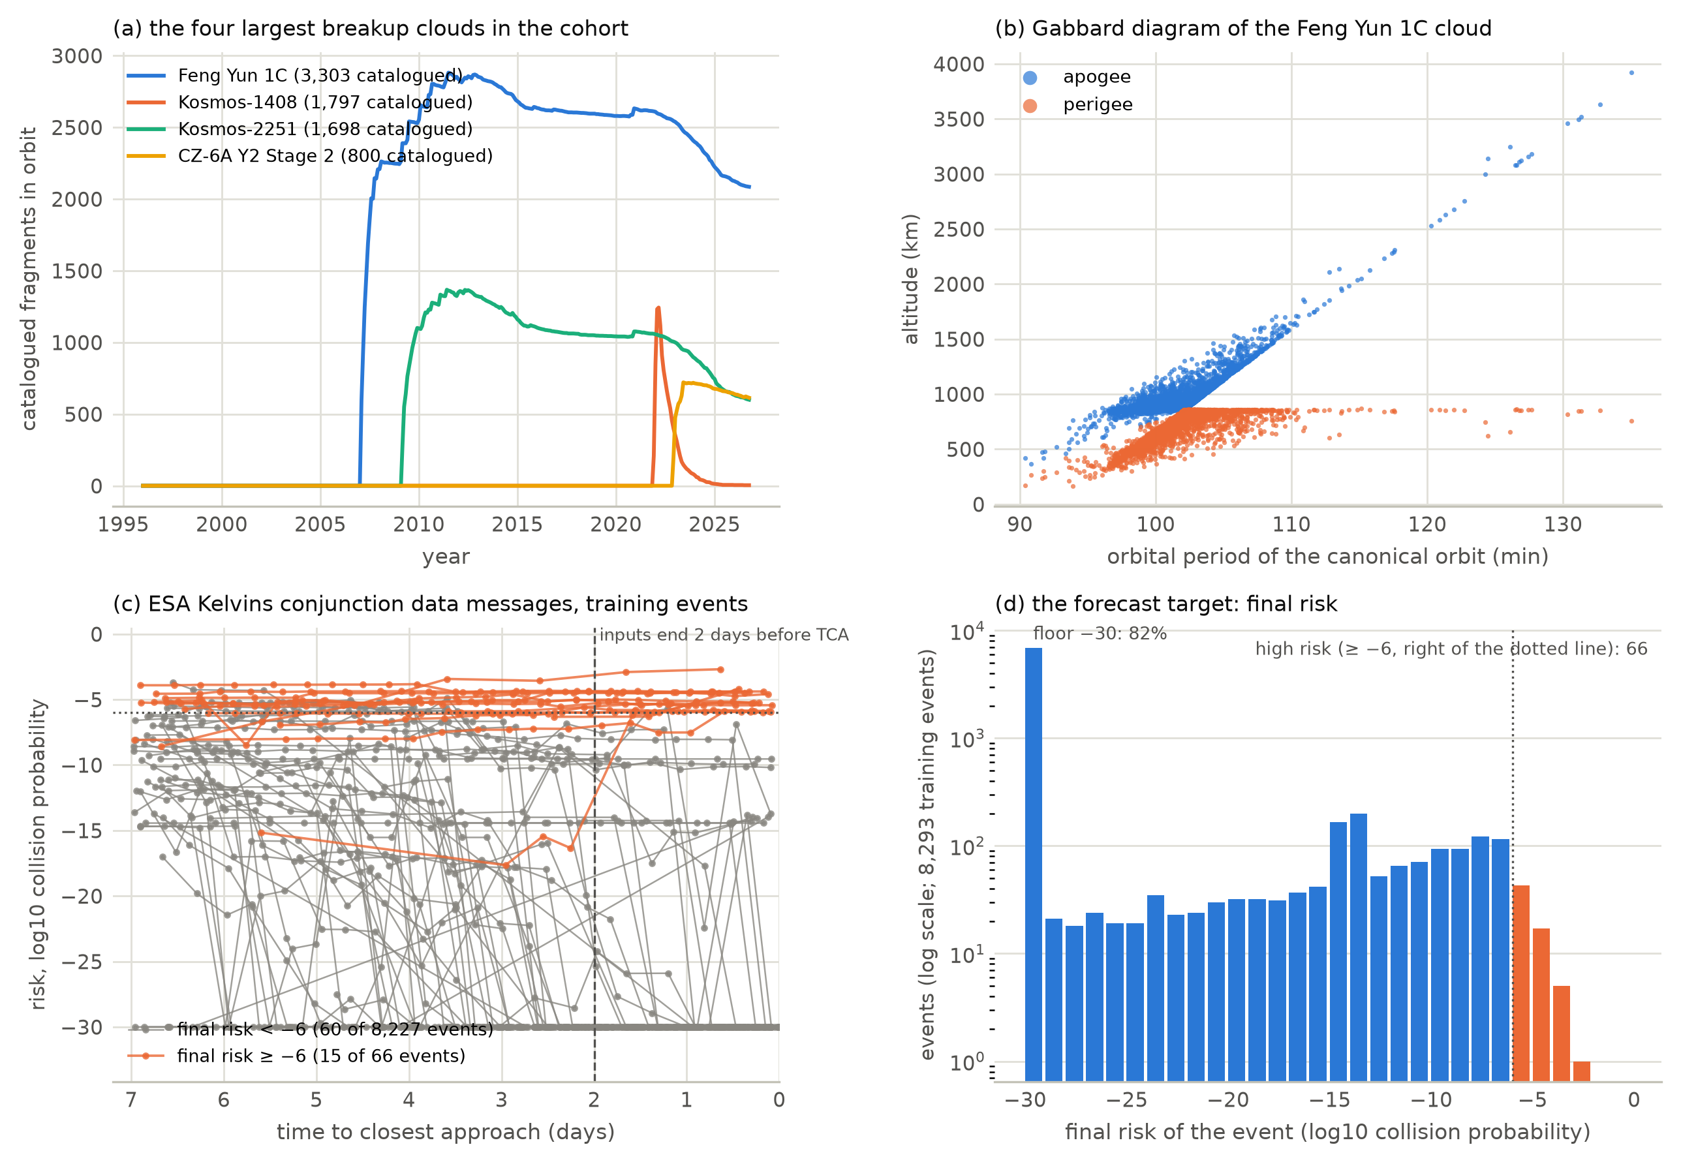
Fig. 5. Debris data. (a) Catalogued fragments in orbit over time for the four largest breakup clouds of the cohort. (b) Gabbard diagram of the largest cloud. (c) Risk sequences of 75 training events, 60 drawn at random from the low-risk events and 15 from the high-risk events, so high-risk events are deliberately oversampled. (d) The forecast target: most final risks lie at the floor.
Telemetry. The Soil Moisture Active Passive and Mars Science Laboratory channels (Hundman et al., 2018) provide 81 channels with 68 and 36 labelled anomaly sequences respectively; the label file lists one channel twice and the two rows are merged. Figure 6 shows example channels with their labels.
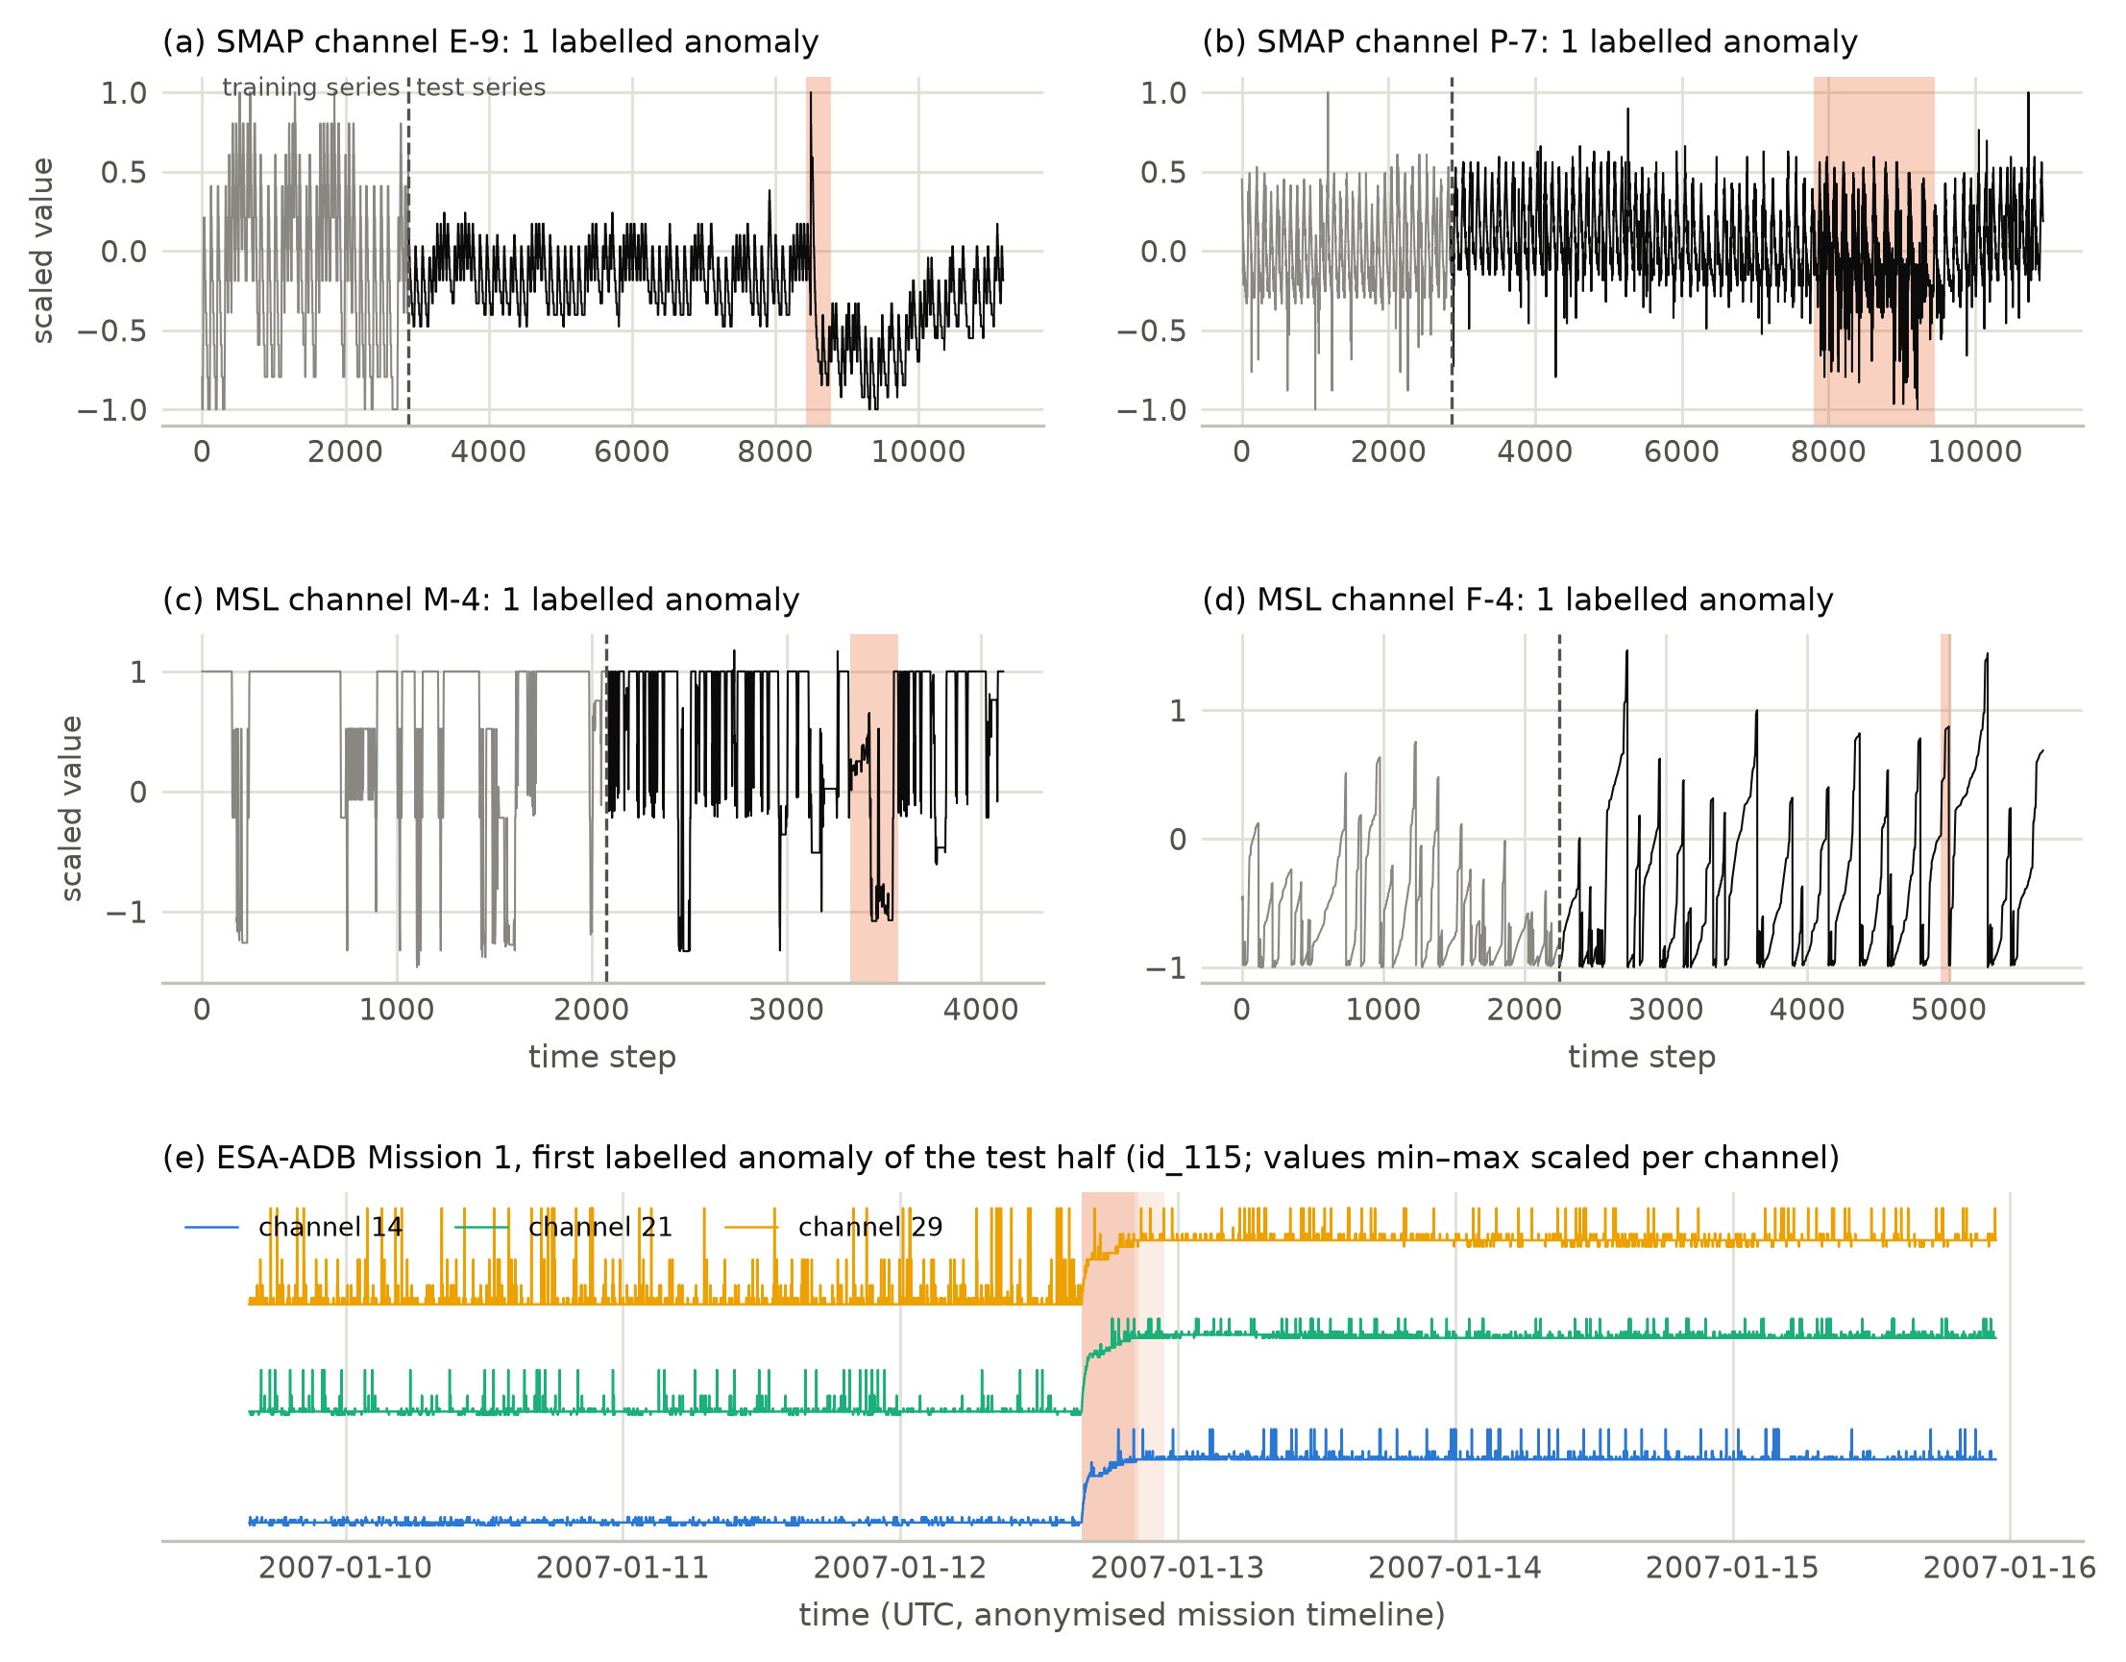
Fig. 6. Telemetry data. Two channels of each spacecraft drawn at random: training series in grey, test series in black, labelled anomaly sequences shaded. The lower panel shows the European Space Agency benchmark around the first labelled anomaly of its test half, for the target channels it affects.
What is not available. Orbital-element histories at catalogue scale require an account whose user agreement forbids redistribution (18th Space Defense Squadron, 2019), and no legitimate public archive exists; the European Space Agency’s debris database and its re-entry predictions also need accounts (ESA Space Debris Office, 2026; Klinkrad, 1991). The re-entry module therefore predicts from a single dated orbit per object rather than from a history, which is the main structural difference between this study and operational practice.

10 Experimental setup and metrics

10.1 Temporal protocol
The prediction time $t_{0}$ is the canonical-orbit epoch. Under the protocol as of origin $O$, the training cohort has $t_{0}<O−7$ yr, the tuning cohort $O−7≤t_{0}<O−5$ yr, and all their outcomes are censored administratively at $O$ so that nothing later than the origin can influence a fitted quantity. The tuning cohort is split by a hash of the launch family into tune-A, used for early stopping, the hyperparameter search, learner selection and gate checks, and tune-B, used for conformal and probability calibration; splitting by family rather than at random prevents siblings of one launch from appearing on both sides. The test cohort starts at $O$ and ends where the five-year follow-up is complete at the snapshot, or at the next origin: $t_{0}<$ 2016-01-01 at origin 2011 and $t_{0}<$ 2021-10-27 at origin 2016. The two origins, 2011-01-01 and 2016-01-01, therefore give two disjoint test periods, which span different phases of the solar cycle. The primary population is objects that cannot manoeuvre; payloads are excluded from it because many are operator-controlled.
For the collision-risk module the official challenge split is used unchanged. For telemetry the official channel split is used, with thresholds fixed in advance.

10.2 Metrics
Table 4 lists every metric and what it is for. Pinball loss over the seven quantiles is primary throughout, because a single predicted date is not a decision-useful object for either re-entry planning or conjunction screening.
Table 4. Metrics. Ranking metrics use the raw probabilities, because isotonic calibration ties scores; calibration metrics use the mapped ones.
Metric | What it measures | Where used
Mean pinball loss | quality of the whole predictive distribution over seven quantiles | re-entry, conjunction
Mean absolute error of the median | point accuracy, $\log_{10}$ days | re-entry
Empirical coverage, width, Winkler score | honesty and sharpness of the intervals | re-entry, conjunction
Harrell’s concordance | ranking over all objects, censored included | re-entry
AUC-PR, AUC-ROC | discrimination at a horizon, on the raw probabilities | all three modules
Brier score, expected calibration error | probability calibration, after isotonic mapping | re-entry, conjunction
Expected over observed count | absolute bias of a probability forecast | couplings C3, T1
$L={MSE}_{HR}/F_{2}$​ | the challenge’s official collision-risk metric | conjunction
Corrected event-wise $F_{0.5}$ | alarm quality, charging alarm time spent on nominal data | health
Kaplan-Meier survival | censoring-aware description of the cohort | re-entry
Cluster bootstrap, 2,000 replicates | intervals resampling launch families, launches or clouds | all
Confidence intervals come from 2,000 cluster-bootstrap replicates, paired for model differences. The resampling unit is the launch family for the catalogue cohorts, the launch for the payload-status test and the cloud for the cloud-population test, because objects sharing an origin do not provide independent evidence. Learner predictions are cached under a fingerprint of the data, features and settings, so a stale result cannot enter a comparison.

10.3 Deviations and prior use of test data
The test sets were not untouched when the reported results were produced, and the full record is in the supplementary material. In summary: an earlier complete run used a different candidate pool and its test results were known before the pool was narrowed to models published 2022–2026; two engineering smoke tests printed test scores before the reported run; every benchmark was scored once before an internal review and corrected afterwards; the window used for the as-of-date tests of C3 and the state-estimation comparison had been analysed earlier in the project; and the head-to-head comparisons, the gate-applied-to-every-learner analysis and the calibrated cloud reading were added after results had been seen. All intervals are nominal 95 % intervals without correction for multiplicity. We report this because it bounds how confirmatory the comparisons can be, and a fresh test period would be needed to confirm them.

11 Results

11.1 The mixture of experts
Table 5 and Figure 7 give the eight-arm comparison that tests the paper’s central claim.
Table 5. Mixture-of-experts arms on both test periods. Columns are the mean pinball loss, the mean absolute error of the median in $\log_{10}$ days, and the empirical coverage of the 90 % conformal interval; the first three numeric columns are origin 2016 and the last three origin 2011. Lowest pinball loss: 0.0499 at origin 2016 and 0.0527 at origin 2011; the proposed gate attains neither.
Fusion arm | Type | Pinball | MAE | Cov. | Pinball | MAE | Cov.
Physics prior only ($g=1$) | single expert | 0.0892 | 0.230 | 0.876 | 0.0527 | 0.148 | 0.974
TabM (2025) | single expert | 0.0593 | 0.192 | 0.877 | 0.0994 | 0.354 | 0.918
TabICLv2 (2026) | single expert | 0.0499 | 0.166 | 0.962 | 0.0596 | 0.160 | 0.919
Kumo-Tabular (2026) | single expert | 0.0508 | 0.162 | 0.974 | 0.0616 | 0.163 | 0.966
XGBoost | baseline | 0.0576 | 0.190 | 0.921 | 0.0648 | 0.231 | 0.894
Equal-weight average ($g=1/2$) | fixed fusion | 0.0691 | 0.205 | 0.838 | 0.0527 | 0.148 | 0.970
Learned constant gate | learned fusion | 0.0601 | 0.193 | 0.877 | 0.0608 | 0.162 | 0.960
Reliability gate fitted on tune-A | learned fusion | 0.0695 | 0.202 | 0.832 | 0.0616 | 0.163 | 0.959
Reliability-gated mixture (proposed) | learned fusion | 0.0604 | 0.193 | 0.874 | 0.0583 | 0.157 | 0.959
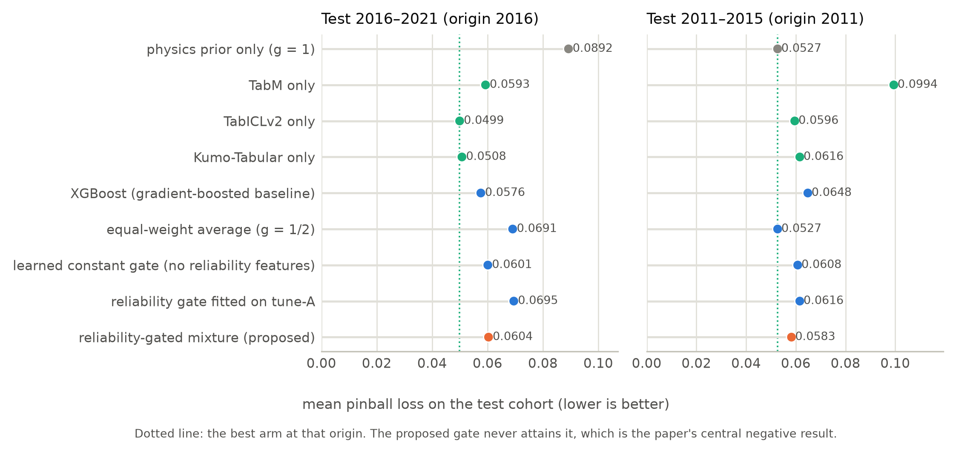
Fig. 7. All eight fusion arms on both test periods. The dotted line marks the best arm at each origin.
The headline comparison is favourable to the learned experts and unfavourable to the fusion. For 2016–2021 the in-context foundation models are the most accurate arms, at 0.0499 and 0.0508 against 0.0892 for the physics prior and 0.0576 for the strongest gradient-boosted baseline, reductions of 44 % and 13 % respectively. For 2011–2015 the ordering changes: the physics prior has the lowest point estimate, 0.0527, and TabM — the arm selected by the tuning split at the other origin — is the worst of all at 0.0994.
The proposed reliability gate reaches 0.0604 and 0.0583. It does not attain the best arm at either origin. It beats the physics prior decisively at 2016 and beats its own learned expert at 2011, but an oracle choosing the single best expert per period would do better in both. Three further points follow from the table. The equal-weight average is the second-best arm at 2011 and among the worst at 2016, so a fixed mixing weight is not a safe default. The learned constant gate, which is the same model without reliability features, is close to the full gate at 2016 and worse at 2011, so the reliability descriptors contribute little at one origin and something at the other. And fitting the gate on the tuning split rather than on out-of-fold training predictions is clearly worse at both origins, which shows the fitting protocol matters more than the parameterisation.
Table 6 gives the paired comparisons with intervals.
Table 6. Head-to-head differences in test pinball loss with paired launch-family cluster bootstraps. A negative difference favours the first model. These comparisons were added after test results had been seen and are nominal.
Origin | Comparison | $Δ$ pinball | 95 % CI | Excludes 0
2016 | Physics prior only $−$ TabICLv2 (2026) | +0.0393 | [+0.0217, +0.0622] | yes
2016 | Physics prior only $−$ Kumo-Tabular (2026) | +0.0385 | [+0.0203, +0.0613] | yes
2016 | Physics prior only $−$ TabM (2025) | +0.0300 | [+0.0147, +0.0493] | yes
2016 | Physics prior only $−$ Reliability-gated mixture | +0.0289 | [+0.0148, +0.0469] | yes
2016 | TabICLv2 (2026) $−$ Kumo-Tabular (2026) | -0.0008 | [-0.0036, +0.0024] | no
2016 | TabICLv2 (2026) $−$ XGBoost | -0.0076 | [-0.0121, -0.0036] | yes
2016 | Kumo-Tabular (2026) $−$ XGBoost | -0.0068 | [-0.0134, -0.0012] | yes
2016 | TabICLv2 (2026) $−$ Reliability-gated mixture | -0.0104 | [-0.0179, -0.0043] | yes
2016 | Kumo-Tabular (2026) $−$ Reliability-gated mixture | -0.0096 | [-0.0181, -0.0023] | yes
2016 | TabICLv2 (2026) $−$ TabM (2025) | -0.0093 | [-0.0162, -0.0036] | yes
2016 | Kumo-Tabular (2026) $−$ TabM (2025) | -0.0085 | [-0.0167, -0.0017] | yes
2011 | Physics prior only $−$ TabICLv2 (2026) | -0.0069 | [-0.0217, +0.0122] | no
2011 | Physics prior only $−$ Kumo-Tabular (2026) | -0.0089 | [-0.0253, +0.0133] | no
2011 | Physics prior only $−$ TabM (2025) | -0.0468 | [-0.1078, +0.0085] | no
2011 | Physics prior only $−$ Reliability-gated mixture | -0.0056 | [-0.0199, +0.0139] | no
2011 | TabICLv2 (2026) $−$ Kumo-Tabular (2026) | -0.0020 | [-0.0058, +0.0024] | no
2011 | TabICLv2 (2026) $−$ XGBoost | -0.0053 | [-0.0124, +0.0001] | no
2011 | Kumo-Tabular (2026) $−$ XGBoost | -0.0032 | [-0.0126, +0.0035] | no
2011 | TabICLv2 (2026) $−$ Reliability-gated mixture | +0.0013 | [-0.0016, +0.0044] | no
2011 | Kumo-Tabular (2026) $−$ Reliability-gated mixture | +0.0033 | [+0.0007, +0.0055] | yes
2011 | TabICLv2 (2026) $−$ TabM (2025) | -0.0399 | [-0.0881, +0.0006] | no
2011 | Kumo-Tabular (2026) $−$ TabM (2025) | -0.0378 | [-0.0862, +0.0009] | no
At 2016 both foundation models are significantly better than the physics prior, the gated mixture, TabM and XGBoost. At 2011 the physics prior cannot be separated from either foundation model or from the gated mixture; the single significant difference among them is that Kumo-Tabular is worse than the gated mixture that fuses it, +0.0033 (+0.0007 to +0.0055). Figure 8 shows what the gate actually does: it places a mean weight of 0.11 and 0.12 on the physics prior, more when the area-to-mass ratio comes from the breakup model than when a design value exists, which is the behaviour the descriptors were designed to produce.
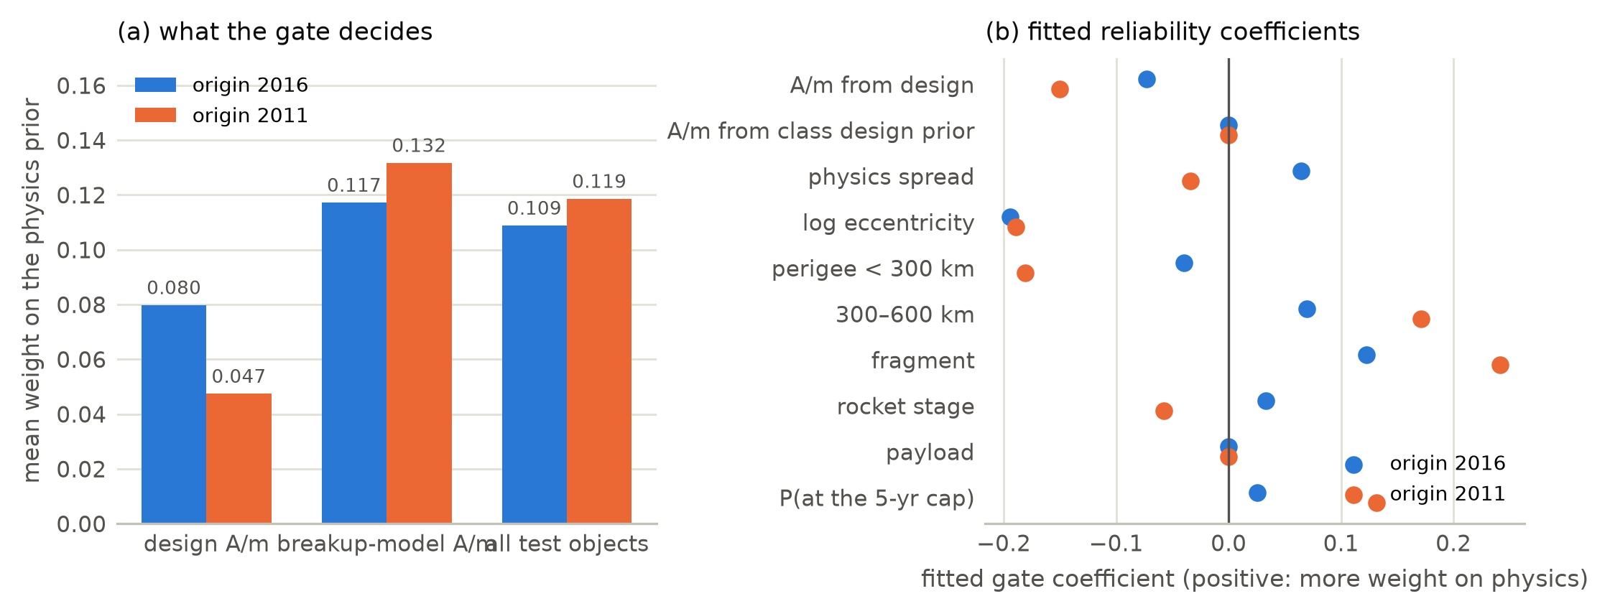
Fig. 8. Gate behaviour. (a) Mean weight placed on the physics prior, by the provenance of the area-to-mass ratio. (b) The fitted reliability coefficients; a positive coefficient shifts weight towards the physics prior.

11.2 Model selection under temporal shift
Selection on a tuning cohort five to seven years older than the test cohort did not identify the arm that generalised best. At 2016 TabM led the tuning split by a wide margin and was significantly worse than both foundation models on test. At 2011 the small tuning cohort (248 objects) selected Kumo-Tabular, which is tied with TabICLv2 on test. A random split would have concealed this; only the forward-in-time protocol exposes it.

11.3 What the module outputs look like
Figure 9 shows the predictive distributions for individual objects and for the cohort.
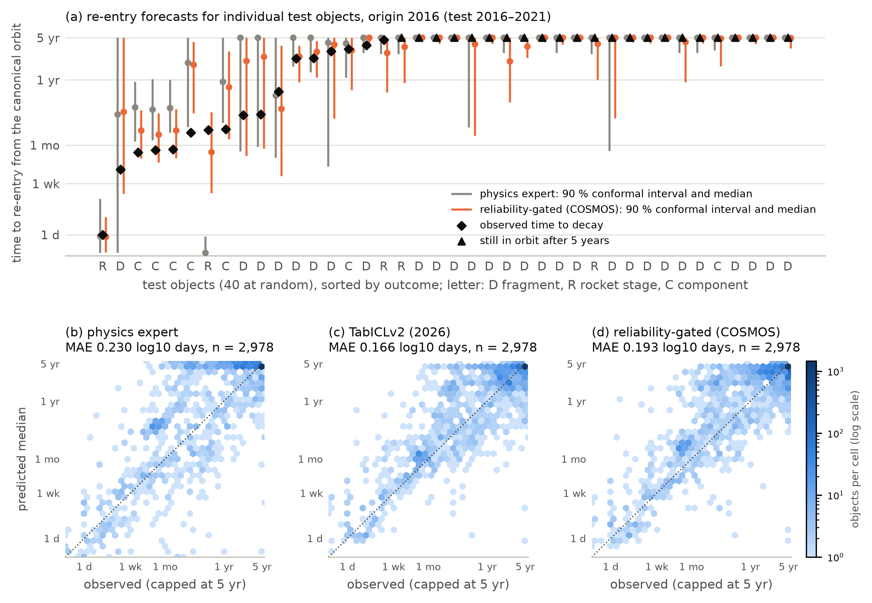
Fig. 9. Re-entry module outputs, origin 2016. (a) Forty test objects drawn at random among those with a known five-year outcome: median and 90 % conformal interval of the physics prior and of the gated mixture, against the observed outcome. (b–d) Predicted median against observed outcome for every such test object.

11.4 Collision risk
Table 7. Collision risk on the official test set. $L$ is the challenge metric, infinite when $F_{2}=0$ because every median falls below the high-risk threshold and the metric divides by zero.
Model | Pinball | AUC-PR | AUC-ROC | $F_{2}$​ | $L$​ | Cov. 90 % | Cov. high risk
Persistence + residual climatology | 1.045 | 0.664 | 0.944 | 0.000 | $∞$​ | 0.910 | 0.593
XGBoost | 0.855 | 0.606 | 0.945 | 0.000 | $∞$​ | 0.917 | 0.433
LightGBM | 0.861 | 0.541 | 0.944 | 0.000 | $∞$​ | 0.905 | 0.253
CatBoost | 0.869 | 0.542 | 0.935 | 0.000 | $∞$​ | 0.912 | 0.467
Quantile multilayer perceptron | 1.035 | 0.434 | 0.901 | 0.000 | $∞$​ | 0.936 | 0.853
TabM (2025) | 0.885 | 0.512 | 0.937 | 0.000 | $∞$​ | 0.919 | 0.727
TabICLv2 (2026) | 0.692 | 0.665 | 0.961 | 0.057 | 30.06 | 0.918 | 0.327
Kumo-Tabular (2026) | 0.653 | 0.733 | 0.970 | 0.168 | 9.89 | 0.942 | 0.480
Learned constant gate | 0.653 | 0.733 | 0.970 | 0.168 | 9.90 | 0.935 | 0.480
Reliability-gated mixture (proposed) | 0.653 | 0.733 | 0.970 | 0.168 | 9.90 | 0.940 | 0.480
Latest-risk point forecast (challenge baseline) |  |  |  |  | 0.69
Kumo-Tabular gives the best predictive distribution, 0.653 against 1.045 for persistence, a reduction of 37 %, and the best discrimination of high-risk events at AUC-PR 0.733. Table 8 shows the margin is significant against every comparator.
Table 8. Paired bootstrap over test events of the collision-risk pinball loss. A negative difference favours Kumo-Tabular.
Comparison | $Δ$ pinball | 95 % CI
Kumo-Tabular $−$ TabICLv2 | -0.039 | [-0.053, -0.025]
Kumo-Tabular $−$ XGBoost | -0.202 | [-0.233, -0.171]
Kumo-Tabular $−$ TabM (2025) | -0.231 | [-0.264, -0.199]
Kumo-Tabular $−$ Persistence + residual climatology | -0.392 | [-0.451, -0.337]
On the official point metric, however, no model beats the latest-risk baseline at 0.694. The reason is visible in Figure 10: 129 of the 150 high-risk events receive a median below the threshold, 41 of them between $−10$ and $−6$, so $F_{2}$ reaches only 0.17. The conformal interval covers 94.2 % of all events but only 48.0 % of the high-risk ones, because the calibration groups are coarse exactly where the decisions are made. This reproduces the challenge’s own finding and an independent re-evaluation (Uriot et al., 2022; Vazquez, 2026).
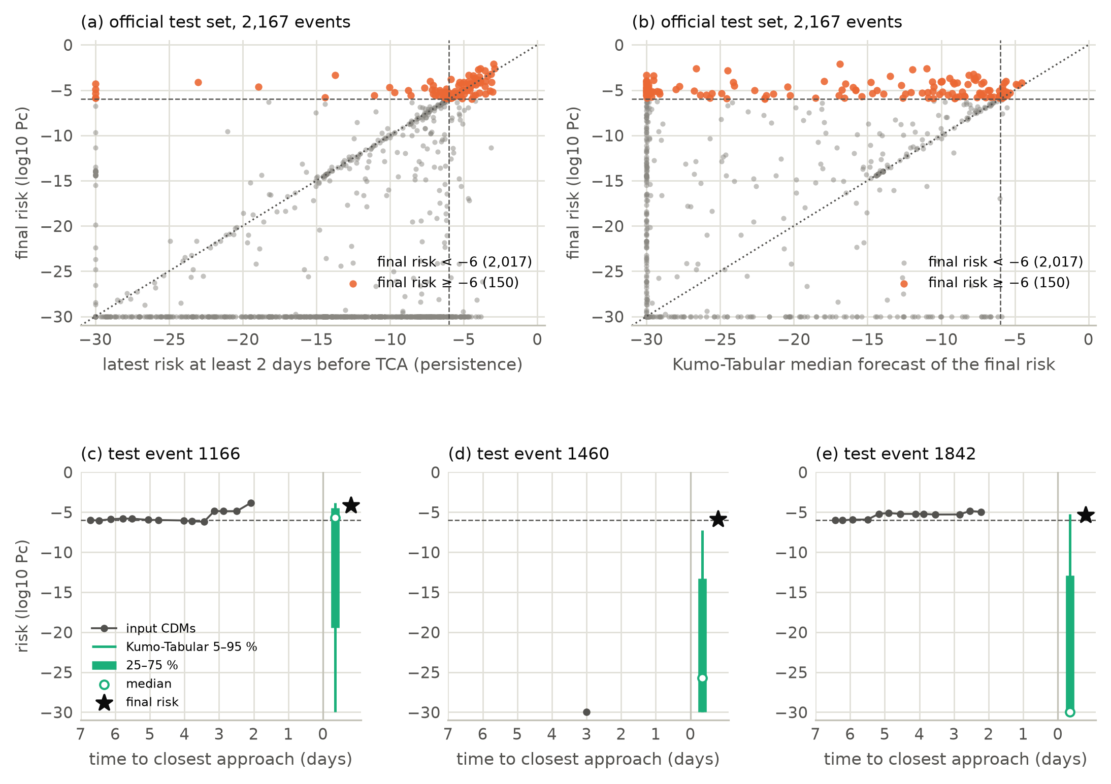
Fig. 10. Collision-risk outputs. (a) Final risk against the latest available risk. (b) Final risk against the median forecast. (c–e) Three high-risk test events drawn at random: input messages, predictive quantiles and the final risk.

11.5 Health
Table 9. Telemetry detectors. AUC-PR is the per-channel mean over anomalous steps; $F_{0.5}$ is the corrected event-wise score, which charges alarm time spent on nominal data. “Late ref.” keeps each detector’s amount of alarm time but places it as one block at the end of the series.
Detector | AUC-PR | $F_{0.5}$​ | Late ref. | AUC-PR | $F_{0.5}$​ | Late ref.
telemanom (published scores) | 0.576 |  |  | 0.473
Chronos-2, zero-shot | 0.343 | 0.170 | 0.197 | 0.367 | 0.035 | 0.224
Ridge autoregression | 0.355 | 0.240 | 0.413 | 0.329 | 0.252 | 0.297
Principal-component reconstruction | 0.322 | 0.249 | 0.306 | 0.328 | 0.212 | 0.314
Nearest-neighbour window | 0.341 | 0.114 | 0.272 | 0.364 | 0.334 | 0.281
Random scores (floor) | 0.129 | 0.000 | 0.000 | 0.141 | 0.000 | 0.000
Always-on alarm (reference) |  | 0.000 |  |  | 0.000
The zero-shot foundation model does not beat the simple detectors. Its per-channel AUC-PR is 0.343 and 0.367, level with ridge, principal-component and nearest-neighbour scoring and far below the published telemanom scores at 0.576 and 0.473. Two benchmark artefacts must be stated alongside these numbers. The always-on alarm reaches an uncorrected event $F_{1}$ of 0.548 and 0.537, higher than every detector, while its corrected $F_{0.5}$ is zero; and because 93.7 % of labelled steps lie in the second half of their series, the late-alarm reference outscores the detector itself in seven of the eight detector–spacecraft pairs. Figure 11 shows the scores and alarms on one channel of each spacecraft.
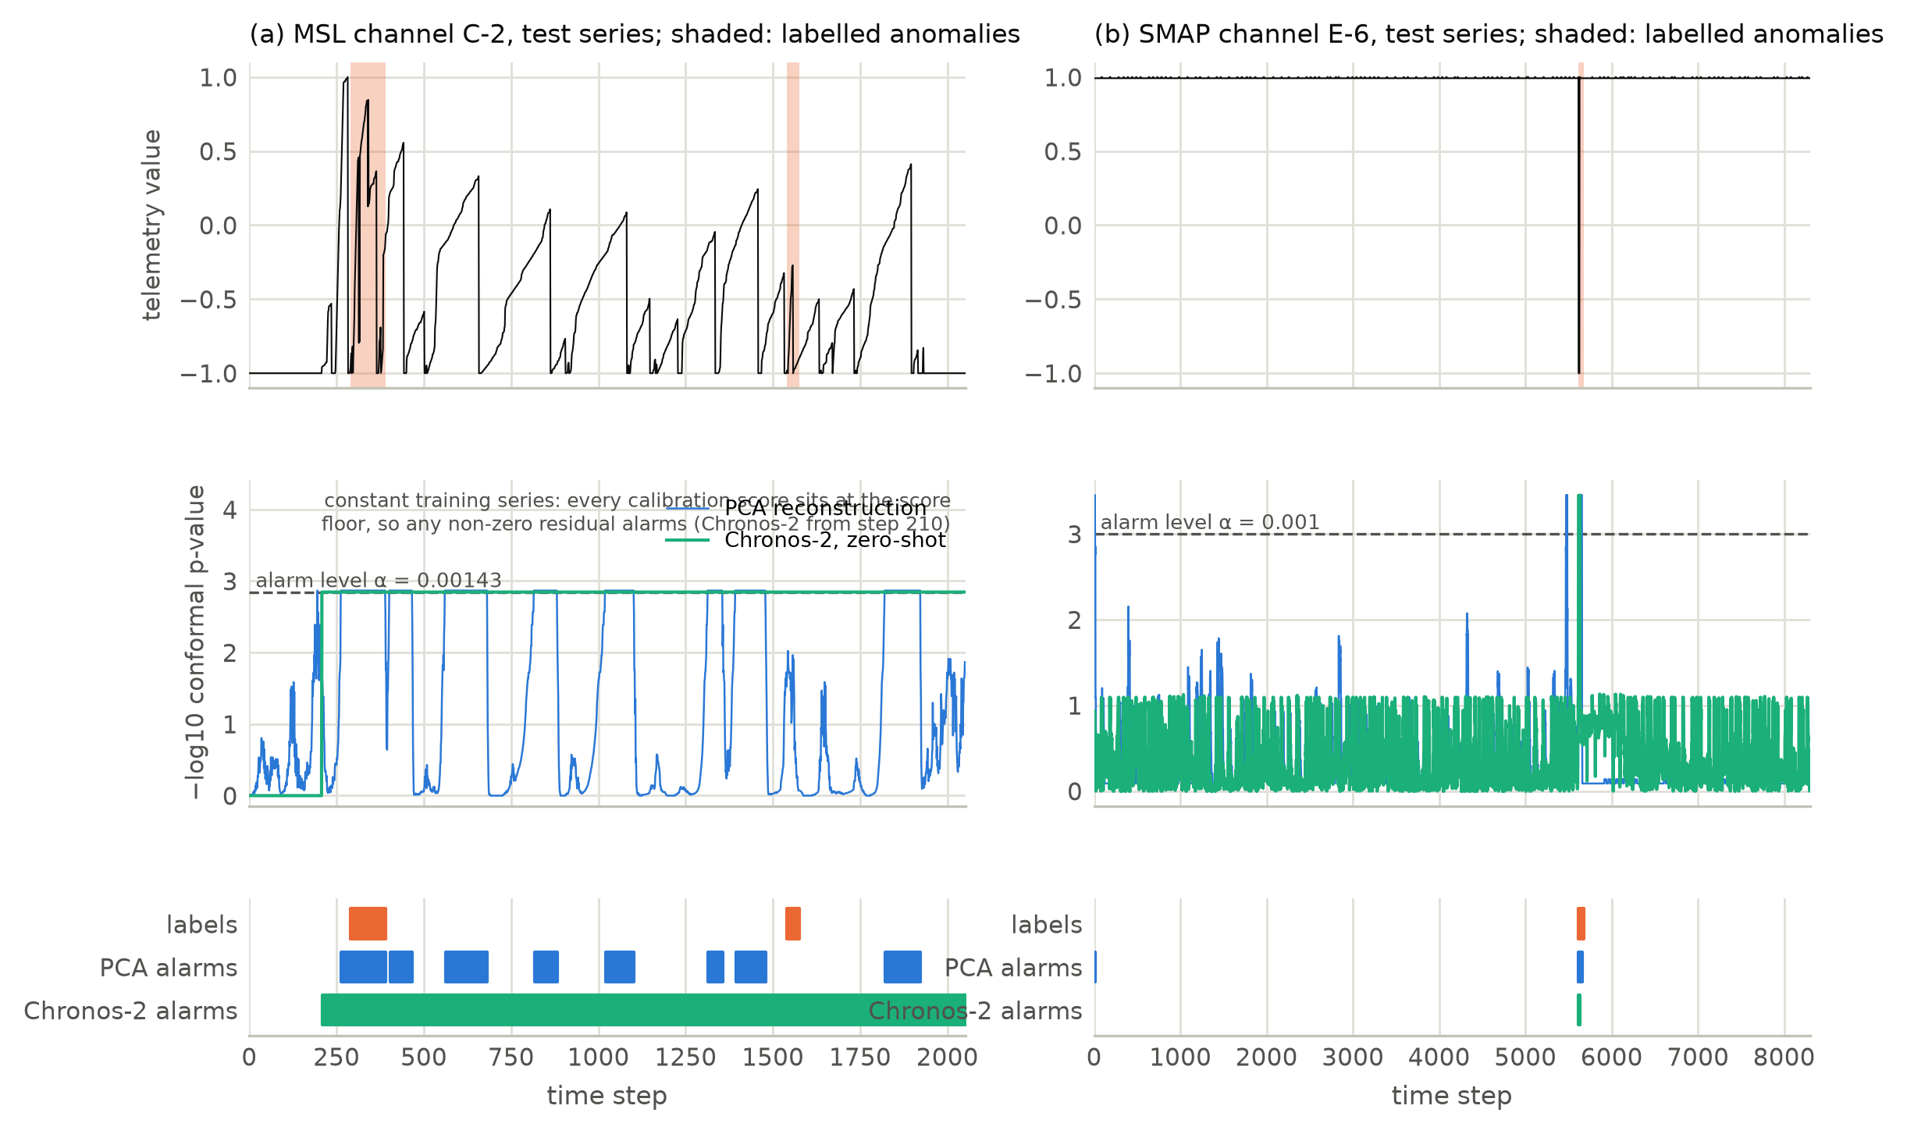
Fig. 11. Health module outputs on the median channel of each spacecraft by zero-shot AUC-PR. Top: test series and labels. Middle: conformal $p$-values with the alarm level. Bottom: labels and each detector’s causal alarms.

12 Ablations and uncertainty evaluation

12.1 Censoring
Any evaluation restricted to objects that have already decayed discards most of the cohort. Table 10 and Figure 12 give the Kaplan–Meier description of both test cohorts, which is model-free and uses the censoring indicator directly.
Table 10. Kaplan–Meier description of the test cohorts. $S(⋅)$ is the estimated survival probability. A median that is “not reached” means more than half the group is still in orbit, so no median lifetime exists for it.
Origin | Group | $n$​ | Decays | Censored | Median (d) | $S$(30 d) | $S$(1 yr) | $S$(5 yr)
2016 | all uncontrolled | 2,993 | 1,594 | 46.7% | 2,780 | 0.895 | 0.768 | 0.558
2016 | fragments | 2,155 | 1,032 | 52.1% | 3,354 | 0.962 | 0.839 | 0.619
2016 | rocket stages | 385 | 250 | 35.1% | 1,050 | 0.789 | 0.617 | 0.415
2016 | components | 453 | 312 | 31.1% | 933 | 0.661 | 0.551 | 0.383
2011 | all uncontrolled | 2,680 | 1,199 | 55.3% | not reached | 0.921 | 0.845 | 0.744
2011 | fragments | 2,078 | 858 | 58.7% | not reached | 0.961 | 0.903 | 0.803
2011 | rocket stages | 267 | 157 | 41.2% | 1,310 | 0.725 | 0.548 | 0.486
2011 | components | 335 | 184 | 45.1% | 3,233 | 0.823 | 0.708 | 0.571
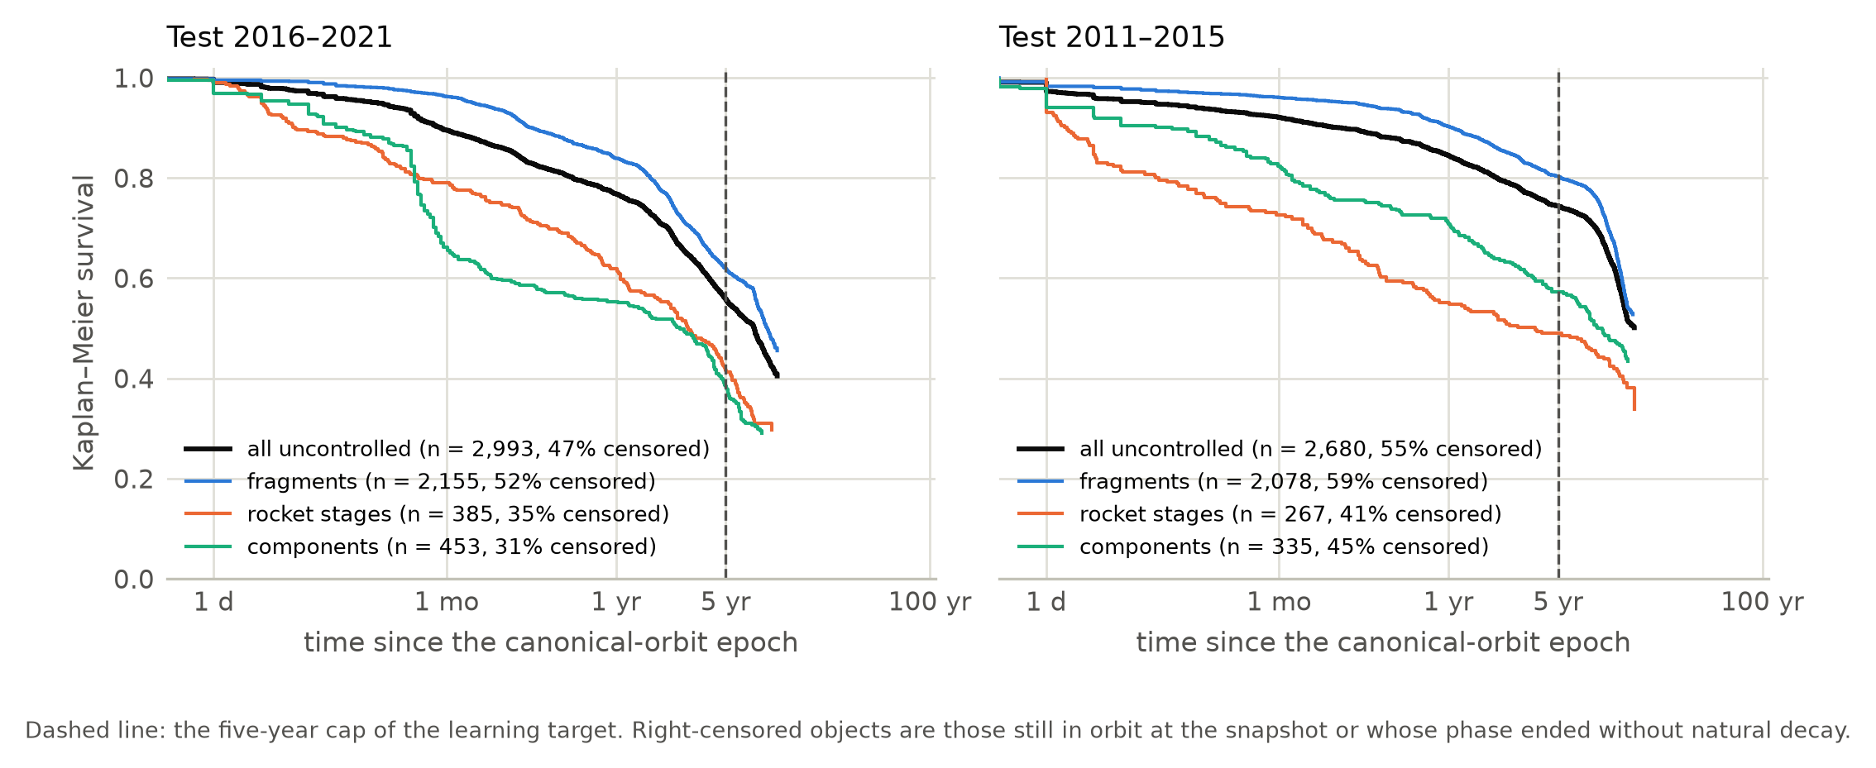
Fig. 12. Kaplan–Meier survival of the test cohorts, overall and by object class, with the censored fraction of each group.
46.7 % of the 2016 cohort and 55.3 % of the 2011 cohort are right-censored. At origin 2011 the median lifetime of the cohort is never reached. Rocket stages and components decay substantially faster than fragments in both periods. This is why the target is capped and scored only where the five-year outcome is known, why the accelerated-failure-time baseline is trained on censored observations as well, and why the comparison in Table 1 against studies that train on decayed objects only is not like-for-like in their favour.

12.2 Feature groups
Removing each feature group from the selected expert and refitting with identical settings and seeds gives the paired effects in Figure 13. The family features are the coupling C1 result reported in Table 2. Design properties help at 2016 (+0.0071, +0.0035 to +0.0121); the physics summaries help the selected expert at 2011 (+0.0022) but hurt at 2016 (-0.0050), which is consistent with the physics prior’s own error growing in the rising phase of the solar cycle. All intervals are nominal and uncorrected for the eight comparisons.
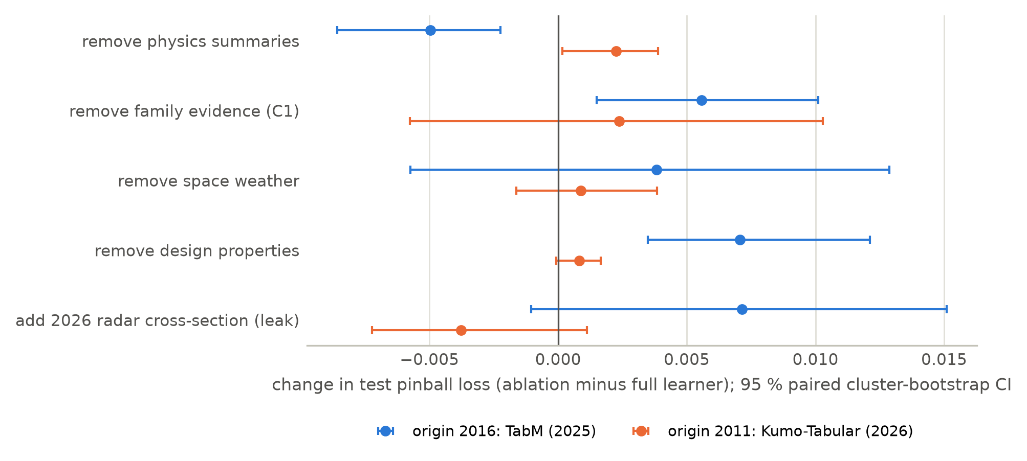
Fig. 13. Feature-group ablations of the selected expert. In the first four rows a group is removed, so a positive change means the group helps; the last row instead adds the leaking covariate, where a positive change means it makes the model worse.

12.3 Leakage through covariate availability
Whether the catalogue publishes a radar cross-section depends on how quickly the object decayed. In the origin-2016 training cohort 75.9 % of objects without a value decayed within 30 days of their canonical-orbit epoch, against 17.2 % of those with one; adjusted for orbit, class and decade, and with standard errors clustered on launch families, the odds ratio is 3.59 (2.09 to 6.17).
The consequence for a modeller is instructive. Adding the covariate changes the test pinball loss by amounts whose intervals include zero at both origins, so point accuracy would not reveal the problem. What it does break is calibration: at origin 2016, where the missingness pattern differs from training, the 90 % coverage of the selected expert falls from 87.7 % to 76.8 %. A covariate that looks like a size measurement is in fact partly an outcome indicator, and the symptom appears in the interval rather than in the mean. We therefore exclude it, and release the availability test with the code.

12.4 Uncertainty quantification
Table 11. Interval rules on both test periods. “Cov. all” is over every test object including those surviving past the five-year cap; “Cov. decayed” is restricted to objects that decayed within five years; width is in $\log_{10}$ days. The first three numeric columns are origin 2016, the last three origin 2011.
Interval rule | Cov. all | Cov. decayed | Width | Cov. all | Cov. decayed | Width
Physics median ±20 % (operational rule) | 0.602 | 0.122 | 0.18 | 0.747 | 0.171 | 0.17
Physics median ±30 % | 0.638 | 0.204 | 0.27 | 0.766 | 0.234 | 0.27
Physics prior, conformal 80 % | 0.738 | 0.419 | 0.35 | 0.944 | 0.805 | 0.65
Physics prior, conformal 90 % | 0.876 | 0.726 | 0.67 | 0.974 | 0.906 | 1.03
Gated median ±20 % | 0.529 | 0.183 | 0.18 | 0.651 | 0.201 | 0.18
Gated median ±30 % | 0.599 | 0.280 | 0.27 | 0.694 | 0.283 | 0.27
Gated mixture, conformal 80 % | 0.717 | 0.543 | 0.43 | 0.923 | 0.776 | 0.88
Gated mixture, conformal 90 % | 0.874 | 0.835 | 0.67 | 0.959 | 0.884 | 1.21
Against the operational practice it would replace, the calibrated interval is a clear improvement on the objects that matter. The ±20 % residual-lifetime window around the physics median — the rule assessed at roughly 90 % coverage in the final days before re-entry (Pardini and Anselmo, 2018) — covers 12.2 % and 17.1 % of objects that decayed within five years when it is applied at canonical-orbit epochs, while the conformal 90 % interval covers 72.6 % and 90.6 %. The comparison is not a criticism of the operational rule, which is designed for a different regime with continuous tracking; it quantifies how far that regime is from forecasting years ahead from one catalogue orbit. Figure 14 places every rule side by side.
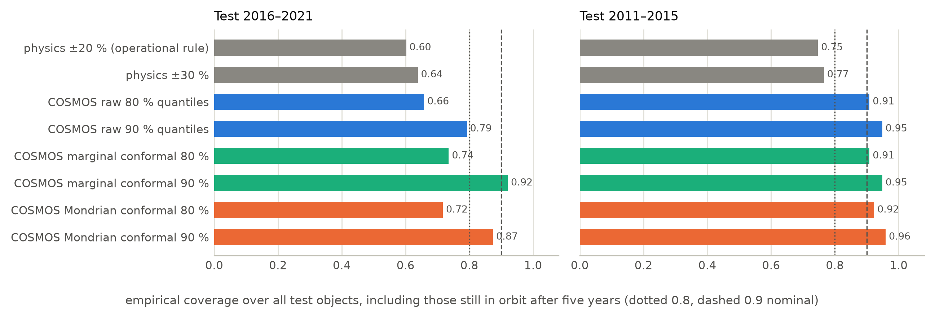
Fig. 14. Interval coverage over all test objects, including those still in orbit after five years.
Conditional coverage. Mondrian grouping is the mechanism intended to make coverage conditional, and Table 11 shows it reaching the nominal level marginally at origin 2011 and falling short at origin 2016 for the arms with the narrowest intervals.
Temporal calibration. Conformal prediction guarantees marginal coverage under exchangeability, and a forward-in-time test period is precisely where exchangeability is doubtful. Table 12 and Figure 15 break the 90 % coverage down by calendar year of the prediction time.
Table 12. Conditional coverage over time. Years with fewer than 25 scored objects are omitted.
Origin | Model | 90 % coverage, first to last test year | First $−$ last
2016 | Reliability-gated mixture | 0.902 · 0.963 · 0.848 · 0.879 · 0.812 · 0.847 | +0.055
2016 | Physics prior only | 0.929 · 0.974 · 0.908 · 0.885 · 0.836 · 0.732 | +0.197
2016 | TabM (2025) | 0.897 · 0.963 · 0.823 · 0.868 · 0.817 · 0.886 | +0.011
2011 | Reliability-gated mixture | 0.978 · 0.974 · 0.929 · 0.930 · 0.957 | +0.021
2011 | Kumo-Tabular (2026) | 0.975 · 0.982 · 0.929 · 0.943 · 0.968 | +0.007
2011 | Physics prior only | 0.980 · 0.980 · 0.965 · 0.957 · 0.978 | +0.002
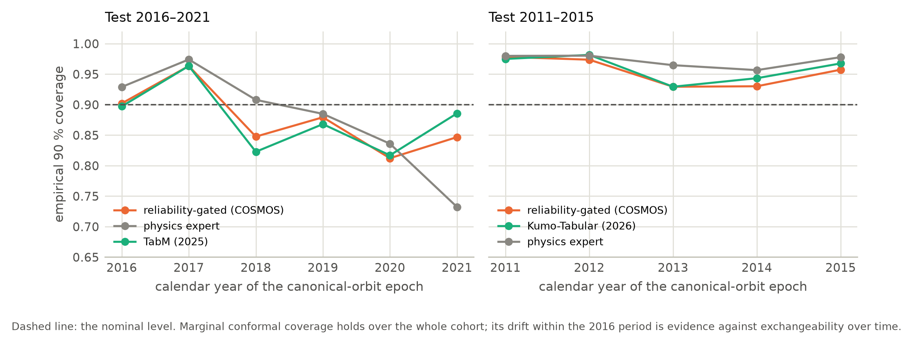
Fig. 15. Coverage by calendar year. The dashed line is the nominal level. Coverage drifts downward across the 2016 test period and is stable across the 2011 period.
At origin 2016 the physics prior’s coverage falls from 0.929 in the first test year to 0.732 in the last, a drop of 0.197, while at origin 2011 it stays between 0.978 and 0.980. The marginal guarantee is kept; what degrades is coverage conditional on time, as the rising phase of solar cycle 25 moves the covariate distribution away from the calibration cohort. To our knowledge this is the first demonstration of the effect on an operational space-surveillance catalogue, and it is a caution for any deployment that calibrates once and then runs for years.

12.5 State estimation for objects in orbit
The lifetime pipeline is fitted at canonical-orbit epochs; applied to objects that have survived for years it over-predicts re-entry by 9.5-fold over a 72-day horizon (6.9 to 13.0), because survival selects low area-to-mass ratios that the fitted model cannot know about. Class priors reduce this to 3.64-fold and conditioning on the catalogue history to 1.37-fold (1.20 to 1.63), still significantly above one. The three variants rank decaying objects almost identically, with AUC-ROC within 0.01 of each other; what differs is calibration, which is the quantity the state-estimation step targets. Figure 16 shows the reliability and the counts.
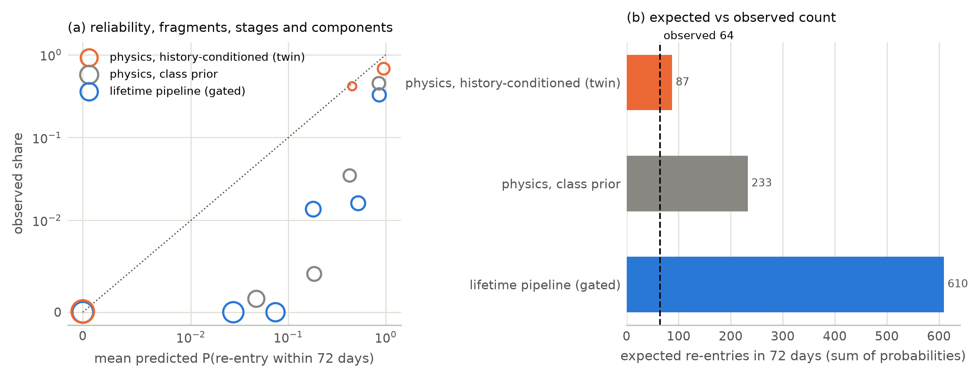
Fig. 16. As-of-date test of the three variants for objects in orbit on 2026-08-16, scored against decays to 2026-10-27. (a) Reliability in six fixed probability bins, marker area growing with the number of objects. (b) Expected against observed re-entries.
This window had been analysed earlier in the project, so this comparison is an as-of-date test rather than a blind one; a dated, hashed forecast released with the code is the blind test, and a later catalogue snapshot will score it.

13 Discussion, limitations and threats to validity

13.1 What the evidence supports
Three claims survive the measurements. First, in-context tabular foundation models transfer to an operational space catalogue: at origin 2016 they reduce pinball loss by 13 % against the best gradient-boosted baseline and by 44 % against the physics prior, with intervals excluding zero, and the same family of models gives significantly the best collision-risk distribution. This is a positive result for in-context learning outside its usual benchmark setting. Second, distribution-free calibration is what makes the output usable: the conformal interval covers a far larger share of decayed objects than the operational window applied at the same horizon, and the Mondrian grouping is what keeps coverage near nominal at the earlier origin. Third, the state estimate matters more than the learner for objects already in orbit, where a Bayesian conditioning step removes most of a ninefold bias that no choice of learner addressed.

13.2 What the evidence does not support
The reliability gate, which is the architectural novelty, does not beat the best single expert at either origin. Table 5 makes this explicit, and we draw three conclusions rather than one. The gate is fitted on out-of-fold predictions of the training period, so it can learn where the physics prior is unreliable but cannot anticipate that a learner will degrade on a future cohort; its descriptors are all properties of the prior. The equal-weight and constant-gate arms show that the benefit of learning the weight at all is small and inconsistent across origins. And the tuning-split variant shows that the fitting protocol dominates the parameterisation. A gate that also saw descriptors of covariate shift is the obvious next step, and it would have to be validated on a third test period rather than on these two.
The honest reading is therefore that reliability gating is a safety mechanism rather than an accuracy mechanism: it prevented the catastrophic arm at each origin (TabM at 2011, the physics prior at 2016) without matching the best one. For an operator who must fix an architecture before knowing which regime the next five years bring, that property has value; for a benchmark table it is a loss.
Two further negative results are reported. Zero-shot time-series forecasting did not beat ridge autoregression on spacecraft telemetry, and on the official collision-risk metric no model beat a baseline that simply repeats the latest risk.

13.3 Threats to validity
Test-set reuse. The test sets were scored more than once during development, the candidate pool was narrowed after an earlier run’s test results were known, and several analyses were added after results had been seen. Section 10 states this and the supplement records it in full. This bounds the comparisons’ confirmatory value; the significance statements should be read as nominal.
Two periods only. Every statement about generalisation rests on two test periods from one catalogue. The direction of the solar-cycle effect is measured, not assumed, but a third period would be needed to establish that the foundation models keep their advantage.
Single orbit per object. The re-entry module predicts from one dated orbit because orbital histories at catalogue scale cannot be redistributed. Operational tools that fit a ballistic coefficient to weeks of tracking data use far more information near re-entry, and our months-to-years forecasts are not comparable with their final-days accuracy.
Priors estimated from catalogue values. The physics prior’s class pools are built from objects that received a radar-derived size, which biases them towards longer-lived objects; the design-data ablation bounds the influence of this.
Telemetry domain. The telemetry benchmarks are real but belong to spacecraft outside the catalogue population, so the health module transfers a method and not a fitted model, and its coupling into the debris modules runs through operational status rather than telemetry. The benchmark’s own metric artefacts, documented in Section 11, mean its absolute scores should not be read as operational detection rates.
Integrator resolution. A step of the decay integrator may not exceed ten days, so for an object whose perigee is already within one kilometre of the re-entry threshold the forecast is reported at the end of that step; two objects in the released forecast have a degenerate interval for this reason. They are within days of re-entry regardless, and no reported comparison depends on them.
Reproducibility. Seeded training on the graphics processor is not bit-reproducible, while on the central processor it is. Repeating the telemetry run moved per-channel AUC-PR by at most $2×{10}^{−5}$ and changed no reported value at three decimals; two runs of the lifetime variant in the as-of-date test gave ratios of 8.9 and 9.5.

14 Conclusions and future work
This paper presented a shared-state digital twin for orbital debris analysis in which a reliability-gated mixture of experts, calibrated by conformal prediction and isotonic regression, forecasts residual orbital lifetime and collision risk, and in which spacecraft health enters through operational status. It was evaluated on 64,516 catalogued objects across two forward-in-time test periods, an official collision-avoidance benchmark and public spacecraft telemetry, with cluster-bootstrap intervals throughout.
The measured findings are:
- In-context tabular foundation models are the most accurate lifetime arms in the later test period, by 13 % against the best gradient-boosted baseline and 44 % against the physics prior, and they give significantly the best collision-risk distribution, 37 % better than persistence. In the earlier period they are statistically tied with the physics prior.
- The reliability gate did not beat the best single expert at either origin. It avoided the worst arm in both, and the fitting protocol mattered more than the gate’s parameterisation.
- Calibrated intervals cover 72.6 % and 90.6 % of decayed objects where the operational ±20 % window applied at the same horizon covers 12.2 % and 17.1 %.
- Conformal coverage conditional on time degrades across a six-year forward test window, falling by 0.197 at origin 2016 while remaining stable at origin 2011.
- Conditioning the area-to-mass ratio on an object’s catalogue history reduces 72-day over-prediction from 9.5-fold to 1.37-fold.
- Of the four couplings, breakup-family evidence helps the learned expert in one of two periods, cloud population is reproduced to about a tenth of a cloud without separating the experts, the status coupling has the expected direction but no significant gain, and the fourth cannot be tested on public data.
- A catalogue covariate can leak the outcome through its availability. Adding it leaves point accuracy unchanged within noise and breaks interval coverage, so leakage of this kind is invisible to a mean-error check.
Future work follows directly from the negative results. The gate should be given descriptors of covariate shift and validated on a third period. The state-estimation step, which produces the largest effect in the paper, is currently Bayesian importance sampling over a physics propagator; replacing it with an amortised neural posterior trained on simulated propagations would make the system’s strongest component a learned one, and we are pursuing that. On the collision-risk side, the gap between the best predictive distribution and the official point metric is a decision-theoretic problem rather than a modelling one, and a learned decision rule over the calibrated probability is the natural next step. Finally, the dated and hashed forecast released with this paper is the only fully blind test of the system, and scoring it against a later catalogue snapshot is the cleanest available validation.

Declarations
Contribution in artificial intelligence and application in engineering. The contribution in artificial intelligence is the reliability-gated mixture of experts with distribution-free calibration described in Section 4, together with the evaluation of recent tabular and time-series foundation models under forward-in-time drift and administrative censoring. The application in engineering is forecasting the low-Earth-orbit debris environment: residual orbital lifetime, collision risk and spacecraft health status.
Credit authorship contribution statement. [Author 1]: conceptualisation, methodology, software, validation, formal analysis, investigation, data curation, writing — original draft, visualisation. [Author 2]: supervision, writing — review and editing. [To be completed by the authors.]
Declaration of competing interest. [To be completed by the authors.]
Funding. [To be completed by the authors.]
Data availability. All data used are public. The catalogue is available under Creative Commons Attribution 4.0 (McDowell, 2020); the CelesTrak catalogue and space-weather files under CelesTrak’s usage policy (Kelso, 2026); the collision-avoidance challenge data under Creative Commons Attribution 4.0 (Uriot et al., 2021); and the telemetry benchmarks under the terms stated by their authors (De Canio et al., 2024; Hundman et al., 2018). The derived cohort table, the density table, all predictions and result files, and the dated forecast will be deposited with a digital object identifier before publication [identifier to be added]. No restricted orbital-element data are used or redistributed. Pretrained weights are obtained from their publishers under their own licences.
Code availability. The code, including data fetchers with checksummed manifests, the three modules, the twin engine and the scripts that generate every table and figure in this paper from the result files, is available ([Author name(s)], 2026); an archived release with a digital object identifier will be created before publication.
Declaration of generative artificial intelligence in the writing process. During the preparation of this work the authors used a generative artificial-intelligence assistant to help write analysis and plotting code and to draft and edit text. The authors reviewed and edited the content and take full responsibility for the published article. Every figure was rendered by the scripts named above from the study’s result files; no figure was generated by a generative model. [The authors must review this statement and adjust it to their actual use.]

References
18th Space Defense Squadron, 2019. Space-track.org user agreement and API documentation.
Acciarini, G., Brown, E., Berger, T., Guhathakurta, M., Parr, J., Bridges, C., Baydin, A.G., 2024. Improving thermospheric density predictions in low-earth orbit with machine learning. Space Weather 22, e2023SW003652. https://doi.org/10.1029/2023SW003652
Acciarini, G., Pinto, F., Letizia, F., Martinez-Heras, J.A., Merz, K., Bridges, C., Baydin, A.G., 2021. Kessler: A machine learning library for spacecraft collision avoidance, in: Flohrer, T., Lemmens, S., Schmitz, F. (Eds.), Proceedings of the 8th European Conference on Space Debris. ESA Space Debris Office, Darmstadt, Germany (virtual). https://conference.sdo.esoc.esa.int/proceedings/sdc8/paper/226
Andaristiyan, M.K., Machmudah, A., Utama, S., Poetro, R.E., Soegiartini, E., 2025. Ballistic coefficient estimation for non-thrustered LEO satellites using historical TLE data, in: 2025 IEEE International Conference on Aerospace Electronics and Remote Sensing Technology (ICARES). IEEE, pp. 1–6. https://doi.org/10.1109/icares67579.2025.11371529
Angelopoulos, A.N., Bates, S., 2023. Conformal prediction: A gentle introduction. Foundations and Trends in Machine Learning 16, 494–591. https://doi.org/10.1561/2200000101
Ansari, A.F., Shchur, O., Küken, J., Auer, A., Han, B., Mercado, P., Rangapuram, S.S., Shen, H., Stella, L., Zhang, X., Goswami, M., Kapoor, S., Maddix, D.C., Guerron, P., Hu, T., Yin, J., Erickson, N., Desai, P.M., Wang, H., Rangwala, H., Karypis, G., Wang, Y., Bohlke-Schneider, M., 2025. Chronos-2: From univariate to universal forecasting. https://arxiv.org/abs/2510.15821
Ansari, A.F., Stella, L., Turkmen, A.C., Zhang, X., Mercado, P., Shen, H., Shchur, O., Rangapuram, S.S., Pineda Arango, S., Kapoor, S., Zschiegner, J., Maddix, D.C., Wang, H., Mahoney, M.W., Torkkola, K., Wilson, A.G., Bohlke-Schneider, M., Wang, B., 2024. Chronos: Learning the language of time series. Trans. Mach. Learn. Res. https://openreview.net/forum?id=gerNCVqqtR
[software] [Author name(s)], 2026. COSMOS-AI: spacecraft telemetry alarm-protocol study code. GitHub, version commit 2525367. https://github.com/AnuSajikumar6264/Cosmos-AI-
Barber, R.F., Candès, E.J., Ramdas, A., Tibshirani, R.J., 2023. Conformal prediction beyond exchangeability. Ann. Stat. 51, 816–845. https://doi.org/10.1214/23-AOS2276
Barnwal, A., Cho, H., Hocking, T., 2022. Survival regression with accelerated failure time model in XGBoost. Journal of Computational and Graphical Statistics 31, 1292–1302. https://doi.org/10.1080/10618600.2022.2067548
Benjamini, Y., Hochberg, Y., 1995. Controlling the false discovery rate: A practical and powerful approach to multiple testing. J. R. Stat. Soc. Ser. B Stat. Methodol. 57, 289–300. https://doi.org/10.1111/j.2517-6161.1995.tb02031.x
Braun, V., Funke, Q., Lemmens, S., Sanvido, S., 2020. DRAMA 3.0 - upgrade of ESA’s debris risk assessment and mitigation analysis tool suite. Journal of Space Safety Engineering 7, 206–212. https://doi.org/10.1016/j.jsse.2020.07.020
Candès, E., Lei, L., Ren, Z., 2023. Conformalized survival analysis. Journal of the Royal Statistical Society Series B: Statistical Methodology 85, 24–45. https://doi.org/10.1093/jrsssb/qkac004
Celletti, A., Pucacco, G., Vartolomei, T., 2021. Reconnecting groups of space debris to their parent body through proper elements. Scientific Reports 11, 22676. https://doi.org/10.1038/s41598-021-02010-x
Chen, T., Guestrin, C., 2016. XGBoost: A scalable tree boosting system, in: Proceedings of the 22nd ACM SIGKDD International Conference on Knowledge Discovery and Data Mining. ACM, pp. 785–794. https://doi.org/10.1145/2939672.2939785
Chu, Q., Wang, Z., Jiang, Y., Hou, P., 2024. Conjunction screening method for cataloged space objects based on GCN model, in: 2024 International Conference on New Trends in Computational Intelligence (NTCI). IEEE, pp. 81–85. https://doi.org/10.1109/NTCI64025.2024.10776423
Chu, Q., Wang, Z., Jiang, Y., Hou, P., Zhao, H., Hua, M., Zhang, P., Yao, D., 2026. Conjunction screening for large-scale resident space objects based on graph neural network. Aerospace Science and Technology 176, 112512. https://doi.org/10.1016/j.ast.2026.112512
[dataset] De Canio, G., Kotowski, K., Haskamp, C., 2024. ESA Anomaly Dataset. Zenodo, version 1.0. https://doi.org/10.5281/zenodo.12528696
Efthymiopoulos, C., Märtens, M., Gaitanas, M., Izzo, D., 2021. Space debris: The origin dataset. https://doi.org/10.5281/zenodo.4986292
EM, A., Stephen, P., Krishnamoorthy, S., ARUL G, B, K., 2026. Physics-gated neural networks for resilient satellite drag correction during geomagnetic storms. https://doi.org/10.5281/zenodo.19217736
Emmert, J.T., Drob, D.P., Picone, J.M., Siskind, D.E., Jones, M., Mlynczak, M.G., Bernath, P.F., Chu, X., Doornbos, E., Funke, B., Goncharenko, L.P., Hervig, M.E., Schwartz, M.J., Sheese, P.E., Vargas, F., Williams, B.P., Yuan, T., 2021. NRLMSIS 2.0: A whole-atmosphere empirical model of temperature and neutral species densities. Earth Space Sci. 8, e2020EA001321. https://doi.org/10.1029/2020EA001321
ESA Space Debris Office, 2026. ESA’s re-entry predictions portal.
European Space Agency, Advanced Concepts Team, 2019. Collision avoidance challenge: Challenge, data, scoring and final results pages (kelvins competition platform). https://kelvins.esa.int/collision-avoidance-challenge/
European Space Agency, Advanced Concepts Team, 2021. Space debris: The origin: Challenge, data, scoring and results pages (kelvins competition platform). https://kelvins.esa.int/space-debris-the-origin/
Frey, S., Colombo, C., Lemmens, S., 2019. Extension of the king-hele orbit contraction method for accurate, semi-analytical propagation of non-circular orbits. Advances in Space Research 64, 1–17. https://doi.org/10.1016/j.asr.2019.03.016
Gibbs, I., Candès, E., 2021. Adaptive conformal inference under distribution shift, in: Advances in Neural Information Processing Systems 34 (NeurIPS 2021). Curran Associates, Inc., pp. 1660–1672. https://proceedings.neurips.cc/paper_files/paper/2021/hash/0d441de75945e5acbc865406fc9a2559-Abstract.html
Gondelach, D.J., Armellin, R., Lidtke, A.A., 2017. Ballistic coefficient estimation for reentry prediction of rocket bodies in eccentric orbits based on TLE data. Mathematical Problems in Engineering 2017, 7309637. https://doi.org/10.1155/2017/7309637
Gorishniy, Y., Kotelnikov, A., Babenko, A., 2025. TabM: Advancing tabular deep learning with parameter-efficient ensembling, in: International Conference on Learning Representations (ICLR). https://arxiv.org/abs/2410.24210
Grinsztajn, L., Oyallon, E., Varoquaux, G., 2022. Why do tree-based models still outperform deep learning on typical tabular data?, in: Advances in Neural Information Processing Systems 35 (NeurIPS 2022). pp. 507–520. https://doi.org/10.52202/068431-0037
Guimarães, M., Soares, C., Manfletti, C., 2023. Taxonomy for resident space objects in LEO: A deep learning approach. https://doi.org/10.48550/arXiv.2311.05430
Harrell, F.E., Califf, R.M., Pryor, D.B., Lee, K.L., Rosati, R.A., 1982. Evaluating the yield of medical tests. JAMA 247, 2543–2546. https://doi.org/10.1001/jama.1982.03320430047030
Hollmann, N., Müller, S., Purucker, L., Krishnakumar, A., Körfer, M., Hoo, S.B., Schirrmeister, R.T., Hutter, F., 2025. Accurate predictions on small data with a tabular foundation model. Nature 637, 319–326. https://doi.org/10.1038/s41586-024-08328-6
Hundman, K., Constantinou, V., Laporte, C., Colwell, I., Soderstrom, T., 2018. Detecting spacecraft anomalies using LSTMs and nonparametric dynamic thresholding, in: Proceedings of the 24th ACM SIGKDD International Conference on Knowledge Discovery & Data Mining. ACM, pp. 387–395. https://doi.org/10.1145/3219819.3219845
Johnson, N.L., Krisko, P.H., Liou, J.-C., Anz-Meador, P.D., 2001. NASA’s new breakup model of EVOLVE 4.0. Advances in Space Research 28, 1377–1384. https://doi.org/10.1016/S0273-1177(01)00423-9
Jung, O., Seong, J., Jung, Y., Bang, H., 2021. Recurrent neural network model to predict re-entry trajectories of uncontrolled space objects. Advances in Space Research 68, 2515–2529. https://doi.org/10.1016/j.asr.2021.04.041
Ke, G., Meng, Q., Finley, T., Wang, T., Chen, W., Ma, W., Ye, Q., Liu, T.-Y., 2017. LightGBM: A highly efficient gradient boosting decision tree, in: Advances in Neural Information Processing Systems 30. https://proceedings.neurips.cc/paper/2017/hash/6449f44a102fde848669bdd9eb6b76fa-Abstract.html
Kelso, T.S., 2026. SATCAT format documentation and CelesTrak usage policy.
Kessler, D.J., Cour-Palais, B.G., 1978. Collision frequency of artificial satellites: The creation of a debris belt. Journal of Geophysical Research: Space Physics 83, 2637–2646. https://doi.org/10.1029/ja083ia06p02637
Kim, S., Choi, K., Choi, H.-S., Lee, B., Yoon, S., 2022. Towards a rigorous evaluation of time-series anomaly detection. Proc. AAAI Conf. Artif. Intell. 36, 7194–7201. https://doi.org/10.1609/aaai.v36i7.20680
King-Hele, D., 1987. Satellite orbits in an atmosphere: Theory and applications. Blackie.
Klinkrad, H., 1991. DISCOS – ESA’s database and information system characterising objects in space. Advances in Space Research 11, 43–52. https://doi.org/10.1016/0273-1177(91)90541-Q
Kotowski, K., Haskamp, C., Andrzejewski, J., Ruszczak, B., Nalepa, J., Lakey, D., Collins, P., Martínez-Heras, J., De Canio, G., 2026. European Space Agency dataset and benchmark for real-world anomaly detection in spacecraft time series. Journal of Data-centric Machine Learning Research 3, 1–76. https://data.mlr.press/assets/pdf/v03-23.pdf
Lakshminarayanan, B., Pritzel, A., Blundell, C., 2017. Simple and scalable predictive uncertainty estimation using deep ensembles, in: Advances in Neural Information Processing Systems 30 (NIPS 2017). Curran Associates, Inc. https://proceedings.neurips.cc/paper_files/paper/2017/file/9ef2ed4b7fd2c810847ffa5fa85bce38-Paper.pdf
Laxhammar, R., Falkman, G., 2010. Conformal prediction for distribution-independent anomaly detection in streaming vessel data, in: Proceedings of the First International Workshop on Novel Data Stream Pattern Mining Techniques. ACM, pp. 47–55. https://doi.org/10.1145/1833280.1833287
Laxhammar, R., Falkman, G., 2015. Inductive conformal anomaly detection for sequential detection of anomalous sub-trajectories. Ann. Math. Artif. Intell. 74, 67–94. https://doi.org/10.1007/s10472-013-9381-7
Li, T., Li, Y., Lan, S., Ren, L., 2023. A method of using back propagation neural network to estimate orbital lifetime of LEO satellites. Advances in Space Research 72, 1961–1969. https://doi.org/10.1016/j.asr.2023.05.026
Licata, R.J., Mehta, P.M., 2022. Uncertainty quantification techniques for data-driven space weather modeling: Thermospheric density application. Scientific Reports 12, 7256. https://doi.org/10.1038/s41598-022-11049-3
Licata, R.J., Mehta, P.M., Tobiska, W.K., Huzurbazar, S., 2022a. Machine-learned HASDM thermospheric mass density model with uncertainty quantification. Space Weather 20, e2021SW002915. https://doi.org/10.1029/2021SW002915
Licata, R.J., Mehta, P.M., Weimer, D.R., Tobiska, W.K., Yoshii, J., 2022b. MSIS-UQ: Calibrated and enhanced NRLMSIS 2.0 model with uncertainty quantification. Space Weather 20, e2022SW003267. https://doi.org/10.1029/2022SW003267
Lichtendahl, K.C., Grushka-Cockayne, Y., Winkler, R.L., 2013. Is it better to average probabilities or quantiles? Manag. Sci. 59, 1594–1611. https://doi.org/10.1287/mnsc.1120.1667
Lidtke, A.A., Gondelach, D.J., Armellin, R., 2019. Optimising filtering of two-line element sets to increase re-entry prediction accuracy for GTO objects. Advances in Space Research 63, 1289–1317. https://doi.org/10.1016/j.asr.2018.10.018
Liu, W., Wu, M., Wan, G., Xu, M., 2024. Digital twin of space environment: Development, challenges, applications, and future outlook. Remote Sensing 16, 3023. https://doi.org/10.3390/rs16163023
Lotti, A., Modenini, D., Tortora, P., 2025. Exploring physics-informed neural networks for orbital lifetime estimation, in: 11th European Conference for Aeronautics and Space Sciences (EUCASS 2025). EUCASS. https://doi.org/10.13009/EUCASS2025-698
McDowell, J.C., 2020. General catalog of artificial space objects. https://planet4589.org/space/gcat
McDowell, J.C., 2022. Historical TLE orbital elements.
NVIDIA, 2026. Kumo tabular: A pretrained tabular foundation model. https://huggingface.co/nvidia/Kumo-Tabular
Operti, A., Braun, V., Lemmens, S., Corpino, S., 2017. Assessing uncertainties in the estimation of the orbital lifetime, in: Proceedings of the 7th European Conference on Space Debris. ESA Space Debris Office, Darmstadt, Germany. https://conference.sdo.esoc.esa.int/proceedings/sdc7/paper/1042
Paparrizos, J., Kang, Y., Boniol, P., Tsay, R.S., Palpanas, T., Franklin, M.J., 2022. TSB-UAD: An end-to-end benchmark suite for univariate time-series anomaly detection. Proc. VLDB Endow. 15, 1697–1711. https://doi.org/10.14778/3529337.3529354
Pardini, C., Anselmo, L., 2004. On the accuracy of satellite reentry predictions. Advances in Space Research 34, 1038–1043. https://doi.org/10.1016/j.asr.2003.01.010
Pardini, C., Anselmo, L., 2008. Impact of the time span selected to calibrate the ballistic parameter on spacecraft re-entry predictions. Advances in Space Research 41, 1100–1114. https://doi.org/10.1016/j.asr.2007.11.013
Pardini, C., Anselmo, L., 2018. Assessing the risk and the uncertainty affecting the uncontrolled re-entry of manmade space objects. Journal of Space Safety Engineering 5, 46–62. https://doi.org/10.1016/j.jsse.2018.01.003
Pardini, C., Moe, K., Anselmo, L., 2012. Thermospheric density model biases at the 23rd sunspot maximum. Planetary and Space Science 67, 130–146. https://doi.org/10.1016/j.pss.2012.03.004
Peng, H., Bai, X., 2020. Machine learning approach to improve satellite orbit prediction accuracy using publicly available data. The Journal of the Astronautical Sciences 67, 762–793. https://doi.org/10.1007/s40295-019-00158-3
Prokhorenkova, L., Gusev, G., Vorobev, A., Dorogush, A.V., Gulin, A., 2018. CatBoost: Unbiased boosting with categorical features, in: Advances in Neural Information Processing Systems 31. https://proceedings.neurips.cc/paper/2018/hash/14491b756b3a51daac41c24863285549-Abstract.html
Qu, J., Holzmüller, D., Varoquaux, G., Le Morvan, M., 2025. TabICL: A tabular foundation model for in-context learning on large data. arXiv preprint arXiv:2502.05564. https://doi.org/10.48550/arXiv.2502.05564
Qu, J., Holzmüller, D., Varoquaux, G., Le Morvan, M., 2026. TabICLv2: A better, faster, scalable, and open tabular foundation model. arXiv preprint arXiv:2602.11139. https://doi.org/10.48550/arXiv.2602.11139
Romano, Y., Patterson, E., Candès, E., 2019. Conformalized quantile regression, in: Advances in Neural Information Processing Systems 32 (NeurIPS 2019). Curran Associates, Inc. https://proceedings.neurips.cc/paper_files/paper/2019/file/5103c3584b063c431bd1268e9b5e76fb-Paper.pdf
Ruszczak, B., Kotowski, K., Evans, D., Nalepa, J., 2025. The OPS-SAT benchmark for detecting anomalies in satellite telemetry. Sci. Data 12, 710. https://doi.org/10.1038/s41597-025-05035-3
Salmaso, F., Trisolini, M., Colombo, C., 2023. A machine learning and feature engineering approach for the prediction of the uncontrolled re-entry of space objects. Aerospace 10, 297. https://doi.org/10.3390/aerospace10030297
Sang, J., Bennett, J.C., Smith, C.H., 2013. Estimation of ballistic coefficients of low altitude debris objects from historical two line elements. Advances in Space Research 52, 117–124. https://doi.org/10.1016/j.asr.2013.03.010
Schmidl, S., Wenig, P., Papenbrock, T., 2022. Anomaly detection in time series: A comprehensive evaluation. Proc. VLDB Endow. 15, 1779–1797. https://doi.org/10.14778/3538598.3538602
Sehili, M.E.A., Zhang, Z., 2024. Multivariate time series anomaly detection: Fancy algorithms and flawed evaluation methodology, in: Nambiar, R., Poess, M. (Eds.), Performance Evaluation and Benchmarking. TPCTC 2023, Lecture Notes in Computer Science. Springer, Cham, pp. 1–17. https://doi.org/10.1007/978-3-031-68031-1_1
Shambaugh, S., 2026. Validation of satellite lifetime predictions at Leonid Space. https://doi.org/10.48550/arXiv.2601.02453
Stevenson, E., Rodriguez-Fernandez, V., Urrutxua, H., 2022. Towards graph-based machine learning for conjunction assessment, in: AMOS 2022 Technical Papers. AMOS Conference. https://doi.org/10.64861/wcsg6194
Tatbul, N., Lee, T.J., Zdonik, S., Alam, M., Gottschlich, J., 2018. Precision and recall for time series, in: Bengio, S., Wallach, H., Larochelle, H., Grauman, K., Cesa-Bianchi, N., Garnett, R. (Eds.), Advances in Neural Information Processing Systems 31 (NeurIPS 2018). Curran Associates, Inc., pp. 1920–1930. https://proceedings.neurips.cc/paper_files/paper/2018/hash/8f468c873a32bb0619eaeb2050ba45d1-Abstract.html
Tulczyjew, Ł., Myller, M., Kawulok, M., Kostrzewa, D., Nalepa, J., 2021. Predicting risk of satellite collisions using machine learning. Journal of Space Safety Engineering 8, 339–344. https://doi.org/10.1016/j.jsse.2021.09.001
Uriot, T., Izzo, D., Martinez-Heras, J., Letizia, F., Siminski, J., Merz, K., 2021. Collision avoidance challenge dataset. https://doi.org/10.5281/zenodo.4463683
Uriot, T., Izzo, D., Simões, L.F., Abay, R., Einecke, N., Rebhan, S., Martinez-Heras, J., Letizia, F., Siminski, J., Merz, K., 2022. Spacecraft collision avoidance challenge: Design and results of a machine learning competition. Astrodynamics 6, 121–140. https://doi.org/10.1007/s42064-021-0101-5
Vazquez, N., 2026. Is the latest message still the best forecast? A pre-registered re-evaluation of machine learning for satellite collision risk. https://doi.org/10.5281/zenodo.23457856
Vovk, V., Gammerman, A., Shafer, G., 2005. Algorithmic learning in a random world. Springer, New York. https://doi.org/10.1007/b106715
Wu, D., Rosengren, A.J., 2023. An investigation on space debris of unknown origin using proper elements and neural networks. Celestial Mechanics and Dynamical Astronomy 135, 44. https://doi.org/10.1007/s10569-023-10157-0
Wu, R., Keogh, E., 2021. Current time series anomaly detection benchmarks are flawed and are creating the illusion of progress. IEEE Trans. Knowl. Data Eng. https://doi.org/10.1109/TKDE.2021.3112126
Xu, X., Wen, H., Wang, Y., Song, H., Liu, T., Chang, S.-Y., 2025. Digital-twin-based satellite orbit prediction for Internet of Things systems. IEEE Internet of Things Journal 12, 6431–6444. https://doi.org/10.1109/JIOT.2024.3424672

