AI Powered Complaint Management System

Author: Anushree S ,
anusrinivas2292005@gmail.com
School of CSE,
Presidency university,Banglore,
Karnataka.

Abstract
Background: Traditional complaint management systems are manual, time-consuming, and prone to human errors, as complaints must be read and categorized individually. This leads to delays and inefficiencies in handling large volumes of user complaints.
Method: This project proposes an AI-powered complaint management system that automates complaint classification using machine learning techniques. The system applies Natural Language Processing (NLP) with TF-IDF vectorization and Logistic Regression to analyze complaint text. It is implemented as a full-stack web application using Flask for backend processing, HTML, CSS, and JavaScript for frontend interaction, and SQLite for data storage. Additionally, SMTP is used for automated email notifications.
Results: The system effectively classifies complaints into appropriate categories with improved accuracy, significantly reducing manual effort and response time. It provides a scalable and efficient solution for managing large volumes of complaints and enhances overall system performance.
Keywords: Complaint Management, Machine Learning, Natural Language Processing, TF-IDF, Logistic Regression, Flask, Full Stack Development

1.Introduction
In today’s digital era, organizations receive a large number of customer complaints through various platforms such as websites, emails, and applications. Efficient handling of these complaints is essential for maintaining customer satisfaction and improving service quality. However, traditional complaint management systems rely heavily on manual processing, where complaints are read, analyzed, and categorized by human operators. This approach is time-consuming, inefficient, and prone to errors, especially when dealing with large volumes of data.
With the advancement of artificial intelligence and machine learning, there is a growing need to automate such processes to improve efficiency and accuracy. Natural Language Processing (NLP), a subfield of artificial intelligence, enables machines to understand and analyze textual data. By applying NLP techniques, complaint texts can be automatically processed and categorized without human intervention.
This project presents an AI-powered complaint management system that integrates machine learning with full-stack web development. The system is designed to automatically classify user complaints into predefined categories using a Logistic Regression model combined with TF-IDF vectorization. The application is developed using Flask as the backend framework, while HTML, CSS, and JavaScript are used for building an interactive frontend. SQLite is used as the database to store complaint data, and SMTP is integrated to send automated email notifications to relevant departments.
The proposed system not only reduces manual effort but also improves response time and ensures scalability. It provides a user-friendly interface for complaint submission and management, along with analytical dashboards for monitoring system performance. By automating the complaint handling process, the system enhances efficiency, accuracy, and overall user experience.

2. Literature Review

Recent advancements in machine learning and natural language processing (NLP) have significantly improved the automation of complaint management systems. Various research works have explored different techniques for text classification, sentiment analysis, and intelligent decision-making in customer service applications.
In [1], the authors presented a comprehensive survey on machine learning approaches for text classification, highlighting the effectiveness of algorithms such as Naïve Bayes, Support Vector Machines (SVM), and Logistic Regression. The study emphasizes that traditional algorithms combined with feature extraction techniques like TF-IDF can achieve high accuracy in classifying textual data. However, the model performance heavily depends on the quality and size of the dataset.
In [2], a deep learning-based approach using Recurrent Neural Networks (RNN) and Long Short-Term Memory (LSTM) was proposed for handling customer complaints. The model demonstrated improved accuracy in capturing contextual information from text compared to traditional methods. Despite better performance, the approach requires large datasets and high computational resources, making it less suitable for lightweight applications.
In [3], the researchers focused on sentiment analysis for complaint prioritization. By analyzing the emotional tone of complaints, the system assigns priority levels to ensure urgent issues are handled first. While this improves response efficiency, it does not fully address the problem of automatic categorization.
In [4], a hybrid approach combining machine learning and rule-based systems was introduced for complaint classification. The system achieved good accuracy but lacked scalability due to its dependence on predefined rules, which require frequent updates.
In [5], a study on web-based complaint management systems highlighted the importance of integrating backend processing with user-friendly frontend interfaces. The system improved accessibility and usability but did not include intelligent automation features.
In [6], researchers applied TF-IDF vectorization with Logistic Regression for text classification tasks and reported efficient performance with lower computational complexity. This approach is widely adopted due to its simplicity and effectiveness in handling structured text data.
In [7], reinforcement learning techniques were explored for adaptive complaint handling systems. The model learns from user interactions to improve decision-making over time. However, such approaches are complex to implement and require continuous training.
In [8], an automated email-based complaint system was proposed, which integrates SMTP for communication. While it improves notification efficiency, it lacks intelligent classification capabilities.
In [9], cloud-based complaint management solutions were developed to handle large-scale data. These systems provide scalability but introduce challenges related to security and data privacy.
In [10], recent studies have explored transformer-based models such as BERT for text classification. These models achieve state-of-the-art performance but require significant computational resources and are not suitable for lightweight applications.

3. Suggested Approach
A. System Overview
The proposed system is an AI-powered complaint management system developed to automate the classification and handling of user complaints. It integrates machine learning techniques with full-stack web development to provide an efficient and scalable solution. The system allows users to submit complaints through a web interface, which are then automatically analyzed and categorized using a trained machine learning model. By eliminating manual intervention, the system reduces processing time, improves accuracy, and enhances overall efficiency in complaint management.
B. System Architecture
The system architecture is designed using a multi-layered approach that includes frontend, backend, machine learning, and database components. The frontend is developed using HTML, CSS, and JavaScript, providing a responsive and user-friendly interface for users to submit and track complaints. The backend is implemented using Python and the Flask framework, which handles request processing, routing, and communication between components. The machine learning module is integrated into the backend and is responsible for analyzing complaint text and predicting categories. The database layer uses SQLite to store complaint details such as category, status, department, and timestamps. Additionally, an email notification system using SMTP ensures that relevant departments are informed about newly assigned complaints in real time..
D. Methodology
The methodology of the proposed system involves multiple stages, starting with preprocessing of input data and ending with complaint classification. When a user submits a complaint, the input text is first preprocessed by converting it to lowercase, removing stop words, eliminating special characters, and performing tokenization. This step ensures that the text is clean and suitable for analysis.
Following preprocessing, the system applies TF-IDF (Term Frequency–Inverse Document Frequency) vectorization to transform the textual data into numerical form. This technique assigns weights to words based on their importance and frequency, allowing the system to represent text as feature vectors.
These feature vectors are then passed to a Logistic Regression model, which is trained to classify complaints into predefined categories. Logistic Regression is chosen due to its efficiency and effectiveness in text classification tasks. The model predicts the category of the complaint based on learned patterns, enabling automatic routing of complaints to the appropriate department.
E. Workflow
The overall workflow of the system begins with the user submitting a complaint through the frontend interface. The complaint data is sent to the backend, where it undergoes preprocessing and feature extraction. The processed data is then passed to the machine learning model, which classifies the complaint into a specific category. Once classified, the complaint is stored in the database along with relevant details. The system then assigns the complaint to the corresponding department and sends an automated email notification using SMTP. Finally, the complaint is displayed on the dashboard, where administrators can monitor and manage its status. This end-to-end workflow ensures efficient and automated complaint handling from input to resolution.
F.Tools and Technologies used
Layer | Technologies
Backend | Flask, Python
Frontend | HTML, CSS, JavaScript, Chart.js
Database | SQLite
ML | Scikit-learn, Joblib
Email | SMTP

The system is built using a combination of modern web and machine learning technologies. The frontend technologies ensure an interactive user interface, while Flask and Python provide a flexible backend environment. Scikit-learn is used to develop the machine learning model, and Joblib is used for efficient model storage and loading. SQLite serves as a lightweight database, and SMTP enables automated email communication

4. System Modules
A. Dashboard
The dashboard module provides a comprehensive overview of the system performance and complaint statistics. It serves as the main interface for administrators to monitor the status of complaints in real time. The dashboard displays key metrics such as total complaints, number of completed and pending cases, and average response time. It also includes graphical visualizations such as pie charts, bar graphs, and line charts to represent complaint categories, departmental distribution, and trends over time. These visualizations are implemented using Chart.js, enabling interactive and dynamic data representation that supports better decision-making.
B. Complaint Classification
The complaint classification module is responsible for analyzing user-submitted complaints and assigning them to appropriate categories. Users enter their complaints in text format through the frontend interface. This data is sent to the backend, where it is processed using natural language processing techniques. The machine learning model, trained using TF-IDF vectorization and Logistic Regression, predicts the category of the complaint based on its content. This automated classification ensures accurate categorization and reduces the need for manual intervention, enabling faster processing of complaints.
C. Case Management
The case management module handles the complete lifecycle of complaints within the system. It provides a structured view of all complaints in a tabular format, including details such as complaint ID, category, assigned department, and current status. The module supports operations for creating, viewing, updating, and deleting complaint records, thereby implementing full CRUD functionality. It also includes filtering options based on status and department, allowing administrators to efficiently manage and track complaints throughout their lifecycle.
D. Department Management
The department management module is used to register and manage different departments within the system. Each department is associated with specific complaint categories and is assigned an email address for communication. When a complaint is classified, the system automatically routes it to the relevant department based on its category. The integration of SMTP enables the system to send automated email notifications to departments whenever a new complaint is assigned, ensuring timely response and efficient coordination.
E. Case Details
The case details module provides a detailed view of individual complaints. When a specific case is selected, the system displays comprehensive information including the complaint text, predicted category, assigned department, status, and timestamps. This detailed view allows administrators to understand the context of the complaint and take appropriate action. The module enhances transparency and ensures that all relevant information is easily accessible for effective complaint resolution.

5. Results and Analysis
A. System Interface and Visualization
The developed system provides an interactive and user-friendly interface for managing complaints. The frontend is designed using HTML, CSS, and JavaScript, ensuring smooth navigation and responsiveness. The dashboard displays key metrics such as total complaints, pending and completed cases, and average response time. It also includes graphical representations such as pie charts, bar graphs, and line charts implemented using Chart.js to visualize complaint categories, departmental distribution, and trends over time.
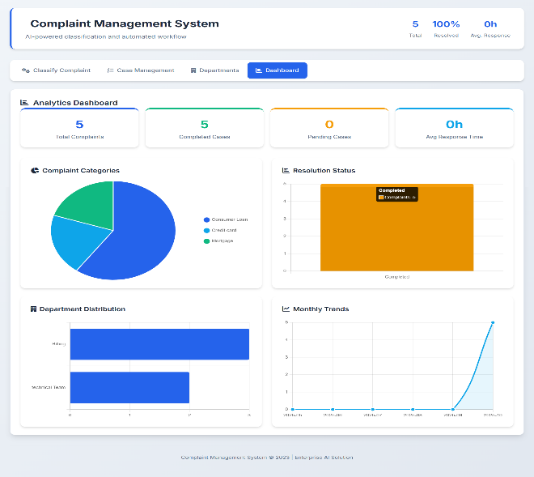
Fig. 1. Dashboard showing complaint statistics and charts
B. Complaint Classification Output
The complaint classification module allows users to enter complaint text and receive predicted categories instantly. The system processes the input using a machine learning model and assigns it to the appropriate department. This automation reduces manual effort and ensures faster processing.
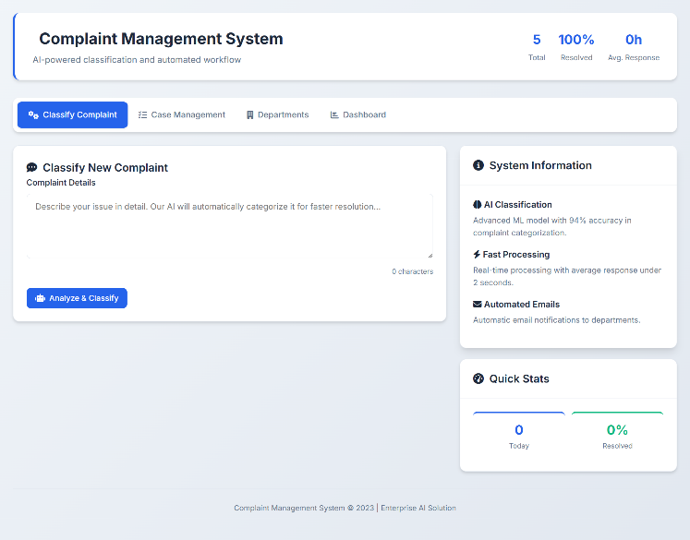
Fig. 2. Complaint classification interface with prediction result
C. Case Management System
The case management module displays all complaints in a structured table format, including details such as complaint ID, category, department, and status. It supports full CRUD operations, allowing administrators to efficiently manage complaints. Filtering options further enhance usability by enabling quick access to specific records.
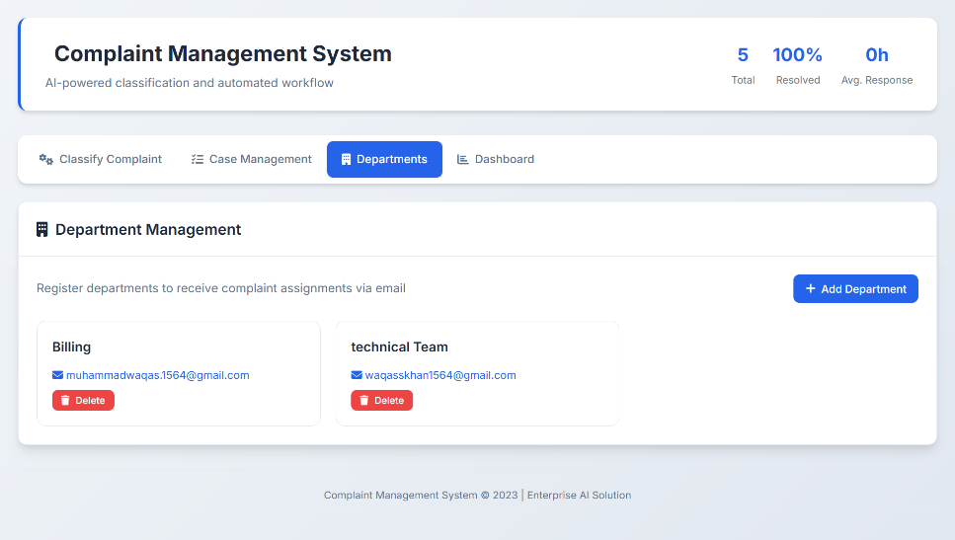
Fig. 3. Case management interface showing complaint records
D. Department and Notification System
The system includes a department management module where departments are registered along with their email addresses. Once a complaint is classified, it is automatically assigned to the respective department, and an email notification is sent using SMTP. This ensures timely communication and faster resolution.
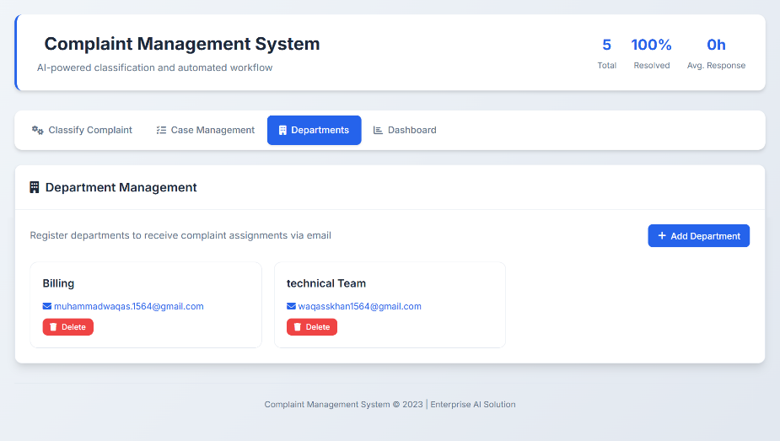
Fig. 4. Department management and email notification system
E. System Performance and Improvements
The system demonstrates significant improvements over traditional complaint management approaches. Automated classification reduces processing time and eliminates human errors, while real-time dashboard updates provide better monitoring capabilities. The integration of machine learning with full-stack development ensures scalability and efficient handling of large volumes of complaints. Overall, the system enhances accuracy, speed, and user experience.

5.Discussion
A. Effectiveness of the Proposed System
The proposed AI-powered complaint management system demonstrates significant improvements in handling and processing user complaints compared to traditional approaches. By integrating machine learning techniques with a full-stack web application, the system is able to automatically classify complaints based on their textual content. This automation reduces dependency on manual intervention and ensures consistent and accurate categorization. The use of TF-IDF vectorization and Logistic Regression provides reliable performance for text classification tasks, making the system efficient for real-time applications.
B. Comparison with Traditional Systems
Traditional complaint management systems rely heavily on manual processing, where human operators are responsible for reading, understanding, and categorizing complaints. This approach is time-consuming, prone to human error, and inefficient when dealing with large volumes of data. In contrast, the proposed system automates the entire process, enabling instant classification and routing of complaints to the appropriate departments. This not only reduces processing time but also minimizes errors associated with manual handling. Additionally, the inclusion of a real-time dashboard and visualization tools enhances monitoring and decision-making, which is often lacking in conventional systems.
C. Overall Impact and Improvements
The integration of machine learning with full-stack development results in a scalable and user-friendly system that can handle a large number of complaints efficiently. The automated email notification feature ensures timely communication with departments, further improving response time. The system also enhances transparency by providing detailed views of complaint status and progress. Overall, the proposed solution offers a more efficient, accurate, and scalable alternative to existing complaint management methods, making it suitable for modern organizational needs.

6.Research Gap
A. Limitations of Existing Systems
Existing complaint management systems largely depend on manual processing or basic rule-based approaches, which are inefficient when handling large volumes of data. These systems require human intervention to read and categorize complaints, leading to increased processing time and a higher probability of errors. Additionally, many traditional systems lack proper data analytics and visualization capabilities, making it difficult for administrators to monitor trends and system performance. Even in systems that incorporate advanced machine learning or deep learning techniques, the models are often computationally expensive, complex to implement, and not suitable for real-time full-stack applications. Furthermore, most existing solutions do not provide seamless integration between frontend interfaces, backend processing, and automated notification systems.
B. Need for the Proposed System
The identified limitations highlight the need for an efficient, automated, and scalable complaint management system. The proposed system addresses these gaps by integrating machine learning with a full-stack web application to enable real-time complaint classification and processing. By using lightweight and efficient techniques such as TF-IDF vectorization and Logistic Regression, the system achieves accurate classification without high computational overhead. The inclusion of a user-friendly frontend, real-time dashboard, and automated email notification system further enhances usability and responsiveness. Therefore, the proposed solution provides a practical and effective approach to modernizing complaint management systems, making them faster, more reliable, and suitable for real-world applications.

7. Advantages and Limitations
A. Advantages
The proposed AI-powered complaint management system offers several advantages over traditional approaches. By automating the classification of complaints using machine learning techniques, the system significantly reduces the need for manual intervention, thereby minimizing human effort and errors. The integration of TF-IDF vectorization and Logistic Regression enables efficient and accurate text classification, making the system suitable for real-time applications. The full-stack implementation ensures a seamless user experience, with an interactive frontend and a robust backend for processing and data management. Additionally, the use of a dashboard with graphical visualizations allows administrators to monitor complaint trends and system performance effectively. The automated email notification feature further enhances responsiveness by ensuring that complaints are immediately communicated to the relevant departments. Overall, the system is scalable and capable of handling large volumes of complaints efficiently.
B. Limitations
Despite its advantages, the proposed system has certain limitations. The performance of the machine learning model depends heavily on the quality and quantity of the training data, which may affect classification accuracy in some cases. The system is limited to predefined categories, which may not fully capture complex or ambiguous complaints. Additionally, while Logistic Regression is efficient, it may not perform as well as advanced deep learning models for highly complex text analysis tasks. The system currently supports a single language, which restricts its applicability in multilingual environments. Furthermore, the reliance on internet connectivity and backend processing may introduce delays in low-network conditions. These limitations indicate areas for improvement in future enhancements.

8. Future Work
The proposed system can be further enhanced by incorporating advanced machine learning and deep learning techniques to improve classification accuracy. Models such as Recurrent Neural Networks (RNN), Long Short-Term Memory (LSTM), or transformer-based models like BERT can be used to better understand complex and contextual complaint data. The system can also be extended to support multiple languages, enabling it to handle complaints from diverse user groups. Integration of a chatbot can provide real-time interaction and instant responses to users, further improving user experience. Additionally, deploying the system as a mobile application can increase accessibility and usability. Future improvements may also include integrating cloud-based databases and scalable architectures to handle very large datasets efficiently. These enhancements would make the system more robust, intelligent, and adaptable to real-world scenarios.

9. Conclusion
In this project, an AI-powered complaint management system has been successfully developed by integrating machine learning techniques with full-stack web technologies. The system automates the process of complaint classification using TF-IDF vectorization and Logistic Regression, reducing manual effort and improving efficiency. The use of Flask for backend development and HTML, CSS, and JavaScript for frontend design ensures a seamless and interactive user experience. SQLite is utilized for efficient data storage, while SMTP enables automated email notifications for timely communication.
The results demonstrate that the system effectively classifies complaints and provides real-time updates through an interactive dashboard. Compared to traditional manual systems, the proposed solution offers faster processing, improved accuracy, and better scalability. Overall, the project highlights the potential of combining machine learning with web development to create intelligent and efficient solutions for real-world problems.
10.Project Repository / Deployment Link
The complete implementation of the proposed AI-powered complaint management system is available in the following GitHub repository. The repository includes the source code, frontend interface, backend implementation, and machine learning model integration.
Repository Link:
https://github.com/AnuSrinivas22/AI-powered-complaint-management-system
The project can be cloned and executed locally for testing and further development. The repository provides all necessary files and configurations required to run the application.

