A Deep Learning-Based Real-Time System for American Sign Language Recognition

Author: Subashree S, Anushree S , Fakhruddin Basha,
subashree092005@gmail.com, anusrinivas2292005@gmail.com , School of CSE,
School of CSE, School of CSE, Presidency university,Banglore,
Presidency university,Banglore, Presidency university,Banglore, Karnataka.
Karnataka. Karnataka.

Abstract
Background
Daily communication of people with hearing loss and others usually had been difficult. American Sign Language (ASL) is needed for communication, and advances in deep learning and computer vision make it feasible to develop automatic sign detection as a means of universal communication. However, the background noises, different hand position errors, and various lighting conditions are some of the challenges to make an accurate model for more types of gestures of this kind. Conventional approaches often do not perform well for high accuracy and high speed at the same time, resulting in delays or misclassification.

Method
To address these problems, we combine MobileNetV2 and transfer learning for capturing informative and discriminative gesture representations. The model is fine-tuned by unfreezing the last 80 layers and using data augmentation (rotation, zoom, brightness) to make it more robust. Moreover, two optimization techniques label smoothing, EarlyStopping and ReduceLROnPlateau are applied to avoid overfitting and for proper learning during the training.

Result
The suggested system showed good classification capacity and stability with a validation accuracy of 95.17%. Better generalization across a variety of gesture variants was achieved by combining optimized MobileNetV2 with efficient regularization. Additionally, a live webcam interface is connected with the trained model to enable real-time ASL gesture identification, offering a quick, precise, and inclusive tool to help the hearing-impaired community communicate on a daily basis.

Keywords: Deep learning, MobileNetV2, transfer learning, gesture recognition, real-time prediction, image classification, and American Sign Language (ASL)

1.Introduction
Although communication is essential to human connection, those who have speech or hearing problems frequently struggle to express themselves. To help close this gap, the hearing-impaired community relies heavily on American Sign Language (ASL) as a communication tool. However, accessibility and inclusion in daily communication are limited because the majority of people are not familiar with sign language. Automated ASL recognition systems that can convert gestures into text or speech in real time are being developed as a solution to this problem[1].

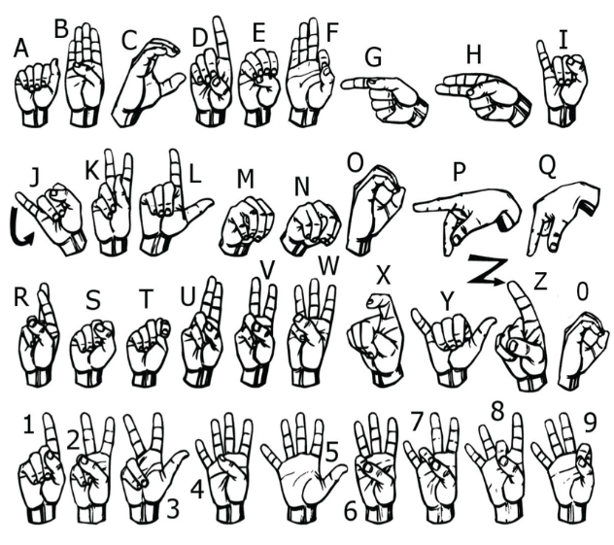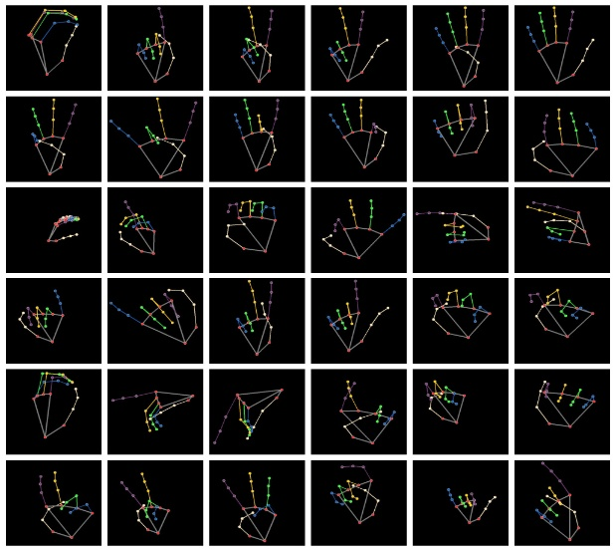
Fig.1 Hand Type: Original ASL movements in RGB pictures. Fig.2 Node Type: Visualization of hand landmarks using MediaPipe.

Different hand forms, orientations, and motions that correspond to English alphabets and words are used to create ASL gestures. Sample ASL hand gestures from the dataset are displayed in [2]Fig.1(A-Z followed by 0-9), demonstrating the visual variety of movements used to train the machine. The system captures the geometric structure of the hand using node-based representations in addition to the raw hand gesture photos. As seen in Fig. 2(0-9 followed by A-Z), these node features, which were produced using MediaPipe landmarks, pinpoint 21 important locations on the hand. The model is better equipped to learn both visual and structural information from gestures because to the combination of hand type and node type data.
Recent advances in computer vision and deep learning have enabled highly accurate automatic recognition of such motions. Convolutional Neural Networks (CNNs) are perfect for gesture identification applications since they have demonstrated efficacy in learning visual patterns. Recognition performance is still impacted by issues including uneven datasets, complicated backgrounds, different lighting conditions, and camera angles.

In order to overcome these obstacles, this study makes use of transfer learning with MobileNetV2, a small and effective model that has already been trained on ImageNet. To enhance the stability and avoid overfitting, the model is refined using a lot of data augmentation and improved using method such as label smoothing, EarlyStopping, and ReduceLROnPlateau.then we connected the trained model to a live camera interface, enabling live ASL gesture prediction with a 95.17% validation accuracy. This system provides a quick, accurate, and comprehensive way for hearing-impaired individuals to communicate [3].

2. Literature Review

2.1Traditional Methods for Recognizing Sign Language
American Sign Language (ASL) gesture recognition has traditionally depended on conventional machine learning methods. Earlier ASL recognition systems utilized handcrafted features such as shape descriptors, Histogram of Oriented Gradients (HOG), and optical flow, combined with algorithms like Support Vector Machines (SVMs) and Hidden Markov Models (HMMs).Though these methods achieved good results in controlled environments, they encountered certain challenges to handle complex backgrounds, live video input, and changes in illumination[4].

2.2 Deep Learning Techniques
Convolutional Neural Networks (CNNs) and other deep learning methods have been popularly used in ASL recognition due to their ability overcome the drawbacks of traditional techniques. Instead of depending on manual designing of features, CNNs automatically extract layered visual features from images. Pre-trained architectures including VGG, ResNet, and MobileNetV2 make transfer learning possible through the knowledge gained from large datasets like ImageNet to be fine-tuned for ASL recognition tasks.In comparison with earlier methods, this approch offers improved recognition accuracy and faster training [5].

2.3 Interfaces Based on Keypoint and Node
In addition to RGB images, modern studies highlights the use of node-based hand motion representations. The hand’s skeletal structure can be signified by hand landmarks that can be obtained through the use of frameworks such as MediaPipe, which remain stable under different lighting conditions, backgrounds, and skin tones studies have shown that integrating node-based representations with raw RGB hand images enhances recognition performance, especially for fine-grained or ambiguous movements by enhancing both motion and shape understanding[6].

2.4 Data Augmentation and Training Methods
Effective training procedures are required for ASL recognition models to reduce overfitting and improve their ability generalization. In handle imbalance in the dataset, widely used data augmentation method include rotation, zooming, translation, brightness variation, horizontal flipping, and the application of class weights. Additionally, optimization techniques such as ReduceLROnPlateau, EarlyStopping, and label smoothing boost the model performance on previously unseen data and maintain training stability [7].

2.5 Real-Time Gesture Recognition
To be effective in real-time scenarios, ASL recognition systems require fast processing capabilities for successful deployment in real-world environments. To address this scenarios, lightweight CNN architectures such as MobileNetV2 are preferred as they balance high accuracy with low computational cost. On Integration with webcam or video input, these models ensure efficient and user-friendly real-time ASL recognition [8].

2.6 Insufficient Research and Incentives
Despite recent advancements, many existing ASL recognition approaches are still computationally demanding or depend solely on RGB images. There is a need for a lightweight, transfer learning–based system in order to achieve both high accuracy and real-time performance, while combining RGB hand features with landmark-based structural information. To address this gap, the proposed project presents a robust and efficient ASL gesture recognition system. [9].

3. Suggested Approach
To achieve higher accuracy and system robustness, the proposed system combines hand-type inputs (RGB images) with node-type inputs (MediaPipe keypoints) for ASL gesture recognition.The overall pipeline includes six main phases: data collection, preprocessing, feature extraction, model training, performance evaluation, and real-time prediction[10].

3.1 Gathering Data
The dataset has multiple classes of ASL gesture images ,each corresponding to a different alphabet. We focus on two different categories of data :
Hand Type: Original ASL movements in RGB pictures( Fig.1)[2].
MediaPipe-based hand landmark representations were taken from these pictures as the Node Type (Fig. 2)[1].

3.2 Preparing Data
Every image has been scaled to 224 x 224 pixels and adjusted to fall between 0 and 1. Rotation, zooming, flipping, brightness modification, translation, and other data augmentation techniques are used to prevent overfitting and enhance dataset diversity [11].

3.3 The Extraction of Features
Essential visual patterns from ASL motions are extracted using the MobileNetV2 model, which was pretrained on the ImageNet dataset. While the top layers are fine-tuned to learn gesture-specific properties, the lower convolutional layers are frozen to maintain general image features like borders and textures. Even with sparse data, this transfer learning technique enhances accuracy and cuts down on training time. In order to properly adapt to ASL visual patterns, the model reuses pre-trained weights. This aids in achieving good classification performance and improved feature representation [12].

3.4Architecture of the Model
(fig.6)The MobileNetV2 model serves as the feature extraction backbone of the proposed American Sign Language (ASL) recognition system's architecture, which is constructed utilizing a transfer learning methodology. Google created MobileNetV2, a small and effective convolutional neural network intended for embedded and mobile vision applications. It is appropriate for real-time gesture detection jobs because it offers a good balance between accuracy and processing cost [13].
Pretrained ImageNet weights are initially put into the MobileNetV2 base model, enabling the system to take advantage of features acquired on a sizable and varied dataset. Low-level features like edges, corners, and shapes that are typical of many image types, including ASL hand movements, can be detected by these pretrained layers. To avoid these generic visual aspects from being changed during early training, the basic model layers are first frozen. The underlying model's final 80 layers are unfrozen to enable fine-tuning once the top layers have been trained, guaranteeing that the model successfully picks up gesture-specific patterns[14].
To enhance the classification capabilities, extra layers are built on top of the MobileNetV2 core. The Global Average Pooling layer reduces feature map dimensions without loosing important information By reducing the number of parameters, this step helps to improve generalization and prevent overfitting. A Dense layer with 256 ReLU-activated neurons is added after the pooling layer in order to detect and recognize even minor changes in hand gestures.
To increase model robustness, a Dropout layer with a rate of 0.3 to 0.5 is added ,which randomly disables certain neurons during training to reduce overfitting ,thereby reducing the model dependence on any one feature. For accurate multi-class gesture recognition, with Softmax activation the final Dense layer generates probability distributions across all ASL alphabet classes. [15].
The architecture of the network is designed to provide both high accuracy and computational efficiency. By utilizing MobileNetV2’s depthwise separable convolutions, the model can be deployed in real time on low-end devices, as these convolutions reduce both the model size and computational load without noticeably affecting performance.

Parameter | Value
Input image size | 224 × 224 × 3
Batch size | 32
Optimizer | Adam
Learning rate | 0.001 (Phase 1), 0.0001 (Phase 2)
Loss function | Categorical Cross-Entropy with Label Smoothing
Epochs | 20 (Phase 1) + 30 (Phase 2)
Dropout | 0.3 – 0.5
Validation split | 20%
Callbacks | EarlyStopping, ReduceLROnPlateau

Table.1 Model Training Hyperparameters

The model is trained using the Adam optimizer ,which efficiently handles sparse gradients with an adaptive learning rate. Since the task involves multi-class classification, the categorical cross-entropy loss function is applied, while label smoothing is applied to prevent overconfident predictions[16].

During training, regularization techniques such as EarlyStopping and ReduceLROnPlateau are applied.When model performance plateaus, ReduceLROnPlateau adjusts the learning rate downward to enhance convergence, whereas EarlyStopping stops training when validation loss shows no improvement, avoiding overfitting[17].
Achieving a validation accuracy of 95.17%, this combination of techniques ensures a robust and efficient network design .By effectively learning both hand-type(RGB images) and node-type ((MediaPipe keypoints))features, supporting strong generalization across varying lighting conditions, hand orientations, and backgrounds[18].
The table below provide insight into the model’s training configuration and architecture. The primary hyperparameters employed in training such as learning rate, batch size, optimizer, and number of epochs are listed in Table 1.They are selected to achieve optimal results with minimal overfitting.

Layer type | Output shape | Parameters
Input layer | (224,224,3) | 0
MobileNetV2(Base) | (7,7,1280) | (2,257,984)
Global average pooling | (1280) | 0
Dense(ReLu) | (256) | (327,936)
Dropout | (256) | 0
Dense (softmax) | (36) | 9,252
Total parameters | --- | 2,595,172

Table 2: CNN Model Architecture Synopsis
The whole architecture is designed to be fast, scalable, and accurate, allowing real-time execution on standard computing devices. Its lightweight design ensures that the system can be deployed even on devices with limited computational resources. With the combination of MobileNetV2’s optimized layers and effective training strategies, the model is capable of recognizing complex ASL gestures and generate accurate predictions in real-time testing.

3.5 Training Models
The most important stage of developing an American Sign Language (ASL) recognition model is training, which ens.ures that the system effectively differentiates between different hand gestures. Base training and fine-tuning are the two major steps of the model's training process MobileNetV2's unique dense layers are learned to adapt to ASL-specific actions during base training, whereas the previously trained convolutional layers remain inactive to preserve broad visual features. Certain deeper layers are unfrozen during the fine-tuning stage, which enhances the model's recognition for minimal moves. The model uses the Adam optimizer because of its reliable convergence and adaptive learning rate. To ensure gradual and stable optimization, the learning rate is set to 0.001 for the base training phase and decreased to 0.0001 during fine-tuning. Since the job involves multi-class classification, the categorical cross-entropy loss function is employed, and label smoothing is utilized to reduce overconfidence in predictions and increase learning stability. The dataset is subjected to data augmentation techniques as rotation, flipping, scaling, and brightness fluctuation in order to increase resilience. This improves the model's ability to generalize to unknown hand orientations and illumination conditions while also increasing the diversity of the data. Because the dataset is split into 80% training and 20% validation, the generalization performance of the model can be properly monitored. EarlyStopping and ReduceLROnPlateau callbacks are used to avoid overfitting. EarlyStopping prevents over-optimization and saves computing time by stopping training as soon as the validation loss stops getting better. When the validation accuracy reaches a plateau, ReduceLROnPlateau dynamically reduces the learning rate, allowing for smaller weight updates in subsequent epochs for improved convergence.
The training accuracy curve for the base training phase is depicted in Fig. 3(a), and it consistently shows an upward trend as the model gains proficiency in gesture classification. The training and validation loss curves are shown in Fig. 3(b), which shows little overfitting over epochs and steady convergence. Figures 4(a) and 4(b) demonstrate that the model attains even greater accuracy and smoother loss reduction when comparing the fine-tuning phase results to the initial training. Collectively, these results highlight the effectiveness of adaptive learning rate scheduling and fine-tuning in enhancing model performance [20].Across successive training epochs, the model shows continuous improvement in both accuracy and loss metrics. The gradual rise in validation accuracy shows the model’s strong ability to generalize to new gesture samples.
After completing both training phases ,results indicate that the model reaches a strong final validation accuracy of 95.17% [21].The overall integration of transfer learning, adaptive optimization, and progressive fine-tuning enables efficient training allows the model to train effectively while reducing the risk of overfitting. The performance visualizations in Figs. 3 and 4 clearly offer the insights to model’s progression throughout training, highlighting the stability and dependability of the developed ASL recognition model.

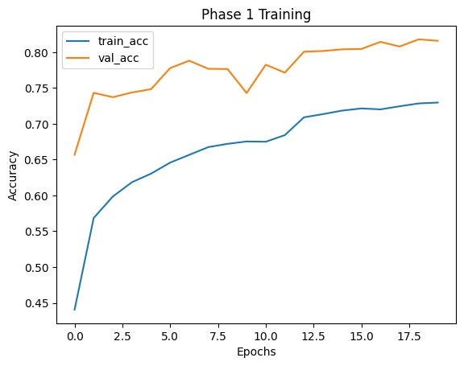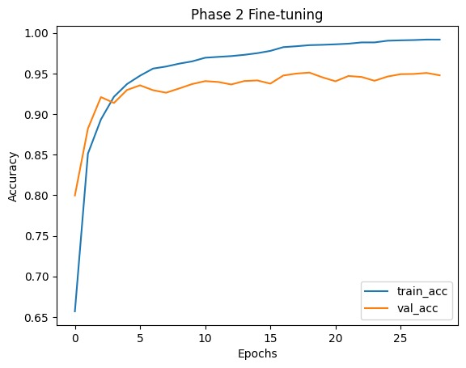
Fig.3:Base model of Training Fig.4:Base model of Fine-tuning
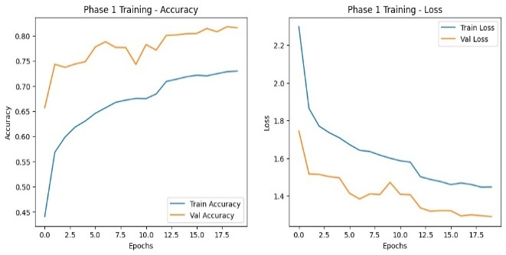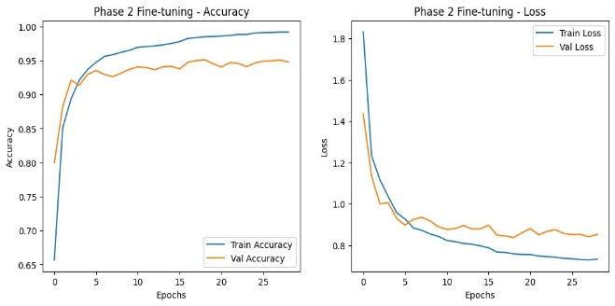

Fig.3(a):Base model of Training Accuracy curve Fig.4(a):Base model of Fine-tuning Accuracy curve
Fig.3(b): Base model of Training Loss curve Fig.4(b): Base model of Fine-tuning Loss curve

3.6 Assessment and Experiments
The performance of the proposed model in gesture recognition was examined by the validation dataset. The model's 95.17% validation accuracy shown high performance in classification. The training and fine-tuning performance graphs (Figures 3 and 4) illustrate continuous convergence with effective learning with stable accuracy enhancements and loss decreases across several epochs. The confusion matrix (Figure 5), which provides in-depth description of predictions that were successfully and improperly assigned across all gesture classes, shows that the majority of signs have been identified correctly. Overall, the evaluation's outcomes validate the performance and reliability of the recommended ASL recognition model for real-time gesture detection [22].
The enhanced MobileNetV2 model showed acceptable generalization, minimizing overfitting and retaining trustworthy validation results.The label smoothing approach made training easier and improved classification on related gesture classes.Also, by removing useless epochs, the EarlyStopping and ReduceLROnPlateau callbacks enhanced the learning time. The model showed robustness in real-world scenarios by adapting to changes in backdrop, hand direction, and light levels. Overall, the results reveal that the recommended approach achieves high accuracy, efficiency, and versatility, which qualifies it for use in real-time ASL recognition systems.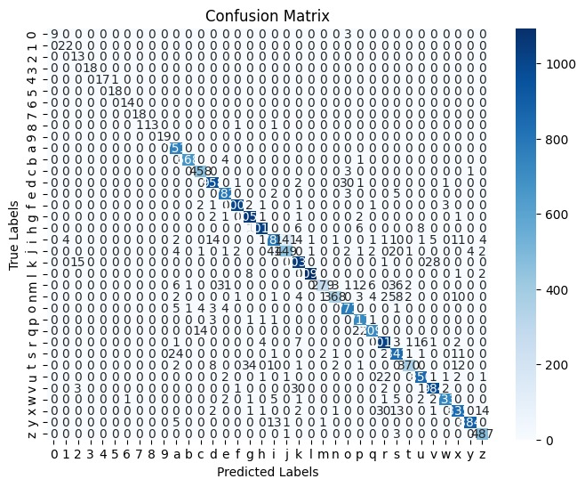
Fig.5 The ASL Gesture Classification Model's Confusion Matrix

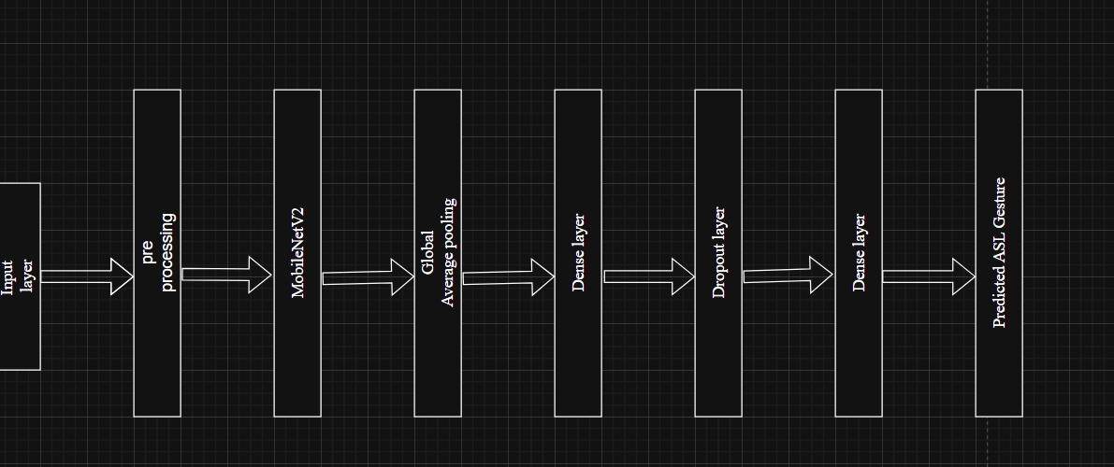
Fig.6: The proposed ASL gesture recognition model's architecture

3.7 Forecasting in Real Time
To validate the real-world usability of the proposed ASL recognition model, a live prediction system was developed using the trained MobileNetV2 model. The system captures video input from a camera, frames preprocessed, and then classified by the model in real time .Preprocessing involves scaling frames to 224×224 pixels, standardizing pixel intensity values and applying any necessary modifications to match the format of the training dataset. A region of interest (ROI) is established on the webcam frame during real time testing to capture hand gestures. During live testing the model performs real-time ASL alphabet prediction, for each frame and the predicted label along with its confidence score is displayed directly on the video output. Users can now observe the model’s predictions in real time ,offering clear evidence of its effectiveness. The combination of high accuracy and low latency in the real-time system confirm the model’s capability for immediate gesture recognition with low computational overhead. The model can perform gesture recognitions even under different hand orientations and lighting scenarios, the model achieves accurate predictions, reflecting the model’s durability and capacity to generalize across varying conditions.
Figure 7 [22] represents a sample output of the real-time ASL prediction system, with the model accurately predicting the corresponding ASL letters based on the hand motion captured by the webcam. This demonstrates that the trained model is useful for real-world applications as well as being successful in offline testing, offering the community of hearing and speech-impaired people a dependable communication tool [23].

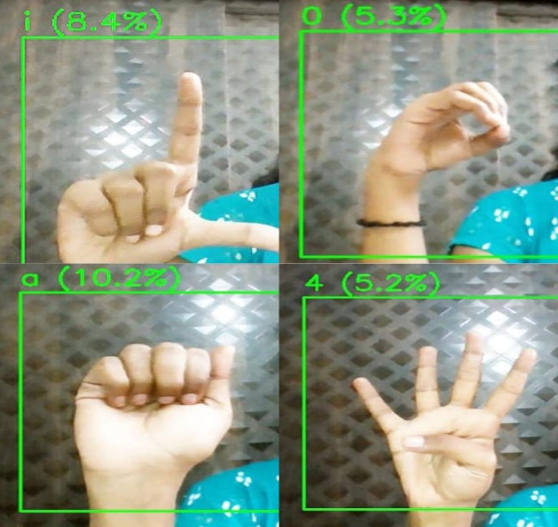
Fig.7: An Example of Real-Time ASL Gestures Prediction Output

3.8 Findings and Analysis
Both quantitative and qualitative tests of the suggested ASL recognition system yielded very encouraging results. The model's remarkable ability to accurately classify complicated hand motions is demonstrated by its 95.17% overall validation accuracy. As seen in Figures 3 and 4, accuracy and loss values both gradually rose during the training and fine-tuning stages, suggesting that the model successfully learnt pertinent gesture elements without experiencing appreciable overfitting. With very few misclassifications between visually identical signs, the confusion matrix (Figure 5) demonstrates that the majority of gesture classes were correctly predicted. These slight errors emerge from varying angles and lighting or from hand forms that overlap. The model's strong performance throughout all group showed its generalizability and durability in the face of these challenges. The usage of MobileNetV2 with transfer learning reduced learning time and computational cost drastically while enhancing accuracy when compared to usual CNN models that were constructed from scratch. Enriching the data by using methods like rotation, zoom, and brightness change boosted the model's capacity to generalize the unfamiliar samples.
The system was viewed as ideal for real-world interaction purposes since it displayed minimal latency in real-time gesture recognition by using the camera during real-world testing. Finally, the results demonstrate that the proposed system provides a flexible, accurate, and efficient way to detect American Sign Language (ASL) gestures, improving accessibility for the deaf and hearing impaired individuals.

4. Conclusion
This project developed a real-time American Sign Language (ASL) recognition system employed a MobileNetV2-based CNN with transfer learning. The model achieved successful training across 36 gesture classes with a validation accuracy of 95.17%, reflecting its high proficiency in recognizing static hand movements. By combining data augmentation, class weighting, and fine-tuning of deeper layers, allowed the model to achieve reliable performance and strong generalization across diverse hand orientations, lighting conditions, and individual user differences .During real-time testing with webcam input, the system confirmed low latency and ability to provide immediate gesture predictions. The observed accuracy and loss curves, along with the confusion matrix, confirm the model’s strong performance and robustness for real-world use.
These results show the proposed system, which provides an interesting and user-friendly approach,could be a valuable tool to help individuals with hearing or speech challenges communicate. The model may be enhanced in subsequent research to support dynamic gestures and gesture sequences, integrate embedded or mobile deployment, and include multi-user situations for additional applications. As a whole, the proposed approach shows that MobileNetV2 for transfer learning is an efficient and powerful approach to create exact and immediate ASL recognition systems[24].

5.Reference
[1]Yan Zhang, Gunther Notni, 3D geometric features based real-time American sign language recognition using PointNet and MLP with MediaPipe hand skeleton detection, Measurement: Sensors, https://doi.org/10.1016/j.measen.2024.101697.

[2]Chong, Teak-Wei & Lee, Boon Giin. (2018). American Sign Language Recognition Using Leap Motion Controller with Machine Learning Approach. Sensors. 18. 3554. 10.3390/s18103554.

[3]Bader Alsharif, Easa Alalwany, Mohammad Ilyas, Transfer learning with YOLOV8 for real-time recognition system of American Sign Language Alphabet, Franklin Open,Volume 8,2024,100165,ISSN 2773-1863,https://doi.org/10.1016/j.fraope.2024.100165.

[4]Pranjal Gogoi, B. Karsh, R.K. Karsh, R.H. Laskar, M.K. Bhuyan,Vision-Based Real-Time Gesture-to-Speech Translation for Sign Language,Procedia Computer Science,Volume 258,2025,Pages 2050-2059,ISSN 1877-0509,
https://doi.org/10.1016/j.procs.2025.04.455.

[5]Sai Niketh Koyineni, Gurram Kumar Sai, Kalwa Anvesh, T Anjali,Silent Expressions Unveiled: Deep Learning for British and American Sign Language Detection,Procedia Computer Science,Volume 233,2024,Pages 269-278,
ISSN 1877-0509, https://doi.org/10.1016/j.procs.2024.03.216.

[6]A. S. M. Miah, M. A. M. Hasan, S. Nishimura and J. Shin, "Sign Language Recognition Using Graph and General Deep Neural Network Based on Large Scale Dataset," in IEEE Access, vol. 12, pp. 34553-34569, 2024, doi: 10.1109/ACCESS.2024.3372425

[7] IVA Adjunct '25: Adjunct Proceedings of the 25th ACM International Conference on Intelligent Virtual Agents
Article No.: 7, Pages 1 – 10 https://doi.org/10.1145/3742886.3756723

[8]https://doi.org/10.3991/ijoe.v17i01.18585 Dhanashree Bendarkar, Pratiksha Somase, Preety Rebari (*), Renuka Paturkar, Arjumand Khan Government College of Engineering, Aurangabad, Maharashtra

[9]Jyotishman Bora, Saine Dehingia, Abhijit Boruah, Anuraag Anuj Chetia, Dikhit Gogoi, Real-time Assamese Sign Language Recognition using MediaPipe and Deep Learning, Procedia Computer Science, https://doi.org/10.1016/j.procs.2023.01.117.

[10]M. Taskiran, M. Killioglu and N. Kahraman, "A Real-Time System for Recognition of American Sign Language by using Deep Learning," 2018 41st International Conference on Telecommunications and Signal Processing (TSP), Athens, Greece, 2018, pp. 1-5, doi: 10.1109/TSP.2018.8441304.

[11]Mohammedali, A. H., Abbas, H. H., & Shahadi, H. I. (2022). Real-time sign language recognition system. International Journal of Health Sciences, 6(S4), 10384–10407. https://doi.org/10.53730/ijhs.v6nS4.12206

[12]A. Thongtawee, O. Pinsanoh and Y. Kitjaidure, "A Novel Feature Extraction for American Sign Language Recognition Using Webcam," 2018 11th Biomedical Engineering International Conference (BMEiCON), Chiang Mai, Thailand, 2018, pp. 1-5, doi: 10.1109/BMEiCON.2018.8609933.

[13]Barbhuiya, Abul Abbas, Ram Kumar Karsh, and Rahul Jain. "CNN based feature extraction and classification for sign language." Multimedia Tools and Applications 80.2 (2021): 3051-3069.

[14]Kumar, Mehul, Sourabh Singh Chouphal, and Suresh Kumar Chelliah. "Developing a CNN and NLP Integrated System for Translating American Sign Language Into Human Language." 2025 International Conference on Advanced Computing Technologies (ICoACT). IEEE, 2025.

[15]Ahmed KASAPBAŞI, Ahmed Eltayeb AHMED ELBUSHRA, Omar AL-HARDANEE, Arif YILMAZ, DeepASLR: A CNN based human computer interface for American Sign Language recognition for hearing-impaired individuals, Computer Methods and Programs in Biomedicine Update, https://doi.org/10.1016/j.cmpbup.2021.100048.

[16]Goswami, Tilottama, and Shashidhar Reddy Javaji. "CNN model for american sign language recognition." ICCCE 2020: Proceedings of the 3rd International Conference on Communications and Cyber Physical Engineering. Singapore: Springer Nature Singapore, 2020.

[17]Saiful, Md Nafis, et al. "Real-time sign language detection using cnn." 2022 International Conference on Data Analytics for Business and Industry (ICDABI). IEEE, 2022.

[18]Kumar, Mehul, Sourabh Singh Chouphal, and Suresh Kumar Chelliah. "Developing a CNN and NLP Integrated System for Translating American Sign Language Into Human Language." 2025 International Conference on Advanced Computing Technologies (ICoACT). IEEE, 2025.

[19]Jonas Rheiner, Daniel Kerger, Matthias Drüppel, From pixels to letters: A high-accuracy CPU-real-time American Sign Language detection pipeline, Machine Learning with Applications, Volume 20, 2025, 100650, ISSN 2666-8270,
https://doi.org/10.1016/j.mlwa.2025.100650.

[20]Cayamcela, Manuel Eugenio Morocho, and Wansu Lim. "Fine-tuning a pre-trained convolutional neural network model to translate American sign language in real-time." 2019 International Conference on Computing, Networking and Communications (ICNC). IEEE, 2019.

[21]Sharma, Shikhar, and Krishan Kumar. "ASL-3DCNN: American sign language recognition technique using 3-D convolutional neural networks." Multimedia Tools and Applications 80.17 (2021): 26319-26331.

[22]Kadhim, Rasha Amer, and Muntadher Khamees. "A real-time american sign language recognition system using convolutional neural network for real datasets." Tem Journal 9.3 (2020): 937.

[23]Arun Prasath, G., and K. Annapurani. "Prediction of sign language recognition based on multi layered CNN." Multimedia Tools and Applications 82.19 (2023): 29649-29669.

[24]Wang, Zhibo, et al. "Hear sign language: A real-time end-to-end sign language recognition system." IEEE Transactions on Mobile Computing 21.7 (2020): 2398-2410.

