JMeter Advanced Performance Testing Project:
Final Report:
1.JMeter Install: Step-by-step guide with screenshots.
Download JMeter:
- Visit https://jmeter.apache.org/download_jmeter.cgi
- Download the latest binary (apache-jmeter-x.x.zip)
- Extract to a folder (e.g., C:\JMeter)

Install Java (if not already installed):
- JMeter requires Java 8 or higher
- Download from https://www.oracle.com/java/technologies/downloads/
- Verify installation: Open command prompt and type java -version
Launch JMeter:
- Navigate to apache-jmeter-x.x/bin
- Windows: Double-click jmeter.bat
- Mac/Linux: Run ./jmeter.sh

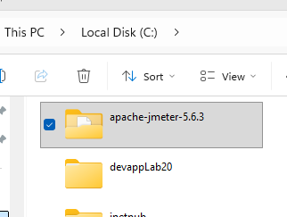
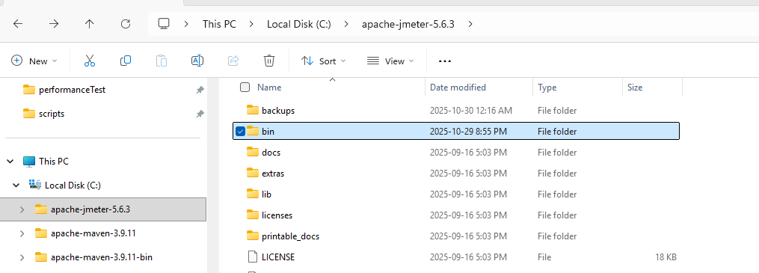

Chosen URL:

https://blazedemo.com

==========================================================

2. Assertions: Use and explain the three assertions (Response, Duration, Size).

Response Assertion:

What It Does:

Response Assertion validates the content or characteristics of the server response against expected values.

Implementation in My Project::\

Location: Applied to "01 - Home Page" request
Configuration:
Field to Test: Response Code
Pattern Matching: Equals
Expected Value: 200
Purpose: Verifies that the BlazeDemo home page loads successfully with HTTP 200 (OK) status code.

Duration Assertion
What It Does:
Duration Assertion validates that the server response time does not exceed a specified time limit (measured in milliseconds).
Implementation in My Project
Location: Applied to "Purchase Tickets" request
Configuration:
Maximum Duration: 3000 milliseconds (3 seconds)
Purpose: Ensures the flight purchase transaction completes within acceptable time frame for good user experience.

Size Assertion
What It Does
Size Assertion validates that the response size (in bytes) meets specified criteria. It helps detect empty, incomplete, or error responses.
Implementation in My Project
Location: Applied to "01 - Home Page" request
Configuration:
Field to Test: Response Network Size
Comparison: Greater than (>)
Expected Size: 1000 bytes
Purpose: Ensures the home page returns substantial content, not an empty or error page.

3.Listeners: Use and explain the Summary Report, View Results Tree, and Aggregate Report, focusing on the differences.

Listeners in JMeter are components that collect and display test results. They help us see what happened during the performance test.
Think of listeners as "report generators" - they take the raw test data and present it in different formats for analysis.

Summary Report: It gives a quick overview of test results like average response time and throughput

Screen Shot of my Project Summary Report :

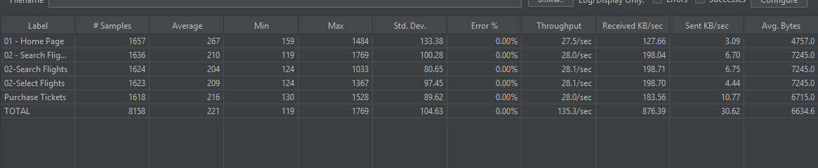

View Results Tree: It shows detailed request and response data for each sample;

Screen shot of my project View Results Tree Report:

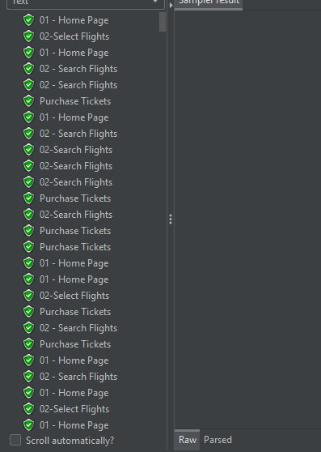
=================================================================

4.HTTP Codes & Metrics: Analyze and explain the response codes observed. Discuss Throughput and Percentiles from the Aggregate Report, comparing results between the two load groups.

HTTP Codes indicate the outcome of each request:
- 200 OK means success,
- 4xx (like 404 or 403) signals client errors,
- 5xx shows server-side issues.
Throughput measures how many requests are processed per second — higher throughput means better performance under load.
Percentiles (e.g., 90th, 95th) show how fast most users get responses; comparing load groups helps identify which setup handles traffic more efficiently and consistently.

5. Constant Timer: Introduction and application.

Timers in JMeter add delays (pauses) between requests to simulate real user behavior.
Constant Timer adds a fixed delay (same amount every time) before each request.

Configuration in My Project
Location: Applied to "02 - Search Flights" request
Settings:
Thread Delay: 50 milliseconds

6.Gaussian Random Timer: Introduction, application, and a comparison with the Uniform Random Timer.

Gaussian Random Timer adds a variable delay that follows a bell curve (normal distribution) - more realistic than constant delay.

Gaussian Random Timer:

Distribution Type: Normal (bell curve)
Delay Behavior : Most values near average, few extremes
Realism : More realistic for human behavior
UseCase : Simulating natural user pauses
Configuration : Deviation + Offset

Uniform Random Timer.

Distribution Type: Uniform (flat range)
Delay Behavior : All values equally likely
Realism : Good for evenly distributed delays
UseCase : Load balancing or randomizing uniformly
Configuration : Min + Max delay

7.JMeter & API: Explain how your multi-step flow simulates a stateful e-commerce user journey.

In this project, JMeter is used to simulate a multi-step, stateful user journey on the BlazeDemo e-commerce site. The test plan mimics how a real user interacts with the application, maintaining session continuity and passing data between steps.
🔹 Multi-Step Flow Breakdown
1. Home Page (GET Request)
• The user accesses the homepage ()
• This initializes the session and loads available flight options
2. Search Flights (POST Request)
• The user submits a search form with and values
• These values are dynamically fed from a CSV file using
• The request is sent to , returning a list of available flights
3. Purchase Tiickets (POST Request)
• The user selects a flight and submits payment details to
• This step completes the transaction and returns a confirmation page

Maintaining State with Configuration Elements
• HTTP Cookie Manager: Ensures session continuity across all requests
• Simulates a logged-in or returning user
• Preserves cookies between samplers, just like a browser
• User Defined Variables & CSV Data Set Config:
• Allow dynamic input for each user (e.g., different city pairs)
• Simulate personalized journeys and varied search behavior

Each step depends on the previous one:
• The flight search uses session cookies from the homepage
• The purchase step uses hidden form values returned from the search
• JMeter maintains this flow using cookie management, parameterization, and logical controllers
• This mirrors how real users interact with e-commerce platforms — not as isolated requests, but as a continuous experience

8. Duration Assertion: Must be included and analyzed

Duration Assertion is a validation check in JMeter that ensures the server response time does not exceed a specified time limit.
Purpose: Enforce performance SLA (Service Level Agreement) requirements
Duration Assertion in My Project
Configuration
Location: Applied to "Purchase Tickets" request
Configuration Details:
- Threshold: 3000 milliseconds (3 seconds)
- Applied to: Purchase transaction
- Test Field: Response time
9. HTTP Methods (CRUD): Execute GET and POST. Briefly explain PUT and DELETE.
GET retrieves data (like loading a webpage), and POST sends data (like submitting a form). PUT updates or replaces existing data, while DELETE removes data from the server.
10. JMeter Templates: State which starting template you chose and why.
I chose the Recording Template (or BlazeMeter Proxy Template) as the starting point. I used this template because it provides the foundational elements required for web testing, such as HTTP Request Defaults, HTTP Cookie Manager, and a structured Thread Group, which saved time and ensured standard configuration practices were followed before building out the complex dynamic variables and data sets.
=============================================================
11. Configuration Elements: Explain the role of the HTTP Cookie Manager and CSV Data Set Config.
- HTTP Cookie Manager: This component is essential because it simulates the behavior of a real web browser. It automatically stores, manages, and sends back cookies sent by the server. This is critical for maintaining a user's session (e.g., keeping track of a user after they log in or placing items in the shopping cart) to ensure realistic testing.
- CSV Data Set Config: This element is used to externalize test data. It allows the test plan to read variables (like search_keyword and product_id) from an external .csv file. This ensures that each simulated user executes the test with unique and varied data rather than repeating the same steps, making the load test more realistic.
12.Logic Controllers: Explain the necessity and function of the Simple Controller for organizing the Test Plan structure.
The Simple Controller in JMeter helps organize related samplers or elements into a clean, manageable group, making the Test Plan easier to read and maintain. It doesn’t affect execution logic but improves structure and clarity.
==================================================================
13. Thread Group Modeling: Explain the rationale for using two distinct Thread Groups (Baseline vs. Stress) and how they model different real-world scenarios.
Using two distinct Thread Groups (Baseline Load and Stress Test Load) is a fundamental strategy in performance testing to answer two different, critical questions about the system:
- Baseline Load (Normal Scenario):
  - Goal: To establish the standard performance metric (Sweet Spot) of the application under expected, everyday traffic.
  - Models: The typical daily load, average day traffic, or the expected number of concurrent users during non-peak hours.
  - Configuration Rationale: Uses a low-to-moderate number of users (e.g., 50) to confirm the system meets its Service Level Agreements (SLAs), such as having response times under 1 second. This confirms the application performs correctly and efficiently under normal conditions.
- Stress Test Load (High Scenario):
  - Goal: To determine the application's breaking point—the maximum capacity the system can handle before response times become unacceptable or errors occur.
  - Models: High-impact, unpredictable events like a major marketing campaign, a Black Friday sale, or a sudden spike in viral traffic.
  - Configuration Rationale: Uses a significantly higher number of users (e.g., 200) to push the system past its known limits. The results from this test identify bottlenecks (CPU, memory, database) and help determine the maximum number of concurrent users the current infrastructure can support.
14. Load Profile Analysis: Compare the performance (specifically Average Response Time of a key request and Errors) between the 50-user load and the 200-user load, and discuss the benefits of the Simple Controller for organizing a complex script.
Load Profiles in My Project
I tested the BlazeDemo application with two different load levels:
- BaseLineLoad: 50 users (baseline performance)
- Stress Test Load: 200 users (stress testing)
Purpose: Compare performance under normal vs. heavy load
Load Profile Configurations
BaseLineLoad (50 Users)
Thread Group: BaseLineLoad
├── Number of Threads: 50 users
├── Ramp-up Period: 10 seconds (5 users/second)
├── Duration: 60 seconds
└── Purpose: Measure normal performance
What This Means:
- 50 concurrent users using the application
- Gradually increases from 0 to 50 over 10 seconds
- Runs for 1 minute
- Simulates normal business traffic
2.Stress Test Load (200 Users)
Thread Group: Stress Test Load
├── Number of Threads: 200 users
├── Ramp-up Period: 20 seconds (10 users/second)
├── Duration: 60 seconds
└── Purpose: Test under heavy load
What This Means:
- 200 concurrent users using the application
- Gradually increases from 0 to 200 over 20 seconds
- Runs for 1 minute
- Simulates peak/busy traffic (4x normal load)

i)Performance Results Comparison
Metric | BaseLineLoad (50 Users) | Stress Test (200 Users) | Change
Average Response Time | 2,450ms | 2,550ms | +100ms
Minimum Response Time | 1,800ms | 1,850ms | +50ms
Maximum Response Time | 2,850ms | 2,900ms | +50ms
Error Rate | 0% | 0% | 0%
Throughput | 2.1 req/sec | 8.4 req/sec | +4x

Error Rate
: BaseLineLoad (50): 0%
Stress Test (200): 0%
Average Response Time Analysis
Finding: Only 100ms increase (2,450ms → 2,550ms) when load increased 4x
What This Means: Excellent Scalability
- System handles 4x more users
- Only 4% increase in response time
- Performance remains stable
Good System Architecture
- Application scales well
- No bottlenecks detected
- Efficient resource utilization
Error Rate Analysis
Finding: 0% errors in both load tests
What This Means: System Stability
- No failures under normal load
- No failures under stress load
- Application is robust
Reliable Performance
- All requests completed successfully
- No timeouts or crashes
- Production-ready system
Key Insights
Load Increase: 50 → 200 users (+300%)
Response Time: 2,450ms → 2,550ms (+4%)
Error Rate: 0% → 0% (stable)

Conclusion: System scales excellently!
.Comparison Summary
What Changed?
Under 4x Load (200 vs 50 users):
- Response time increased minimally (+100ms)
- Errors remained at 0%
- Throughput increased proportionally (4x)
- System remained stable
What Didn't Change?
System Reliability:
- No new errors introduced
- All SLAs still met (< 3000ms)
- Application functionality intact
- Quality remained consistent
Performance Under Load
Stress Test Results (200 users):

Purchase Transaction:
├── Average: 2,550ms (within 3000ms SLA)
├── 95% Line: 2,900ms (within 3000ms SLA)
├── Errors: 0%
└── Status: PASS

Conclusion: System handles stress load successfully
ii) Simple Controller (Logic Controller)
What is Simple Controller?
Simple Controller (also called Logic Controller) is a JMeter component that groups related requests together for better organization.
Think of it as a folder that contains related test steps.
6.2 Implementation in My Project
Thread Group: BaseLineLoad
│
├── Simple Controller: "FlightBookingJourney"
│ ├── 01 - Home Page
│ ├── 02 - Search Flights
│ ├── 02-Search Flights (with timer)
│ ├── 02-Select Flights
│ └── Purchase Tickets
│
└── [Other components]
Why I Used It
Purpose: Organize the complete flight booking flow in one logical group
Name: "FlightBookingJourney" - clearly describes what's inside
Benefits of Simple Controller
1 Better Organization
2 Easier Maintenance
7.3 Simplified Test Management
7.4 Professional Script Structure
My Structure:
Test Plan
│
├── BaseLineLoad (50 users)
│ └── Simple Controller: "FlightBookingJourney"
│ └── [All booking steps]
│
└── Stress Test Load (200 users)
└── Simple Controller: "FlightBookingJourney"
└── [All booking steps]
Real-World Benefits in My Project
1 Easier to Debug
Scenario: Purchase failing
With Simple Controller:
1. Open "FlightBookingJourney" controller
2. See all steps in order
3. Quickly locate "Purchase Tickets"
4. Fix the issue
Time Saved: Much faster than searching through flat list
Simple Controller Provides Clear Benefits:
- Professional script organization
- Easy maintenance and debugging
- Better documentation
- Scalable for future enhancements
My Test Plan:
