Name: Anu Aniyammal.S

Date: 16/11/2024

1. **Created linux VM in azure with public key (listed below) and ip (172.176.249.83: TESTVM)**

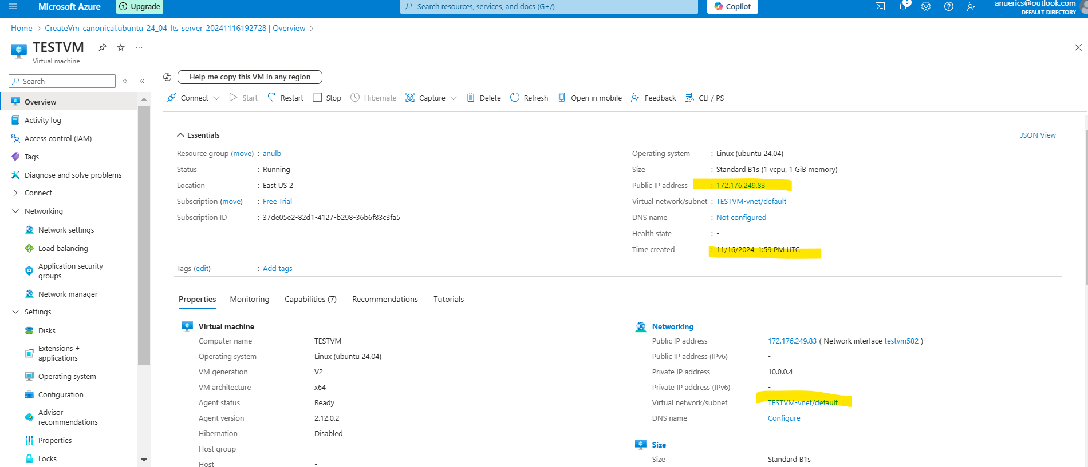

* Installing ansible on host machine through commands

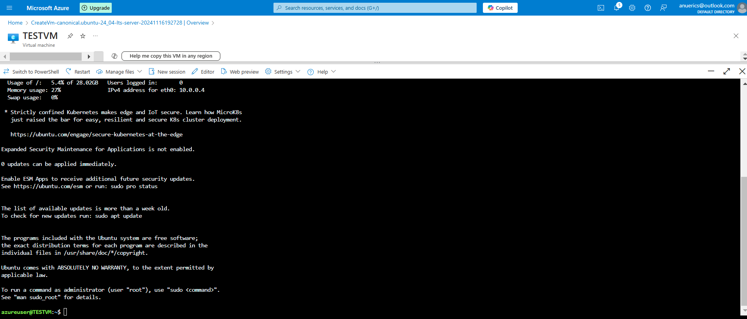

* Hosted added and pinged

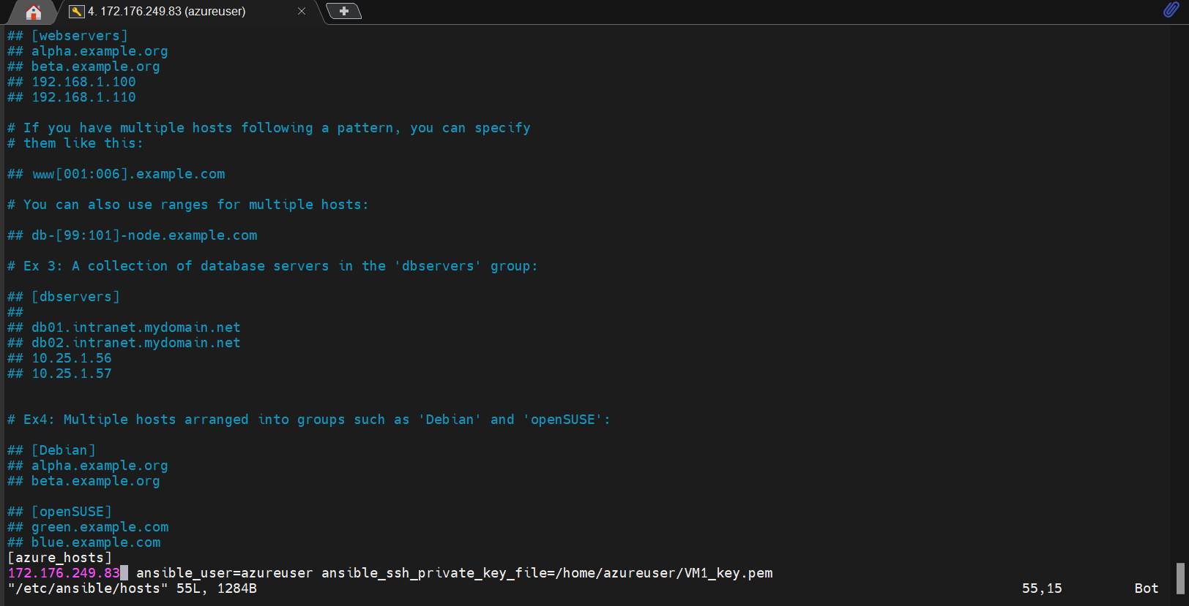

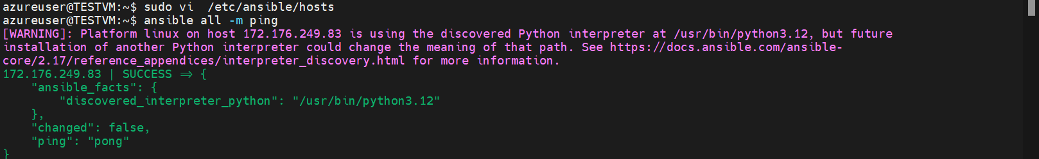

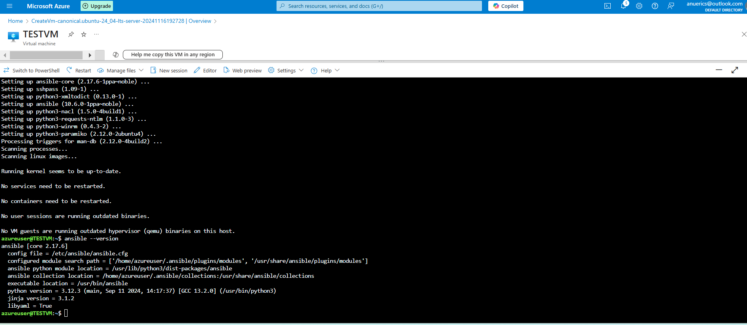

1. **. store the certificate in ansible vault.**

* Created ssh key using ssh-keygen -t rsa -b 2048 -f ~/.ssh/id_rsa and **placed private key stored in secrets.yml ansible vault.**



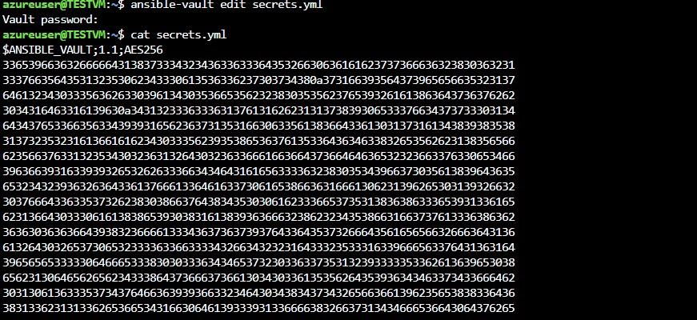

**3. Using the host created above perform the below operation using ansible playbook**

1. **Install terraform and git on the machine: installed through commands**.

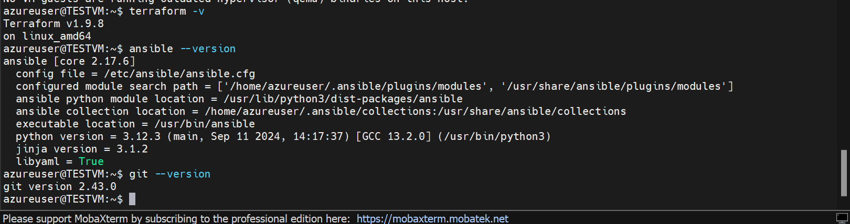

**Playbook script : ---**

- name: Automate tasks on the Azure VM

hosts: all

become: yes

tasks:

- name: Install required packages (Terraform and Git)

apt:

name:

- terraform

- git

state: present

update_cache: yes

- name: Clone the Terraform GitHub repository

git:

repo: "https://github.com/Anuaniyammal/Terraform-tasks.git"

dest: /tmp/Terraform-tasks

version: main

- name: Change directory to "Windows VM" folder and execute Terraform scripts

shell: |

cd /tmp/Terraform-tasks/Windows\ VM

terraform init

terraform apply -auto-approve

register: terraform_output

- name: Capture the Terraform output

debug:

msg: "{{ terraform_output.stdout }}"

- name: Cleanup cloned files (delete the repository folder)

file:

1. **Clone the git repo which has tf scripts:**

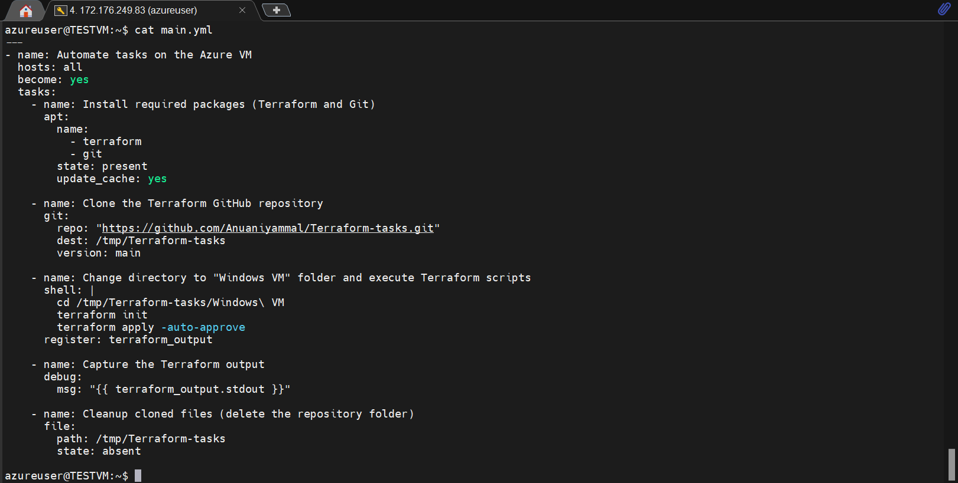

1. **Execute the tf script (https://github.com/Anuaniyammal/Terraform-tasks/tree/e146610819adf82cc94f34cafacab85c4511d13d/Windows%20VM)**

**and capture the output:**

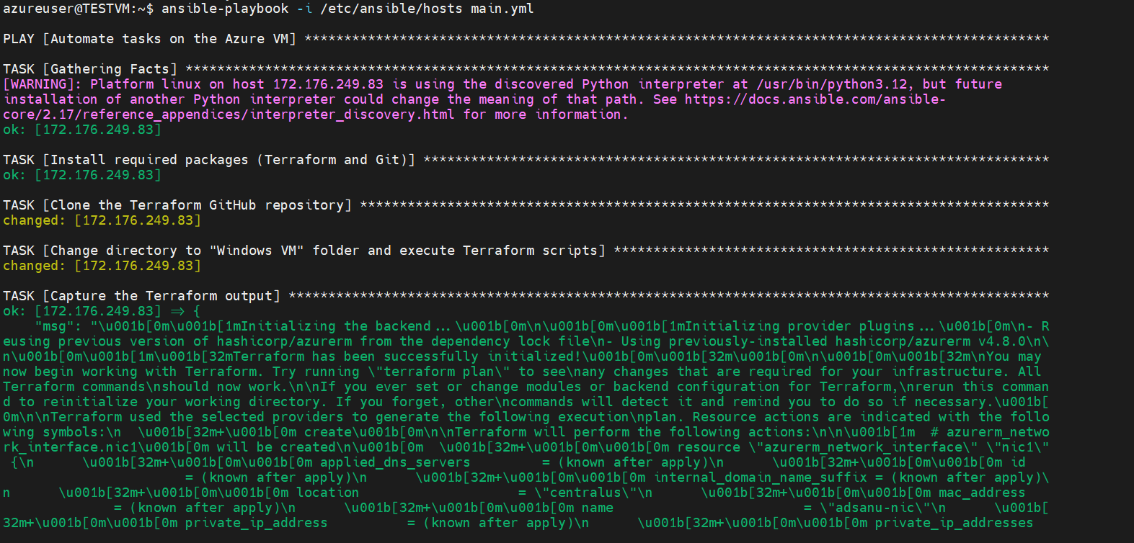

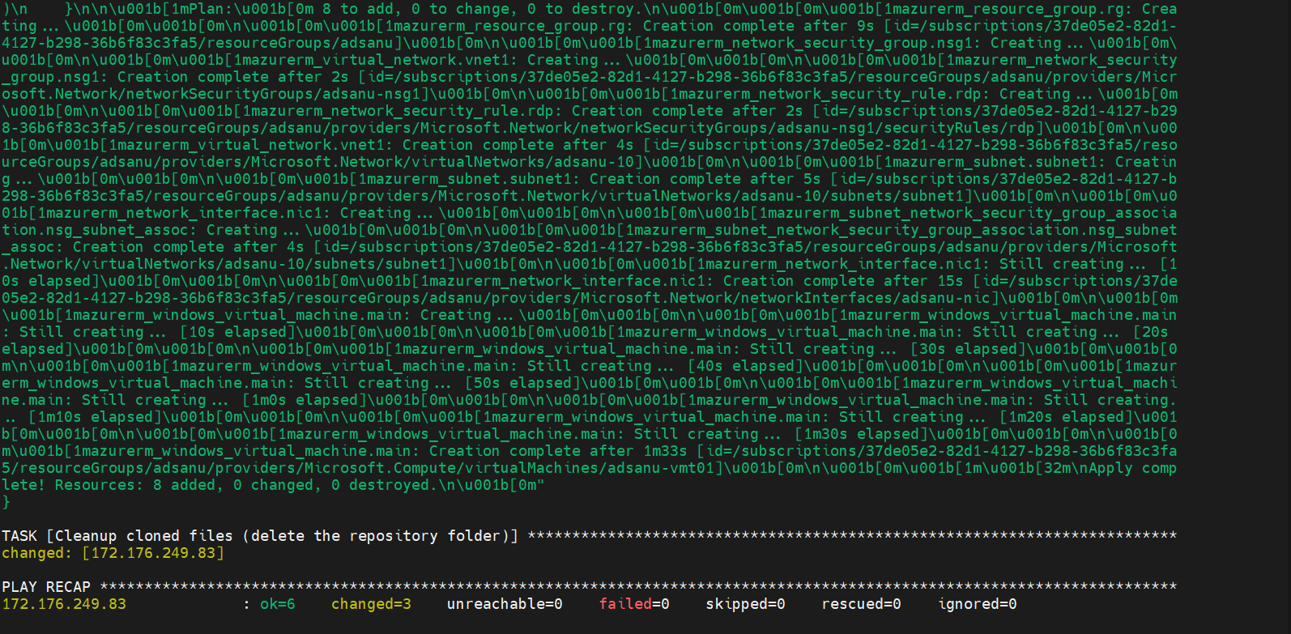

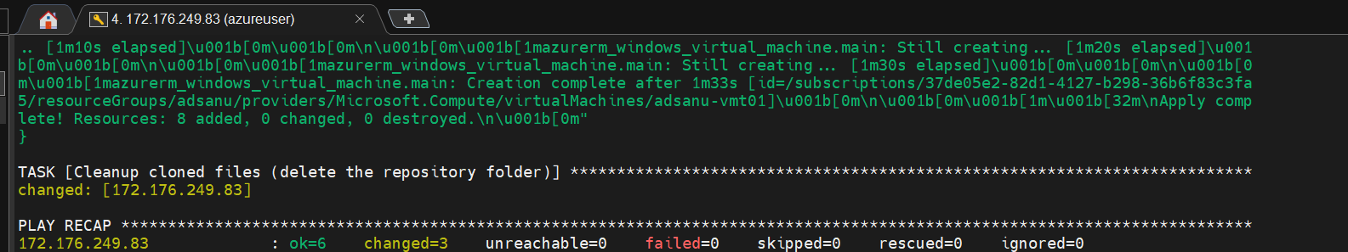

**Resources created and Portal snaps:**

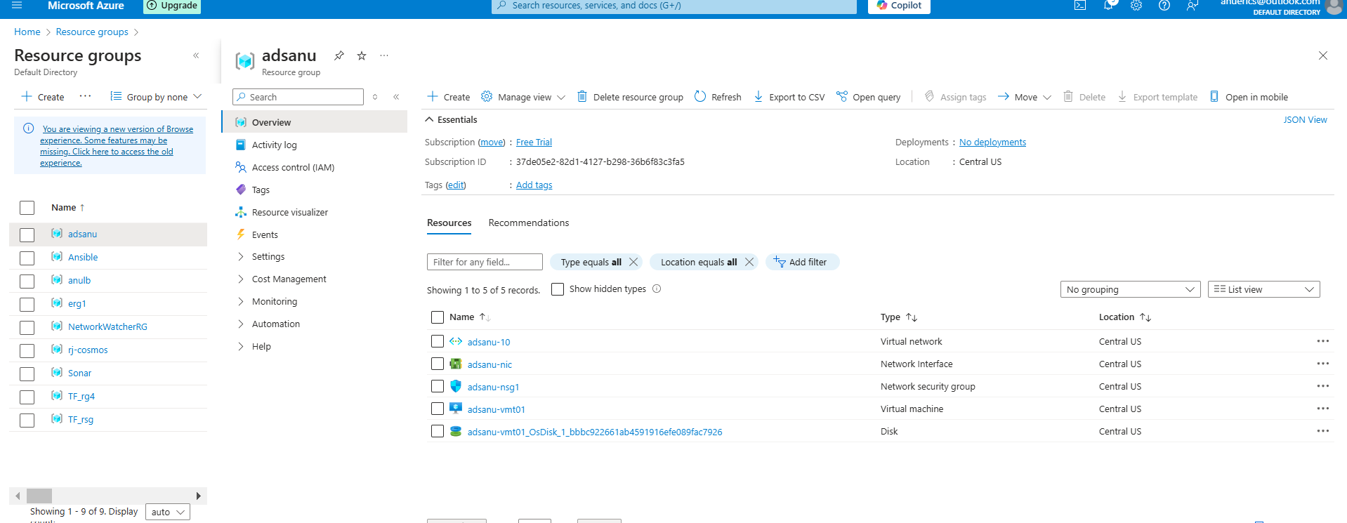

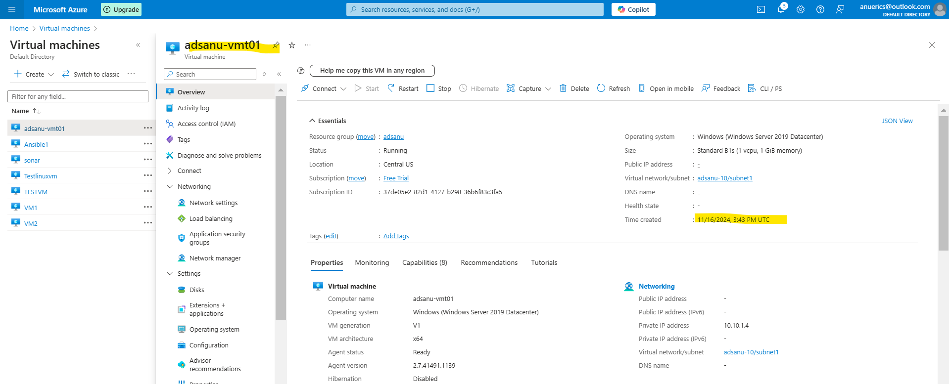

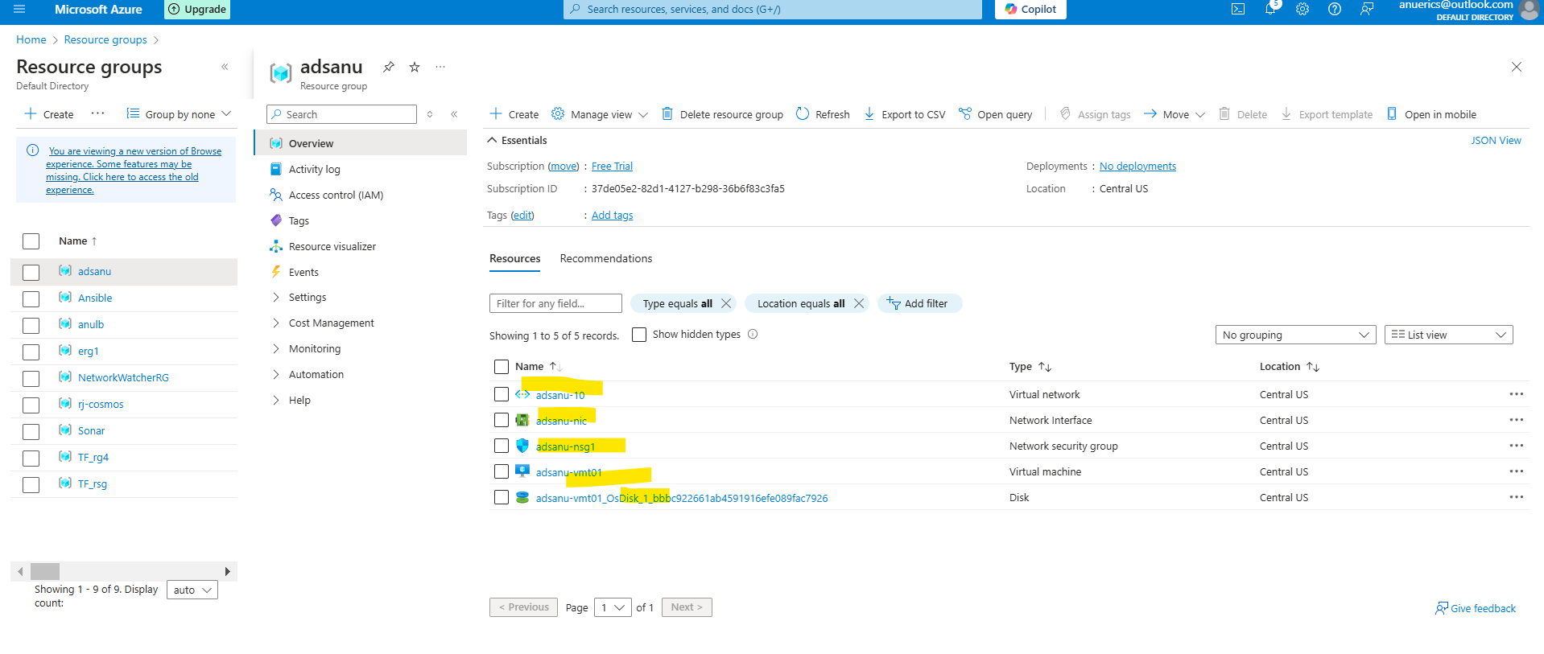

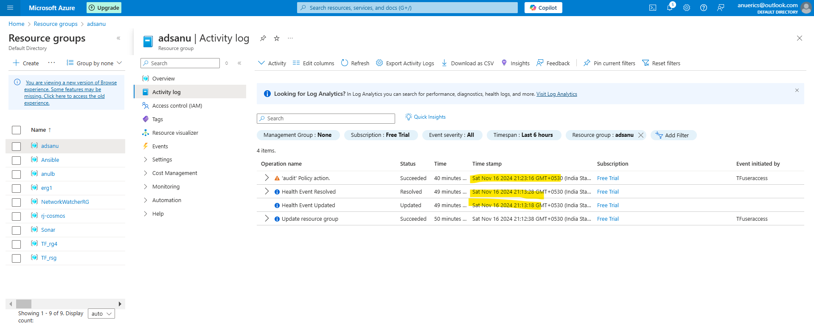

**4. create a github repository with name ABC-1611**

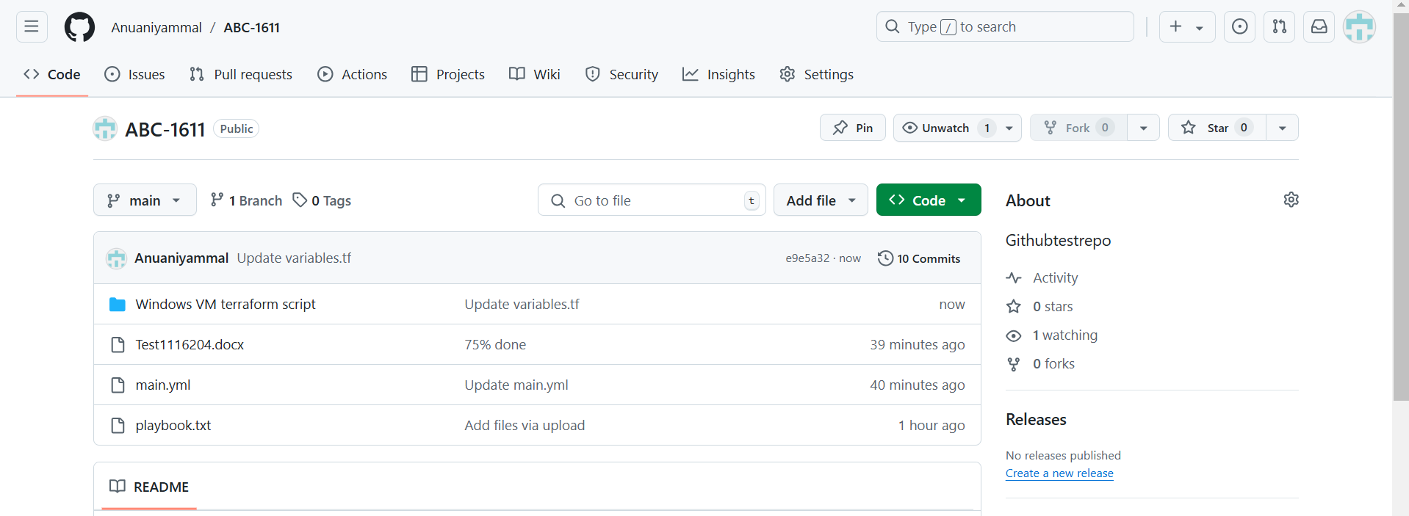

**5. push the playbook configuration to the repo**

