Practical Task 2 Spark
1)Completed the first task in the etl_job.py
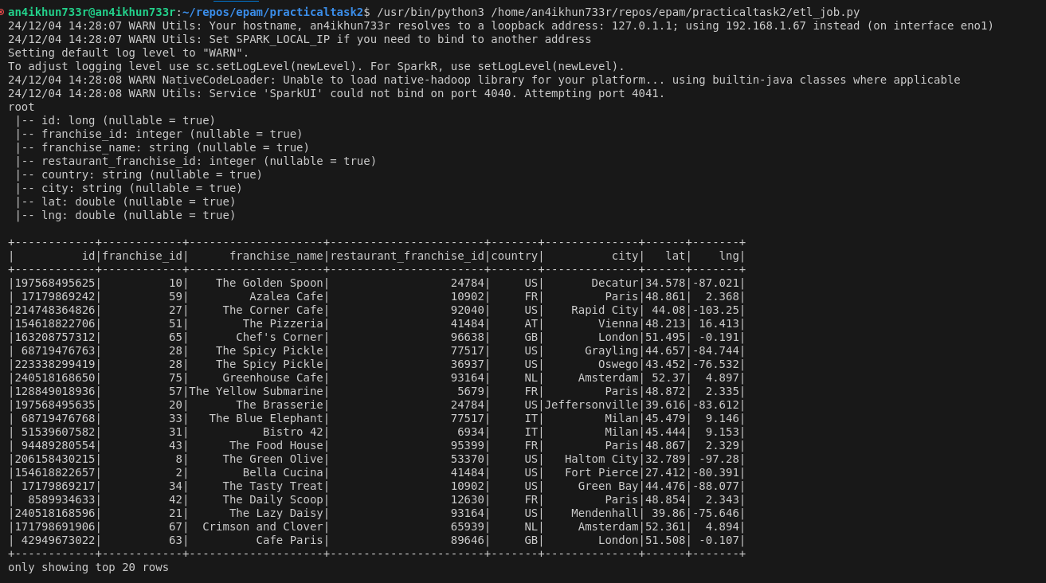
2)Completed the second task in the etl_job.py
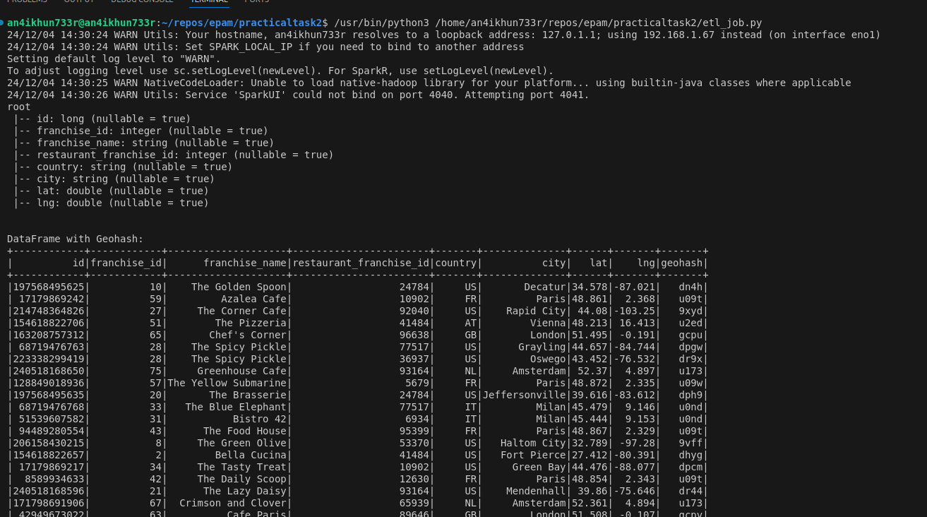
3)Completed the Join
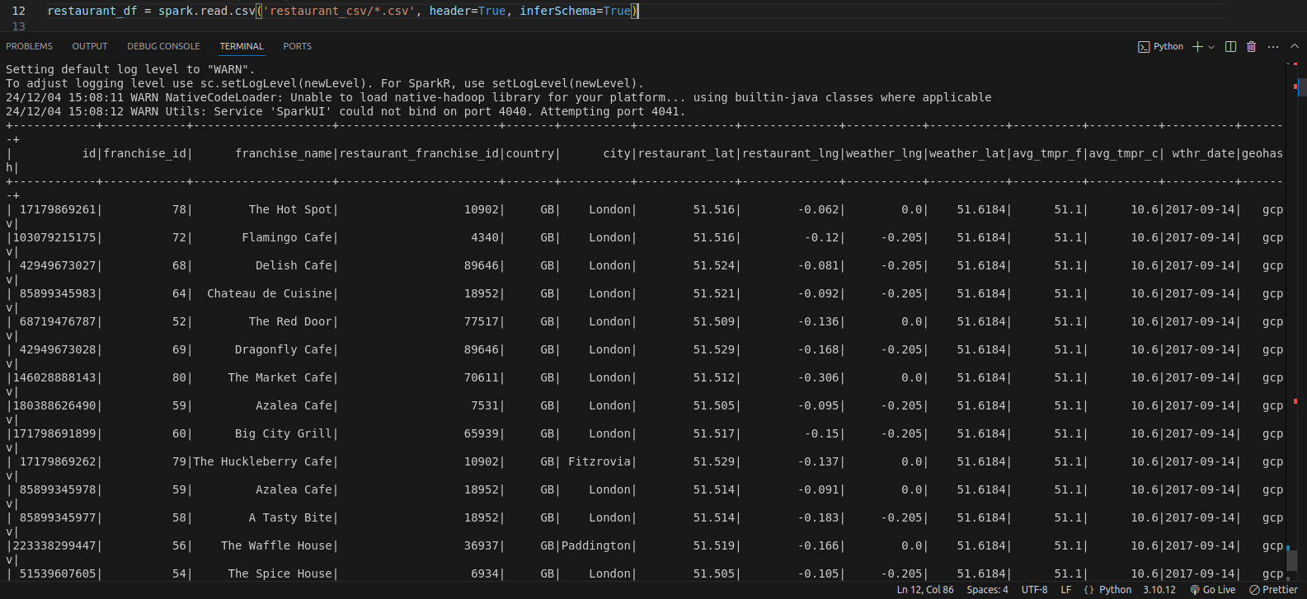
4)parquet files created
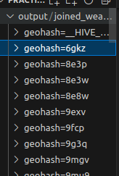

5) Tests Implemented

