Assignment 3: Architectural Modeling and Design
Course: Software Architecture
Group: SE-2302
Student: Diana Abish

1. Introduction and System Overview
The selected system is a web-based interactive educational platform built around a digital contour map of Kazakhstan. Its primary goal is to support geography education in secondary schools and universities by replacing static printed maps with an interactive and centrally maintained digital resource.
The platform allows students to explore geographic regions and thematic layers, while teachers can use the system to explain material, attach educational content, and assess learning outcomes. Administrators and subject-matter experts are responsible for validating geographic data and ensuring that the information presented to users remains accurate and up to date. The system is designed to improve learning effectiveness while keeping the interaction simple and intuitive for classroom use.

2. Domain Model
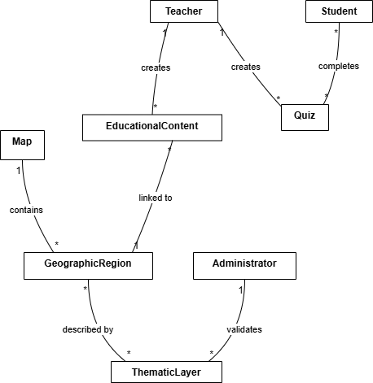
Figure 1: Domain Model Diagram.
2.1 Purpose
The domain model describes the problem domain using business-oriented terminology that is understandable to non-technical stakeholders. It focuses on educational and geographic concepts rather than on software or implementation details.
2.2 Key Domain Entities and Attributes
The core domain entities of the system are:
Entity | Description | Key attributes
Map | Educational representation of Kazakhstan used in the system | title, description, base scale
Geographic Region | A specific area shown on the map (administrative or natural) | name, region type, spatial extent
Thematic Layer | A category of geographic information displayed on the map | name, category, default visibility
Educational Content | Learning materials linked to regions or layers | title, main text, media references
Quiz | Assessment activity related to geographic topics | topic, number of questions, related region/layer
Student | Learner using the system | —
Teacher | Educator creating content and quizzes | —
Administrator | Role responsible for validation and approval | —
2.3 Relationships
- A Map contains multiple Geographic Regions.
- A Geographic Region can be associated with several Thematic Layers.
- Educational Content is linked to either a Geographic Region or a Thematic Layer.
- A Teacher creates Educational Content and Quizzes.
- A Student interacts with the Map and completes Quizzes.
- An Administrator validates geographic data before it becomes available to users.
2.4 Business Rules
- Only teachers are allowed to create or modify educational content and quizzes.
- Students can view approved map layers but cannot change geographic data.
- All thematic layers must correspond to the national geography curriculum.
- Geographic data changes must be reviewed and approved by an administrator before publication.
2.5 Explanation
The selected entities and rules reflect the essential concepts of geography education and assessment. The domain model helps establish a shared understanding of system requirements and serves as a foundation for more detailed architectural models.

3. Informational Model
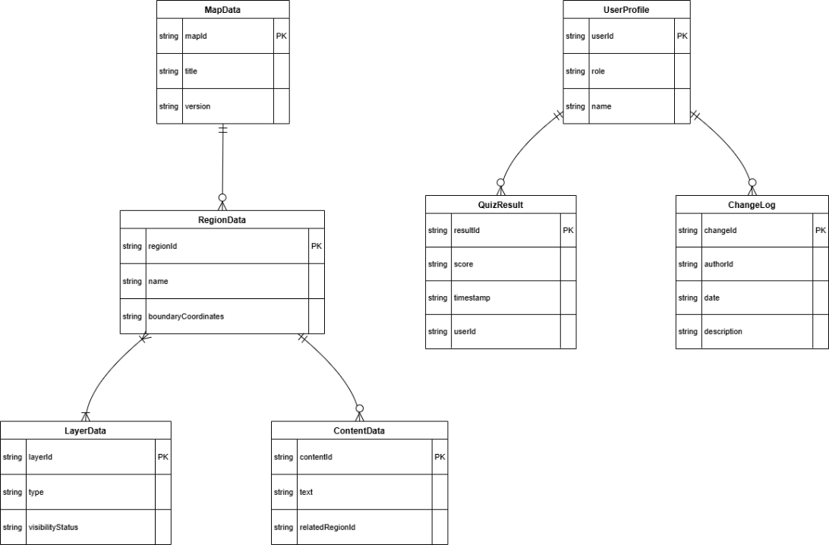
Figure 2: Informational Model Diagram.

3.1 Purpose
The informational model describes how data is structured and related within the system. It provides more detail than the domain model and focuses on data organization and integrity, while remaining independent of any specific technologies.
3.2 Data Entities, Attributes, and Types
Data entity | Attributes (with types)
MapData | mapId (identifier), title (string), version (string)
RegionData | regionId (identifier), name (string), boundaryCoordinates (geometric data)
LayerData | layerId (identifier), type (string), visibilityStatus (enumeration)
ContentData | contentId (identifier), text (string), relatedRegionId (identifier)
UserProfile | userId (identifier), role (enumeration), name (string)
QuizData | quizId (identifier), topic (string), relatedRegionId (identifier)
QuizResult | resultId (identifier), score (numeric), timestamp (datetime), userId (identifier)
ChangeLog | changeId (identifier), authorId (identifier), date (datetime), description (string)

3.3 Relationships and Constraints
- Each RegionData belongs to exactly one MapData.
- A LayerData entry may be linked to one or more regions.
- QuizResult records must reference existing users and quizzes.
- A layer can only be shown to students when its visibility status is set to “approved”.
- All modifications to base map data must be recorded in the ChangeLog.

3.4 Comparison with the Domain Model
While the domain model explains what the system represents from an educational perspective, the informational model defines how this information is structured and constrained. Both views are necessary: one clarifies meaning, the other ensures data consistency.

4. Design Model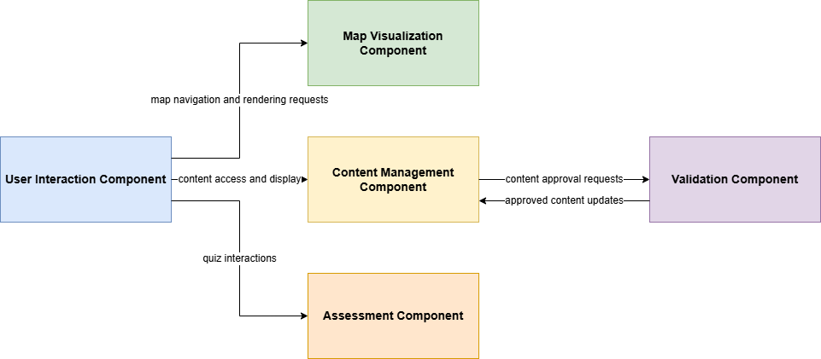
Figure 3: Design (Component) Model Diagram.
4.1 Purpose
The design model presents a high-level view of the internal structure of the system. It identifies major components, their responsibilities, and interactions, without describing implementation or technical details.
4.2 Main Components and Responsibilities
- User Interface and Interaction Component – handles user input, navigation, and presentation of map content.
- Map Rendering and Navigation Component – responsible for displaying geographic regions, overlaying thematic layers, and supporting zoom and pan operations.
- Educational Content and Quiz Management Component – manages learning materials, quizzes, and their associations with geographic elements.
- Assessment Processing Component – evaluates quiz submissions and records results.
- Data Validation and Approval Workflow Component – supports review and approval of geographic and educational data.
4.3 Interactions and System Boundaries
User actions are first processed by the User Interface and Interaction Component, which then coordinates with the other internal components. All listed components are considered part of the system boundary. External interactions are limited to users and external geographic data providers.

5. Context Diagram
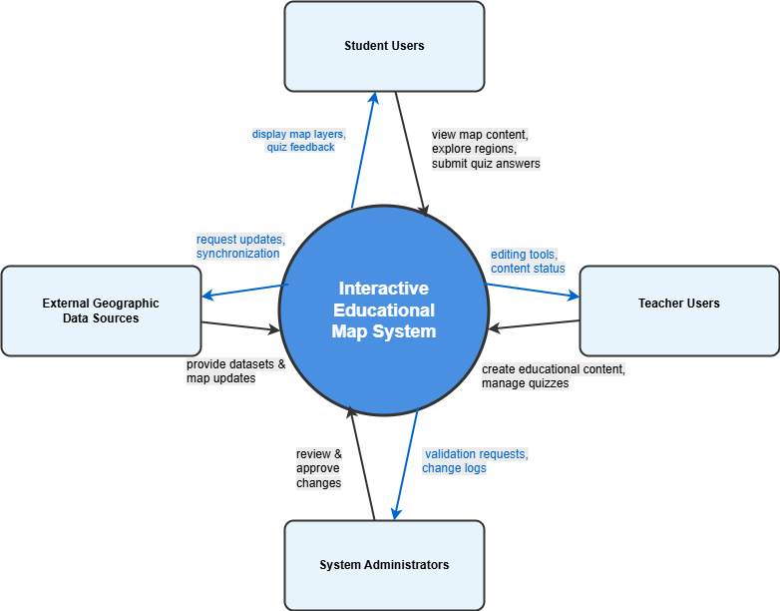
Figure 4: System Context Diagram.
The context diagram represents the system as a single unit and illustrates its interactions with external actors.
External actors:
External actor | Interaction with the system
Student | Views map content, explores regions and layers, completes quizzes
Teacher | Creates and updates educational content, manages quizzes
Administrator | Reviews and approves geographic data and content changes
External Geographic Data Sources | Provide official geographic datasets and upda

This diagram qualifies as a context diagram because it shows only the system as a whole and its external interactions, without exposing any internal structure.

6. Architectural Design Decisions
Decision 1: Modular Internal Structure
- Context: The system must evolve over time as educational requirements change.
- Problem: How to organize responsibilities within the system to support future changes.
- Options:
  - A single unified structure.
  - A modular structure with clearly separated responsibilities.
- Decision: A modular internal structure was chosen.
- Consequences: This approach improves maintainability and clarity, while introducing a moderate increase in conceptual complexity.
Decision 2: Centralized Data Validation
- Context: Geographic accuracy is essential in an educational system.
- Problem: How to control modifications to core geographic data.
- Options:
  - Allow all users to edit data freely.
  - Require administrator approval for changes.
- Decision: Centralized validation by administrators was selected.
- Consequences: Data reliability is improved, but content updates may take longer to appear.

7. Model Consistency Analysis
All architectural models describe the same system from different perspectives and remain consistent with one another. For example, the Geographic Region appears as a business concept in the domain model, as RegionData in the informational model, and is primarily handled by the Map Rendering and Navigation Component in the design model.
User roles such as Student, Teacher, and Administrator are also consistent across models. They define responsibilities in the domain model, are represented through user roles in the informational model, and influence component interactions and workflows in the design model. Maintaining this consistency helps prevent misunderstandings and architectural mismatches.

8. Assumptions and Open Questions
Assumptions
- Most educational institutions have stable internet access.
- The system does not store highly sensitive personal data.
Open Questions
- Is offline access required for schools with limited connectivity?
- How should conflicts be handled if multiple teachers edit the same content simultaneously?

