Development of a mobile application for connecting senders and travelers for intercity parcel delivery
Assignment-3

Assem Temirbay (SE-2301), Nuraiym Sadyk (SE-2302), Danial Yerzhigit (SE-2314)

Introduction and System Overview
System Name: P2P Air Parcel Delivery Platform.
Purpose: A mobile platform that connects Senders (people needing urgent delivery) with Travelers (air passengers with spare luggage capacity) to provide ultra-fast intercity logistics in Kazakhstan.
Main Users:
- Senders: Need to send items quickly and at a lower cost than traditional express services.
- Travelers: Want to offset their travel expenses by utilizing their unused baggage allowance.
- Recipients: Individuals waiting for the parcel at the destination.
- System Administrator: Manages user verification, handles disputes, and monitors system health.

Domain Model
2.1 Key Domain Entities:
- User: A person registered in the system (can be a Sender, Traveler, or both).
- Traveler Profile: A specialized profile containing verification status (KYC) and travel history.
- Delivery Request (Parcel): Information about the item, weight, size, destination, and offered reward.
- Flight Trip: A traveler’s itinerary (flight number, date, route) to which a parcel can be matched.
- Transaction (Escrow): A financial record holding the funds until the recipient confirms delivery.
- Review/Rating: Feedback left by users after a completed delivery to maintain trust.
2.2 Business Rules:
- KYC-Mandatory: A user cannot post a "Flight Trip" or accept a "Delivery Request" without completing a 100% ID verification via a third-party KYC service.
- Escrow Protection: Payment must be authorized by the Sender before the Traveler picks up the parcel, but funds are only released to the Traveler after the Recipient provides a secure confirmation code.
- Baggage Limit Compliance: A Traveler cannot accept a parcel that exceeds their registered spare luggage capacity for a specific trip.
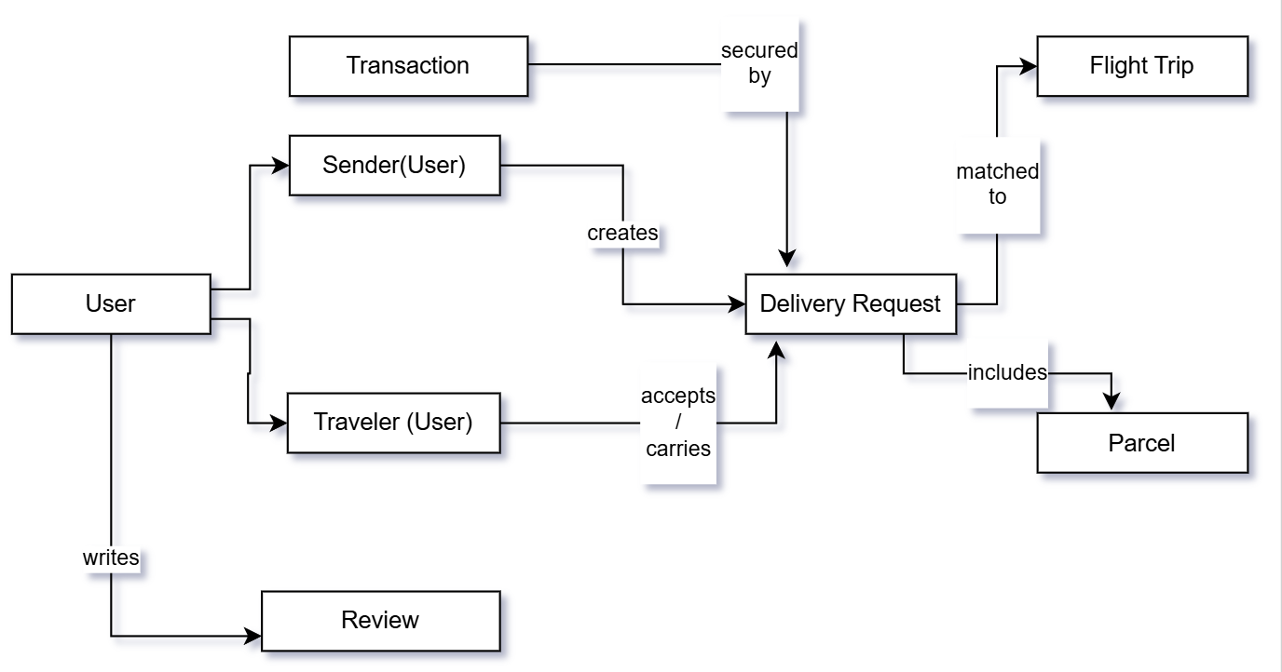
Figure 1. Domain Model Diagram

Informational Model
3.1 Purpose
The purpose of the Informational Model is to describe how data is structured, stored, and related within the system, independent of any specific technology or implementation.
It defines the static view of system information, focusing on data entities, their attributes, data types, relationships, and integrity constraints.
3.2 Information Model Description
3.2.1 Key Data Entities and Attributes
- User
Attribute | Data Type | Description
user_id | UUID | Unique identifier
full_name | String | User’s full name
phone_number | String | Contact number
email | String | Email address
role | Enum | Sender, Courier, Admin
rating | Decimal | Average user rating
created_at | DateTime | Registration timestamp
updated_at | DateTime | Last update timestamp

- Parcel
Attribute | Data Type | Description
parcel_id | UUID | Unique identifier
description | String | Parcel description
weight | String | Parcel weight
size_category | Enum | Small, Medium, Large
status | Enum | Created, In Transit, Delivered
created_at | DateTime | Creation timestamp
updated_at | DateTime | Last update timestamp
- Delivery Request
Represents a delivery offer created by a sender.
Attribute | Data Type | Description
request_id | UUID | Unique identifier
parcel_id | UUID | Reference to associated Parcel
pickup_location | String | Parcel weight
dropoff_location | String | Small, Medium, Large
price | Decimal | Estimated value
request_status | Enum | Open, Accepted, Canceled
created_at | DateTime | Creation timestamp
updated_at | DateTime | Last update timestamp
- Delivery Assignment
Represents the assignment of a courier to a delivery request.
Attribute | Data Type | Description
assignment_id | UUID | Unique identifier
user_id | UUID | Reference to associated User
request_id | UUID | Reference to associated Delivery Request
delivery_status | Enum | Assigned, Picked up, Delivered
assigned_at | DateTime | Assignment timestamp
created_at | DateTime | Creation timestamp
updated_at | DateTime | Last update timestamp
- Payment
Attribute | Data Type | Description
payment_id | UUID | Unique identifier
assignment_id | UUID | Reference associated to Delivery Assignment
payer_id | UUID | Reference associated to Sender User
payee_id | UUID | Reference associated to Courier User
amount | Decimal | Payment amount
currency | String | Payment currency
payment_status | Enum | Pending, Held, Released, Refunded
created_at | DateTime | Payment creation timestamp
3.2.2 Relationships Between Entities
- A User can create multiple DeliveryRequests
- A DeliveryRequest is associated with one Parcel
- A DeliveryRequest can have one DeliveryAssignment
- A User (Courier) can have multiple DeliveryAssignments
- A DeliveryRequest is linked to one Payment
- A User can be involved in multiple Payments
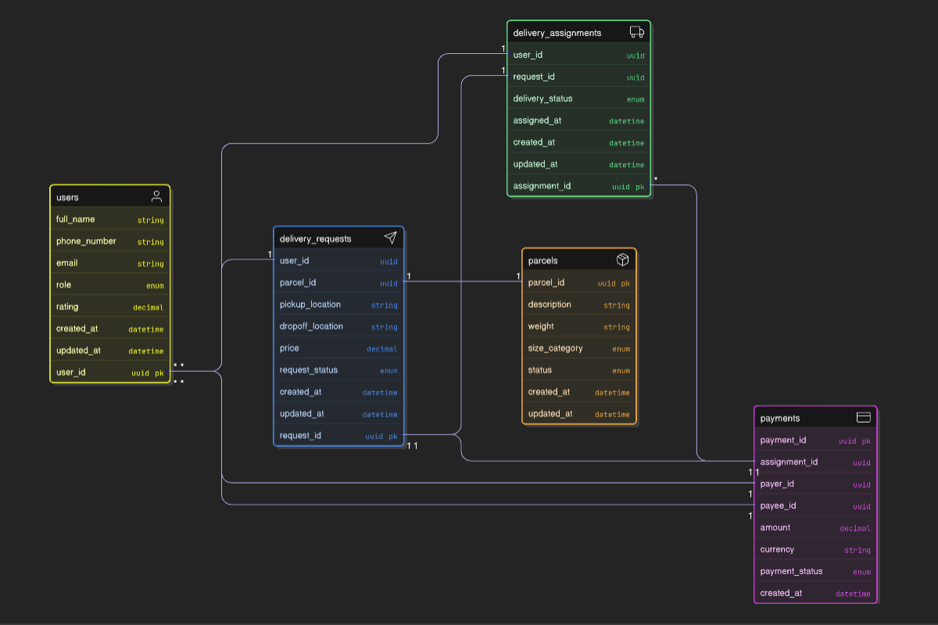
Figure 2. Information Model Diagram
3.3 Comparison: Domain Model vs Informational Model
Difference Between the Models
- The Domain Model focuses on real-world concepts and business meaning, such as users, parcels, and deliveries.
- The Informational Model focuses on data structure, including attributes, data types, and relationships, without describing business rules or behavior.

Why Both Models are Needed
- The Domain Model ensures correct understanding of the problem space.
- The Informational Model ensures data consistency, completeness, and correctness before system design and implementation.
- Together, they bridge the gap between business understanding and technical system design.

Design Model
4.1 Purpose
The purpose of the Design Model is to represent the system’s high-level technical structure, identifying main components, their responsibilities, interactions, and system boundaries without exposing low-level implementation details.

4.2 Design Model Description
4.2.1 Main Software Components

- User Management Component
Responsibilities:
- User registration and authentication
- Profile management
- Role handling (sender, courier, admin)

- Delivery Management Component
Responsibilities:
- Creation and management of delivery requests
- Parcel tracking
- Status updates

- Matching & Assignment Component
Responsibilities:
- Matching couriers to delivery requests
- Managing delivery assignments
- Preventing conflicting assignment

- Payment Processing Component
Responsibilities:
- Payment initiation and confirmation
- Holding and releasing funds
- Tracking payment status

- Rating & Feedback Component
Responsibilities:
- Collecting user ratings
- Calculating average ratings
- Preventing duplicate feedback

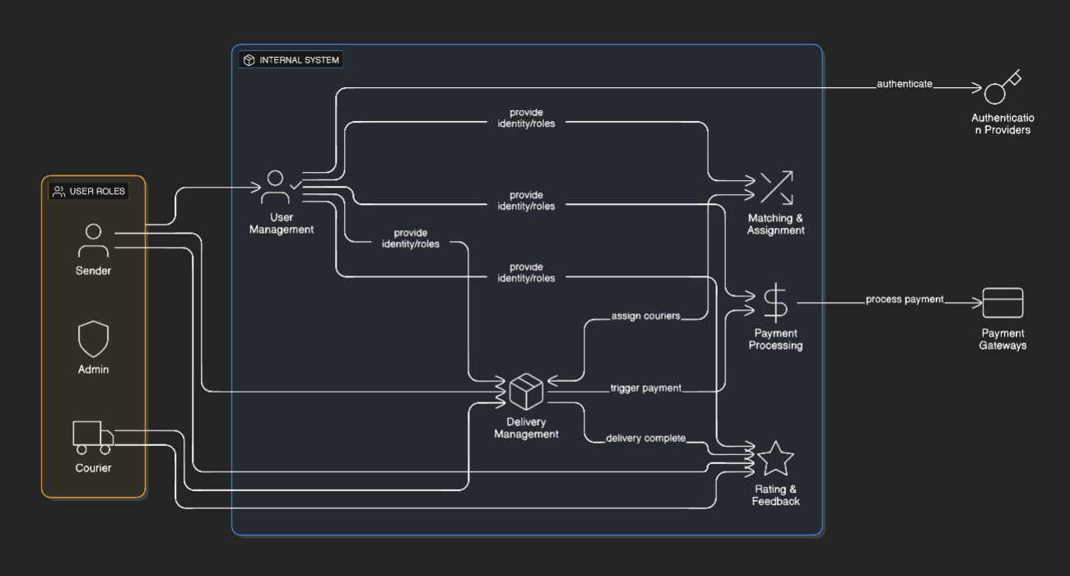
Figure 3. Design Model Diagram
4.2.2 Component Interactions
- The User Management Component provides user identity and role information to all other components
- The Delivery Management Component interacts with the Matching Component to assign couriers
- The Payment Component is triggered when a delivery request is accepted
- The Rating Component is activated after successful delivery completion

4.2.3 System Boundaries
- The system includes user interaction, delivery coordination, and payment management
- External services (e.g., payment gateways or notification systems) are treated as external actors
- The design model defines only internal responsibilities, not third-party implementations

Context Diagram
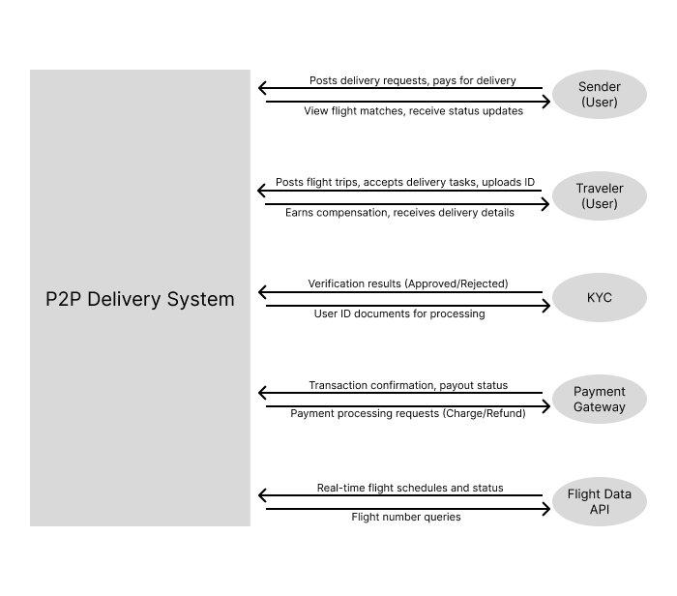
Figure 4. Context Diagram
KYC Verification Service (External API), Payment Gateway (External API), and Flight Data API (External API)
This is a context diagram because it represents the entire system as a single central process/box, showing only interactions (data flows) with external entities (Users: Senders, Travelers, Recipients, Admin; External Systems: KYC Verification Service, Payment Gateway, Flight Data API). Common mistakes avoided: no internal components/details shown, no data stores or subprocesses inside the system box.

Architectural Design Decisions
This section describes two key architectural design decisions made for the P2P Air Parcel Delivery Platform. These decisions are derived from the system's requirements for trust, security, and efficient matching in a peer-to-peer environment.
Decision 1: Mandatory KYC Verification for Travelers
- Context: The system operates in a trust-sensitive domain where travelers carry valuable parcels for strangers. Legal and safety constraints in Kazakhstan require user verification, and the platform must minimize fraud risks without overly burdening users.
- Problem: How to ensure sufficient trust between senders and travelers while allowing quick onboarding.
- Options:
  - Option A: No verification or optional self-declaration.
  - Option B: Full mandatory KYC (ID verification via third-party service) before posting or accepting trips.
- Decision: Chosen Option B — mandatory 100% KYC for travelers before they can post Flight Trips or accept Delivery Requests.
- Consequences: Increases trust and reduces fraud (positive for user adoption and dispute reduction), but may slow down traveler onboarding (trade-off: higher barrier to entry). Relies on external KYC service availability.
Decision 2: Use of Escrow Mechanism for Payments
- Context: Financial transactions occur between untrusted parties, with physical handover before final delivery confirmation. The platform must protect both sender (from non-delivery) and traveler (from non-payment).
- Problem: How to handle payments securely without the platform holding funds directly (to avoid regulatory issues as a non-bank entity).
- Options:
  - Option A: Direct payment from sender to traveler upon pickup.
  - Option B: Escrow-based payment via external payment gateway (funds held until recipient confirmation).
- Decision: Chosen Option B — escrow protection where payment is authorized upfront but released only after secure confirmation code from recipient.
- Consequences: Enhances security and trust (reduces disputes), supports dispute resolution by admin. Trade-off: dependency on external payment gateway (potential fees, integration complexity) and slight delay in traveler payout.

Model Consistency Analysis
The domain, informational, design, and context models are interconnected and maintain consistency across abstraction levels:
- Relationships:
  - The Domain Model provides business-oriented concepts (e.g., Delivery Request, Flight Trip, Escrow Transaction) that map directly to data entities in the Informational Model (e.g., Delivery Request → DeliveryRequest entity with attributes; Flight Trip is implied through matching logic).
  - The Informational Model refines domain entities into structured data (attributes, relationships like one-to-many between User and DeliveryRequest), providing the foundation for the Design Model components (e.g., Delivery Management Component handles DeliveryRequest creation/tracking).
  - The Design Model groups data and behavior into components (e.g., Matching & Assignment Component uses data from Informational Model to enforce business rules from Domain Model).
  - The Context Diagram shows the system as a black box interacting with external actors/services (e.g., KYC Verification Service for Domain Model's mandatory KYC rule; Payment Gateway for escrow).
- Consistency of Concepts:
  - Core entities like User, Parcel/Delivery Request, and Transaction are present across models with consistent meaning (e.g., User roles in Domain → role enum in Informational → handled in User Management Component).
  - Business rules (e.g., baggage limit compliance) are reflected in data constraints (Informational) and component responsibilities (Design).
- Potential Problems from Inconsistency:
  - If Domain and Informational models diverge (e.g., missing attribute for spare baggage capacity), it could lead to implementation errors like allowing overweight assignments.
  - Inconsistency between Informational and Design could cause data not being properly handled by components (e.g., payment status not tracked → escrow failures).
  - Overall, inconsistencies would complicate maintenance, increase bugs, and misalign the system with business needs.

Assumptions and Open Questions
Assumptions:
- Users have access to smartphones and reliable internet for mobile app usage.
- External services (KYC, Payment Gateway, Flight Data API) are reliable, compliant with Kazakh regulations, and provide necessary APIs.
- Parcels are non-prohibited items (no dangerous goods, in line with airline rules).
- The platform focuses primarily on domestic intercity flights in Kazakhstan initially.
- Recipients will be provided with secure confirmation codes via the app.
Open Questions:
- How to integrate real-time flight data verification to prevent fake trips?
- What dispute resolution process details (e.g., evidence upload) beyond admin intervention?
- Scalability for international expansion (beyond Kazakhstan intercity)?
- Exact prohibited items list and automated checks during parcel creation.
- Notification mechanisms (push vs. SMS) for users in areas with poor internet.

