**Anubhav Bej**

**Write up about the steps of setup and essentials of AWS EC2**

1.On the Amazon Web Services site ([here's the link](https://aws.amazon.com/)), click on "Sign In to the Console". Sign in if you have account. If you don't, you will need to make one.

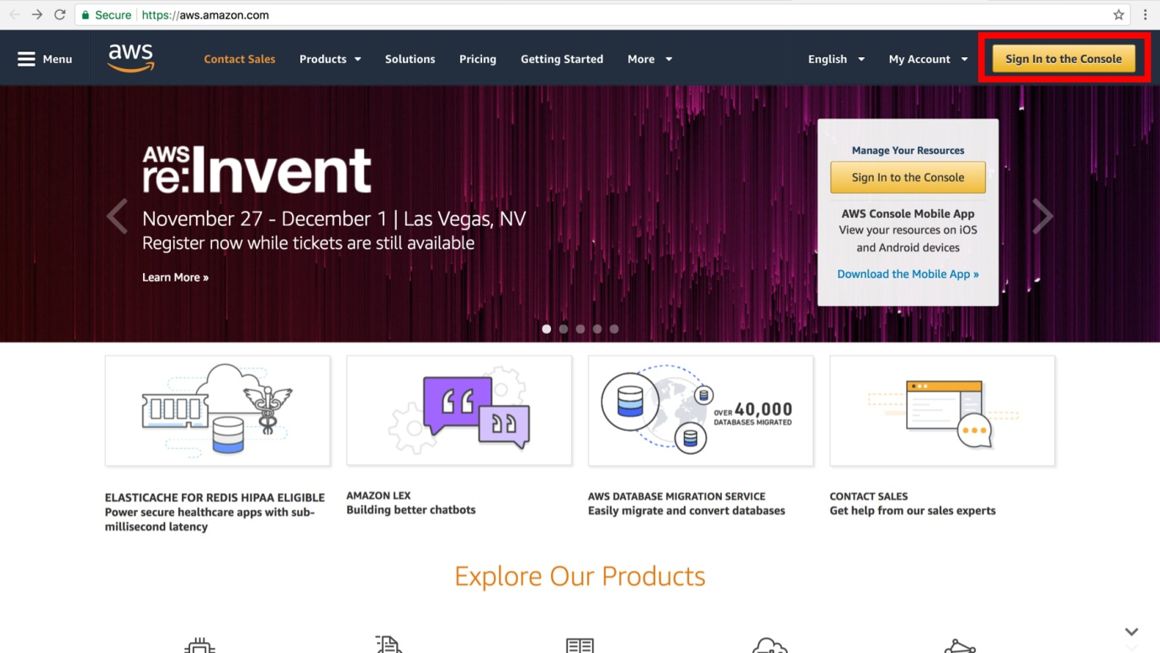

2.On the EC2 Dashboard, click on EC2.

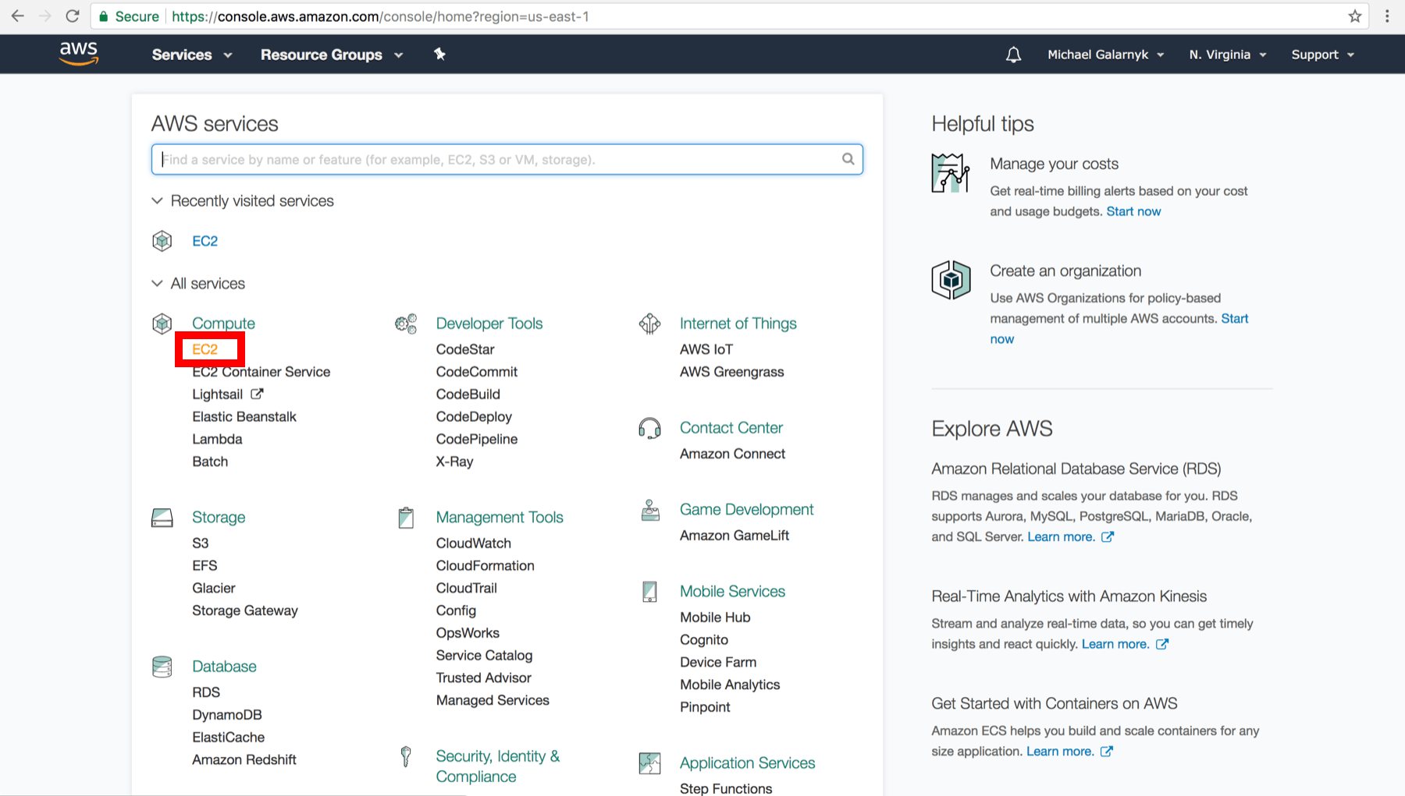

**Create an Instance**

3.On the Amazon EC2 console, click on Launch Instance.

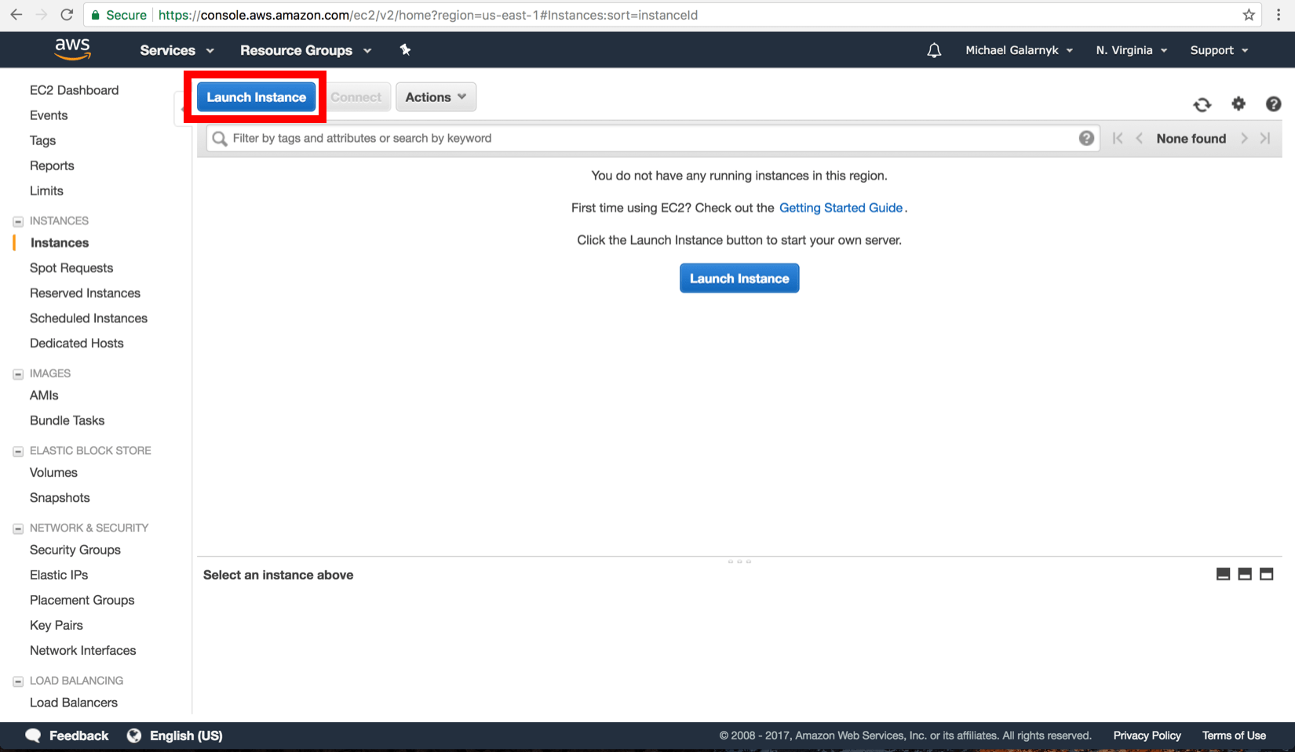

4.Click on the "Select" button in the row with Microsoft Windows Server 2016 Base. Please note that this will create a Windows based instance instead of a typical Linux based instance. This effects how you will connect to the instance.

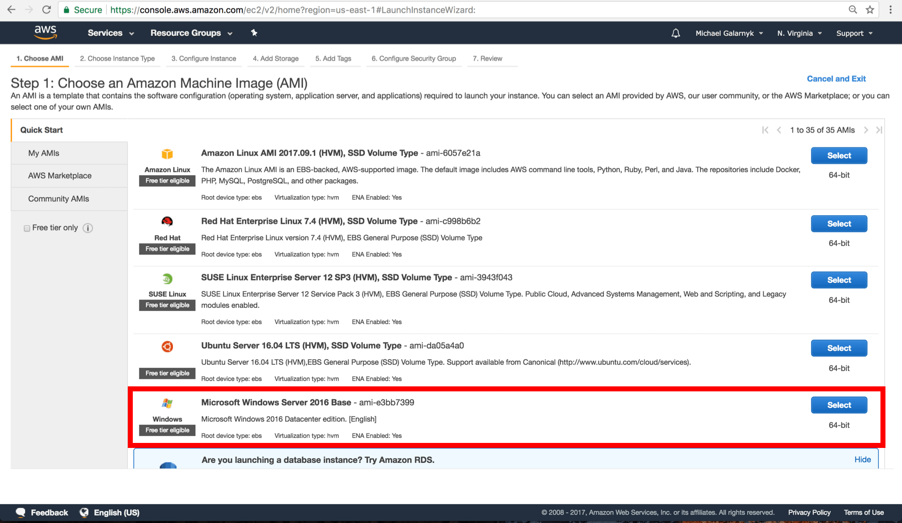

5.Make sure t2 micro (free instance type) is selected.

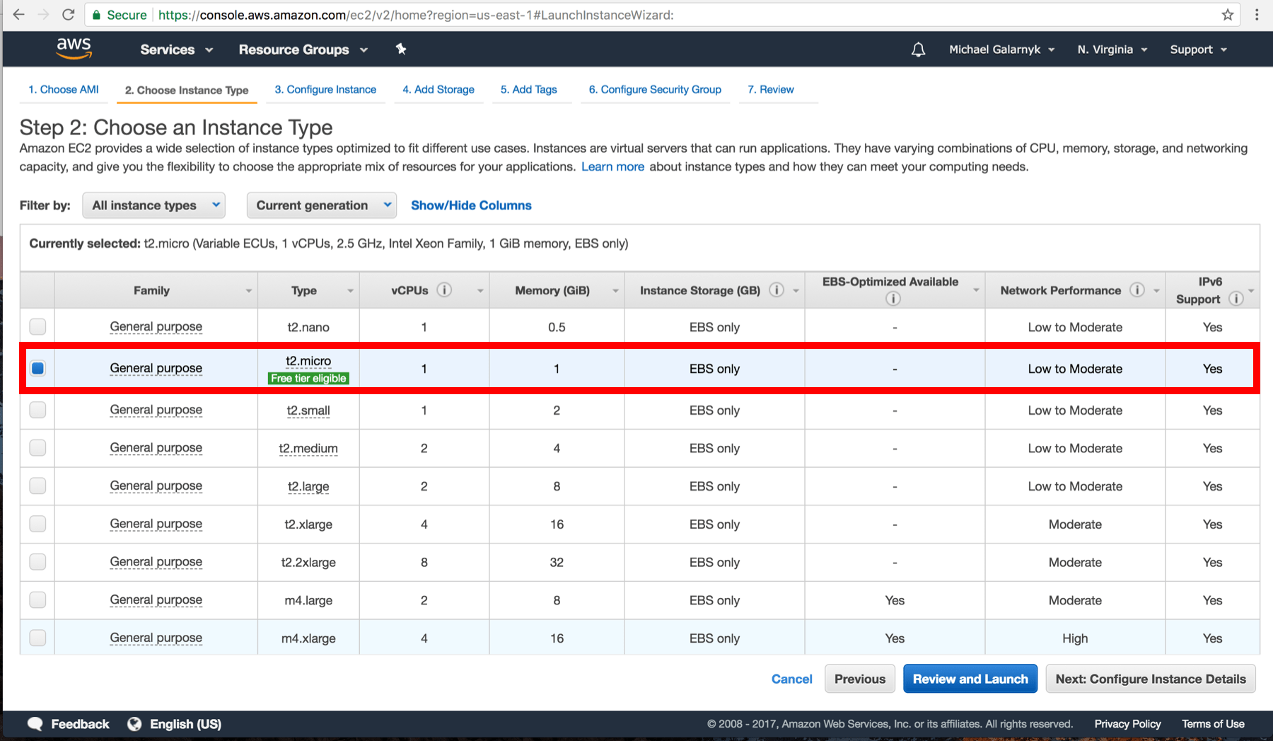

and click on "Review and Launch"

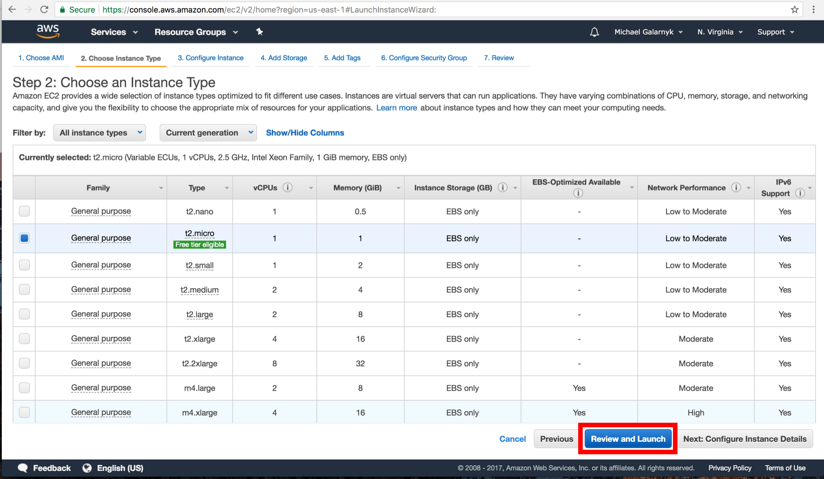

6.Click on Launch.

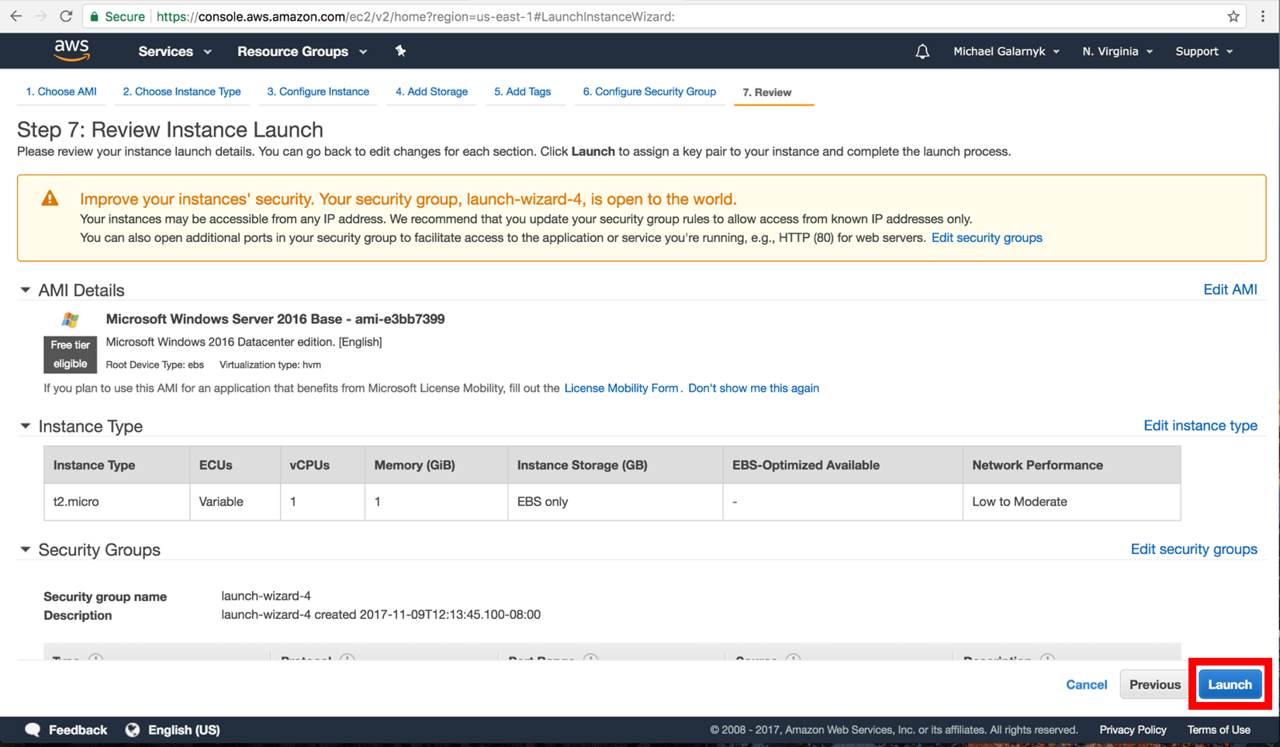

7.Select "Create a new key pair". In the box below ("Key pair name"), fill in a key pair name. I named my key DataCampTutorial, but you can name it whatever you like. Click on "Download Key Pair". This will download the key. Keep it somewhere safe.

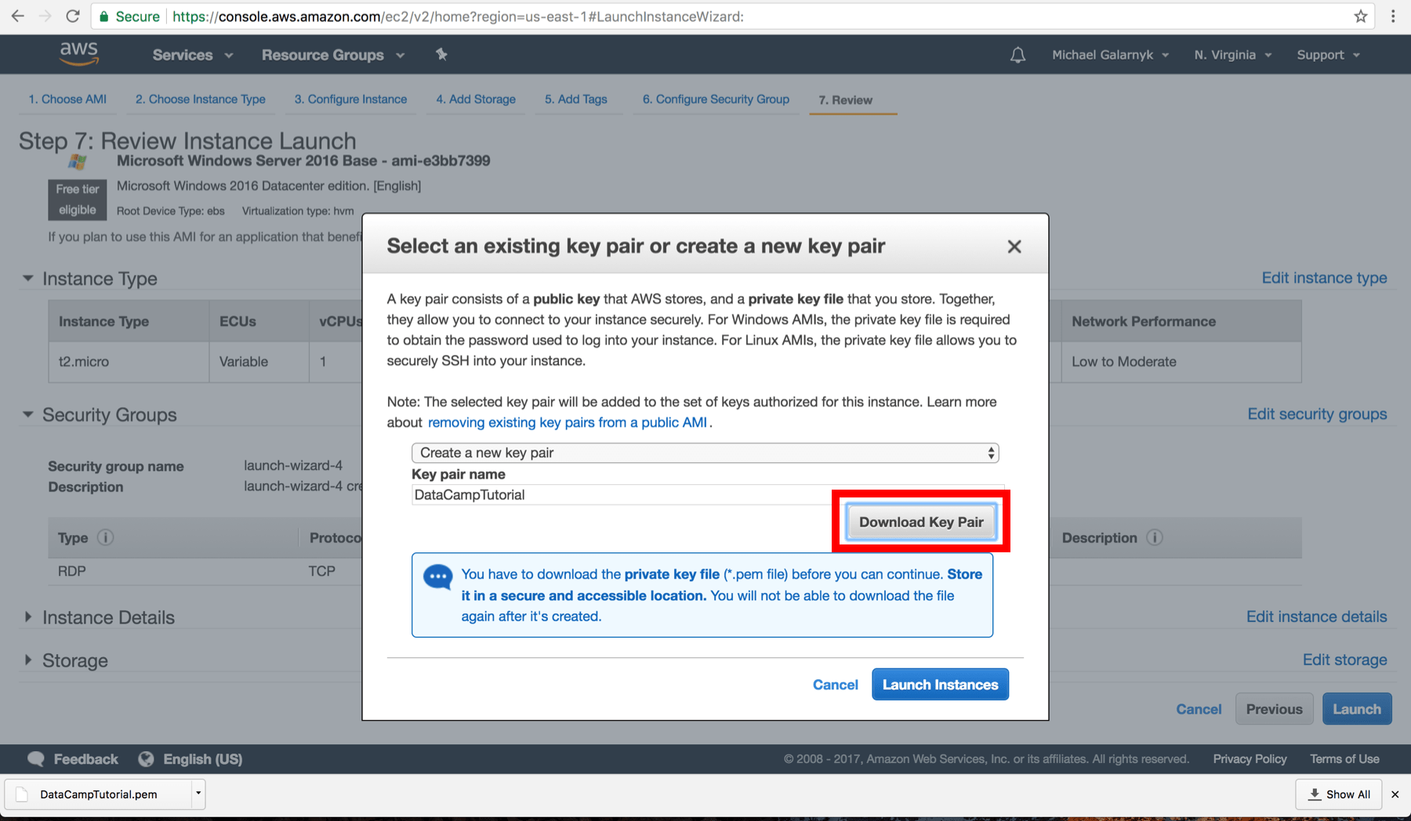

Next, click on "Launch Instances"

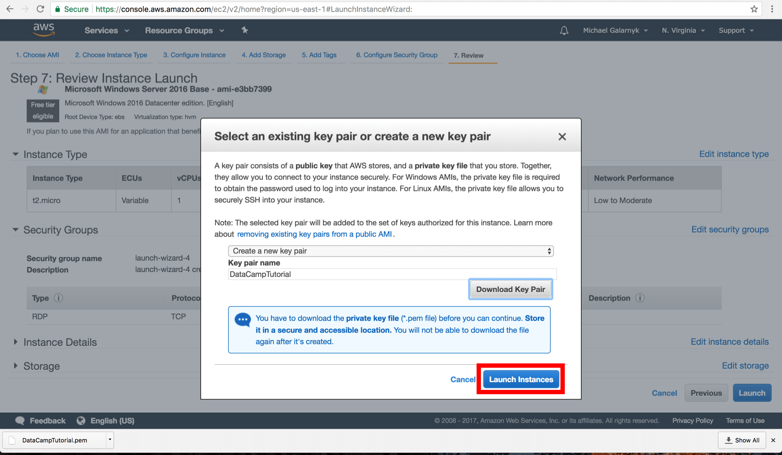

8.The instance is now launched. Go back to the Amazon EC2 console. I would recommend that you click on what is enclosed in the red rectangle as it will bring you back to the console.

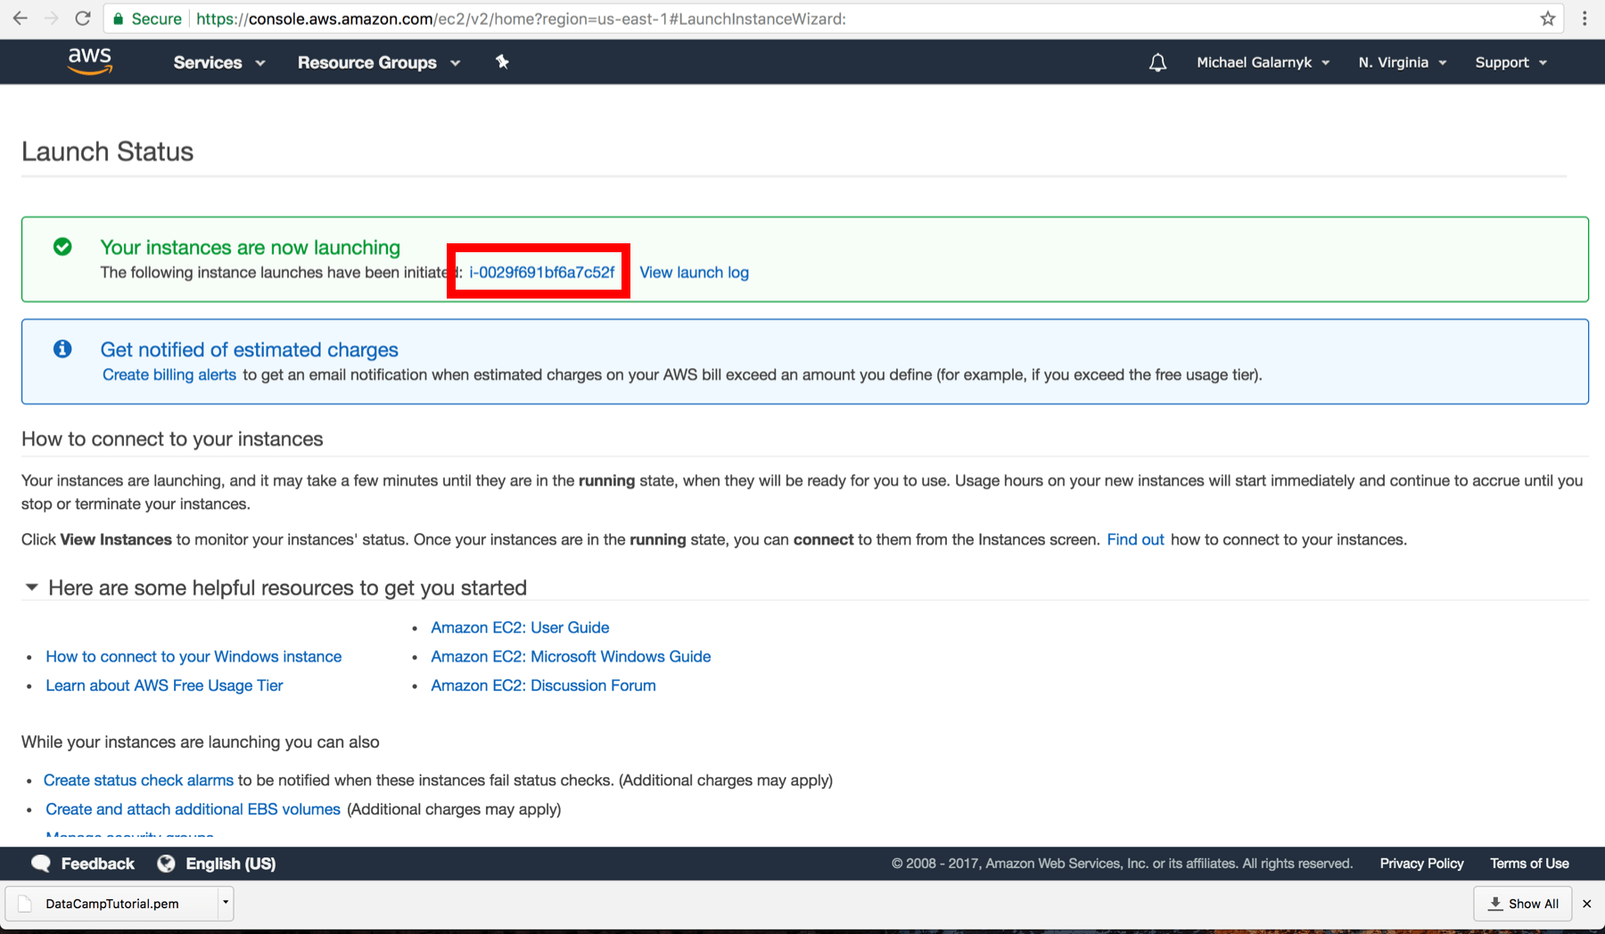

9.Wait till you see that "Instance State" is running before you proceed to the next step. This can take a few minutes.

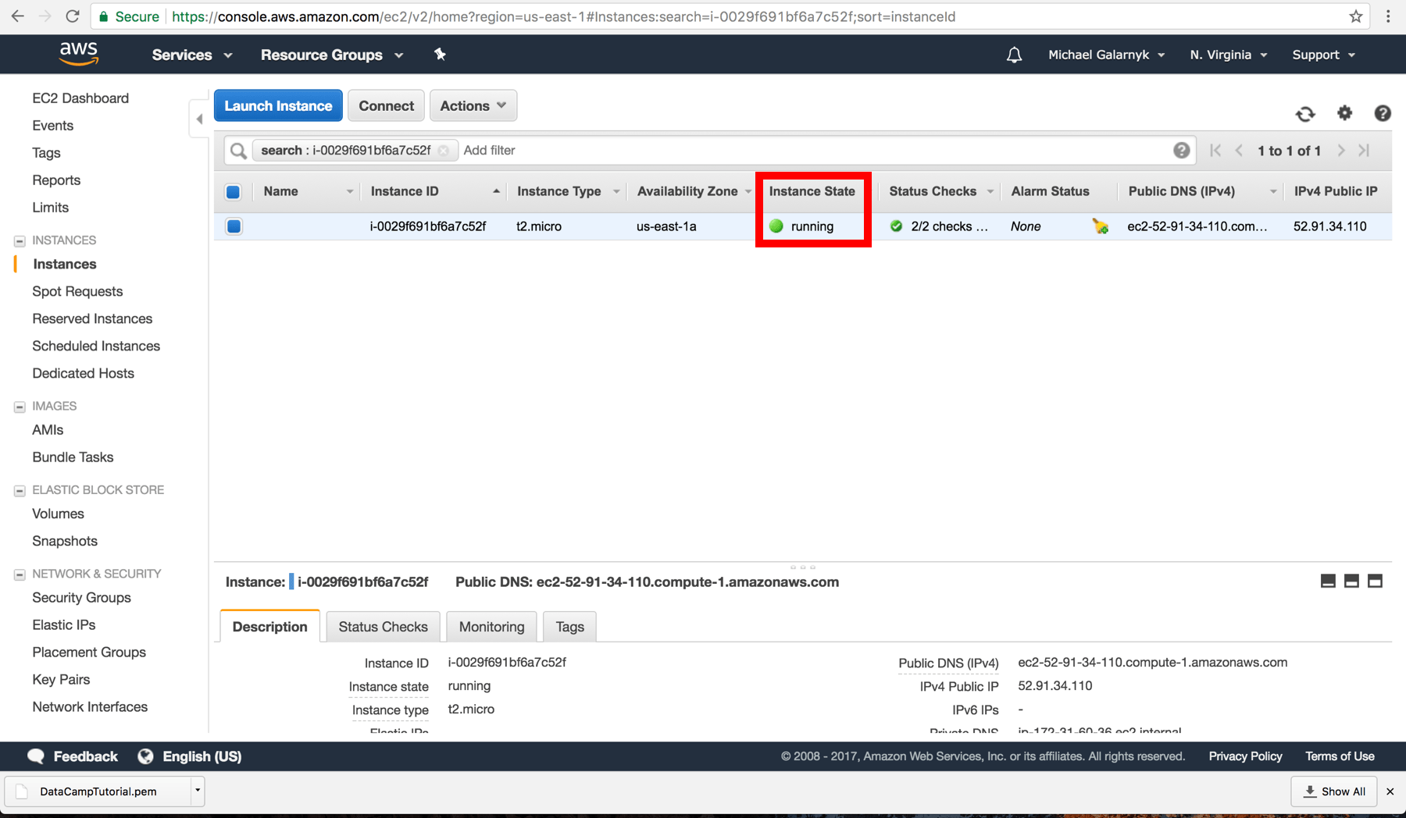

### Connect to your Instance

10.Click on connect.

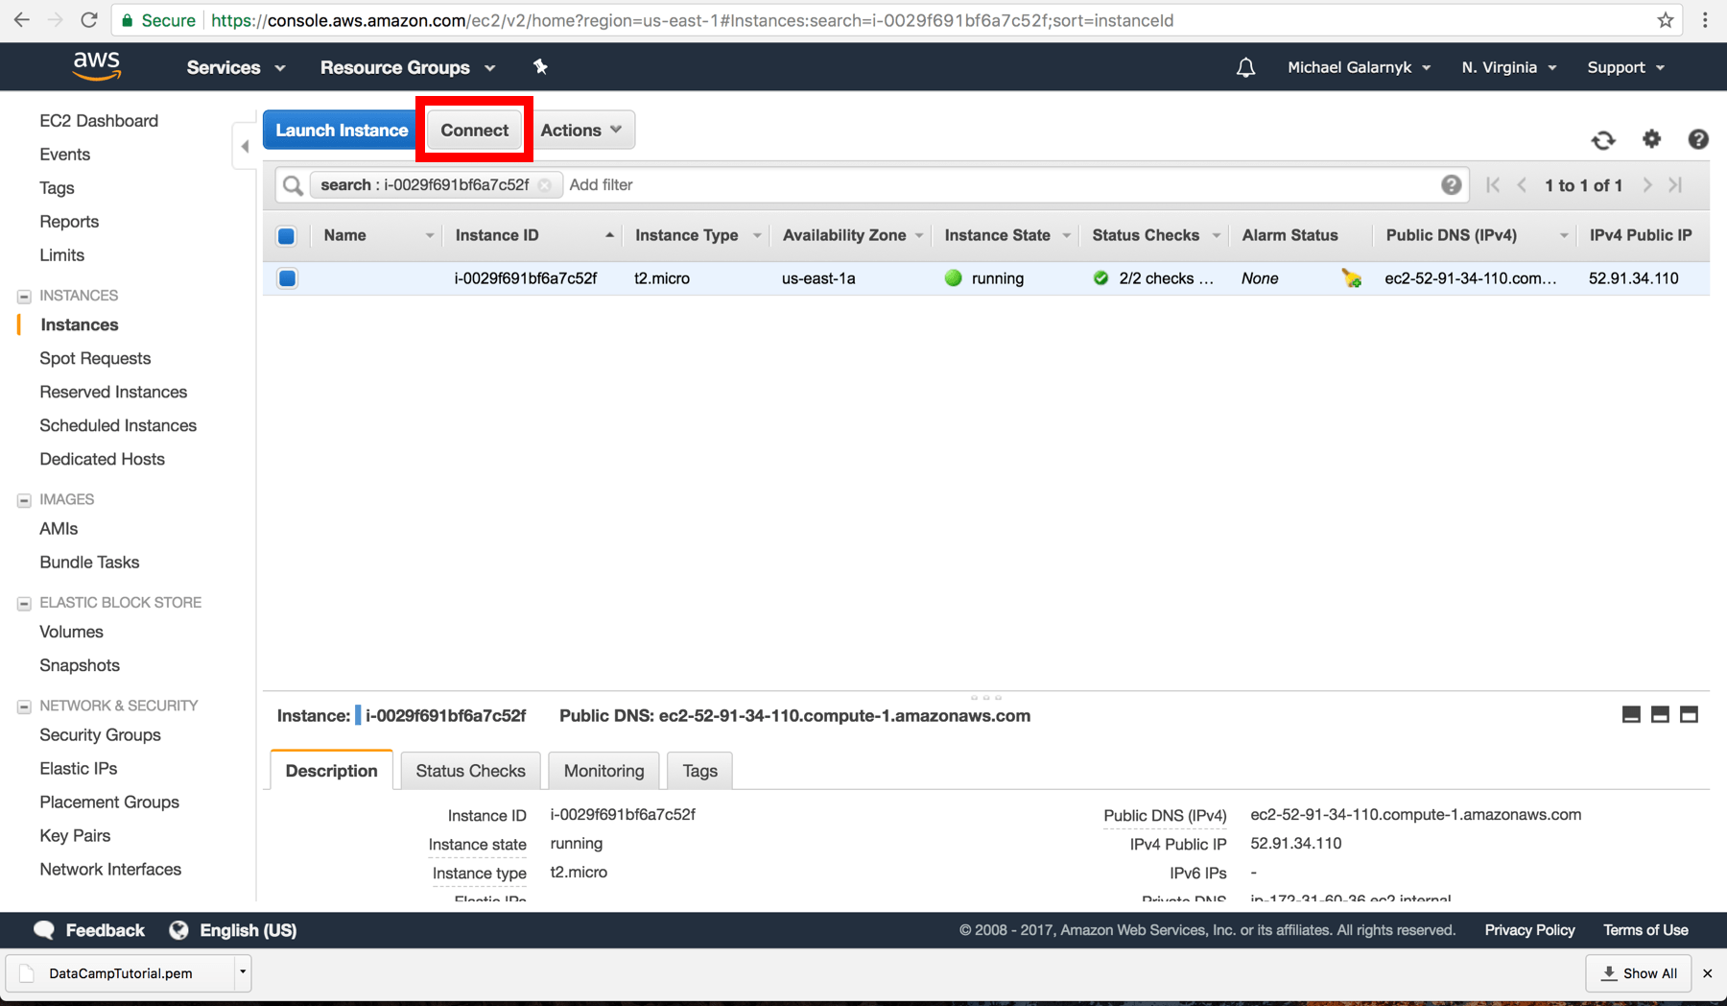

11.Click on "Download Remote Desktop File". Save the remote desktop file (rdp) file somewhere safe.

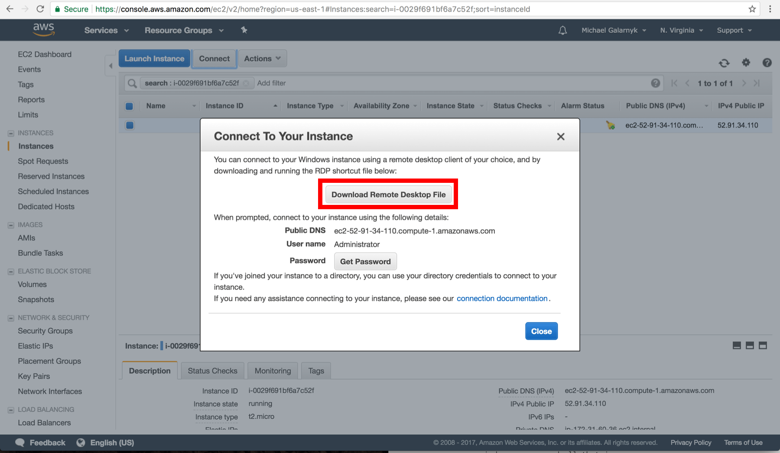

12.Click on "Get Password". Keep in mind that you have to wait at least 4 minutes after you launch an instance before trying to retrieve your password.

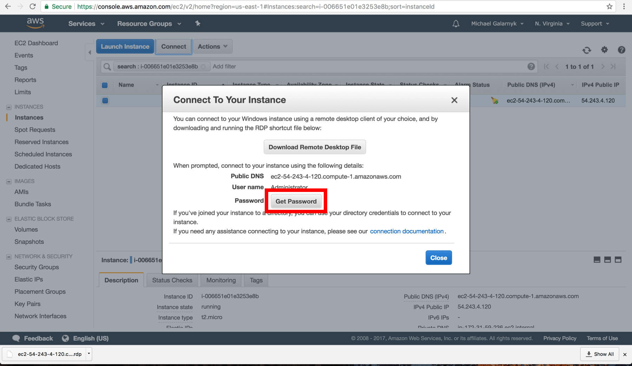

13.Choose the pem file you downloaded from step 7 and then click "Decrypt Password"

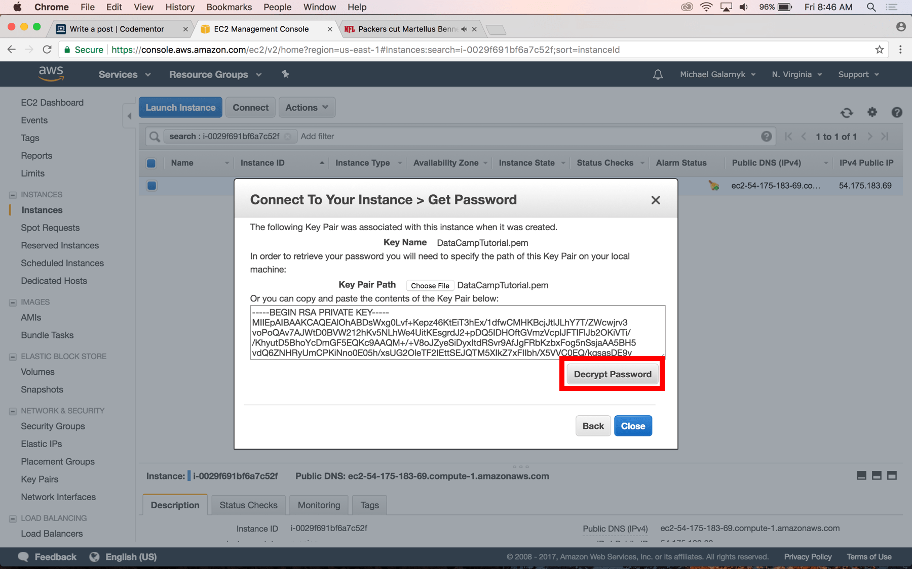

14.After you decrypt your password, save it somewhere safe. You will need it to log into your instance.

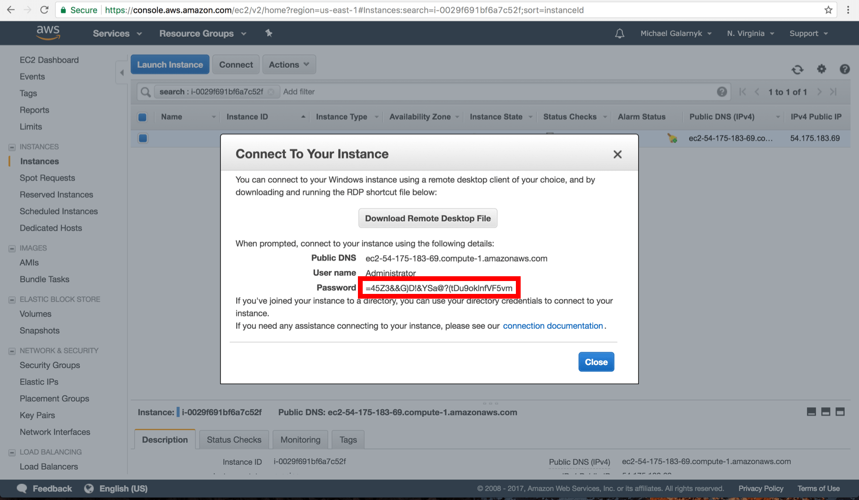

15.Open your rdp file. Click on continue. If your local computer is a Mac, you will need to download "Microsoft Remote Desktop" from the App Store to be able to open your rdp file.

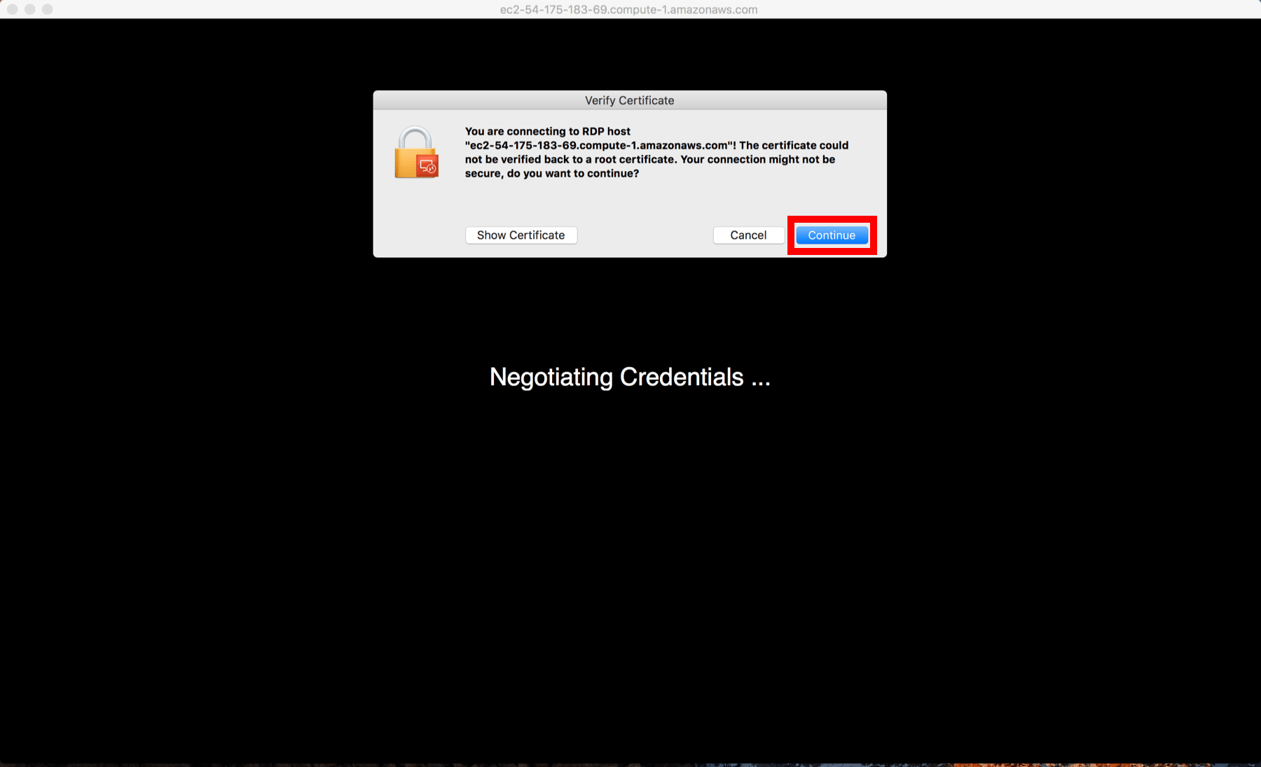

16.Enter your password you got from step 14

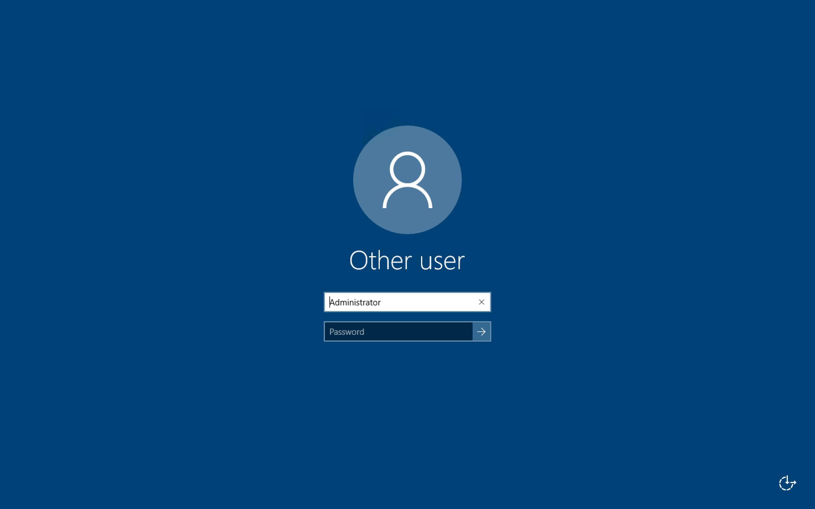

After you enter your password, you should see a screen like this

