COGNIVOX

1. Introduction
Cognivox is a multi-agent Generative AI system architected to perform deep reasoning, document intelligence, research automation, and tool-augmented actions in complex enterprise environments.
The system is designed around agent collaboration, retrieval augmentation, memory systems, and structured tool integration, forming a robust, auditable and highly transparent AI automation platform.
This document explains:
- system modules
- multi-agent dynamics
- data ingestion mechanisms
- retrieval & memory architecture
- tool orchestration
- security and operational aspects
The aim is to provide a clear technical understanding of how Cognivox works across all layers.
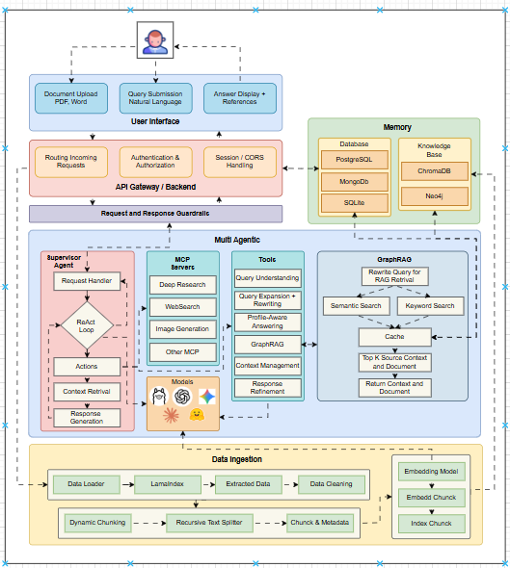

2. System Overview
Cognivox architecture consists of four major layers:
- User Interface Layer
- API Gateway & Backend
- Multi-Agent Orchestration Engine
- Data & Knowledge Systems (Memory + RAG + Databases)
These layers provide an end-to-end flow from user input → agent reasoning → tool execution → retrieval → final answer generation.

3. User Interface Layer
The UI provides the interaction surface for all user roles. It includes:

3.1 Document Upload Module
Supports:
- PDF (.pdf)
- Word (.docx)
- Images (JPG/PNG)
- Excel tables
Users can upload documents for ingestion, analysis, and RAG-based querying.

3.2 Natural Language Query Window
Allows users to input:
- questions
- research tasks
- comparison requests
- instructions

3.3 Answer Display Panel
Shows:
- final generated answer
- references (document pages, metadata)
- context used
- confidence indicators
- optional memory-derived signals

3.4 Role-Specific Views
End User View
- simple answers + references
- no agent traces
Analyst/Developer View
- agent chain
- tool calls
- retrieval context
- GraphRAG hops
- response refinement logs
Admin View
- system metrics
- model usage
- ingestion statistics
- permissions (RBAC/ABAC)
- infrastructure health

4. API Gateway / Backend Layer
This layer controls the secure flow of data from UI → Agents → Tools → Models.

4.1 Core Responsibilities

A. Request Routing
Maps each incoming request to the appropriate supervisor agent.

B. Authentication & Authorization
Uses:
- JWT
- Role-based and attribute-based policy enforcement
- Session tokens
- CORS restrictions

C. Request/Response Guardrails
Implements:
- input validation
- harmful content filtering
- safety rating
- tool execution permissions

D. Session Management
Tracks:
- active sessions
- memory inclusion/exclusion per user
- model preferences

5. Multi-Agentic Engine (Core Layer)
This is the most important component of Cognivox, consisting of:
- Supervisor Agent
- MCP Worker Agents
- Tools Layer
- Model Router
- GraphRAG Retrieval Module

5.1 Supervisor Agent
The Supervisor Agent controls the entire reasoning workflow.

Responsibilities
- Request Handling
Parses the incoming request and performs intent extraction.
- Chain-of-Thought Planning
Creates a multi-step plan for the worker agents.
- ReAct Loop Execution
Alternates between:
  - Thought
  - Tool usage
  - Observation
  - Next action
- Context Retrieval
Interacts with:
  - GraphRAG
  - Memory
  - Database
- Action Delegation
Assigns tasks to:
  - Search Agent
  - Document Agent
  - Reasoning Agent
  - Extraction Agent
  - Web Agent
  - Other MCP worker agents
- Final Response Generation
Combines:
  - tool results
  - retrieved context
  - worker agent output
  - refined answer
The Supervisor prioritizes safety, determinism, and accuracy.

5.2 Worker Agents (MCP Servers)
These are specialized agents with narrow skill sets.

Core Worker Types:
- Deep Research Agent
- WebSearch Agent
- Image Generation Agent
- Table Extraction Agent
- LLM-Tool Router Agent
- Summary Agent
- Document Agent
Each worker interacts with structured MCP tools.
Workers operate independently, but Supervisor coordinates them.

5.3 Tools Layer
Tools significantly enhance system ability beyond LLM reasoning.

Tools Include:
- Query Understanding Tools
- Query Expansion Tools
- Query Rewriting Tools
- Profile-Aware Rewriting
- Semantic RAG Tools
- GraphRAG Tools
- Content Management Tools
- Response Refinement Tools
Every tool adheres to strict schema validation via MCP.

5.4 Model Runtime Layer
Models run locally and remotely.

Local (Ollama engine)
- Qwen
- Llama
- Mistral
Used for:
- fast tasks
- offline mode
- cost efficiency

Cloud Models
- GPT
- Claude
- Gemini
Used for:
- heavy reasoning
- high accuracy

6. GraphRAG Engine (Retrieval Layer)
GraphRAG is the primary retrieval architecture and includes:

6.1 Query Rewriting for Retrieval
Before searching, the system rewrites the query to align it with document structure and embeddings.

6.2 Semantic Search
Uses embeddings from ChromaDB to locate chunks based on meaning.

6.3 Keyword Search
Classic text-matching algorithms for precision recall.

6.4 Graph-Based Multi-Hop Retrieval
From Neo4j:
- Entities
- Chunks
- Topics
- Relationships

6.5 Cache Layer
Caches:
- Top-K chunks
- utility scores
- document snippets

6.6 Final Context Assembly
GraphRAG outputs:
- ranked context
- document-based references
- chunk metadata

7. Memory Architecture
Memory is divided into four types:

7.1 PostgreSQL
Stores:
- user profiles
- system logs
- auth data

7.2 MongoDB
Stores:
- long-term memory embeddings
- ingestion metadata
- structured document info

7.3 ChromaDB
Stores:
- vector embeddings for documents
- semantic indexes

7.4 Neo4j
Stores:
- knowledge graph
- relationships
- entity maps
- topic clusters

7.5 SQLite
Stores:
- session-level short-term memory

8. Data Ingestion Pipeline
Before documents are usable by RAG:

8.1 Data Loader
Uploads raw files.

8.2 Lamination Layer
Breaks files into meaningful components:
- pages
- tables
- paragraphs

8.3 Extraction Layer
Extracts:
- raw text
- tables
- images
- metadata

8.4 Data Cleaning
Removes:
- noise
- formatting issues
- headers/footers
- OCR hallucinations

8.5 Dynamic Chunking
Chunks are created based on:
- semantic boundaries
- token sizes

8.6 Recursive Text Splitter
Splits long text intelligently to preserve context.

8.7 Embedding Generation
Converts processed chunks into vectors.

8.8 Index Building
Stores:
- embeddings in Chroma
- relationships in Neo4j
- metadata in MongoDB

9. End-to-End Flow of a Query
- User uploads a document or submits a query
- Backend validates and forwards to Supervisor
- Supervisor rewrites query (if needed)
- RAG retrieval fetches context
- Worker agents perform specialized tasks
- Tools refine content
- Models generate the final answer
- Response is refined and returned
- UI renders answer and references

10. Future Enhancements
- Multi-modal RAG (images + text)
- Real-time video-to-RAG pipeline
- Autonomous continuous-learning agents
- Multi-agent edge deployment

11. Summary
Cognivox is a highly modular, multi-agent, enterprise-ready GenAI system with deep integration of:
- RAG
- Knowledge graphs
- Tools
- Memory
- Ingestion
- Supervisor logic
The system is designed for accuracy, transparency, explainability, and enterprise-scale automation.

