Industry 4.0 Smart Clause Selection

1. Introduction
This document presents the Technical Approach and Validation Report for the SmartClause Proof of Concept (PoC) developed for the HAL Procurement System. The PoC expands the earlier implementation, which was limited to Annexure-2A and Annexure-2B, to now include Annexure-1, Annexure-2, Annexure-3, and Annexure-4 within a single, unified workflow.
The objective of this document is to describe the system architecture, user interaction flow, annexure logic, and validation outcomes in a clear and implementation-oriented manner, aligned with the actual PoC execution.

2. Problem Statement
Preparation of RFQs in large procurement organizations involves identifying and assembling the correct set of contractual, commercial, and compliance clauses from multiple regulatory sources. Clause applicability depends on several parameters such as tender mode, tender type, estimated value, vendor category, and nature of goods or services.
In the current manual process, this activity is time-consuming and prone to inconsistencies and omissions. SmartClause addresses this challenge by introducing a deterministic, rule-driven system that automates clause selection and annexure generation, thereby improving consistency, traceability, and turnaround time.

3. Objectives of the SmartClause
The key objectives of the SmartClause are:
- To automate clause selection using deterministic, rule-based logic
- To demonstrate end-to-end RFQ and annexure generation
- To validate clause applicability across different value thresholds and tender scenarios
- To support offline deployment in a secure enterprise environment
- To generate standardized Excel and PDF outputs that are directly usable by procurement users

4. High-Level System Architecture
The SmartClause PoC follows a layered and modular architecture to clearly separate user interaction, business logic, annexure processing, data management, and output generation. This design ensures maintainability, scalability, and ease of validation.

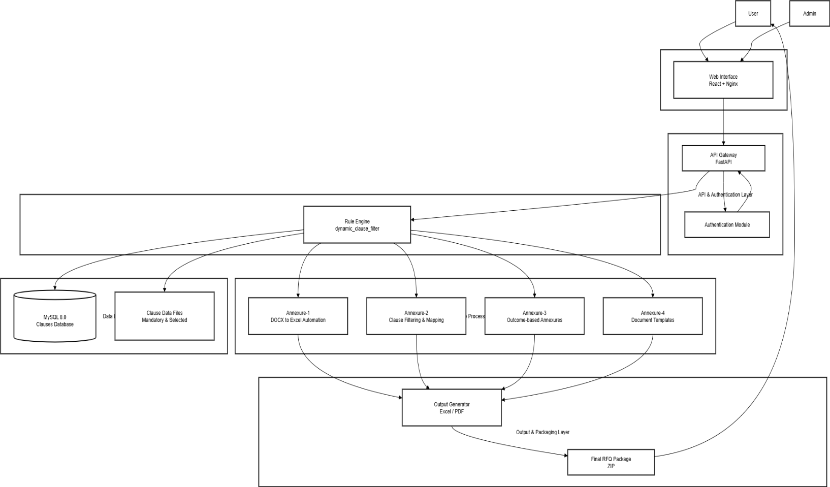

5. Detailed Architecture Description

5.1 Presentation Layer
The presentation layer is a browser-based web application built using React and served through Nginx. It provides a guided, step-wise user experience for RFQ and annexure generation. The interface supports both standard users and administrative users, allowing administrators to manage clauses and configuration data.

5.2 API & Authentication Layer
The backend is implemented using FastAPI and acts as the API gateway. This layer is responsible for request validation, authentication, and routing. Only authenticated users are allowed to execute rule evaluations or generate annexures, ensuring controlled access within the enterprise environment.

5.3 Application & Rule Engine Layer
This layer contains the core business logic of SmartClause. The Rule Engine, implemented in Python, evaluates tender input parameters against predefined deterministic rules. Based on this evaluation, the engine identifies applicable clauses and determines which annexures need to be generated.

5.4 Annexure Processing Layer
Each annexure is implemented as an independent module:
- Annexure-1: Automates conversion of proprietary DOCX documents into structured Excel compliance matrices.
- Annexure-2: Filters and maps applicable clauses based on rule engine output.
- Annexure-3: Generates outcome-based annexures driven primarily by estimated tender value.
- Annexure-4: Generates pricing and document templates using uploaded files or external data sources.

5.5 Data Layer
The data layer consists of a MySQL 8.0 database storing master clauses, metadata, and rule mappings. Supporting data files are used for mandatory clause lists and annexure templates.

5.6 Output & Packaging Layer
This layer generates final Excel and PDF documents using standard libraries and packages all outputs into a single ZIP file for user download.

6. User Interface Flow and Input Dependency
The SmartClause PoC user interface is designed as a two-step workflow, clearly separating document-driven annexures from rule-driven annexures.

6.1 Page 1: Annexure-1 and Annexure-4 Inputs
The first page focuses on annexures that are independent of tender filtering parameters.
- Annexure-1: Users upload proprietary DOCX files, which are automatically converted into structured Excel compliance matrices.
- Annexure-4: Users upload pricing or data files (XLS/XLSX/CSV) or connect to an Oracle database to generate standardized pricing or document templates.
These inputs do not depend on tender mode, estimate, or vendor type.
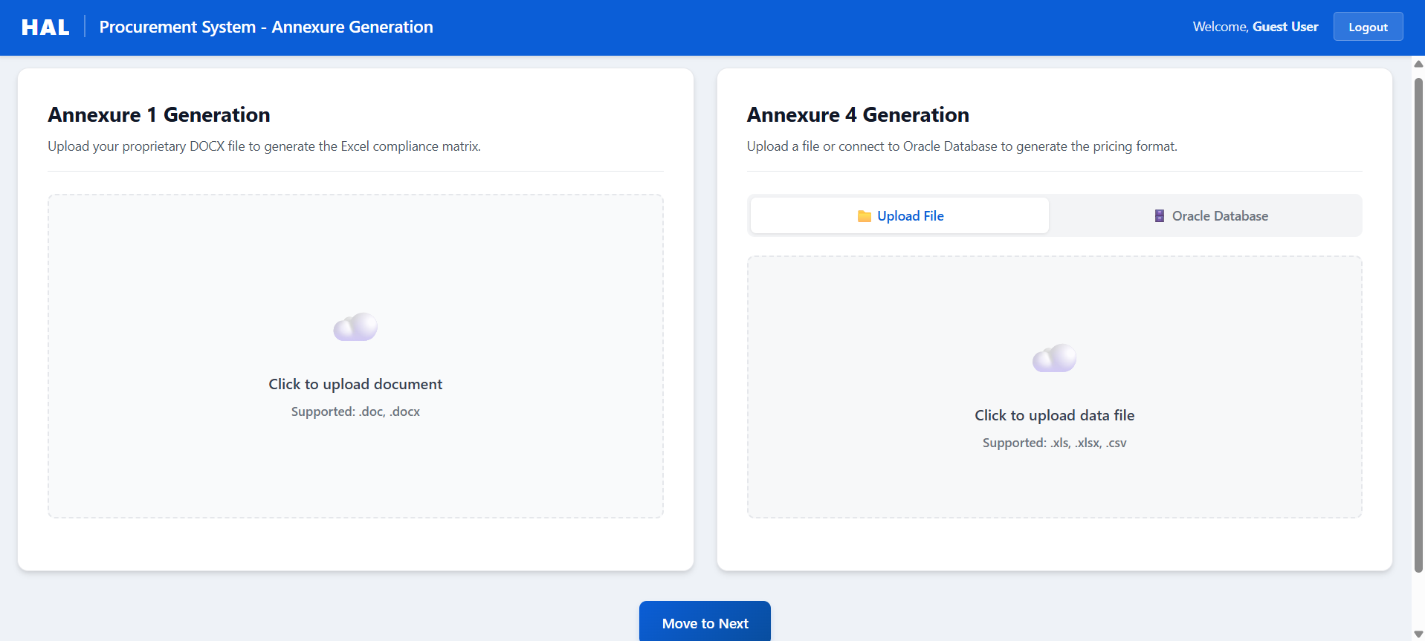

6.2 Page 2: Annexure-2 and Annexure-3 Inputs
The second page captures tender-specific parameters required for clause selection:
- Mode of Tender
- Type of Tender
- Estimated Value (Estimate)
- Vendor Type
- Goods / Services
- Other applicability flags
These parameters are passed to the Rule Engine for evaluation.
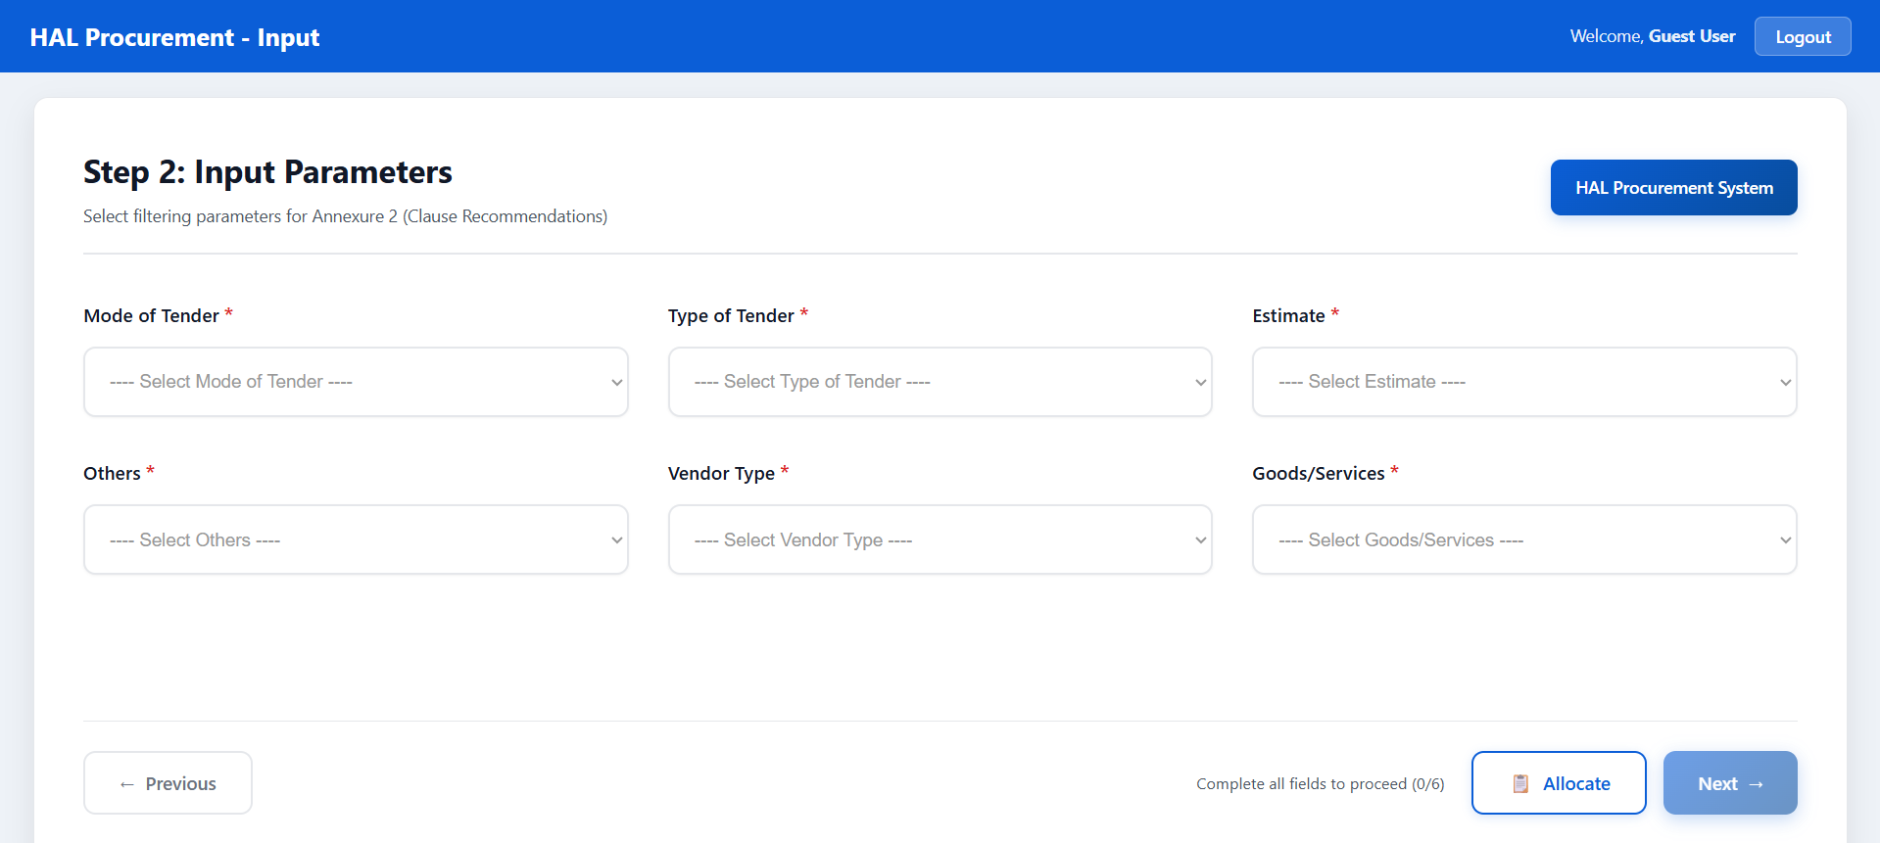

6.3 Estimate-Based Dependency
The Estimated Value parameter plays a key role in output determination:
- It influences clause applicability in Annexure-2
- It directly controls outcome selection in Annexure-3
Specifically:
- Estimate < ₹10 Crores → Lower-value Annexure-3 output
- Estimate ≥ ₹10 Crores → Higher-value Annexure-3 output
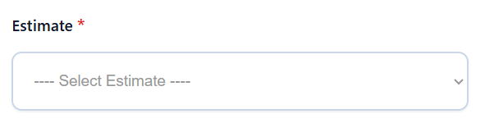

6.4 Combined Output Generation
After inputs from both pages are processed, outputs from Annexure-1 through Annexure-4 are generated in a single execution flow and packaged together as the final RFQ output.
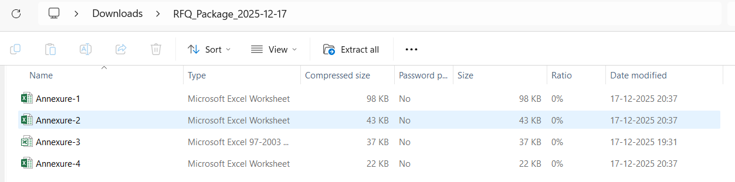

7. Validation of Inputs and Outputs
Validation was performed by correlating user inputs with system outputs across multiple test scenarios. The following observations were confirmed during the PoC:
- Identical inputs consistently produce identical outputs
- Annexure-3 outputs change correctly based on estimate thresholds
- Clause selection in Annexure-2 aligns with defined Input parameters
- Generated Excel and PDF files are structurally and functionally correct
- Zip file all Annexure Together
These results confirm the deterministic and reliable behavior of the SmartClause.
7.1 Annexure -1
- Input docx
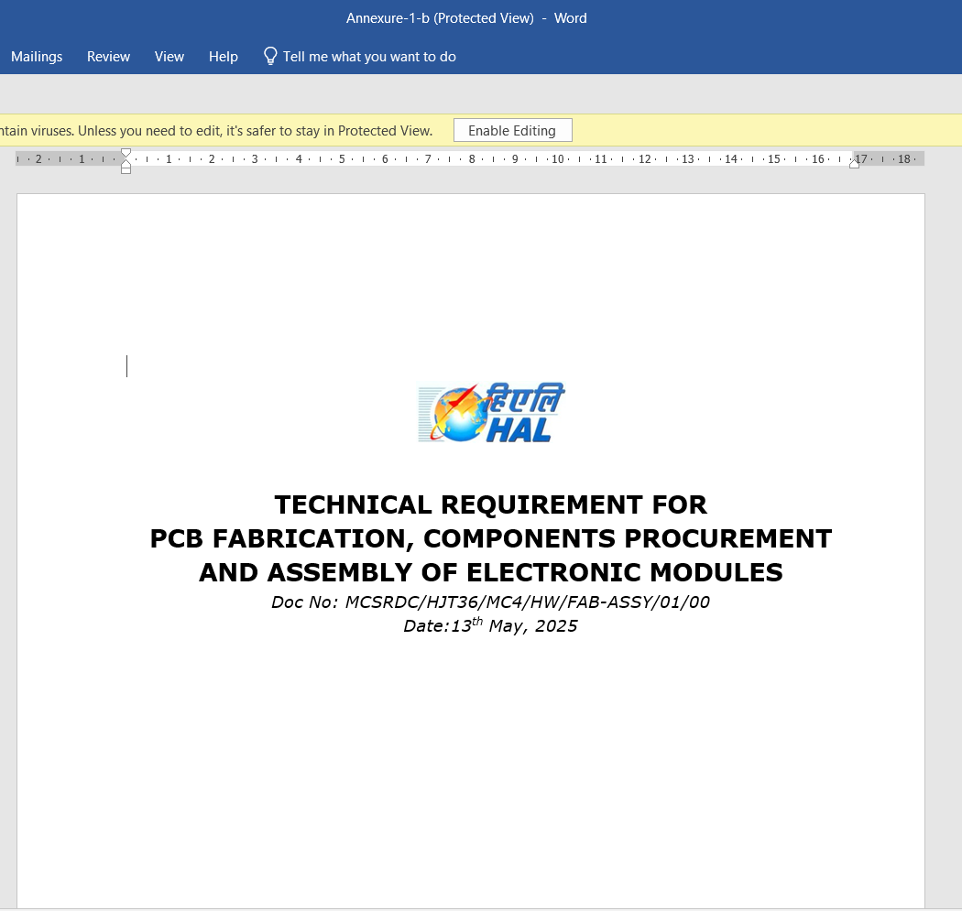
- Output Generated
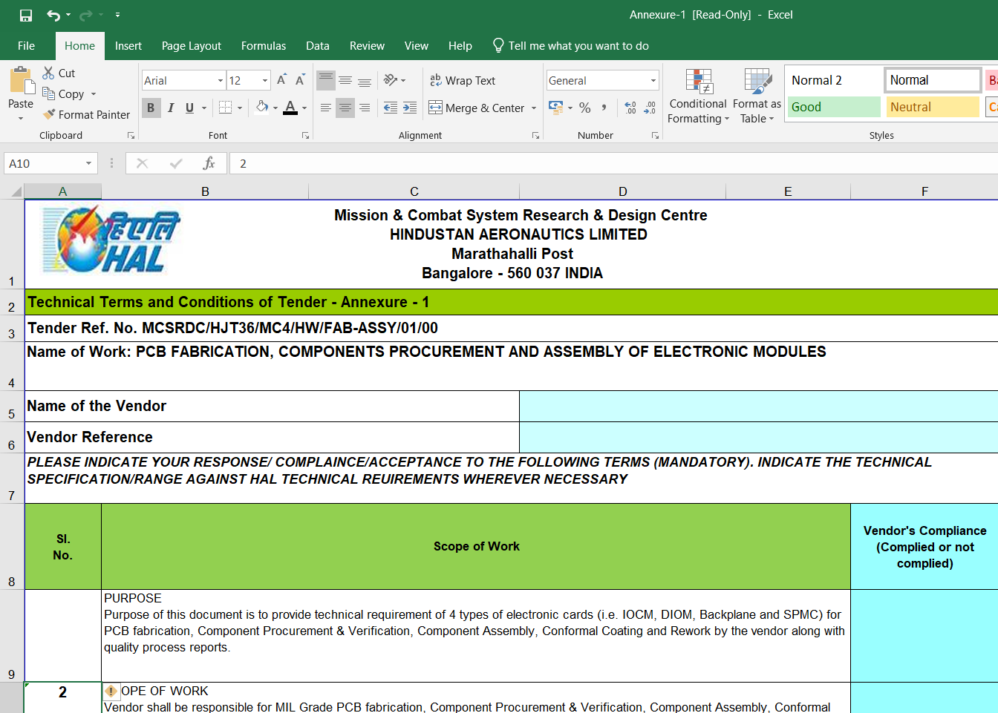

7.2 Annexure – 2
- Test case – 1
Mode of Tender | Type of Vendor | Estimated Value | Others | Type of Vendor | Goods & Service
Manual | Open | 5 cr and above | Design & Production | Indian | Goods

Expected output: Integrity Pact
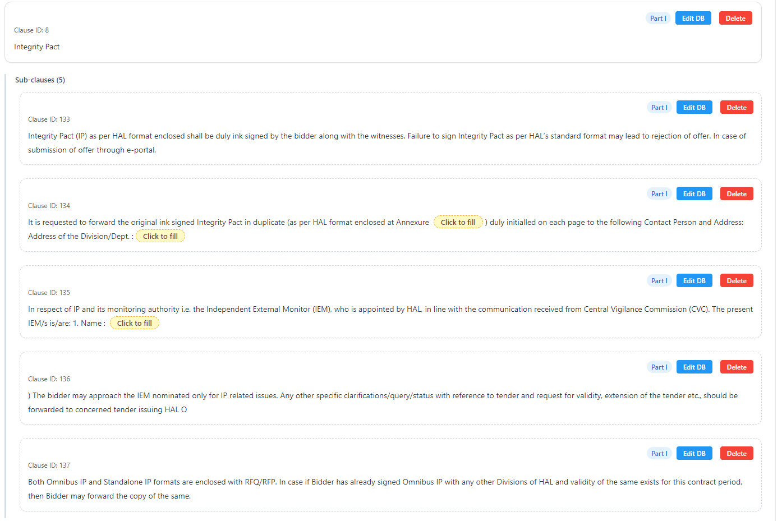

- Test case – 2
Mode of Tender | Type of Vendor | Estimated Value | Others | Type of Vendor | Goods & Service
Manual | Open | 5 cr & above | Design & Production | Indian | Goods

Expected output: Security Deposit
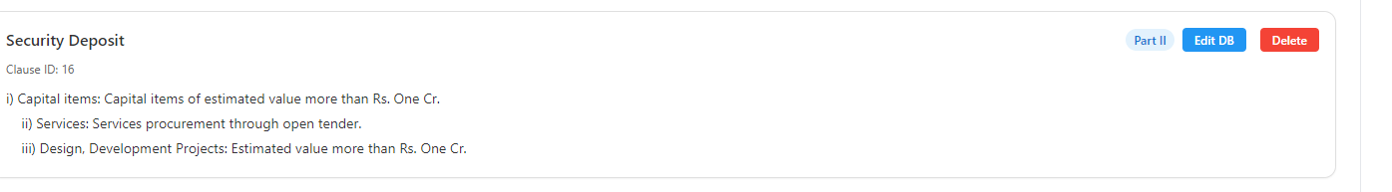

- Test case – 3
Mode of Tender | Type of Vendor | Estimated Value | Others | Type of Vendor | Goods & Service
Gem/eportal | Open | 1 crore & above | Design & Production | Both | Goods

Expected output: PBG both Indigenous & Foreign bidders
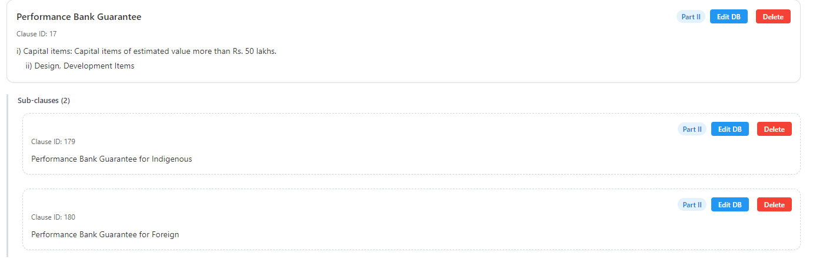
- Test case - 4

Mode of Tender | Type of Vendor | Estimated Value | Others | Type of Vendor | Goods & Service
Gem/eportal | Global, open, limited | 1 crore & above | Design & Production | Both | Goods

Expected output: Repeat Order
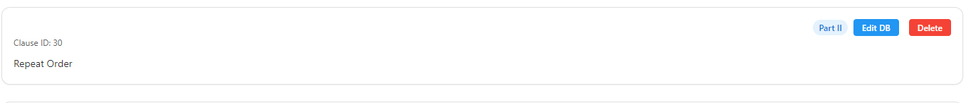

- Test case – 5
Mode of Tender | Type of Vendor | Estimated Value | Others | Type of Vendor | Goods & Service
Email | Open | 1 crore & above | Design & Production | Indian | Goods

Expected output: PBG Indigenous bidder
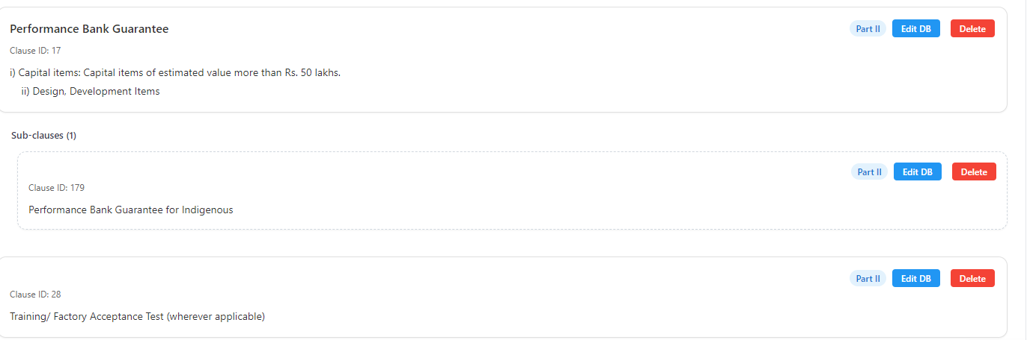

- Test case – 6
Mode of Tender | Type of Vendor | Estimated Value | Others | Type of Vendor | Goods & Service
Manual | Open | 50 lakhs & above | Design & Production | Foreign | Goods & Service

Expected output: PBG Foreign bidder
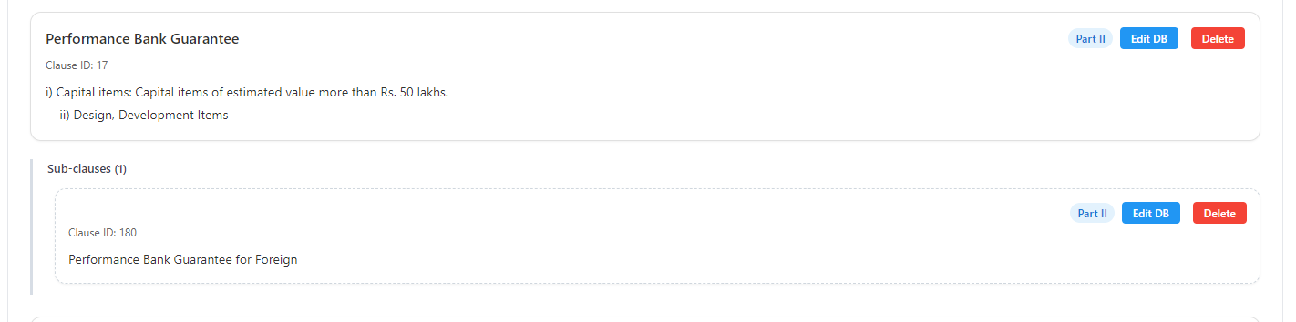
- Test case –
Mode of Tender | Type of Vendor | Estimated Value | Others | Type of Vendor | Goods & Service
Email | Global, open, limited | 5 lakhs & above | Design & Production | Foreign | Service

Expected output: Withholding Tax
7.3 Annexure – 4
- Input csv
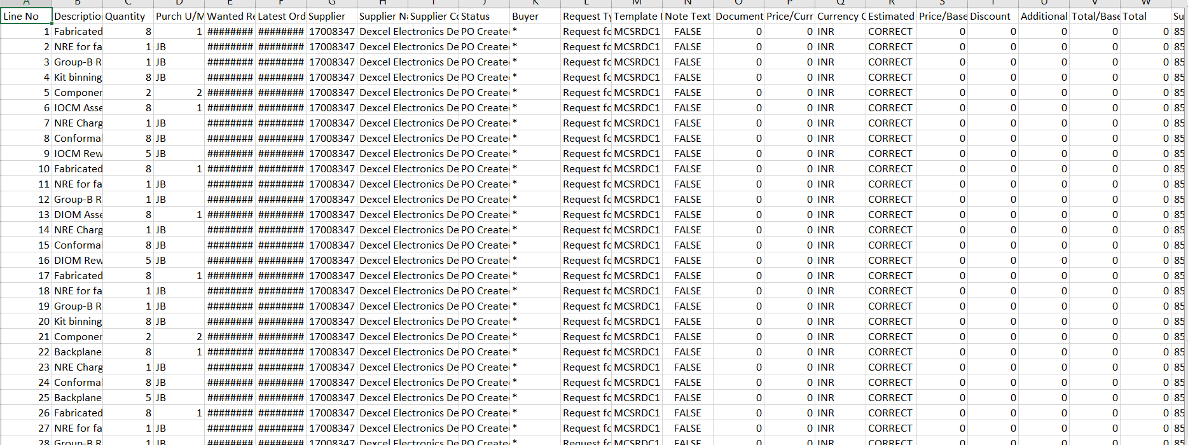
- Output Generated
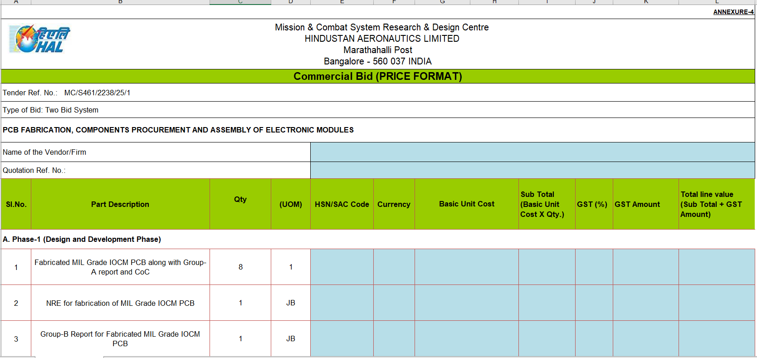

8. Conclusion
The SmartClause PoC successfully demonstrates a complete, rule-driven approach for RFQ clause selection and annexure generation. By integrating Annexure-1, Annexure-2, Annexure-3, and Annexure-4 into a unified workflow, the system significantly reduces manual effort, improves compliance consistency, and provides a scalable foundation for future enhancements.
Deployment & Testing Summary:
The PoC has been successfully deployed on a production server using Dockerized services (MySQL, FastAPI backend, Nginx frontend) and tested across multiple client systems connected to the server. All test scenarios produced correct outputs, validating the system's reliability in a networked enterprise environment.

