

DESIGN DOCUMENT

Lab 2 (Training Part)

COMP8117-1-R-2021S

SUBMITTED TO:

Dr. Aznam Yacoub

LAB PARTNER

ARSHDEEP KAUR

110030302

SUBMITTED BY:

ANUBHA SHARMA

110037181

Version 1

18-06-2021



##### Question 1. In your opinion, what kind of computational problems (representations, computations, structures, algorithms, …), do you have to solve when you read these specifications? What details are not expressed in these specifications?

The approach followed is top-down.

1. There is a lack of clarity around artificial intelligence, like how the artificial intelligence is employed.
2. The NFR has a mismatch as a result of the mobile app.

##### Question 2. Rewrite the specifications from the computational point of view in an informal way.

1. Login using user name and password. User inputs username and password. The system authenticates the same, and the user is granted access to the system.
2. Forget password feature can be used to update the current password in case user forgets. User inputs the new password, system updates the current password and user can login using the new password.

**Question 3. Represents these new specifications using Class Diagrams and Sequence Diagrams. What do you notice?**

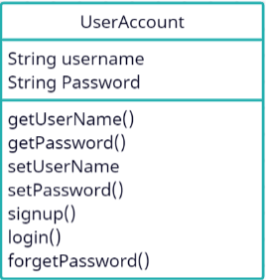

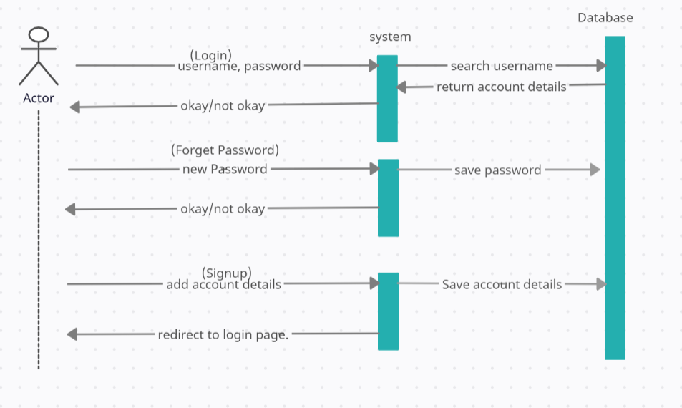

**Question 4. Implement with the language of your choice these diagrams without assuming more than the information represented in your diagrams. What do you notice?**

