

DESIGN DOCUMENT

Lab 2

COMP8117-1-R-2021S

SUBMITTED TO:

Dr. Aznam Yacoub

LAB PARTNER

ARSHDEEP KAUR

110030302

SUBMITTED BY:

ANUBHA SHARMA

110037181

Version 1

18-06-2021



##### Translate the user domain expressed in this need to specifications using UML diagrams of your choice.

The domain of the simulation of biological animals. Here in particular, we will be showing the evolution of the butterfly.

The below state diagram shows the different stages of the evolution of the butterfly

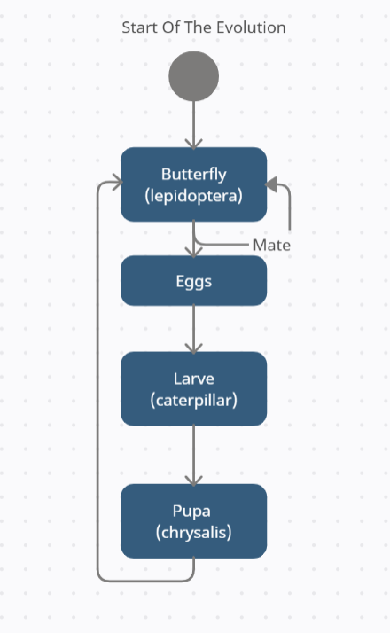

##### Choose an architecture to implement the simulator and create a high-level design using UML Class Diagrams. Your diagram must highlight the architecture.

This implementation uses state pattern defined

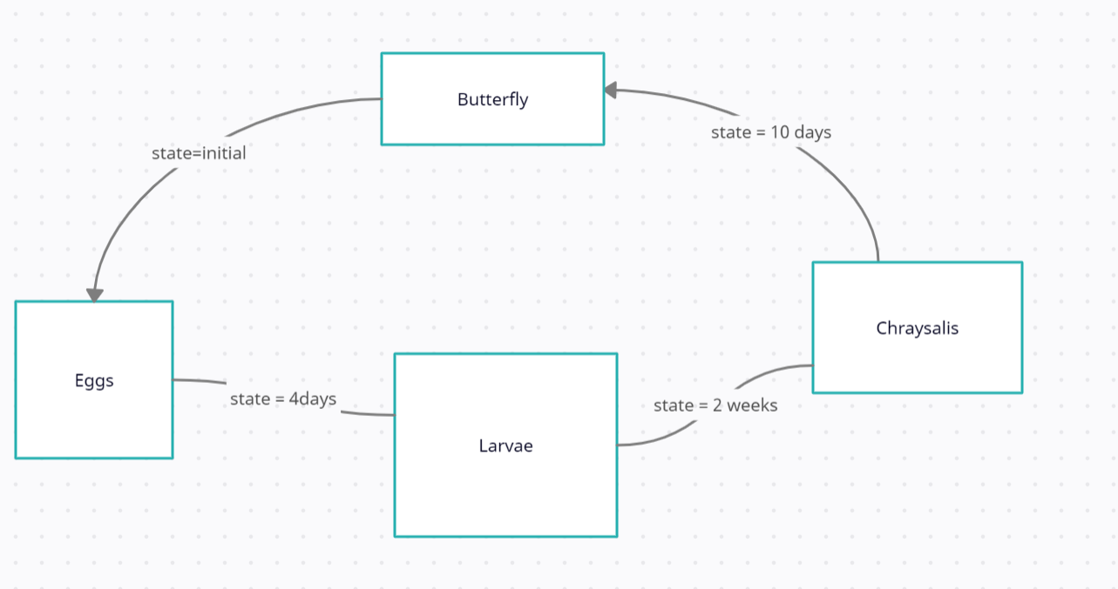

1. **Choose a programming language and a framework to create your simulator. Create low-level diagrams representing your simulator.**

The language that chosen to create the simulator is Java. The program uses state pattern to implement the simulation.

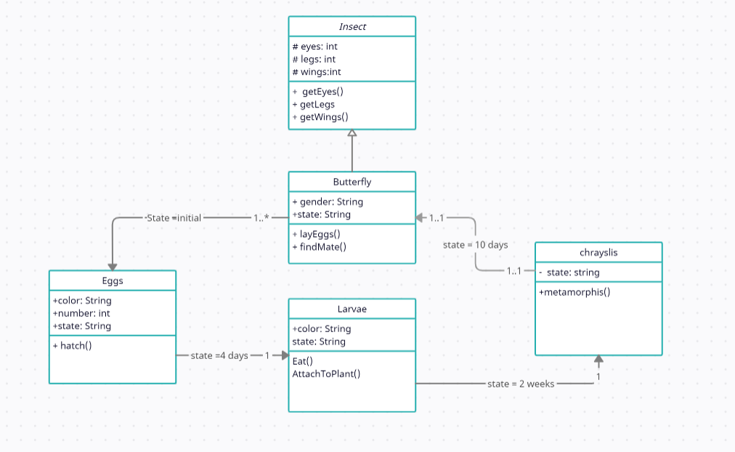

1. **Implement a prototype of simulator using the diagrams, programming language and framework you decided in question 3. Evaluate the percentage of work overload (how many details were not present in the diagram and that you had to add during the implementation).**

All the java files can be found with the attached package

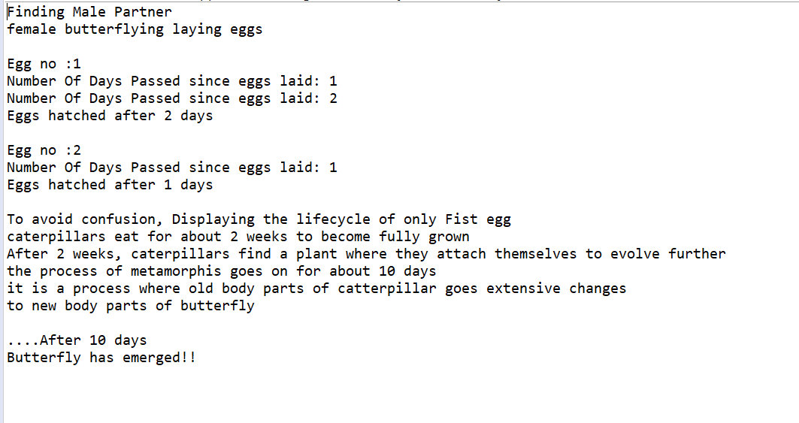

The work overload:

1. For the butterfly class, 2 details were not present, the no of eggs laid and the partner details, which makes about 10% of the work.
2. Larvae has to extend the insects, which was not mentioned in the diagrams.