**Constraint Analyzer Project**

**Constraint Data:**

* Source - Data is taken from the years 2015 to 2018.
* Energy Velocity is the vendor from where Historical Constraint data is pulled out.
* The reason for taking two different data sources for Constraint data and Transmission Outages data is that the mapping document used for mapping the Constraint-Contingency pair to the Transmission Lines in PowerWorld is pulled from ERCOT which maps more closely to Energy Velocity’s Constraint data than Yes Energy’s Constraint Data.
* Although, we are trying to pull constraint data from Yes energy as well and compare whether the above-mentioned fact is correct or not.
* Parameters considered in Historical Constraint Data:
* Monitored Element Name
* Contingency Name
* Local Date Time (Hour Beginning) with minutes
* Shadow Price ($/MWh)
* ISO Name
* Flowgate Name
* Time Zone
* Market Type
* Off/On Peak (entered manually by us)

All the columns other than the one mentioned above are deleted for all the years.

Mapping Documents:

* Mapping documents which are considered are from the year 2019 July month.

Processing of constraint data:

* Unique pairs of contingency-monitored element are extracted and stored in a new file.
* This new file is used for mapping the contingency name to its from bus number and to bus number, similarly monitored elements are mapped to the from bus number and to bus number.
* Observations after mapping for contingency name:

Total unique pairs – 11867

Unmapped Contingency names – 8015

Mapped Contingency names – 3852

Examples of names which were not mapped: Mostly had a full name rather than just characters and numbers.

Contingency names in historical data:

Lamar Power Prt.- Paris Sw 345kv

Concord to Johnson Switch (Oncor) 345 KV

Midlothian Anp (Amer Nat Pwr) to Venus Switch 345 KV

DMBDMBD5

Actual

‘Contingency’ column values in mapping document:

DADEWES8

DADNPLW8

DAMOLAM9

DCHSPSA8

* Observation after mapping for monitored element name:

Total unique pairs – 11867

Unmapped monitored element names – 3851

Mapped monitored element names – 8016

Both contingency and monitored element mapped – 2634

The monitored element name has almost similar naming pattern as the ‘op_eqcode’ column in auction mapping document.

The ones that are not mapping:

Monitored element names:

BIG_FOOT_69A1

BLESSING_1382

BOW_FMR1

Op_eqcode value:

BIG_FO_MOORE1_1

BLESSING_1

BOW_CRA_1

* Using approximate string-matching approach:

Work in progress

**Transmission data:**

* Data is taken from the years 2014 to 2019
* Yes Energy – data pulled using the Get_Historical_Trans_Outage_v1.py
* Link to .py file - S:\asset ops\GO_Group\Interns\2019\Anubha\Constraint Project\Data\Get_Historical_Trans_Outage_v1.py
* Initially, all the duplicate transmission outages are removed keeping only the unique ones. Also, a column in ‘YEAR’ sheet is formatted in a particular manner to use for matching it with a column of ‘AuctionMappingJUL2019’ sheet which is formatted in the similar manner. (all this is done using python code file)
* After performing the above step for every year from 2014 to 2019, all these files were combined into one where sheet1 of this combined excel file had duplicates in it and sheet2 had all unique mapped transmission outages.
* Using approximate string-matching approach to verify the mapping:

For this – ‘from’ column was split into two columns named ‘from_split_1’ and ‘from_split_2’

Matching was done as follows:

For LINE facility – from_bus_name was approximately matched with ‘from_split_1’ column and ‘fromstation’ column separately using two functions: ratio and partial_ratio for each. The maximum matching percentage among all the 4 comparisons was taken as final matching.

to_bus_name was approximately matched with ‘from_split_2’ column and ‘tostation’ column separately using two functions: ratio and partial_ratio for each. The maximum matching percentage among all the 4 comparisons was taken as final matching.

For XFMR facility - from_bus_name was approximately matched with ‘from_split_1’ column and ‘fromstation’ column separately using two functions: ratio and partial_ratio for each. The maximum matching percentage among all the 4 comparisons was taken as final matching.

to_bus_name was approximately matched with ‘from_split_1’ column and ‘tostation’ column separately using two function ratio and partial_ratio for each. The maximum matching percentage among all the 4 comparisons was taken as final matching.

Graphs –

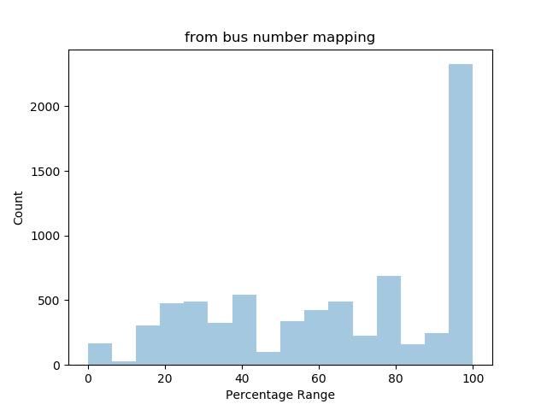

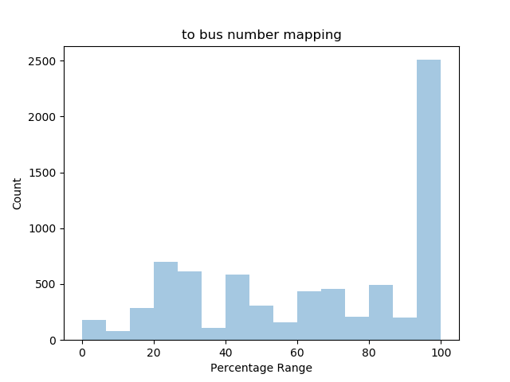

Transmission outages final combined excel file columns:

|  |  |  |
| --- | --- | --- |
| circuit_id – created (mapping) | Facility – present | Facilityid – present |
| Combine – present | facility_type – present | From – created (reported name) |
| Enddate – present | Fromstationid – present | from_bus_name – created (mapping) |
| from_bus_number – created (mapping) | planned_startdate – present | To – created (reported_name) |
| Fromstation – present | Publishdate – present | to_bus_name – created (mapping) |
| Fromzone – present | reliability_accuracy – present | to_bus_number – created (mapping) |
| Iso – present | reliability_score – present | Tostation – present |
| Kv – present | reported_name – present | Tostationid – present |
| Lastchangedate – present | reported_name_duplicate – created | Tozone – present |
| open_close – present | Startdate – present | Type – present |
| planned_enddate – present | Status – present | type_detail – present |
| status_detail – present |  | Ticketid – present |

Reported name

|  |  |
| --- | --- |
| HHGT 34KV T2T XFMR | GILA-HIWAY_9 138KV GILA_HIWAY_01 |
| HHGT 138KV T2L XFMR | ENPOI-ENLSW_RC 138KV ENLSWRC1 |
| HHGT 345KV T2H XFMR | MORRIS-NUECES_B 138KV MORRIS_NUECES01 |

* Auction mapping file used is of 2019 July month.

Unique Constraint and Contingency Pair:

|  |  |  |  |  |  |  |  |  |  |  |  |  |  |  |  |  |  |  |  |
| --- | --- | --- | --- | --- | --- | --- | --- | --- | --- | --- | --- | --- | --- | --- | --- | --- | --- | --- | --- |
| **ISO Name** | **Flowgate Name** |  | **Monitored Element Name** | **Contingency Name** | **Local Datetime (Hour Beginning) with Minutes** | **Time Zone** | **Market Type** | **Shadow Price $/MWh** | **On Peak/Off Peak - EAST** | **Contingency Mapped From Bus Number** | **Contingency Mapped From Bus Name** | **Contingency Mapped To Bus Number** | **Contingency Mapped To Bus Name** | **Contingency Circuit Id** | **Monitored Line From Bus Number** | **Monitored Line From Bus Name** | **Monitored Line To Bus Number** | **Monitored Line To Bus Name** | **Monitored Circuit Id** |
| ERCOT ISO | 100027_D_1 |  | 100027_D_1 | Actual | 2018-01-08 03:00:00 | CST | DA | 1.099 | Off Peak |  |  |  |  |  | 242 | WHITNEYDM | 243 | WHITNEYSW | 1 |
| ERCOT ISO | 100027_D_1 L/O DCPSWOF5 | DCPSWOF5 | 100027_D_1 | Cpses - Dcses And -Wolf Hollow 345kv | 2018-03-24 13:00:00 | CDT | DA | 0.041 | Off Peak |  |  |  |  |  | 242 | WHITNEYDM | 243 | WHITNEYSW | 1 |
| ERCOT ISO | 100027_D_1 L/O DSAMTHS5 | DSAMTHS5 | 100027_D_1 | Samsw-Thses 345kv | 2018-01-01 00:00:00 | CST | DA | 0.035 | Off Peak | 13405 | THOUSE_ | 68090 | SAMSW | 1 | 242 | WHITNEYDM | 243 | WHITNEYSW | 1 |
| ERCOT ISO | 100027_D_1 L/O DSAMVEN5 | DSAMVEN5 | 100027_D_1 | Samsw-Vensw 345kv | 2018-01-02 01:00:00 | CST | DA | 1.619 | Off Peak | 1906 | VENUS_S5 | 68090 | SAMSW | 1 | 242 | WHITNEYDM | 243 | WHITNEYSW | 1 |
| ERCOT ISO | 100027_D_1 L/O SBOSELM5 | SBOSELM5 | 100027_D_1 | Bosque Switch to Elm Mott 345 KV | 2018-01-04 06:00:00 | CST | DA | 0.421 | Off Peak | 246 | BOSQUESW5 | 3406 | ELM_MOTT | 1 | 242 | WHITNEYDM | 243 | WHITNEYSW | 1 |

Auction Contingency Mapping Document July 2019:

|  |  |  |  |  |  |  |  |  |
| --- | --- | --- | --- | --- | --- | --- | --- | --- |
| **Contingency** | **DeviceName** | **DeviceType** | **Action** | **From Bus Number** | **From Bus Name** | **To Bus Number** | **To Bus Number** | **Circuit Id** |
| DADEWES8 | 5754 ADERHOLD 8360 ELSA4A 1 | LINE | OUT | 5754 | ADERHOLD | 8360 | ELSA4A | 1 |
| DADEWES8 | 5754 ADERHOLD 8963 HEC4A 1 | LINE | OUT | 5754 | ADERHOLD | 8963 | HEC4A | 1 |
| DADEWES8 | 8354 WESLACO4 8360 ELSA4A 1 | LINE | OUT | 8354 | WESLACO4 | 8360 | ELSA4A | 1 |

Auction Mapping Document July 2019:

|  |  |  |  |  |  |  |  |  |  |
| --- | --- | --- | --- | --- | --- | --- | --- | --- | --- |
| **CRR_Tag** | **Operations_Name** | **OP_EQCODE** | **LNNAME** | **EQNAME** | **From #** | **From Name** | **To #** | **To Name** | **Circuit ID** |
| 1 ROANSPRARE 5 SANDYSW 1 | SNDYSS_RPR | SNDYSS_RPR_1 | SNDYSS_RPR | 1 | 1 | ROANSPRARE | 5 | SANDYSW | 1 |
| 1 ROANSPRARE 964 GIBN_CREK 1 | RPR_GIBC | RPR_GIBC_1 | RPR_GIBC | 1 | 1 | ROANSPRARE | 964 | GIBN_CREK_8 | 1 |
| 2 KEITHSW 4 IOLA 1 | IOLA_KEITHSW | IOLA_KEITHSW_1 | IOLA_KEITHSW | 1 | 2 | KEITHSW | 4 | IOLA | 1 |

Unique Constraint-Contingency Pair from year 2014 to 2019 – Yes Energy

|  |  |  |  |  |  |  |  |  |  |  |  |  |  |  |  |  |  |  |  |  |
| --- | --- | --- | --- | --- | --- | --- | --- | --- | --- | --- | --- | --- | --- | --- | --- | --- | --- | --- | --- | --- |
| **constraint** | **code** | **contingency** | **hrs** | **%_hrs** | **total_$** | **avg_$** | **max_$** | **constraint_id** | **contingen._id** | **reported_name** | **contingency_from_bus_number** | **contingency_from_bus_name** | **contingency_to_bus_number** | **contingency_to_bus_name** | **contingency_circuit_id** | **constraint_from_bus_number** | **constraint_from_bus_name** | **constraint_to_bus_number** | **constraint_to_bus_name** | **constraint_circuit_id** |
| LENSW-PUTN 138KV LENSW_PUTN21 | LENSWPUTN21 | BASE CASE | 6465 | 73.80137 | 1928.817 | 0.22018459 | 27.685 | 10000797514 | 10000756754 | PUTN-LENSW 138KV LENSW_PUTN2_1 |  |  |  |  |  |  |  |  |  |  |
| CADDOTN-APACHE 138KV G138_4B_1 | G1384B1 | STEJGR38 | 4878 | 55.684932 | 2121.142 | 0.2421395 | 9.864 | 10000821951 | 10002500648 | CADDOTN-APACHE 138KV G138_4B_1 | 38530 | TNTEJAS | 38575 | TNGRENB | 1 | 38710 | TNCADDO___1 | 38720 | TNAPACHE__1 | 1 |
| ESCONDID-EAGLE_PS 138KV EAGLEP_ESCOND1_1 | EAGLEPESCOND11 | SEAGES28 | 4761 | 54.349315 | 29726.494 | 3.39343539 | 54.562 | 10001982351 | 10001982352 | ESCONDID-EAGLE_PS 138KV EAGLEP_ESCOND1_1 | 8260 | ESCONDID | 8270 | EAGLE_PS | 2 | 8260 | ESCONDID4A | 8270 | EAGLE_PS4A | 1 |
| LOLITA-FORMOSA 138KV FORMOS_LOLITA1_1 | FORMOSLOLITA11 | DVICV_D8 | 3562 | 40.6621 | 57794.655 | 6.59756336 | 1310.58 | 10000806842 | 10000800620 | LOLITA-FORMOSA 138KV FORMOS_LOLITA1_1 | 8143 | V_DUPSW4 | 8172 | VICTORIA | 1 | 8125 | LOLITA4A | 8126 | FORMOSA4A | 1 |

Auction Mapping Document September 2019:

|  |  |  |  |  |  |  |  |  |  |
| --- | --- | --- | --- | --- | --- | --- | --- | --- | --- |
| **crr_tag** | **operations_name** | **op_eqcode** | **lnname** | **eqname** | **from_#** | **from_name** | **to_#** | **to_name** | **circuit_id** |
| 1 ROANSPRARE 5 SANDYSW 1 | SNDYSS_RPR | SNDYSSRPR1 | SNDYSS_RPR | 1 | 1 | ROANSPRARE | 5 | SANDYSW | 1 |
| 1 ROANSPRARE 964 GIBN_CREK 1 | RPR_GIBC | RPRGIBC1 | RPR_GIBC | 1 | 1 | ROANSPRARE | 964 | GIBN_CREK_8 | 1 |
| 2 KEITHSW 4 IOLA 1 | IOLA_KEITHSW | IOLAKEITHSW1 | IOLA_KEITHSW | 1 | 2 | KEITHSW | 4 | IOLA | 1 |

Auction Contingency Document September 2019:

|  |  |  |  |  |  |  |  |  |
| --- | --- | --- | --- | --- | --- | --- | --- | --- |
| **Contingency** | **DeviceName** | **DeviceType** | **Action** | **From Bus Number** | **From Bus Name** | **To Bus Number** | **To Bus Name** | **Circuit Id** |
| DADEWES8 | 5754 ADERHOLD 8360 ELSA4A 1 | LINE | OUT | 5754 | ADERHOLD | 8360 | ELSA4A | 1 |
| DADEWES8 | 5754 ADERHOLD 8963 HEC4A 1 | LINE | OUT | 5754 | ADERHOLD | 8963 | HEC4A | 1 |

Unmapped transmission outages: (Same Sheet)

|  |  |  |  |  |  |  |
| --- | --- | --- | --- | --- | --- | --- |
| **facility** | **facility_type** | **fromstation** | **fromstationid** | **reported_name** | **reported_name_duplicate** | **tostation** |
| GILA-HIWAY_9 138KV GILA_HIWAY_01 | LINE | GILA | 10000700793 | GILA-HIWAY_9 138KV GILA_HIWAY_01 | GILA-HIWAY_9 138KV GILA_HIWAY_01 | HIWAY 9 |
| BOOTS-SPUR 138KV BOOTS_SPUR11 | LINE | BOOTS | 10002230810 | BOOTS-SPUR 138KV BOOTS_SPUR11 | BOOTS-SPUR 138KV BOOTS_SPUR11 | SPUR |
| JERRY-HARGROVE 138KV JERRY_HARGRO01 | LINE | JERRY | 10002492713 | JERRY-HARGROVE 138KV JERRY_HARGRO01 | JERRY-HARGROVE 138KV JERRY_HARGRO01 | HARGROVE |
| BATES-GARZA 138KV BATES_GARZA01 | LINE | BATES | 10000699666 | BATES-GARZA 138KV BATES_GARZA01 | BATES-GARZA 138KV BATES_GARZA01 | GARZA |

Unmapped transmission outages similarity percentage: (Same Sheet)

|  |  |  |  |
| --- | --- | --- | --- |
| **from_matching_code** | **to_matching_code** | **to_ratio** | **from_ratio** |
| IOLA * GILL2A * GILA4A * | HIWAY_94A * | 75 * | 75 * 80 * 80 * |
| BROOKS * | SPUR4A * SPUR2A * | 80 * 80 * | 73 * |
| PERRY8 * PERRY9 * JERRY4A * | GROVE * | 77 * | 73 * 73 * 83 * |
| OATES * BATES4A * ALIBATES * | GARZA2A * GARZA4A * | 83 * 83 * | 80 * 83 * 77 * |

Exact Matches: (Different Sheet)

|  |  |  |  |
| --- | --- | --- | --- |
| **fromstation** | **from_matching_code** | **tostation** | **to_matching_code** |
| GILA | IOLA * GILL2A * GILA4A * | HIWAY 9 | HIWAY_94A * |
| BOOTS | BROOKS * | SPUR | SPUR4A * SPUR2A * |
| JERRY | PERRY8 * PERRY9 * JERRY4A * | HARGROVE | GROVE * |
| BATES | OATES * BATES4A * ALIBATES * | GARZA | GARZA2A * GARZA4A * |
| COTULLA | COTULLASUB9 * COTULLA4A * | JARDIN | JARDIN4A * CARDINAL * |
| HAMILTON ROAD | HAMILTON * HAMILTON4A * | CAUTHORN | CAUTHORN4A * |
| LON HILL | ZIONHILL * LON_HILL2A * | STRATTON | SUTTON * STANTON_9 * STANTON_8 * STRATTON4A * STRATTON2A * |
| LA PRYOR | LAPRYOR2A * | UVALDE CSW | UVALDESW9 * |