**Salary Prediction for Different Jobs Using Machine Learning Model**

**Objective:**

* Which features are the strongest for Salary Prediction
* Which model can predict better if a new dataset of similar kind is provided.

**Target Variable:**

salary_in_usd

**Predictor Variables:**

* work_year
* experience_level
* employment_type
* job_title
* salary
* salary_currency
* salary_in_usd
* employee_residence
* remote_ratio
* company_location
* company_size

**Exploratory Data ANALYSIS:**

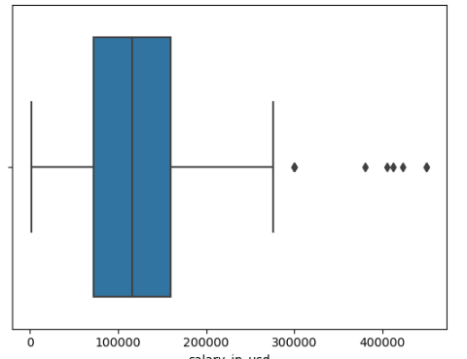 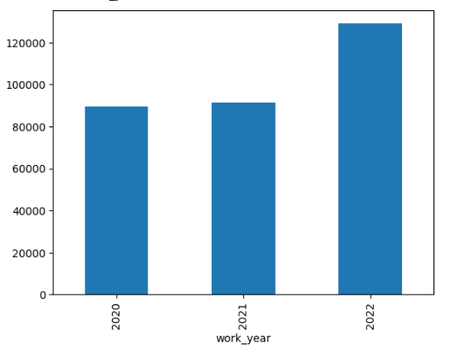

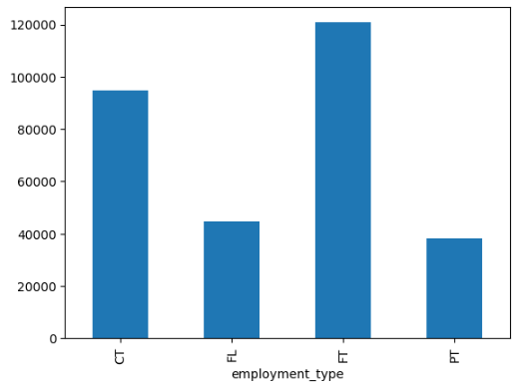 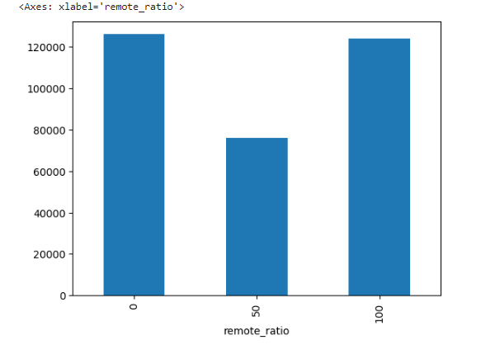

**Feature Engineering:**

* Indexing Categorical Variables
* Encoding Categorical Variables
* Vectorising
* Scaling

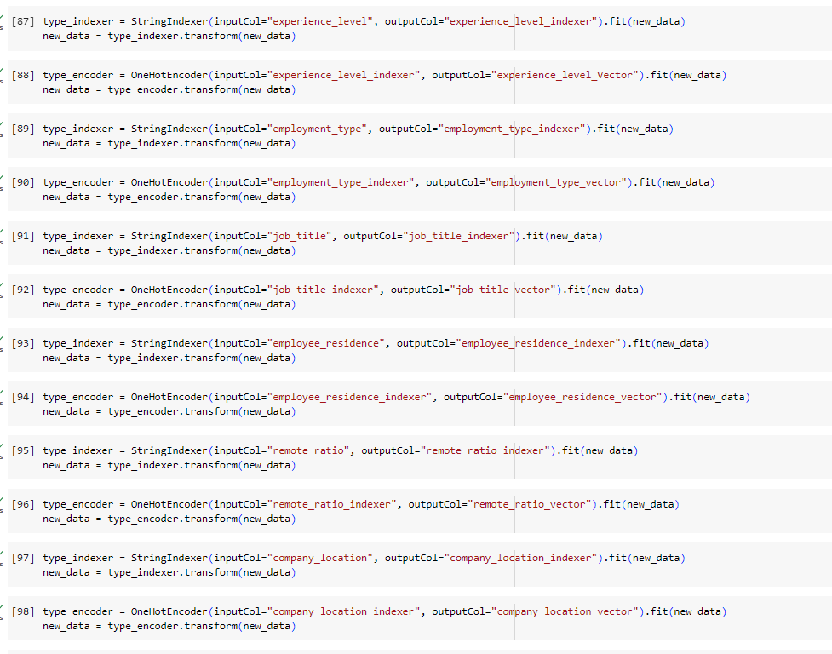

**Modelling:**

**Linear Model**

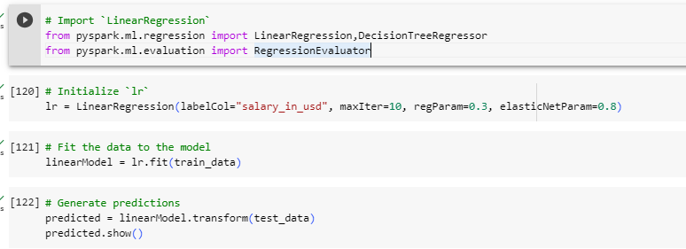

**Decision Tree**

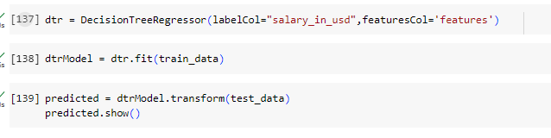

**Model Comparison**

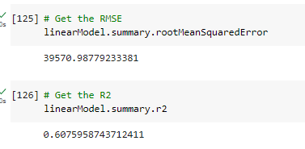

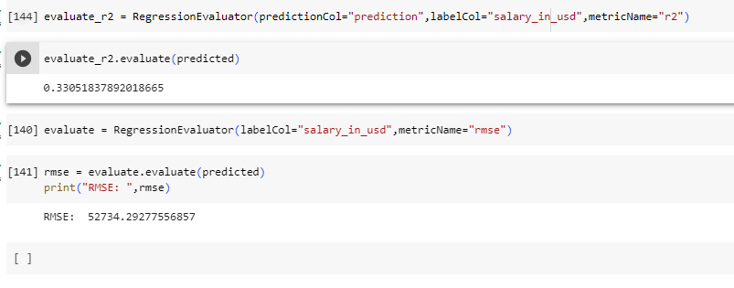

**Conclusion:**

Linear Regression Model has given the better result with R2 score: 0.60