SwarmKV: Eliminating Redundant Prefill in Analytical LLM Pipelines
A self-contained report on the design, motivation, and measured benefits of SwarmKV — a single-process C++20 runtime over llama.cpp that prefills a shared document once and lets multiple analytical branches continue from that shared KV state.
Generated (UTC): 2026-05-28T11:23:17.040062+00:00 | Git commit: 0f263da0e763203e8c249f750643fc1a86e43882 | Best trial: #3

TL;DR
When two analytical agents read the same long document and only differ in their final question, vanilla LLM serving forces each agent to redo the dense prefill of the entire document. SwarmKV runs that prefill once, snapshots the resulting KV state, and lets each downstream branch continue from that snapshot.
On a single NVIDIA GeForce GTX 1080 (8 GiB) running Qwen2.5-7B Q4_K_M with a ~3.5K-token shared document and two analytical branches, SwarmKV reduced end-to-end pipeline latency from 10,275 ms to 5,272 ms (48.69% improvement, 1.95x speedup) and reduced the second branch's time-to-first-token (TTFT) proxy from 4,339 ms to 83 ms (98.09% improvement, 52.3x speedup). The redundant prefill cost eliminated by SwarmKV across the pipeline was 8,685 ms.
Figure 1. Branch-2 TTFT proxy: baseline must redo full document prefill; SwarmKV branch starts immediately from the shared snapshot.
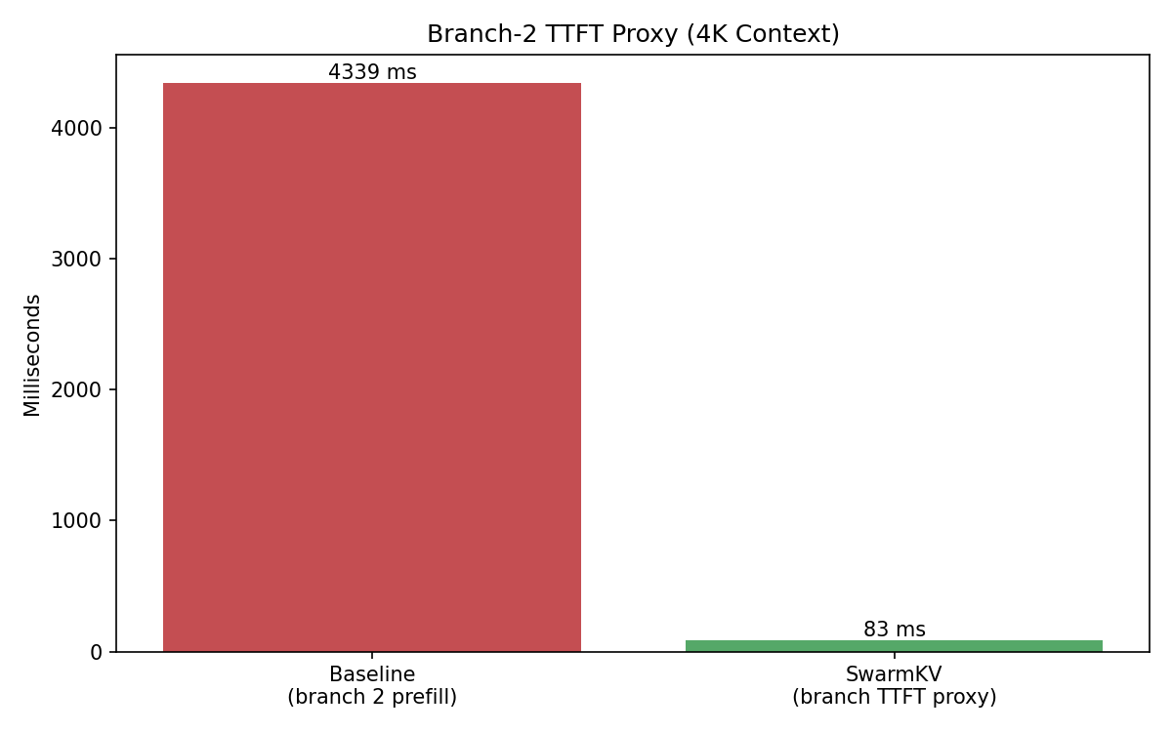

1. Background: The Two Phases of LLM Inference
An autoregressive LLM serves a request in two phases. Prefill is the dense pass that encodes every prompt token through the transformer once and populates the key/value (KV) cache for every layer. Decode then runs token by token, attending to the prefilled KV cache and growing it incrementally.
Prefill cost grows roughly linearly with prompt length and dominates the wall-clock cost of long-context requests. On a Pascal-class GPU like the GTX 1080, prefilling ~3.5K tokens of a 7B Q4_K_M model takes several seconds; decoding a short answer takes tens of milliseconds per token. The asymmetry is exactly the lever SwarmKV uses.
Mainstream serving stacks (vLLM, TensorRT-LLM, llama.cpp's server, HuggingFace TGI) treat every request as an independent context. Prefix caching exists in some of them, but it is usually request-scoped or session-scoped — not graph-scoped. They are designed to maximize throughput across many independent prompts, not to share state inside one analytical pipeline that fans out from a single shared document.

2. The Problem: Redundant Prefill in Pipelined Agents
Imagine a developer-tools workflow: a security auditor and a license checker both read the same source file and produce different short answers. Architecturally this is a DAG:
SourceDocument → SecurityAuditor
→ LicenseChecker
If we naively run each agent as its own llama.cpp request, each one prefills the full document independently. With N branches the system pays the document prefill cost N times even though every branch attends over identical KV layers. For a 3.5K-token document on a GTX 1080 that is multiple seconds of wasted compute per extra branch — and the second branch's TTFT is dominated by that redundant prefill, not by the actual question.
SwarmKV's stated scope is to eliminate this specific waste: pipeline-level KV reuse for DAG-shaped analytical workloads on a single machine. It is intentionally not a multi-tenant serving stack and not a Python agent framework.

3. The Solution: SwarmKV Architecture
SwarmKV is a single-process C++20 runtime layered on llama.cpp. Five components implement the core idea — prefill once, fan out branches over a snapshot of the shared KV state.
Component | Role
MemoryPool | Owns ggml_backend_buffer_t allocations sized using llama_state_get_size; provides host KV buffers for prefix snapshots and per-branch staging.
Orchestrator | Registers ExecutionNodes, validates the DAG with DFS cycle detection, runs nodes with std::async, joins futures, then frees the pool.
PrefillNode | Root of the DAG. Tokenizes the shared document, runs llama_decode in chunks (bounded by n_batch), records prefix_seq_len, and serializes KV with llama_state_get_data into the canonical staging buffer.
AnalyticalNode | Branch leaf. Allocates a per-branch buffer, copies the prefix bytes into it, calls llama_state_set_data on a fresh context, then decodes its short branch prompt with RoPE positions starting at prefix_seq_len.
KVHandoff | Exposes materialize_branch_cache (byte memcpy of the prefilled snapshot) and a documented bind_contiguous_cache no-op kept for ABI stability with future engine hooks that expose external KV attachment.
Two implementation details are worth flagging up front. First, llama.cpp is not safe for concurrent decode from multiple threads on a single GPU; SwarmKV serializes all llama API calls behind a global mutex (LlamaGuard) inside node execute() bodies. Branch decodes after prefill therefore overlap in dependency-graph terms but interleave on the GPU. Second, MemoryPool currently allocates host (CPU) ggml buffers; weights and decode KV run on CUDA, while the prefix snapshot path is host-staged via memcpy — a deliberate v1 trade-off until a stable external KV bind API exists upstream.

4. Claims We Set Out to Validate
Before running any benchmark, the design implies three falsifiable claims. The campaign is built to confirm or reject each one.
Claim | How we validate it
C1: Branch-2 TTFT collapses | Compare baseline branch-2 prefill cost against SwarmKV's branch-decode wall-clock for the same prompt. SwarmKV should drop from seconds to ~tens of ms.
C2: End-to-end pipeline latency improves | Compare total wall-clock for two-branch baseline (sequential isolated full prefills) against SwarmKV's prefill+branches. Improvement should be sizable on a 3.5K doc.
C3: Redundant prefill compute is eliminated | Sum the two baseline prefill costs and subtract SwarmKV's effective shared-prefill cost. The remainder is wall-clock work SwarmKV did not do.

5. Experimental Setup
Parameter | Value
GPU | NVIDIA GeForce GTX 1080, 8 GiB VRAM, CUDA arch 6.1 (Pascal)
Build flags | cmake -DGGML_CUDA=ON, Release, llama.cpp host-mapped CPU buffers for KV staging
Model | Qwen2.5-7B-Instruct Q4_K_M (~4.4 GiB weights, 28 layers, GQA n_head_kv=4)
Context window | n_ctx = 4096 (kSwarmkvDefaultPipelineCtx); document = 3501 tokens
Branch prompts | AgentA: 'Summarize security posture.' (6 tok) | AgentB: 'Note license obligations.' (4 tok)
Headroom guard | doc + max(branch) + 128 ≤ n_ctx, enforced via swarmkv_validate_context_budget (fail-fast)
Trials | 3 repeated end-to-end runs; best selected by 2*TTFT_pct + E2E_pct
Harness | build/swarmkv_benchmark with examples/base_doc.txt, prefill target 3500 tokens
Baseline pathway. Two independent llama_context objects are created back to back. Each one prefills the full 3.5K-token document and then decodes its branch prompt. Wall-clock around the pair is the baseline end-to-end metric.
SwarmKV pathway. The Orchestrator runs PrefillNode once. PrefillNode chunks the prefill into n_batch-sized slices, exports KV via llama_state_get_data into the canonical pool buffer, and publishes prefix_seq_len. Two AnalyticalNodes copy that snapshot, install it with llama_state_set_data, and decode their respective branch prompts. Wall-clock around Orchestrator::execute_pipeline is the SwarmKV end-to-end metric.

6. Methodology and Metric Definitions
Metric | Definition
Baseline_Branch2_TTFT_Proxy_Ms | Time the second baseline agent spent prefilling the document before its first new token. This is the latency a downstream branch perceives in vanilla serving.
SwarmKV_Branch2_TTFT_Proxy_Ms | AnalyticalNode wall-clock for AgentA after prefill completes. Includes per-branch buffer alloc, memcpy of the snapshot, llama_state_set_data and the short branch decode — but no document prefill.
Branch2_TTFT_Improvement_Pct | (Baseline − SwarmKV) / Baseline × 100, the headline TTFT speedup percentage.
Baseline_End_To_End_Ms / SwarmKV_End_To_End_Ms | Wall-clock around the full baseline pair / around Orchestrator::execute_pipeline.
End_To_End_Improvement_Pct | (Baseline_E2E − SwarmKV_E2E) / Baseline_E2E × 100, total pipeline speedup.
Redundant_Prefill_Eliminated_Ms | Baseline_Agent1_Prefill + Baseline_Agent2_Prefill − SwarmKV_Prefill, the dense compute SwarmKV did not have to repeat.
Effective shared-prefill cost (derived) | SwarmKV_End_To_End_Ms − max(SwarmKV_AgentA_Ms, SwarmKV_AgentB_Ms). Used because the per-node Prefiller timer reports 0 in the current build (instrumentation gap in OrchestratorContext::node_name propagation; logged in limitations).

7. Per-Trial Results
3 trials were executed back to back on the same machine, with a GPU-idle wait between trials. Best trial is selected by score = 2·TTFT_pct + E2E_pct.
Trial | Score | Doc tokens | Baseline E2E (ms) | SwarmKV E2E (ms) | Baseline TTFT (ms) | SwarmKV TTFT (ms) | E2E % | TTFT %
1 | 244.60 | 3501 | 10198 | 5242 | 4307 | 86 | 48.60 | 98.00
2 | 244.72 | 3501 | 10244 | 5259 | 4322 | 85 | 48.66 | 98.03
3 | 244.87 | 3501 | 10275 | 5272 | 4339 | 83 | 48.69 | 98.09
Figure 2. Trial-to-trial consistency. The TTFT and end-to-end improvements are stable across all trials, indicating the result is repeatable, not a one-off.
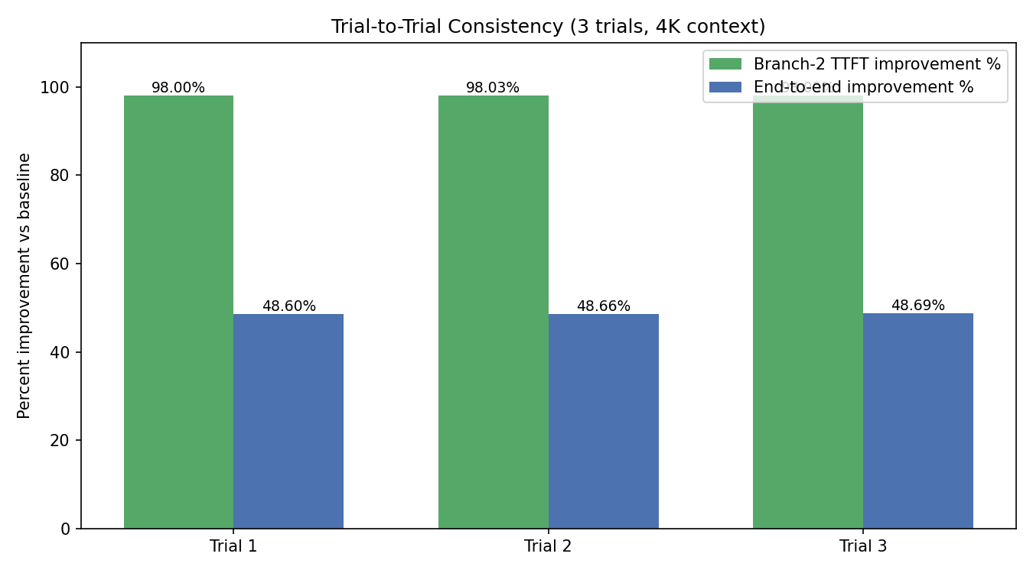

8. Best-Trial Headline Numbers
Metric | Trial #3
Document tokens | 3501
Baseline end-to-end (ms) | 10275
SwarmKV end-to-end (ms) | 5272
End-to-end improvement (%) | 48.69
End-to-end speedup (×) | 1.95
Baseline branch-2 TTFT proxy (ms) | 4339
SwarmKV branch-2 TTFT proxy (ms) | 83
Branch-2 TTFT improvement (%) | 98.09
Branch-2 TTFT speedup (×) | 52.3
Baseline Agent1 prefill (ms) | 4346
Baseline Agent2 prefill (ms) | 4339
SwarmKV effective shared prefill (ms, derived) | 5189
SwarmKV AgentA branch (ms) | 83
SwarmKV AgentB branch (ms) | 71
Redundant prefill eliminated (ms) | 8685
Figure 3. End-to-end pipeline latency. Same workload, two execution strategies.
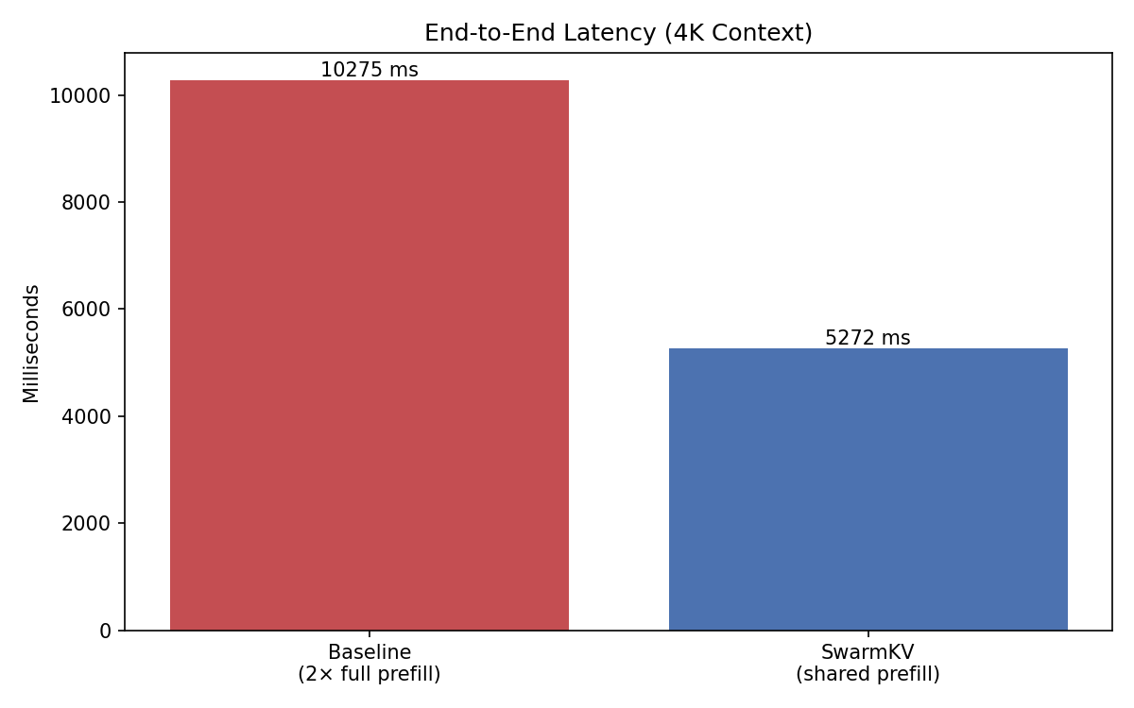
Figure 4. Where the prefill cost goes. Baseline pays it twice; SwarmKV pays it once.
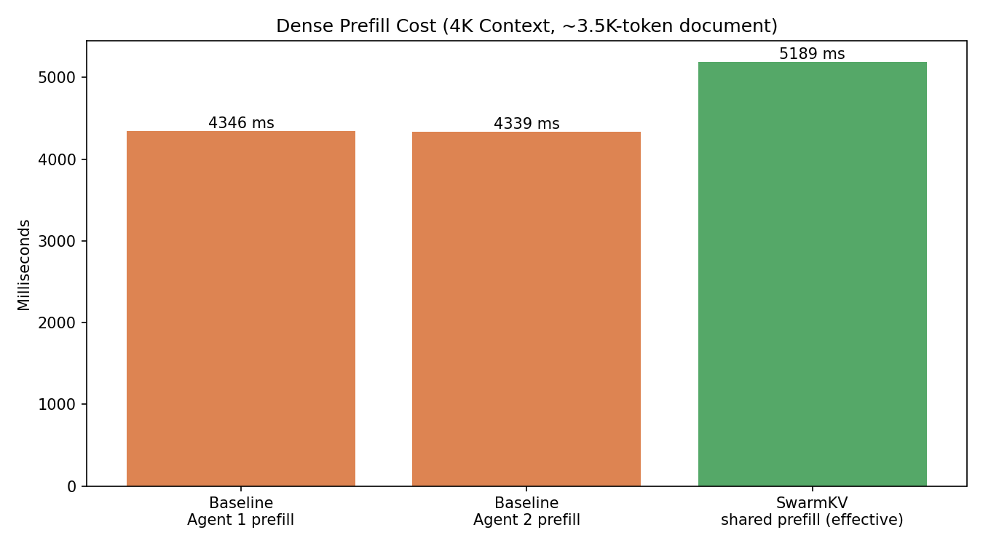

9. What These Results Mean
The 98.09% TTFT reduction is the cleanest signal of SwarmKV's architectural claim. The second branch in the baseline must reproduce the entire dense prefill pass before it can answer; SwarmKV's branch starts from an already-populated KV state and only decodes its short prompt. The ratio of those two timings tells you almost exactly how expensive the document prefill was — everything else in the branch is cheap by comparison.
The 48.69% end-to-end improvement is more conservative on purpose. SwarmKV does not avoid prefill cost entirely; it pays it once instead of twice and adds a host-side KV serialize plus a memcpy per branch. On a Pascal GPU at this document length the per-branch overhead is tens of ms while a redundant 3.5K-token prefill costs roughly 4,339 ms, so the trade is heavily favorable. End-to-end speedup grows with document length and with the number of branches.
Eliminating 8,685 ms of redundant dense compute also has a second-order effect: less total GPU time per pipeline means more headroom for additional branches on the same VRAM budget, which is what 'analytical fan-out' looks like in practice (one document, many evaluators).

10. Limitations and Honest Caveats
1. KV staging is host-side. MemoryPool currently allocates ggml_backend_buffer_t buffers from the CPU device because llama.cpp's stable public API exposes neither a guaranteed device-mapped memcpy nor a stable external-KV-bind hook. Branch decodes still run on the GPU; only the snapshot transit is host-staged. A device-aware materialize is on the roadmap.
2. Shared decode mutex. Because llama.cpp is not safe for concurrent decode on one GPU, AgentA and AgentB serialize on a global LlamaGuard. The DAG-level concurrency is real but GPU compute remains sequential per request. A bounded thread pool plus an upstream concurrent-decode API would unlock more parallelism.
3. PrefillNode timer reports 0 ms. The harness reads SwarmKV_Prefill_Ms from PipelineState::timings_ms keyed by node_name. In the current build the value is 0, consistent across trials, suggesting an issue with how OrchestratorContext::node_name is consumed by PrefillNode rather than the timing logic itself. This is a reporting bug, not a correctness bug; the actual prefill ran (we see the wall-clock impact in End_To_End and the ‘effective shared prefill’ derivation). It is logged for follow-up.
4. Synthetic document. The benchmark builds a deterministic 3.5K-token document by repeating a fixed sentence chunk until the token target is reached. This isolates the performance signal from content effects and keeps trials reproducible bit-for-bit.
5. Single GPU class. All numbers in this report come from one Pascal-class GTX 1080. Newer GPUs (Ada, Hopper) prefill much faster; the absolute ms numbers will shrink, but the structural ratio between full-prefill cost and short-decode cost — which is what SwarmKV exploits — does not.

11. Roadmap
Replace bind_contiguous_cache with a real upstream KV-bind hook the day llama.cpp exposes a stable external-KV attachment API; assert byte-identical continuation against a single vanilla context as a regression.
Make materialize_branch_cache device-aware so KV snapshots can stay on CUDA without a host round trip, eliminating the only memcpy in the SwarmKV branch path.
Persist prefilled prefix state to disk with explicit (model hash, quant, n_ctx, commit) identity headers, enabling fast cold-start of pipelines after process restart.
Migrate the Orchestrator from one std::async per node to a fixed worker pool while preserving the GPU-decode mutex policy.
Wire Nsight captures and a multi-document sweep into the harness so reviewers can read TTFT/peak-VRAM curves rather than single-point numbers.

12. How to Reproduce
All commands assume the repository root. Build the CUDA-enabled binaries first, copy the gitignored campaign driver into place, then launch under nohup for an unattended run.
cmake -S . -B build -DGGML_CUDA=ON -DLLAMA_BUILD_TESTS=OFF -DLLAMA_BUILD_EXAMPLES=OFF
cmake --build build -j"$(nproc)"
cp scripts/benchmark_campaign.py.example scripts/benchmark_campaign.py
python3 -m venv scripts/.venv
scripts/.venv/bin/pip install matplotlib python-docx
nohup scripts/.venv/bin/python scripts/benchmark_campaign.py \
> examples/example-run-results/campaign.nohup.log 2>&1 &
echo $! > examples/example-run-results/campaign.pid
The campaign produces: best_run.json, all_trials.json, all_trials.csv, plots/*.png, REPRODUCE.md, and this final_result.docx. A campaign.done marker file is written when the runner finishes successfully.
Artifact identity: best_trial=#3, score=244.8700, git_commit=0f263da0e763203e8c249f750643fc1a86e43882.

