Linux Programming: Assignment-7:

- What is a bash shell script? Give one example.
- A Bash shell script refers to a simple text file that contains a set of commands written for the Bash shell to execute. It is mainly used to automate repetitive tasks, system administration work, or run multiple commands in sequence without typing them manually each time.

- e.g.) #!/bin/bash
echo "Welcome to Bash scripting!"
echo "Today’s date is:"
date

- Write a simple shell script to print “Hello World”.

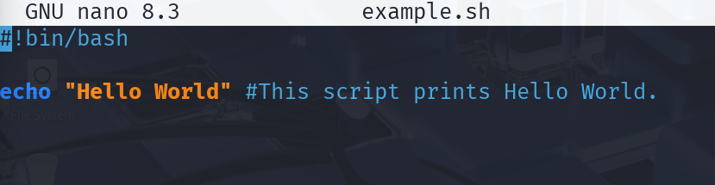



- What is the purpose of comments (#) in a shell script?
- In a shell script, the # symbol is used to write comments.
Comments are statements that are not executed by the shell — they are meant to explain the code, make it easier to understand, and help others (or yourself later) know what each part of the script does.

- How do you declare variables (int, float, double, string, Boolean, and char in a shell script?

- In a shell script, variables are not declared with data types like in other programming languages.
All variables by default behave as strings by default, and their type is determined automatically based on how they are used.
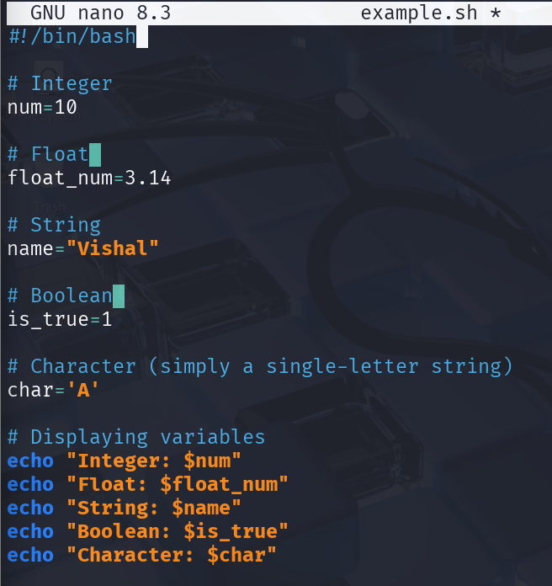
- Write a shell script to display the current date and time of the system.
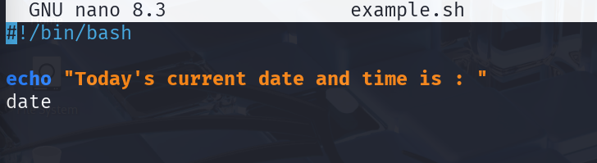

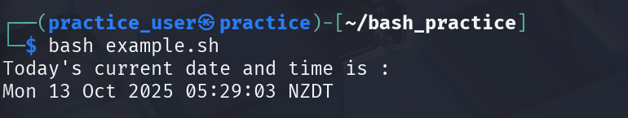

- Explain the difference between a constant and a variable in bash script.
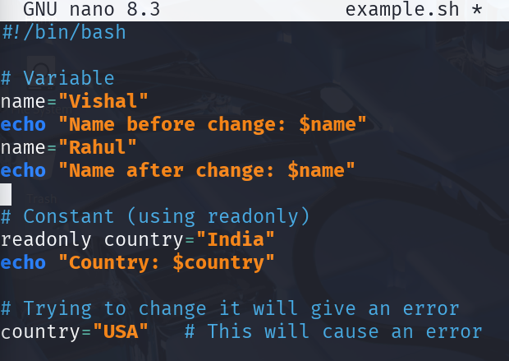

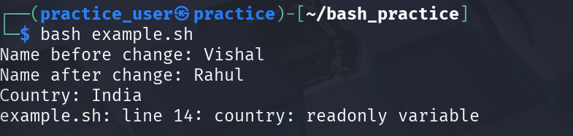
- Write a shell script to read two integer number from the user and compute the sum of both the number.
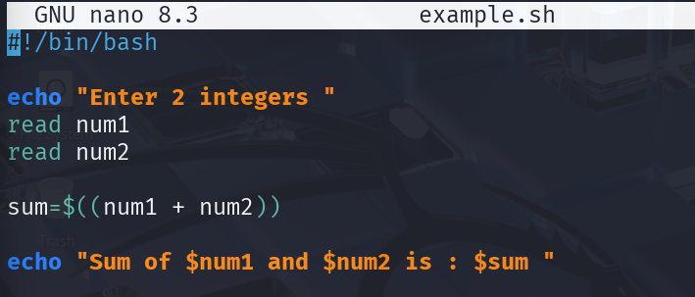
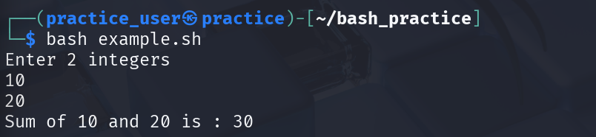

- What is the use of source command in shell scripting?
- The “source” command in a shell script is used to run a script in the current shell so that any variables, functions, or environment changes made by the script remain available after it finishes.
- Unlike running the script with “bash script.sh”, which executes it in a new shell, source keeps all changes in your current shell.

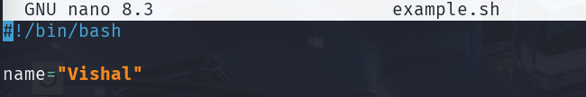

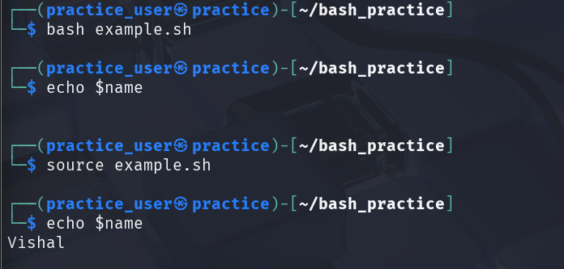

- On running “bash example.sh” , output is empty, because the variable was only set in the new shell that has now exited.
- But on running it with source , it gives the output which means that source sets the variable in the current shell.

- How can you debug a shell script? Give two methods.
- Using -x (trace execution)

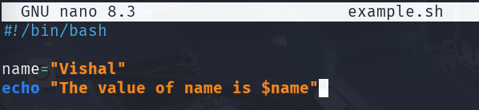

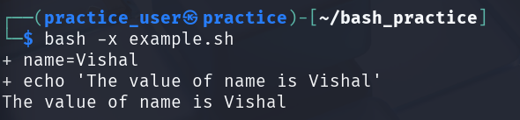
- + shows each command before execution.
- If there’s any error t will print an error message before executing it.
- Thus, helping us to debug easily.

- Using -n (syntax check)
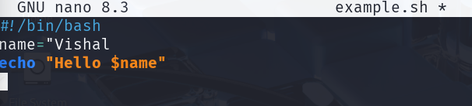

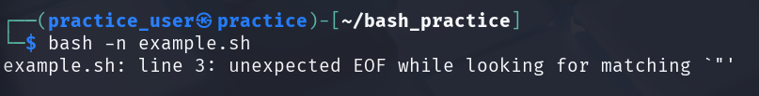

- The command 'bash -n' does not execute the script.
- It checks for syntax correctness only.
- If it dosen’t return anything, the syntax is correct.
- Write a bash script to create and delete a file.

#!/bin/bash

# Create a file named example.txt
touch example.txt
echo "File example.txt created."

# Check if the file exists
if [ -f example.txt ]; then
echo "The file exists. Now deleting it..."

# Delete the file
rm example.txt
echo "File example.txt deleted."
else
echo "File does not exist."
fi

