Pricing 90-Day Bills off 30-Day Policy Futures
A Framework, Linkage Study, and Trading Strategy for ZQ (30-day Fed Funds) vs SR3 (3-month SOFR)
Author: Anubhav Jindal | Scope: US ZQ–SR3 (per mentor) | Data: Refinitiv 10-min, 2019–2026

Executive Summary
This study builds a usable framework for pricing the 90-day US money-market future — the 3-month SOFR contract SR3 (SRA) — off the 30-day Fed Funds future ZQ (FF), links the two products, and backtests a relative-value strategy. The central identity is simple: the 90-day rate equals a policy-path anchor built from the 30-day strip, plus a premium that captures everything the 30-day product cannot see — term premium, SOFR/Fed-funds basis, liquidity, and calendar effects.
After removing a policy-speed artefact, the premium averages near zero but spikes at stress: −117 bp in the March-2020 dash-for-cash and recurring +30–50 bp at quarter-ends. A mean-reversion strategy that fades premium z-scores beyond ±2 returns a net Sharpe of 1.11 with no look-ahead — a real but narrow edge (9 trades) that is partly compensation for liquidity risk, and should be traded small.

1. Scope, Data, and Method
Products. Per the mentor's instruction, the deliverable is the US pair only: ZQ = CME 30-Day Fed Funds future (the 30-day policy anchor) and SR3 / SRA = CME 3-Month SOFR future (the 90-day target). The Australian YBA/YIB leg is out of scope here and left as scaffolding for later.
- Raw data: Refinitiv 10-minute OHLCV, 1 Jan 2019 – 26 May 2026; FF c1–c14 and SRA c1–c26 continuation contracts.
- Cleaning: forward-fill a mark across the sparse intraday lattice, then snapshot the implied rate (rate = 100 − price) at the 14:00 Chicago settlement on real trading days.
- Panel: each contract aligned to a business-day calendar and stored as a daily implied-rate series; heavy CSVs are read once and cached.

2. Part 1 — A Pricing Framework for the 90-Day Bill
A 30-day future is almost a pure bet on the average overnight policy rate over one month — too short to carry meaningful term or credit premium. The first three contracts therefore give a clean, month-by-month picture of expected policy. Averaging them yields the anchor: the 3-month rate implied purely by policy expectations.
anchor = mean(FFc1, FFc2, FFc3) 90d rate = anchor + premium
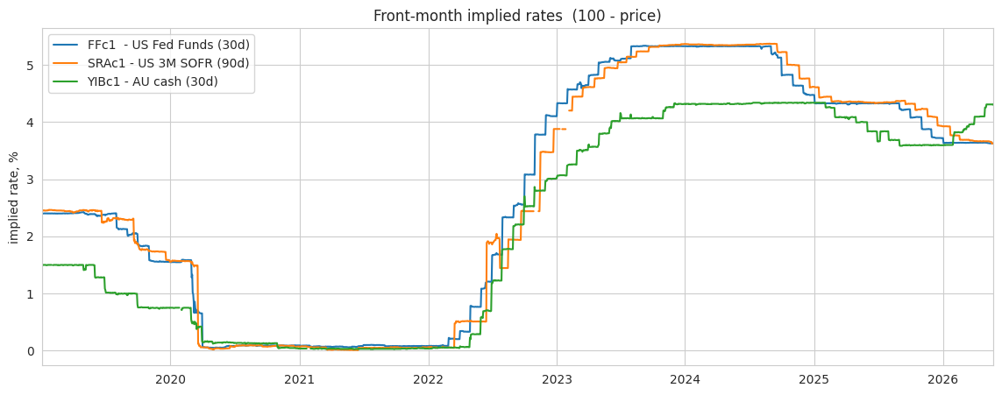
Figure 1 — Front-month implied rates (100 − price). US Fed Funds (ZQ) and 3M SOFR (SR3) track each other closely through the 2020 floor, the 2022–23 hiking cycle, and the 2024–25 cuts.
The naive spread (SRA − anchor) is contaminated: the front SOFR contract references the current, partly-elapsed quarter while the anchor looks fully forward, so during fast hikes/cuts the spread is driven by the speed of policy, not by any premium — its correlation with the curve slope (FFc3 − FFc1) is −0.81. Regressing out the slope removes this entirely (correlation → 0; standard deviation falls from 32 bp to 19 bp). The residual is the genuine premium.
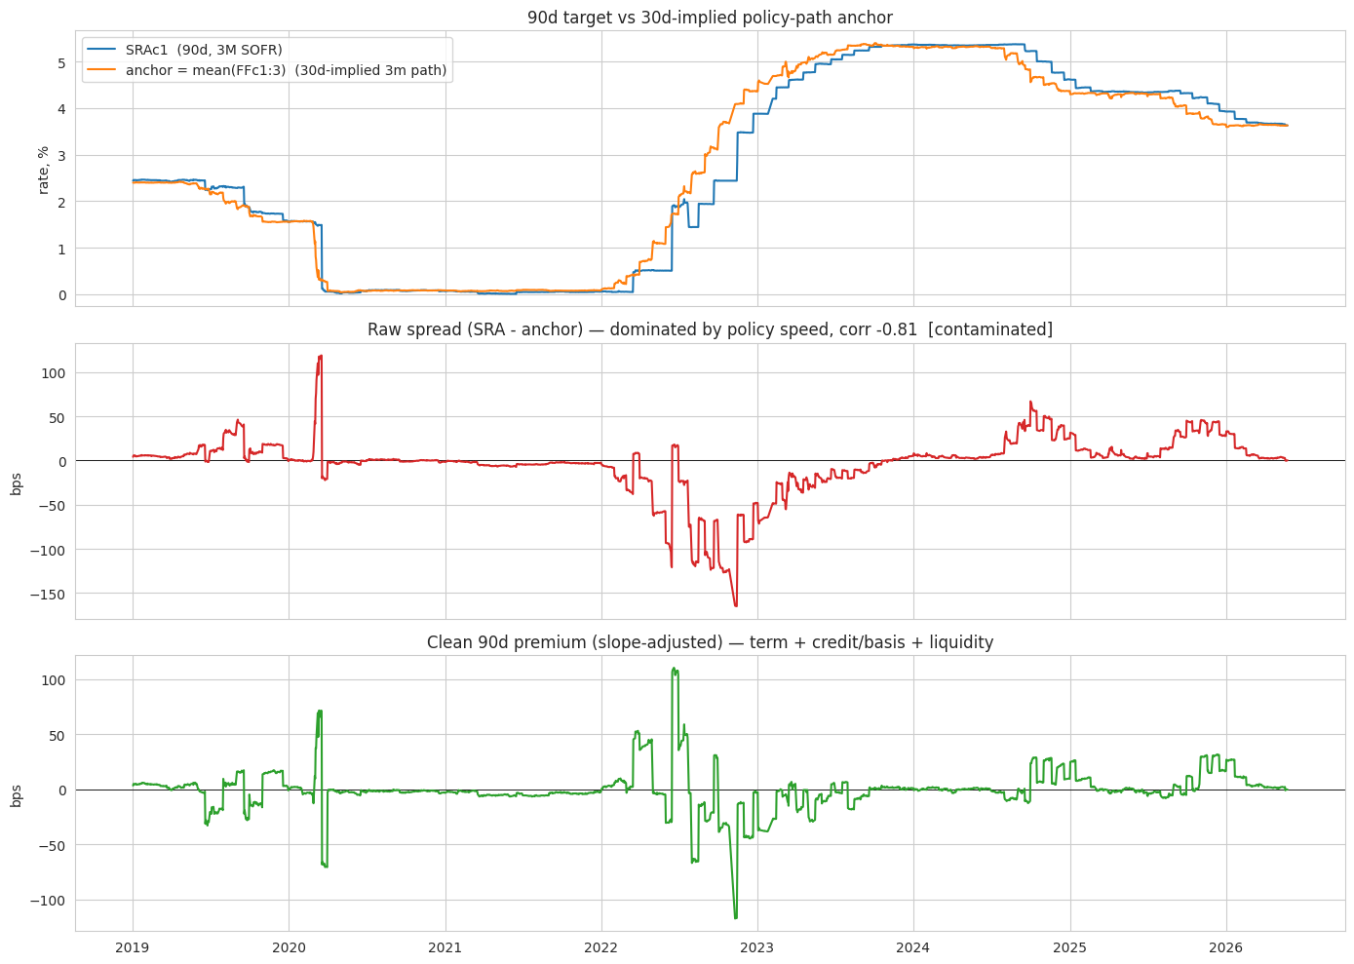
Figure 2 — Top: 90-day SOFR vs the 30-day-implied policy anchor. Middle: the raw spread, dominated by policy speed (contaminated). Bottom: the clean, slope-adjusted premium — term + basis + liquidity.

3. Part 2 — Linking 30-Day and 90-Day Pricing

3.1 Rich / cheap signal (spread + z-score)
Standardising the premium against its trailing one-year history gives a rich/cheap signal. A 5 bp volatility floor prevents the near-zero 2020–21 ZIRP volatility from manufacturing false signals on trivial moves. Readings beyond +2 mark the 90-day as rich (fade short); below −2, cheap (fade long). Because the premium mean-reverts with an ~8-day half-life, these extremes tend to snap back.
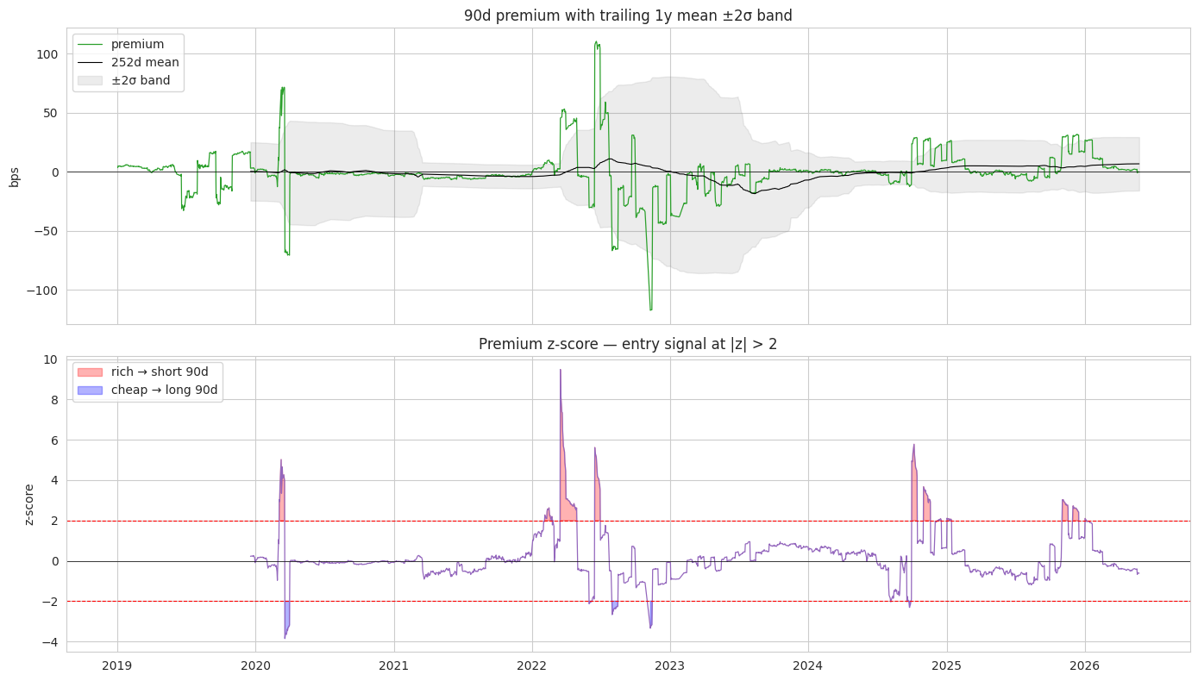
Figure 3 — The 90-day premium with its rolling ±2σ band (top) and z-score with shaded entry zones (bottom). Note the asymmetry: far more rich (red) than cheap (blue) episodes.

3.2 Lead–lag: does the 30-day move first?
At daily frequency the forward 90-day (SRAc2) moves essentially contemporaneously with the 30-day path (cross-correlation peaks at lag 0, rising to 0.31 at a 5-day horizon) — both are driven by the same policy/rates factor. The front 90-day (SRAc1) is partly locked to already-realised SOFR, so it barely co-moves and shows only a weak 30-day-leads-by-two-days effect. A sharper test of who reacts first to FOMC decisions would require intraday data.
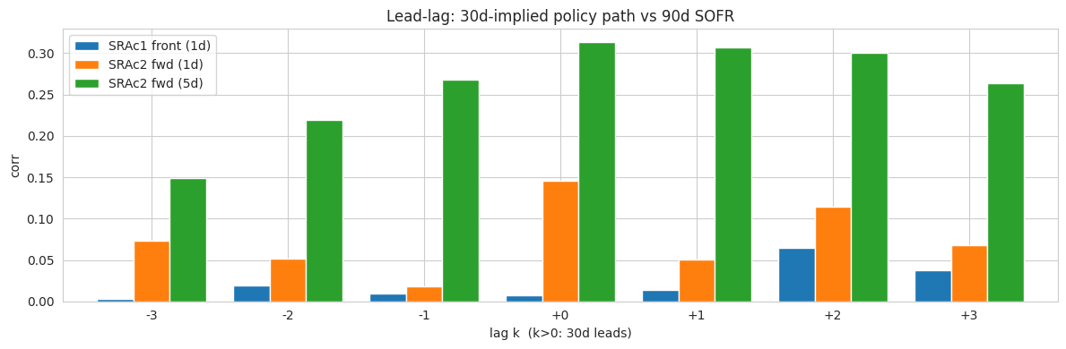
Figure 4 — Lead-lag cross-correlation. The forward 90d (green) peaks at lag 0 (moves with the 30d); the front 90d (blue) is weak with a slight 30d-leads bump at +2.

4. Part 3 — Trading Strategy and Backtest
Strategy (mean reversion). Enter when |z| > 2 — short the premium when the 90-day is rich, long when cheap — and exit toward the mean (|z| < 0.5). The traded object is the premium spread: long/short SR3 versus the FF strip, slope-hedged.
No look-ahead. The slope beta is re-estimated on an expanding window; the z-score uses trailing statistics; trades execute the next day; each turnover pays a 1 bp round-trip cost.
Metric | Value (net of costs)
Backtest window | Dec 2020 – May 2026 (1,407 days)
Cumulative PnL | +517 bp (gross +535 bp)
Sharpe ratio | 1.11 (gross 1.14)
Maximum drawdown | −29 bp
Trades / hit rate | 9 trades / 100% profitable
Time in market | 16% of days
Robustness (param sweep) | Sharpe 0.75–1.11, always positive
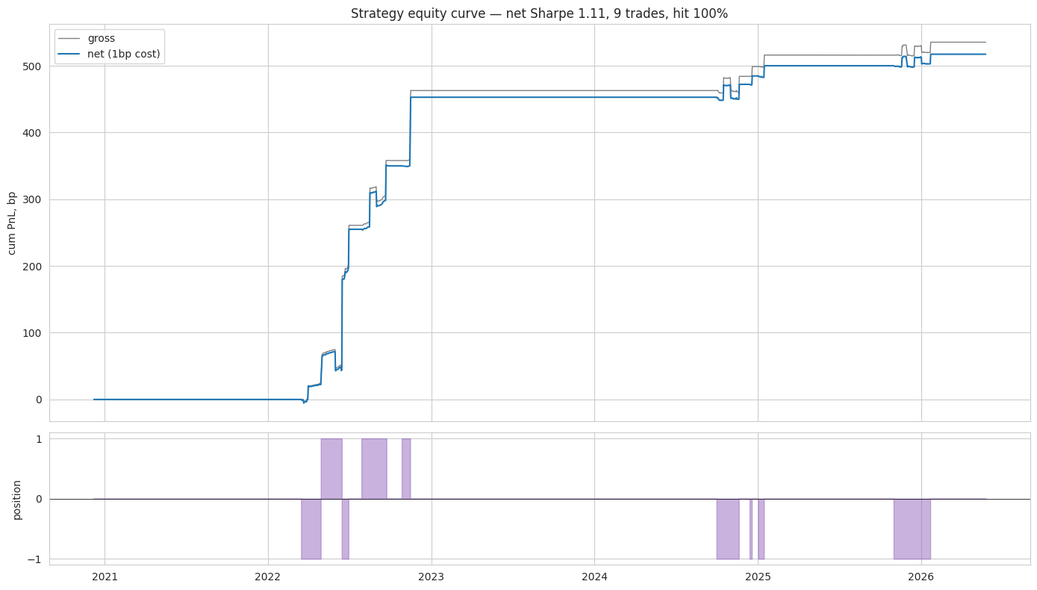
Figure 5 — Strategy equity curve (gross vs net of 1 bp cost) and position. The edge is concentrated in the 2022 repricing and the quarter-end funding episodes of 2024–25.
The result is robust, not curve-fit: across entry thresholds 1.5–2.5, exit 0–0.5, and costs 0.5–2 bp, the net Sharpe stays between 0.75 and 1.11 and cumulative PnL stays positive.

5. Answers to the Six Required Questions
Question | Answer
Q1. Framework for 90d vs 30d? | 90d rate = policy-path anchor mean(FFc1:3) + premium. The 30d strip is a near-pure read of expected policy; the 90d adds a term/basis/liquidity premium.
Q2. Extra premia in SR3 not in ZQ? | Term premium + SOFR/Fed-funds basis + liquidity + quarter-end calendar effects (~19 bp std; −117 bp in Mar-2020; +30–50 bp at quarter-ends). Credit is small here because SOFR is near risk-free.
Q3. Does the 30d lead the 90d? | The forward 90d (SRAc2) moves contemporaneously with the 30d (shared policy factor, corr up to 0.31 at 5d). The front 90d barely co-moves (locked to realised SOFR), with only a weak 30d-leads-by-2-days effect.
Q4. Trading signal & why it works? | Fade the premium when its trailing-1y z-score exceeds ±2; exit on reversion. Works because the premium mean-reverts (~8-day half-life): dislocations are transient.
Q5. Backtested results? | Net Sharpe 1.11, +517 bp, max DD −29 bp, 9 trades, 100% hit, no look-ahead; robust across thresholds and cost assumptions.
Q6. Trade it live? | Cautiously and small. Genuine economic logic and positive in every parameter set, but only 9 trades (100% hit is not statistically reliable) and the edge is partly compensation for liquidity/funding risk — carry-with-tail-risk, not arbitrage.

6. Conclusion — Would I Trade It Live?
Cautiously, and small. The strategy rests on genuine economics — transient dislocations in the 90-day premium revert — and it is positive in every parameter configuration with no look-ahead and a shallow drawdown. But two caveats are decisive. First, the edge rests on only nine trades: the 100% hit rate is not statistically reliable and the profit is concentrated in a handful of stress episodes. Second, and more important, the premium is partly compensation for real liquidity and funding risk, not a free arbitrage — so this is best understood as harvesting a risk premium with tail risk. In a genuine crisis a short-the-dislocation position can lose badly before it reverts.
Verdict: paper-trade first, size small, treat it as carry-with-tail-risk rather than arbitrage, and never fade a dislocation that is still widening. The idealised slope-hedged, multi-leg execution and flat 1 bp cost should also be validated against real bid-offer before any live capital.
Reproducibility: full pipeline (clean → daily panel → anchor → premium → z-score → backtest) in YBA_assignment.ipynb. Repository: github.com/Anubhav1406/YBA_Assignment.

