# AWS Advanced

**RDS | EC2 database program**

(Create a MySQL instance using RDS and access it using a custom program from an EC2 instance using an appropriate role)

1. Create a private MySQL RDS
   1. Create a "Dev/Test" MySQL instance
   2. Select "Non publicly" available DB
   3. DB instance = "flipbasket", UID/PWD = root/password
   4. AZ = 2a, create a new SG
   5. 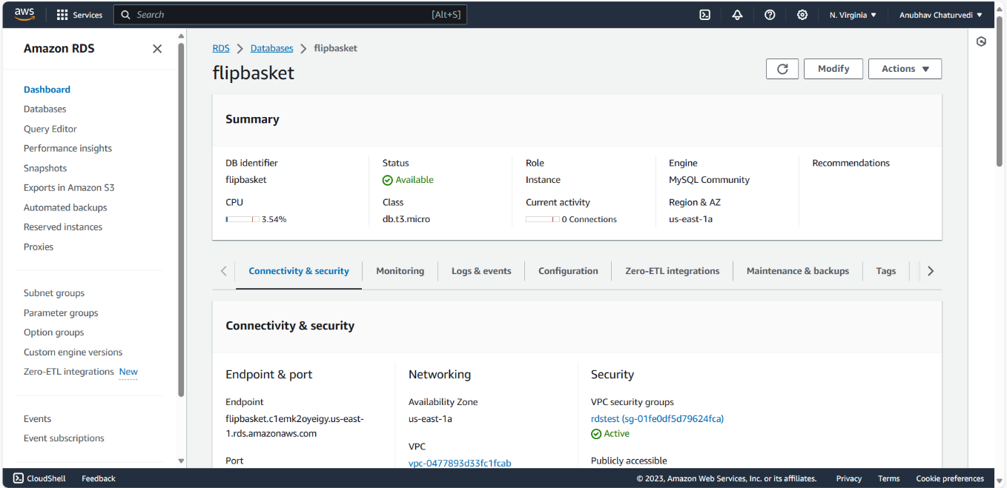IMP When the RDS instance is created check the SG to ensure that the "inbound" rule does not have any specific IP address, instead use the VPC CIDR block of the EC2 instance. Otherwise we will not be able to connect from the EC2 instance
2. Create 1 EC2 instance using the 7 step workflow
   1. Use the usual Ubuntu 20.04 LTS AMI in AZ1
   2. Download a new PEM file and SSH to the instance

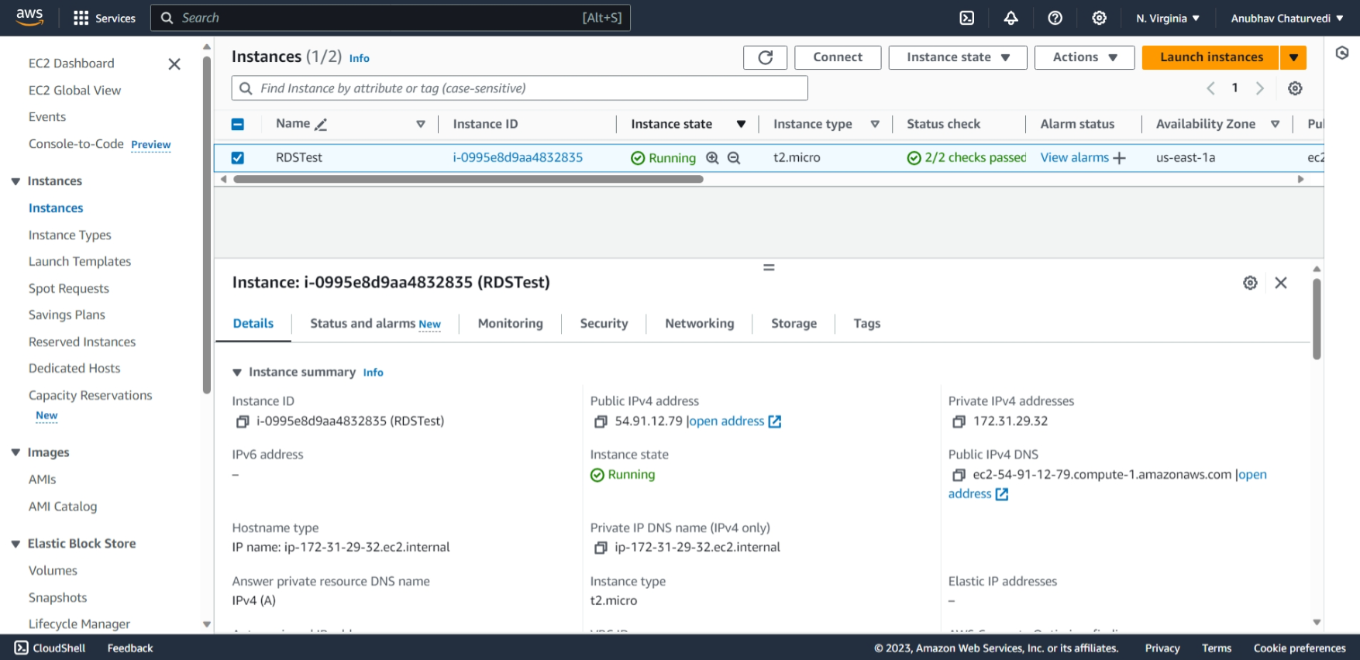

1. IAM
   1. Attach the pre-created role “labinstanceprofile” to the instance OR use an IAM role using the permission “RDSFullAccess”

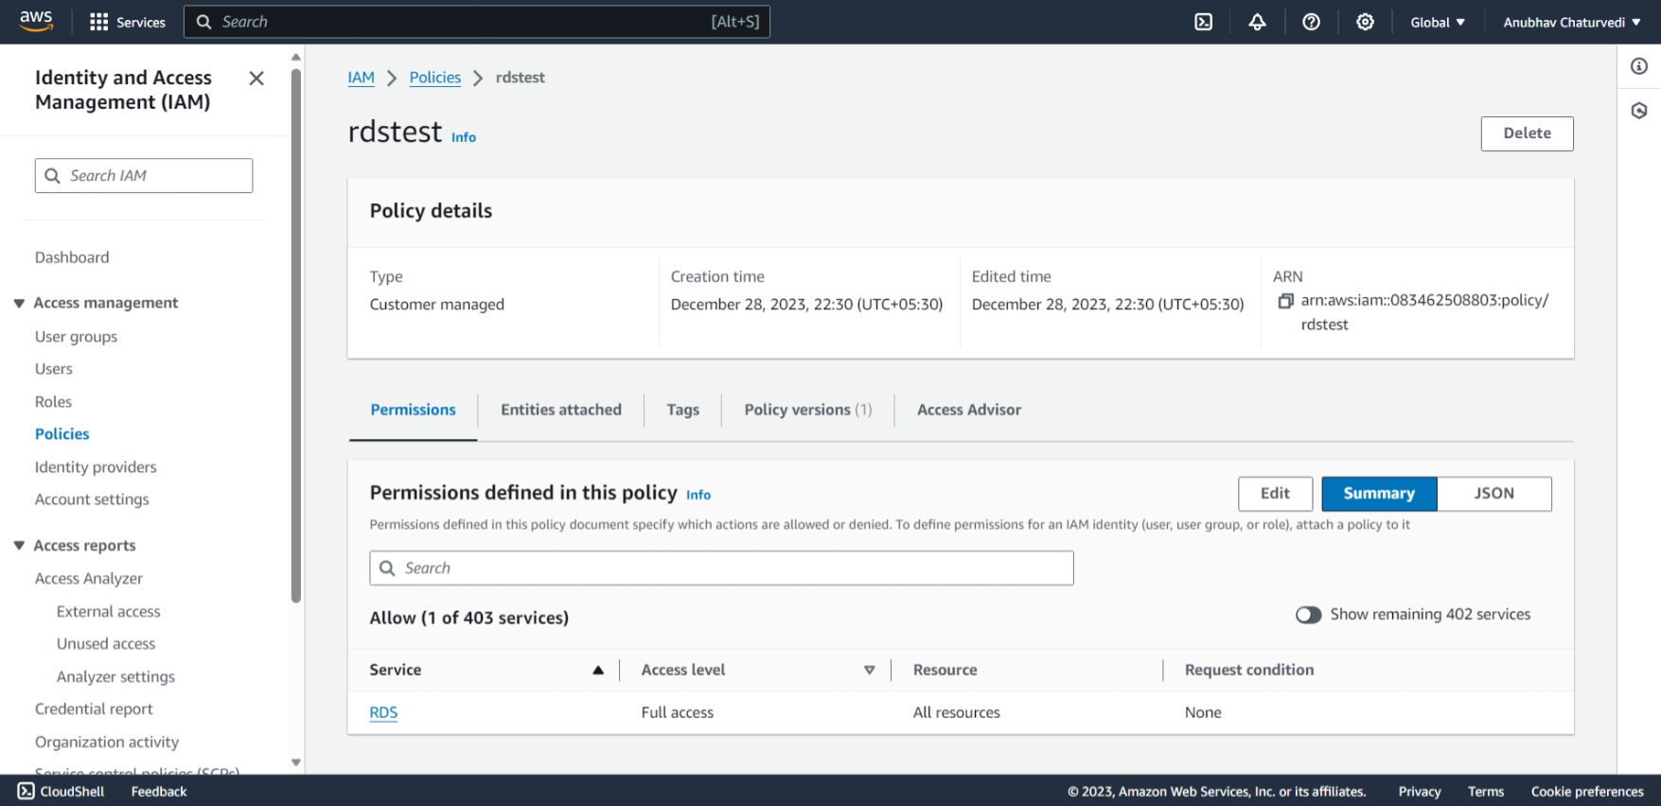

1. SSH to the EC2 instance and fire the following commands
   1. sudo apt update
   2. sudo apt install mysql-client

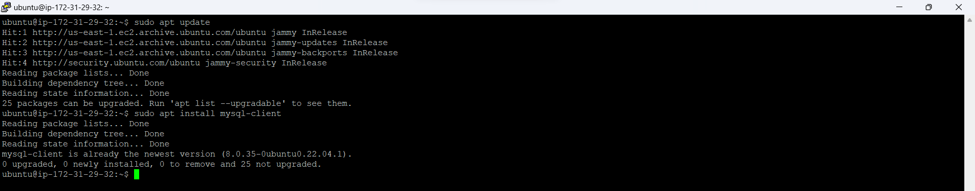

1. Connect to the RDS instance & create the data
   1. wget https://d6opu47qoi4ee.cloudfront.net/employees.sql
   2. mysql -h [RDS end point] -u admin -p

You should get the MySQL prompt after entering the password

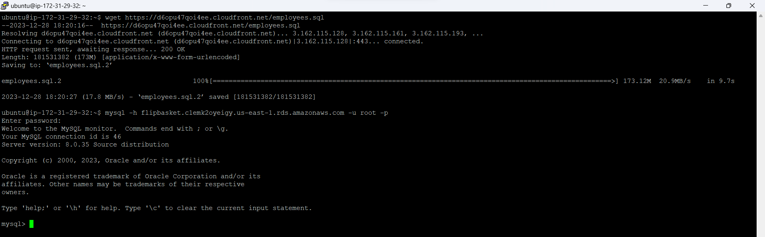

* 1. create database employees;
  2. use employees;

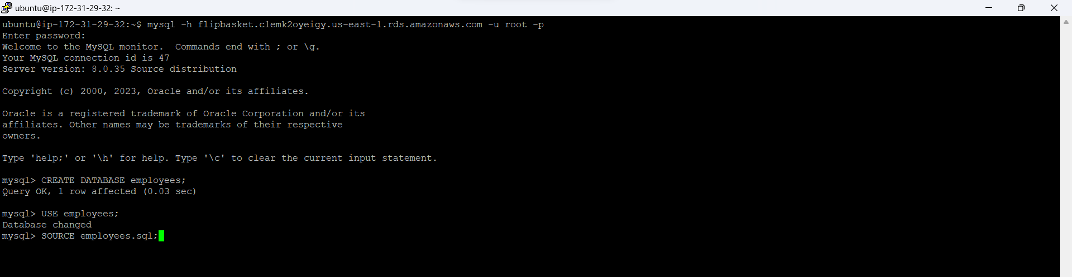

* 1. source employees.sql

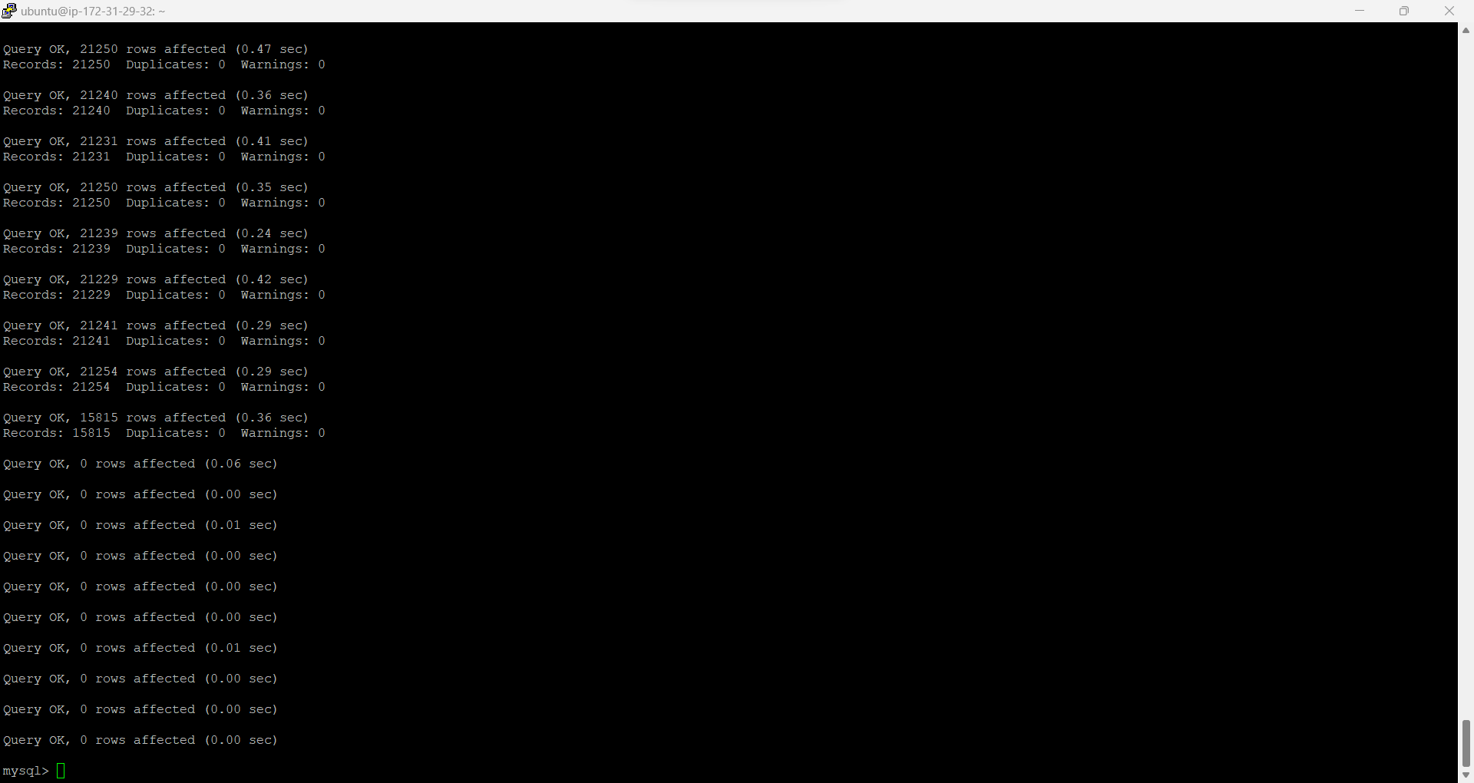

* 1. describe employees;
  2. Note the column names in a text editor from the output of the above command
  3. Close the mysql terminal

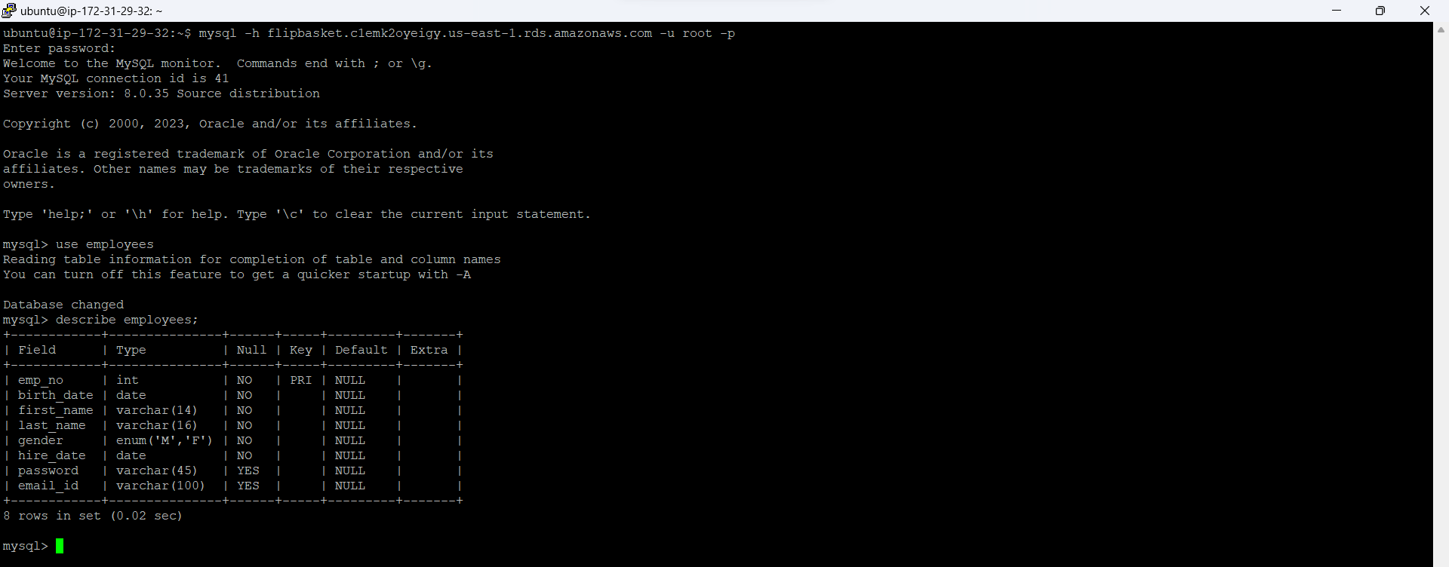

1. Follow the steps for the Python program connecting to the RDS instance from EC2
2. sudo apt install python2-minimal
3. sudo apt install python3-pip
4. sudo pip3 install boto3
5. sudo pip3 install mysql-connector-python
6. sudo pip3 install pymysql

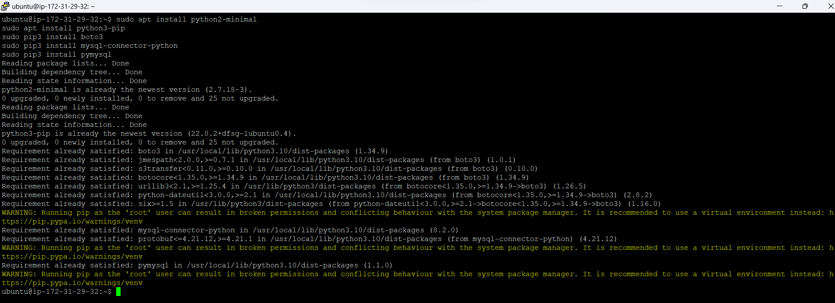

1. Use the rds.py as the template and update the hostname to the endpoint of your RDS instance and run the program
2. wget <https://d6opu47qoi4ee.cloudfront.net/rds.py>

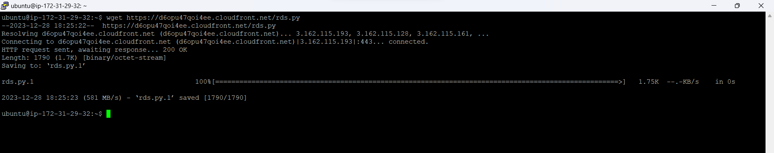

1. Modify the python program in all the places marked with "TBD"

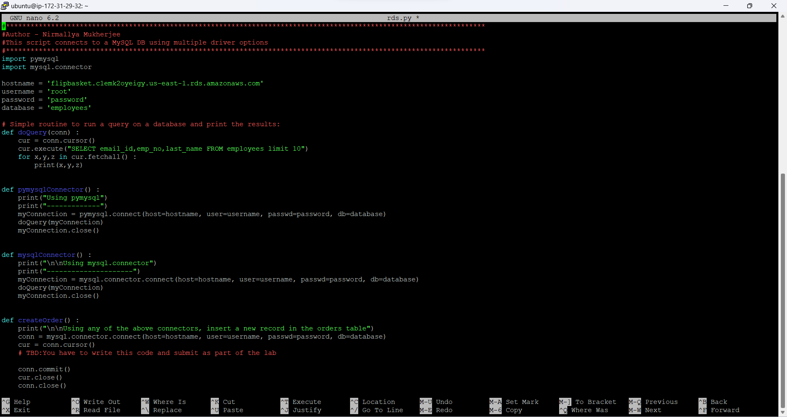

1. python3 rds.py

