Problem Statement - Create an Autoscaling group using Terraform on AWS. The instances in the group should have Nginx installed on them. Parameters in the ASG can be set at your discretion and should be mentioned in the solution documentation.

Any variables in the script should be placed in a separate variables.tf file. The output of the script should be the DNS of the associated load balancer.

Grading Criteria

1. Documentation explaining the solution architecture and template created - 10 marks  
   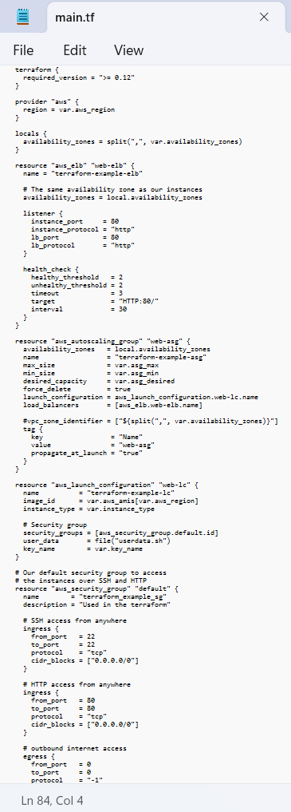
2. Shell script used to install Nginx 5 marks  
     
   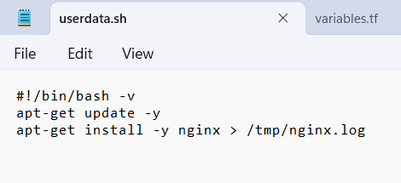
3. Separate variables file 5 marks  
     
   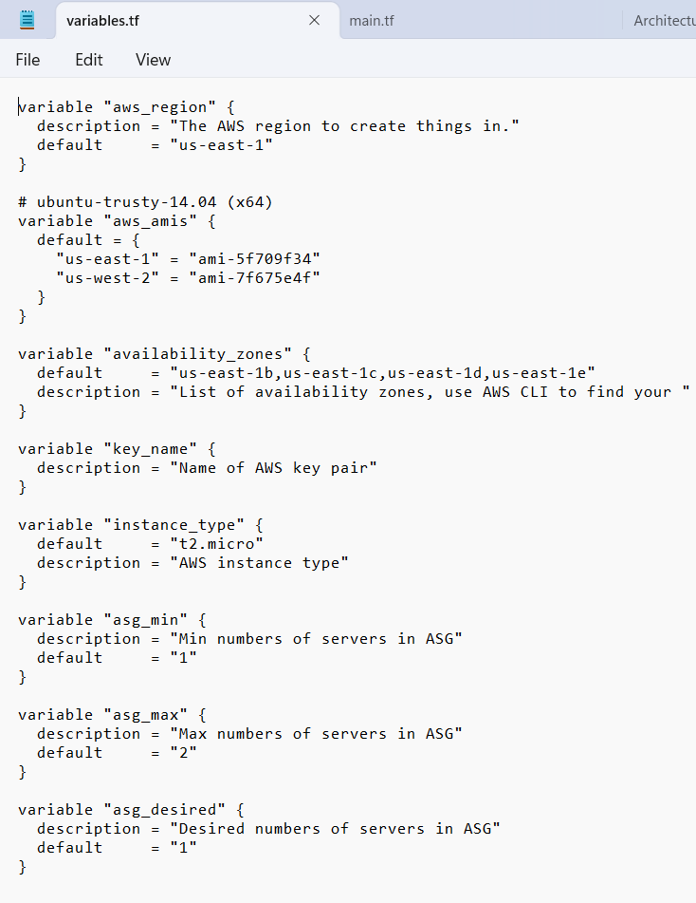
4. Output file showing DNS of load balancer 10 marks  
     
   
5. Terraform script with given components
   1. Security groups 2 marks  
        
      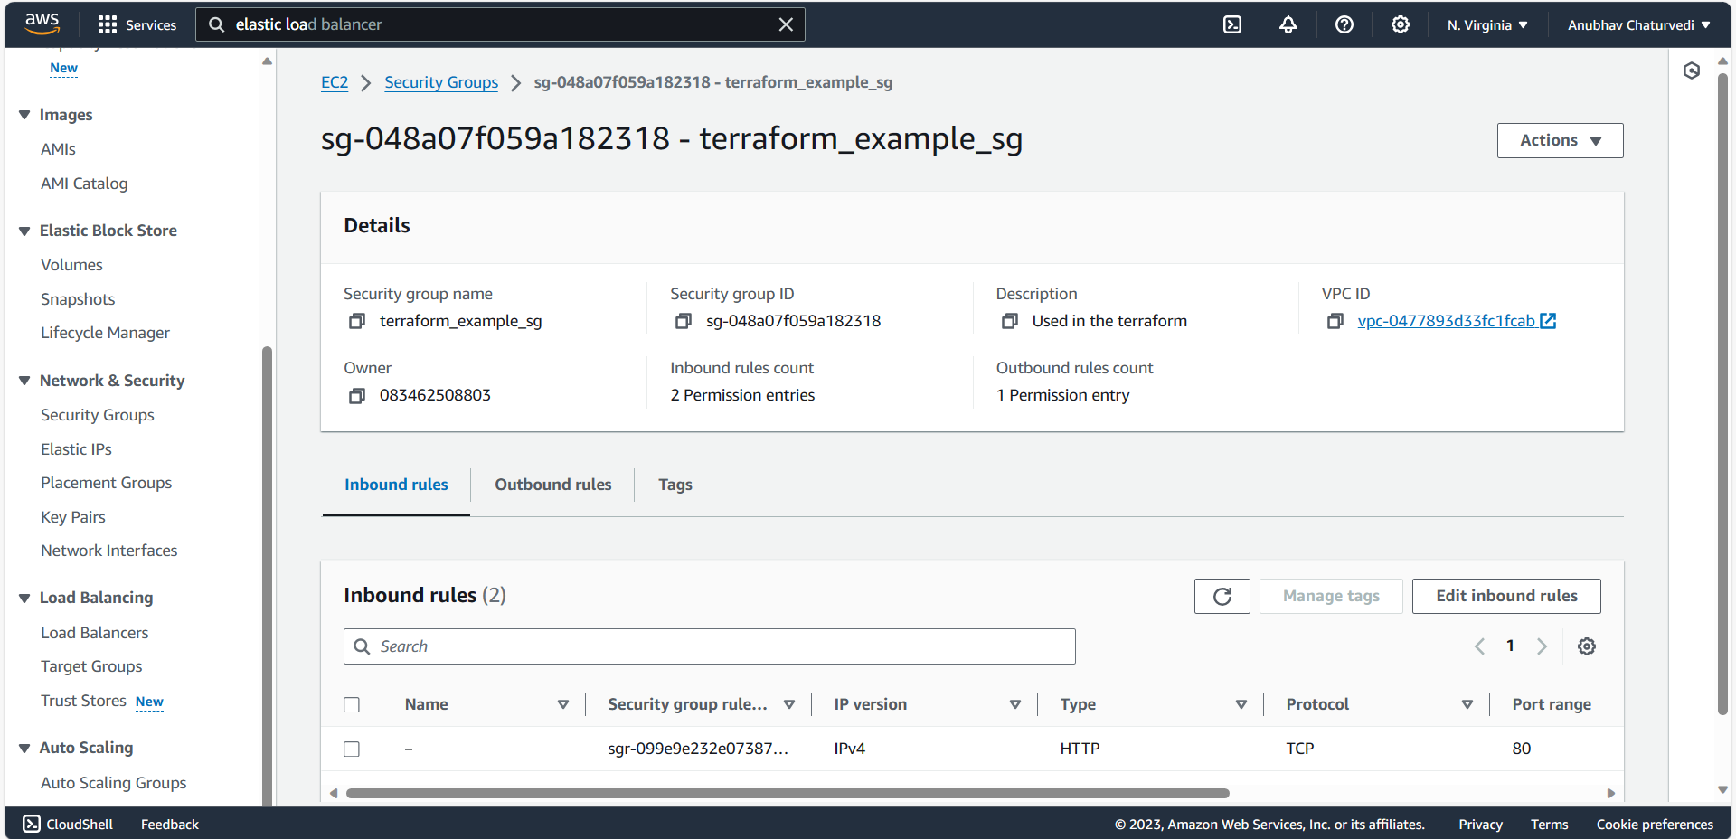
   2. EC2 instances 3 marks  
        
      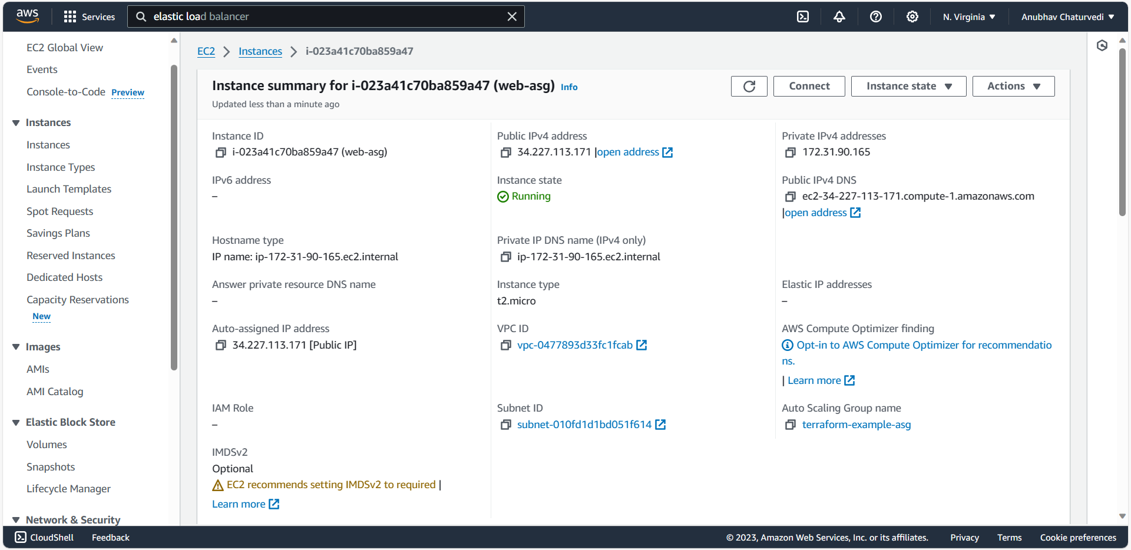
   3. Elastic Load balancer 5 marks  
        
      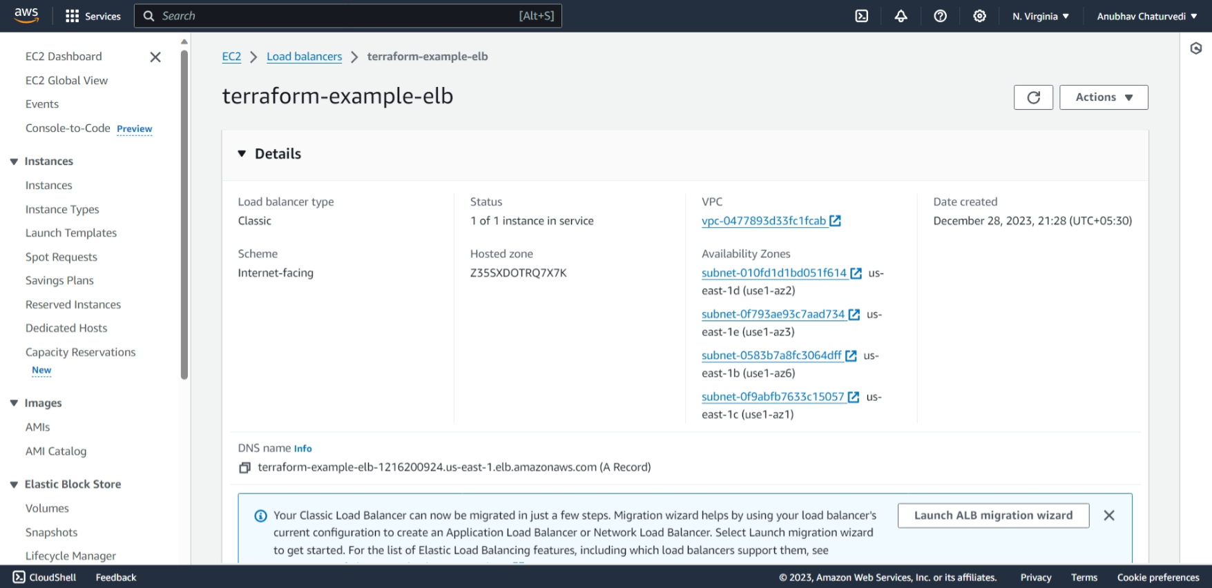
   4. Autoscaling group 5 marks  
        
      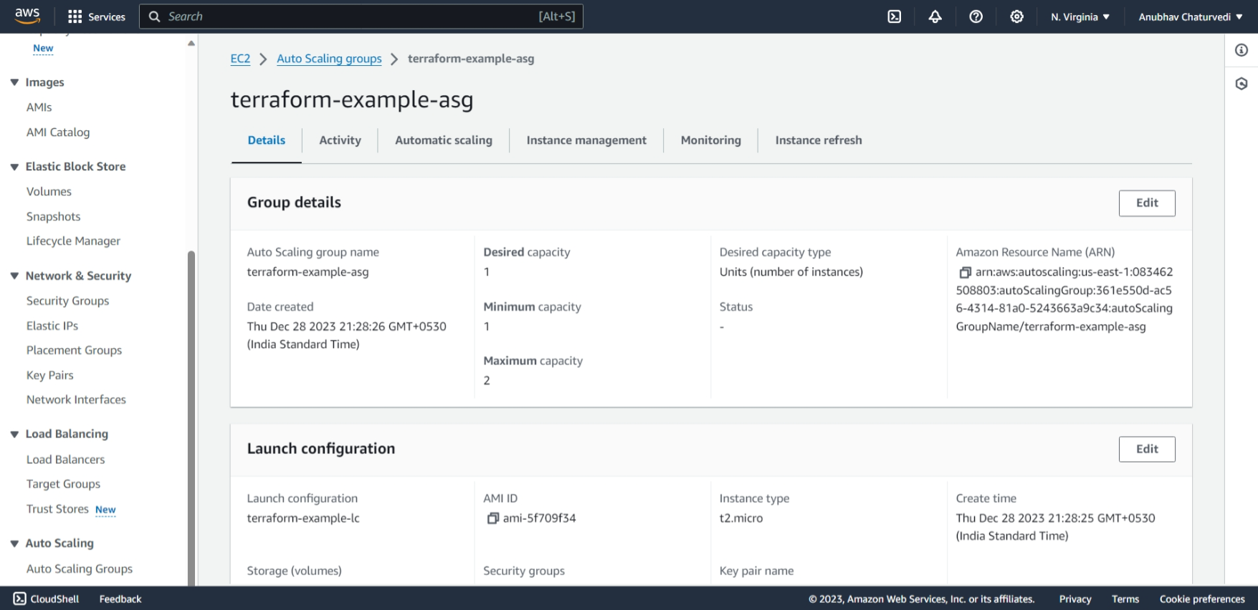
6. Screenshot showing successful execution of Terraform script 5 marks  
     
   