Chapter 6:

Decimal to Binary – divide by 2 until quotient becomes 0

Binary to Decimal – Multiply from right to left in increasing order of 2 to the power 1,2,3,4,…

Common Number:

0 – 00

1 – 01

2 – 10

3 – 11

4 – 100

5 – 101

6 – 110

7 – 111

8 – 1000

9 – 1001

10 - 1010

Two’s Compliment:

Most Significant Bit (MSB) it is of great importance as it tells us about the sign of any number i.e it is positive or negative.

If MSB is 0 the number is positive

If MSB is 1 the number is negative

How to determine the MSB?  
int n=10;

Binary: 01010 this 0 here represents MSB.

When converting decimal to binary:

1. Convert to Binary form
2. Prefix with a 0
3. Ones compliment i.e change 0 with 1 and 1 with 0.
4. Add +1.

Int n=10;

1. 1010
2. 01010
3. 0101
4. 0101  
    +1

10110

When Converting binary to decimal

1. Ones compliment
2. +1

Chapter 7: Bitwise Operators

Bitwise & (and)

0 & 0 – 0

0 & 1 – 0

1 & 0 – 0

1 & 1 – 1

Bitwise | (or)

0 | 0 – 0

0 | 1 – 1

1 | 0 – 1

1 | 1 – 1

Bitwise ^ (XOR)

(Exclusive or)

If the bit it same the answer will be zero. If the bits are different the answer will be one.

0^0=0

0^1=1

1^1=0

1^0=1

0100

^1000

1100 =(12)10

Bitwise << Left Shift operator

N<<I;

Where n is the binary form,  
  
bitwise shift operator means ;

N<<I; means shift binary form by I places.

N<<1;

If n=4;

100 it will shift to 100 _ this empty space will be filled with 0 automatically, it’ll be 8 as 8=1000

A<<b

Ans=a*2^b

Example: 3<<2 gives 12 as output

Bitwise>> Right Shift operator

Works similarly, creates a space at the left most corner and adds 0 by default.

a>>b

ans=a/2^b

Operator Precedence

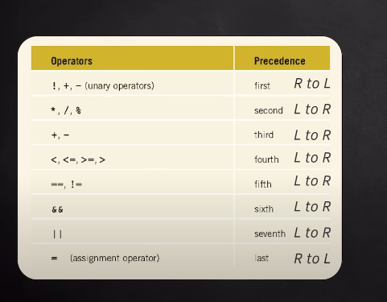

Scope

Scope means the area where our variable can be accessed/used.

Scope is of two types: Local Scope and Global Scope

Local Scope: means making local variables i.e. jo variables humne if else, block of code,function ke andar define kar diye they are all locally defined and fall in local scope.

They are not accessible outside of their scope.

Global Variables:

We generally make those global variables whom we want to be accessible throughout our file/code.

Koi bhi variable jiski access sabko dena chahte hai uskko global bana lete hai

Data Type modifiers

Change meaning of data types

* long
* short
* long long
* signed
* unsigned

int float double are by default signed.

Signed int means int can store positive and negative both numbers.

Unsigned means that it’ll be positive always.