AMITY SCHOOL OF ENGINEERING AND TECHNOLOGY
PAYMENT BEHAVIOUR &
DIGITAL PAYMENT INTELLIGENCE
Customer segmentation using unsupervised machine learning
PROJECT REPORT | JULY-DECEMBER 2026
Subject: Fundamentals of Machine Learning (MLE2503)
Department: Artificial Intelligence / BioMedical Engineering
Semester: 5th
Student Name: Anubhav Dash
UID: A501132524011
Data note: this submission uses a reproducible synthetic dataset for demonstration.

Executive Summary
This project develops a customer payment-behaviour segmentation workflow for retail and digital-payment contexts. The assignment objective is to discover useful groups from payment and transaction characteristics and evaluate payment-mode-only features against a richer combination of payment preference, spending, frequency, cashback, and promotion usage.
The reproducible dataset contains 7,535 transaction rows for 720 synthetic customers over 1 January to 31 December 2025. Data preparation removed 44 duplicate transaction IDs, excluded 28 non-positive amount rows, imputed missing fields, and capped extreme positive transaction values at the 99.5th percentile (18,757.38 INR). The resulting analysis uses 7,463 cleaned transaction rows and aggregates them to 720 customer observations.
At five clusters, payment-mode-only K-Means achieved a Silhouette Score of 0.4949 and Davies-Bouldin Index of 0.7043. The richer payment + behaviour K-Means solution achieved 0.2821 and 1.3577, respectively. This is a meaningful trade-off: payment-only patterns are more geometrically distinct, while richer features support more detailed offer, spending, channel, and EMI-oriented actions. A final five-segment combined-feature solution is profiled for operational recommendations, with its lower internal separation explicitly acknowledged.
All dataset values and model results in this report are synthetic demonstrations. They must not be represented as observations from a real bank, UPI provider, card network, wallet, or retailer. Before deployment, the approach requires validation using appropriately governed operational data.

Contents
- 1. Introduction and industry context
- 2. Problem formulation and objectives
- 3. Literature and supporting context
- 4. Dataset and data dictionary
- 5. Data preprocessing and feature engineering
- 6. Exploratory data analysis
- 7. Machine-learning methodology
- 8. Results and model comparison
- 9. Customer cluster profiles
- 10. Industry recommendations
- 11. Limitations, ethics and future work
- 12. Conclusion
- References

1. Introduction and Industry Context
Retail customers can choose among UPI, cards, cash, digital wallets, and EMI / buy-now-pay-later options. A payment provider or retailer may see different combinations of payment preference, basket value, purchase frequency, promotion response, and checkout channel. Designing one uniform checkout journey or discount policy for all customers can be ineffective: a cashback-driven wallet user, a cash-preferring customer, and an EMI user have different observed patterns and may respond differently to incentives.
The Reserve Bank of India reports that digital transactions represented 99.8% of the volume of non-cash retail payments in FY 2023-24 and that UPI accounted for 79.6% of retail payment volume in that year [1, 2]. These national context statistics motivate study of payment behaviours; they are not measurements from this synthetic dataset.
The project uses unsupervised learning because the objective is discovery of behavioural groups rather than predicting a pre-labelled target. Clusters are interpreted after training using summary statistics, then translated into cautious operational hypotheses.

2. Problem Formulation and Objectives

Problem statement
Develop an ML-based customer payment-behaviour segmentation model and evaluate whether meaningful customer groups can be identified using payment and transactional characteristics. This matches Problem Statement 7 in the provided assignment brief.

Objectives
- Inspect transaction data, identify missing and duplicate records, and evaluate abnormal transaction values.
- Aggregate transaction-level records to customer-level features and encode multi-mode preferences as payment shares.
- Standardize features and compare K-Means with Ward agglomerative clustering.
- Compare payment-mode-only features with payment + spending + frequency + offer-usage features.
- Evaluate solutions with the Elbow Method, Silhouette Score, and Davies-Bouldin Index.
- Use PCA for visualization, profile clusters, and propose data-driven checkout, cashback, and EMI recommendations.

Research questions
- Do payment-mode shares alone create clearer clusters than richer behavioural features?
- Which observed clusters differ in payment preference, annualized-in-period spending, offer use, and channel?
- How should recommendations differ by cluster without using payment patterns for high-stakes or punitive decisions?

3. Literature and Supporting Context
RBI publications describe the growth and changing structure of digital payments in India, including the scale of UPI and related payment infrastructure [1, 2]. This makes customer payment-mode behaviour relevant to checkout design, incentive policy, and digital-payment experience.
The World Bank Global Findex Database 2025 documents global patterns in account ownership, payments, borrowing, and use of digital technologies, drawing on nationally representative surveys across 141 economies [3]. It reinforces an important design point for payment intelligence: access and usage can differ across customer groups, so digital-first experiences should not assume that every customer has the same access or preference.
For method selection, scikit-learn describes K-Means as minimizing within-cluster sum of squares, while agglomerative clustering builds a hierarchy by repeatedly merging observations or clusters [4]. The Silhouette Coefficient measures how well-separated a sample is from its nearest other cluster; higher is generally better. Davies-Bouldin compares within-cluster dispersion with distances between cluster centroids; lower is generally better [4]. Neither internal metric substitutes for business validation. PCA is used here to project standardized features into two dimensions for visual review; a two-dimensional plot cannot preserve all higher-dimensional structure [5].

4. Dataset Description and Data Dictionary
The transaction file `payment_transactions_synthetic.csv` contains 7,535 raw rows, 13 fields, and 720 customer identifiers. Dates range from 2025-01-01 to 2025-12-31. The underlying values are synthetically generated to represent varied behaviours, then deliberately seeded with duplicates, missing values, non-positive amounts, and a few extreme positive values so that cleaning decisions can be demonstrated.
Field | Description
transaction_id | Unique transaction reference; used to detect duplicated rows.
customer_id | Synthetic customer identifier used for customer-level aggregation.
transaction_date | Date of the transaction; parsed as datetime for temporal EDA.
transaction_amount_inr | Transaction value in INR; used for spending and ticket-size features.
payment_mode | UPI, Card, Digital Wallet, Cash, or EMI/BNPL.
channel | Mobile App, Website, or Physical Store.
merchant_category | Synthetic category such as Groceries, Apparel, Electronics, Dining, Pharmacy, Home & Living, or Travel.
cashback_used / cashback_amount_inr | Whether cashback was used and the synthetic cashback amount.
discount_pct / promo_applied / promo_type | Discount depth and whether a promotion was applied; promotion type can be missing when no promotion applies.
emi_tenure_months | Synthetic EMI duration; zero when EMI/BNPL was not used.

Data source qualification: no personal or real payment-provider data is included. Synthetic customer IDs are not linked to identifiable individuals. The latent generator persona is not included as a training feature or target label.

5. Preprocessing and Feature Engineering

5.1 Data quality treatment
Operation | Observed / applied treatment | Rationale
Duplicate transactions | Removed 44 duplicated transaction IDs. | Avoid double-counting the same transaction.
Invalid values | Excluded 28 rows with amount <= 0. | Non-positive values are not treated as ordinary completed purchases in this synthetic sample.
Missing amounts | Median-imputed 30 missing amount values. | Median is robust to a right-skewed amount distribution.
Missing categorical fields | Imputed missing payment mode/category using the sample mode; blank promotion type is set to None. | Preserves records and distinguishes absence of a promotion.
Cashback / discount | Missing cashback values filled with zero where not recorded; discount constrained to 0-100. | Keeps feature values within interpretable bounds.
Extreme high amounts | Capped positive amounts above the 99.5th percentile at 18,757.38 INR. | Reduces leverage of synthetic extreme values while retaining rows.

The clean transaction table contains no missing values in the fields used by the workflow. In real payment data, negative amounts may represent legitimate refunds, reversals, or chargebacks and should be modeled with explicit transaction-type labels instead of simply removed.

5.2 Customer-level feature engineering
Transactions are grouped by customer to create one row per customer. Payment preference is represented by share of transactions per mode rather than assigning each customer to only one payment category.
Feature group | Examples | Purpose
Payment mix | UPI, card, wallet, cash, and EMI/BNPL transaction shares. | Characterize mode preference while allowing multi-mode use.
Spending | Total spend, average and median transaction value; log total and log average spend. | Reduce skew and capture spend/ticket-size differences.
Frequency | Transaction count and transactions per active month. | Distinguish frequent from occasional purchasers.
Incentive behaviour | Cashback-use rate, average discount percentage, promotion response rate, mean cashback amount. | Characterize observable offer engagement, not causal discount sensitivity.
Channel / variety | Mobile-app, website, physical-store shares and merchant-category diversity. | Contextualize customer journeys and breadth of purchases.

The payment-only feature set includes five payment-share features. The combined feature set adds spending, frequency, incentive and channel variables, for 17 features in total. Numeric features are standardized using StandardScaler before distance-based clustering. No supervised train/test split is used because there is no target label and the primary task is descriptive unsupervised segmentation. A production prediction task or temporal generalization test would require an appropriate hold-out design.

6. Exploratory Data Analysis
After cleaning, 7,463 records remain, corresponding to 720 unique customers. Mean transaction amount is 1,394.69 INR and the median is 493.65 INR. The positive skew and very large upper tail make robust summaries and log transforms useful. In the cleaned table, 31.8% of transactions record cashback use and 40.8% record a promotion.
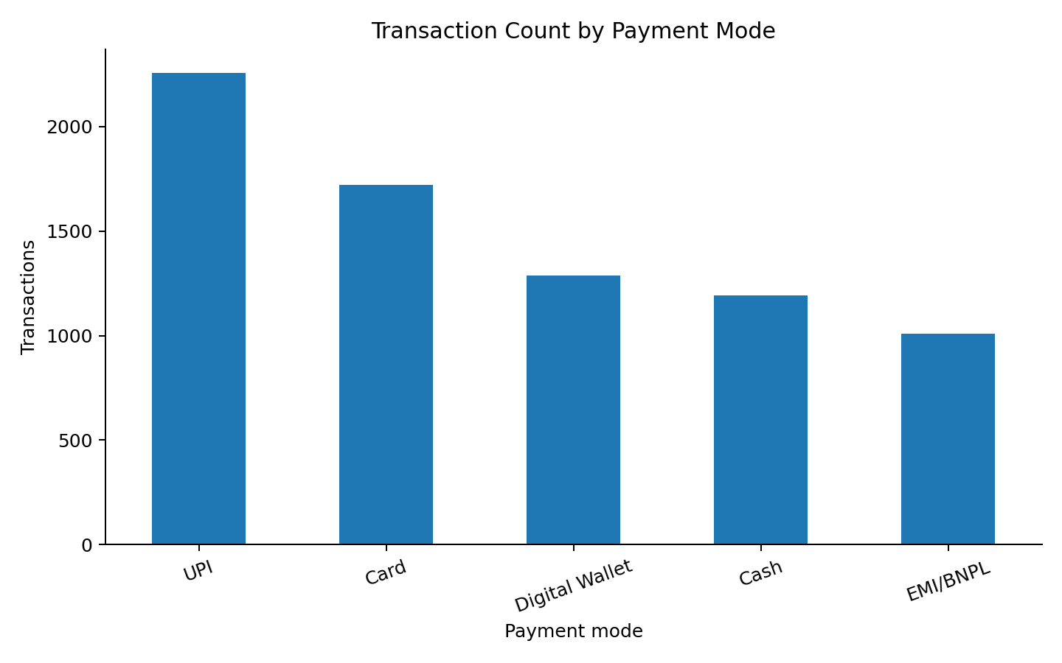
Figure 1. Transaction counts by payment mode after cleaning.
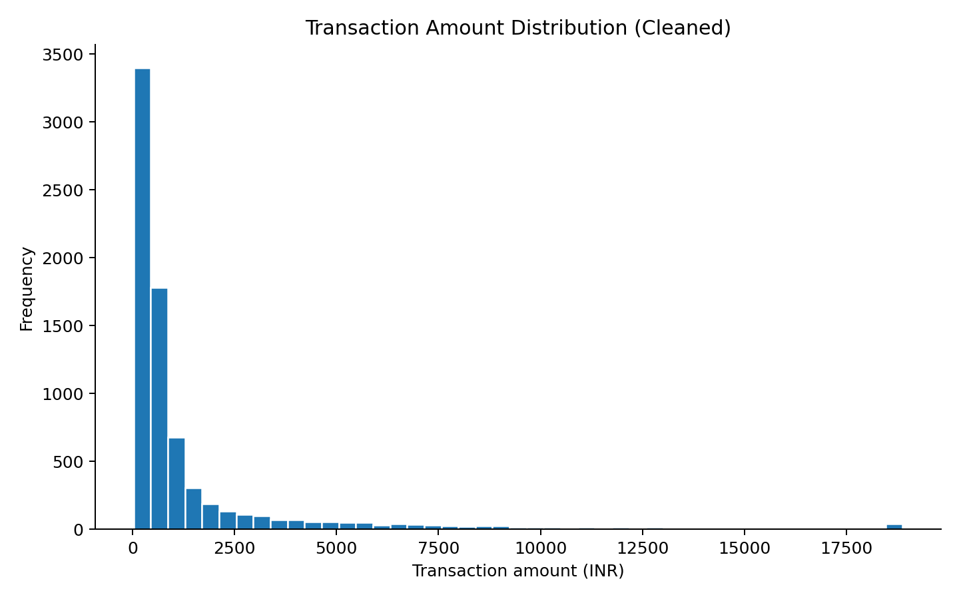
Figure 2. Transaction-value distribution; skew motivates log-spend features and robust capping.
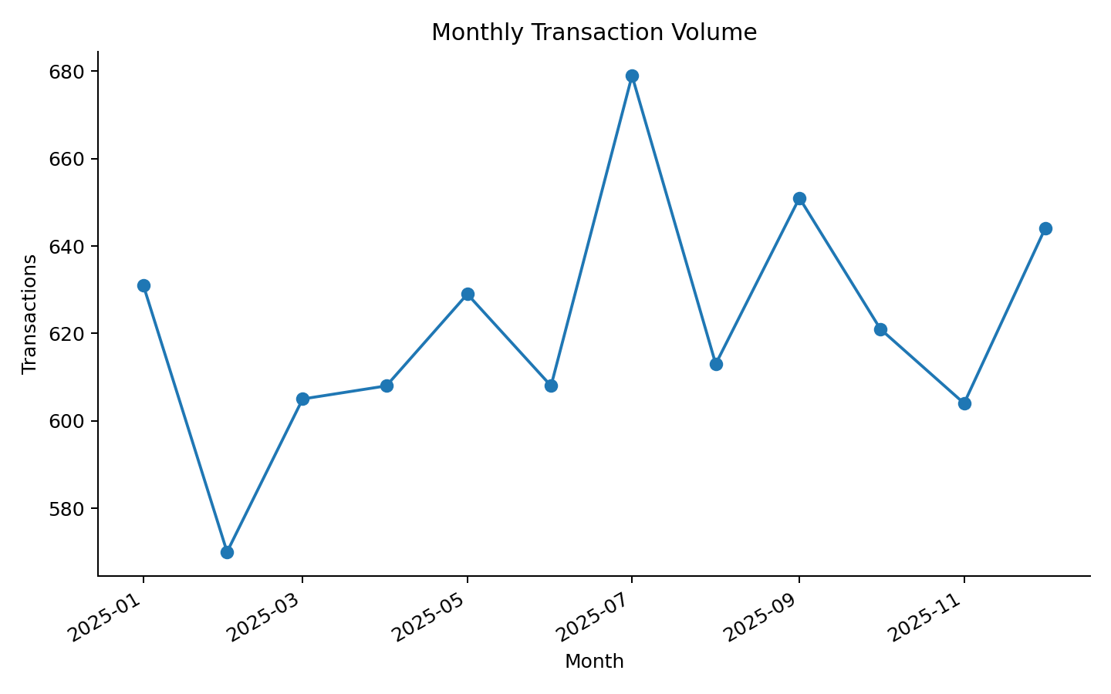
Figure 3. Monthly transaction volume across the synthetic observation year.
Payment mode | Count | Share (%)
UPI | 2,256 | 30.2%
Card | 1,720 | 23.0%
Digital Wallet | 1,287 | 17.2%
Cash | 1,191 | 16.0%
EMI/BNPL | 1,009 | 13.5%

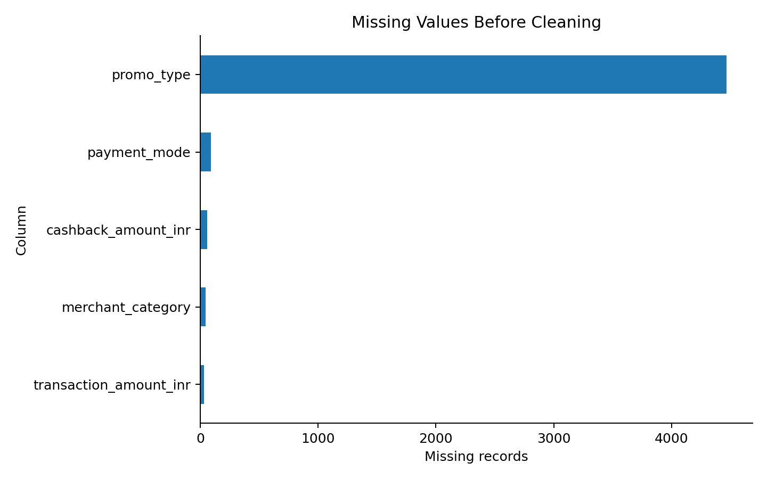
Figure 4. Missing-value counts before the cleaning procedure.

7. Machine-Learning Methodology

7.1 K-Means
K-Means assigns each customer to the nearest centroid and minimizes the within-cluster sum of squared Euclidean distances. It is efficient and works well as a baseline when features have been standardized. The number of clusters is chosen by reviewing inertia (Elbow Method), Silhouette Score, Davies-Bouldin Index, cluster sizes, and whether the resulting profiles support clear actions.

7.2 Ward agglomerative clustering
Ward agglomerative clustering starts with each observation as its own cluster and repeatedly merges groups based on an increase in within-cluster variance. It provides a different clustering structure and is compared at the same k and feature sets. A truncated dendrogram is provided as a visual aid; the final internal metrics are computed over all 720 customers.

7.3 Evaluation metrics
Metric | Interpretation | Preferred direction
Inertia / WCSS | Within-cluster sum of squares; decreases as k increases. Look for diminishing returns. | Lower, but inspect the elbow rather than minimizing alone.
Silhouette Score | Compares average within-cluster distance with nearest other-cluster distance; range [-1, 1]. | Higher is better.
Davies-Bouldin Index | Average similarity between each cluster and its most similar alternative, based on dispersion/separation. | Lower is better.
PCA plot | Projects standardized features into two principal components for visual inspection. | No single preferred score; look for structure and overlap.

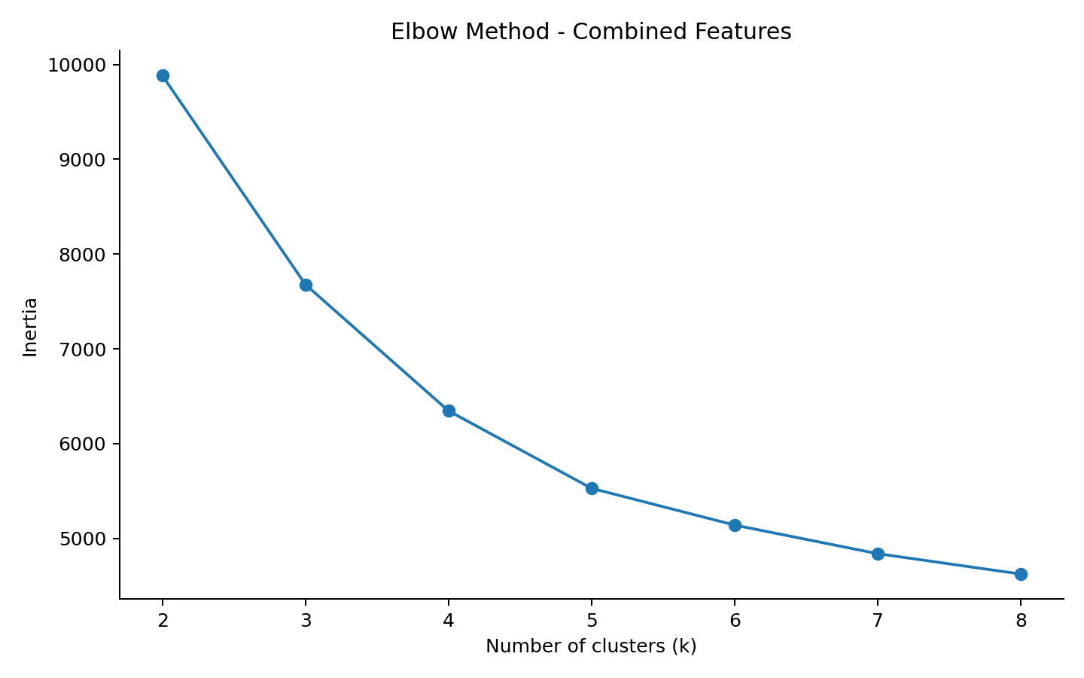
Figure 5. Elbow curve for the combined feature set.
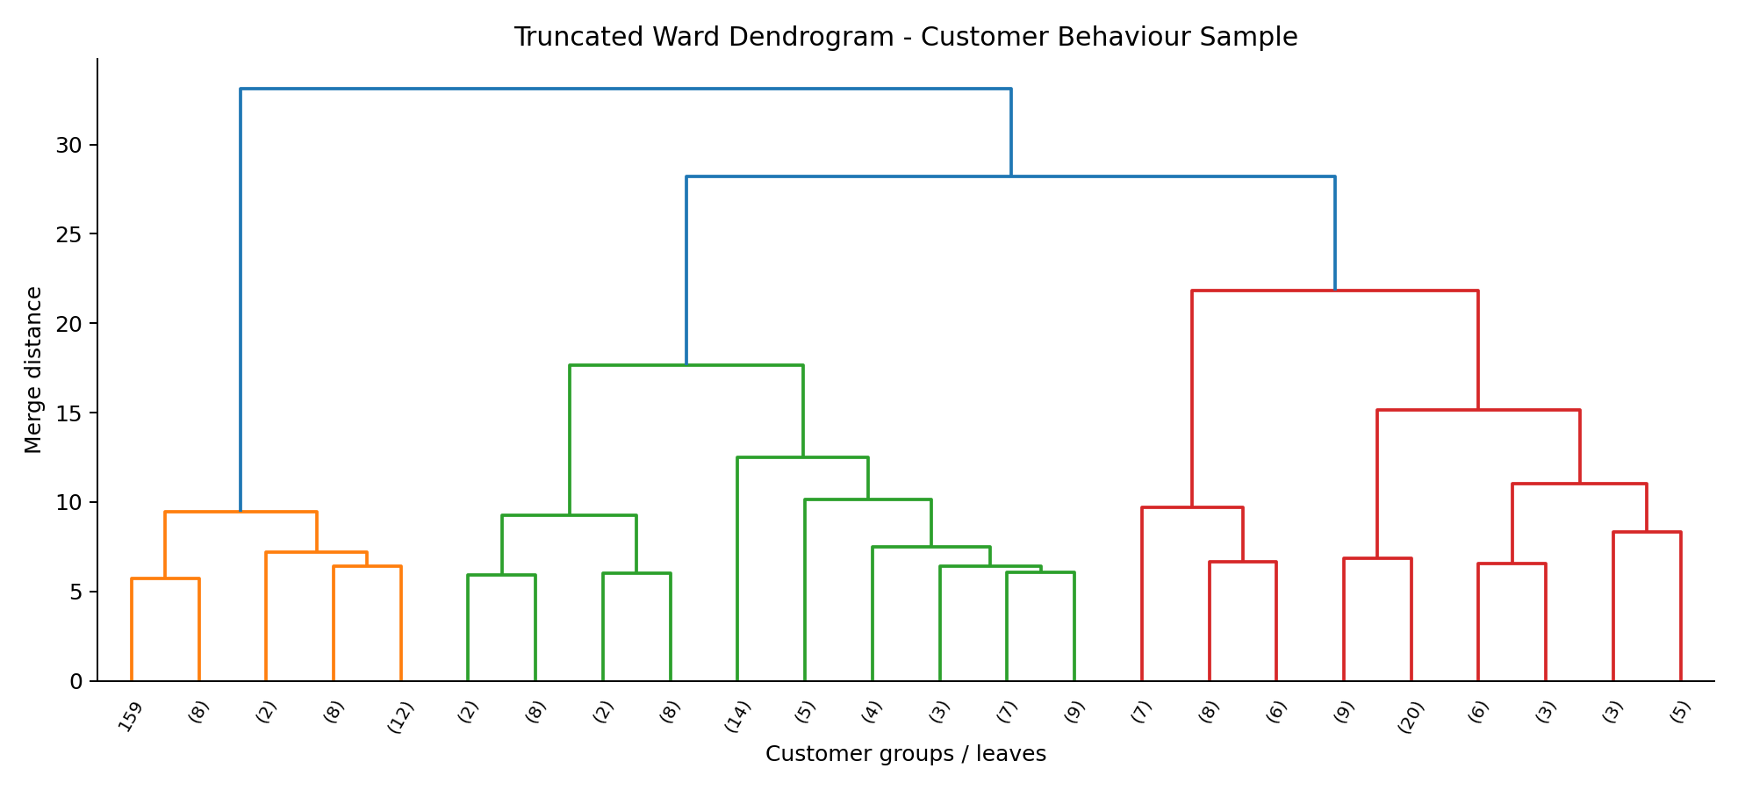
Figure 6. Truncated Ward dendrogram for a reproducible 160-customer subsample.

8. Results and Model Comparison
For the combined feature set, the best Silhouette Score across k = 2 to 8 is 0.2821 at k = 5. The curve shows diminishing reduction in inertia around the four-to-five-cluster region. Davies-Bouldin is 1.3465 at k = 4 and 1.3577 at k = 5, so the separation metrics are not unanimous. The five-cluster solution is retained for the main business profiling because it yields five readable payment-oriented groups and provides a consistent comparison at k = 5; this is an interpretability choice, not proof of a globally optimal segmentation.
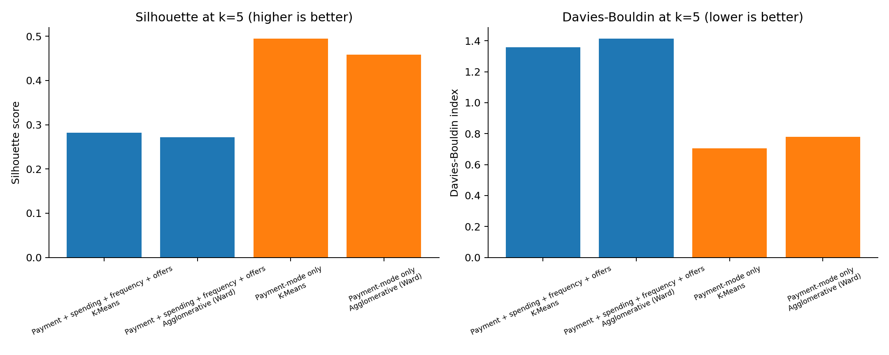
Figure 7. Internal metric comparison at k = 5: payment-only features separate more cleanly.
Feature design | Algorithm | k | Silhouette ↑ | Davies-Bouldin ↓
Payment-mode only | K-Means | 5 | 0.4949 | 0.7043
Payment-mode only | Agglomerative (Ward) | 5 | 0.4583 | 0.7789
Payment + spending + frequency + offers | K-Means | 5 | 0.2821 | 1.3577
Payment + spending + frequency + offers | Agglomerative (Ward) | 5 | 0.2717 | 1.4146

Interpretation: at k = 5, payment-mode-only K-Means is stronger on both internal metrics than the combined-feature K-Means (0.4949 vs 0.2821 silhouette; 0.7043 vs 1.3577 Davies-Bouldin). Adding correlated and less sharply separated behavioural dimensions spreads customer profiles across more dimensions, which can reduce geometric separation. However, the combined profile gives the business decision-maker direct measures of spending, offers, channel, and EMI usage. The feature choice should depend on whether the aim is clean payment preference groups or operationally enriched profiles.
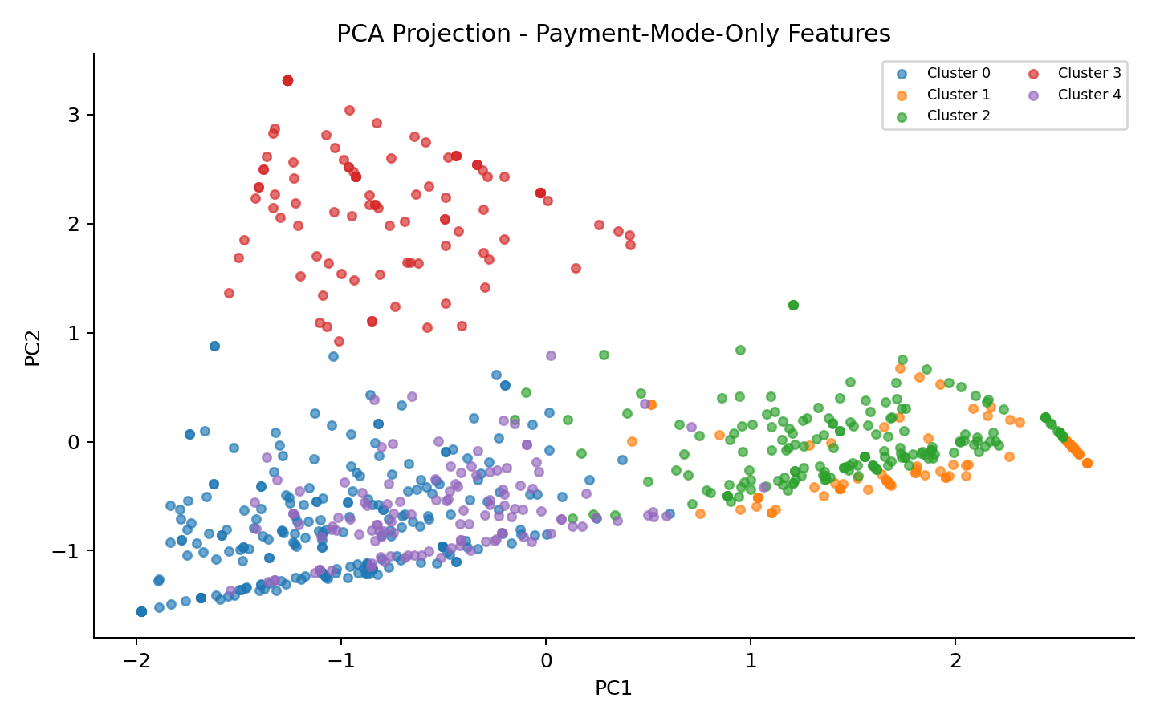
Figure 8. PCA view of payment-mode-only K-Means clusters.
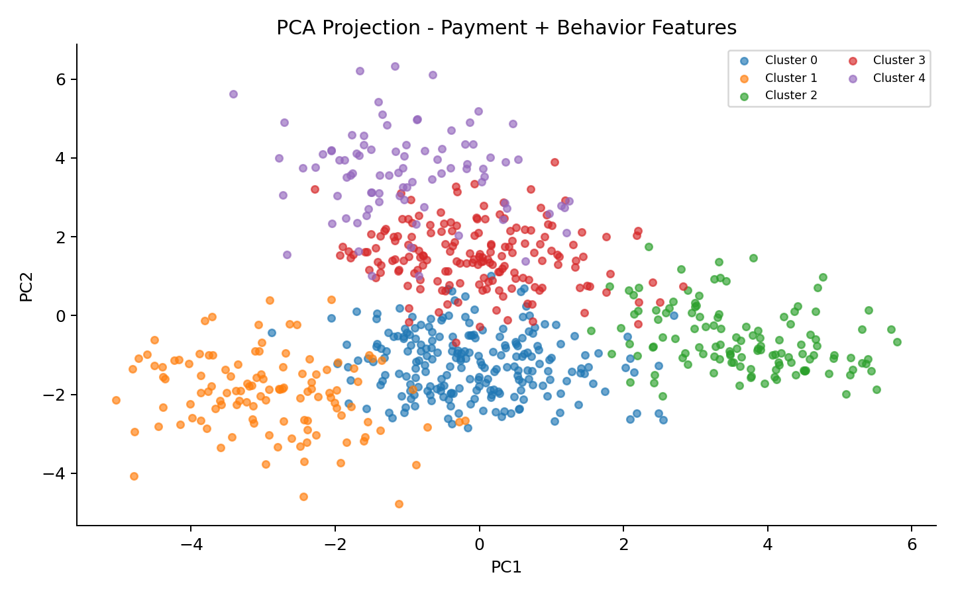
Figure 9. PCA view of the final combined-feature segmentation; overlap is visible.

9. Final Customer Cluster Profiles
The five-cluster combined-feature K-Means solution is summarized below. Segment names are assigned after clustering from the highest average payment-mode share; numeric cluster IDs have no ordinal meaning.
Cluster | Segment | Customers | Share | Avg txn (INR) | Avg spend (INR) | Cashback users | Avg discount
0 | UPI-centric customers | 221 | 30.7% | 803 | 9,122 | 27.5% | 5.6%
1 | Wallet/offer-oriented customers | 117 | 16.2% | 974 | 13,459 | 76.9% | 11.8%
2 | Cash-oriented customers | 123 | 17.1% | 526 | 4,114 | 2.7% | 2.9%
3 | Card-oriented customers | 172 | 23.9% | 1,740 | 18,627 | 19.1% | 5.0%
4 | EMI/BNPL-oriented customers | 87 | 12.1% | 4,754 | 35,724 | 24.1% | 6.7%

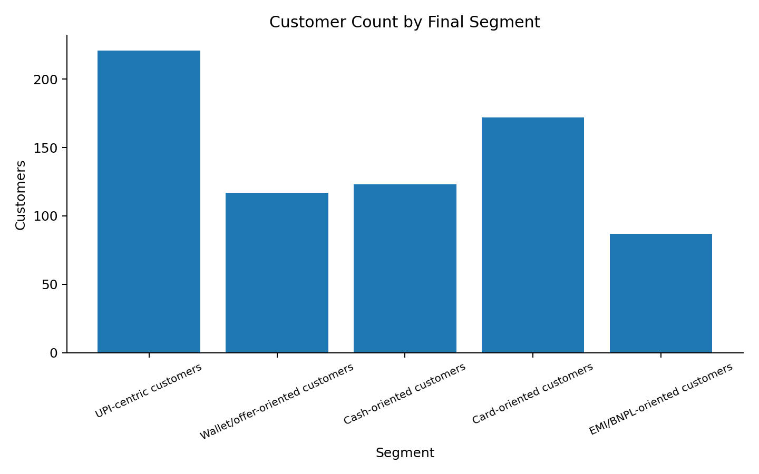
Figure 10. Final segment sizes; labels are descriptive rather than predictive.
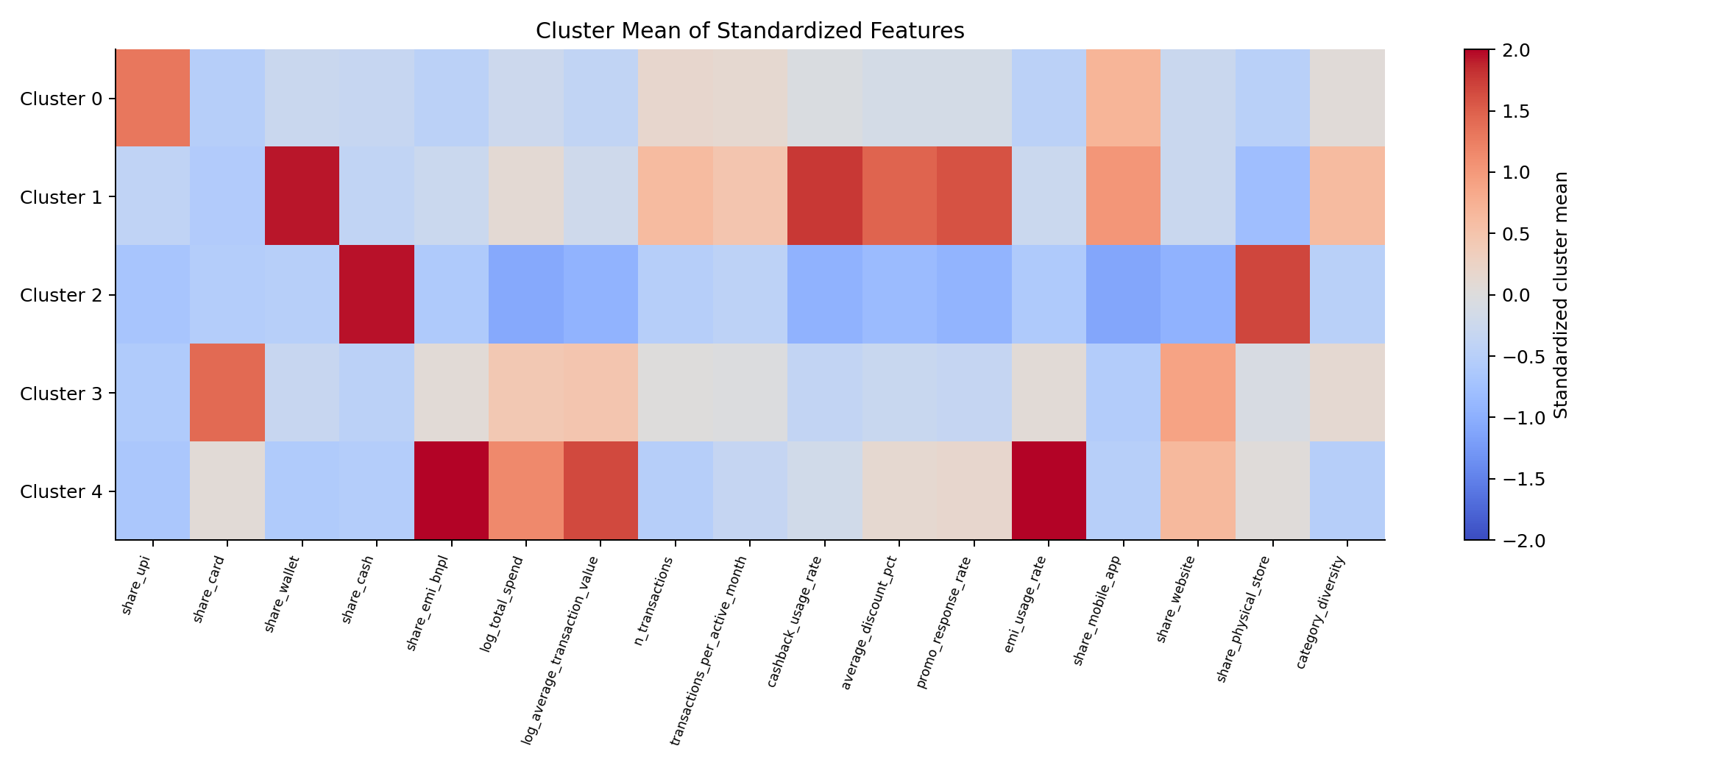
Figure 11. Cluster mean of standardized features; brighter/darker cells mark above/below overall mean patterns.

10. Industry Recommendations

UPI-centric customers (221 customers, 30.7%)
Keep UPI visible at checkout, reduce avoidable steps, and test low-cost instant rewards or repeat-purchase flows. Measure incremental lift instead of paying rewards to all UPI purchases.

Wallet/offer-oriented customers (117 customers, 16.2%)
Test wallet and cashback campaigns with treatment/control groups. Use reward caps and incremental contribution margin to avoid subsidizing transactions that would have occurred anyway.

Cash-oriented customers (123 customers, 17.1%)
Keep cash and assisted payment options accessible. Offer optional, non-coercive digital onboarding and explain benefits without penalizing cash users.

Card-oriented customers (172 customers, 23.9%)
Consider relevant card-linked offers and value-added benefits, but compare against no-offer controls and monitor total checkout conversion and margin.

EMI/BNPL-oriented customers (87 customers, 12.1%)
Make total repayment cost, rates/fees, tenure, and due dates easy to understand. Use affordability safeguards and avoid incentivizing unnecessary borrowing.
Operational measurement: run controlled experiments, compare incremental gross margin and customer experience, monitor opt-out/complaint rates, and review segment stability over time. Cluster descriptions should be used for aggregate service design, not individual punitive treatment.

11. Limitations, Ethics, and Future Work
- Synthetic data: segment sizes, spending and discount rates are generated for demonstration and do not estimate real Indian customer behaviour.
- Descriptive clustering is not causal inference: cashback use and discounts are associated variables; the model cannot show that a promotion caused a purchase.
- Internal cluster metrics favor the payment-only feature set; richer combined features have lower separation. The final combined solution is retained for business richness, with this limitation made explicit.
- The data covers one synthetic year. Real deployment should test temporal stability and re-train only under documented controls.
- Production data would require access controls, purpose limitation, data minimization, retention rules, auditability, and security review.
- Payment patterns should not be used on their own to infer protected traits or make high-stakes credit, eligibility, or punitive decisions.
- Future work: validate on permissioned real data, compare robust scaling and alternative distances, run cluster-stability tests, and conduct controlled incentive experiments.

12. Conclusion
The project delivers a reproducible end-to-end payment-behaviour segmentation pipeline using customer-level payment shares and enriched spending/frequency/offer features. It covers data inspection, cleaning, feature engineering, standardization, K-Means, Ward agglomerative clustering, internal metrics, Elbow analysis, a dendrogram, PCA views, profile tables, and actionable but cautious recommendations.
The results show that adding behavioural features improves the operational richness of customer profiles but reduces internal geometric separation at k = 5. For this reason, a sensible deployment path would retain both views: payment-only segments for clean payment-mode taxonomy, and a combined-feature view for designing aggregate experience and incentive experiments. Any real-world use must first validate the model against genuine, governed data and measurable business outcomes.

References
[1] Reserve Bank of India. (2024). Annual Report 2023-24, Department of Payment and Settlement Systems. https://systemhealth.rbi.org.in/Scripts/AnnualReportPublications.aspx_Id%3D1409%281%29.html
[2] Reserve Bank of India. (2024). Chapter III: Digitalisation and Payment Revolution in India. https://rbi.org.in/scripts/PublicationsView.aspx?id=22459
[3] World Bank. (2025). The Global Findex Database 2025: Report and data on financial inclusion, payments, borrowing and digital connectivity. https://www.worldbank.org/en/publication/globalfindex/report
[4] scikit-learn developers. Clustering: K-Means, agglomerative clustering, and clustering performance evaluation. https://scikit-learn.org/stable/modules/clustering.html
[5] scikit-learn developers. Principal Component Analysis (PCA). https://scikit-learn.org/stable/modules/decomposition.html#pca
[6] Rousseeuw, P. J. (1987). Silhouettes: A Graphical Aid to the Interpretation and Validation of Cluster Analysis. Journal of Computational and Applied Mathematics, 20, 53-65.

