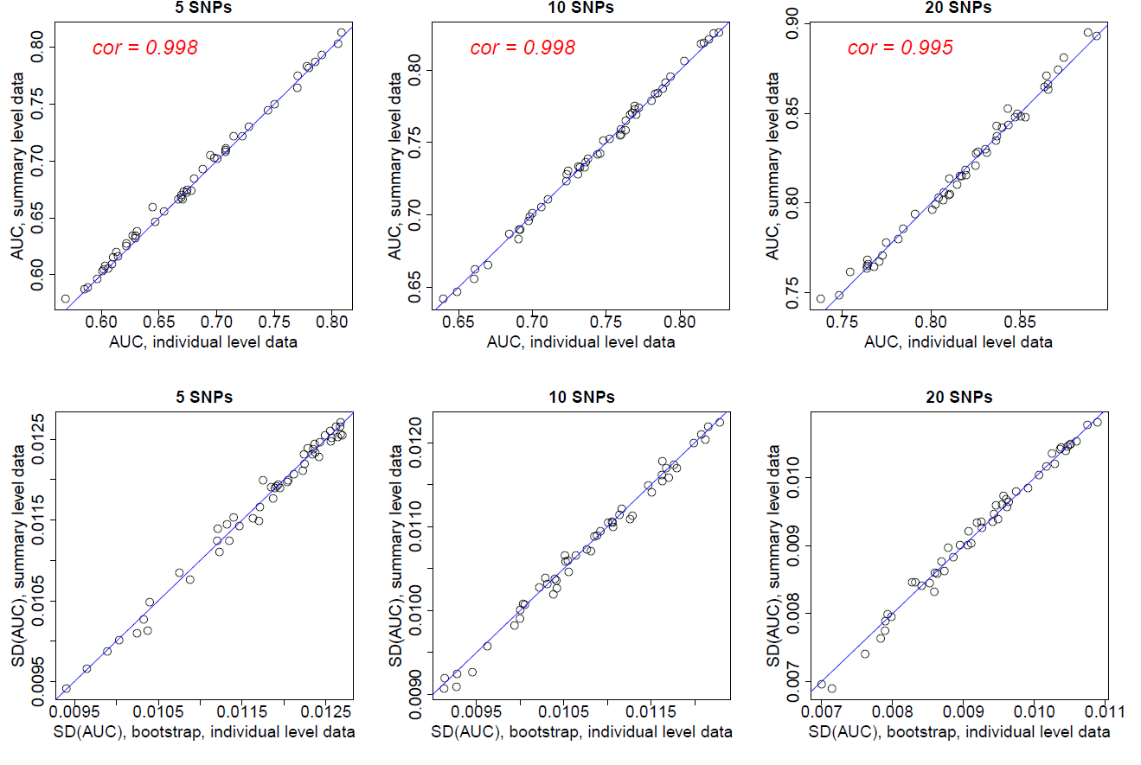

Supplementary Figure 1. AUC values and the standard errors for PRS with independent SNPs based on simulation study. Each data point represents one simulation. For each simulation, we calculated the AUC and its variance based on individual data (x-coordinate) and using SummaryAUC (y-coordinate). Simulation results assuming .

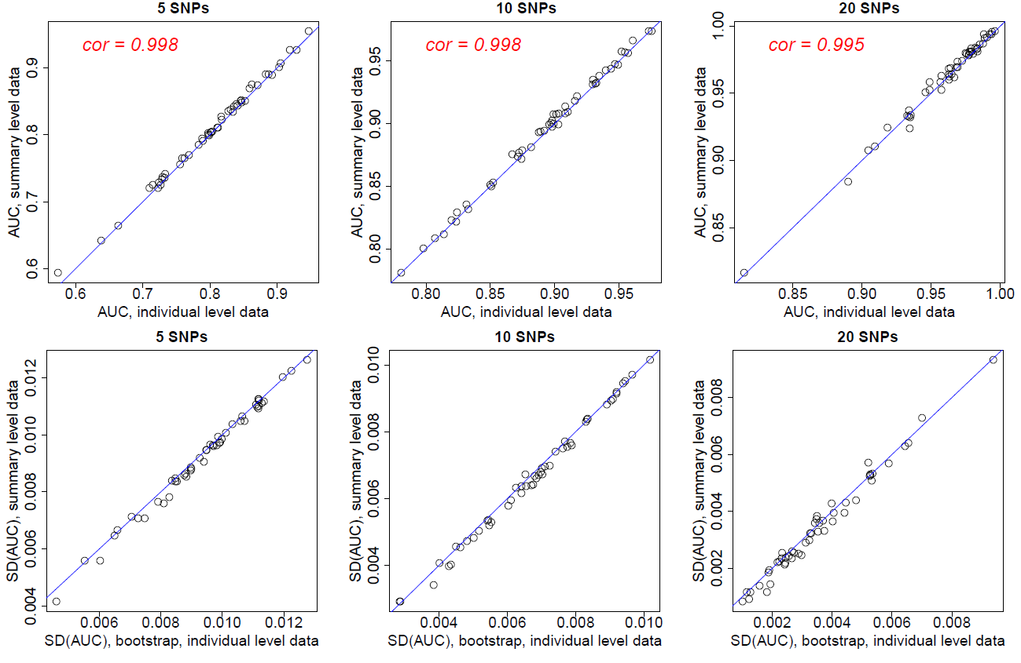

Supplementary Figure 2. AUC values and the standard errors for PRS with independent SNPs based on simulation study. Each data point represents one simulation. For each simulation, we calculated the AUC and its variance based on individual data (x-coordinate) and using SummaryAUC (y-coordinate). Simulation results assuming .

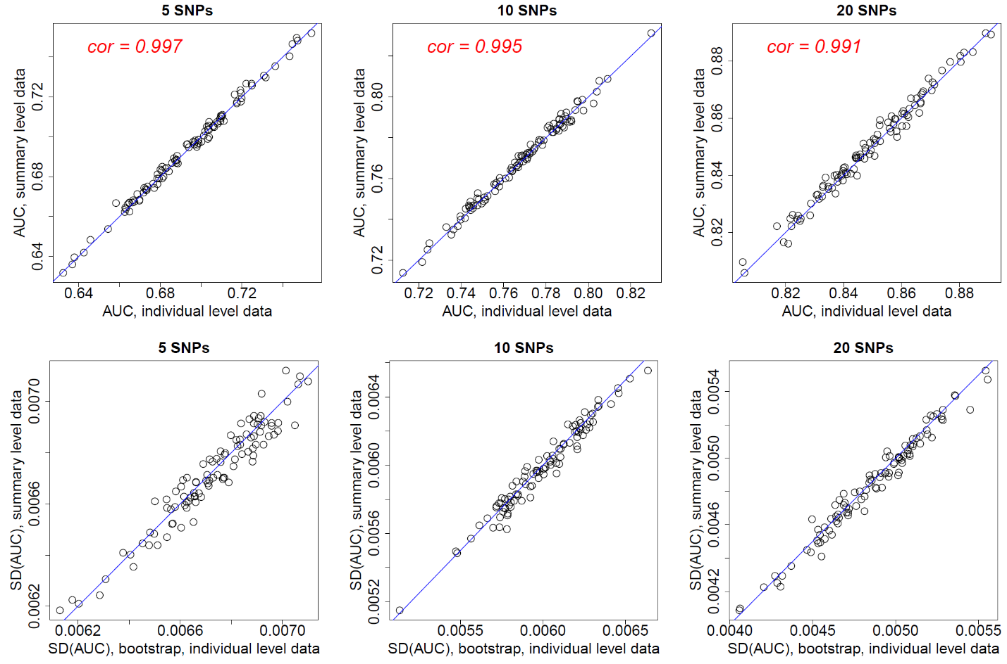

Supplementary Figure 3. AUC values and the standard errors for PRS with independent SNPs based on simulation study. Each data point represents one simulation. For each simulation, we calculated the AUC and its variance based on individual data (x-coordinate) and using SummaryAUC (y-coordinate).

Additional simulations. SNP list, effect allele frequencies and ORs are from publications of nine diseases: Crohn’s diseases (Lee, et al., 2013), type 1 diabetes (Onengut-Gumuscu, et al., 2015), Alzheimer’s disease (Sleegers, et al., 2015), testicular cancer (Wang, et al., 2017), multiple sclerosis (Sawcer, et al., 2011), prostate cancer (Schumacher, et al., 2018), melanoma (Law, et al., 2015), rheumatoid arthritis (Okada, et al., 2014) and psoriasis (Strange, et al., 2010).

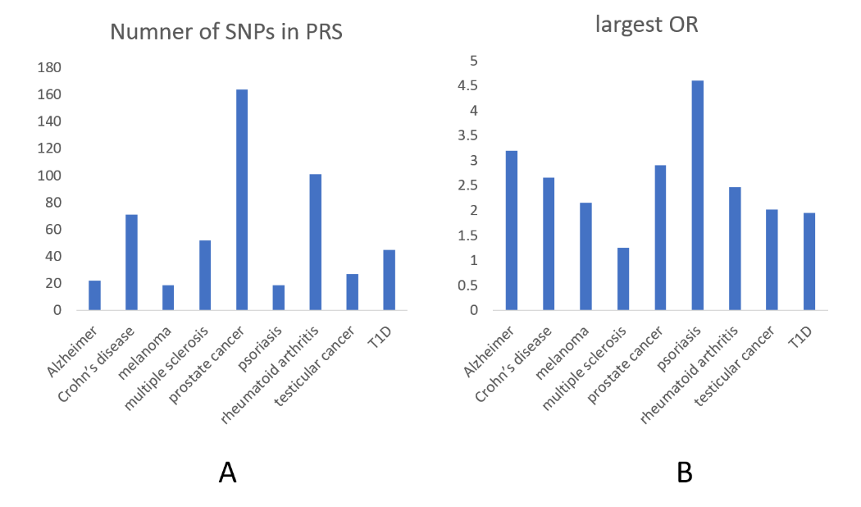

Supplementary Figure 4. (A). Number of SNPs included in PRS for 9 diseases. (B) The largest OR for each disease. SNPs with MAF<1% were excluded from analysis.

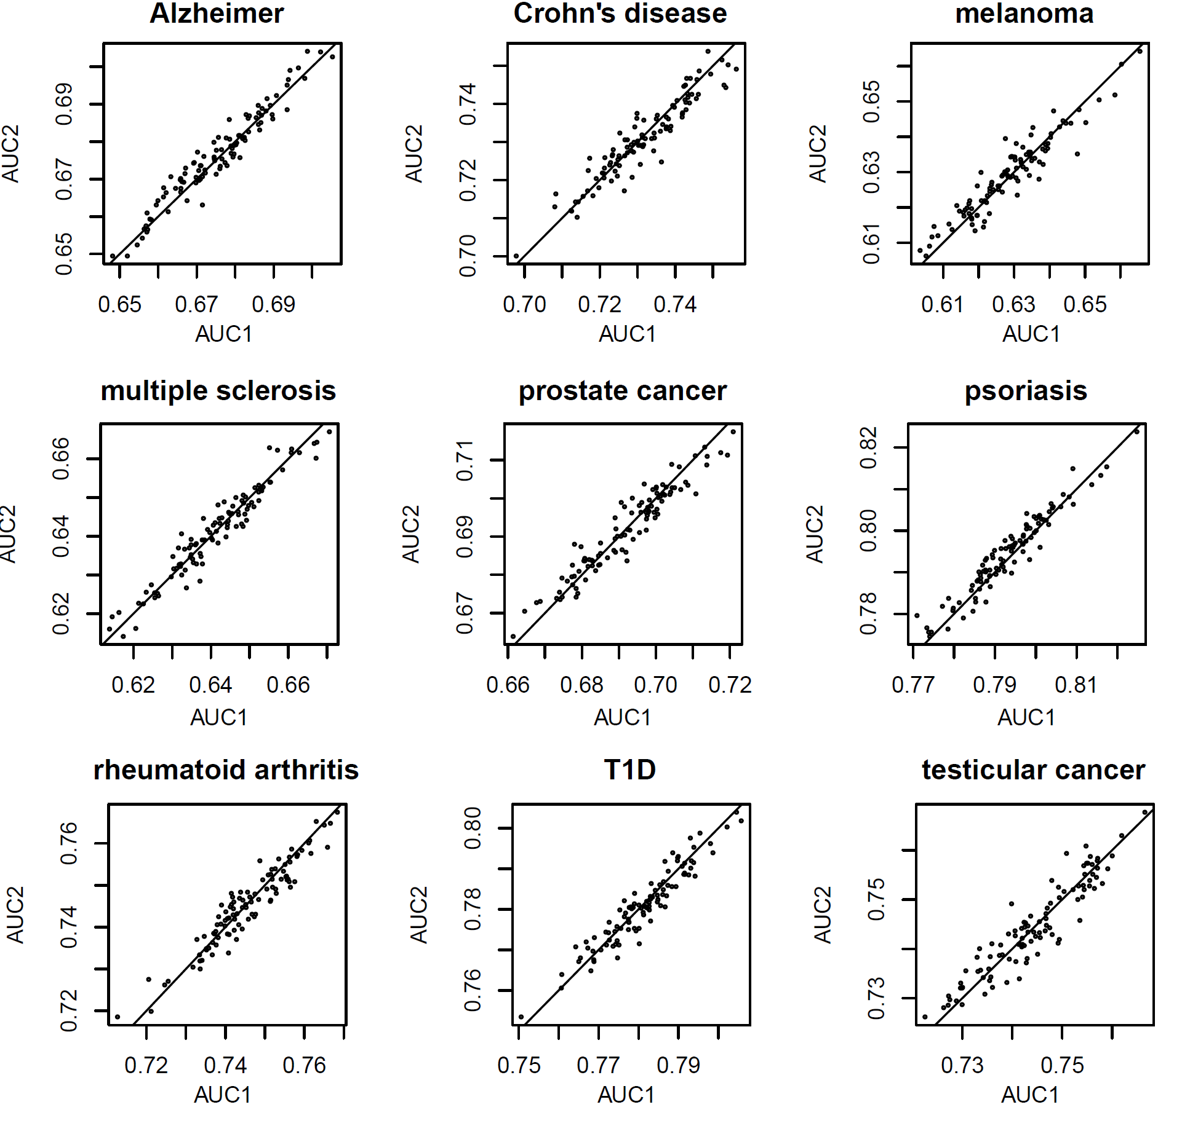Supplementary Figure 5. AUC based on individual data (AUC1) v.s. AUC based on SummaryAUC (AUC2). We performed 100 simulations for each disease.

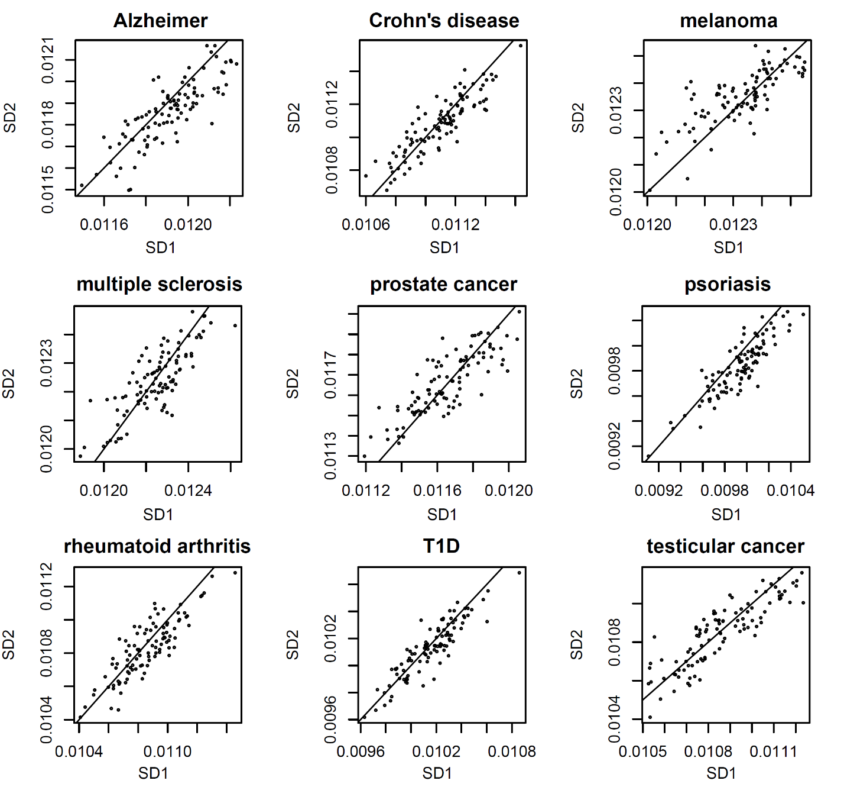Supplementary Figure 6. Standard deviation of AUC estimator based on individual data (SD1, 10000 bootstrap) v.s. SD based on SumamryAUC (SD2). We performed 100 simulations for each disease. We performed 100 simulations for each disease.

**Referenes**

Law, M.H., et al. Genome-wide meta-analysis identifies five new susceptibility loci for cutaneous malignant melanoma. *Nat. Genet.* 2015;47(9):987-995.

Lee, S.H., et al. Genetic relationship between five psychiatric disorders estimated from genome-wide SNPs. Nature Genetics 2013;45(9):984-994.

Okada, Y., et al. Genetics of rheumatoid arthritis contributes to biology and drug discovery. Nature 2014;506(7488):376-381.

Onengut-Gumuscu, S., et al. Fine mapping of type 1 diabetes susceptibility loci and evidence for colocalization of causal variants with lymphoid gene enhancers. Nature Genetics 2015;47(4):381-386.

Sawcer, S., et al. Genetic risk and a primary role for cell-mediated immune mechanisms in multiple sclerosis. Nature 2011;476(7359):214-219.

Schumacher, F.R., et al. Association analyses of more than 140,000 men identify 63 new prostate cancer susceptibility loci. Nature Genetics 2018;50(7):928-936.

Sleegers, K., et al. A 22-single nucleotide polymorphism Alzheimer's disease risk score correlates with family history, onset age, and cerebrospinal fluid. Alzheimers Dement 2015;11(12):1452-1460.

Strange, A., et al. A genome-wide association study identifies new psoriasis susceptibility loci and an interaction between HLA-C and ERAP1. Nature Genetics 2010;42(11):985-990.

Wang, Z.M., et al. Meta-analysis of five genome-wide association studies identifies multiple new loci associated with testicular germ cell tumor. Nature Genetics 2017;49(7):1141-1147.