Namrata Jiten Patel

Assignment 1

Generate hash when nonce is 7890

Current block data having two transactions

Ravi sent revanth 345666

Shyam sent ram 34123

Take previous block hash as “23986yasjdasudyr326gyajsd”

Generate hash value by changing atleast one string in any of above value.

Iterate 4 times

Test.js

const Blockchain=require('./blockchain');

const bitcoin=new Blockchain();

//calling the crete block function

var newBlock=bitcoin.createNewBlock('asdhujg677rsdmsdadb','23986yasjdasudyr326gyajsd',7890)

//code for gnenrating new transactions

var newTransaction=bitcoin.createNewTransaction(345666,'Ravi','Revanth');

var newTransaction=bitcoin.createNewTransaction(34123,'Shyam','Ram');

console.log(bitcoin);

blockchain.js

function Blockchain(){

this.chain = [];

this.newTransactions = [];

}

//creation and addition of the block to the chain

Blockchain.prototype.createNewBlock = function(hashOfBlock,previousHash,nonceOfBlock){

const newBlock = {

index:this.chain.length+1,

timestamp:Date.now(),

transactions:this.newTransactions,

hash:hashOfBlock,

previousBlockHash:previousHash,

nonce:nonceOfBlock

};

this.chain.push(newBlock);

return newBlock;

}

Blockchain.prototype.createNewTransaction=function(amount,sender,recipient){

const newTransaction={

amount:amount,

sender:sender,

recipient:recipient

};

this.chain.push(newTransaction);

return newTransaction;

}

module.exports = Blockchain;

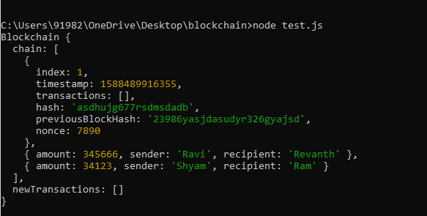

Test.js

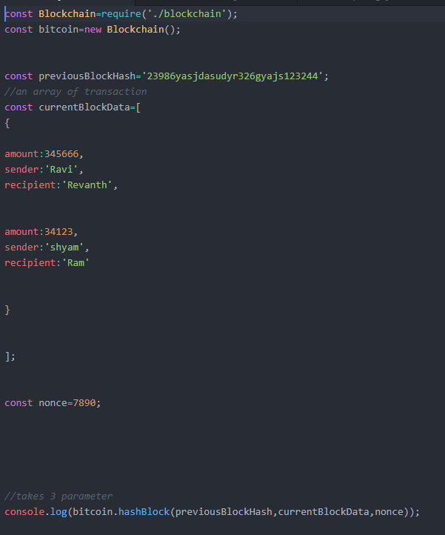

--------------------------------------------------------------------------------------------------------------------------------------

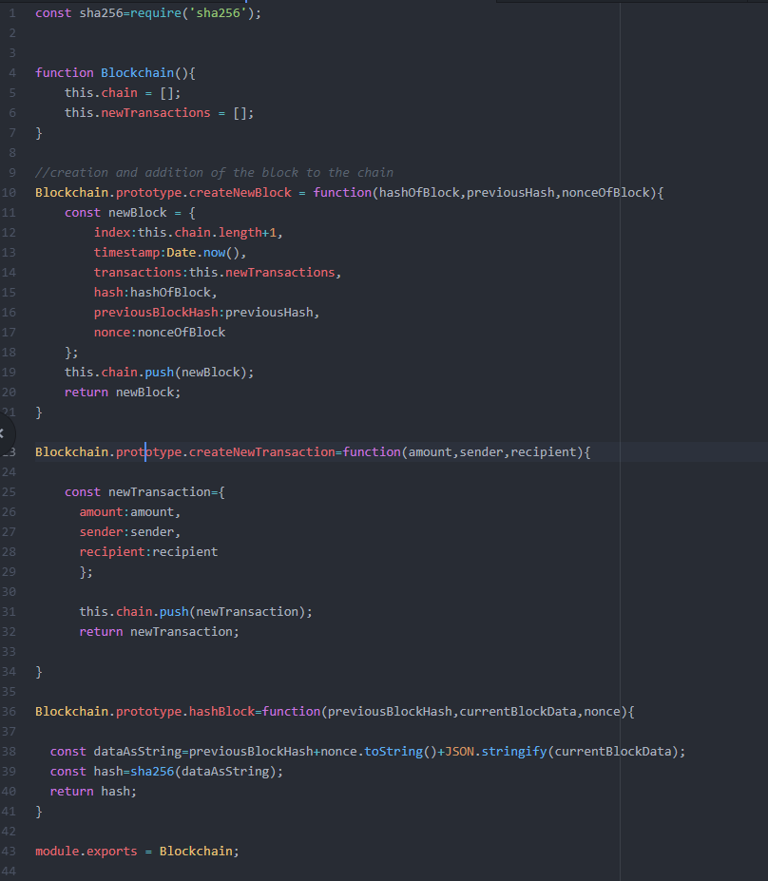

Generating HASH



Making Changes in previous hash block and generating hash

