ELECTRICAL LOAD FORECASTING THROUGH LSTM

**Anubhav Chetu Rana1, Rakesh Kumar Yadav2, Rishabh Vishnoi3**

1,2,3International Institute of Information Technology,Bhubaneswar,India

|  |  |  |
| --- | --- | --- |
| **Article Info** |  | **ABSTRACT** |
| ***Article history:***  Received Oct 1, 2018  Revised Dec 10, 2018  Accepted Jan 25, 2019 |  | For a power supplier, meeting demand-supply equilibrium is of utmost importance. Electrical energy must be generated according to demand, as large amount of electrical energy cannot be stored. For proper functioning of a power supply system, adequate model for predicting load is a necessity. In the present world, in almost every industry, whether it be healthcare, agriculture, consulting etc, growing digitization and automation is a prominent feature. As a result, large sets of data related to these industry are being generated, which when subjected to rigorous analysis, yield out of the box methods to optimize the business and services offered.Power sector too is being influenced by these trends. Incorporating data analytics and Machine learning techniques, makes an industry more efficient and flexible. It provides easier solutions to complex issues and can even glean out relations of commercial or scientific interest between two seemingly unrelated aspects of functioning.This paper aims to ascertain the viability of LSTM, a RNN network capable of handling both long term and short term dependencies of data sets, for predicting load that is to be met by a dispatch centre located in a major city.The result show appreciable accuracy in forecasting future demand. |
| ***Keywords:***  Long short-term memory  Recurrent Neural Network  Root mean square deviation  Factors affecting load  Daily load Curve  Monthly Load Curve |
| *This is an open access article under the [CC BY-SA](https://creativecommons.org/licenses/by-sa/4.0/) license.* |
| ***Corresponding Author:***  Name of Corresponding Author,  Department of Electrical and Computer Engineering,  National Chung Cheng University,  168 University Road, Minhsiung Township, Chiayi County 62102, Taiwan, ROC.  Email: [lsntl@ccu.edu.tw](mailto:lsntl@ccu.edu.tw) | | |

1. **INTRODUCTION**

Electricity is an extremely important source of energy and plays a significant role in a country’s economic development. [1] Load forecasting is necessary for proper functioning of electrical dispatch centers .Load forecasting is a method used to maintain synchronicity of demand and supply of electrical power. With a greater contention for market and greater de centralization, short term forecasting is becoming more significant [2]. In an age where smart grids with advanced sensing and communication are fast becoming a reality, load forecasting is a field where scope and necessity of accuracy is increasing day by day [3].

Numerous significant decisions depend upon the load forecasts like economic dispatch, distribution schedule, schedule of protection and maintenance measures [4]. From proper maintenance of equipment to economic strategies of the suppliers, load forecasting has a significant impact [5]. Especially for small scale consumption units, peak load forecasting is very important [6]. Moreover there has been an increased tendency of winters being colder and summers being more extreme than before. Therefore, greater use of equipment like Air Conditioners and heaters, and their use has become even more frequent [7]. This has led to more swings in terms of peak load and minimum load.

There are many factors that impact electrical load, their inter relation is complex and so is the extent to which one factor over rides one another. The factors can be divided into three categories [8]. Climate is considered the most important factor [9]. The Short-term factors: They are factors that last only a little duration, like a sudden weather change. The Middle-term factors : They last for a substantial duration and have a distinct characteristic which governs the corresponding load variation. For example seasonal climatic variations. The Long-term factors : They last for a significant time period, and usually over multiple forecasting periods [10].

For a particular area, temperature is the measure of average warmth or coolness of the surrounding. Temperature is far more influential than other factors like wind speed and cloud cover [11].

When temperature falls to a certain extent, it becomes cold and households require more energy [12]. Similarly after a rise in temperature, more energy is required. Both in summers and winters there is strong correlating contribution between temperature and load curve. There is positive co relation for summers, .ie with temperature rise in summer leading to increased consumption of electrical load as appliances such as fans, coolers, A.Cs etc are turned on and if in summer the temperature falls, the same appliances are turned off for lesser load consumption. But there is a negative co relation for winters, as only when temperature falls, appliances used keep the households warm are used. Generally it can be seen, on working days there’s substantial differences in load demands compared to working days and Weekends.There’s lower consumption on Tuesdays to Thursday while on weekends and days closer to weekends such as Mondays and Fridays the consumption is higher [13]. Another trend that can be observed is that on moving holidays: Holidays which do not have any fixed date, eg the religious festivals, also impact the forecast. Generally on days of festivals, the demand is relatively higher. But since industrial activities are lesser, the overall consumption prediction becomes difficult.

In a broad sense there are two types of models proposed or used for predicting future electrical demands, conventional statistical techniques and AI based techniques.Classic models use historical data and process them, and the estimates of parameters in such models can be easily interpreted.

The models and techniques that fall under this category include ARIMA (Auto Regressive Moving Average) [14], the Regression Seasonal ARIMA Generalized Autoregressive Conditional Heteroskedastic (Reg-SARIMA-GARCH) model [15], Support Vector machine models [16]. Time series model for series exhibiting multiple complex seasonalities (TBATS) [17]. AI techniques on the other hand prove to be more flexible due to their ability to adapt to moving data. The AI functions are non linear and non parametric. In general, the AI models yield better results than traditional ones [18]. Nueral Networks, Deep learning models e.t.c have proven to be more accurate for electrical load forecasts than traditional model.

In their 2017 paper [19], "Deep learning for household load forecasting—A novel pooling deep RNN. "Shi, Heng, Minghao Xu, and Ran Li, used novel pooling RNN to achieve comparatively much better results than conventional Compared with the state-of-the-art techniques in household load forecasting. Similarly, Fahiman, Fateme and their co-researchers found in their paper “Improving load forecasting based on deep learning and K-shape clustering.”, that their methods had greater accuracy than traditional ones including some AI techniques [20].

With the advent of smart grids and ever diversifying application of data analytics, huge amount of data inflow and ever increasing applications based on their analysis is expected. AI and machine learning techniques are expected to find variety of uses not only in load forecasting but also in theft detection [21], protection and safety of Nuclear [22] and Thermal power plants [23] along with power price determination [24].

This paper has attempted to explore implementation of relatively newer AI techniques in the domain of electrical load forecasting. Forecasting for electrical loads is a complex process that is prone to slight errors even when utmost care is taken in choosing the methods. This occurs due to the multiple factors influencing load patterns. Even such slight errors can lead to grave consequences to power system equipment and also gravely impact economic interests. These patterns are sometimes completely independent of each other and thus it becomes inherently impossible to find a co-relation.This paper inspects use of LSTM model to solve this complex problem. For the same, we have ensure that the data set on which this study is to be done, is organically dynamic and encapsulates the impact of all the factors. To achieve this, we use data taken from a major dispatch center, SLDC state load dispatch centre, located in Delhi, one of the biggest cities of one of the biggest cities in the world in terms of active consumers.This paper therefore, inspects applicability of LSTM model in load forecasting over a dynamic consumer base. This can create a platform for further exploration of the problem through LSTM using optimisers and supporting mechanisms. LSTM proves to be appreciably viable in handling the complex problem that Electrical Load Forecasting presents.

**2. RESEARCH METHOD**

Our focus in this paper was to use LSTM model to correctly predict the electrical load. LSTM is often used for time series forecasting, we chose to test how accurate it is for electrical load forecasting. For the purpose of implementing the algorithm on organic and potent data set, we scrapped the site State Load Dispatch Centre, Delhi. We scrapped through the data of 28th of January till 28th of February.

From the Table 1, 20 epochs were taken, with a batch consisting of 4600 data points.For cross validating 10 epochs were taken. The epochs and batch size were first decided on the basis of calculations and then approximated by trial and error for best possible result.

The resultant model training data is shown below:

Table 1. Parameters for each epoch of model development and training

|  |  |  |  |
| --- | --- | --- | --- |
| EPOCHS | Time taken and Time per step | Loss | Value Loss |
| 1 | 8s 1ms/step | 0.0320 | 0.0190 |
| 2 | 6s 1ms/step | 0.0235 | 0.0137 |
| 3 | 6s 1ms/step | 0.0160 | 0.0094 |
| 4 | 6s 1ms/step | 0.0112 | 0.0091 |
| 5 | 6s 1ms/step | 0.0103 | 0.0088 |
| 6 | 6s 1ms/step | 0.0099 | 0.0085 |
| 7 | 6s 1ms/step | 0.0096 | 0.0082 |
| 8 | 6s 1ms/step | 0.0093 | 0.0080 |
| 9 | 6s 1ms/step | 0.0091 | 0.0078 |
| 10 | 6s 1ms/step | 0.0090 | 0.0076 |
| 11 | 6s 1ms/step | 0.0088 | 0.0074 |
| 12 | 6s 1ms/step | 0.0087 | 0.0073 |
| 13 | 6s 1ms/step | 0.0086 | 0.0072 |
| 14 | 6s 1ms/step | 0.0085 | 0.0071 |
| 15 | 7s 1ms/step | 0.0084 | 0.0070 |
| 16 | 9s 1ms/step | 0.0084 | 0.0069 |
| 17 | 7s 1ms/step | 0.0083 | 0.0069 |
| 18 | 7s 1ms/step | 0.0083 | 0.0068 |
| 19 | 6s 1ms/step | 0.0082 | 0.0067 |
| 20 | 7s 1ms/step | 0.0082 | 0.0067 |

After the forecasts, we used RMSE to compare the actual load to the forecast done by the model and received satisfactory results.

**2.1. The Lstm Model**

Traditional Neural Networks do not have the ability to use the concept of memory. They can’t use the knowledge of previous states. This is a major drawback. Recurrent Neural Networks in terms architecture is not that different to the conventional Neural Network. An RNN however is capable of learning from memory.

Figure 1 shows a traditional Neural Networks, it is clear that since the output of Neural Networks don’t loop back to previous layers, the previous states have no contribution towards future ones. Figure 2 shows a simple RNN, with a loop.Recurrent Neural Networks have proved to be powerful and accurate in its application. LSTM is a slightly different kind of RNN that overcomes some shortcomings of the standard version.

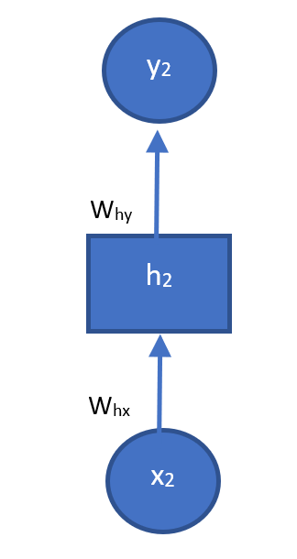 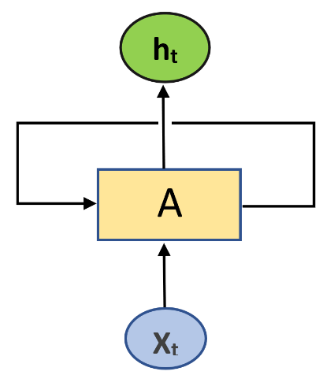

Figure-1 Traditional Neural Network Diagram ; Figure-2 RNN Diagram

LSTM does not suffer from the long term dependency problem of usual RNNs. Recurrent Neural Networks have a tendency to prove inefficient when data shows more recent dependency than long term. LSTM does not have this issue and is considered suitable for time series modelling.LSTMs like RNN have a chain like structure. However, in LSTM the repeating module has a slightly more complex structure. Each module has 4 layers and each layer interact with one another.

From the Figure-3, We can see a cell state, represented by the top line running through the entire chain. The cell state only involves in a few linear interactions. LSTM repeating module has the ability to either attach or delete the information running in the cell state.This is achieved through a “Gate”.Gate basically maintains or changes the cell state.

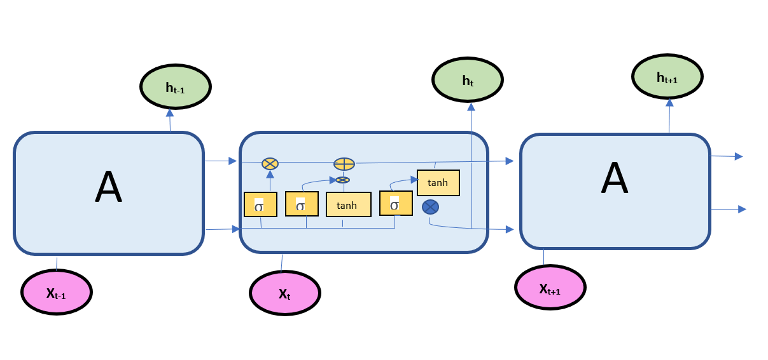

Figure-3 Basic Structure of LSTM

Fig 4 shows how one of the reason LSTM is different from RNN is the absence of a cell state. The cell state is the key to LSTM’s ability to recognise short term pattern. Fig 5 highlights the initial step, which is to determine if the incoming information from the cell state is to be deleted or not.

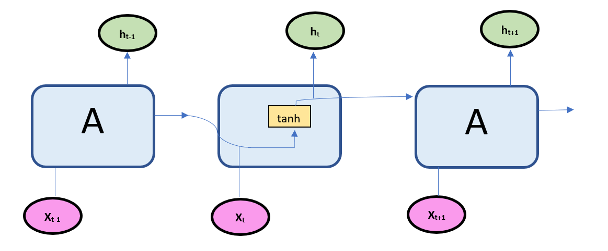

Figure-4 RNN do not have Cell States

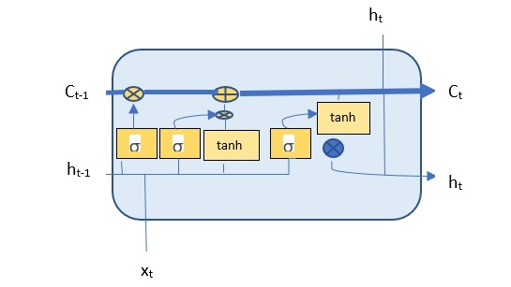

Figure-5 Highlighting a cell state

The initial step is to determine if the information from an incoming cell state has to be deleted. This is determined by “forget gate layer”. Thereafter, we decide if we have to add any information. This is divided into two steps. An “input Gate layer” will determine the values which are to be updated, afterwards a tan h section that creates a set of value that is to be added in cell state. Hereafter, they are combined to update the state.To achieve that, we multiply the old state with Function F(t). And we add to it, It∗ *C*~*t.* Finally, we employ a sigmoid layer which determines what will be the output. We now use tanh which restricts values to a smaller range. Now we ensure certain selected sections are treated as outgoing output using another gate.

**3. RESULTS AND DISCUSSION**

**3.1. Dataset Source**

For the data, we have scrapped the site of SLDC (The state Load despatch centre), Delhi. The SLDC is responsible for integrated power supply to Delhi. The site updates load data every five minute. To scrap the data we have used Beautiful soup, a python library used for basic scrapping. It is capable of extracting data from HTML and XML documents. We took load data for the last month. The load data is taken every 5 minute.

Figure 6 shows the load data obtained for 23rd of February, 2021. It can be see, the load demanded is lesser in the night and peaks during a time span of 9 to 12 o’clock span. In Figure 7 we see the variation of load of load from 28th of January, 2021 till 28th of February 2021.It shows the entire 30 day period load.

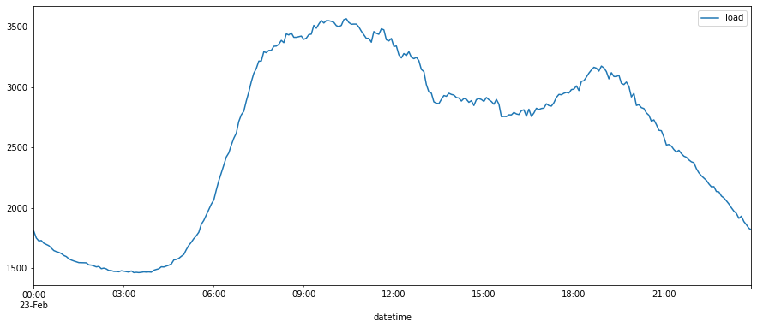

Figure-6 Load Data on a particular date

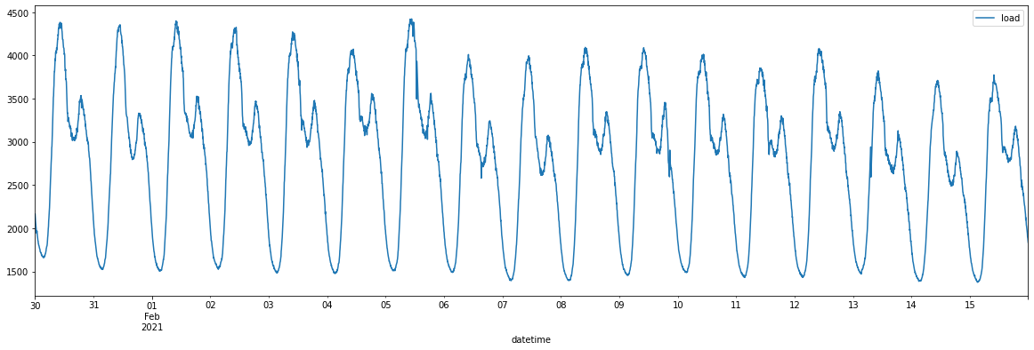

Figure-7 Variation of Load in a particular month

**3.2. Data Cleaning and Preparation**

Now using seasonal decompose from Python’s Stats model library, we decompose the data (using daily frequency as a basis) into trends, seasonality and residue.

Fig 8 shows the results of using seasonal decompose, the top most is the actual observed data, the next section shows the prevalent trend and then the regularity of structure is shown by the seasonal part. The next section is the residual part.

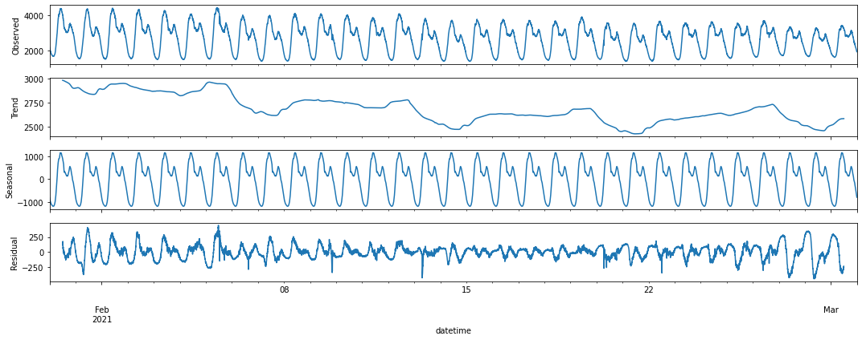 Figure-8 Observed,Trend,Seasonal and Residual Data

**3.3. Identifying The Trend Of The Time Series Data Set And Detrending**

The second section of Fig 3.4 shows trend of data, which can be considered to be a time series data set. A trend is defined as a regular increase and decrease of values over the mean. The trend present in the data set is of stochastic type. Zhang, G. Peter, and Min Qi have argued that detrending can reduce errors in forecasts and improve overall performance [25]. Thus removal of this trend can improve the forecasting ability of the model. Removal of a trend is called detrending. Detrending must be done with proper methods else becomes detrimental. Detrending doesn’t always improve the performance, specifically for ML applications. However, we have chosen to detrend our data because it has proven to be beneficial for time series forecasting.[26]

**3.4. Removing Seasonality and Rescaling The Data**

Seasonality refers to regularly repeating patterns in the data set. Seasonal components have a tendency to obscure the actual data pattern that is significant for modelling. We have used difference method to remove seasonality for our data set. Now before the data set can be used for training and fitting into the network, it should be scaled down to much lower values so that those processing are faster and more efficient. We have scaled down our data to lie between -1 to 1. Figure 9 shows the data after detrending, removal of seasonality and rescaling.

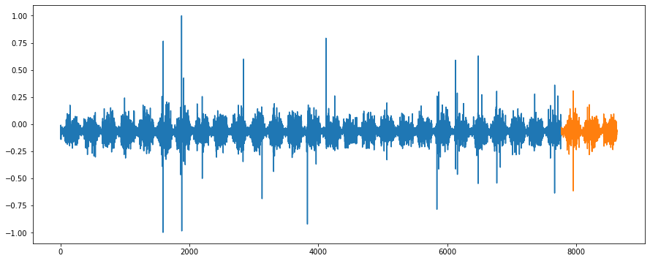

Y axis scaled data

X data points

Figure 9 Detrended and Rescaled data

**3.5. Model Training And Forecast**

First data is reshaped and treated to start the Model Training. From Keras.layers, we directly invoke LSTM and from Keras. Models we invoke Sequential, now we have to decide the epochs and batch size. We have decided to run the model training for 30 epochs the batch size has been taken as one. After training for 30 epochs and cross validating as well, the model is ready for making forecasts. Fig 10 shows the above figure shows the forecast.

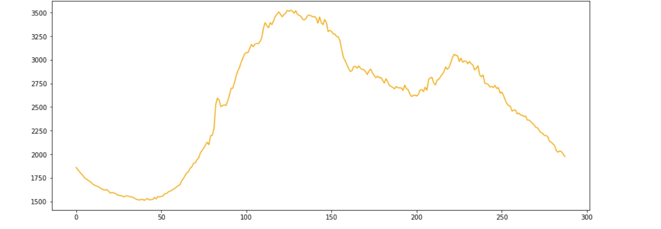

Figure-10 Load Forecast

**3.6. Error Parameter : Root Mean Square Error and Comparison of Forecast with actual load**

RMSE or root mean squared error is one of the standard error parameter when only two dimensions are involved. CJ Willmort and Kenji Matsuura argued MAE is a more natural measure of judging average error [27] Howeverit can be argued as per the paper "Root mean square error (RMSE) or mean absolute error (MAE)?–Arguments against avoiding RMSE in the literature." [28] concluded RMSE is in fact an essential error parameter in model development and argued against the discontinuation of it’s use.We have chosen RMSE as it doesn’t get affected by curse of dimensionality.

**3.7. Comparison Of Forecast With Actual Load**

The figure 11 shows a comparison between forecasts and actual load. The forecast is depicted in orange colour, while the blue graph represents actual load. It shows appreciable accuracy except for a distinct region located left to the middle mark.

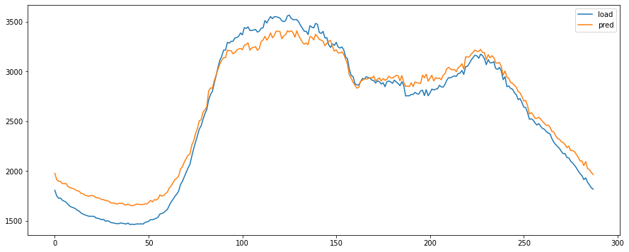

Y axis : Load in watts

X axis :time

Figure-11 Comparison between Actual Load and Load Forecast

The RMSE evaluation reveals an error of 127 watts, which is well within the range of appreciable accuracy, being about 4.1 % to 3 .2 % of the observed range of peak load experienced in a day.

**4. CONCLUSION**

LSTM shows appreciable accuracy for electrical load forecasts. It outperforms traditional statistical prediction models and also outperforms many earlier used standard RNN methods. However, room for error still persists. Therefore LSTM can be enhanced with addition of another techniques.As Yi Wang, Dahua Gan showed a LSTM model supported by pinball loss results in better performance than a standard one [29] Another method is to use various optimizers to improve the performance of LSTM network and then using it for the forecasts. Tarik A. Rashid and is colleagues in their paper “Using Accuracy Measure for Improving the Training of LSTM with Metaheuristic Algorithms” show how optimisers results in improving the performance [30]. All in all, LSTMs can prove to be quite efficient for load forecasts, especially if further improvements is applied on the model.

We ensured that the methodology is subjected to a dynamic data set. As we have taken the data from a major dispatch center which is subjected to varying factors affecting load, as it provides energy to a large part of Delhi. So, the model was subjected to a highly complex dataset, which was born out of an amalgamation of various factors. The model performed appreciably against such data giving a minor error percentage in terms of RMSE. Therefore we conclude that LSTM as a single model is relatively more suitable for Electrical load forecasting than traditional methods. Moreover its superiority might improve beyond other AI techniques with the use of correct optimisers.

**5. REFRENCES**

1. V. Lepojevic and M. A. Pesic, "Forecasting electricity consumption by using holt-winters and seasonal regression models", *Economics and organization*, vol. 8, no. 4, pp. 421-431, 2011.
2. Y. Kim, H. Son, and S. Kim, "Short term electricity load forecasting for institutional buildings", *Energy Reports,* vol. 5, pp. 1270-1280, Nov 2019.
3. M. Tariq and H. V. Poor, "Electricity theft detection and localization in grid-tied microgrids", *IEEE Transactions on Smart Grid*, vol. 9, no. 3, pp. 1920-1929, Aug 2016.
4. M. Ali, M. Adnan and M. Tariq, "Optimum control strategies for short term load forecasting in smart grids", *International journal of electrical power & Energy systems,* vol.113, pp. 792-806, Dec 2019.
5. V. Gupta and S. Pal, "An overview of different types of load forecasting methods and the factors affecting the load forecasting", *International Journal for Research in Applied Science & Engineering Technology (IJRASET)*, vol. 5, no.4, pp. 729-733, Apr 2017.
6. A. Kavousian, R. Rajagopal and M. Fischer, "Determinants of residential electricity consumption: Using smart meter data to examine the effect of climate, building characteristics, appliance stock, and occupants' behavior", *Energy,* vol. 55, pp. 184-194, 2013.
7. M. Santamouris*,* N. Papanikolaou, I. Livada, I. Koronakis*,* "On the impact of urban climate on the energy consumption of buildings", *Solar energy,* vol. 70, no. 3, pp. 201-216, Jan 2001.
8. B. Xue and J. Geng, "Dynamic transverse correction method of middle and long term energy forecasting based on statistic of forecasting errors", *Proceedings of Conference on Power & Energy IPEC,* pp. 253-256, Dec 2012*.*
9. L. Hernández,C. Baladron, J. M. Aguiar, L. Calavia, "Experimental analysis of the input variables’ relevance to forecast next day’s aggregated electric demand using neural network", *Energies,* vol. 6, no. 6, pp. 2927-2948, Jun 2013.
10. N. Kandil, R. Wamkeue, M. Saad and S. Georges, "An Efficient Approach for Short term Load Forecasting using Artificial Neural Networks”, *IEEE International Symposium on Industrial Electronics*, vol.3, pp.1928-1932, July 2006.
11. S. Parkpoom, G. P. Harrison and J. W. Bialek, "Climate change impacts on electricity demand ", *Universities Power Engineering Conference*, vol. 3, pp. 1342-1346, Sept 2014.
12. K. B. Sahay and M. M. Tripathi, "Day ahead hourly load forecast of PJM electricity market and iso new england market by using artificial neural network" *Proceedings of Innovative Smart Grid Technologies Conference (ISGT) 2014 IEEE PES*, vol.3, pp. 1342-1346, Sept 2004.
13. C. M. Lee and C. N. Ko, "Short-term load forecasting using lifting scheme and ARIMA models", *Expert Systems with Applications,* vol. 38, no. 5, pp. 5902-5911, May 2011.
14. Y. Kim, H. Son, and S. Kim, "Short term electricity load forecasting for institutional buildings*", Energy Reports* vol.5, pp. 1270-1280, Nov 2019.
15. B. J. Chen and M. W. Chang, "Load forecasting using support vector machines: A study on EUNITE competition 2001", *IEEE transactions on power systems,* vol. 19,no. 4, pp. 1821-1830, Nov 2004.
16. M. H. Jifri, E. E. Hassan and N. H. Miswan, "Forecasting performance of time series and regression in modeling electricity load demand", *2017 7th IEEE International Conference on System Engineering and Technology (ICSET) IEEE,* pp. 12-16, Oct 2017.
17. C. Deb*,* L. S. Eang, J. Y. Yang and M. Santamouris, "Forecasting diurnal cooling energy load for institutional buildings using Artificial Neural Networks", *Energy and Buildings,* vol. 121, pp. 284-297,Jun 2016.
18. H. Shi, M. Xu and R. Li, "Deep learning for household load forecasting—A novel pooling deep RNN", *IEEE Transactions on Smart Grid,* vol. 9, no. 5, pp. 5271-5280, Mar 2017.
19. F. Fahiman, S. M. Erfani and S. Rajasegarar, "Improving load forecasting based on deep learning and K-shape clustering", *2017 International Joint Conference on Neural Networks* (IJCNN) IEEE, pp. 4134-4141, May 2017.
20. G. P. Zhang and M. Qi, "Neural network forecasting for seasonal and trend time series", *European journal of operational research,* vol. 160, no. 2, pp. 501-514, Jan 2005.
21. K. Zheng, Q. Chen, Y. Wang and C. Kang "A novel combined data-driven approach for electricity theft detection", *IEEE Transactions on Industrial Informatics,* vol. 15, no. 3, Oct 2018.
22. C. Worrell, L. Luangkesorn, J. Haight, “Machine learning of fire hazard model simulations for use in probabilistic safety assessments at nuclear power plants", *Reliability Engineering & System Safety,* vol. 183, pp. 128-142, Mar 2019.
23. P. Hundi, R. Shahsavari, “Comparative studies among machine learning models for performance estimation and health monitoring of thermal power plants”, *Applied Energy,* vol. 265, May 2020.
24. S. C. Chan, K. M. Tsui, H. C. Wu and Y. Hou, "Load/price forecasting and managing demand response for smart grids: Methodologies and challenges", *IEEE signal processing magazine,* vol. 29, no. 5, pp. 68-85, Aug 2012.
25. L. E. Raffalovich, "Detrending time series: A cautionary note", *Sociological Methods & Research,* vol. 22, no. 4, pp. 492-519, May 1994.
26. J. Lu, G. J. Carbone, J. Haight, "Detrending crop yield data for spatial visualization of drought impacts in the United States, 1895–2014", *Agricultural and forest meteorology,* vol. 237, pp. 196-208, May 2017.
27. C. J. Willmott and K. Matsuura, "Advantages of the mean absolute error (MAE) over the root mean square error (RMSE) in assessing average model performance", *Climate research,* vol. 30, no. 1, pp. 79-82, Dec 2005.
28. T. Chai and R. R. Draxler, "Root mean square error (RMSE) or mean absolute error (MAE)–Arguments against avoiding RMSE in the literature", *Geoscientific model development,* vol. 7, no. 3, pp. 1247-1250, Jun 2014.
29. Y.Wang, D. Gan, M. Sun, N. Zhang, Z. Lu and C. Kang, "Probabilistic individual load forecasting using pinball loss guided LSTM", *Applied Energy,* vol. 235, pp. 10-20, Feb 2019.
30. T. A. Rashid, P. Fattah and D. K. Awla, ”Using Accuracy Measure for Improving the Training of LSTM with Metaheuristic Algorithms”, *Procedia Computer Science,* vol. 140, pp. 324-333, Jan 2018.