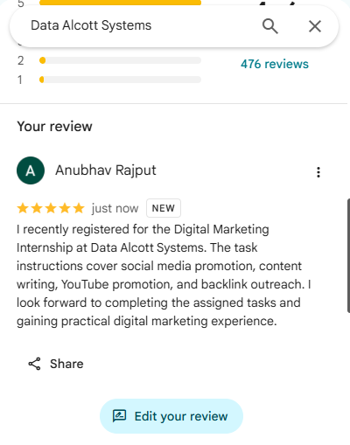
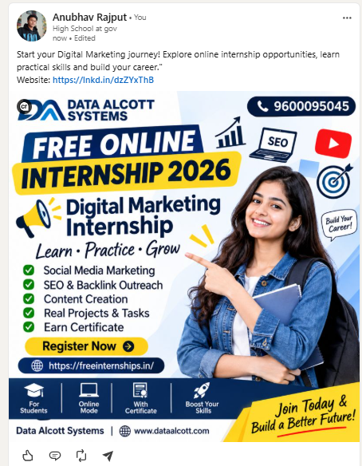
https://lnkd.in/p/dZ9DWnbV

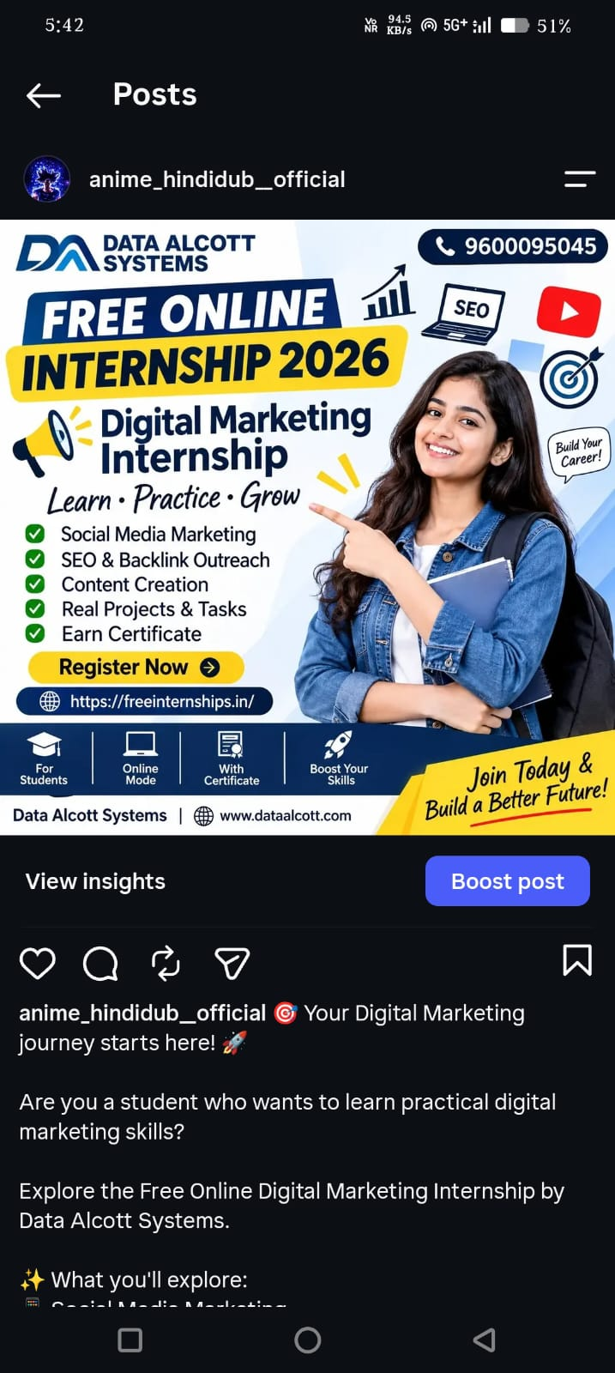
https://www.instagram.com/anime_hindidub__official/p/DfKIE65tHld/

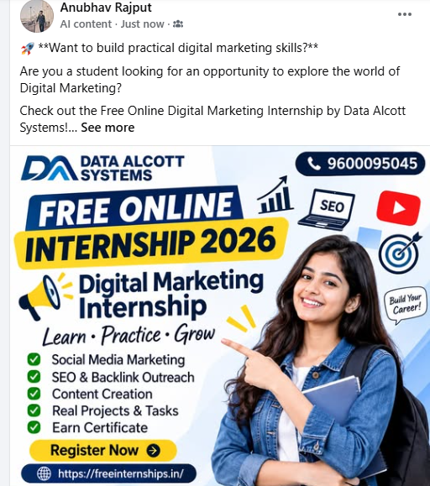
https://www.facebook.com/share/p/1CLYMPss6z/

https://lnkd.in/p/d4bAxsFM

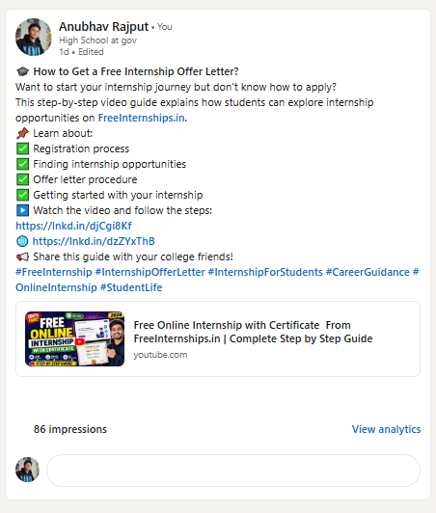

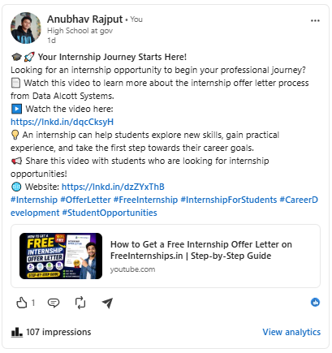
https://lnkd.in/p/dZSrch7e

https://lnkd.in/p/dfrCZnuE
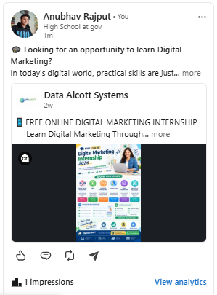

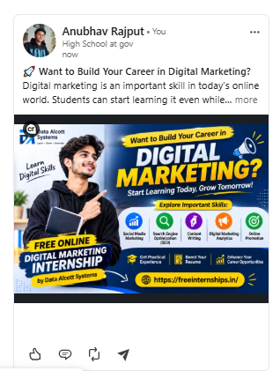
Day 2
https://www.linkedin.com/feed/update/urn:li:share:7522689957308657664?actorCompanyId=89810961&openCollaboratorList=false

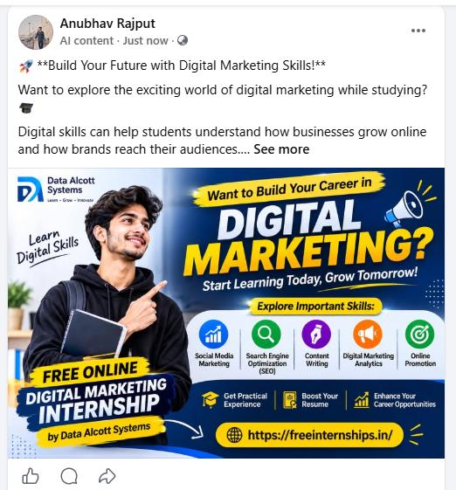
https://www.facebook.com/share/p/1A6sZ3oFco/

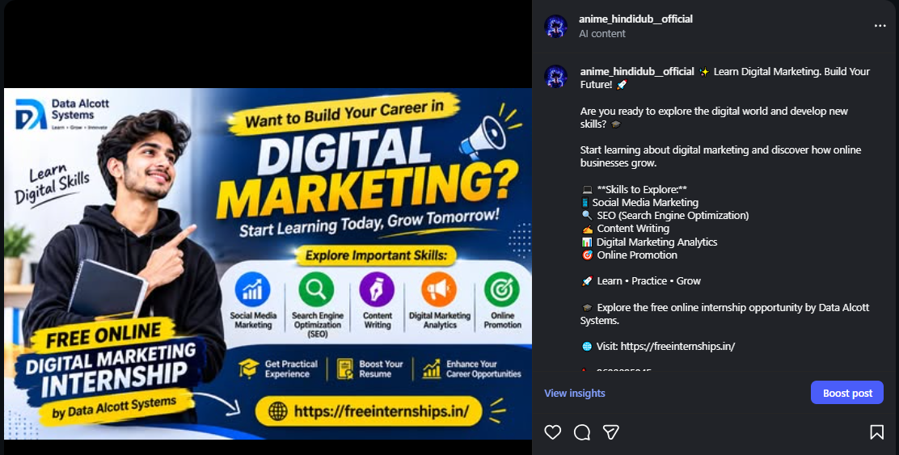
https://www.instagram.com/p/DfNKPbBjRa5/?utm_source=ig_web_copy_link&exln=MzRlODBiNWFlZA==&srtk=MzRlODBiNWFlZA==

youtube
https://lnkd.in/p/d7RFiSeH
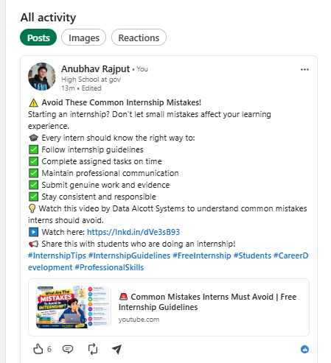

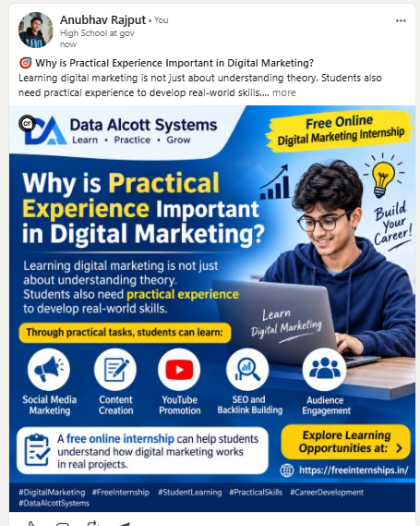
day 3

post 1
https://lnkd.in/p/dR-9kHxv

https://lnkd.in/p/dDJ4CNSC
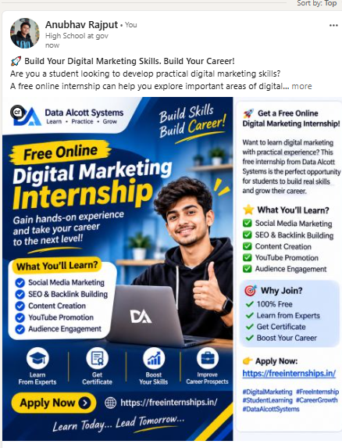
post 2

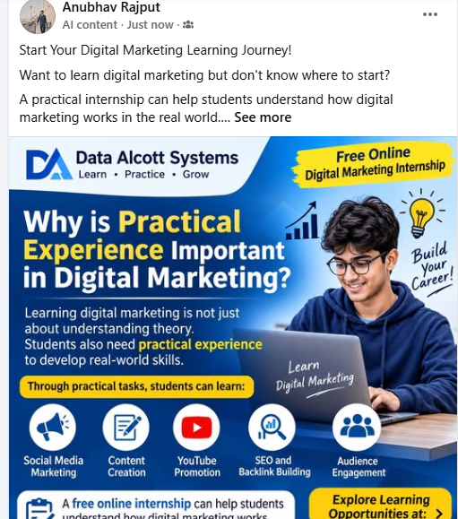
https://www.facebook.com/share/p/1Ft8xEFoT8/

https://www.instagram.com/p/DfP7haRjbUI/?utm_source=ig_web_copy_link
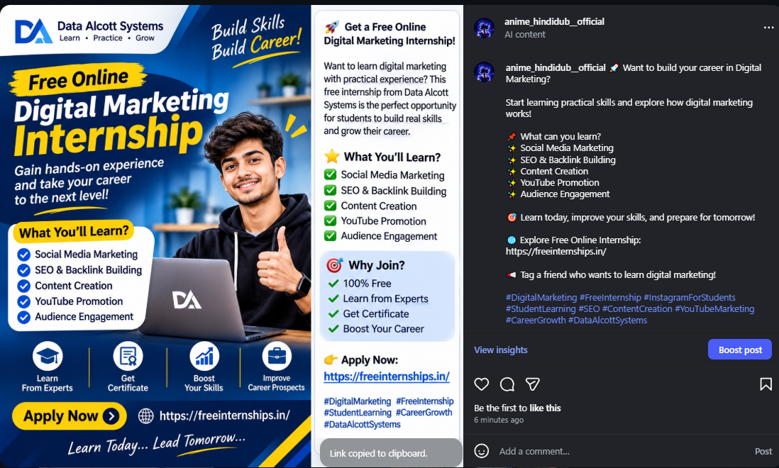
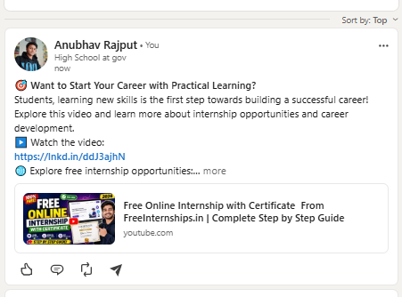
YOUTUBE REPOST 1 POST - https://lnkd.in/p/dXi_eUui

POST 2
https://lnkd.in/p/dwTESmNC

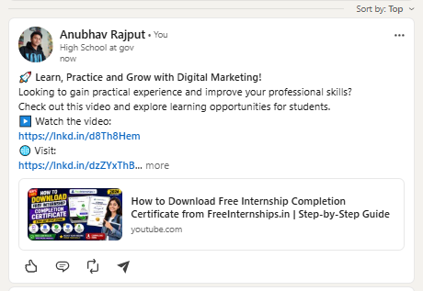

REPOST LINKDIN
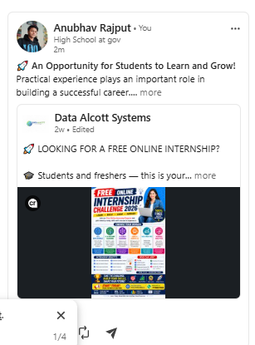
https://lnkd.in/p/dzaiaU7X

day 4
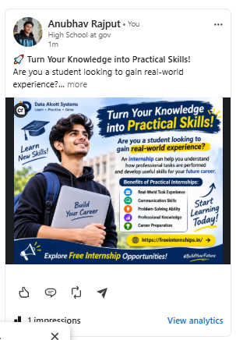
https://lnkd.in/p/dxYwp5Wt
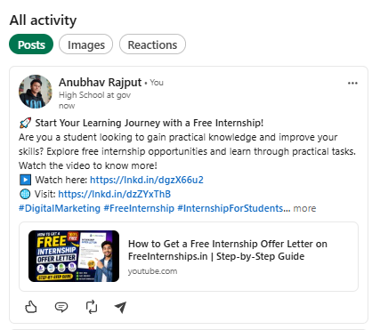https://lnkd.in/p/dmETtq5Q

https://lnkd.in/p/diuUgP8Q
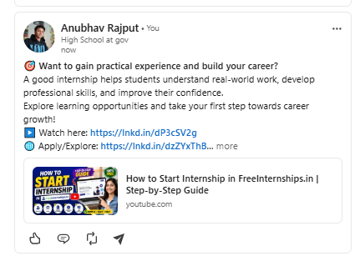
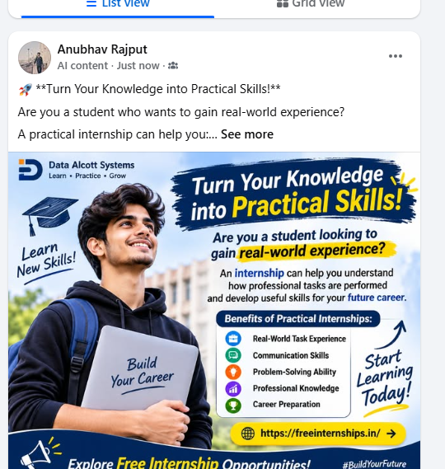

https://www.facebook.com/share/p/1QC3dreMxG/

https://www.opendirectory.in/cgi-bin/add.cgi
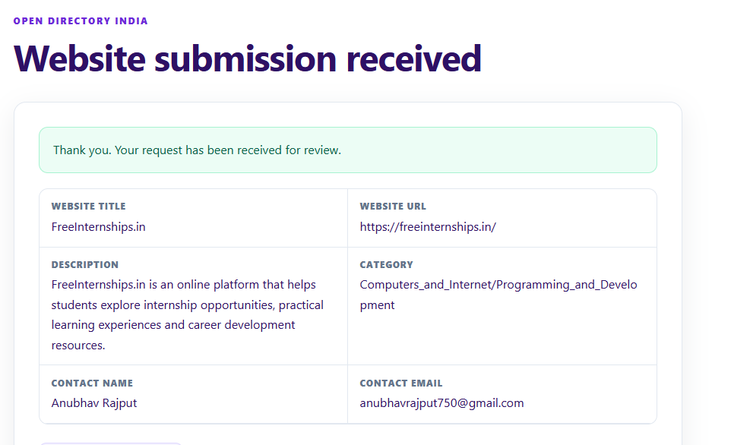

https://zearches.com/?status=ok#submission-feedback
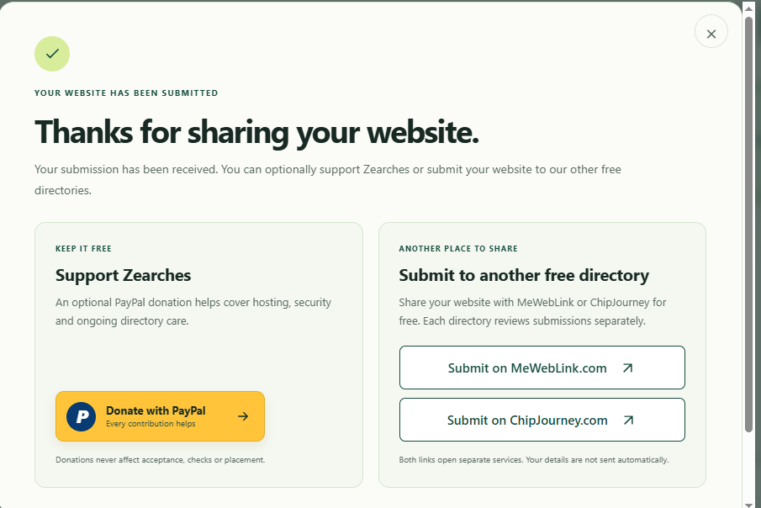

Day 5
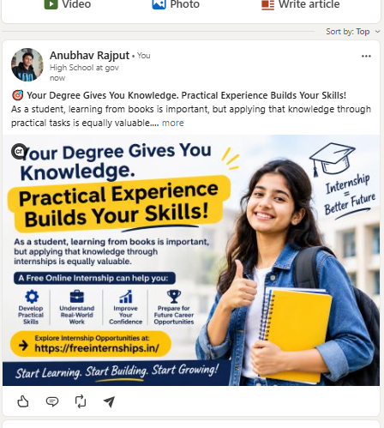
https://lnkd.in/p/dXDWn6NK
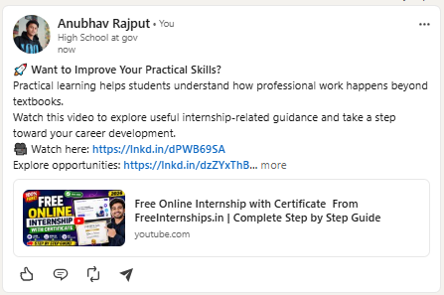
https://lnkd.in/p/dEjdJFHK

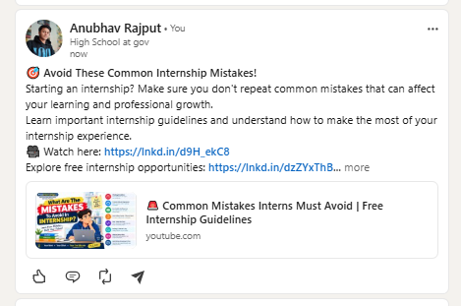
https://lnkd.in/p/dh7yX3sc

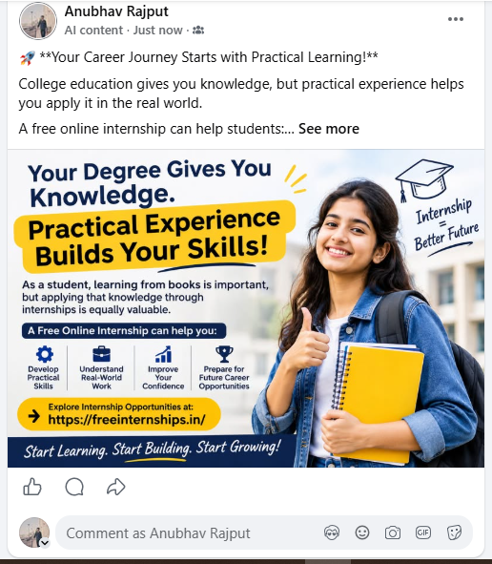
https://www.facebook.com/share/p/18gJQPJo7x/

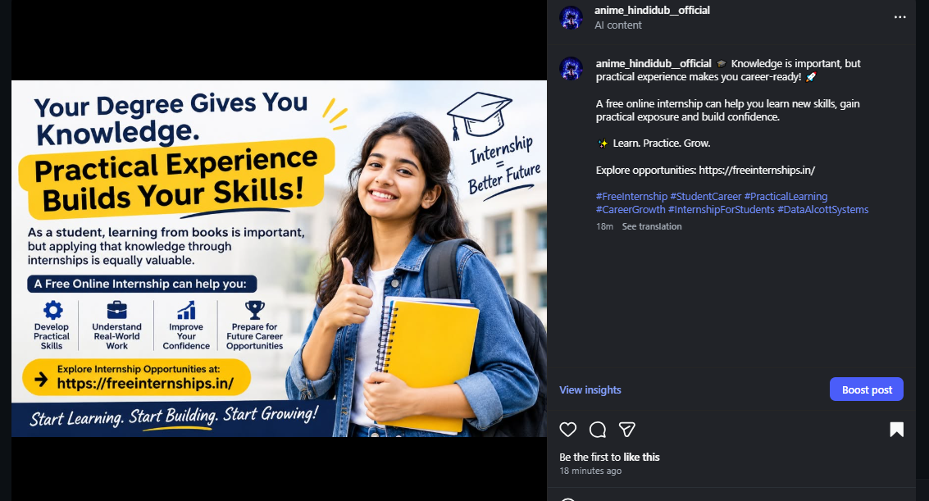
https://www.instagram.com/p/DfUpaohjSU6/?utm_source=ig_web_copy_link&cplk=MzRlODBiNWFlZA==&srtk=MzRlODBiNWFlZA==
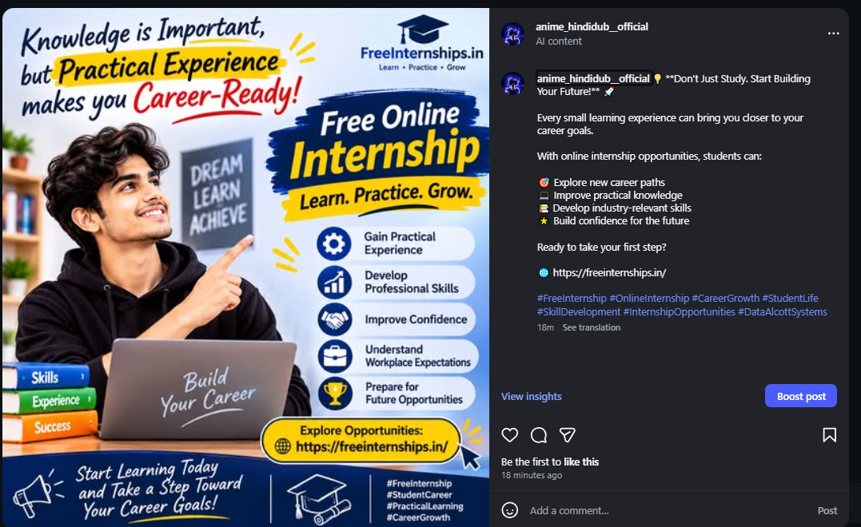
https://www.instagram.com/p/DfUpjL2DVgk/?utm_source=ig_web_copy_link&vrfl=MzRlODBiNWFlZA==&srtk=MzRlODBiNWFlZA==

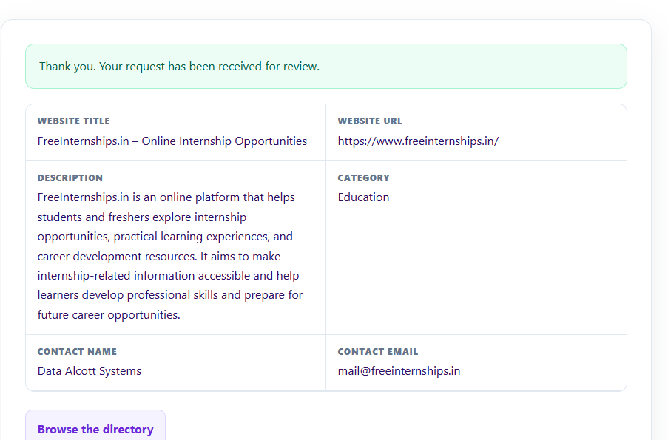
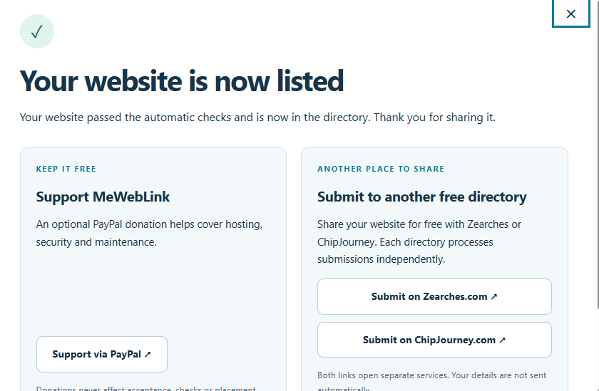

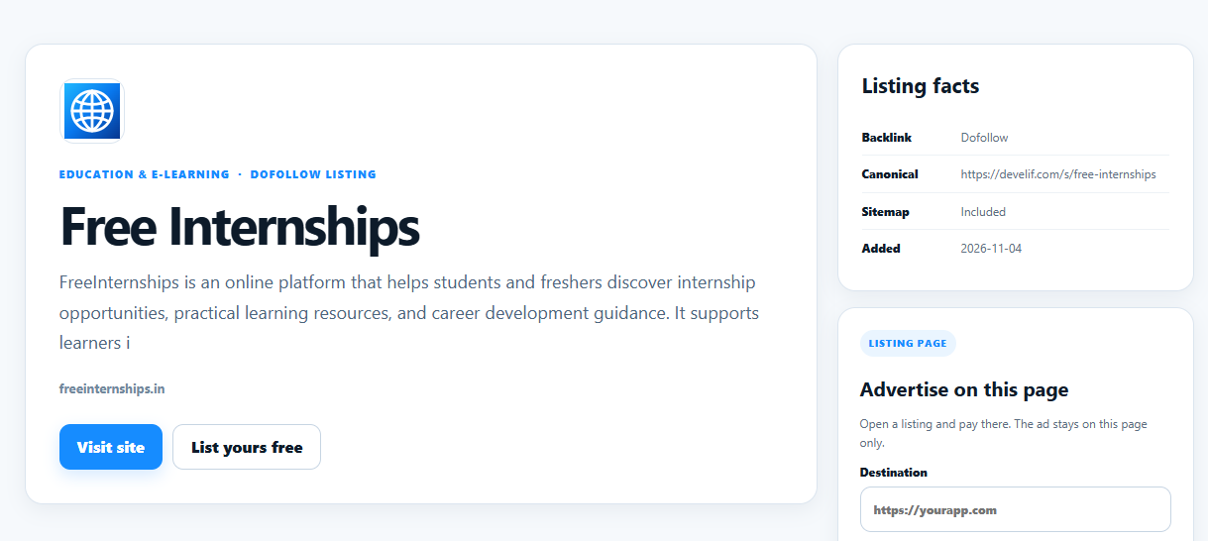

Day 6
https://lnkd.in/p/ddXEXbum
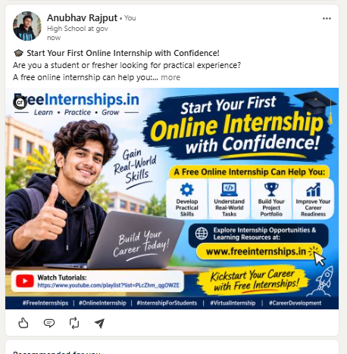

https://lnkd.in/p/dcE_dEbX]

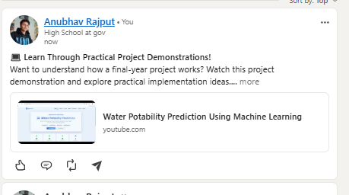

https://lnkd.in/p/dcE_dEbX
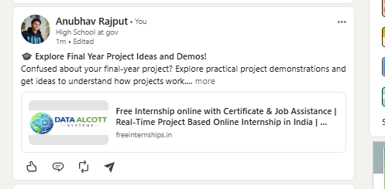
https://www.facebook.com/share/p/1HvsM7DTvm/
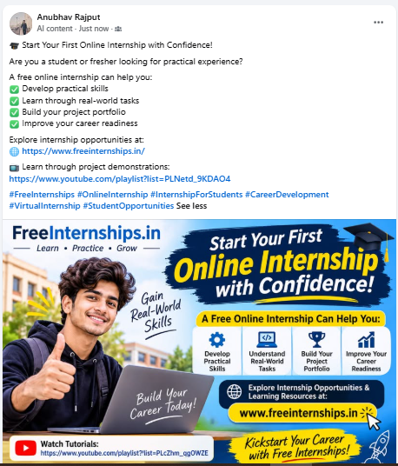

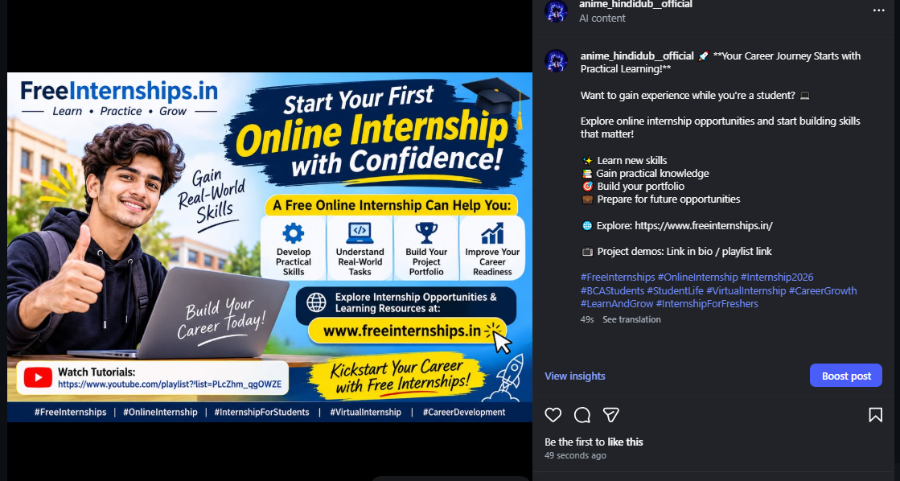
https://www.instagram.com/p/DfXtIGrjYJA/?utm_source=ig_web_copy_link&obrf=MzRlODBiNWFlZA==&srtk=MzRlODBiNWFlZA==



