CallE — Intelligent Model Router
Reducing enterprise GenAI operating cost without sacrificing support quality or safety
Role: Hybrid AI Product Manager + AI Project Manager
Company: CallE
Industry: B2B customer-support SaaS
Delivery horizon: 12–16 weeks for MVP / pilot
Primary KPI: AI Cost per Resolved Interaction
____________________________________________________________

Evidence & Disclosure
This is a simulated case study. It is designed to demonstrate product judgment, AI decision-making, technical understanding, and project delivery not to claim real CallE production outcomes.
Label | Meaning
FACT | Information established in the case-study brief
ASSUMPTION | A reasonable value used because real information is unavailable
HYPOTHESIS | A proposition the MVP is designed to test
TARGET | A desired future outcome
SIMULATED / ILLUSTRATIVE | Example analysis used to demonstrate decision-making

No simulated customers, research, benchmarks, financial results, production deployments, or AI performance are presented as real evidence.
____________________________________________________________

1. The Hook
CallE processes approximately 100,000 AI support interactions per month, with every request currently routed to the highest-capability model selected as its baseline.
The product question is not:
“Which LLM is best?”
It is:
Can CallE reduce the cost of resolving customer issues while maintaining an agreed quality threshold and keeping risky decisions under human control?
That reframes the problem from model selection into business-value optimisation under quality, cost, latency, reliability, privacy, and safety constraints.

2. Executive Summary
CallE is a B2B customer-support SaaS platform whose AI capability helps customers resolve support issues and helps human support agents handle escalated cases.
The current workflow uses a premium LLM for every interaction.
This creates a potential economic inefficiency because support requests vary substantially in:
- Complexity
- Token volume
- Risk
- Context requirements
- Need for reasoning
- Need for human intervention
A simple FAQ should not automatically consume the same model capability as a complex troubleshooting request. Conversely, a high-risk security or payment issue should not be routed to a cheaper model merely because it is cheaper.

Proposed solution
Build a hybrid intelligent model router that combines:
- Deterministic safety and business rules
- AI-assisted intent and complexity classification
- A model-selection policy
- Response validation
- Premium-model fallback
- Human escalation

Primary objective
Reduce AI Cost per Resolved Interaction while maintaining quality at or above the premium-model baseline.

Secondary objectives
- Increase automated resolution
- Reduce unnecessary premium-model usage
- Reduce human support workload
- Improve escalation quality
- Establish repeatable model governance
The project is intentionally structured as a controlled hypothesis-validation exercise.

3. Business Context

3.1 Company
CallE is a B2B customer-support SaaS company.
Its product provides AI-assisted customer support across business-specific support workflows.

3.2 Primary users

Customers
Customers interact with CallE to:
- Ask support questions
- Troubleshoot problems
- Obtain product information
- Resolve routine issues
- Escalate unresolved issues

Support agents
Agents handle cases that AI cannot safely or reliably resolve.
They need:
- A concise issue summary
- Customer intent
- Relevant context
- Suggested category
- Suggested response
- Reason for escalation
- Confidence / risk signal

3.3 Business problem
FACT: The scenario assumes 100,000 AI interactions per month and a premium-model workflow for every request.
PRODUCT PROBLEM: CallE may be paying premium-model economics for requests that do not require premium-model capability.
But simply moving requests to cheaper models could reduce quality or increase human workload.
Therefore the actual problem is:
How can CallE optimise model economics while protecting customer experience, support operations, and safety?

4. Why the Problem Matters
If CallE does nothing:
- AI infrastructure/API spend may grow with usage.
- Premium-model usage remains high.
- Simple requests may consume unnecessary capability.
- The company has limited ability to optimise model economics by request type.
- Human workload may remain unnecessarily high when AI fails without useful escalation context.
If CallE over-optimises:
- Quality may fall.
- More requests may require human intervention.
- High-risk cases could be mishandled.
- Customer trust could decline.
- Apparent AI savings could become operational costs.
The strategic objective is therefore:
Optimise the economics of successful, safe resolution,not merely the price of an LLM call.

5. Root Cause
The visible problem is:
AI costs are high.
The deeper product problem is:
The current workflow does not differentiate model capability requirements across heterogeneous support requests.
A support platform receives:
- Simple FAQs
- Summaries
- Classification
- Standard troubleshooting
- Complex reasoning
- Long-context questions
- Ambiguous requests
- High-risk requests
These have different capability and risk profiles.

6. AI Opportunity Map

Problem | Traditional solution | AI opportunity | Human role | Recommendation
Simple FAQ | Static rules/search | Lightweight model where appropriate | Exception handling | Automate
Classification | Rules / ML classifier | AI-assisted classification | Review edge cases | Hybrid
Summarisation | Template/rules | LLM summarisation | Validate escalation context | Automate with controls
Troubleshooting | Decision trees | Model + authorised context | Escalate failures | Hybrid
Complex reasoning | Rules become difficult | Higher-capability model | Review when uncertain | Premium + controls
High-risk request | Deterministic policy | AI assists interpretation | Human decision | Human-controlled
Account-specific action | Workflow automation | AI can interpret intent | Authorised agent performs action | Human-controlled
Uncertain response | Retry/rules | Confidence + validation | Human review | Escalate

Product conclusion
AI is useful for interpreting variable natural-language requests, but deterministic rules and humans remain essential for safety-critical decisions.

7. Product Vision
Make every CallE AI interaction economically efficient without compromising the quality or safety of customer support.

Mission
Route each support request to the least expensive eligible model capable of safely resolving that request, with validation, fallback, and human escalation when necessary.

Product goal
Validate whether intelligent routing can improve unit economics while preserving the quality of the existing premium-model workflow.

Value proposition
For CallE:
Use premium AI capability where it creates value, not by default.
For customers:
Receive fast, reliable support with human intervention when automation is inappropriate.
For support agents:
Receive better-prepared escalations instead of starting each case from scratch.

8. Product Strategy

Principle 1 — Quality before optimisation
Cost reduction is only valuable if support quality remains acceptable.

Principle 2 — Risk overrides cost
A high-risk request should never be routed to a cheaper model simply because it is cheaper.

Principle 3 — Capability-based routing
The decision should be:
“What is the least expensive eligible capability for this request?”
not:
“What is the cheapest model?”

Principle 4 — Human escalation is a product outcome
Some requests should deliberately leave the automated path.

Principle 5 — Evidence before scale
The routing strategy must be validated experimentally before broad rollout.

9. Current-State Journey
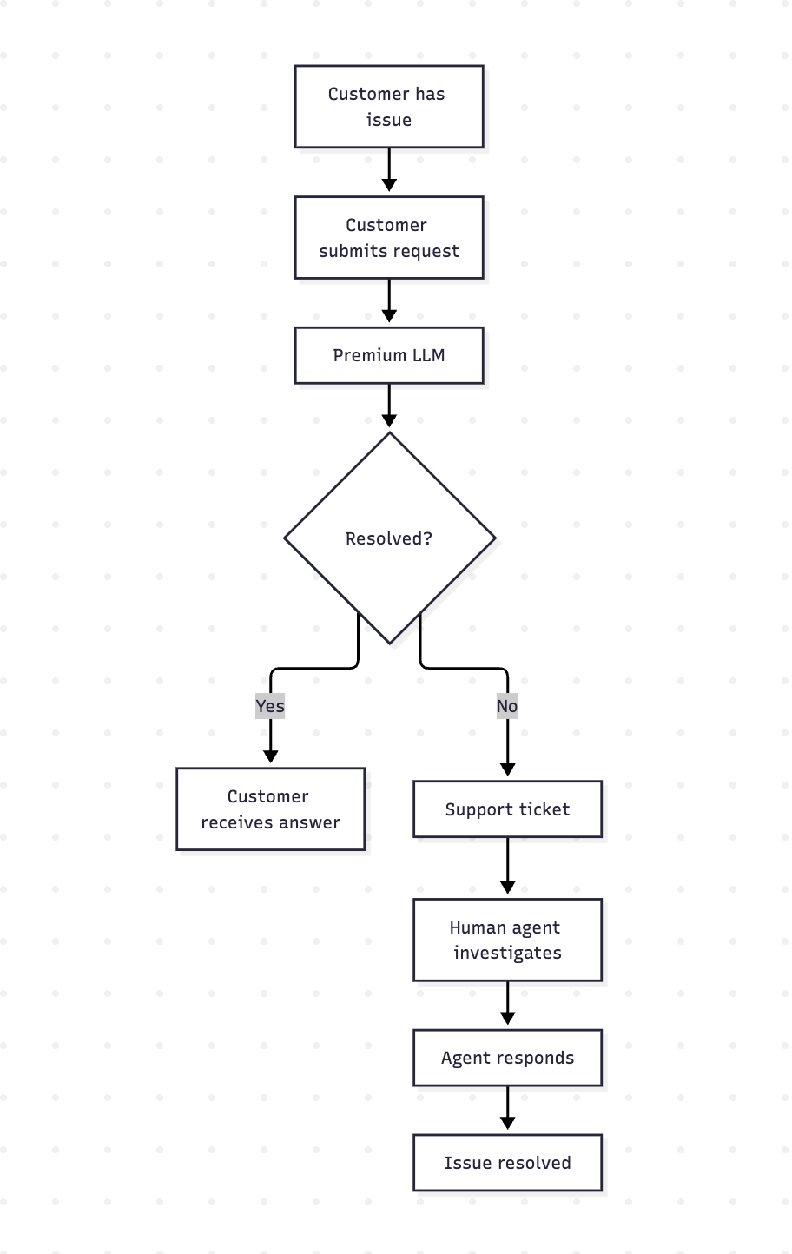

Current pain points
- Every request receives premium-model capability.
- Model cost is not differentiated by request requirements.
- Failed AI interactions create human workload.
- Agents may need to reconstruct the conversation.
- There is limited routing intelligence between request characteristics and model selection.

10. Future-State Journey
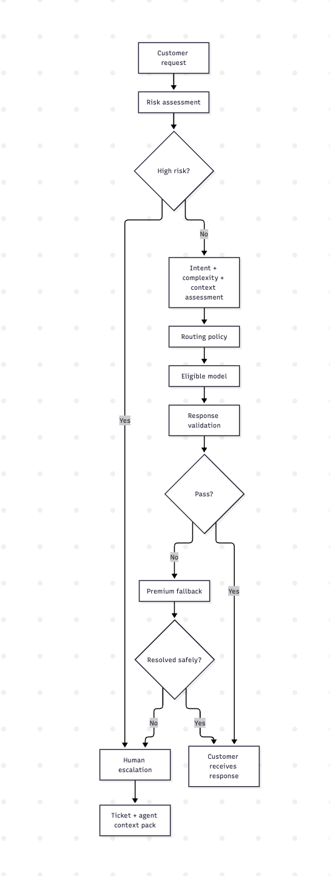

11. Routing Logic
The router evaluates four major dimensions:

1. Risk
Is automation permitted?

2. Complexity
What level of reasoning is required?

3. Context requirement
Does the request require authorised support context?

4. Confidence
Is the system sufficiently confident to proceed?
Then the policy engine considers:
- Quality eligibility
- Cost
- Latency
- Reliability
- Privacy/security
- Model availability

12. Routing Policy
Incoming request
|
v
Risk assessment
|
+---- High risk ------------------> Human escalation
|
v
Intent / complexity / context
|
v
Eligible-model policy
|
+---- Simple / low risk ----------> Lower-cost eligible model
|
+---- Moderate -------------------> Mid-tier eligible model
|
+---- Complex --------------------> Premium model
|
v
Response validation
|
+---- Pass -----------------------> Customer
|
+---- Fail -----------------------> Premium fallback
|
+-- Safe resolution --> Customer
|
+-- Still unresolved --> Human

13. High-Risk Guardrails
The following cases should bypass normal cost optimisation or require human review:
- Refund/payment disputes
- Account/security issues
- Highly frustrated customers
- Sensitive personal information
- Requests requiring account-specific actions
- Medical/safety-related queries
- AI uncertainty / low confidence
- Other business-specific risks

Guardrail principle
A request can be cheap to process but expensive to get wrong.
Therefore risk is a hard eligibility constraint, not simply another weighted score.

14. Human-in-the-Loop Design

AI completely resolves the issue
Customer → AI → validated answer → resolved

AI cannot safely resolve
Customer
↓
AI attempt
↓
Validation failure / uncertainty / risk
↓
Ticket creation
↓
Human agent
↓
Investigation
↓
Agent response
↓
Resolution
The human path is not treated as an AI failure alone.
The product should optimise the handoff quality.

15. Agent Context Pack
When AI escalates a case, the agent should receive:
Field | Purpose
Issue summary | Understand the case quickly
Customer intent | Understand what the customer wants
Suggested category | Speed up triage
Relevant knowledge/context | Reduce investigation effort
Suggested response | Accelerate drafting
Actions attempted | Avoid duplicate work
Reason for escalation | Explain why automation stopped
Confidence/risk signal | Support agent judgment

Product principle
When AI cannot resolve the issue, it should still reduce the human's work.

16. RAG Decision
RAG is deliberately not a new MVP build.
CallE can use existing authorised support-context capabilities where available.
Potential knowledge sources include:
- FAQs
- Product documentation
- Previous support tickets
- Internal policies
- Troubleshooting guides

MVP boundary
Use existing authorised retrieval/context capabilities; do not build a new RAG/vector infrastructure layer during MVP.

Phase 2
Evaluate a dedicated retrieval architecture if pilot evidence shows it is necessary.
This protects the MVP from unnecessary technical scope.

17. Product Requirements

Functional Requirements

FR-001 — Risk Classification
The system shall identify requests that require mandatory human review.
Acceptance criteria
- Given a request matching a mandatory high-risk condition
- When the routing process begins
- Then the request is prevented from entering the normal low-cost automated path.

FR-002 — Complexity Classification
The system shall classify the approximate complexity/capability requirement of an interaction.

FR-003 — Context Assessment
The system shall determine whether authorised support context is required for reliable resolution.

FR-004 — Model Selection
The system shall select an eligible model according to the routing policy.

FR-005 — Response Validation
The system shall validate generated responses before automated delivery.
Validation should consider:
- Correctness
- Relevance
- Completeness
- Safety
- Groundedness where applicable
- Confidence
- Resolution suitability

FR-006 — Premium Fallback
If a lower-cost model fails validation but the request remains safe for automation, the system shall retry using the premium baseline.

FR-007 — Human Escalation
The system shall create/escalate a support case when:
- The request is high risk.
- Confidence is insufficient.
- Validation fails critically.
- Premium fallback cannot safely resolve the issue.

FR-008 — Agent Context Pack
Escalated cases shall contain structured AI-generated context.

FR-009 — Automated Resolution
An interaction shall be counted as AI-resolved only when the issue is completely resolved without human involvement.

FR-010 — Audit Trail
The system shall retain the routing and outcome path for evaluation and governance.

18. Non-Functional Requirements

NFR-001 — Security
- Authentication
- Authorisation
- PII controls
- Secure API communication
- Vendor data-use review
- Access logging

NFR-002 — Performance
Routing and validation must stay within an acceptable support latency budget.

NFR-003 — Availability
A model/API failure must not become a single point of failure for support.

NFR-004 — Scalability
The architecture must support increasing interaction volume without requiring a proportional increase in premium-model usage.

NFR-005 — Auditability
Routing decisions and escalation reasons should be traceable.

19. AI Requirements

AIR-001
Model routing must respect mandatory safety constraints.

AIR-002
Model eligibility must be evaluated by support-task category, not only overall average performance.

AIR-003
Lower-cost models must have a safe fallback path.

AIR-004
AI-generated customer responses must be validated before automated delivery.

AIR-005
Model/policy changes must be evaluated against the established benchmark before controlled deployment.

20. User Stories
As a customer, I want CallE to resolve routine support issues quickly so that I don't need to wait for a human agent.
As a support agent, I want escalated cases to contain a clear issue summary and context so that I can investigate faster.
As a product manager, I want to measure cost per resolved interaction so that I can determine whether routing creates real economic value.
As a support leader, I want risky requests escalated to humans so that automation does not compromise customer safety or trust.

21. Prioritisation
For this MVP, MoSCoW is appropriate because the immediate delivery problem is scope control within a 12–16 week window.
Capability | Priority | Rationale
Risk classification | Must | Safety gate
Complexity classification | Must | Core routing input
Model routing | Must | Core hypothesis
Response validation | Must | Quality gate
Premium fallback | Must | Recovery path
Human escalation | Must | Safety/resolution
Agent context pack | Must | Reduce handoff cost
Automated resolution | Must | Primary outcome
Historical-ticket context | Must | Support workflow
Customer-facing AI | Must | Core user experience
Agent assist | Must | Handoff efficiency
New RAG infrastructure | Won't — MVP | Scope control
Executive dashboard | Won't — MVP | Measurement can exist without UI
Fine-tuning | Won't — MVP | Not required to test hypothesis
Voice support | Won't — MVP | Unrelated to core hypothesis
Autonomous financial actions | Won't — MVP | High risk

22. Roadmap
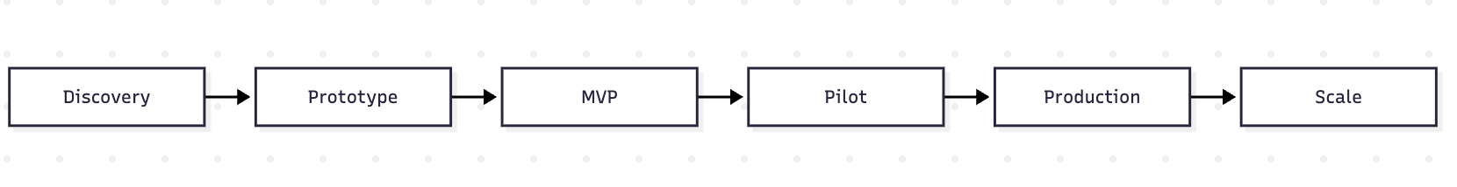

Discovery
Define the business problem, baseline, benchmark and guardrails.

Prototype
Prove routing and fallback mechanics.

MVP
Build the end-to-end controlled workflow.

Pilot
Compare dynamic routing against the premium baseline.

Production
Deploy only after pilot gates pass.

Scale
Expand model coverage, categories, retrieval and channels based on evidence.

23. Technology Decision

Options considered
Option | Strength | Weakness | Decision
Premium model for all requests | Strong quality baseline | High cost | Baseline
Cheapest model for all | Low model cost | Quality/safety risk | Reject
Rules only | Explainable | Limited language flexibility | Insufficient
LLM chooses everything | Flexible | Governance/opacity risk | Reject
Single-model optimisation | Simple | Provider dependency | Limited
Hybrid routing | Flexible + controllable | More orchestration | Recommend

Recommended architecture
Hybrid routing with deterministic safety controls, AI-assisted classification, policy-based model selection, validation, premium fallback and human escalation.

24. Architecture

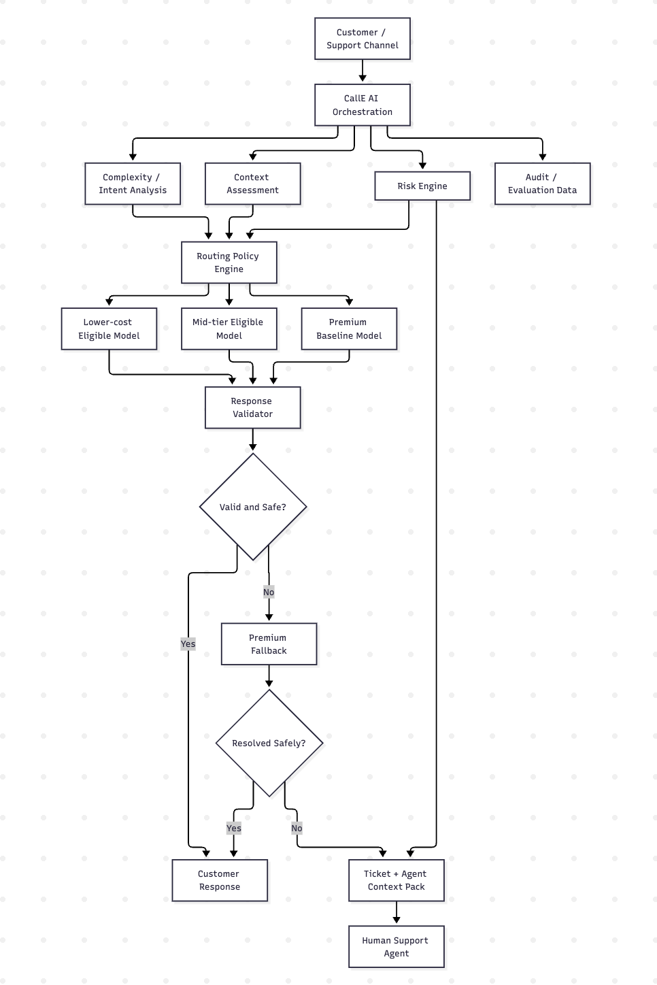

Component responsibilities

Risk engine
Determines whether automated handling is permitted.

Complexity / intent analysis
Interprets the natural-language request.

Context assessment
Determines whether authorised support information is required.

Routing policy engine
Applies model eligibility rules and optimisation criteria.

Model layer
Generates the response.

Validator
Checks output quality and safety.

Fallback
Provides a recovery path.

Human escalation
Provides safe resolution when automation is inappropriate.

Audit/evaluation data
Supports measurement, troubleshooting and governance.

25. Product Manager vs Technical Ownership
A critical boundary in this project:
Area | Product Manager | Engineering | ML/AI | Project Manager
Business problem | Own | Consult | Consult | Consult
PRD | Own | Input | Input | Input
Routing policy | Define | Implement | Advise | Track delivery
Quality threshold | Define | Support | Measure/evaluate | Track
Model implementation | Decide requirements | Build | Optimise/evaluate | Coordinate
Architecture | Contribute | Own technical design | Contribute | Coordinate
AI benchmark | Define decision need | Support | Execute | Track
Security controls | Define requirements | Implement | Support | Coordinate
Delivery plan | Define priorities | Estimate | Estimate | Own
Risks | Product risks | Technical risks | AI risks | Own project RAID
Pilot decision | Recommend | Provide evidence | Provide evidence | Coordinate

The PM is not claiming to have personally built every technical component.
The role is to:
Identify the problem → define the product → translate requirements → work with technical teams → make informed AI decisions → manage delivery → manage risks → measure outcomes.

26. Model Evaluation Framework

Evaluation dimensions
Dimension | Weight
Answer quality | 30%
Cost | 25%
Latency | 15%
Reliability | 10%
Context capability | 10%
Privacy/security | 10%
Total | 100%

Important decision rule
The weights are CallE product decisions for this hypothetical case, not universal industry standards.
A model that fails a mandatory safety/security requirement cannot compensate through a higher weighted score.

27. Benchmark Design

Benchmark size
ASSUMPTION: 180 curated support scenarios.
Category | Cases
Simple FAQ | 20
Standard support | 20
Summarisation / classification | 20
Troubleshooting | 20
Complex reasoning | 20
Long-context | 20
Ambiguous requests | 20
High-risk | 20
Adversarial / prompt injection | 20
Total | 180

Benchmark disclosure
SIMULATED / CURATED BENCHMARK DESIGN
The benchmark is not claimed to represent CallE's actual customer population.

28. AI Evaluation

Model quality
Evaluate:
- Correctness
- Precision/recall where applicable
- Groundedness
- Relevance
- Completeness

AI safety
Evaluate:
- Hallucination
- PII leakage
- Prompt injection
- Unsafe outputs
- Bias where relevant

Product performance
Evaluate:
- Task completion
- Automated resolution
- Human escalation
- Agent time saved
- Latency

Business performance
Evaluate:
- AI cost
- AI Cost per Resolved Interaction
- Productivity
- ROI

29. Experiment Design

Hypothesis
If CallE routes lower-risk and lower-complexity interactions to appropriately capable lower-cost models while reserving premium capability for requests that genuinely require it, then AI Cost per Resolved Interaction can decrease without reducing quality below the premium baseline.

Control
100% of eligible requests
↓
Premium baseline

Treatment
Risk-aware dynamic routing
↓
Eligible model
↓
Validation
↓
Fallback / escalation where required

Primary success metric
AI Cost per Resolved Interaction

Quality threshold
Treatment quality ≥ premium baseline

Safety threshold
No critical safety threshold breach

Decision rule
Proceed only if:
- Economic improvement is meaningful.
- Quality remains at or above the agreed baseline.
- Mandatory safety controls pass.
- Operational impact is acceptable.

30. Economics

Baseline
The baseline cost model begins with:
100,000 monthly interactions × premium-model cost per interaction
But request sizes vary, so a more realistic model needs token-volume assumptions.

Illustrative request profiles
Profile | Input tokens | Output tokens
Short | 500 | 150
Medium | 1,500 | 400
Long | 4,000 | 1,000

These values are ASSUMPTIONS, not CallE measurements.

Cost model
For each interaction:
Model cost = input tokens × input price + output tokens × output price
At product level:
AI Cost per Resolved Interaction = Total variable AI cost ÷ AI-resolved interactions
A complete economic model should also include:
- Routing/classification cost
- Validation cost
- Fallback calls
- Retrieval/context costs where applicable
- Human operational impact

31. Why Cost per Request Is Not Enough
Consider two hypothetical strategies:

Strategy A
Very cheap model.
- Low AI cost
- Poor resolution
- High escalation

Strategy B
Moderately higher AI cost.
- Higher resolution
- Lower escalation
- Better customer outcomes
Strategy A may look better if we only measure:
Cost per interaction
But Strategy B may create more business value.
Therefore the primary economic KPI is:
AI Cost per Resolved Interaction

32. Illustrative Scenario — Not a Result
The following is deliberately SIMULATED / ILLUSTRATIVE.
Strategy | Cost | Quality | Interpretation
All premium | High | Strong | Safe baseline; weak optimisation
Aggressive low-cost routing | Low | Below threshold | Reject
Balanced routing | Lower | At/above threshold | Potential candidate

The product decision is not:
“Choose the strategy with the lowest cost.”
It is:
Choose the strategy that creates acceptable economic improvement while preserving quality and safety.

33. KPI Framework

North-star economic KPI

AI Cost per Resolved Interaction
Measures economic efficiency of actual AI resolution.

Quality guardrail

Quality score
Treatment must remain at or above the premium baseline.

Safety guardrails
- Critical safety failure rate
- PII leakage
- Unsafe automation
- Incorrect high-risk routing

Supporting metrics
Metric | Purpose
Automated resolution rate | AI effectiveness
Premium-model usage % | Routing efficiency
Fallback rate | Routing quality
Human escalation rate | Workload transfer
Cost / interaction | Raw economics
Cost / resolved interaction | Primary economic KPI
Latency | Customer experience
Quality score | Primary guardrail
Safety failure rate | Critical guardrail

34. Project Charter

Objective
Validate whether intelligent model routing can reduce CallE's AI Cost per Resolved Interaction without reducing quality below the premium baseline.

Scope
Design, build and pilot:
- Risk classification
- Complexity classification
- Model routing
- Response validation
- Premium fallback
- Human escalation
- Agent context
- Automated resolution

Out of scope
- New RAG infrastructure
- Autonomous refunds
- Autonomous payment decisions
- Autonomous account changes
- Fine-tuning
- Custom foundation model
- Voice
- Global expansion
- Executive dashboard

Deliverables
- PRD
- Evaluation benchmark
- Routing policy
- Prototype
- MVP
- Security assessment
- UAT
- Pilot
- Executive recommendation

Timeline
12–16 weeks

Constraints
- Quality cannot fall below the agreed baseline.
- High-risk automation must remain controlled.
- Model/API providers create external dependencies.
- MVP scope must remain limited.

35. Work Breakdown Structure

1. Discovery
- Stakeholder alignment
- Current-state mapping
- Business objectives
- Baseline definition
- Risk taxonomy

2. Requirements
- PRD
- User stories
- Acceptance criteria
- AI requirements
- Safety requirements

3. UX / Workflow
- Customer journey
- Escalation journey
- Agent context design
- Failure states

4. Architecture
- Routing architecture
- Policy engine
- Model integrations
- Fallback architecture
- Audit design

5. AI Development
- Benchmark
- Risk classification
- Complexity classification
- Evaluation
- Validation

6. Engineering
- Orchestration
- APIs
- Ticket integration
- Agent workflow
- Logging

7. Testing
- Functional QA
- AI evaluation
- Safety testing
- Adversarial testing
- Integration testing

8. Security
- PII
- Vendor review
- Prompt injection
- Access control
- Data retention

9. UAT
- Support SME testing
- Acceptance criteria
- Defect resolution

10. Pilot
- Control
- Treatment
- KPI measurement
- Failure analysis

11. Launch
- Readiness review
- Controlled release
- Rollback plan

12. Monitoring
- Quality
- Cost
- Resolution
- Escalation
- Model review

36. 14-Week Delivery Plan
Phase | Weeks | Key deliverable
Discovery & baseline | 1–2 | Product requirements + evaluation framework
Model evaluation | 3–4 | Model evaluation report
Routing prototype | 5–7 | Working routing prototype
Support workflow | 8–9 | End-to-end escalation workflow
Testing & UAT | 10–11 | MVP readiness assessment
Controlled pilot | 12–14 | Pilot evidence + recommendation
Contingency | 15–16 | Calibration / remediation if required

The 14-week plan is the baseline; weeks 15–16 provide contingency for remediation or optimisation.

37. Sprint Plan

Sprint 1 — Baseline
Objective: Establish current state.
Tasks
- Current-state mapping
- KPI definitions
- Risk taxonomy
- Benchmark specification
Definition of Done
- Baseline workflow documented
- KPI definitions approved
- Evaluation scope agreed

Sprint 2 — Model Evaluation
Objective: Establish model eligibility.
Tasks
- Candidate model selection
- Benchmark dataset
- Evaluation rubric
- Cost model
- Initial testing
Definition of Done
- Benchmark executable
- Evaluation criteria approved
- Initial eligibility matrix available

Sprint 3 — Routing Prototype
Objective: Prove the core routing mechanism.
Tasks
- Risk classification
- Complexity classification
- Policy engine
- Model integration
Definition of Done
- Requests can be routed
- Routing decisions are logged
- Basic fallback path exists

Sprint 4 — Validation & Fallback
Objective: Make routing safe and recoverable.
Tasks
- Response validation
- Quality gates
- Premium fallback
- Failure handling
Definition of Done
- Invalid responses are blocked
- Safe failures reach premium fallback
- Critical failures escalate

Sprint 5 — Agent Workflow
Objective: Improve human handoff.
Tasks
- Ticket creation
- Issue summary
- Intent
- Suggested response
- Escalation reason
- Historical context
Definition of Done
- Agent receives a structured escalation package

Sprint 6 — Security & UAT
Objective: Validate MVP readiness.
Tasks
- PII tests
- Prompt-injection tests
- Security review
- Support SME UAT
- Defect remediation
Definition of Done
- Mandatory safety/security criteria pass
- UAT acceptance criteria met

Sprint 7 — Pilot
Objective: Measure business impact.
Tasks
- Control/treatment setup
- Controlled traffic
- KPI measurement
- Failure analysis
- Executive review
Definition of Done
- Pilot evidence collected
- Scale/iterate/stop recommendation prepared

38. RACI
Activity | PM | Engineering | ML/AI | Data | Security | Support SME
Business objective | A/R | C | C | C | C | C
PRD | A/R | C | C | C | C | C
Model selection | A | C | R | C | C | C
Benchmark | A | C | R | R | C | C
Routing policy | A/R | C | C | C | C | C
Router implementation | C | A/R | R | C | C | —
Safety requirements | A | C | R | C | R | C
Agent workflow | A | R | C | C | C | R
UAT | A | R | R | C | C | R
Pilot | A/R | R | R | R | C | C
Executive recommendation | A/R | C | C | C | C | C

A = Accountable, R = Responsible, C = Consulted

39. Stakeholder Management
Stakeholder | Power | Interest | Expectations | Decision rights | Communication
Executive sponsor | High | High | Business value and risk | Investment | Biweekly
Product | High | High | Product outcome | Product policy | Weekly
Support leadership | High | High | Resolution/workload | Operational acceptance | Weekly
Engineering | High | High | Clear scope | Technical implementation | 2–3× weekly
ML/AI | Medium | High | Evaluation clarity | Model evaluation | Weekly
Security | High | Medium | Safe architecture | Security approval | At gates
Finance | Medium | Medium | Cost model | Economic validation | At business case/pilot
Support agents | Medium | High | Useful escalations | UAT feedback | During UAT/pilot

40. Dependency Register

Dependency | Type | Impact | Mitigation
Model APIs | Vendor | High | Multi-provider fallback
Historical tickets | Data | High | Confirm access early
Ticketing integration | Technology | Medium | Prototype early
Security approval | Security | High | Start during architecture
Support SME availability | Business | Medium | Reserve UAT capacity
Benchmark dataset | Data | Medium | Define in discovery
Engineering capacity | Internal | High | Capacity check before commitment
Provider pricing | Vendor | Medium | Maintain scenario-based economics

41. Risk Register
Risk | Probability | Impact | Severity | Mitigation | Owner | Trigger
Complex request routed to cheap model | High | High | Critical | Category thresholds + validation + premium fallback | PM + ML | Quality failure
Quality below baseline | Medium | High | High | Benchmark gate + pilot guardrail | PM + ML | Score below threshold
Vendor/API outage | Medium | High | High | Multi-provider fallback | Engineering | API failure
Savings lower than expected | Medium | High | High | Pilot before scale | PM | KPI misses target
Hallucination | Medium | High | High | Validation + authorised context | ML | Incorrect response
PII exposure | Medium | High | High | Redaction + security controls | Security | Security test failure
Prompt injection | Medium | High | High | Adversarial testing + guardrails | Security + ML | Successful attack
Model drift | Medium | High | High | Periodic re-evaluation | ML | Performance deterioration
Excessive fallback | Medium | Medium | Medium | Routing calibration | PM + ML | Fallback spike
Latency increase | Medium | Medium | Medium | Routing latency budget | Engineering | SLA breach
Scope creep | High | Medium | High | Explicit MVP boundaries | PM/PMO | New feature requests

42. Governance

Model / routing policy change
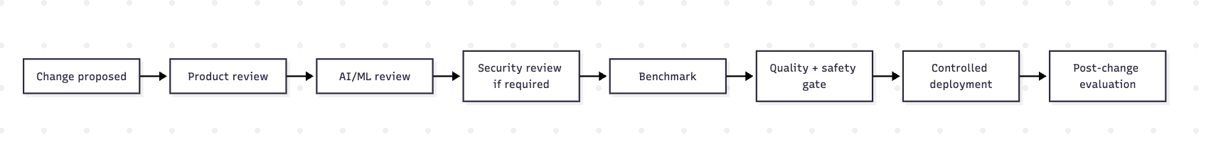

Re-evaluation triggers
- Provider pricing changes
- New model release
- Quality deterioration
- Increased fallback
- Changed request distribution
- Safety incident
- Provider outage
- Significant change in context/retrieval behaviour

43. Pilot Design

Control
100% of control traffic uses the premium baseline.

Treatment
Treatment traffic uses the intelligent routing strategy.

Compare
- Quality
- AI cost
- Cost/resolved interaction
- Automated resolution
- Escalation
- Fallback
- Latency
- Safety

Pilot decision matrix
Outcome | Decision
Cost improves + quality passes + safety passes | Proceed toward controlled rollout
Cost improves + quality close to threshold | Iterate routing
Cost improves + quality below threshold | Reject configuration
Quality passes + savings too small | Reconsider business case
Safety threshold fails | Stop / remediate

44. Launch Plan

Alpha
Objective: Technical validation.
Users: Internal engineering/AI teams.
Exit: Routing, validation and safety paths work.

Beta
Objective: Workflow validation.
Users: Selected support agents.
Exit: UAT passes.

Pilot
Objective: Business validation.
Users: Controlled customer traffic.
Exit: Economic, quality and safety gates pass.

Production
Objective: Controlled production deployment.
Exit: Stable operating metrics and incident controls.

Scale
Objective: Expand model coverage and routing categories.
Exit: Continued evidence of economic and customer value.

45. Change Management

Change Request 1 — Add a new RAG system

Original requirement
Use existing authorised support-context capabilities; no new RAG infrastructure in MVP.

Requested change
Add a vector database and new retrieval pipeline.

Impact
- Engineering scope
- Security review
- Evaluation work
- Additional latency
- New operational dependency

Recommendation
Reject for MVP.
Evaluate dedicated RAG in Phase 2 after validating whether retrieval is a material source of failure.

Change Request 2 — Automate payment disputes

Original requirement
High-risk financial issues require human control.

Requested change
Allow AI to resolve low-value payment disputes autonomously.

Impact
- Financial risk
- Customer trust
- Compliance/security considerations
- New validation requirements

Recommendation
Reject for MVP.
Human review remains the control point.

Change Request 3 — Add another model provider

Original requirement
Evaluate a defined candidate model set.

Requested change
Add another provider to the benchmark.

Impact
- Additional benchmark effort
- Security/vendor review
- Integration work

Recommendation
Conditional acceptance only if the model has a credible capability/cost advantage and can be evaluated without threatening the pilot timeline.

46. Post-Launch Measurement

AI performance monitoring
- Model quality
- Hallucination
- PII leakage
- Prompt injection
- Safety incidents
- Category-level failures
- Model drift

Product analytics
- Automated resolution
- Escalation
- Fallback
- Agent workload
- Customer support outcomes

Business metrics
- AI spend
- Cost/interaction
- Cost/resolved interaction
- Productivity

Incident management
Critical incidents should trigger:
- Automated protection/fallback where available
- Incident classification
- Technical investigation
- Product impact assessment
- Corrective action
- Model/policy re-evaluation

47. Expected Outcome
There is intentionally no fabricated numerical result.
The expected outcome of the MVP is decision-quality evidence answering:
- Can lower-cost models handle meaningful categories of CallE support traffic?
- Can routing reduce premium-model utilisation?
- Can this happen without falling below the quality baseline?
- Do safety guardrails work?
- Does the resulting economics justify the added orchestration complexity?
The project succeeds if it produces enough evidence to make a confident scale / iterate / stop decision.

48. Executive Decision Memo

Recommendation
Approve a controlled 12–16 week MVP/pilot to test intelligent model routing rather than approving a full production rollout upfront.

Why this solution?
CallE's issue is not simply expensive LLMs.
It is the mismatch between:
Request requirements ↔ model capability ↔ model cost.
A hybrid router addresses that mismatch while preserving human control over risky cases.

Why now?
The scenario assumes 100,000 monthly AI interactions, making AI unit economics strategically relevant.

Why AI?
Support requests are expressed in natural language and vary in intent, complexity and context requirements.

Why this architecture?
It combines:
- Deterministic safety
- AI classification
- Policy-based routing
- Multiple model options
- Validation
- Premium fallback
- Human oversight

Why this MVP?
It tests the central hypothesis without building unnecessary infrastructure.

What are we NOT doing?
- New RAG infrastructure
- Autonomous financial actions
- Fine-tuning
- Voice
- Global expansion
- Executive dashboard

Biggest risk
Routing a complex or high-risk request to an insufficiently capable model.

Biggest assumption
CallE's interaction population contains enough lower-complexity, lower-risk requests for routing to create meaningful economic improvement.

What should leadership approve?
A controlled experiment—not a guaranteed cost-saving programme.

49. Retrospective & Critical Thinking

Biggest uncertainty
The actual distribution of CallE requests by:
- Complexity
- Token volume
- Risk
- Context requirement
- Resolution outcome
Without this distribution, projected savings remain uncertain.

Biggest product risk
A routing policy could optimise average cost while creating unacceptable failures in important support categories.

Biggest technical trade-off
More sophisticated routing can improve optimisation but introduces:
- More latency
- More orchestration
- More failure modes
- More governance overhead
The router must therefore earn its complexity through measurable economic value.

Most important assumption
There are enough interactions that can be safely resolved by lower-cost eligible models to justify the added routing complexity.

What I would validate first with real users
I would validate:
- Whether customers perceive quality differences across model paths.
- Which support categories agents consider unsafe to automate.
- Whether AI-generated escalation summaries actually save agent time.
- Which failure types cause the most rework.
- Whether customers prefer immediate escalation over low-confidence automated answers.

Data required before further investment
- Actual interaction distribution
- Actual token consumption
- Current premium-model spend
- Baseline quality
- Automated resolution rate
- Escalation rate
- Agent handling time
- Existing retrieval/context architecture
- Security constraints
- Negotiated model pricing

50. What I Would Do Differently
If this moved from portfolio simulation to a real product, I would not begin by building the router.
I would first obtain a representative sample of real support interactions and establish:
What percentage of requests actually require premium capability?
Then I would segment those requests by complexity, risk, token volume and resolution outcome.
That data would determine whether routing is worth pursuing.
I would also run the initial experiment offline before changing customer-facing behaviour.
The sequence would be:
Real interaction sample
↓
Baseline evaluation
↓
Offline routing simulation
↓
Failure analysis
↓
Controlled pilot
↓
Production decision
This reduces the risk of discovering after implementation that the available optimisation opportunity is too small.

51. Key Product Decisions
Decision | Rationale
Optimise cost/resolved interaction | Avoid false savings
Premium model remains baseline | Preserve quality reference
Hybrid routing | Combine AI flexibility with deterministic control
Risk as a hard gate | Protect high-risk workflows
Category-specific evaluation | Prevent averages from hiding failures
Premium fallback | Recover safe failures
Human escalation | Preserve human control
Existing context capability | Avoid unnecessary RAG build
No new RAG in MVP | Protect timeline
No dashboard in MVP | Prioritise product validation
Pilot before production | Evidence before scale
Multi-vendor evaluation | Reduce provider dependency

52. Portfolio Artifacts
This case study can be presented with the following supporting visuals:
- Executive problem statement
- Current-state journey
- Future-state journey
- AI opportunity map
- Model evaluation matrix
- Routing decision tree
- Architecture diagram
- PRD / MVP scope
- Prioritisation matrix
- 14–16 week delivery plan
- WBS
- RACI
- Stakeholder map
- RAID / risk register
- Pilot experiment design
- KPI scorecard
- Governance flow
- Executive decision memo

53. Final Thesis
The strongest way to describe this project is:
I did not approach the problem as “build an AI router.” I approached it as an enterprise product economics problem: determine whether CallE can use different levels of AI capability for different support requests while maintaining the quality and safety customers expect.
I defined the product strategy, decision criteria, quality thresholds, routing policy, guardrails, MVP scope and experiment design; worked across engineering, ML/AI, security and support stakeholders; and structured a 12–16 week pilot to determine whether the economics justified scaling.
The core lesson is:
Optimisation is not minimising AI cost. It is maximising business value under quality, risk, operational and cost constraints.

Remaining evidence gap
The case intentionally does not claim:
- Real CallE customer research
- Real CallE production metrics
- Real CallE model spend
- Real CallE benchmark results
- Real CallE savings
- Real CallE ROI
Those would require real organisational data.
That limitation is a feature of the portfolio: it demonstrates that the PM can identify what is known, what is assumed, and what must be validated rather than manufacturing evidence.

