Ablation and Encoder Study
Optimization-Based Deep Learning Framework for Kidney Disease Detection and Segmentation from Ultrasound Images
Generated 25 September 2026 · 30 training runs · 3 seeds per configuration · Produced by Ablation_and_Encoder_Study.ipynb

1. Protocol
Two studies share one protocol. The module ablation switches off each component of the multi-task model in turn, holding everything else fixed. The encoder comparison replaces the ResNet-34 backbone with three lighter alternatives, holding the model and training fixed.
- Seeds. 3 per configuration, reported as mean ± standard deviation. Single runs are not interpretable on this dataset: retraining an identical recipe with a different seed moves AUC by up to 0.074.
- Fidelity. 256 × 256 input, 12 epochs, batch 8. This is deliberately below the 512 × 512 / 15-epoch protocol used for the headline results, so the absolute values here are lower and should be compared only with each other.
- No checkpoint selection. The final-epoch model is evaluated. Selecting a checkpoint on a noisy validation metric was previously shown to shift AUC by about 0.037, which would confound the comparison.
- Operating point. The decision threshold is chosen on validation within each run and applied to test; it is never tuned on test.
- Cost. Mean 3.7 minutes per run on an RTX 3050 Laptop GPU.
Interpretation rule used throughout: a difference is called real only if it exceeds the run-to-run spread. With 3 seeds this study can detect large effects, not small ones, and differences below roughly 0.026 AUC are reported as "within noise" regardless of their sign.

2. Module ablation
Each row removes one component from the full model. Because the encoder is shared, removing a head also removes the auxiliary supervision it provided, so a drop measures the loss of that training signal as well as the loss of the output.
Configuration | Params | Diagnosis AUC | Multi-pathology AUC | Kidney Dice | vs full model
Full model (reference) | 24.44 M | 0.8607 ± 0.0399 | 0.8105 ± 0.0037 | 0.8116 ± 0.0384 | reference
Without lesion-guided pooling | 24.44 M | 0.8813 ± 0.0080 | 0.7677 ± 0.0211 | 0.7621 ± 0.0395 | +0.0206 (within noise)
Without anatomical consistency | 24.44 M | 0.8825 ± 0.0143 | 0.7903 ± 0.0311 | 0.8048 ± 0.0096 | +0.0218 (within noise)
Without lesion segmentation | 22.86 M | 0.8728 ± 0.0270 | 0.7823 ± 0.0206 | 0.7546 ± 0.0485 | +0.0122 (within noise)
Without local-pathology head | 24.43 M | 0.8629 ± 0.0131 | 0.5000 ± 0.0000 | 0.8564 ± 0.0060 | +0.0022 (within noise)
Without kidney segmentation | 22.87 M | 0.8848 ± 0.0129 | 0.7997 ± 0.0202 | 0.0000 ± 0.0000 | +0.0241 (within noise)
Classification heads only | 21.29 M | 0.8649 ± 0.0051 | 0.7906 ± 0.0110 | 0.0000 ± 0.0000 | +0.0042 (within noise)

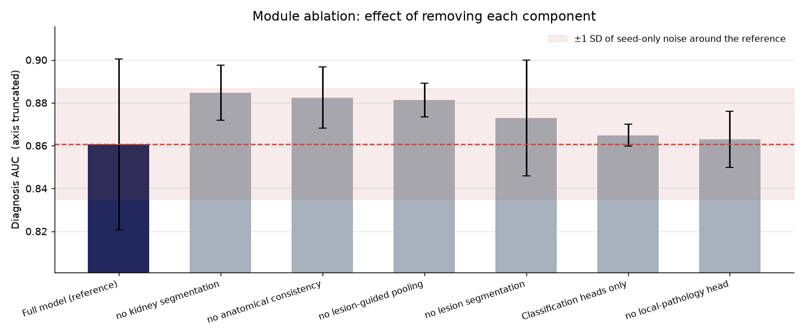
Figure 1. Diagnosis AUC after removing each module. The shaded band is ±1 SD of seed-only variation around the full model; bars inside it are not distinguishable from the reference.

2.1 What the ablation shows
- Removing lesion-guided pooling — multi-pathology AUC falls by 0.0428 (0.8105 to 0.7677).
- Removing lesion segmentation — multi-pathology AUC falls by 0.0282 (0.8105 to 0.7823).
Segmentation metrics behave differently from classification: removing a decoder necessarily drives its own Dice to zero, so those columns confirm the switch worked rather than measuring a trade-off.

3. Encoder comparison
The full model is retrained with each backbone. All four downsample by a factor of 32 and feed the same decoders and heads; only the channel width differs, which the architecture reads from the encoder rather than assuming.
Encoder | Encoder params | Total params | Diagnosis AUC | Multi-pathology AUC | Kidney Dice | vs ResNet-34
resnet34 | 21.28 M | 24.44 M | 0.8607 ± 0.0399 | 0.8105 ± 0.0037 | 0.8116 ± 0.0384 | reference
efficientnet_b0 | 4.01 M | 10.72 M | 0.8569 ± 0.0136 | 0.7576 ± 0.0366 | 0.8017 ± 0.0124 | -0.0038 (within noise)
mobilenet_v3_large | 2.97 M | 8.20 M | 0.8248 ± 0.0232 | 0.7211 ± 0.0170 | 0.8063 ± 0.0115 | -0.0359 (lower)
shufflenet_v2_x1_0 | 1.25 M | 6.78 M | 0.8321 ± 0.0049 | 0.7169 ± 0.0181 | 0.8136 ± 0.0217 | -0.0286 (lower)

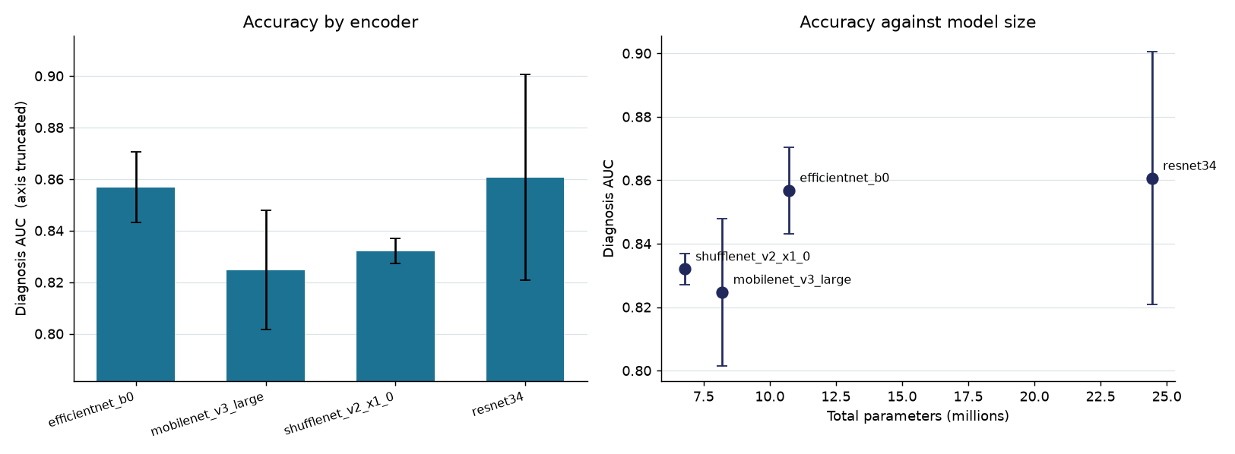
Figure 2. Accuracy by encoder, and accuracy against model size. Error bars are standard deviation over seeds.

3.1 Accuracy against size
- Binary diagnosis survives a much smaller backbone. efficientnet_b0 reaches 0.8569 ± 0.0136 against ResNet-34's 0.8607 ± 0.0399, a difference within the noise band, using 10.72 M parameters instead of 24.44 M (2.3x smaller).
- Multi-pathology does not survive. Every lighter backbone loses multi-pathology AUC relative to ResNet-34 (efficientnet_b0 -0.0529, mobilenet_v3_large -0.0894, shufflenet_v2_x1_0 -0.0935). The nine-way pathology task appears to need the larger backbone's capacity even where binary diagnosis does not, which is consistent with it being the harder task and the one where this project already trails the benchmark.
- Smallest model. shufflenet_v2_x1_0 at 6.78 M parameters, 3.6x smaller than ResNet-34, reaching 0.8321 ± 0.0049 (lower than the reference).
- Caveat. Parameter count is not latency. These encoders differ in how efficiently they use hardware, and depthwise-separable backbones often run slower per parameter than their size suggests. A timing measurement is still needed before a deployment claim is complete.

4. All configurations, all metrics
Configuration | Diagnosis AUC | Multi-pathology AUC | Kidney Dice | Lesion Dice (lesion-bearing) | Balanced accuracy
Full model (reference) | 0.8607 ± 0.0399 | 0.8105 ± 0.0037 | 0.8116 ± 0.0384 | 0.3674 ± 0.0183 | 0.7744 ± 0.0503
Without lesion-guided pooling | 0.8813 ± 0.0080 | 0.7677 ± 0.0211 | 0.7621 ± 0.0395 | 0.3570 ± 0.0494 | 0.7639 ± 0.0333
Without anatomical consistency | 0.8825 ± 0.0143 | 0.7903 ± 0.0311 | 0.8048 ± 0.0096 | 0.3894 ± 0.0089 | 0.7815 ± 0.0277
Without lesion segmentation | 0.8728 ± 0.0270 | 0.7823 ± 0.0206 | 0.7546 ± 0.0485 | 0.0000 ± 0.0000 | 0.7991 ± 0.0287
Without local-pathology head | 0.8629 ± 0.0131 | 0.5000 ± 0.0000 | 0.8564 ± 0.0060 | 0.3651 ± 0.0127 | 0.7819 ± 0.0183
Without kidney segmentation | 0.8848 ± 0.0129 | 0.7997 ± 0.0202 | 0.0000 ± 0.0000 | 0.3520 ± 0.0360 | 0.7757 ± 0.0191
Classification heads only | 0.8649 ± 0.0051 | 0.7906 ± 0.0110 | 0.0000 ± 0.0000 | 0.0000 ± 0.0000 | 0.7856 ± 0.0054
efficientnet_b0 | 0.8569 ± 0.0136 | 0.7576 ± 0.0366 | 0.8017 ± 0.0124 | 0.3736 ± 0.0112 | 0.7868 ± 0.0307
mobilenet_v3_large | 0.8248 ± 0.0232 | 0.7211 ± 0.0170 | 0.8063 ± 0.0115 | 0.3416 ± 0.0237 | 0.7214 ± 0.0202
shufflenet_v2_x1_0 | 0.8321 ± 0.0049 | 0.7169 ± 0.0181 | 0.8136 ± 0.0217 | 0.3627 ± 0.0069 | 0.7545 ± 0.0035

Balanced accuracy uses the validation-tuned threshold. Multi-pathology AUC of exactly 0.5000 indicates the head was removed in that configuration, not that it performed at chance.

5. Limitations
- Reduced fidelity. Results come from 256 × 256 inputs and 12 epochs. Conclusions about relative ordering may not transfer exactly to the full 512 × 512 / 15-epoch protocol.
- Statistical power. 3 seeds per configuration detects large effects only. A null result here means "not shown", not "no effect".
- Single split. These runs use the fixed 70/15/15 split rather than cross-validation, so fold-difficulty variance is not averaged out.
- Encoder pretraining differs. All backbones use ImageNet weights, but they were trained with different recipes and augmentation, which is part of what is being compared.
- Coupled removals. Removing the lesion decoder also removes lesion-guided pooling and the consistency term, since both depend on it. That row is a combined ablation, not an isolated one.

