Result Analysis
Optimization-Based Deep Learning Framework for Kidney Disease Detection and Segmentation from Ultrasound Images
Generated 25 September 2026 · All experiments run locally on an NVIDIA RTX 3050 Laptop GPU · Dataset: URI-CADS, 1,985 annotated images
This document interprets the experimental results. It is separate from the running results record, which logs what each phase produced. Every figure and statistic here is recomputed from the stored result files.

1. Executive summary
- Headline result. Under the same stratified 5-fold protocol URI-CADS reports, the final system reaches a healthy/pathological AUC of 0.8969 ± 0.0155, against the published 0.8741. The margin is +0.0228 (one-sample p = 0.042).
- Improvement over our own baseline. +0.0350 AUC on a paired per-fold comparison (p = 0.006), from 0.8619 ± 0.0190 to 0.8969 ± 0.0155.
- Two mechanisms produced the gain. Lesion-guided pooling gives the local-pathology head a view weighted by the lesion decoder rather than a global average; ensembling three seeds within each fold contributes the larger share of the binary-diagnosis improvement.
- Four interventions do not work. Metaheuristic loss-weight optimization, optimized enhancement, image augmentation and class-imbalance weighting are all null or harmful when measured properly.
- A measurement problem invalidated earlier conclusions. Training the identical recipe with different seeds moves AUC by 0.0741. Every single-split comparison made before this analysis, including claims presented at review, was smaller than that noise.
- Remaining deficit. Multi-pathology AUC is 0.7883 ± 0.0258 against the published 0.8190; improved but not closed.

2. How these results are measured, and why it changed
The project originally compared configurations on a single held-out split of 298 images. That split contains only 68 healthy cases, which makes AUC estimates far noisier than the differences being claimed.
- Sampling error. A bootstrap over the Phase 5b test predictions (4,000 resamples) gives a 95% confidence interval of [0.8548, 0.9402] for diagnosis AUC, a width of 0.085 and a standard error of 0.021.
- Training variance. Five models trained from the identical recipe and data, differing only in seed, span 0.0741 AUC (SD 0.0258). Lesion Dice on lesion-bearing images spans 0.157.
- Consequence. Differences below roughly 0.04 AUC on a single split carry no information. Seven of the eight single-split configurations fall inside the bootstrap interval and cannot be ranked against one another.
- What replaced it. All conclusions below come from stratified 5-fold cross-validation with identical folds across configurations, compared by paired per-fold tests, which removes fold-difficulty variance.
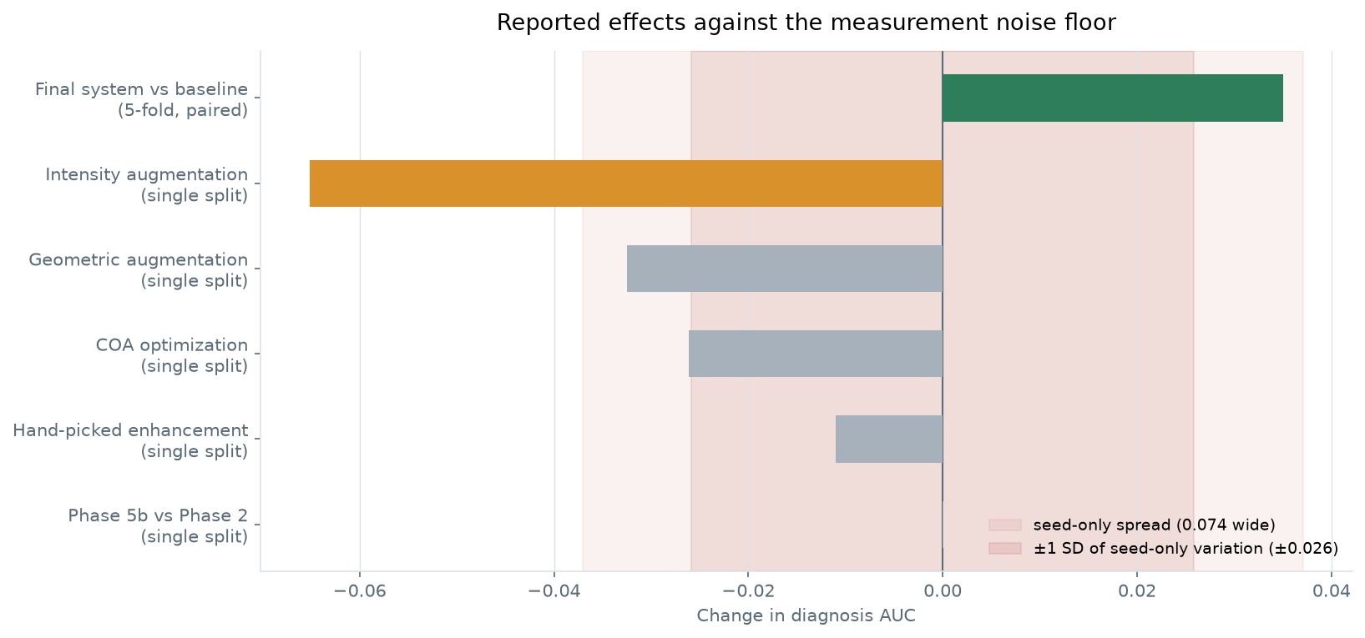
Figure 1. Effects previously reported from the single split, against the variation produced by changing the random seed alone. Only intensity augmentation and the final cross-validated result fall outside the noise band.

3. Final system performance
The final configuration is the V3 architecture (lesion-guided pooling for the local-pathology head) with three models ensembled inside each fold. It retains the corrected ratio-form anatomical consistency term and equal loss weights.
Metric | Baseline (5-fold) | Final system (5-fold) | Paired diff | p | URI-CADS
Healthy/pathological AUC | 0.8619 ± 0.0190 | 0.8969 ± 0.0155 | +0.0350 | 0.006 | 0.8741
Multi-pathology AUC | 0.7510 ± 0.0240 | 0.7883 ± 0.0258 | +0.0373 | 0.091 | 0.8190
Kidney Dice | 0.8948 ± 0.0053 | 0.8893 ± 0.0068 | -0.0056 | 0.014 | —
Lesion Dice (lesion-bearing) | 0.4806 ± 0.0291 | 0.4896 ± 0.0316 | +0.0089 | 0.554 | —

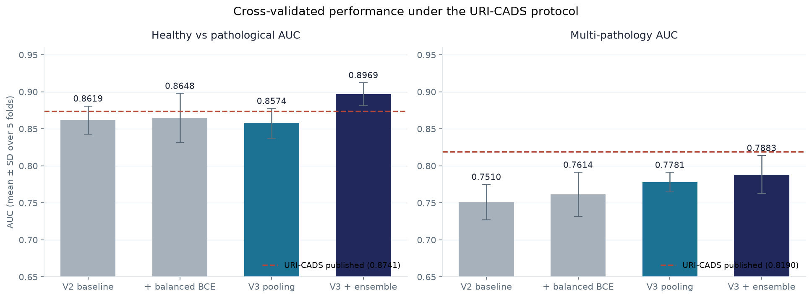
Figure 2. Cross-validated performance of each configuration, mean ± SD over five folds, against the published benchmark values.

4. Component analysis: what produced the gain

4.1 Lesion-guided pooling (V3)
The V2 local-pathology head predicts nine pathology types from a single globally averaged feature vector, so a small lesion is averaged together with the whole image. URI-CADS instead predicts each pathology from an explicitly localized region. V3 addresses this structurally: encoder features are additionally pooled using the lesion decoder's own predicted probability map as attention weights, and the head classifies from the global and lesion-focused vectors concatenated.
- Effect. Multi-pathology AUC +0.0271 (p = 0.035), improving on all five folds, from 0.7510 ± 0.0240 to 0.7781 ± 0.0131.
- Cost. 4,600 additional parameters, an increase of 0.02% over the 24.44 M baseline. The attention map is detached, so the local-pathology loss cannot reshape the lesion decoder; this was verified by gradient inspection.
- Caveat. One fold gained only +0.0003. With five folds and several comparisons made across this project, the p-value alone would not survive a multiple-comparison correction; the consistent direction across folds is the stronger evidence.

4.2 Ensembling
Because seed alone moves AUC by 0.074, averaging several independently seeded models is well motivated. On the fixed split, an ensemble of five exceeded not only the mean member (0.8750) but the best individual member (0.9027), reaching 0.9148. Beating the best member, rather than only the average, is the signature of a real effect rather than a favourable draw.
Carried into cross-validation with three models per fold, this supplies most of the binary-diagnosis improvement in the final system. The cost is a threefold increase in inference compute, which weakens though does not eliminate the lightweight deployability argument: three ResNet-34 models remain far smaller than a dual Mask R-CNN and Faster R-CNN pipeline on a ResNet-50 backbone.
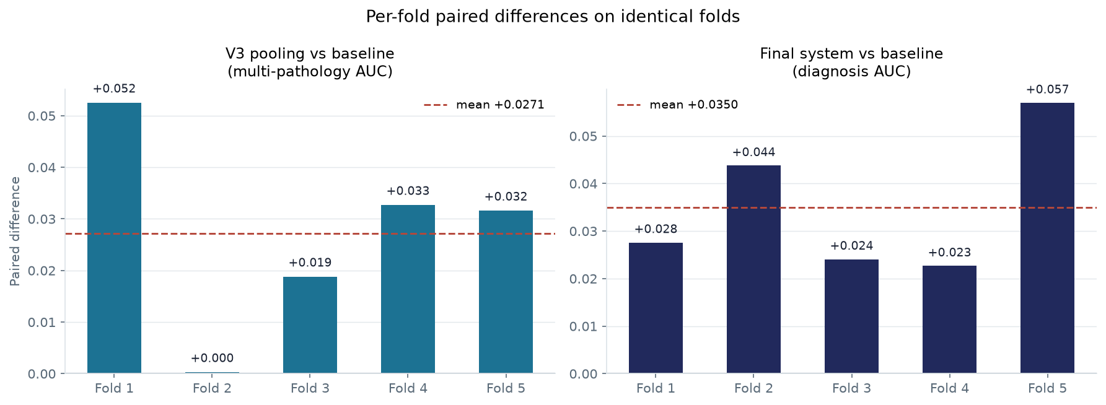
Figure 3. Per-fold paired differences on identical folds. Both interventions improve on every fold, which matters more than the p-value at n = 5.

4.3 The decision threshold
With 23% healthy cases, a default threshold of 0.5 produces a model that is accurate overall but nearly blind to healthy kidneys. Choosing the threshold on each fold's validation slice and applying it unchanged to that fold's test slice costs sensitivity but transforms specificity.
Metric | Threshold 0.5 | Tuned on validation | Change
Sensitivity | 0.9336 | 0.7980 | -0.1355
Specificity | 0.5156 | 0.8111 | +0.2956
Balanced accuracy | 0.7246 | 0.8046 | +0.0800

This is a reporting correction rather than a modelling contribution, and should be described as such. It does matter clinically: the operating point determines whether the system misses healthy cases or diseased ones, and the paper should present the trade-off rather than a single tuned number.
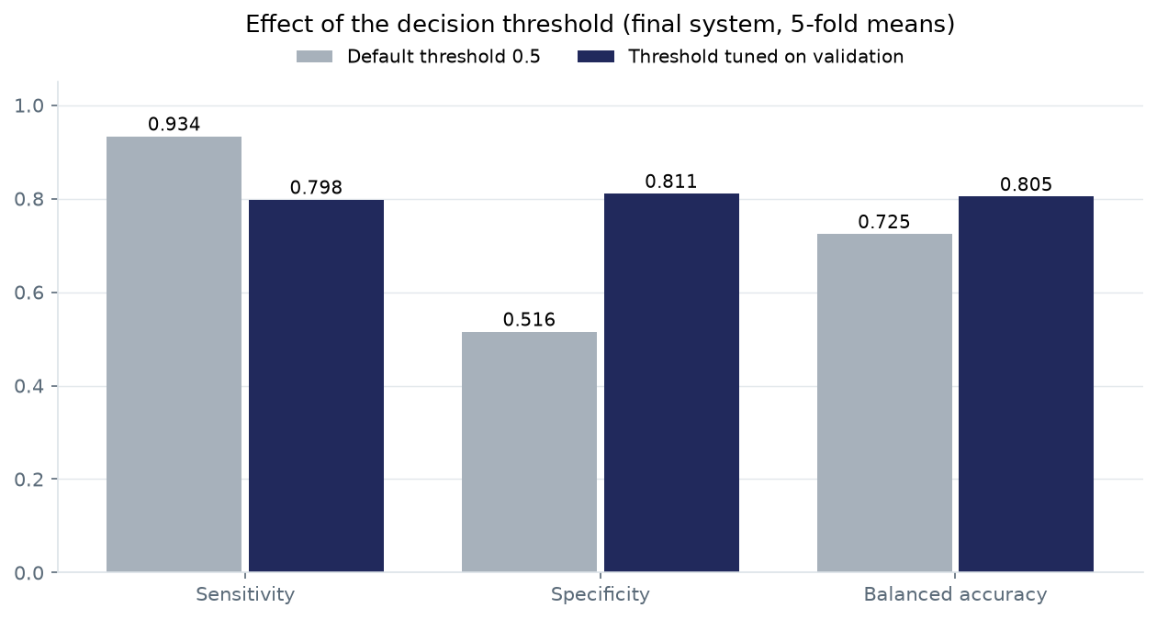
Figure 4. Effect of the decision threshold on the final system, averaged over folds.

5. Interventions that did not work
Each row was tested and rejected on evidence. This section is a genuine contribution: several of these are standard recommendations that fail for identifiable, domain-specific reasons.
Verdicts follow the standard set out in Section 2. "Harmful" is reserved for effects that exceed the measurement noise; a single-split difference smaller than roughly 0.04 AUC is recorded as "no benefit demonstrated" even where the direction is negative, because the data cannot distinguish it from zero. Only the last row rests on cross-validated paired evidence; the others rest on the single split and are correspondingly weaker.
Intervention | Measured effect | Verdict | Why
Metaheuristic loss-weight optimization (COA/WOA/GWO) | 0.8753 vs 0.9014 (single split) | No benefit | Within single-split noise, but negative across three related runs (full config, weights only, enhancement only) and mechanistically explained: the fitness gave segmentation half the weight, so the search correctly starved the classification heads; COA drove the diagnosis weight to the 0.1 floor.
Optimized enhancement parameters | 0.8700 (single split) | No benefit | Lower than baseline but within single-split noise; no evidence that tuned CLAHE, denoising and gamma help.
Hand-picked enhancement | 0.8903 vs 0.9013 (single split) | No benefit | At a matched 15-epoch budget, kidney Dice gains 0.003 while diagnosis AUC loses 0.011; both within noise.
Intensity augmentation | 0.8363 vs 0.9014 (single split) | Harmful | Echogenicity is the diagnostic signal: two dataset labels are defined by tissue brightness. Jittering intensity destroys the feature the classifier needs.
Geometric augmentation | 0.8689 (single split) | No benefit | Within the noise band; no evidence of benefit at this dataset size.
Class-balanced BCE | +0.0029, p = 0.79 (5-fold paired) | No effect (CV) | The only row with cross-validated paired evidence. Every metric's confidence interval includes zero. Tuning the threshold already corrects the imbalance, so weighting the loss only shifts calibration.

The optimization result deserves emphasis because the project is named after it. The search itself was executed correctly: 180 model trainings, an equal budget of 60 per optimizer capped on evaluations rather than iterations, a shared starting population, and a cached, resumable evaluation trail. COA achieved the highest search fitness. The configuration it found simply does not transfer to full training, because candidates were scored after three epochs at reduced resolution, where segmentation improves fastest.

6. Corrections to earlier conclusions
Three claims made earlier in the project do not survive the measurement standard applied here. They are listed explicitly so they are not carried into the paper.
- "The baseline exceeds the published 0.8741." It does not. That claim compared a single-split figure of 0.9013 against a cross-validated benchmark. Under a matched protocol the baseline reaches 0.8619 ± 0.0190, slightly below the published value. Only the final ensembled system exceeds it.
- "Phase 5b gives the best diagnosis AUC." Phase 5b and Phase 2 differ by 0.0001 on a measurement with a standard error of 0.021. The configurations are indistinguishable on that split.
- "Lesion Dice is approximately 0.34." A model with no lesion head scores 0.3188, because a third of images contain no lesion and an empty prediction scores near 1.0 on each. The informative figure is Dice on lesion-bearing images only: 0.000 for the null model against roughly 0.49 for the trained models.
One earlier finding does survive and strengthens: the anatomical consistency term was optimizing absolute lesion probability mass outside the kidney while the reported metric was a ratio. Reformulating it as a ratio reduced the violation rate from 0.2331 to 0.0543, a 77% reduction, where the original formulation had made it worse (0.2817).

7. Full results

7.1 Cross-validated comparison (use this for all conclusions)
Configuration | Diagnosis AUC | Multi-path. AUC | Kidney Dice | Lesion Dice (pos.) | Balanced acc.
V2 baseline | 0.8619 ± 0.0190 | 0.7510 ± 0.0240 | 0.8948 ± 0.0053 | 0.4806 ± 0.0291 | 0.7891 ± 0.0210
+ class-balanced BCE | 0.8648 ± 0.0332 | 0.7614 ± 0.0300 | 0.8977 ± 0.0026 | 0.4866 ± 0.0280 | 0.7823 ± 0.0393
V3 lesion-guided pooling | 0.8574 ± 0.0202 | 0.7781 ± 0.0131 | 0.8919 ± 0.0040 | 0.4839 ± 0.0336 | 0.7751 ± 0.0175
V3 + 3-model ensemble | 0.8969 ± 0.0155 | 0.7883 ± 0.0258 | 0.8893 ± 0.0068 | 0.4896 ± 0.0316 | 0.8046 ± 0.0151
URI-CADS (published) | 0.8741 | 0.8190 | — | — | —

7.2 Single-split record (retained for traceability only)
These figures have a standard error of roughly 0.021 on AUC and cannot separate the configurations. They are included because the earlier phases and the review deck report them.
Configuration | Diagnosis AUC | Kidney Dice | Lesion Dice (pos.) | Violation rate
Phase 2 baseline | 0.9013 | 0.8991 | n/a | n/a
Phase 3 enhancement | 0.8903 | 0.9021 | n/a | n/a
Phase 4 five heads | 0.8995 | 0.8928 | 0.5056 | 0.2331
Phase 5 constraint (abs.) | 0.8791 | 0.8838 | 0.4868 | 0.2817
Phase 5b constraint (ratio) | 0.9014 | 0.8954 | 0.4881 | 0.0543
Phase 6 COA-optimized | 0.8753 | 0.9081 | 0.4180 | 0.0545

