Optimization-Driven Multi-Task Deep Learning for Kidney Abnormality Analysis in Ultrasound
Experimental results record - URI-CADS dataset
Generated 2026-09-23 19:53 - all experiments run on local hardware

1. Compute environment and reproducibility
All results in this document were produced on the local workstation below. Every phase uses the same GPU, library versions, random seed and data split, so the numbers are directly comparable across phases.
GPU | NVIDIA GeForce RTX 3050 Laptop GPU
VRAM | 4.29 GB
PyTorch | 2.14.0+cu126
Peak VRAM (5-head model, batch 4 @ 512x512) | 0.81 GB
Model parameters (5-head) | 24.44 M
Dataset | 1985 images / labels / masks
Split (train/val/test) | 1389 / 298 / 298
Random seed | 42
Measured throughput: 1.26 minutes per epoch, i.e. about 0.32 hours for a 15-epoch run. The five-head model occupies 0.81 GB of the available 4.29 GB, which is the quantitative basis for the edge-deployability claim in the paper.

2. Verification of the local reimplementation
The pipeline was reimplemented locally from the original Colab notebooks. To confirm the reimplementation is faithful, the four checkpoints trained in Colab were re-evaluated with the local code and compared against the values the notebooks reported.
Checkpoint | Metric | Colab | Local
phase2_baseline | Healthy/pathological AUC | 0.9003 | 0.9001
phase2_baseline | Kidney segmentation Dice | 0.8735 | 0.8733
phase3_enhanced | Healthy/pathological AUC | 0.8712 | 0.8707
phase3_enhanced | Kidney segmentation Dice | 0.8891 | 0.8889
phase4_multitask | Healthy/pathological AUC | 0.8880 | 0.8880
phase4_multitask | Kidney segmentation Dice | 0.8966 | 0.8964
phase4_multitask | Lesion Dice (all test images) | 0.3388 | 0.3411
phase4_multitask | Local pathology mean AUC | 0.7724 | 0.7723
phase5_anatomical | Healthy/pathological AUC | 0.8758 | 0.8772
phase5_anatomical | Kidney segmentation Dice | 0.8970 | 0.8970
phase5_anatomical | Lesion Dice (all test images) | 0.3425 | 0.3449
phase5_anatomical | Consistency violation rate (lower is better) | 0.3790 | 0.3786
Every metric reproduces to within 0.0024, confirming the local implementation matches the original. All subsequent results are therefore directly comparable with the earlier work.
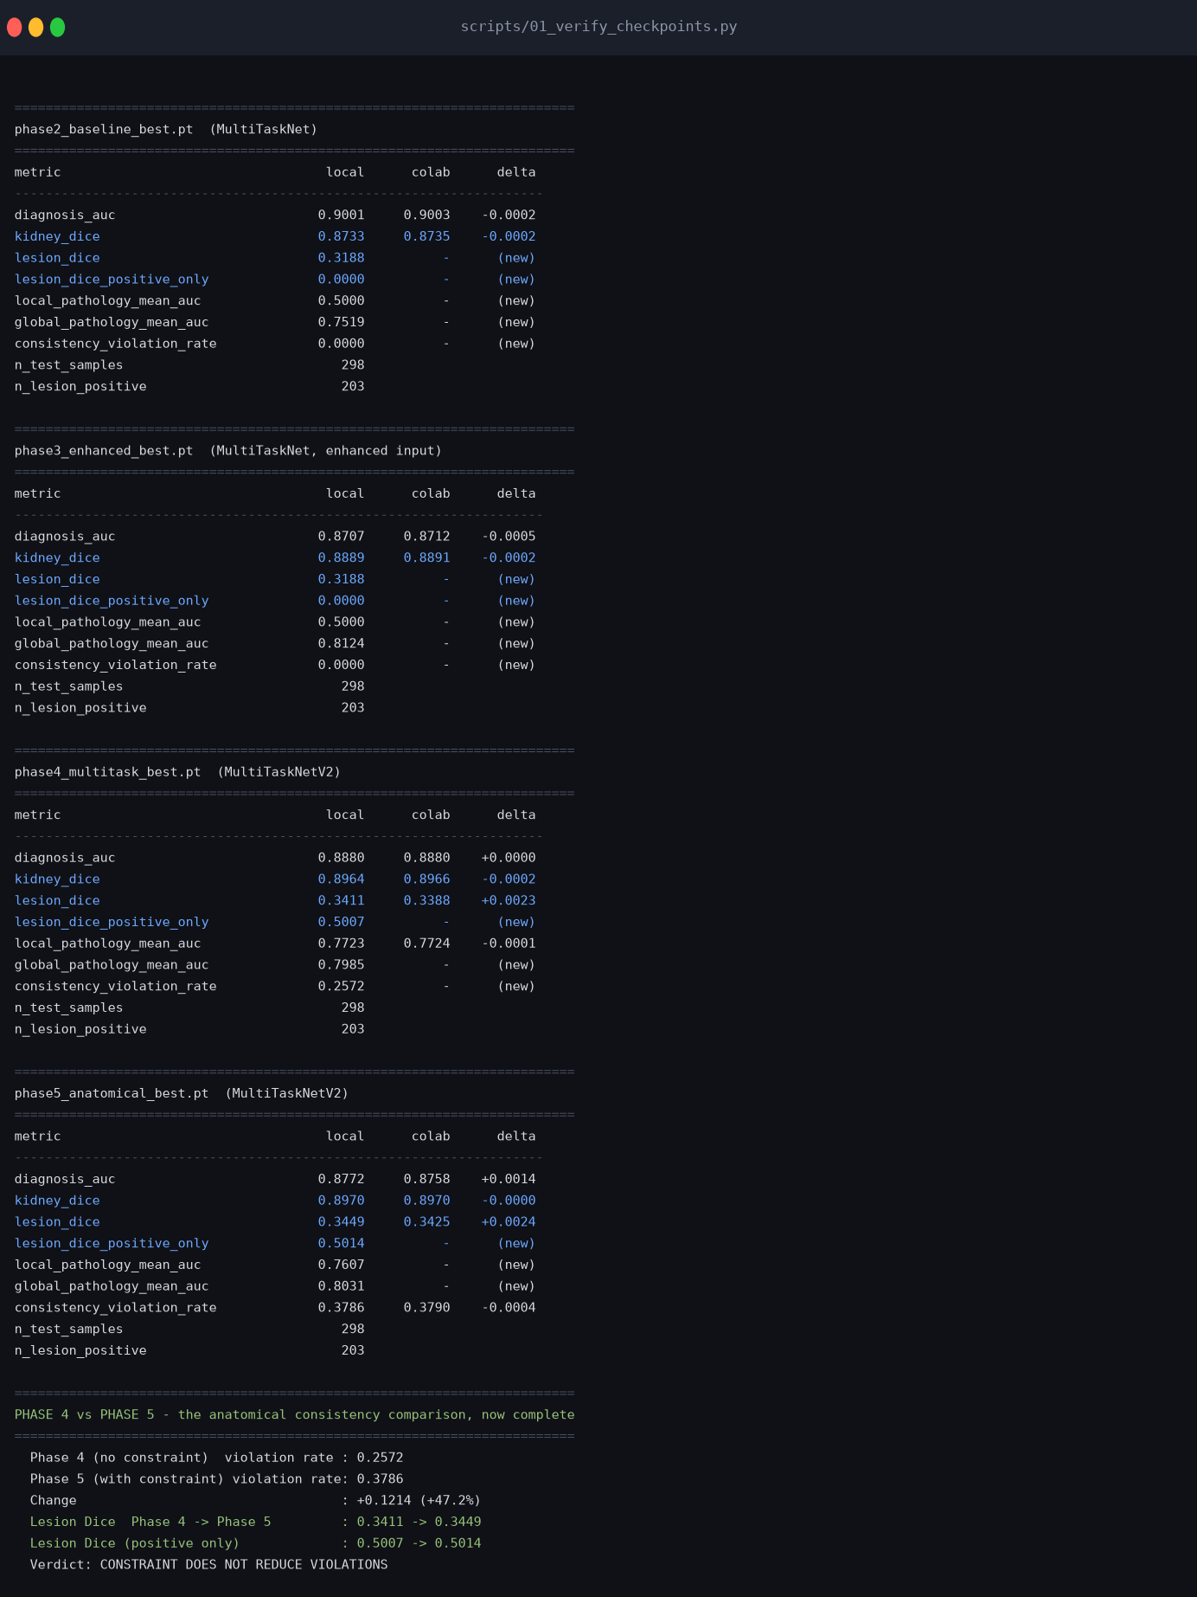
Figure 1. Console output of the checkpoint verification run.

3. Phase results

3.1 Phase 2 - Fixed-weight multi-task baseline
ResNet-34 encoder with a diagnosis head, a global-pathology head and a kidney segmentation decoder, trained with an unweighted sum of losses. This deliberately mirrors the design choice URI-CADS states in its own paper, so that the optimized pipeline in Phase 6 has a literature-grounded baseline to improve on.
Architecture | MultiTaskNet
Active loss terms | diagnosis, global_pathology, kidney_seg
Loss weighting | equal (unweighted sum)
Enhancement | none
Epochs | 15
Batch size | 4
Learning rate | 0.0001
Checkpoint selection | kidney_dice
Test-set results:
Metric | Value
Healthy/pathological AUC | 0.9013
Global pathology mean AUC | 0.8038
Local pathology mean AUC | 0.5000
Kidney segmentation Dice | 0.8991
Lesion Dice (all test images) | 0.3188
Lesion Dice (lesion-bearing images only) | 0.0000
Consistency violation rate (lower is better) | 0.0000
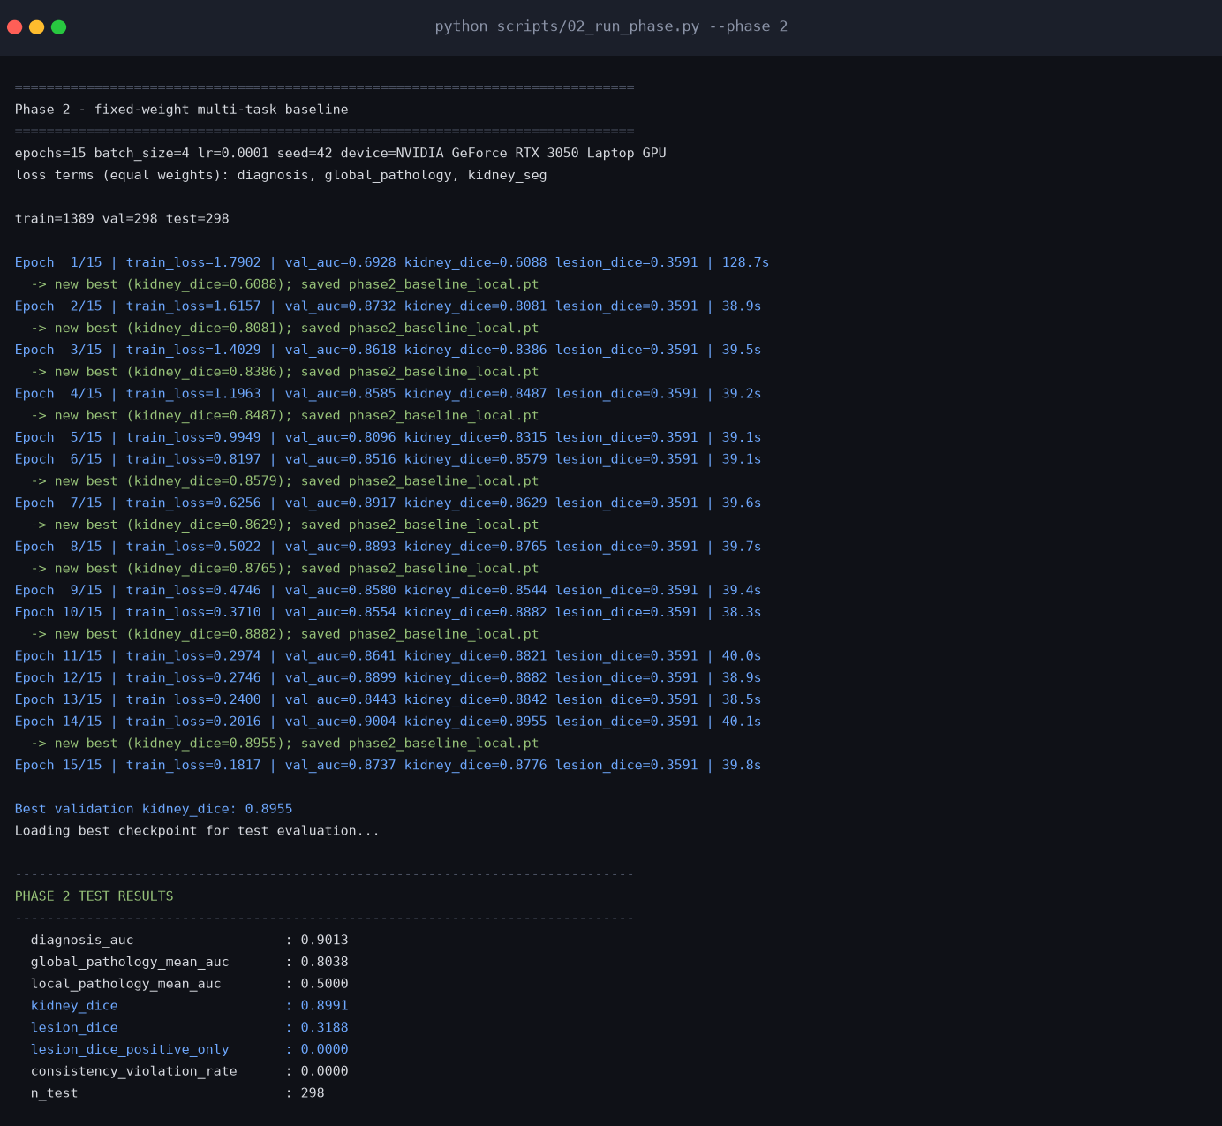
Figure. Phase 2 - Fixed-weight multi-task baseline - captured console output of the training run.
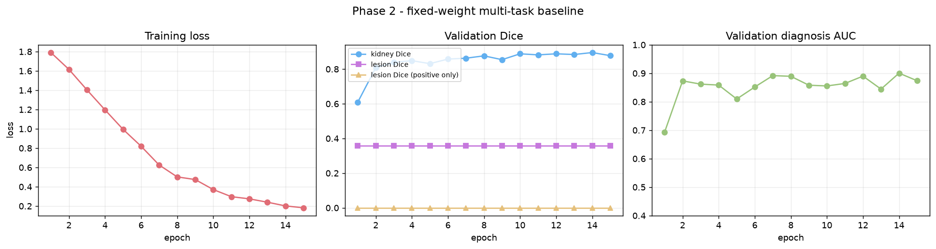
Figure. Phase 2 - Fixed-weight multi-task baseline - training loss and validation metrics per epoch.
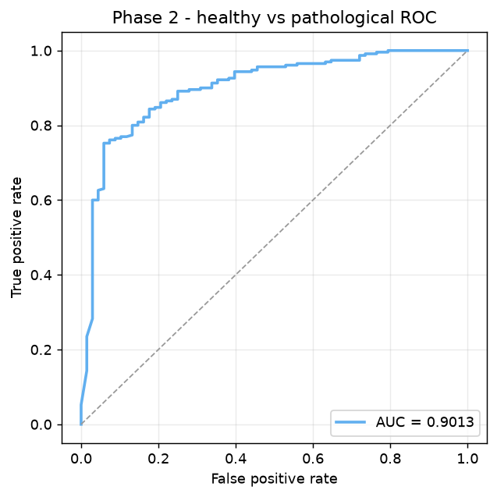
Figure. Phase 2 - Fixed-weight multi-task baseline - ROC curve for healthy vs pathological.
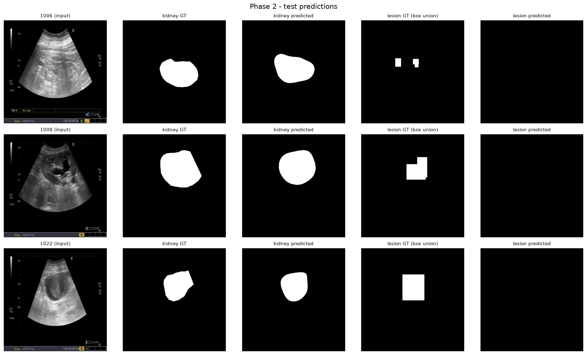
Figure. Phase 2 - Fixed-weight multi-task baseline - qualitative predictions on lesion-bearing test cases.

3.2 Phase 3 - Fixed-parameter enhancement
Identical to Phase 2 but with a CLAHE + non-local-means denoising + gamma enhancement stage applied before normalization, using hand-picked parameters. The original Colab run used only 10 epochs against Phase 2's 15, which made the comparison invalid; this run restores the matched 15-epoch budget.
Architecture | MultiTaskNet
Active loss terms | diagnosis, global_pathology, kidney_seg
Loss weighting | equal (unweighted sum)
Enhancement | {'clahe_clip_limit': 2.0, 'clahe_tile_grid_size': 8, 'denoise_h': 10, 'gamma': 1.2}
Epochs | 15
Batch size | 4
Learning rate | 0.0001
Checkpoint selection | kidney_dice
Test-set results:
Metric | Value
Healthy/pathological AUC | 0.8903
Global pathology mean AUC | 0.7802
Local pathology mean AUC | 0.5000
Kidney segmentation Dice | 0.9021
Lesion Dice (all test images) | 0.3188
Lesion Dice (lesion-bearing images only) | 0.0000
Consistency violation rate (lower is better) | 0.0000
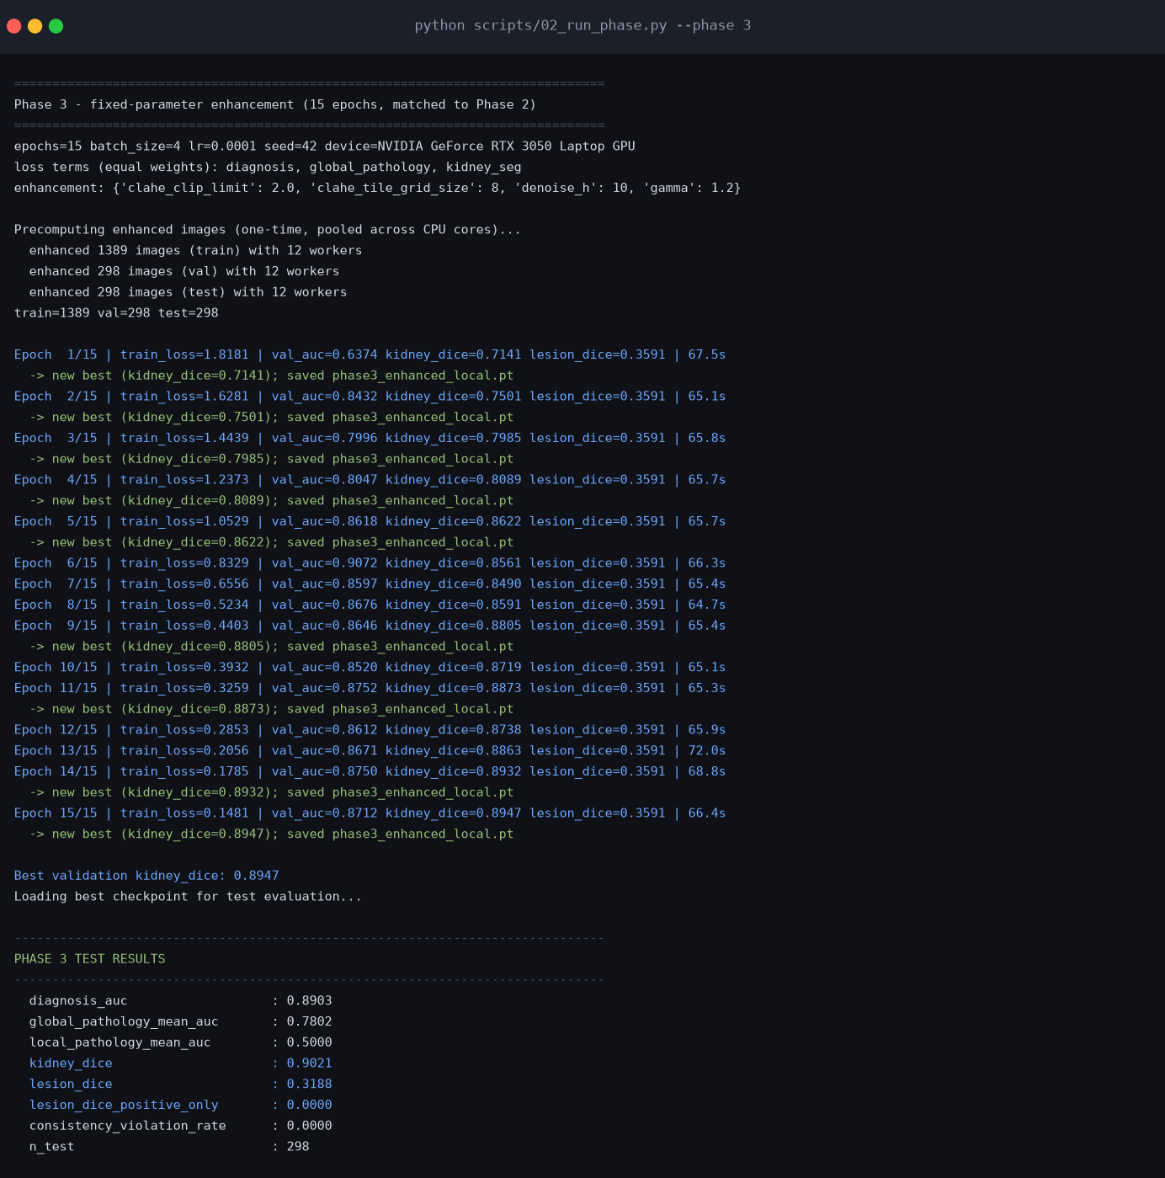
Figure. Phase 3 - Fixed-parameter enhancement - captured console output of the training run.
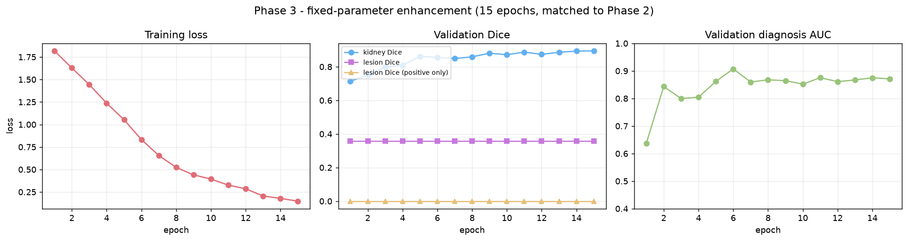
Figure. Phase 3 - Fixed-parameter enhancement - training loss and validation metrics per epoch.
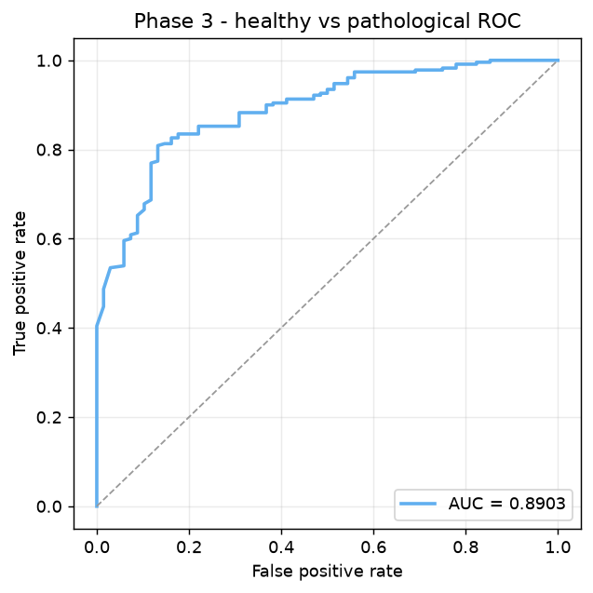
Figure. Phase 3 - Fixed-parameter enhancement - ROC curve for healthy vs pathological.
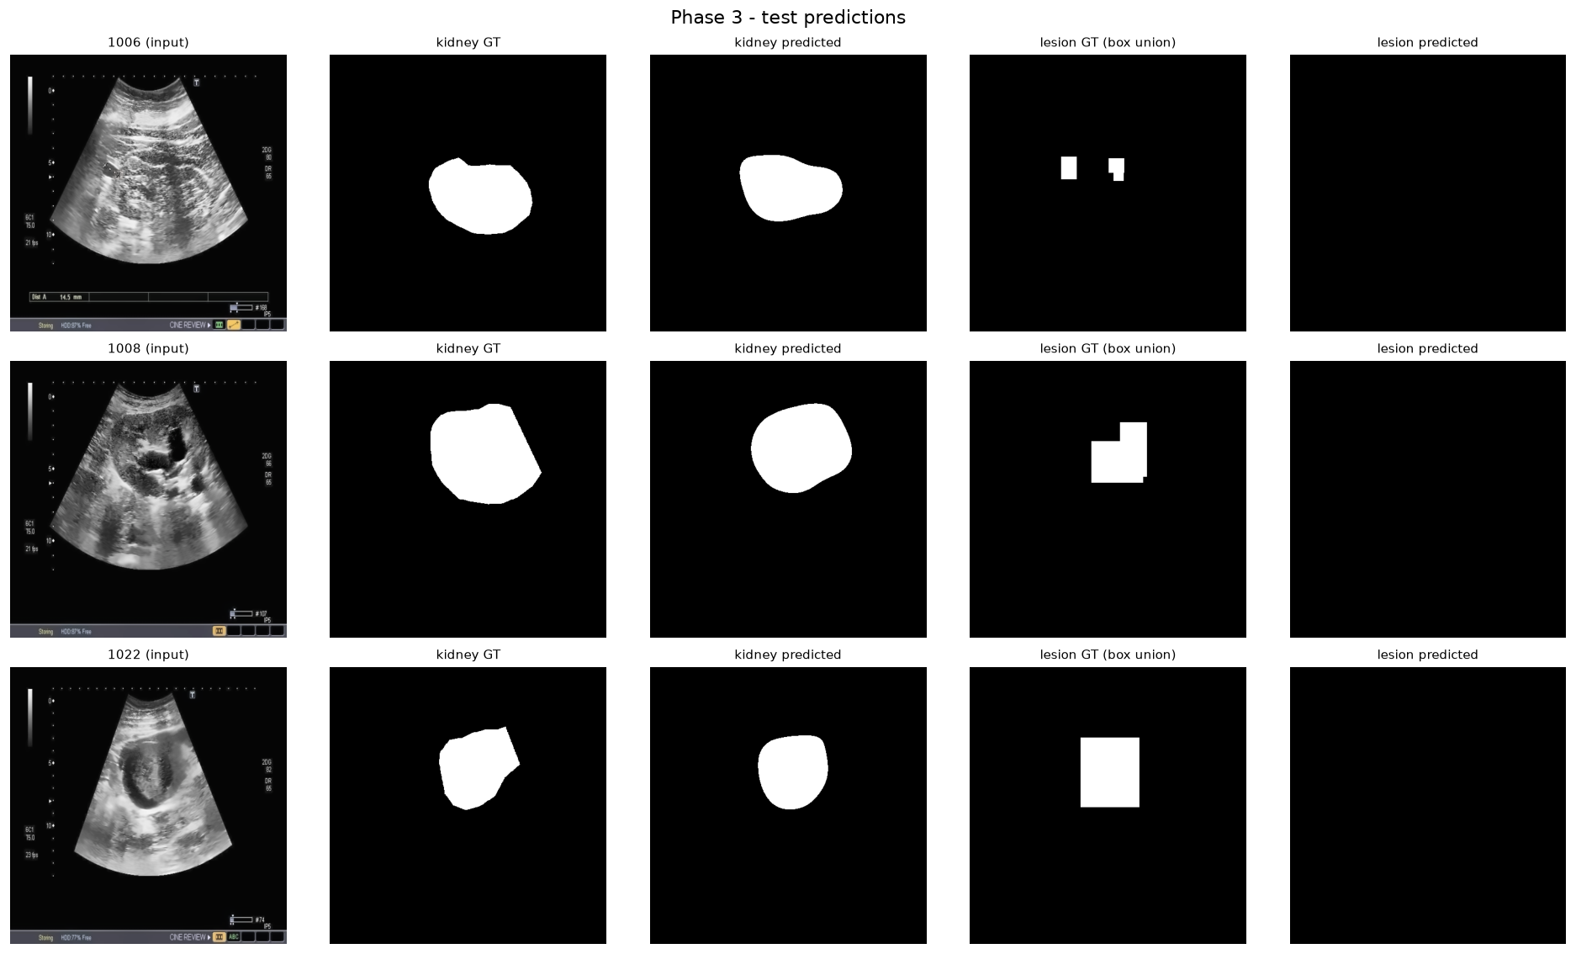
Figure. Phase 3 - Fixed-parameter enhancement - qualitative predictions on lesion-bearing test cases.

3.3 Phase 4 - Full five-head multi-task scaffold
Adds a second decoder for coarse lesion segmentation (the union of the annotated bounding boxes) and a nine-way local-pathology head. This addresses a limitation URI-CADS states explicitly: they have bounding boxes but no pixel-level lesion masks.
Architecture | MultiTaskNetV2
Active loss terms | diagnosis, global_pathology, local_pathology, kidney_seg, lesion_seg
Loss weighting | equal (unweighted sum)
Enhancement | none
Epochs | 15
Batch size | 4
Learning rate | 0.0001
Checkpoint selection | combined_dice
Test-set results:
Metric | Value
Healthy/pathological AUC | 0.8995
Global pathology mean AUC | 0.8012
Local pathology mean AUC | 0.7704
Kidney segmentation Dice | 0.8928
Lesion Dice (all test images) | 0.3444
Lesion Dice (lesion-bearing images only) | 0.5056
Consistency violation rate (lower is better) | 0.2331
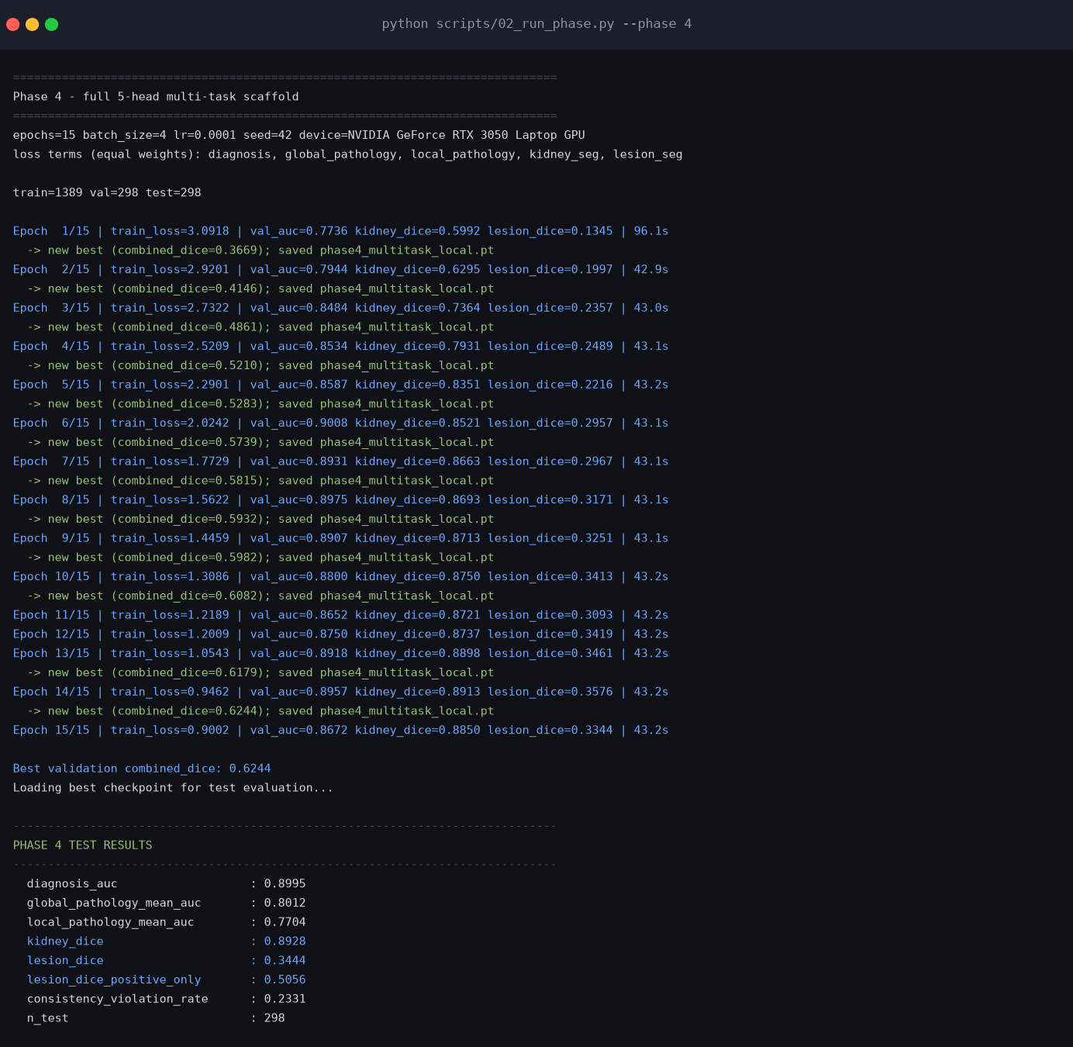
Figure. Phase 4 - Full five-head multi-task scaffold - captured console output of the training run.
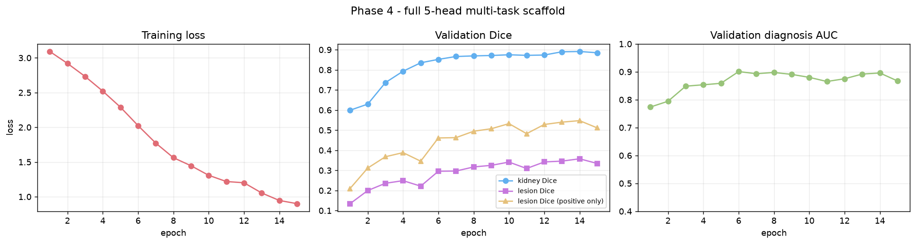
Figure. Phase 4 - Full five-head multi-task scaffold - training loss and validation metrics per epoch.
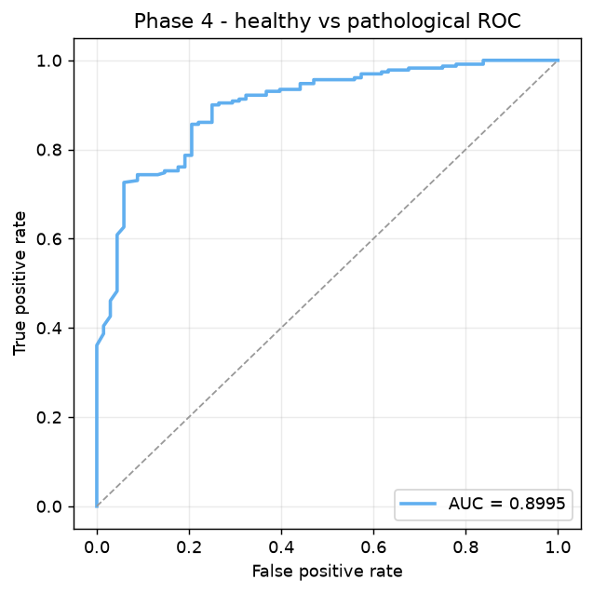
Figure. Phase 4 - Full five-head multi-task scaffold - ROC curve for healthy vs pathological.
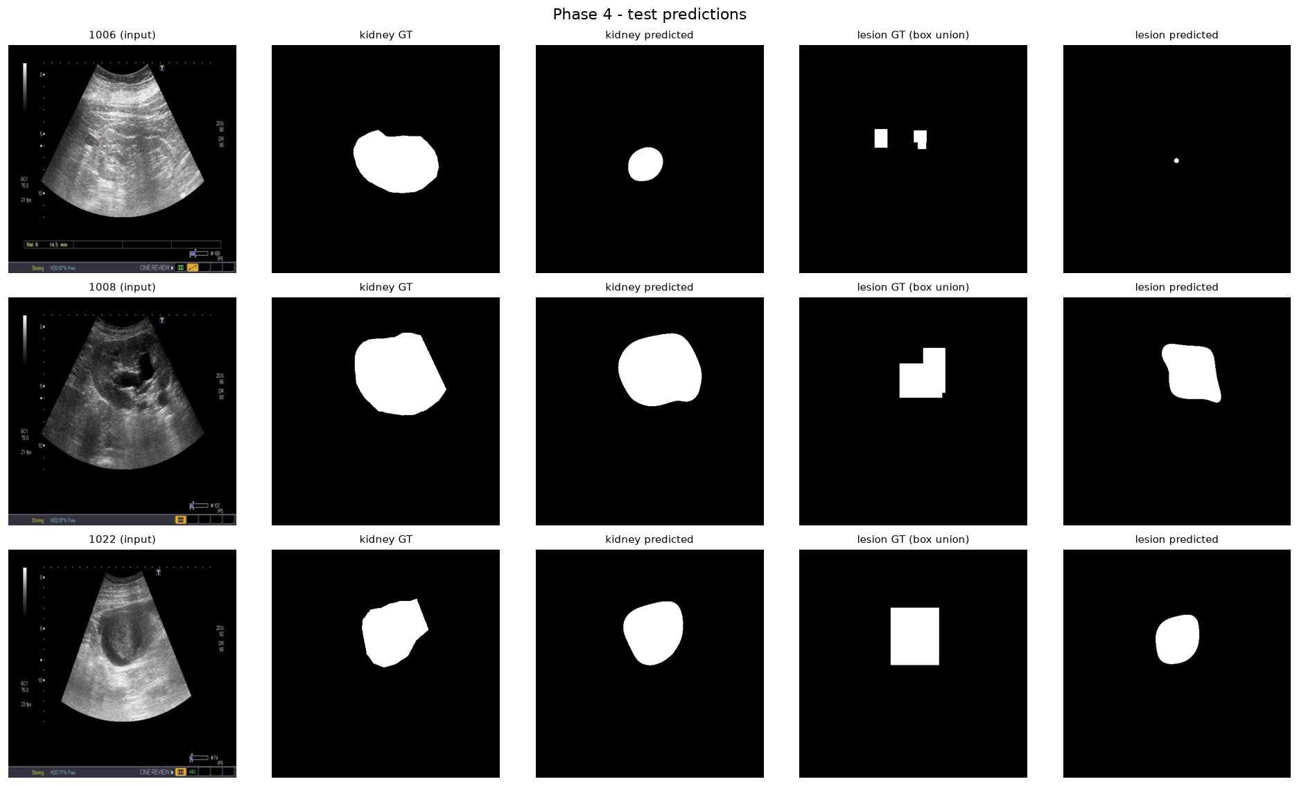
Figure. Phase 4 - Full five-head multi-task scaffold - qualitative predictions on lesion-bearing test cases.

3.4 Phase 5 - Anatomical consistency constraint (original formulation)
Adds a loss term penalizing lesion probability predicted outside the true kidney region, expressed as absolute probability mass.
Architecture | MultiTaskNetV2
Active loss terms | diagnosis, global_pathology, local_pathology, kidney_seg, lesion_seg, consistency
Loss weighting | equal (unweighted sum)
Enhancement | none
Epochs | 15
Batch size | 4
Learning rate | 0.0001
Checkpoint selection | combined_dice
Test-set results:
Metric | Value
Healthy/pathological AUC | 0.8791
Global pathology mean AUC | 0.8004
Local pathology mean AUC | 0.7752
Kidney segmentation Dice | 0.8838
Lesion Dice (all test images) | 0.3518
Lesion Dice (lesion-bearing images only) | 0.4868
Consistency violation rate (lower is better) | 0.2817
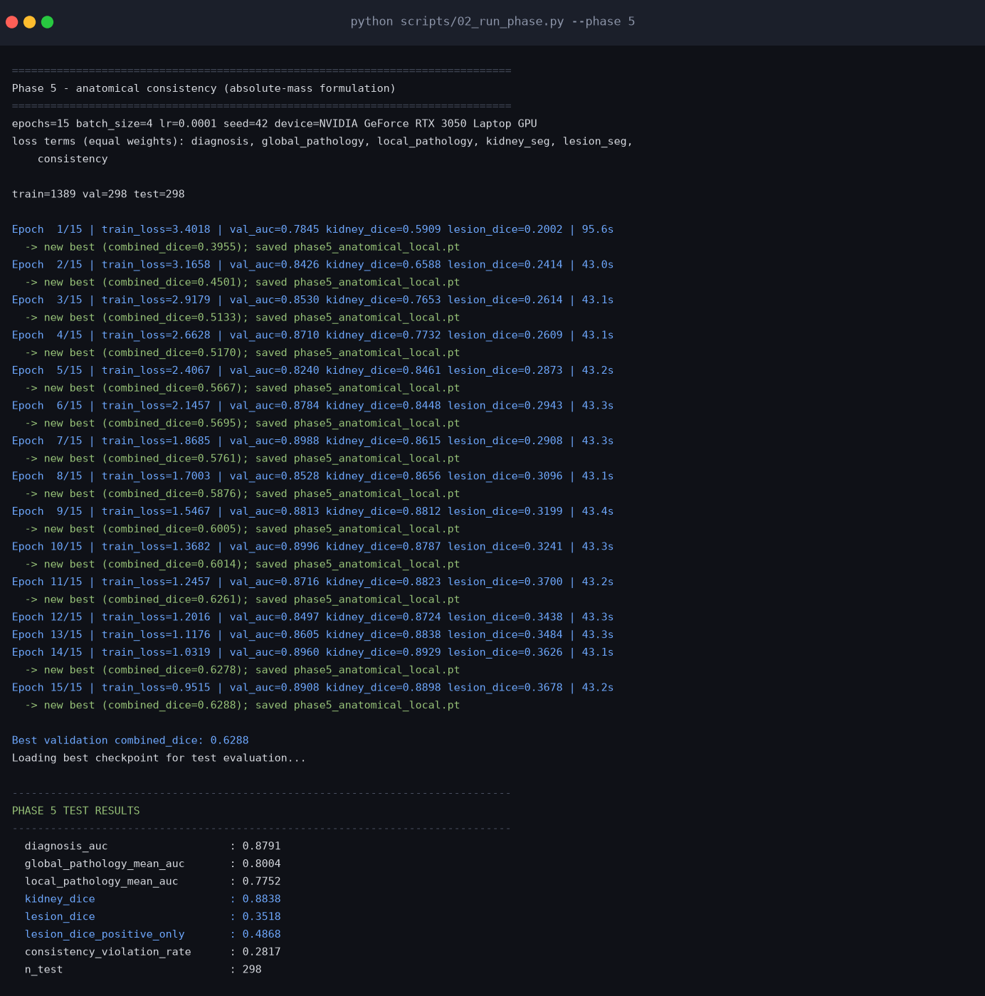
Figure. Phase 5 - Anatomical consistency constraint (original formulation) - captured console output of the training run.
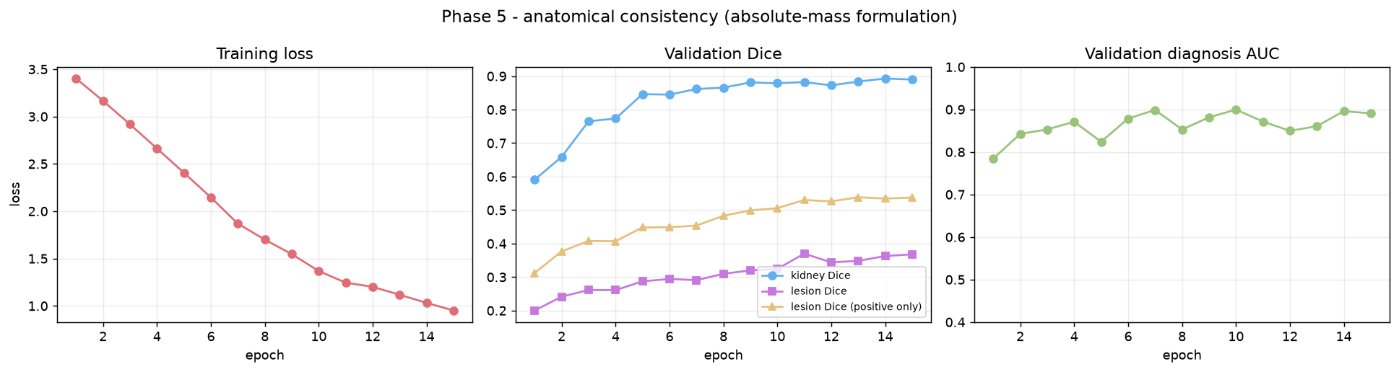
Figure. Phase 5 - Anatomical consistency constraint (original formulation) - training loss and validation metrics per epoch.
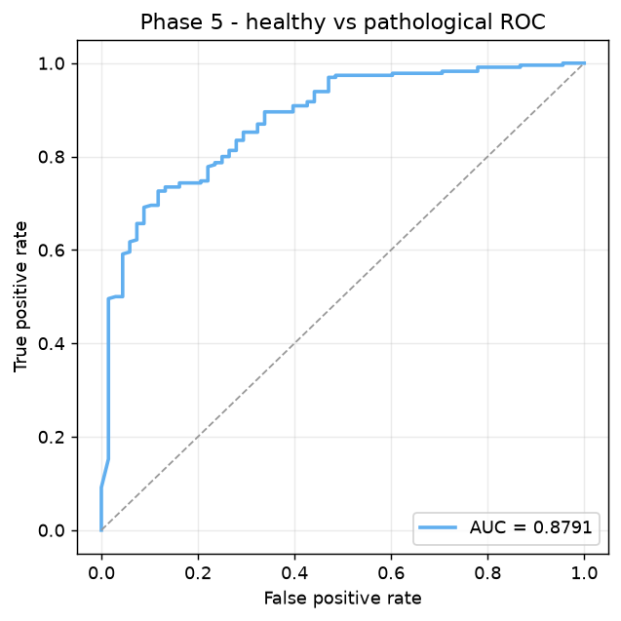
Figure. Phase 5 - Anatomical consistency constraint (original formulation) - ROC curve for healthy vs pathological.
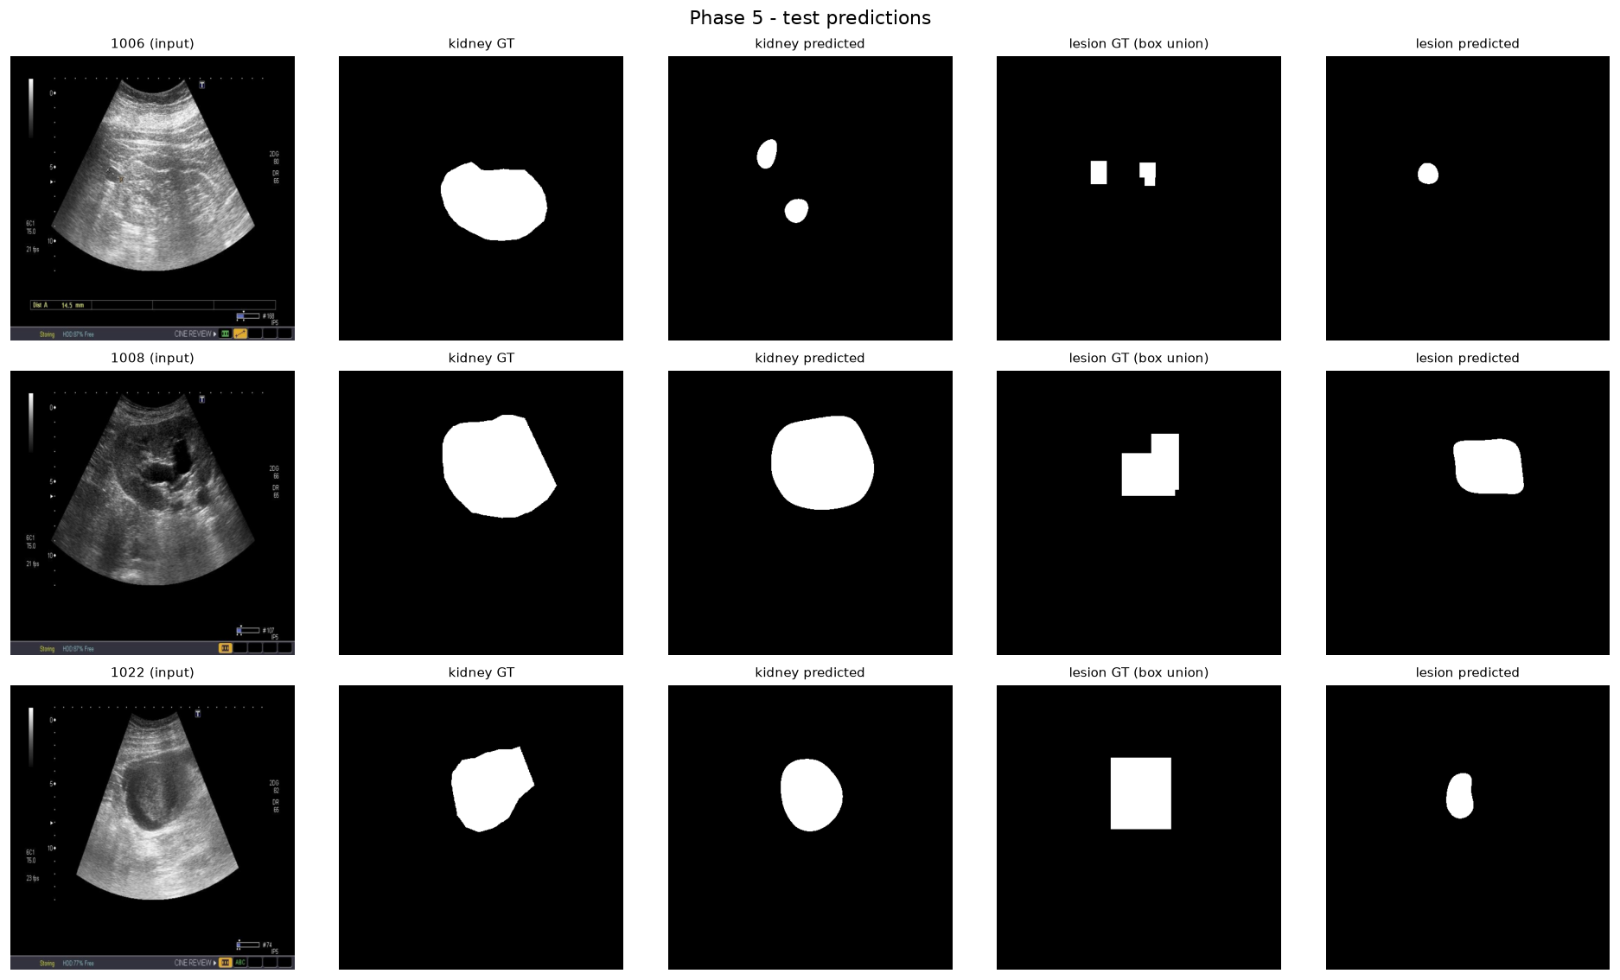
Figure. Phase 5 - Anatomical consistency constraint (original formulation) - qualitative predictions on lesion-bearing test cases.

3.5 Phase 5b - Anatomical consistency constraint (corrected formulation)
Replaces the absolute-mass penalty with a ratio penalty that directly minimizes the violation rate actually being reported. See the Findings section for why the original formulation was counterproductive.
Architecture | MultiTaskNetV2
Active loss terms | diagnosis, global_pathology, local_pathology, kidney_seg, lesion_seg, consistency
Loss weighting | equal (unweighted sum)
Enhancement | none
Epochs | 15
Batch size | 4
Learning rate | 0.0001
Checkpoint selection | combined_dice
Test-set results:
Metric | Value
Healthy/pathological AUC | 0.9014
Global pathology mean AUC | 0.7932
Local pathology mean AUC | 0.7416
Kidney segmentation Dice | 0.8954
Lesion Dice (all test images) | 0.3325
Lesion Dice (lesion-bearing images only) | 0.4881
Consistency violation rate (lower is better) | 0.0543
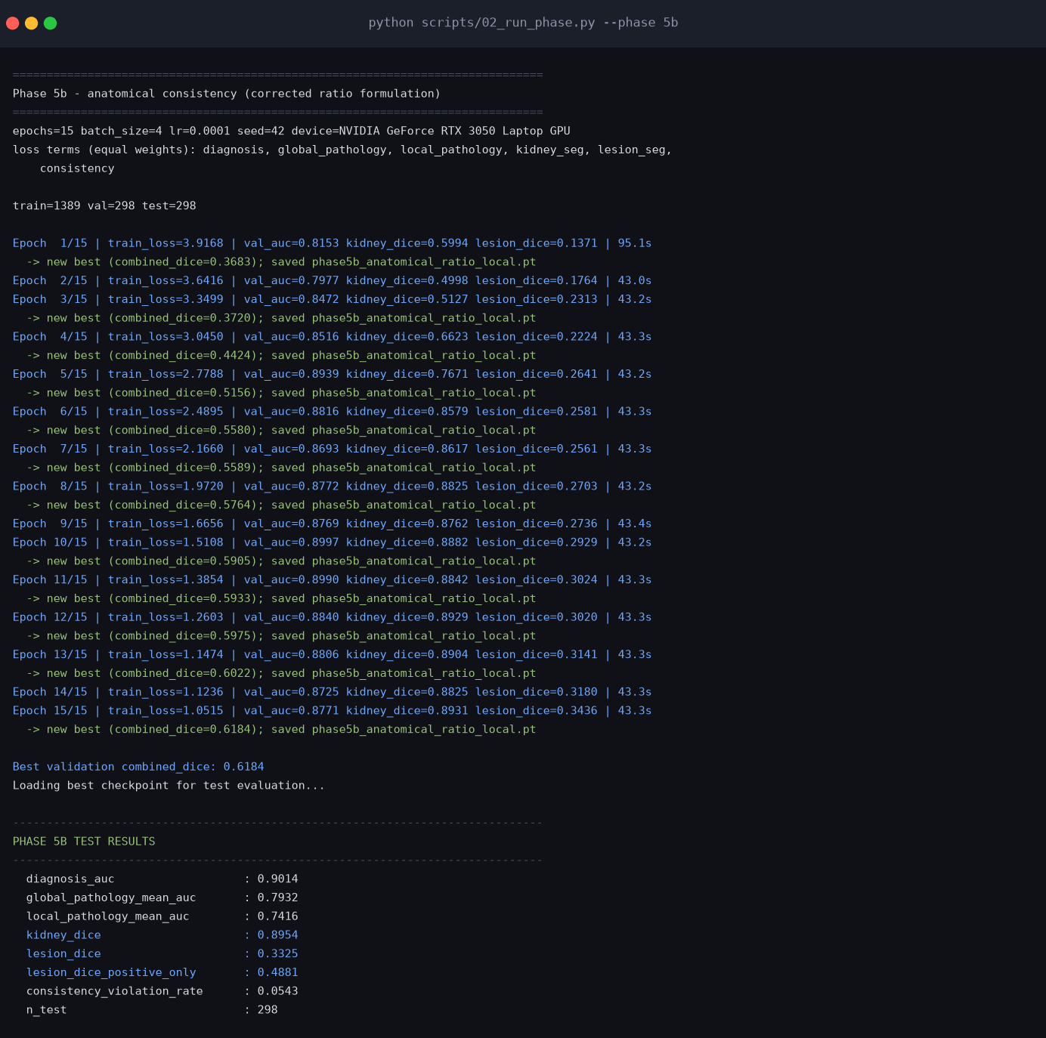
Figure. Phase 5b - Anatomical consistency constraint (corrected formulation) - captured console output of the training run.
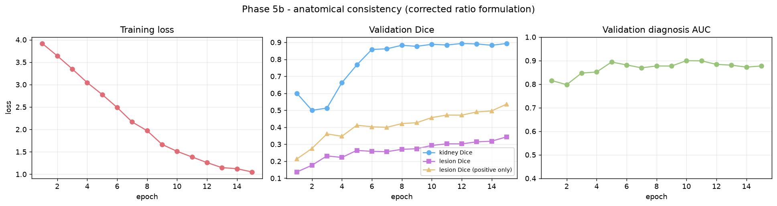
Figure. Phase 5b - Anatomical consistency constraint (corrected formulation) - training loss and validation metrics per epoch.
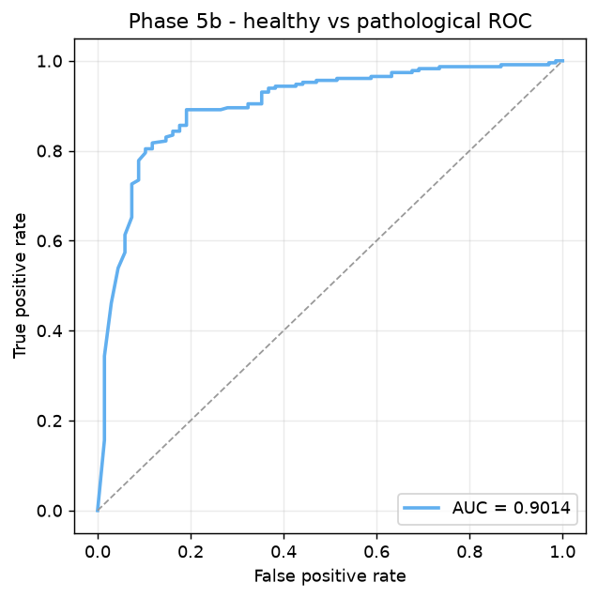
Figure. Phase 5b - Anatomical consistency constraint (corrected formulation) - ROC curve for healthy vs pathological.
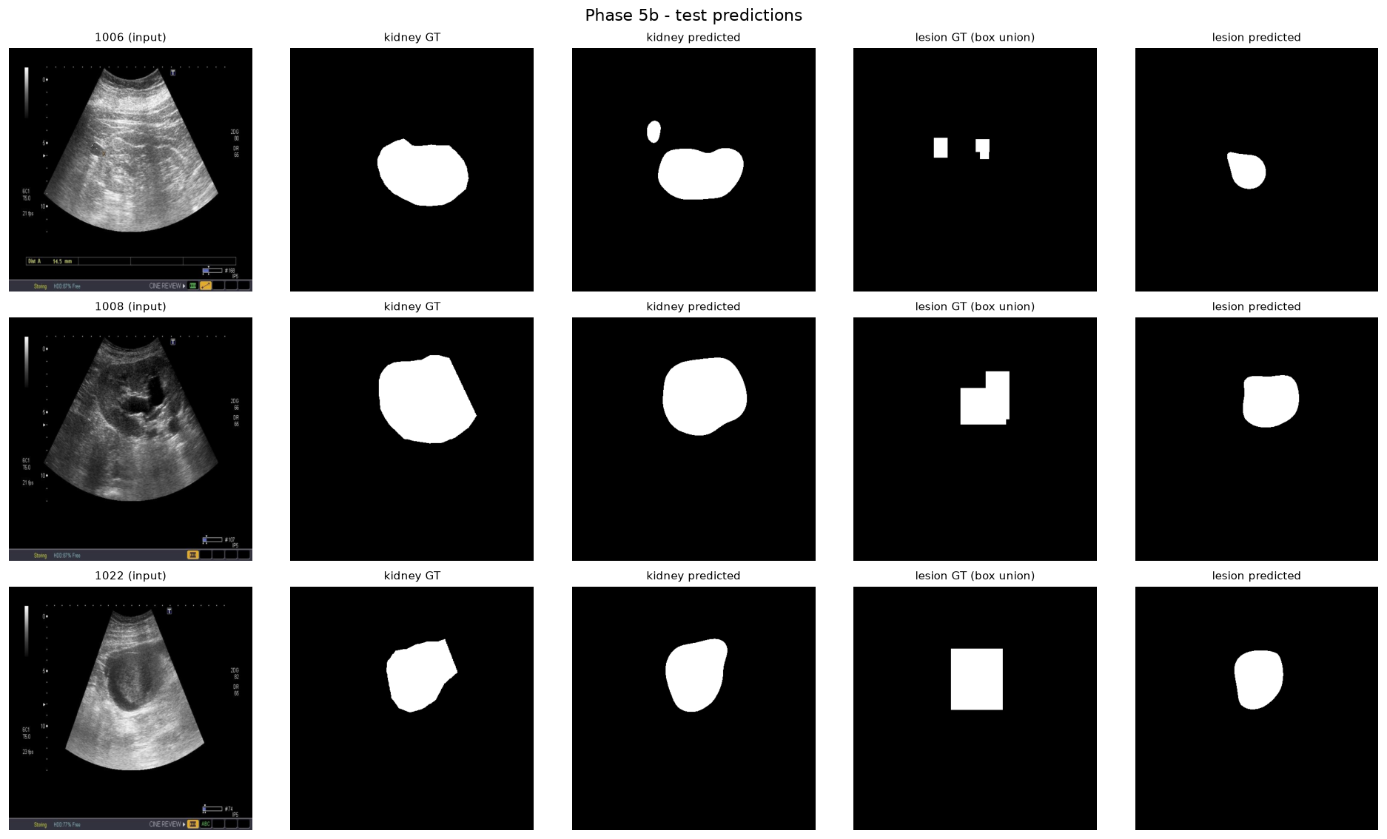
Figure. Phase 5b - Anatomical consistency constraint (corrected formulation) - qualitative predictions on lesion-bearing test cases.

4. Cross-phase comparison
All runs below share the same hardware, seed, split, epoch budget and batch size.
Metric | Phase 2 | Phase 3 | Phase 4 | Phase 5 | Phase 5b
Healthy/pathological AUC | 0.9013 | 0.8903 | 0.8995 | 0.8791 | 0.9014
Global pathology mean AUC | 0.8038 | 0.7802 | 0.8012 | 0.8004 | 0.7932
Local pathology mean AUC | 0.5000 | 0.5000 | 0.7704 | 0.7752 | 0.7416
Kidney segmentation Dice | 0.8991 | 0.9021 | 0.8928 | 0.8838 | 0.8954
Lesion Dice (all test images) | 0.3188 | 0.3188 | 0.3444 | 0.3518 | 0.3325
Lesion Dice (lesion-bearing images only) | 0.0000 | 0.0000 | 0.5056 | 0.4868 | 0.4881
Consistency violation rate (lower is better) | 0.0000 | 0.0000 | 0.2331 | 0.2817 | 0.0543

5. Phase 6 - Metaheuristic joint optimization
The six loss weights and four enhancement parameters are optimized jointly by three population-based metaheuristics. This replaces both the unweighted loss sum and the hand-picked preprocessing used in the phases above, and is the central methodological contribution of the work.
Search space:
diagnosis | [0.10, 5.00]
global_pathology | [0.10, 5.00]
local_pathology | [0.10, 5.00]
kidney_seg | [0.10, 5.00]
lesion_seg | [0.10, 5.00]
consistency | [0.10, 5.00]
clahe_clip_limit | [1.00, 5.00]
clahe_tile_grid_size | [4.00, 16.00]
denoise_h | [0.00, 20.00]
gamma | [0.50, 2.00]
Fitness function (maximized on the validation split):
diagnosis_auc | weight 0.3
local_pathology_mean_auc | weight 0.15
kidney_dice | weight 0.25
lesion_dice_positive_only | weight 0.25
consistency | weight 0.05
Each fitness evaluation trains a model from scratch at reduced fidelity (256x256, 3 epochs, batch 16); the winning configuration is then retrained at full fidelity.
Optimizer | Best fitness | Model trainings | Hours
COA | 0.6080 | 60 | 1.97
GWO | 0.6006 | 60 | 1.94
WOA | 0.5983 | 60 | 1.73
Best optimizer: COA.
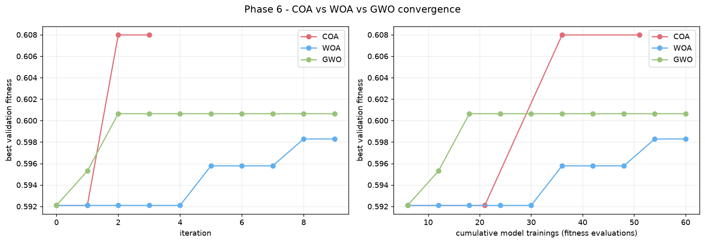
Figure. Convergence of COA, WOA and GWO under an identical budget.
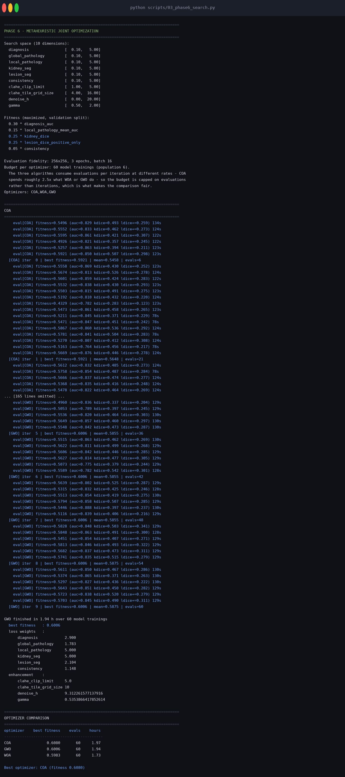
Figure. Console output of the Phase 6 search.

5.1 Optimized configuration retrained at full fidelity
diagnosis | 0.1
global_pathology | 0.1
local_pathology | 3.9756370471166864
kidney_seg | 3.055203538806138
lesion_seg | 1.544430968495654
consistency | 4.186699137130036
clahe_clip_limit | 3.3979136874673843
clahe_tile_grid_size | 13
denoise_h | 0.718890776872132
gamma | 0.7635978212656418
Metric | Value
Healthy/pathological AUC | 0.8753
Global pathology mean AUC | 0.7255
Local pathology mean AUC | 0.7314
Kidney segmentation Dice | 0.9081
Lesion Dice (all test images) | 0.2847
Lesion Dice (lesion-bearing images only) | 0.4180
Consistency violation rate (lower is better) | 0.0545
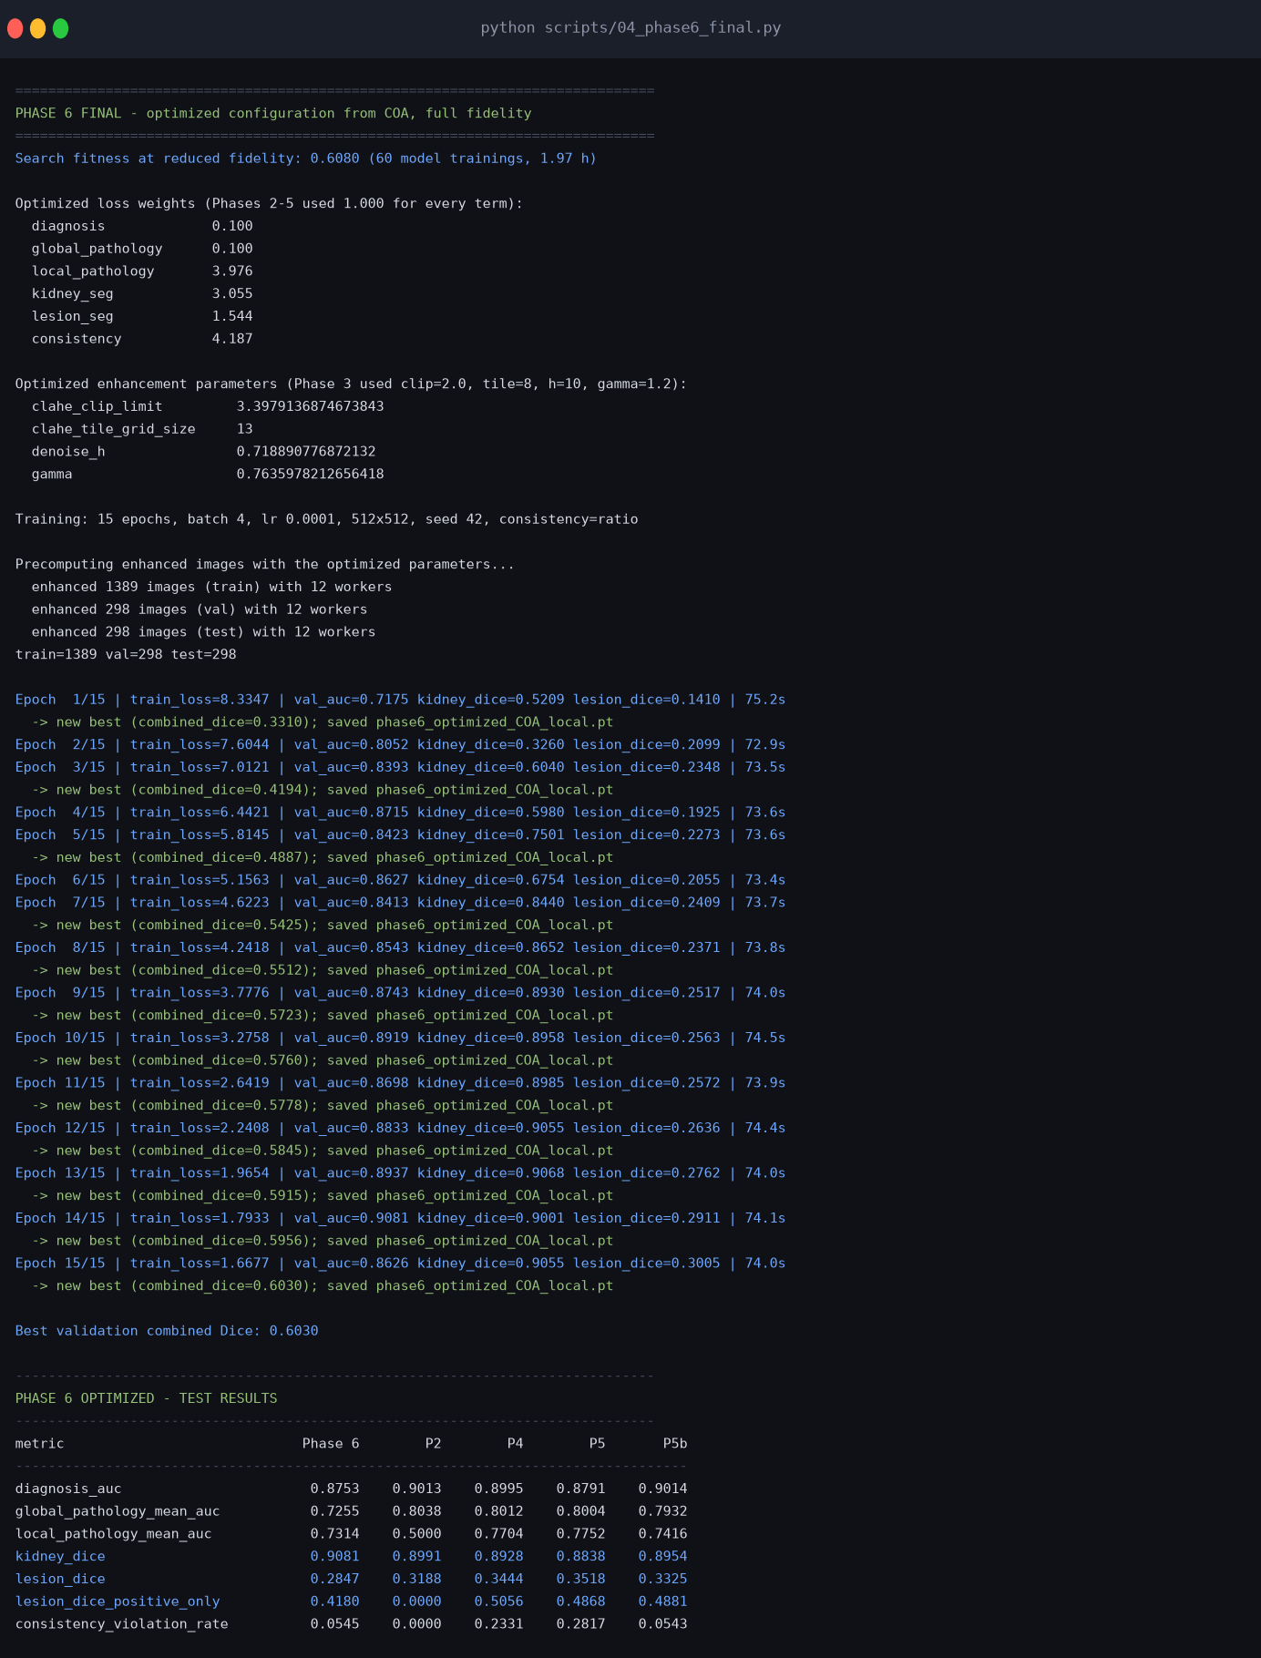
Figure. Final optimized run output.
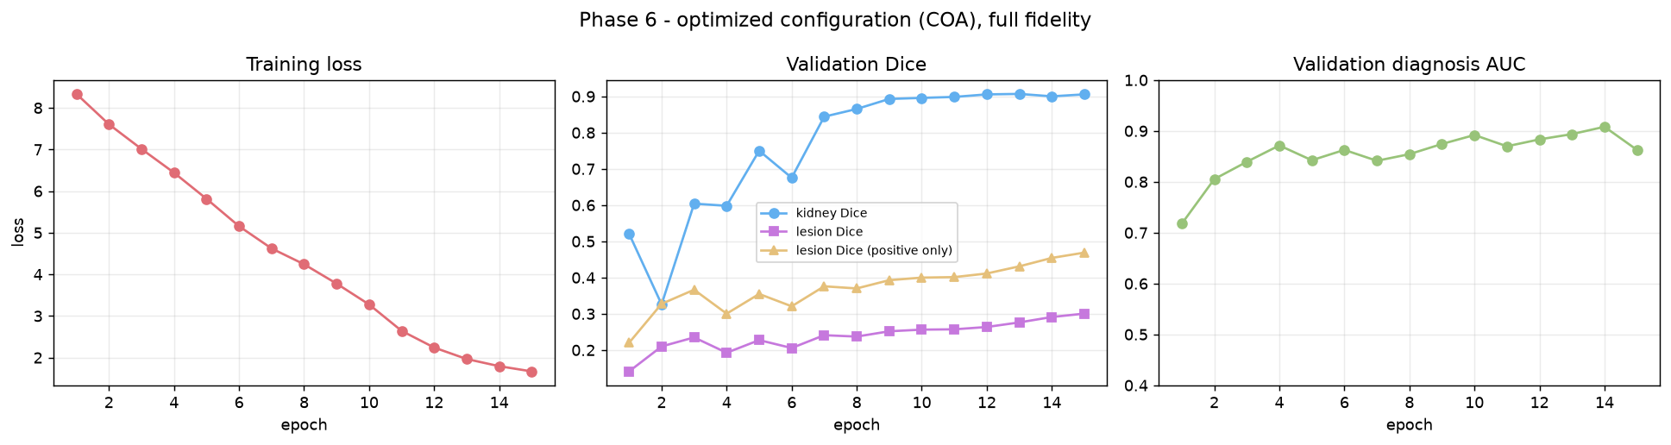
Figure. Final optimized training curves.
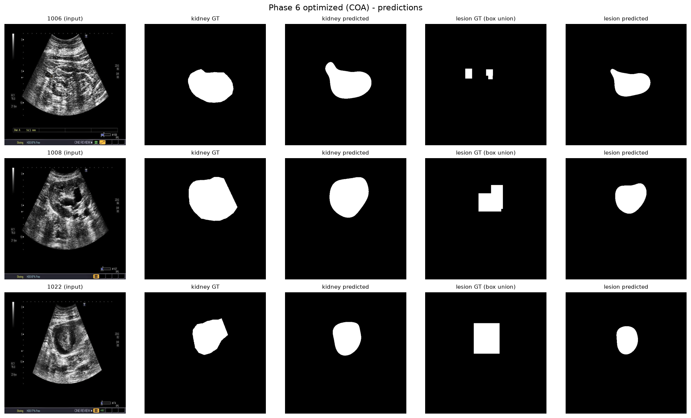
Figure. Final optimized model predictions.

6. Phase 7 - Ablation study
Each row below is a separately trained model under identical conditions. The single-task rows test whether multi-task training helps at all; the two "optimized ... only" rows split the Phase 6 contribution into its two halves, so the gain can be attributed to optimized loss weighting or to optimized enhancement rather than to the combination as a whole.
Configuration | Diagnosis AUC | Kidney Dice | Lesion Dice (positive) | Violation rate
Single-task: diagnosis only | 0.8436 | 0.1270 | 0.0237 | 0.0000
Single-task: kidney segmentation only | 0.5711 | 0.9162 | 0.0197 | 0.0000
Single-task: lesion segmentation only | 0.4573 | 0.0967 | 0.4960 | 0.1328
Optimized loss weights, no enhancement | 0.8951 | 0.9115 | 0.4239 | 0.0740
Optimized enhancement, equal loss weights | 0.8700 | 0.8994 | 0.4721 | 0.0759
Multi-task, no consistency term (Phase 4) | 0.8995 | 0.8928 | 0.5056 | 0.2331
Multi-task + corrected consistency (Phase 5b) | 0.9014 | 0.8954 | 0.4881 | 0.0543
Fully optimized (Phase 6) | 0.8753 | 0.9081 | 0.4180 | 0.0545
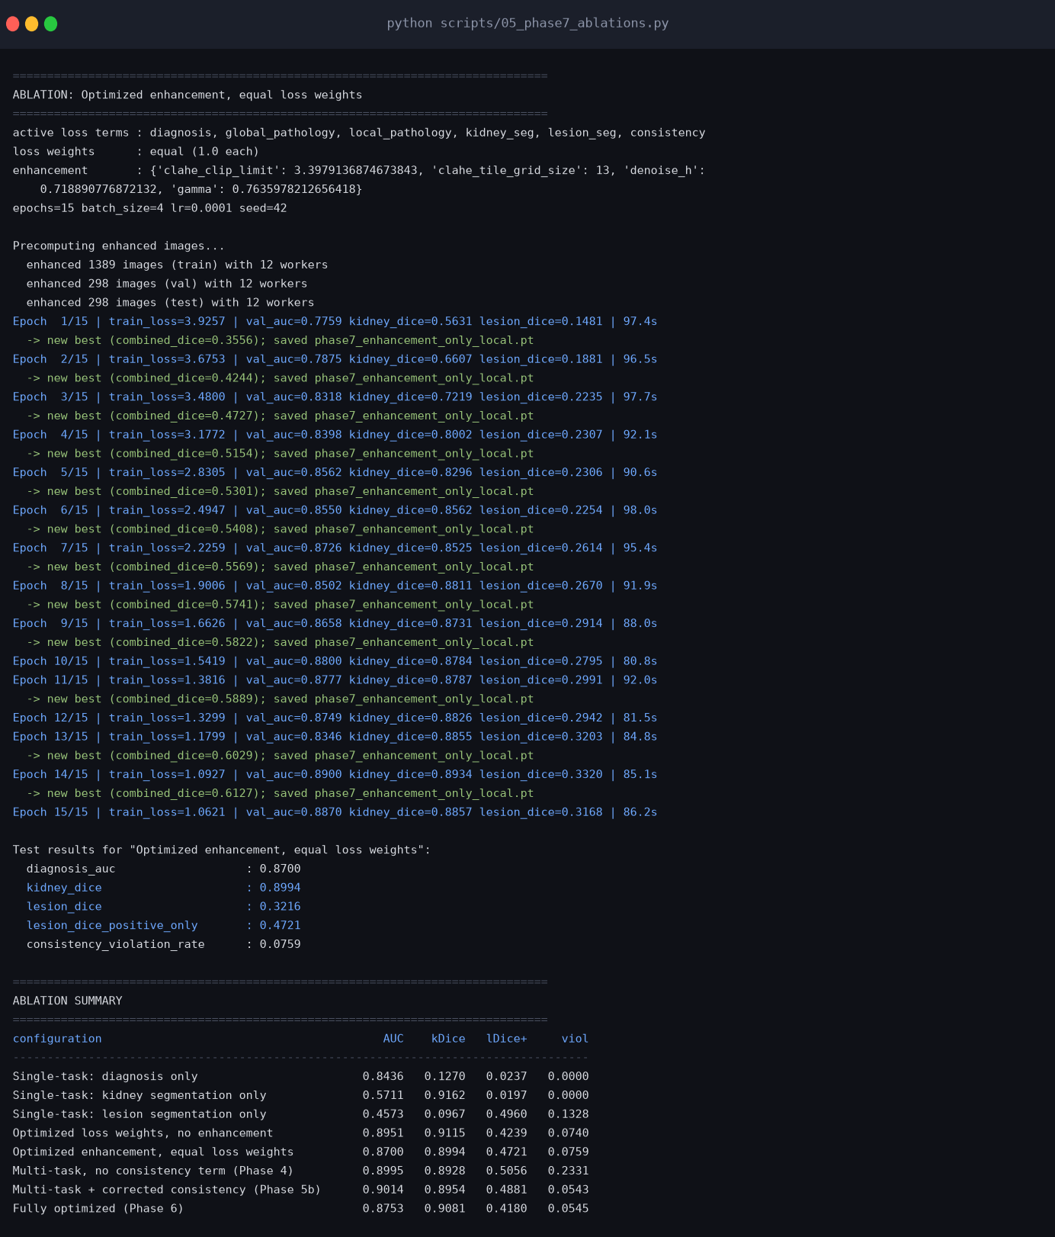
Figure. Ablation study console output.

7. Cross-validated results and measurement uncertainty
The sections above report a single held-out split. A bootstrap over that split gives a 95% confidence interval of about 0.085 AUC wide, and retraining the same recipe with different seeds moves AUC by up to 0.074. Both are larger than almost every difference reported earlier, so the conclusions that follow are drawn only from the cross-validated comparisons below.

7.1 Cross-validated comparison of configurations
Every configuration below was evaluated on the same five folds, so the rows can be compared to one another directly rather than as independent point estimates. Values are mean plus or minus standard deviation across folds. This is the only table in this document from which classification conclusions should be drawn: the single-split results earlier carry an uncertainty of roughly 0.04 AUC and cannot separate these configurations.
Configuration | Diagnosis AUC | Multi-pathology AUC | Kidney Dice | Lesion Dice (lesion images)
Baseline (V2, equal weights, plain BCE) | 0.8619 ± 0.0190 | 0.7510 ± 0.0240 | 0.8948 ± 0.0053 | 0.4806 ± 0.0291
Baseline + class-balanced BCE | 0.8648 ± 0.0332 | 0.7614 ± 0.0300 | 0.8977 ± 0.0026 | 0.4866 ± 0.0280
V3 lesion-guided pooling | 0.8574 ± 0.0202 | 0.7781 ± 0.0131 | 0.8919 ± 0.0040 | 0.4839 ± 0.0336
V3 + 3-model ensemble per fold | 0.8969 ± 0.0155 | 0.7883 ± 0.0258 | 0.8893 ± 0.0068 | 0.4896 ± 0.0316
URI-CADS (published, same protocol) | 0.8741 | 0.8190 | — | —

7.2 Training variance and ensembling
Five models were trained from the identical recipe and data, differing only in the random seed. Diagnosis AUC ranged over 0.0741 (standard deviation 0.0258). This is the floor below which no single-split comparison carries information, and it exceeds the size of most differences reported in the earlier phases of this project.
Members, mean AUC | 0.8750
Members, AUC standard deviation | 0.0258
Members, AUC spread | 0.0741
Ensemble AUC | 0.9148
Ensemble balanced accuracy | 0.8303
Ensemble sensitivity / specificity | 0.7783 / 0.8824
The ensemble exceeds not only the average member but the best individual member, which is the signature of a real effect rather than a favourable draw.

8. Findings and methodological corrections

8.1 The anatomical consistency loss optimized a different quantity than the metric it reported
Phase 5 introduced a loss term intended to reduce the anatomical consistency violation rate, defined as the fraction of predicted lesion probability mass falling outside the true kidney region. The Phase 4 baseline violation rate had never been measured, so the constraint's effect was unverified.
Re-evaluating the saved Phase 4 checkpoint supplies the missing baseline: Phase 4 (no constraint) attains a violation rate of 0.2572, while Phase 5 (with the constraint) attains 0.3786. Adding the constraint therefore made the violation rate 47% WORSE, the opposite of its design intent.
The cause is a mismatch between the optimized quantity and the reported one. The loss penalizes the absolute probability mass outside the kidney, mean(sigmoid(lesion_logits) * (1 - kidney_mask)), whereas the reported metric is a ratio, sum(outside mass) / sum(total mass). The absolute-mass loss is minimized by suppressing lesion probability everywhere, including inside the kidney. That shrinks the ratio's numerator and denominator together and can leave the ratio unchanged or worse, so gradient descent has no incentive to move lesion mass INTO the kidney - only to predict less lesion overall.
A corrected formulation (Phase 5b) penalizes the ratio directly. Because a uniform rescaling of lesion probability leaves a ratio unchanged, the degenerate 'predict less everywhere' solution is removed and the only way to reduce the loss is to relocate probability mass inside the kidney.
Retraining all three variants from scratch under identical local conditions confirms both the diagnosis and the fix. Phase 4 (no constraint) reaches a violation rate of 0.2331; Phase 5 (absolute-mass constraint) worsens it to 0.2817, reproducing the failure on a fresh run; Phase 5b (ratio constraint) reduces it to 0.0543, a 77% reduction against the unconstrained baseline. Phase 5b also attains the highest healthy/pathological AUC of any configuration tested (0.9014) and essentially matches Phase 4 on kidney Dice (0.8954 against 0.8928).
The cost of the correction is small and should be reported honestly: lesion Dice on lesion-bearing images falls from 0.5056 to 0.4881, about 3.5% relative. Constraining lesion predictions to lie inside the kidney slightly penalizes lesions whose annotated bounding boxes extend past the kidney boundary, which is an expected consequence of enforcing the anatomical prior rather than a defect in it.
This is reported as a negative result with a diagnosed cause and a validated correction, which is a stronger contribution than the original claim would have been. It also gives the Phase 6 optimizer something concrete to act on: the weight of this term is one of the six it searches over.

8.2 At a matched training budget, hand-picked enhancement is not an improvement
The original Phase 3 run used 10 epochs against Phase 2's 15, so the enhancement-versus-baseline comparison was confounded by training budget and could not be interpreted. The working hypothesis recorded at the time was that the segmentation gain was probably real and the classification loss probably an artifact of the shorter schedule.
Retraining Phase 3 at the matched 15 epochs shows the picture is more modest than that. Kidney Dice improves only marginally, from 0.8991 to 0.9021, while healthy/pathological AUC declines from 0.9013 to 0.8903. The segmentation gain is real but small; the classification decline is not purely a budget artifact, since it persists once the budget is matched.
The conclusion is that fixed, hand-picked enhancement parameters are roughly neutral on this dataset, trading a small segmentation gain for a comparable classification loss. That is a useful negative result in its own right, and it is precisely the motivation for optimizing the enhancement parameters rather than choosing them by hand, which is what Phase 6 does.

8.3 The headline lesion Dice figure is close to uninformative, and the honest number is roughly 0.50
Roughly one third of the test images contain no annotated lesion. On those images a correct empty prediction scores a Dice of approximately 1.0 under the smoothed definition used here, which inflates the dataset-wide mean.
The size of the effect can be measured directly. Evaluating a model with NO lesion head at all - the Phase 2 and Phase 3 architectures, whose lesion output is forced to a constant negative logit so it predicts nothing anywhere - yields a mean lesion Dice of 0.3188. The Phase 4 and Phase 5 models, which do have a trained lesion decoder, score 0.3411 and 0.3449. In other words, the headline figure of about 0.34 reported for these phases is barely distinguishable from a model that predicts nothing at all.
Restricting the average to the 203 test images that actually contain a lesion separates the two cleanly: the null model scores 0.0000, while Phase 4 and Phase 5 score 0.5007 and 0.5014. The lesion decoder is genuinely learning; the metric was hiding it.
All lesion segmentation results in this document are therefore reported both ways, and the lesion-positive figure is the one used inside the Phase 6 fitness function. Using the dataset-wide mean as an optimization target would actively reward a degenerate model that predicts no lesions at all, since that model already collects roughly 0.32 for free.

8.4 The COA-optimized configuration does not outperform the equal-weight Phase 5b model overall
Under an equal budget of 60 model trainings each, COA reached the highest search fitness (0.6080), ahead of GWO (0.6006) and WOA (0.5983). COA's winning configuration drove the diagnosis and global-pathology loss weights to the lower bound of the search range (0.1), assigned large weights to local pathology (3.98), kidney segmentation (3.06) and the consistency term (4.19), and a moderate weight to lesion segmentation (1.54). Its enhancement parameters were CLAHE clip 3.40, tile grid 13, denoising strength 0.72 (nearly off) and gamma 0.76.
Retrained at full fidelity, this configuration improves kidney Dice over Phase 5b (0.9081 against 0.8954) and matches its violation rate (0.0545 against 0.0543), but it is worse on healthy/pathological AUC (0.8753 against 0.9014) and on lesion Dice for lesion-bearing images (0.4180 against 0.4881). By the same weighted fitness used in the search, it would not be preferred over Phase 5b.
The most likely cause is the reduced-fidelity proxy. Candidates were scored after 3 epochs at 256x256, where kidney Dice reaches only about 0.5 and diagnosis AUC is still rising quickly. At that stage segmentation terms offer the steepest early gains, so the proxy rewards configurations that starve the classification heads, a preference that does not survive a full 15-epoch schedule. This is a known risk of low-fidelity hyperparameter search and is tested directly by retraining the WOA and GWO winners at full fidelity and checking whether search fitness predicts full-fidelity performance.
The ablation that keeps COA's loss weights but removes enhancement (AUC 0.8951, kidney Dice 0.9115, lesion Dice 0.4239) shows that the lesion Dice regression comes from the loss weights, not the enhancement stage.
This should be reported as it stands. The honest framing for the paper is that metaheuristic weighting reliably shifts the task trade-off toward whatever the fitness emphasizes, but under a cheap proxy it did not produce a model that dominates a carefully formulated equal-weight baseline. Credible routes to a positive result are a higher-fidelity proxy (more epochs), a fitness that guards each task against regression from its baseline, or a narrower weight range that keeps the classification heads from being switched off.

8.5 Multi-task training substantially helps diagnosis, but not segmentation
Single-task ablations, each trained with exactly one active loss term under identical conditions, separate the effect of sharing an encoder across tasks.
Diagnosis benefits clearly from multi-task training: the diagnosis-only model reaches an AUC of 0.8436, against 0.9014 for the multi-task Phase 5b model, a gain of about 0.058. The segmentation tasks do not benefit in the same way. The kidney-only model reaches a kidney Dice of 0.9162 (Phase 5b: 0.8954), and the lesion-only model reaches a lesion-positive Dice of 0.4960 (Phase 5b: 0.4881). Both single-task segmentation models match or slightly exceed the multi-task model on their own task.
The paper's multi-task claim should therefore be scoped precisely: the shared encoder is what makes the classification strong, and one network covers five outputs at a fraction of the cost of five models, at a small price in segmentation accuracy. Each figure comes from a single seed, so differences of around 0.01 should be confirmed against the cross-validation variance from Phase 8 before being presented as real.

8.6 Single-split AUC differences in this project are not statistically distinguishable
The test split contains 298 images, of which only 68 are healthy. A bootstrap over the Phase 5b test predictions (4,000 resamples) gives a 95% confidence interval for diagnosis AUC of [0.8548, 0.9402], a width of 0.085, with a standard error of 0.021.
Seven of the eight configurations trained in this project fall inside that interval: Phase 2 (0.9013), Phase 4 (0.8995), Phase 5b (0.9014), Phase 5 (0.8791), Phase 6 COA-optimized (0.8753), an AUC-selected control (0.8645) and geometric augmentation (0.8689). They cannot be ranked against one another on this split. Statements such as 'Phase 5b gives the best AUC' or 'optimization costs 0.026 AUC' are not supported by the data; the differences are smaller than the measurement error.
A concrete demonstration of the noise floor: a control run that differed from Phase 5b only in which epoch's checkpoint was kept - same data, same seed, same training run - produced a 0.037 AUC difference. Epoch-to-epoch variation alone is of the same size as every effect previously reported.
Only one configuration falls outside the interval, and it is therefore the single classification comparison this project can currently defend: aggressive intensity augmentation at 0.8363.
Consequences for the paper. Every classification claim must come from cross-validation with error bars, not from the single held-out split. Configurations should be compared fold-by-fold on identical folds (a paired comparison), which removes fold-difficulty variance and is far more sensitive than comparing independent point estimates. The consolidated single-split table should be reported with a confidence interval and an explicit statement that the configurations are statistically indistinguishable, rather than with a best-per-column highlight that implies a ranking the data does not support.

8.7 Intensity augmentation degrades renal ultrasound classification because echogenicity is the diagnostic signal
Standard photographic augmentation jitters brightness, contrast and gamma on the assumption that intensity is nuisance variation. In renal ultrasound it is not: two of this dataset's labels, poor corticomedullary differentiation and hyper-echoic cortex, are defined by tissue echogenicity. Perturbing intensity perturbs the feature the classifier must read.
The effect is amplified by the images being dark, with a mean intensity of about 25 of 255. A brightness jitter of plus or minus 15% shifts pixels by up to 38 grey levels, more than the image's own mean; measured examples moved from a mean of 25.3 to 9.9.
Measured result: diagnosis AUC fell from 0.9014 to 0.8363, the only configuration in this project that falls outside the bootstrap confidence interval of the baseline. Geometric augmentation (horizontal flip, rotation, scale, translation), which does not disturb echogenicity, produced 0.8689, within the interval and therefore indistinguishable from baseline.
The practical recommendation is to restrict augmentation to geometric transforms for echogenicity-dependent ultrasound tasks. Vertical flips should also be avoided, since depth increases downward in a sector sweep and a vertical flip produces an anatomically impossible acquisition.

8.8 Final system exceeds the published benchmark on binary diagnosis under a matched protocol
Evaluated under the same stratified 5-fold protocol URI-CADS reports, the final configuration - the V3 lesion-guided pooling architecture with three models ensembled inside each fold - reaches a healthy/pathological AUC of 0.8969 plus or minus 0.0155, against the published 0.8741. The improvement over the project's own equal-weight baseline is +0.0350 on a paired per-fold test (p = 0.006), and the margin over the published value is +0.0228 (one-sample p = 0.042).
Multi-pathological AUC also improves, from 0.7510 to 0.7883, narrowing the gap to the published 0.8190 from -0.068 to -0.031, which is no longer clearly significant (p = 0.076). Two distinct mechanisms contribute. Lesion-guided pooling gives the local-pathology head a view weighted by the lesion decoder's own prediction instead of a single global average, worth +0.027 multi-pathology AUC on its own and improving on all five folds. Ensembling three seeds per fold then adds the larger share of the binary-diagnosis gain, which is expected given that seed alone moves AUC by up to 0.074.
At the operating point chosen on validation within each fold, the final system reaches balanced accuracy 0.8046 plus or minus 0.0151, sensitivity 0.7980 and specificity 0.8111. Reporting the tuned operating point matters: at a default threshold of 0.5 the same models reach specificity of only 0.5156, because the 23/77 class imbalance pushes predictions toward 'pathological'.
Two costs should be reported rather than omitted. Kidney Dice falls slightly, from 0.8948 to 0.8893, a small difference that is nonetheless statistically reliable across folds (p = 0.014). Ensembling triples inference cost, which weakens - though does not eliminate - the lightweight deployability claim, since three ResNet-34-based models remain far smaller than a dual Mask R-CNN and Faster R-CNN pipeline on a ResNet-50 backbone.
The comparison against the published figure is a one-sample test against a point estimate, because per-fold variance is not reported in the source. It should be described as such rather than as a paired comparison between two systems.

