Experiment No.: 1
Title: Demonstrate inline, internal, and external JavaScript; use console methods; create a webpage showing user info and a welcome message.
Software/Tools Required: HTML5 , CSS3 , JavaScript , Visual Studio Code , Google Chrome
Theory: JavaScript is a client-side scripting language used to make web pages interactive and dynamic. It can be included in a webpage using inline, internal, or external scripting methods. JavaScript performs operations, manipulates HTML elements through the DOM (Document Object Model), and responds to user actions. Console methods such as console.log(), console.warn(), and console.error() help in debugging and testing code. In this experiment, JavaScript is used to display user information, show a welcome message, and demonstrate different scripting techniques.

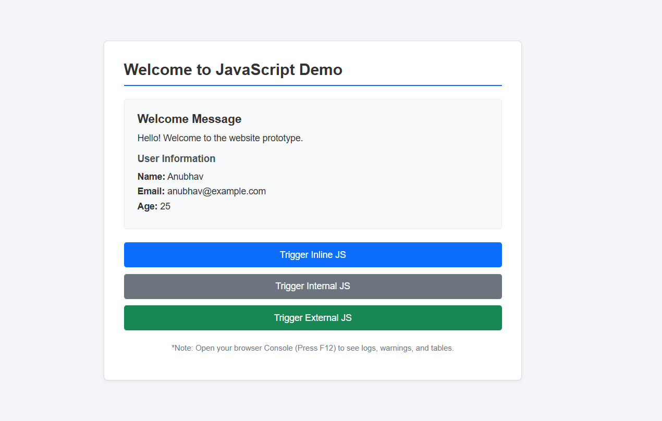

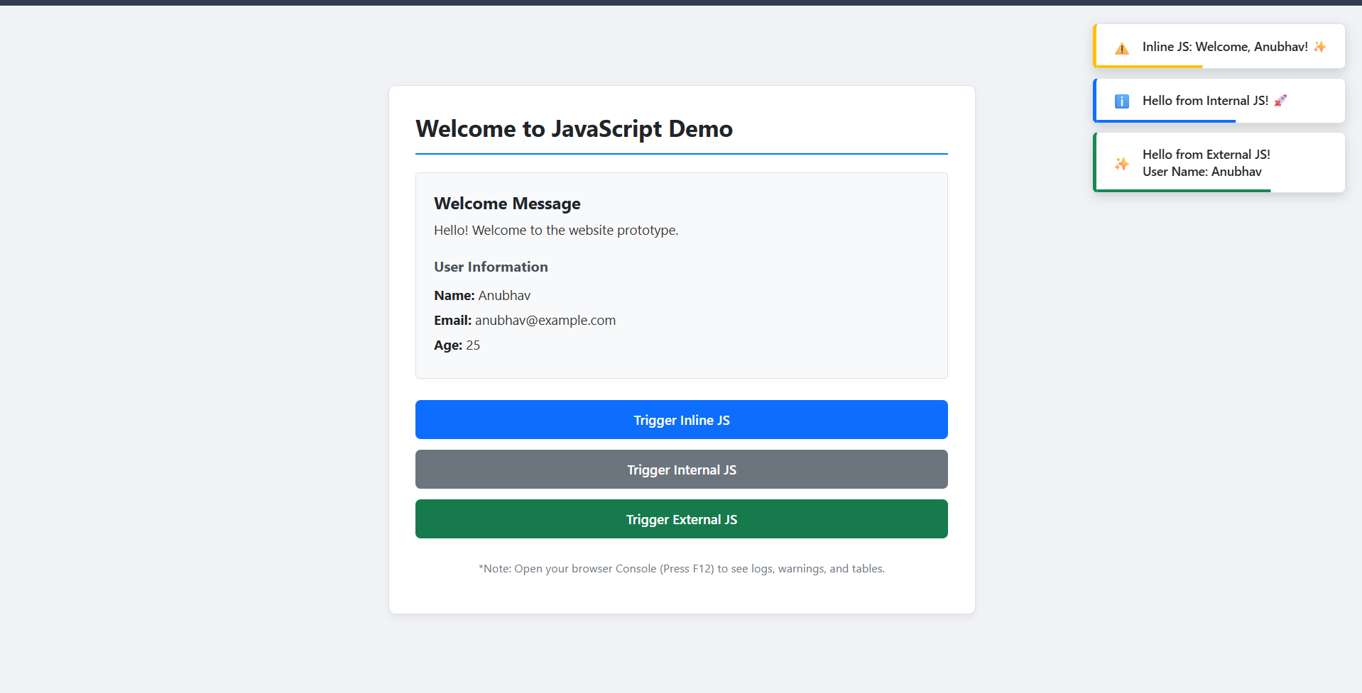

Result: The webpage was successfully created using HTML, CSS, and JavaScript. It demonstrated inline, internal, and external JavaScript, displayed user information with a welcome message, and showed various console methods in the browser console.
Conclusion: The experiment helped in understanding the different ways of including JavaScript in a webpage and how it interacts with HTML elements. It also demonstrated the use of console methods for debugging and basic DOM manipulation.
Experiment No.: 2
Title: Use var, let, const, and demonstrate basic features like template literals and destructuring; build a billing calculator with user input.
Software/Tools Required: HTML5, CSS3, JavaScript, VS Code , Google Chrome
Theory: JavaScript uses var, let, and const to declare variables with different scopes. The prompt() function accepts user input, while template literals simplify string formatting. Object destructuring extracts object properties into variables. These ES6 features are used to build a billing calculator that calculates the subtotal, GST (18%), and total bill, and displays a formatted receipt.

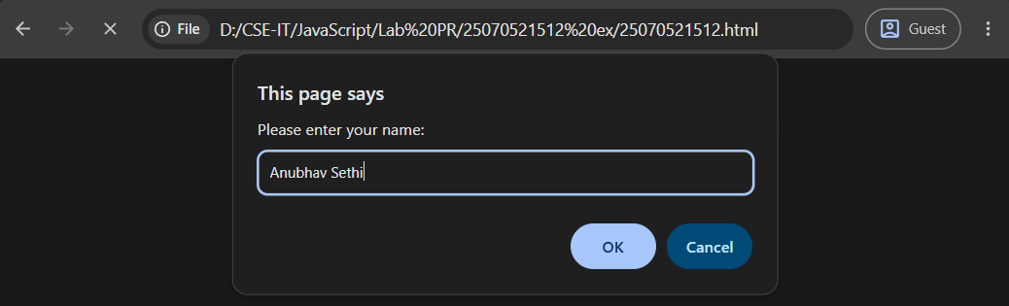
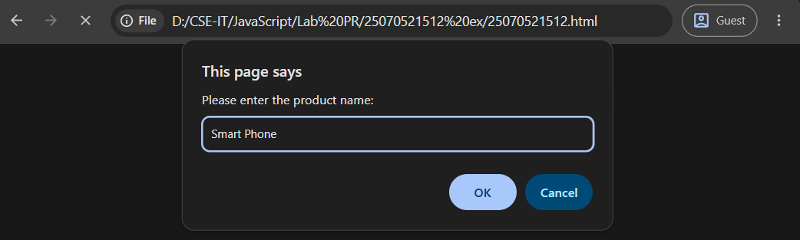
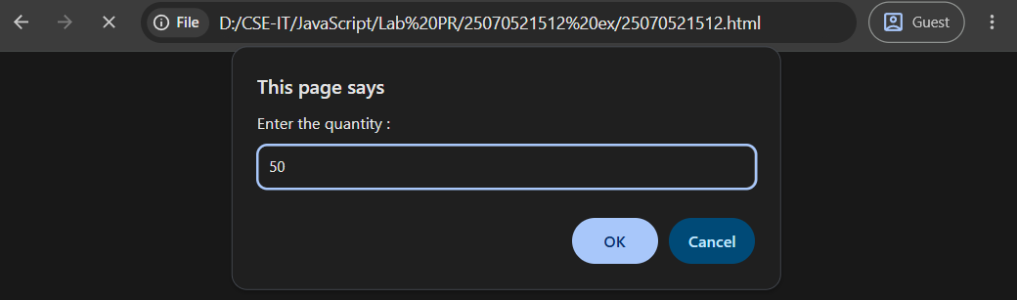
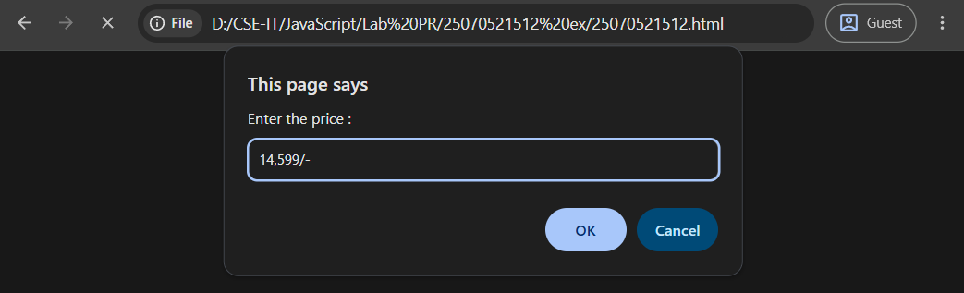
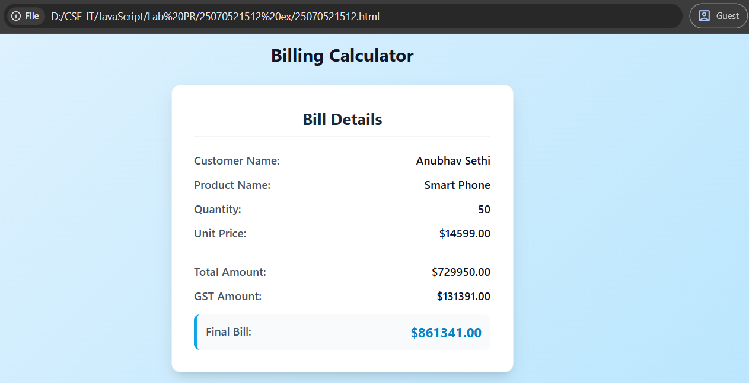

Result: A billing calculator was successfully developed using JavaScript. It accepted user input, calculated the subtotal, GST (18%), and total amount, and displayed a formatted billing receipt on the web page.
Conclusion: The experiment demonstrated the use of var, let, const, prompt(), template literals, and object destructuring to create an interactive and user-friendly billing application.
Experiment No.: 3
Title: Implement control structures and form validation; create a grading system based on user-entered marks.
Software/Tools Required: HTML5, CSS3, JavaScript, VS Code, Google Chrome
Theory: Control structures control the flow of a program using conditions such as if-else and loops. Form validation checks whether user-entered data is valid and within the required range. A grading system uses these concepts to validate marks and assign grades based on predefined mark ranges.
Output:
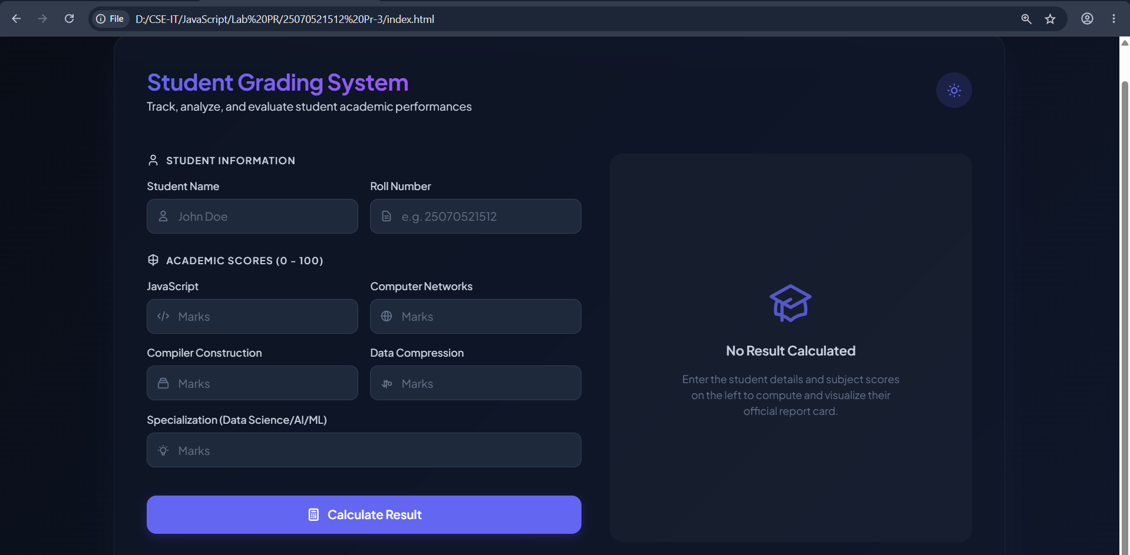
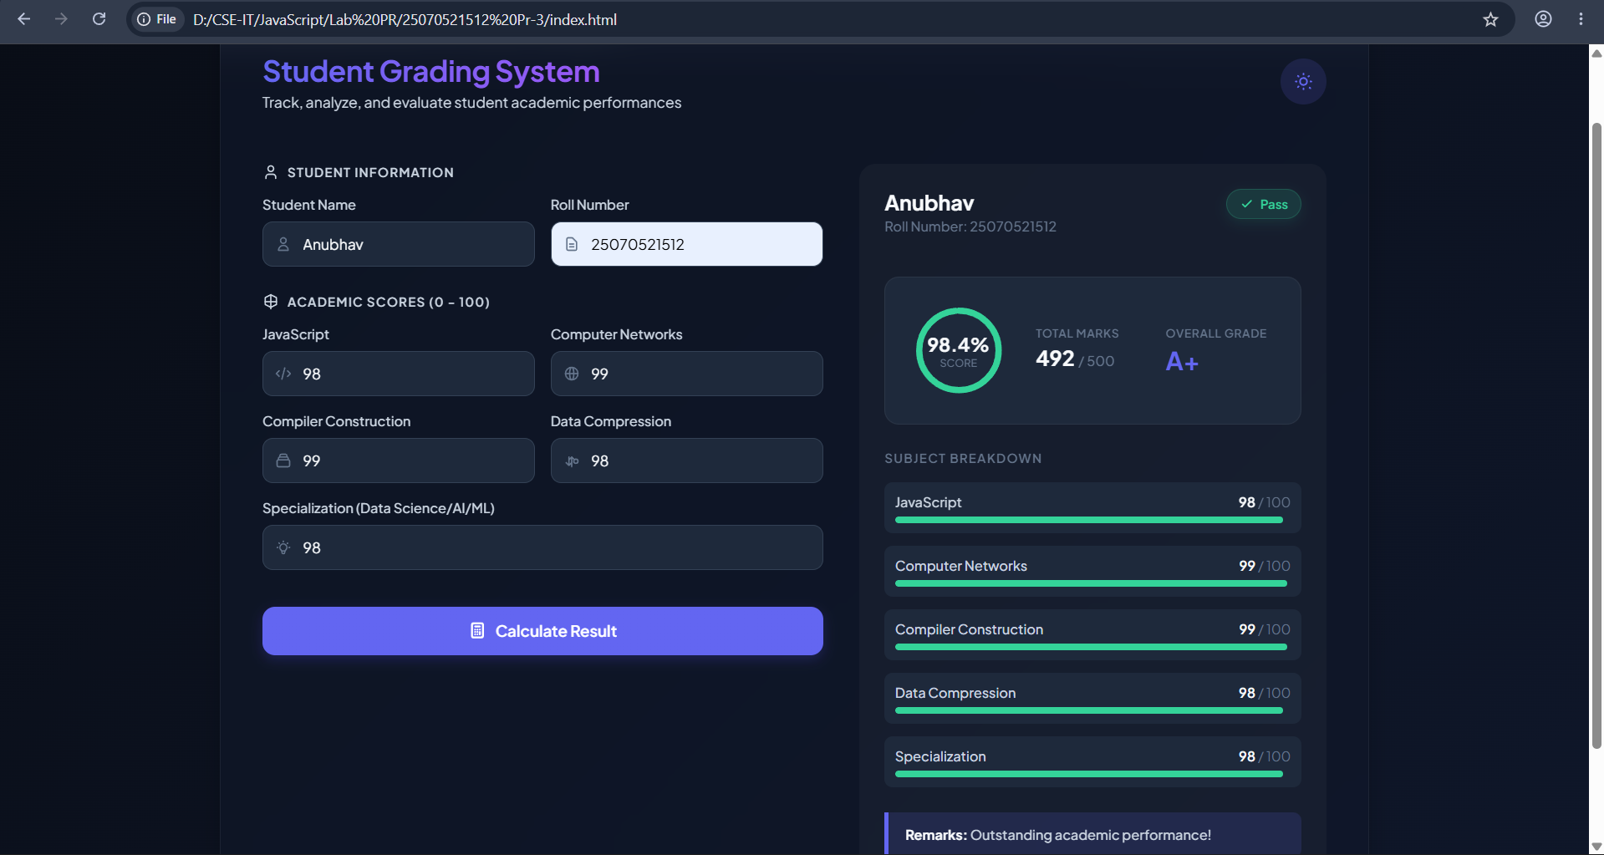

Result: A Successfully implemented control structures and form validation to accept user-entered marks and generate the corresponding grade accurately.
Conclusion: The experiment demonstrated the use of control structures and form validation; created a grading system based on user-entered marks.
Experiment No.: 4
Title: Use function types, scope, and closures; apply try-catch; build a palindrome checker.
Software/Tools Required: HTML5, CSS3, JavaScript, VS Code, Google Chrome
Theory: Functions help organize reusable code, while scope determines variable accessibility and closures allow functions to retain access to outer-scope variables. try-catch handles runtime errors safely. A palindrome checker compares a string with its reverse to determine whether it reads the same forward and backward.
Output:
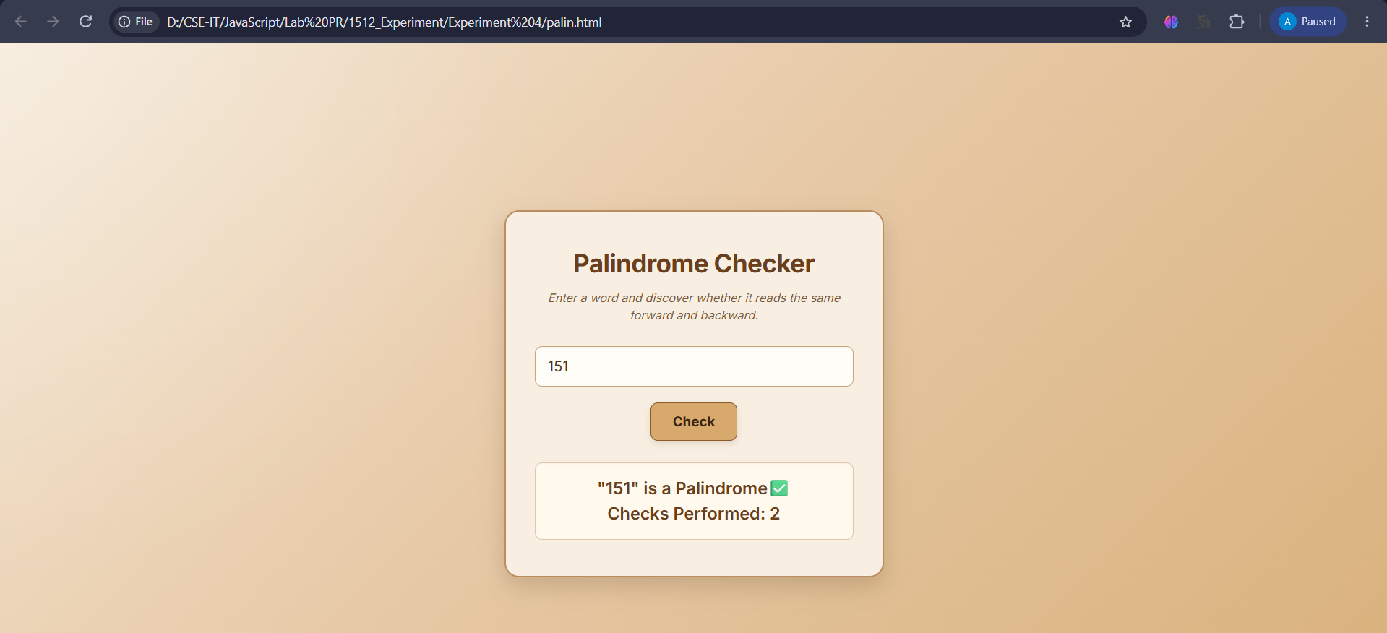
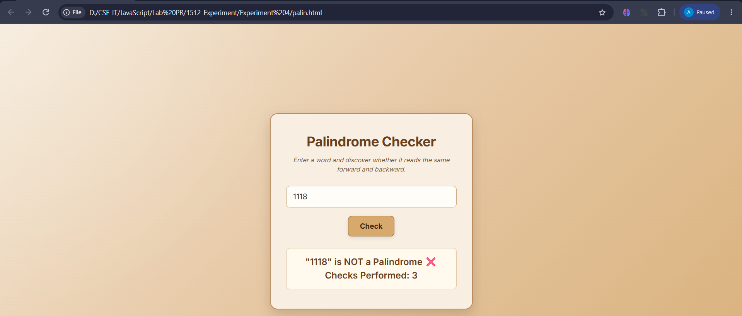

Result: Successfully implemented function types, scope, closures, and try-catch, and developed a palindrome checker that correctly identifies palindrome and non-palindrome inputs.
Conclusion: Successfully implemented functions, scope, closures, error handling, and a palindrome checker using JavaScript concepts.
Experiment No.: 5
Title: Apply array methods and object handling; create a cart total calculator with discount logic.
Software/Tools Required: HTML5, CSS3, JavaScript, VS Code, Google Chrome
Theory: Array methods are used to process and manipulate collections of data, while objects store related information as key-value pairs. These concepts can be combined to manage cart items, calculate the total price, and apply discount logic based on predefined conditions.
Output:
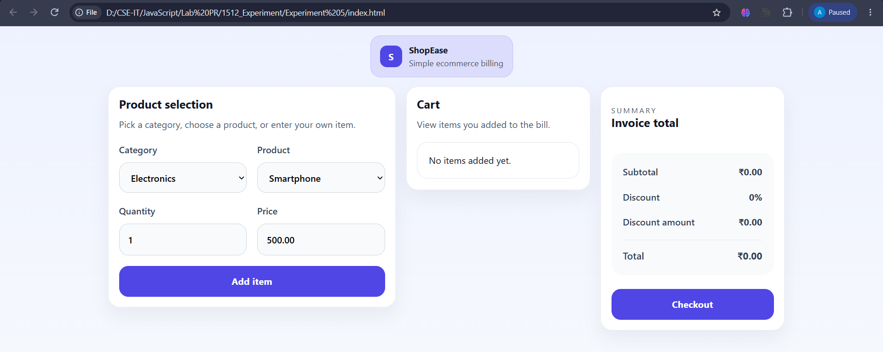
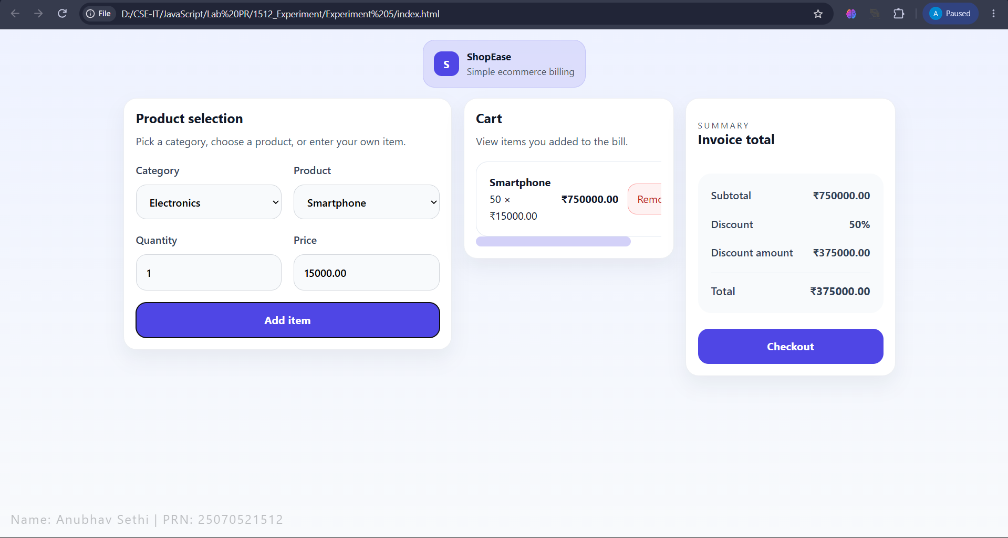
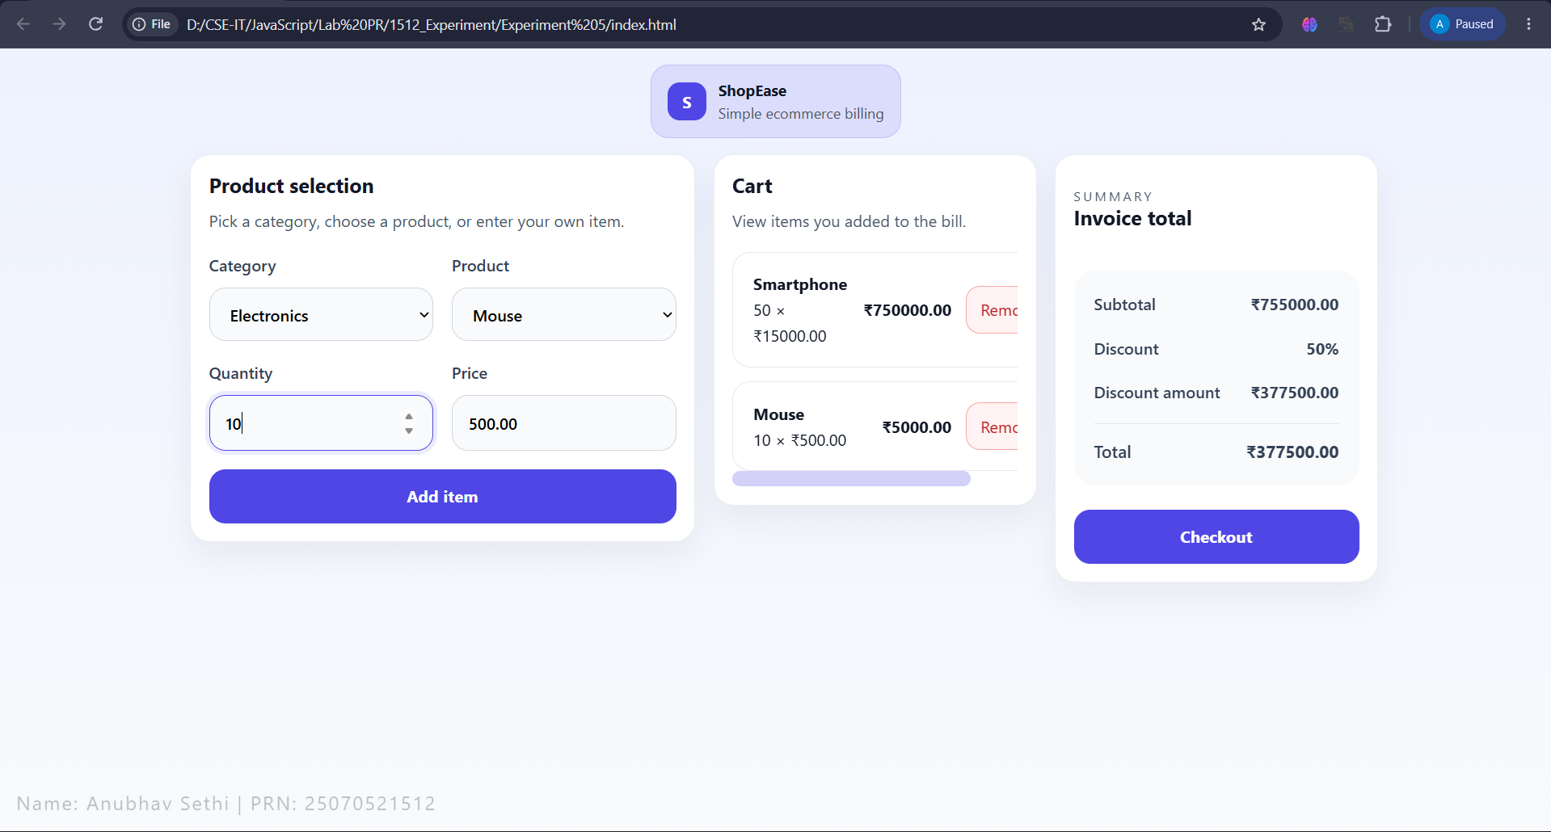
Result: Successfully implemented array methods and object handling to calculate the shopping cart total and apply the appropriate discount.
Conclusion: The practical demonstrated effective use of arrays, objects, and conditional discount logic for cart management.
Experiment No.: 6
Title: Use string functions and regex for email validation, data extraction, and text analysis.
Software/Tools Required: HTML5, CSS3, JavaScript, VS Code, Google Chrome
Theory: JavaScript provides string functions such as toLowerCase(), includes(), substring(), and replace() for text processing. Regular expressions (Regex) are used to search, extract, and validate text patterns, such as checking whether an email has a valid format.
Output:
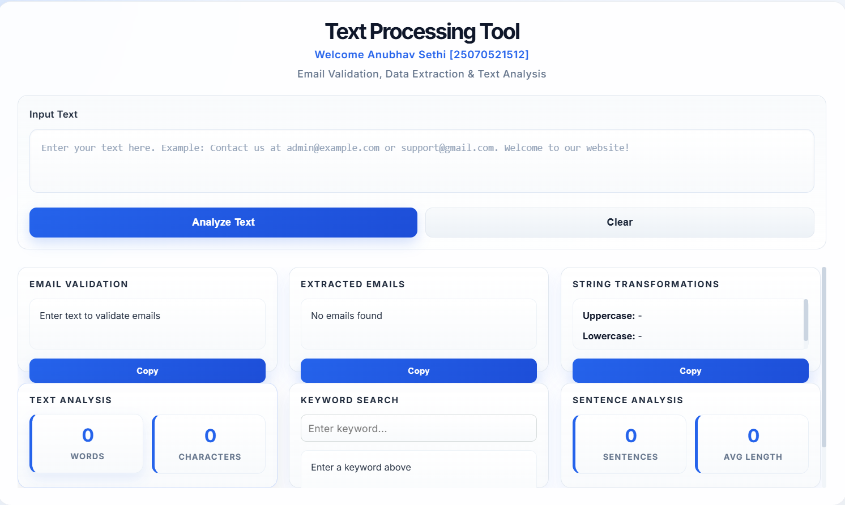

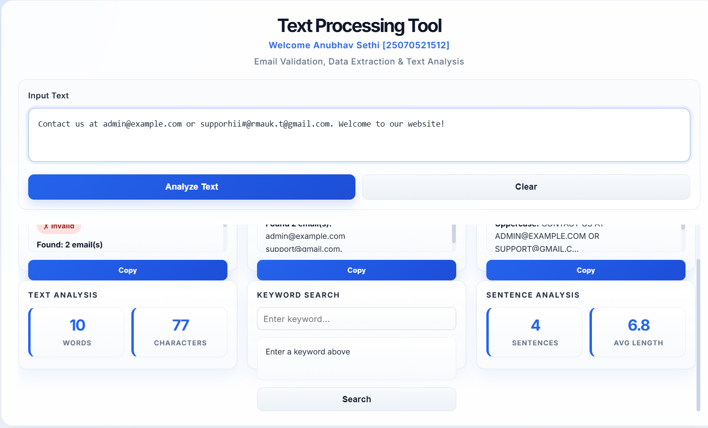
Result: Email validation, data extraction, and text analysis were successfully performed using JavaScript string methods and regular expressions..
Conclusion: String functions and Regex provide an efficient way to process, validate, search, and extract text data in JavaScript.
Experiment No.: 7
Title: Perform DOM traversal and updates; develop a to-do list app with add, edit, and delete features.
Software/Tools Required: HTML5, CSS3, JavaScript, VS Code, Google Chrome
Theory: JavaScript provides DOM (Document Object Model) traversal and manipulation techniques to access, navigate, and modify HTML elements dynamically. Methods such as querySelector(), querySelectorAll(), parentElement, and children are used to traverse the DOM, while createElement(), appendChild(), textContent, setAttribute(), and remove() are used to update or modify elements. Event handling allows these operations to be performed in response to user actions, making web pages interactive and dynamic.

Output:



Result: DOM elements were successfully traversed, created, updated, and removed using JavaScript. User interactions were handled dynamically to manage webpage content.
Conclusion: Thus, JavaScript DOM traversal and manipulation provide an effective way to create interactive web interfaces and dynamically manage HTML content.
Experiment No.: 8
Title: Access and validate form fields using events; design a gym admission form with live input checks.
Software/Tools Required: HTML5, CSS3, JavaScript, VS Code, Google Chrome
Theory: JavaScript provides DOM methods like getElementById() and querySelector() to access form fields. Event handlers such as input, change, and submit detect user actions, while validation conditions check whether the entered data is correct. Live validation gives immediate feedback without requiring page reloads..

Output:
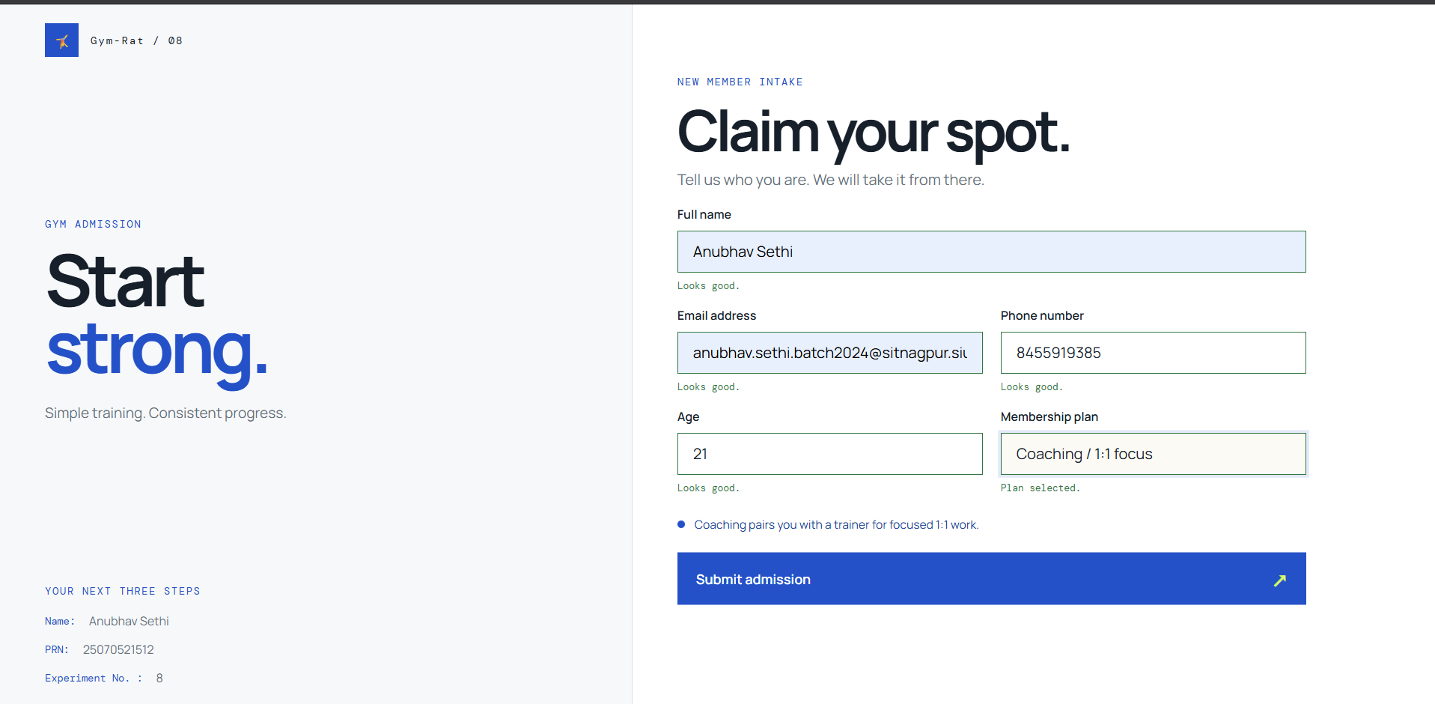
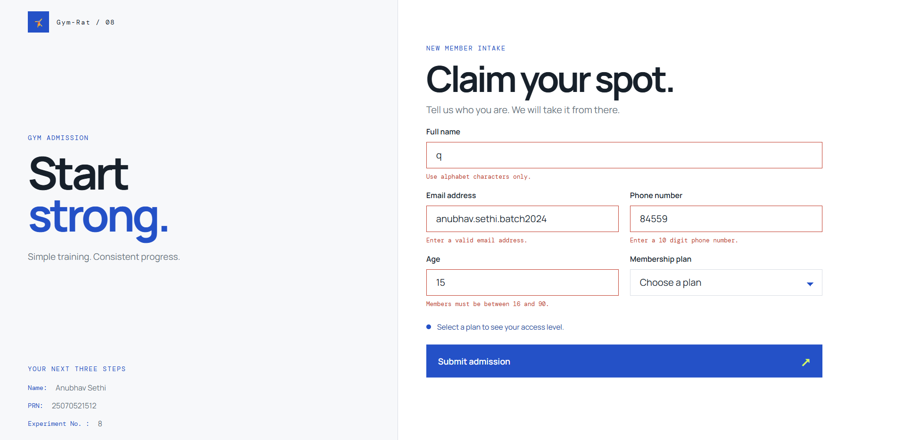


Result: Form fields were successfully accessed, monitored, and validated using JavaScript events and DOM manipulation.
Conclusion: Thus, JavaScript event handling and form validation provide an effective way to manage user input, detect errors, and maintain accurate form data.

Experiment No.: 9
Title: Implement localStorage and sessionStorage to save user preferences like theme settings.
Software/Tools Required: HTML5, CSS3, JavaScript, VS Code, Google Chrome
Theory: In JavaScript, localStorage and sessionStorage are part of the Web Storage API used to store data in the browser as key-value pairs. localStorage stores data persistently, so it remains available even after closing and reopening the browser, while sessionStorage stores data only for the current browser session and is cleared when the tab is closed. Both provide methods such as setItem(), getItem(), removeItem(), and clear() for managing stored data, and are commonly used for saving preferences such as theme settings, language preferences, and temporary user data.

Output:

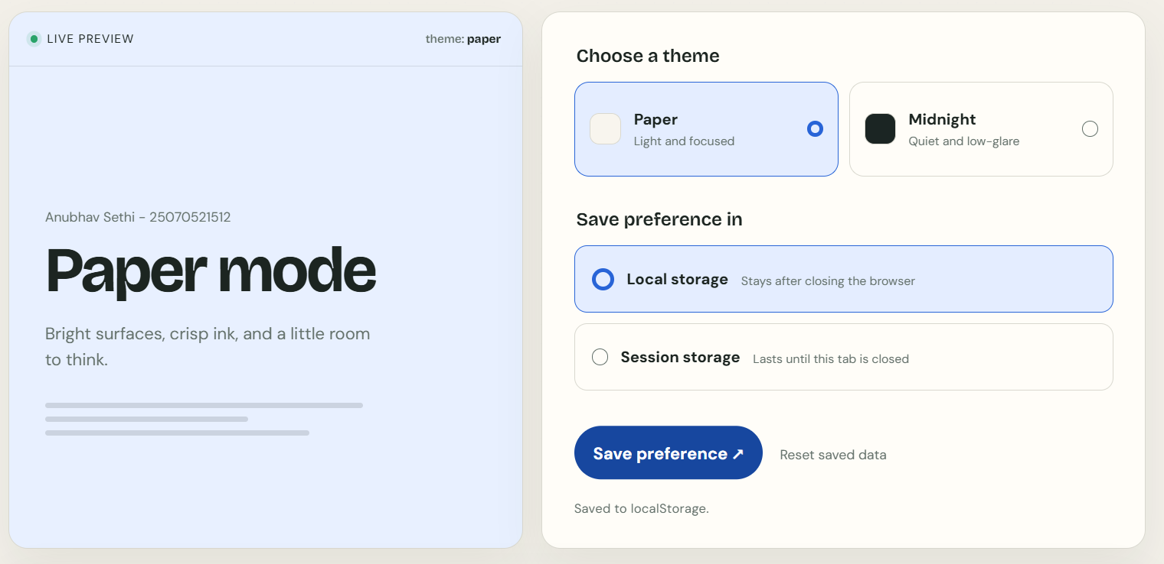
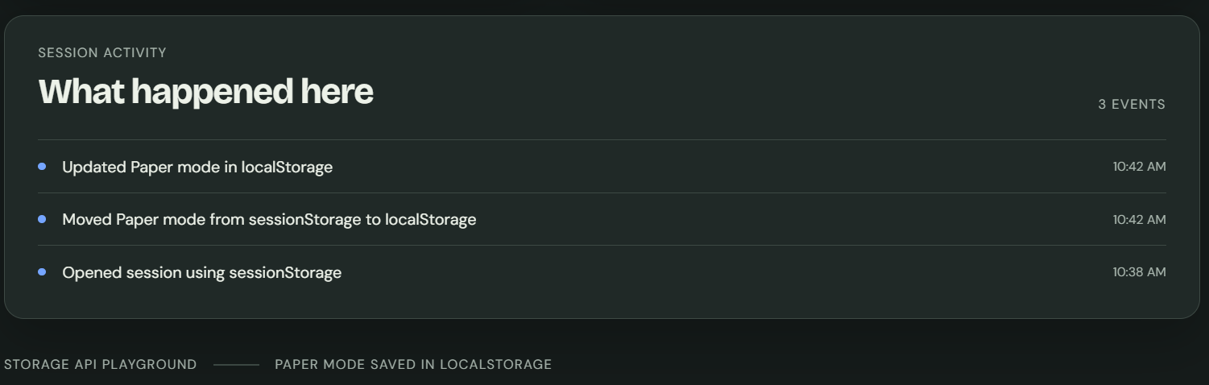

Result: User preferences such as theme settings were successfully stored, retrieved, and managed using JavaScript localStorage and sessionStorage.
Conclusion: Thus, localStorage and sessionStorage can be effectively used in JavaScript to store and manage user preferences, improving the personalized and consistent user experience of web applications.
Experiment No.: 10
Title: Load and display JSON data using fetch() and jQuery $.getJSON(); render results dynamically in a table.
Software/Tools Required: HTML5, CSS3, JavaScript, VS Code, Google Chrome
Theory: In JavaScript, localStorage and sessionStorage are part of the Web Storage API used to store data in the browser as key-value pairs. localStorage stores data persistently, so it remains available even after closing and reopening the browser, while sessionStorage stores data only for the current browser session and is cleared when the tab is closed. Both provide methods such as setItem(), getItem(), removeItem(), and clear() for managing stored data, and are commonly used for saving preferences such as theme settings, language preferences, and temporary user data.

Output:

Result: User preferences such as theme settings were successfully stored, retrieved, and managed using JavaScript localStorage and sessionStorage.
Conclusion: Thus, localStorage and sessionStorage can be effectively used in JavaScript to store and manage user preferences, improving the personalized and consistent user experience of web applications.

