Experiment No.: 1
Title: Demonstrate inline, internal, and external JavaScript; use console methods; create a webpage showing user info and a welcome message.
Software/Tools Required: HTML5, CSS3, JavaScript, Visual Studio Code, Google Chrome
Code:
HTML Code:
<!doctype html>
<html lang="en">
<head>
<meta charset="UTF-8" />
<meta name="viewport" content="width=device-width, initial-scale=1.0" />
<title>Simple JavaScript Demo</title>
<link rel="stylesheet" href="style.css?v=2" />
</head>
<body>
<!-- Toast Container -->
<div id="toast-container" class="toast-container"></div>
<div class="container">
<h1>Welcome to JavaScript Demo</h1>
<!-- User Info Section -->
<div class="profile-card">
<h2>Welcome Message</h2>
<p id="welcome-text">Hello! Welcome to the website prototype.</p>

<h3>User Information</h3>
<div id="user-info">
<p><strong>Name:</strong> <span id="user-name">Anubhav</span></p>
<p>
<strong>Email:</strong>
<span id="user-email">anubhav@example.com</span>
</p>
<p><strong>Age:</strong> <span id="user-age">25</span></p>
</div>
</div>

<!-- Buttons demonstrating JS styles -->
<div class="button-section">
<!-- 1. Inline JavaScript -->
<button
onclick="
console.warn('Inline JS: Warning logged on button click!');
showToast('Inline JS: Welcome, Anubhav! ✨', 'warning');
"
>
Trigger Inline JS
</button>

<!-- 2. Internal JavaScript -->
<button id="btn-internal">Trigger Internal JS</button>

<!-- 3. External JavaScript -->
<button id="btn-external">Trigger External JS</button>
</div>

<p class="footer-note">
*Note: Open your browser Console (Press F12) to see logs, warnings, and
tables.
</p>
</div>

<!-- Link to External JavaScript -->
<script src="script.js"></script>

<!-- INTERNAL JAVASCRIPT -->
<script>
// Console log when internal script runs
console.log("Internal JS script tag loaded.");
console.info(
"Internal JS can update page content and respond to user actions.",
);

// Fill the welcome text and user info from the shared userData object
const welcomeText = document.getElementById("welcome-text");
const nameField = document.getElementById("user-name");
const emailField = document.getElementById("user-email");
const ageField = document.getElementById("user-age");

if (
welcomeText &&
nameField &&
emailField &&
ageField &&
typeof userData !== "undefined"
) {
welcomeText.textContent = `Hello ${userData.name}! Welcome to your JavaScript demo page.`;
nameField.textContent = userData.name;
emailField.textContent = userData.email;
ageField.textContent = userData.age;
console.log("Internal JS: User info updated on the page.");
}

// Handle Internal Button Click
document
.getElementById("btn-internal")
.addEventListener("click", function () {
// Use console.error (Console Method 3)
console.error("Internal JS: Error simulation logged on click!");
showToast("Hello from Internal JS! 🚀", "info");
});
</script>
</body>
</html>

CSS Code:
/* Simple & Clean Styling Matching the Reference Image */
body {
font-family: -apple-system, BlinkMacSystemFont, "Segoe UI", Roboto, Helvetica, Arial, sans-serif;
background-color: #f0f2f5;
color: #333333;
margin: 0;
padding: 40px 20px;
display: flex;
justify-content: center;
align-items: center;
min-height: 100vh;
box-sizing: border-box;
}
.container {
width: 100%;
max-width: 600px;
background-color: #ffffff;
padding: 30px;
border-radius: 8px;
border: 1px solid #dee2e6;
box-shadow: 0 4px 6px rgba(0, 0, 0, 0.05);
}
h1 {
color: #212529;
font-size: 26px;
font-weight: 700;
margin-top: 0;
margin-bottom: 20px;
border-bottom: 2px solid #007bff;
padding-bottom: 12px;
}
.profile-card {
background-color: #f8f9fa;
border: 1px solid #dee2e6;
padding: 20px;
border-radius: 4px;
margin-bottom: 24px;
}
.profile-card h2 {
font-size: 19px;
font-weight: 700;
color: #212529;
margin-top: 0;
margin-bottom: 8px;
}
.profile-card p {
margin: 8px 0;
font-size: 15px;
color: #333333;
}
.profile-card h3 {
font-size: 16px;
font-weight: 700;
color: #495057;
margin-top: 20px;
margin-bottom: 12px;
}
.profile-card strong {
color: #212529;
}
.button-section {
display: flex;
flex-direction: column;
gap: 12px;
}
button {
font-family: inherit;
font-size: 15px;
font-weight: 500;
padding: 12px 20px;
cursor: pointer;
background-color: #0d6efd;
color: white;
border: none;
border-radius: 6px;
transition: background-color 0.15s ease-in-out;
text-align: center;
display: block;
width: 100%;
}
button:hover {
background-color: #0b5ed7;
}
#btn-internal {
background-color: #6c757d;
}
#btn-internal:hover {
background-color: #5c636a;
}
#btn-external {
background-color: #198754;
}
#btn-external:hover {
background-color: #157347;
}
.footer-note {
margin-top: 24px;
font-size: 13px;
color: #6c757d;
text-align: center;
}
.toast-container {
position: fixed;
top: 20px;
right: 20px;
z-index: 9999;
display: flex;
flex-direction: column;
gap: 10px;
}
.toast {
min-width: 280px;
background-color: #ffffff;
border: 1px solid #dee2e6;
border-radius: 6px;
box-shadow: 0 4px 12px rgba(0, 0, 0, 0.15);
overflow: hidden;
position: relative;
opacity: 0;
transform: translateX(120%);
transition: transform 0.3s ease, opacity 0.3s ease;
}
.toast.show {
transform: translateX(0);
opacity: 1;
}
.toast.hide {
transform: translateX(120%);
opacity: 0;
}
.toast-content-wrapper {
padding: 14px 18px;
display: flex;
align-items: center;
gap: 12px;
}
.toast-icon {
font-size: 16px;
}
.toast-message {
font-size: 14px;
color: #212529;
font-weight: 500;
line-height: 1.4;
}
.toast-progress {
position: absolute;
bottom: 0;
left: 0;
height: 3px;
width: 100%;
transform-origin: left;
animation: toast-timer 4s linear forwards;
}
.toast.success {
border-left: 4px solid #198754;
}
.toast.success .toast-progress {
background-color: #198754;
}
.toast.info {
border-left: 4px solid #0d6efd;
}
.toast.info .toast-progress {
background-color: #0d6efd;
}
.toast.warning {
border-left: 4px solid #ffc107;
}
.toast.warning .toast-progress {
background-color: #ffc107;
}
.toast.error {
border-left: 4px solid #dc3545;
}
.toast.error .toast-progress {
background-color: #dc3545;
}
@keyframes toast-timer {
from { transform: scaleX(1); }
to { transform: scaleX(0); }
}
@media (max-width: 480px) {
.toast-container {
top: auto;
bottom: 20px;
right: 20px;
left: 20px;
}
.toast {
transform: translateY(120%);
}
.toast.show {
transform: translateY(0);
}
.toast.hide {
transform: translateY(120%);
}
}

JavaScript Code:
console.log("External JS file has successfully loaded!");

const userData = {
name: "Anubhav",
email: "aanubhav@123gmail.com",
age: 22,
};
// Toast Notification Function
function showToast(message, type = "success") {
const container = document.getElementById("toast-container");
if (!container) return;
const toast = document.createElement("div");
toast.className = `toast ${type}`;
let icon = "🔔";
if (type === "success") icon = "✨";
if (type === "error") icon = "❌";
if (type === "warning") icon = "⚠️";
if (type === "info") icon = "ℹ️";
toast.innerHTML = `
<div class="toast-content-wrapper">
<span class="toast-icon">${icon}</span>
<span class="toast-message">${message.replace(/\n/g, "<br>")}</span>
</div>
<div class="toast-progress"></div>
`;
container.appendChild(toast);
// Trigger CSS animations
setTimeout(() => {
toast.classList.add("show");
}, 10);
// Automatically remove toast
setTimeout(() => {
toast.classList.remove("show");
toast.classList.add("hide");
toast.addEventListener("transitionend", () => {
toast.remove();
});
}, 4000);
}
// When the page finishes loading, display the user info table in the console and trigger a toast
window.onload = function () {
console.log("User Information Table:");
// Display data as a table in the browser console (Console Method 2)
console.table(userData);
// Pop up toast welcome message
showToast("Welcome back, Anubhav! 🌟", "success");
};
// Handle External Button Click
document.getElementById("btn-external").addEventListener("click", function () {
console.log("External JS: Button clicked!");
showToast("Hello from External JS!\nUser Name: " + userData.name, "success");
});

Output:
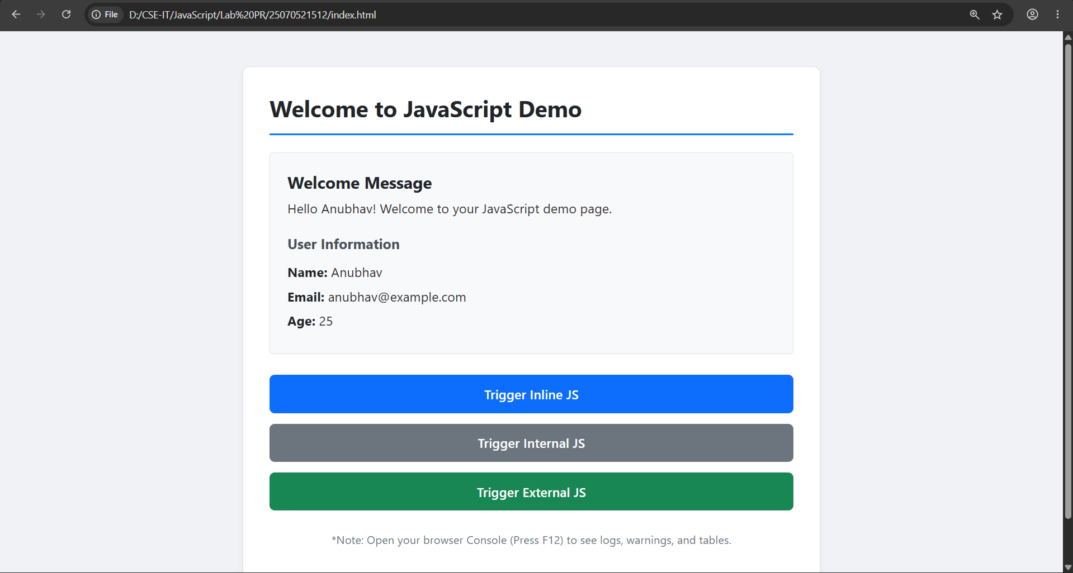

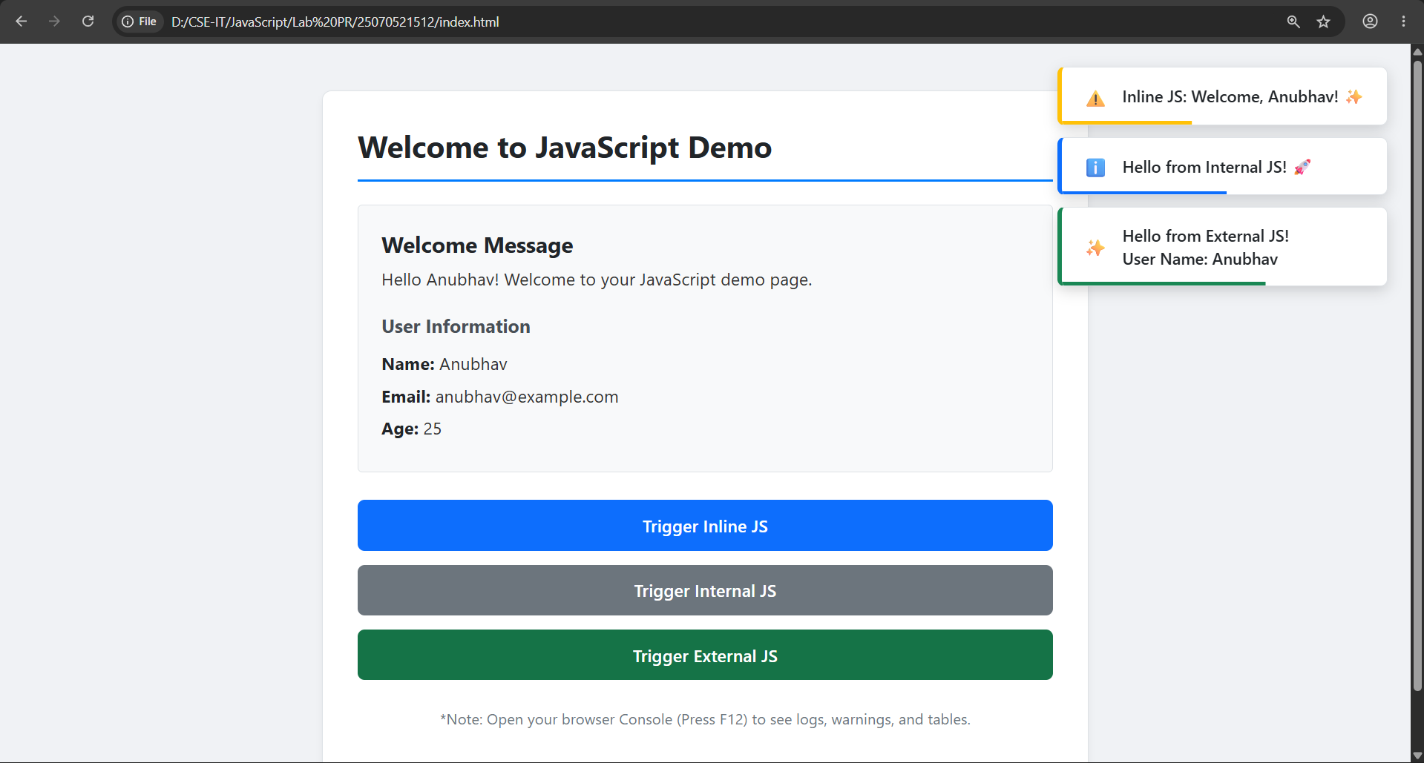
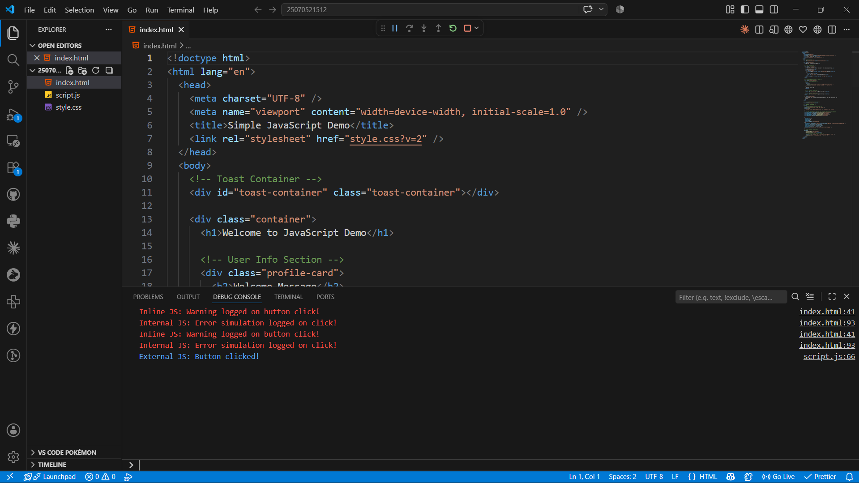
Result: The webpage was successfully created using HTML, CSS, and JavaScript. It demonstrated inline, internal, and external JavaScript, displayed user information with a welcome message, and showed various console methods in the browser console.
Conclusion: The experiment helped in understanding the different ways of including JavaScript in a webpage and how it interacts with HTML elements. It also demonstrated the use of console methods for debugging and basic DOM manipulation.
Case Study No.: 1
Title: Create a webpage for college department and link the student information page with it and write a JavaScript program to display "Welcome to SIT Nagpur" in an alert box.
Software/Tools Required: HTML5 , CSS3 , JavaScript , Visual Studio Code , Google Chrome
Code:
HTML Code:
<!doctype html>
<html lang="en">
<head>
<meta charset="UTF-8" />
<meta name="viewport" content="width=device-width, initial-scale=1.0" />
<title>SIT Nagpur IT Department</title>
<link rel="preconnect" href="https://fonts.googleapis.com" />
<link rel="preconnect" href="https://fonts.gstatic.com" crossorigin />
<link
href="https://fonts.googleapis.com/css2?family=Outfit:wght@400;500;600;700&display=swap"
rel="stylesheet"
/>
<link rel="stylesheet" href="style.css" />
</head>
<body>
<header class="site-header">
<div class="brand-group">
<span class="brand-mark">SIT</span>
<div>
<p class="brand-label">Information Technology</p>
<p class="brand-subtitle">
Symbiosis Institute of Technology, Nagpur
</p>
</div>
</div>
<nav class="top-nav" aria-label="Primary navigation">
<a href="index.html" class="nav-link active">Home</a>
<a href="student_info.html" class="nav-link">Student Records</a>
</nav>
</header>
<main>
<section class="hero-card">
<div class="hero-copy">
<p class="eyebrow">Department Portal</p>
<h1>Information Technology Department</h1>
<p>
Welcome to the official IT department portal for students and
faculty. Access student records, academic announcements, and
department information in a clean, responsive interface.
</p>
<div class="btn-container">
<a href="student_info.html" class="btn">View Student Information</a>
</div>
</div>
<div class="hero-panel">
<article class="stat-card">
<p class="stat-label">Active students</p>
<p class="stat-value">320+</p>
</article>
<article class="stat-card">
<p class="stat-label">Programs</p>
<p class="stat-value">B.Tech • MBA</p>
</article>
<article class="stat-card">
<p class="stat-label">Academic year</p>
<p class="stat-value">2026–2027</p>
</article>
</div>
</section>
<section class="card overview-card">
<h2>About the Department</h2>
<p>
The Information Technology department at SIT Nagpur supports
innovation, industry-aligned learning, and academic excellence. Our
portal provides a polished, accessible view of student data and
department updates for campus stakeholders.
</p>
</section>
</main>
<footer class="page-footer">
<p>Symbiosis Institute of Technology, Nagpur • © 2026</p>
</footer>
<script src="js.js"></script>
</body>
</html>

CSS Code:
:root {
color-scheme: light;
font-family:
"Outfit",
-apple-system,
BlinkMacSystemFont,
"Segoe UI",
Roboto,
sans-serif;
background: #f4f7fb;
color: #1f2937;
--bg: #f4f7fb;
--surface: #ffffff;
--surface-soft: #f8fafc;
--border: #d1d9e6;
--primary: #164e9d;
--primary-strong: #0f3b7d;
--accent: #0ea5e9;
--text: #1f2937;
--muted: #64748b;
--card-shadow: 0 24px 60px rgba(15, 23, 42, 0.08);
}

* {
box-sizing: border-box;
}
html,
body {
margin: 0;
min-height: 100%;
}
body {
background:
radial-gradient(
circle at top left,
rgba(14, 165, 233, 0.12),
transparent 32%
),
radial-gradient(
circle at bottom right,
rgba(22, 78, 157, 0.16),
transparent 28%
),
var(--bg);
color: var(--text);
margin: 0 auto;
max-width: 1100px;
padding: 24px;
}
body::before {
content: "";
position: fixed;
inset: 0;
pointer-events: none;
}
.site-header {
display: flex;
justify-content: space-between;
align-items: center;
padding: 22px 0;
gap: 24px;
}
.brand-group {
display: flex;
align-items: center;
gap: 16px;
}
.brand-mark {
display: inline-flex;
align-items: center;
justify-content: center;
width: 52px;
height: 52px;
border-radius: 14px;
background: linear-gradient(135deg, #2563eb 0%, #1d4ed8 100%);
color: white;
font-weight: 700;
font-size: 1.15rem;
letter-spacing: 0.02em;
}
.brand-label {
margin: 0;
font-size: 1rem;
font-weight: 700;
}
.brand-subtitle {
margin: 4px 0 0;
color: var(--muted);
font-size: 0.92rem;
}
.top-nav {
display: flex;
gap: 18px;
flex-wrap: wrap;
}
.nav-link {
color: var(--muted);
text-decoration: none;
font-size: 0.95rem;
font-weight: 600;
padding: 10px 12px;
border-radius: 10px;
transition: all 0.2s ease;
}
.nav-link:hover,
.nav-link.active {
color: var(--primary-strong);
background: rgba(37, 99, 235, 0.08);
}
main {
display: grid;
gap: 24px;
}
.card {
background: var(--surface);
border: 1px solid rgba(226, 232, 240, 0.9);
border-radius: 24px;
box-shadow: var(--card-shadow);
padding: 32px;
}
.hero-card {
display: grid;
grid-template-columns: minmax(0, 1.4fr) minmax(240px, 1fr);
gap: 24px;
align-items: center;
}
.hero-copy {
max-width: 620px;
}
.eyebrow {
margin: 0 0 16px;
font-size: 0.92rem;
font-weight: 700;
letter-spacing: 0.08em;
text-transform: uppercase;
color: var(--accent);
}
h1,
h2 {
margin: 0;
color: var(--text);
line-height: 1.1;
}
h1 {
font-size: clamp(2rem, 2.4vw, 3rem);
margin-bottom: 18px;
}
h2 {
font-size: 1.55rem;
margin-bottom: 14px;
}
p {
margin: 0 0 18px;
line-height: 1.75;
color: var(--muted);
font-size: 1rem;
}
.hero-panel {
display: grid;
gap: 16px;
}
.stat-card {
background: var(--surface-soft);
border: 1px solid rgba(226, 232, 240, 0.95);
border-radius: 18px;
padding: 22px;
}
.stat-label {
margin: 0 0 8px;
font-size: 0.95rem;
color: var(--muted);
font-weight: 600;
}
.stat-value {
margin: 0;
font-size: 1.45rem;
font-weight: 700;
color: var(--text);
}
.overview-card {
padding: 32px;
}
.btn-container {
margin-top: 16px;
}
.btn {
display: inline-flex;
align-items: center;
justify-content: center;
padding: 14px 26px;
border-radius: 999px;
background: linear-gradient(135deg, var(--primary), #2563eb);
color: #ffffff;
text-decoration: none;
font-weight: 700;
font-size: 0.98rem;
transition:
transform 0.2s ease,
box-shadow 0.2s ease,
background-color 0.2s ease;
box-shadow: 0 18px 32px rgba(37, 99, 235, 0.18);
}
.btn:hover {
transform: translateY(-2px);
box-shadow: 0 24px 40px rgba(37, 99, 235, 0.18);
}
.btn-secondary {
background: var(--surface-soft);
color: var(--text);
box-shadow: none;
border: 1px solid rgba(226, 232, 240, 0.95);
}
.btn-secondary:hover {
background: #eef2ff;
}
.table-container {
overflow-x: auto;
border-radius: 18px;
border: 1px solid rgba(226, 232, 240, 0.95);
box-shadow: inset 0 0 0 1px rgba(255, 255, 255, 0.5);
}
table {
width: 100%;
border-collapse: collapse;
min-width: 520px;
}
th,
td {
padding: 18px 20px;
text-align: left;
border-bottom: 1px solid rgba(226, 232, 240, 1);
}
th {
background: var(--surface-soft);
color: var(--text);
font-weight: 700;
letter-spacing: 0.01em;
}
tbody tr {
transition: background-color 0.2s ease;
}
tbody tr:hover {
background: #f8fafc;
}
tbody tr:last-child td {
border-bottom: none;
}
.page-footer {
text-align: center;
color: var(--muted);
padding: 18px 0 8px;
font-size: 0.95rem;
}
@media (max-width: 860px) {
.hero-card {
grid-template-columns: 1fr;
}
}
@media (max-width: 640px) {
body {
padding: 18px;
}
.site-header {
flex-direction: column;
align-items: flex-start;
}
.top-nav {
width: 100%;
justify-content: flex-start;
}
.btn,
.nav-link {
width: fit-content;
}
}

JavaScript Code:
window.addEventListener("load", function () {
alert("Welcome to SIT Nagpur");
});
console.log("Welcome to SIT Nagpur IT Department Portal");

Student Report:
<!doctype html>
<html lang="en">
<head>
<meta charset="UTF-8" />
<meta name="viewport" content="width=device-width, initial-scale=1.0" />
<title>Student Information | SIT IT Department</title>
<link rel="preconnect" href="https://fonts.googleapis.com" />
<link rel="preconnect" href="https://fonts.gstatic.com" crossorigin />
<link
href="https://fonts.googleapis.com/css2?family=Outfit:wght@400;500;600;700&display=swap"
rel="stylesheet"
/>
<link rel="stylesheet" href="style.css" />
</head>
<body>
<header class="site-header">
<div class="brand-group">
<span class="brand-mark">SIT</span>
<div>
<p class="brand-label">Student Information</p>
<p class="brand-subtitle">
Department of Information Technology, Nagpur
</p>
</div>
</div>
<nav class="top-nav" aria-label="Primary navigation">
<a href="index.html" class="nav-link">Department Home</a>
<a href="student_info.html" class="nav-link active">Student Records</a>
</nav>
</header>
<main>
<section class="card content-card">
<h2>Registered Students</h2>
<p>
This table shows the current student records maintained by the IT
department.
</p>
<div class="table-container">
<table>
<thead>
<tr>
<th>Roll No</th>
<th>Name</th>
<th>Email</th>
</tr>
</thead>
<tbody>
<tr>
<td>101</td>
<td>Anubhav Sethi</td>
<td>anubhav@email.com</td>
</tr>
<tr>
<td>102</td>
<td>Saksham Kathale</td>
<td>saksham@email.com</td>
</tr>
<tr>
<td>103</td>
<td>Nil Dhoke</td>
<td>nil@email.com</td>
</tr>
</tbody>
</table>
</div>
<div class="btn-container">
<a href="index.html" class="btn btn-secondary">&larr; Back to Home</a>
</div>
</section>
</main>
<footer class="page-footer">
<p>Symbiosis Institute of Technology, Nagpur • © 2026</p>
</footer>
<script src="js.js"></script>
</body>
</html>

Output:

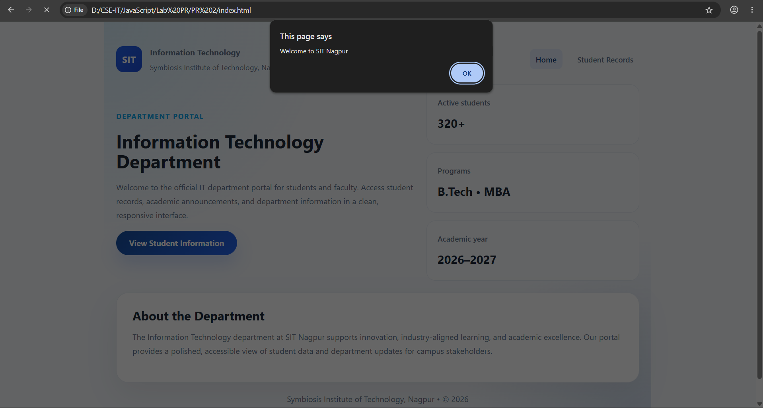

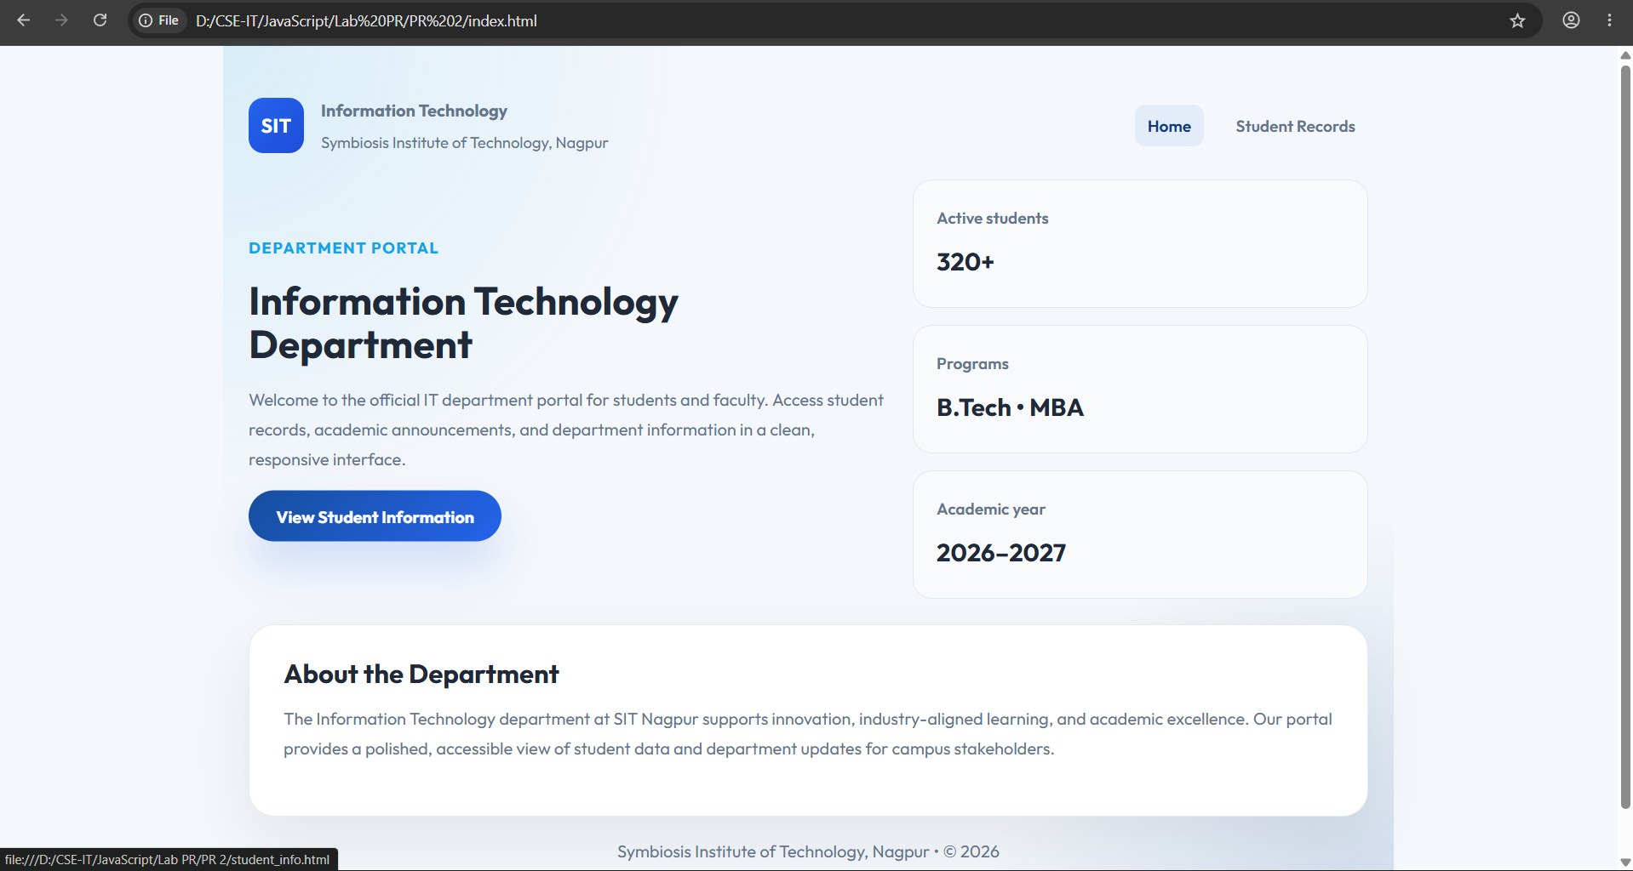
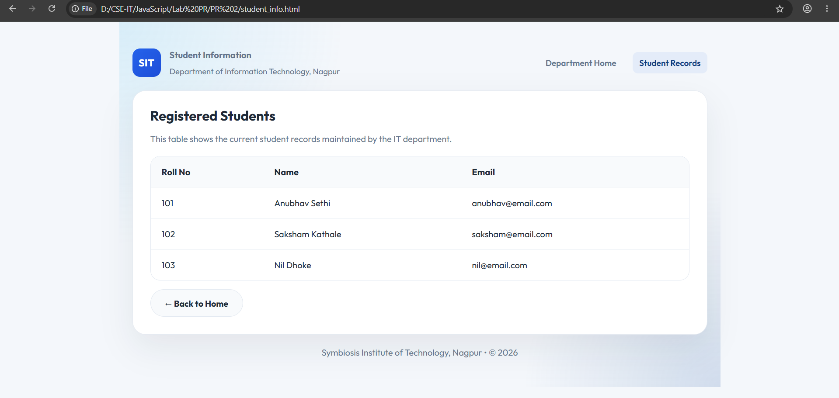
Result: The webpage was successfully created using HTML, CSS, and JavaScript. It demonstrated inline, internal, and external JavaScript, displayed user information with a welcome message, and showed various console methods in the browser console.
Conclusion: The experiment helped in understanding the different ways of including JavaScript in a webpage and how it interacts with HTML elements. It also demonstrated the use of console methods for debugging and basic DOM manipulation.

Experiment No.: 2
Title: Use var, let, const, and demonstrate basic features like template literals and destructuring; build a billing calculator with user input.
Software/Tools Required: HTML5, CSS3, JavaScript, VS Code , Google Chrome
Code:
Index.html:
<!DOCTYPE html>
<html lang="en">
<head>
<meta charset="UTF-8">
<meta name="viewport" content="width=device-width, initial-scale=1.0">
<title>Cafe Billing Receipt</title>
<link rel="stylesheet" href="style.css">
</head>
<body>
<div class="receipt">
<div class="logo">

</div>
<h1>CAFE AROMA</h1>
<p class="subtitle">
Fresh Coffee • Fresh Food
</p>
<div id="bill"></div>
<div class="footer">
<strong>Thank You!</strong>
<br>
Visit Again
</div>
</div>
<script src="script.js"></script>
</body>
</html>
Script.js:
// Using var
var customerName = prompt("Enter Your Name");
// Using let
let productName = prompt("Enter Product Name");
let price = Number(prompt("Enter Price Per Product"));
let quantity = Number(prompt("Enter Quantity"));
// Using const
const GST_RATE = 0.18;
// Calculations
let subtotal = price * quantity;
let gst = subtotal * GST_RATE;
let total = subtotal + gst;
// Create Object
const receipt = {
customerName,
productName,
price,
quantity,
subtotal,
gst,
total
};
// Object Destructuring
const {
customerName: cname,
productName: pname,
price: pprice,
quantity: qty,
subtotal: sub,
gst: gstAmount,
total: grandTotal
} = receipt;
// Display Receipt using Template Literals
document.getElementById("bill").innerHTML = `
<div class="row">
<span>Customer</span>
<span>${cname}</span>
</div>
<div class="row">
<span>Product</span>
<span>${pname}</span>
</div>
<div class="row">
<span>Price</span>
<span>₹${pprice.toFixed(2)}</span>
</div>
<div class="row">
<span>Quantity</span>
<span>${qty}</span>
</div>
<hr>
<div class="row">
<span>Subtotal</span>
<span>₹${sub.toFixed(2)}</span>
</div>
<div class="row">
<span>GST (18%)</span>
<span>₹${gstAmount.toFixed(2)}</span>
</div>
<hr>
<div class="total">
<span>TOTAL</span>
<span>₹${grandTotal.toFixed(2)}</span>
</div>
`;
Style.css:
*{
margin:0;
padding:0;
box-sizing:border-box;
font-family:"Courier New", monospace;
}
body{
min-height:100vh;
display:flex;
justify-content:center;
align-items:center;
background:
linear-gradient(rgba(0,0,0,.15),rgba(0,0,0,.15)),
url("https://encrypted-tbn0.gstatic.com/images?q=tbn:ANd9GcT5qZ22xW3517kfMJRCK
s7_Jul0AzmZ-IZyH4FU5ozLAOv5fwEfpjXiZo&s=10");
background-size:cover;
background-position:center;
}
.receipt{
width:420px;
background:white;
padding:30px;
border-radius:12px;
box-shadow:0 15px 35px rgba(0,0,0,.35);
position:relative;
}
.receipt::after{
content:"";
position:absolute;
left:0;
bottom:-12px;
width:100%;
height:20px;
background:
repeating-linear-gradient(
-45deg,
white 0px,
white 10px,
transparent 10px,
transparent 20px
);
}
.logo{
text-align:center;
font-size:55px;
}
h1{
text-align:center;
color:#5d4037;
margin-top:10px;
}
.subtitle{
text-align:center;
color:#777;
margin-bottom:25px;
}
.row{
display:flex;
justify-content:space-between;
margin:15px 0;
font-size:17px;
}
hr{
border:none;
border-top:2px dashed #999;
margin:18px 0;
}
.total{
background:#6f4e37;
color:white;
padding:15px;
border-radius:8px;
display:flex;
justify-content:space-between;
font-size:22px;
font-weight:bold;
}
.footer{
text-align:center;
margin-top:30px;
color:#777;
font-size:15px;
}
.footer strong{
color:#5d4037;
}

Output:
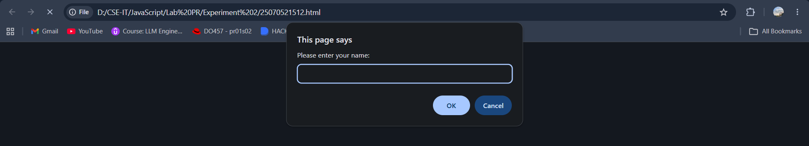
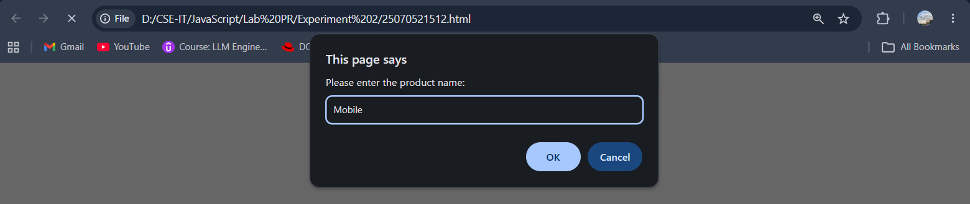

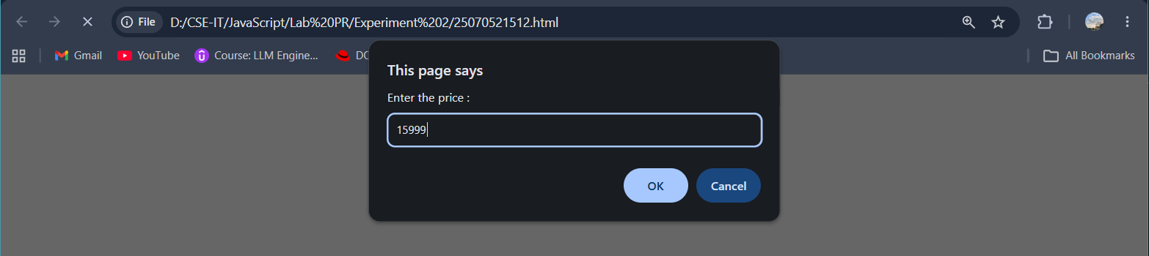
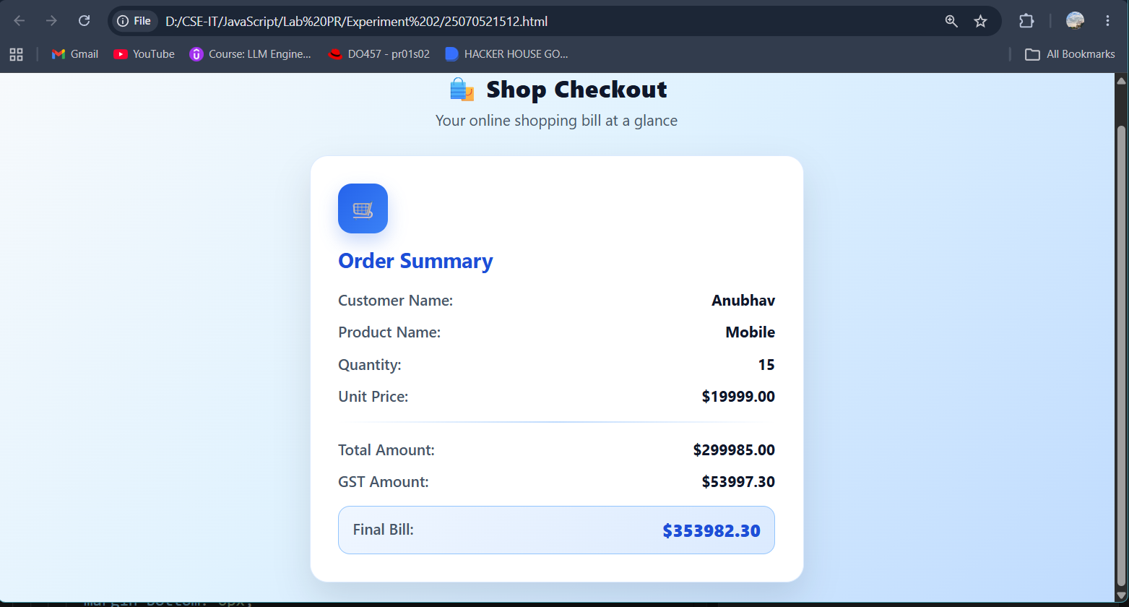

Result: A billing calculator was successfully developed using JavaScript. It accepted user input, calculated the subtotal, GST (18%), and total amount, and displayed a formatted billing receipt on the web page.
Conclusion: The experiment demonstrated the use of var, let, const, prompt(), template literals, and object de-structuring to create an interactive and user-friendly billing application.

Case Study No.: 2
Title: Develop the webpage for an online shopping website with using HTML,CSS and HTML5 tags and calculate the bill using Customer Name, Mobile number, Invoice Number, Product Name, Quality (in Kgs), Rate per Kg(Rs), Discount(%), GST(%), Packing Charges(Rs), Payment Mode (Cash/Card/UPI).
Software/Tools Required: HTML5 , CSS3 , JavaScript , Visual Studio Code , Google Chrome
Code:

Output :

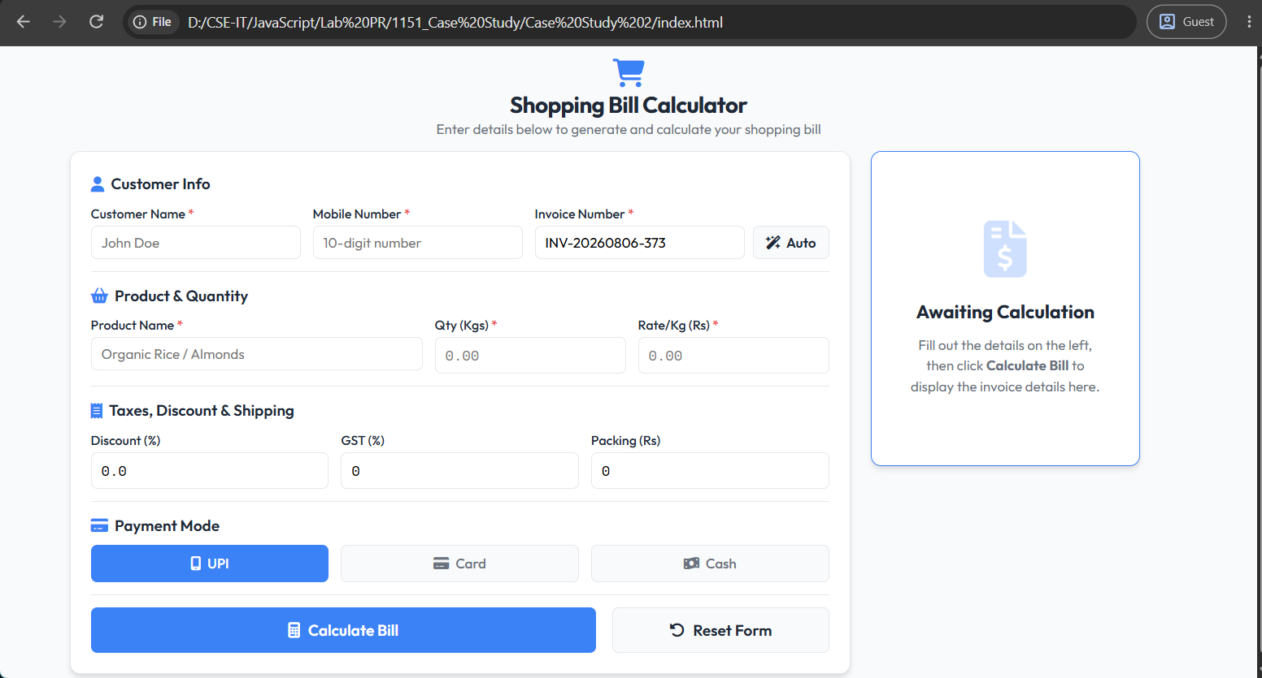

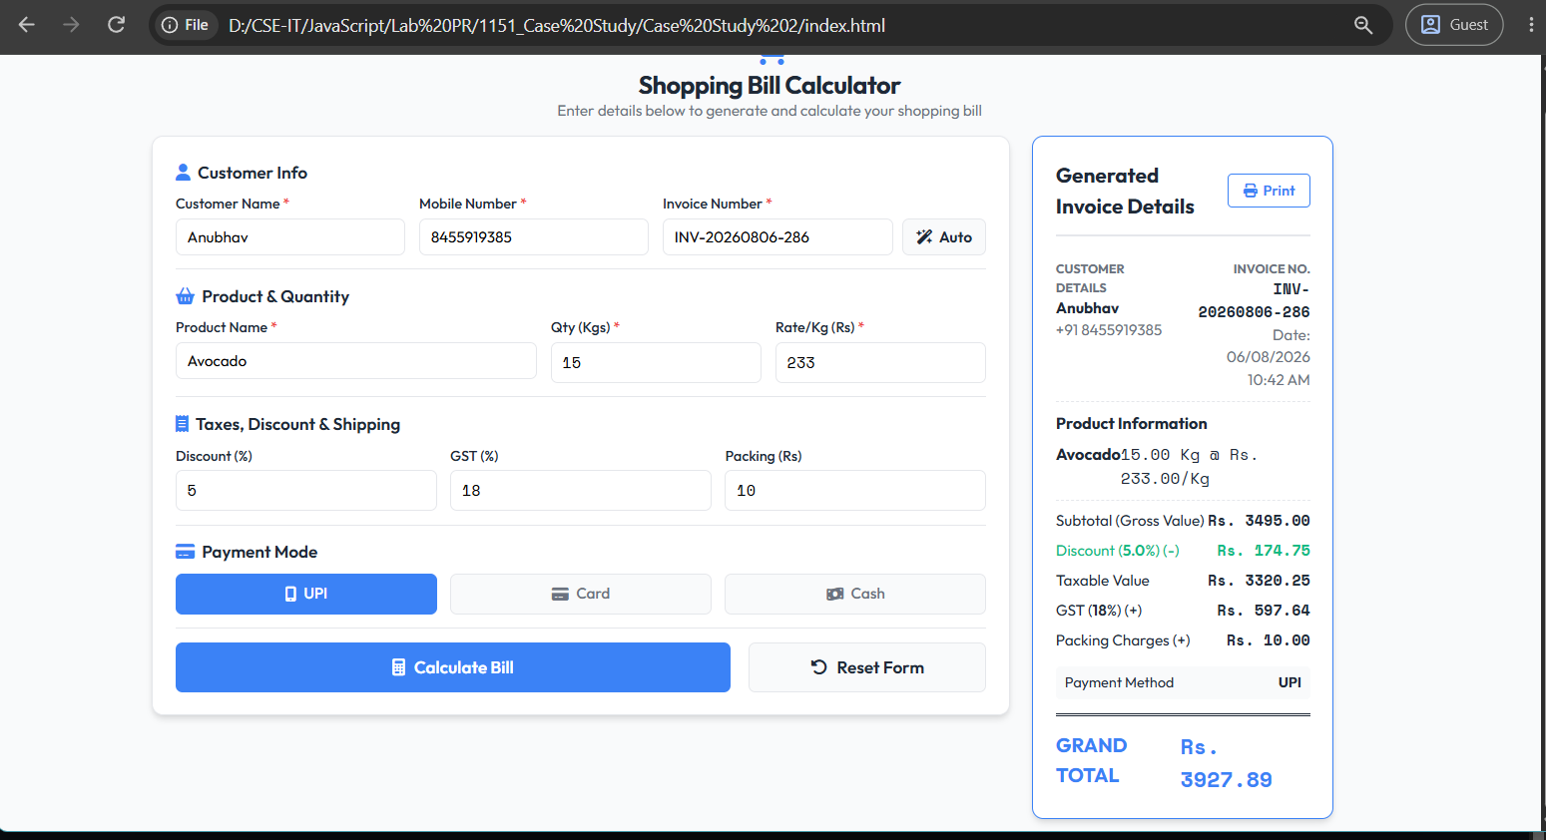

Result: The FreshMart Smart Billing System was successfully developed with a responsive user interface that accurately calculates the bill, applies discounts, GST, and packing charges, and generates a printable invoice.
Conclusion: The experiment demonstrated the use of HTML, CSS, and JavaScript to create an interactive and user-friendly e-commerce billing application with real-time calculations and form validation.

Experiment No.: 3
Title: Implement control structures and form validation; create a grading system based on user-entered marks.
Software/Tools Required: HTML5, CSS3, JavaScript, VS Code, Google Chrome
CODE:

HTML Code:

<!DOCTYPE html>
<html lang="en" data-theme="light">
<head>
<meta charset="UTF-8">
<meta name="viewport" content="width=device-width, initial-scale=1.0">
<title>Student Grading System</title>
<link rel="stylesheet" href="style.css">
</head>
<body>

<div class="dashboard">
<!-- Header -->
<header class="header">
<div class="title-section">
<h1>Student Grading System</h1>
<p>Track, analyze, and evaluate student academic performances</p>
</div>
<button id="themeToggle" class="theme-toggle-btn" aria-label="Toggle Theme">
<!-- Sun/Moon Icon will be injected by JavaScript -->
<svg id="themeIcon" xmlns="http://www.w3.org/2000/svg" fill="none" viewBox="0 0 24 24" stroke="currentColor" stroke-width="2">
<!-- Default moon path -->
<path id="themePath" stroke-linecap="round" stroke-linejoin="round" d="M20.354 15.354A9 9 0 018.646 3.646 9.003 9.003 0 0012 21a9.003 9.003 0 008.354-5.646z" />
</svg>
</button>
</header>
<div class="dashboard-grid">
<!-- Left Panel: Form -->
<form id="gradeForm" class="form-card">
<div>
<div class="section-title">
<svg xmlns="http://www.w3.org/2000/svg" width="16" height="16" viewBox="0 0 24 24" fill="none" stroke="currentColor" stroke-width="2" stroke-linecap="round" stroke-linejoin="round"><path d="M19 21v-2a4 4 0 0 0-4-4H9a4 4 0 0 0-4 4v2"/><circle cx="12" cy="7" r="4"/></svg>
Student Information
</div>
<div class="form-row">
<div class="input-group">
<label for="studentName">Student Name</label>
<div class="input-wrapper">
<svg class="input-icon" xmlns="http://www.w3.org/2000/svg" fill="none" viewBox="0 0 24 24" stroke="currentColor" stroke-width="2">
<path stroke-linecap="round" stroke-linejoin="round" d="M16 7a4 4 0 11-8 0 4 4 0 018 0zM12 14a7 7 0 00-7 7h14a7 7 0 00-7-7z" />
</svg>
<input type="text" id="studentName" placeholder="John Doe" required>
</div>
</div>
<div class="input-group">
<label for="rollNumber">Roll Number</label>
<div class="input-wrapper">
<svg class="input-icon" xmlns="http://www.w3.org/2000/svg" fill="none" viewBox="0 0 24 24" stroke="currentColor" stroke-width="2">
<path stroke-linecap="round" stroke-linejoin="round" d="M9 12h6m-6 4h6m2 5H7a2 2 0 01-2-2V5a2 2 0 012-2h5.586a1 1 0 01.707.293l5.414 5.414a1 1 0 01.293.707V19a2 2 0 01-2 2z" />
</svg>
<input type="text" id="rollNumber" placeholder="e.g. 25070521512" required>
</div>
</div>
</div>
</div>
<div>
<div class="section-title">
<svg xmlns="http://www.w3.org/2000/svg" width="16" height="16" viewBox="0 0 24 24" fill="none" stroke="currentColor" stroke-width="2" stroke-linecap="round" stroke-linejoin="round"><path d="m4 6 8-4 8 4v10l-8 4-8-4z"/><path d="M12 2v20"/><path d="M4 12h16"/></svg>
Academic Scores (0 - 100)
</div>
<div class="form-row" style="margin-bottom: 15px;">
<div class="input-group">
<label for="javascript">JavaScript</label>
<div class="input-wrapper">
<svg class="input-icon" xmlns="http://www.w3.org/2000/svg" fill="none" viewBox="0 0 24 24" stroke="currentColor" stroke-width="2">
<path stroke-linecap="round" stroke-linejoin="round" d="M10 20l4-16m4 4l4 4-4 4M6 16l-4-4 4-4" />
</svg>
<input type="number" id="javascript" min="0" max="100" placeholder="Marks" required>
</div>
</div>
<div class="input-group">
<label for="computer-networks">Computer Networks</label>
<div class="input-wrapper">
<svg class="input-icon" xmlns="http://www.w3.org/2000/svg" fill="none" viewBox="0 0 24 24" stroke="currentColor" stroke-width="2">
<path stroke-linecap="round" stroke-linejoin="round" d="M21 12a9 9 0 01-9 9m9-9a9 9 0 00-9-9m9 9H3m9 9a9 9 0 01-9-9m9 9c1.657 0 3-4.03 3-9s-1.343-9-3-9m0 18c-1.657 0-3-4.03-3-9s1.343-9 3-9m-9 9a9 9 0 019-9" />
</svg>
<input type="number" id="computer-networks" min="0" max="100" placeholder="Marks" required>
</div>
</div>
</div>
<div class="form-row" style="margin-bottom: 15px;">
<div class="input-group">
<label for="compiler-construction">Compiler Construction</label>
<div class="input-wrapper">
<svg class="input-icon" xmlns="http://www.w3.org/2000/svg" fill="none" viewBox="0 0 24 24" stroke="currentColor" stroke-width="2">
<path stroke-linecap="round" stroke-linejoin="round" d="M19 11H5m14 0a2 2 0 012 2v6a2 2 0 01-2 2H5a2 2 0 01-2-2v-6a2 2 0 012-2m14 0V9a2 2 0 00-2-2M5 11V9a2 2 0 012-2m0 0V5a2 2 0 012-2h6a2 2 0 012 2v2M7 7h10" />
</svg>
<input type="number" id="compiler-construction" min="0" max="100" placeholder="Marks" required>
</div>
</div>
<div class="input-group">
<label for="data-compression">Data Compression</label>
<div class="input-wrapper">
<svg class="input-icon" xmlns="http://www.w3.org/2000/svg" fill="none" viewBox="0 0 24 24" stroke="currentColor" stroke-width="2">
<path stroke-linecap="round" stroke-linejoin="round" d="M8 7v12m0 0l-4-4m4 4l4-4m0 6V7m0 0l-4 4m4-4l4 4m5 2a3 3 0 11-6 0 3 3 0 016 0z" />
</svg>
<input type="number" id="data-compression" min="0" max="100" placeholder="Marks" required>
</div>
</div>
</div>
<div class="input-group">
<label for="specialization">Specialization (Data Science/AI/ML)</label>
<div class="input-wrapper">
<svg class="input-icon" xmlns="http://www.w3.org/2000/svg" fill="none" viewBox="0 0 24 24" stroke="currentColor" stroke-width="2">
<path stroke-linecap="round" stroke-linejoin="round" d="M9.663 17h4.673M12 3v1m6.364 1.636l-.707.707M21 12h-1M4 12H3m3.343-5.657l-.707-.707m2.828 9.9a5 5 0 117.072 0l-.548.547A3.374 3.374 0 0014 18.469V19a2 2 0 11-4 0v-.531c0-.895-.356-1.754-.988-2.386l-.548-.547z" />
</svg>
<input type="number" id="specialization" min="0" max="100" placeholder="Marks" required>
</div>
</div>
</div>
<button type="submit" class="submit-btn">
<svg xmlns="http://www.w3.org/2000/svg" width="18" height="18" fill="none" viewBox="0 0 24 24" stroke="currentColor" stroke-width="2.5">
<path stroke-linecap="round" stroke-linejoin="round" d="M9 7h6m0 10v-3m-3 3h.01M9 17h.01M9 14h.01M12 14h.01M15 11h.01M12 11h.01M9 11h.01M7 21h10a2 2 0 002-2V5a2 2 0 00-2-2H7a2 2 0 00-2 2v14a2 2 0 002 2z" />
</svg>
Calculate Result
</button>
</form>
<!-- Right Panel: Result Display -->
<div class="result-card-container" id="resultContainer">
<div class="empty-state">
<svg xmlns="http://www.w3.org/2000/svg" fill="none" viewBox="0 0 24 24" stroke="currentColor">
<path stroke-linecap="round" stroke-linejoin="round" stroke-width="1.5" d="M12 14l9-5-9-5-9 5 9 5zm0 0l6.16-3.422a12.083 12.083 0 01.665 6.479A11.952 11.952 0 0012 20.055a11.952 11.952 0 00-6.824-2.998 12.078 12.078 0 01.665-6.479L12 14zm-4 6v-7.5l4-2.222" />
</svg>
<h3>No Result Calculated</h3>
<p>Enter the student details and subject scores on the left to compute and visualize their official report card.</p>
</div>
</div>
</div>
</div>
<script src="script.js"></script>
</body>
</html>

CSS Code:

@import url("https://fonts.googleapis.com/css2?family=Plus+Jakarta+Sans:wght@400;500;600;700&display=swap");
:root {
--bg-gradient: linear-gradient(135deg, #f8fafc, #e2e8f0);
--card-bg: rgba(255, 255, 255, 0.85);
--card-border: 1px solid rgba(226, 232, 240, 0.8);
--text-primary: #0f172a;
--text-secondary: #475569;
--text-muted: #94a3b8;
--primary: #4f46e5;
--primary-hover: #4338ca;
--primary-light: rgba(79, 70, 229, 0.1);
--success: #10b981;
--success-bg: rgba(16, 185, 129, 0.1);
--fail: #ef4444;
--fail-bg: rgba(239, 68, 68, 0.1);
--shadow:
0 10px 30px -10px rgba(0, 0, 0, 0.05), 0 1px 3px rgba(0, 0, 0, 0.02);
--shadow-hover:
0 20px 40px -15px rgba(79, 70, 229, 0.08), 0 1px 5px rgba(0, 0, 0, 0.03);
--input-bg: #ffffff;
--input-border: #cbd5e1;
--input-focus: #4f46e5;
--card-radius: 20px;
--transition: all 0.3s cubic-bezier(0.4, 0, 0.2, 1);
}
[data-theme="dark"] {
--bg-gradient: linear-gradient(135deg, #090d16, #0f172a);
--card-bg: rgba(15, 23, 42, 0.65);
--card-border: 1px solid rgba(255, 255, 255, 0.06);
--text-primary: #f8fafc;
--text-secondary: #cbd5e1;
--text-muted: #64748b;
--primary: #6366f1;
--primary-hover: #4f46e5;
--primary-light: rgba(99, 102, 241, 0.15);
--success: #34d399;
--success-bg: rgba(52, 211, 153, 0.15);
--fail: #f87171;
--fail-bg: rgba(248, 113, 113, 0.15);
--shadow: 0 10px 30px -10px rgba(0, 0, 0, 0.3), 0 1px 3px rgba(0, 0, 0, 0.1);
--shadow-hover:
0 20px 40px -15px rgba(99, 102, 241, 0.15), 0 1px 5px rgba(0, 0, 0, 0.15);
--input-bg: #1e293b;
--input-border: #334155;
--input-focus: #6366f1;
}
* {
margin: 0;
padding: 0;
box-sizing: border-box;
font-family:
"Plus Jakarta Sans",
-apple-system,
BlinkMacSystemFont,
"Segoe UI",
Roboto,
Helvetica,
Arial,
sans-serif;
}
body {
background: var(--bg-gradient);
color: var(--text-primary);
display: flex;
justify-content: center;
align-items: center;
min-height: 100vh;
padding: 40px 20px;
transition: var(--transition);
}
.dashboard {
width: 100%;
max-width: 1100px;
background: var(--card-bg);
border: var(--card-border);
backdrop-filter: blur(20px);
-webkit-backdrop-filter: blur(20px);
border-radius: var(--card-radius);
padding: 40px;
box-shadow: var(--shadow);
transition: var(--transition);
display: flex;
flex-direction: column;
gap: 30px;
}
.dashboard:hover {
box-shadow: var(--shadow-hover);
}
/* Header Styles */
.header {
display: flex;
justify-content: space-between;
align-items: center;
border-bottom: 1px solid var(--card-border);
padding-bottom: 20px;
}
.title-section h1 {
font-size: 28px;
font-weight: 700;
letter-spacing: -0.5px;
background: linear-gradient(to right, var(--primary), #a855f7);
-webkit-background-clip: text;
-webkit-text-fill-color: transparent;
margin-bottom: 4px;
}
.title-section p {
color: var(--text-secondary);
font-size: 14px;
}
/* Theme Toggle */
.theme-toggle-btn {
background: var(--primary-light);
border: 1px solid var(--card-border);
color: var(--primary);
cursor: pointer;
padding: 10px;
border-radius: 50%;
width: 44px;
height: 44px;
display: flex;
align-items: center;
justify-content: center;
transition: var(--transition);
}
.theme-toggle-btn:hover {
transform: scale(1.05);
background: var(--primary);
color: #ffffff;
}
.theme-toggle-btn svg {
width: 20px;
height: 20px;
}
/* Grid Layout */
.dashboard-grid {
display: grid;
grid-template-columns: 1.2fr 1fr;
gap: 35px;
}
@media (max-width: 900px) {
.dashboard-grid {
grid-template-columns: 1fr;
}
.dashboard {
padding: 24px;
}
}
/* Form Styles */
.form-card {
display: flex;
flex-direction: column;
gap: 25px;
}
.section-title {
font-size: 16px;
font-weight: 600;
color: var(--text-secondary);
display: flex;
align-items: center;
gap: 8px;
margin-bottom: 15px;
text-transform: uppercase;
font-size: 12px;
letter-spacing: 1px;
}
.form-row {
display: grid;
grid-template-columns: 1fr 1fr;
gap: 15px;
}
@media (max-width: 500px) {
.form-row {
grid-template-columns: 1fr;
}
}
.input-group {
display: flex;
flex-direction: column;
gap: 8px;
}
.input-group label {
font-size: 13px;
font-weight: 500;
color: var(--text-secondary);
display: flex;
align-items: center;
gap: 6px;
}
.input-wrapper {
position: relative;
display: flex;
align-items: center;
}
.input-icon {
position: absolute;
left: 12px;
color: var(--text-muted);
pointer-events: none;
width: 16px;
height: 16px;
}
.input-wrapper input {
width: 100%;
padding: 12px 12px 12px 38px;
background: var(--input-bg);
border: 1px solid var(--input-border);
color: var(--text-primary);
border-radius: 10px;
font-size: 14px;
transition: var(--transition);
}
.input-wrapper input:focus {
outline: none;
border-color: var(--input-focus);
box-shadow: 0 0 0 4px var(--primary-light);
}
.input-wrapper input::placeholder {
color: var(--text-muted);
}
/* Chrome/Safari/Edge/Opera hide spinner arrows */
.input-wrapper input::-webkit-outer-spin-button,
.input-wrapper input::-webkit-inner-spin-button {
-webkit-appearance: none;
margin: 0;
}
/* Firefox hide spinner arrows */
.input-wrapper input[type="number"] {
-moz-appearance: textfield;
}
/* Submit Button */
.submit-btn {
width: 100%;
padding: 14px;
background: linear-gradient(135deg, var(--primary), #6366f1);
color: white;
border: none;
border-radius: 12px;
font-size: 15px;
font-weight: 600;
cursor: pointer;
transition: var(--transition);
display: flex;
align-items: center;
justify-content: center;
gap: 8px;
box-shadow: 0 4px 12px rgba(79, 70, 229, 0.25);
margin-top: 10px;
}
.submit-btn:hover {
transform: translateY(-2px);
box-shadow: 0 6px 20px rgba(79, 70, 229, 0.4);
background: linear-gradient(135deg, var(--primary-hover), #4f46e5);
}
.submit-btn:active {
transform: translateY(0);
}
/* Result / Certificate Styles */
.result-card-container {
background: rgba(255, 255, 255, 0.03);
border: 1px dashed var(--card-border);
border-radius: 16px;
padding: 24px;
display: flex;
align-items: center;
justify-content: center;
min-height: 480px;
transition: var(--transition);
position: relative;
overflow: hidden;
}
/* Empty State */
.empty-state {
text-align: center;
display: flex;
flex-direction: column;
align-items: center;
gap: 16px;
color: var(--text-muted);
max-width: 280px;
animation: fadeIn 0.5s ease-out;
}
.empty-state svg {
width: 64px;
height: 64px;
stroke-width: 1.2;
color: var(--primary);
opacity: 0.8;
}
.empty-state h3 {
font-size: 16px;
color: var(--text-secondary);
font-weight: 600;
}
.empty-state p {
font-size: 13px;
line-height: 1.5;
}
/* Result Screen */
.result-content {
width: 100%;
display: flex;
flex-direction: column;
gap: 24px;
animation: slideUp 0.6s cubic-bezier(0.16, 1, 0.3, 1);
}
/* Result Header */
.result-header {
display: flex;
justify-content: space-between;
align-items: flex-start;
border-bottom: 1px solid var(--card-border);
padding-bottom: 16px;
}
.student-info h2 {
font-size: 20px;
font-weight: 700;
color: var(--text-primary);
margin-bottom: 2px;
}
.student-info p {
color: var(--text-muted);
font-size: 13px;
font-weight: 500;
}
/* Badge System */
.badge {
padding: 6px 12px;
border-radius: 20px;
font-size: 12px;
font-weight: 600;
display: inline-flex;
align-items: center;
gap: 6px;
}
.badge-pass {
background: var(--success-bg);
color: var(--success);
border: 1px solid rgba(52, 211, 153, 0.2);
box-shadow: 0 4px 12px rgba(52, 211, 153, 0.1);
}
.badge-fail {
background: var(--fail-bg);
color: var(--fail);
border: 1px solid rgba(248, 113, 113, 0.2);
box-shadow: 0 4px 12px rgba(248, 113, 113, 0.1);
}
/* Overview Section (Circular progress + KPI stats) */
.overview-panel {
display: flex;
align-items: center;
gap: 24px;
background: var(--input-bg);
border: var(--card-border);
border-radius: 14px;
padding: 20px;
}
.progress-circular-wrapper {
position: relative;
width: 100px;
height: 100px;
display: flex;
align-items: center;
justify-content: center;
}
.progress-ring {
transform: rotate(-90deg);
}
.progress-ring__background {
stroke: var(--card-border);
}
.progress-ring__circle {
stroke-linecap: round;
transition: stroke-dashoffset 0.8s ease-out;
}
.progress-percentage {
position: absolute;
font-size: 18px;
font-weight: 700;
color: var(--text-primary);
display: flex;
flex-direction: column;
align-items: center;
}
.progress-percentage span {
font-size: 10px;
color: var(--text-muted);
font-weight: 500;
text-transform: uppercase;
}
.stats-grid {
flex-grow: 1;
display: grid;
grid-template-columns: 1fr 1fr;
gap: 15px;
}
.stat-item {
display: flex;
flex-direction: column;
gap: 4px;
}
.stat-label {
font-size: 11px;
font-weight: 600;
text-transform: uppercase;
letter-spacing: 0.5px;
color: var(--text-muted);
}
.stat-value {
font-size: 20px;
font-weight: 700;
color: var(--text-primary);
}
.stat-value.grade {
color: var(--primary);
font-size: 24px;
}
/* Subjects Performance List */
.performance-list {
display: flex;
flex-direction: column;
gap: 12px;
}
.performance-header {
font-size: 12px;
font-weight: 600;
text-transform: uppercase;
letter-spacing: 1px;
color: var(--text-muted);
margin-bottom: 4px;
}
.subject-row {
display: flex;
flex-direction: column;
gap: 6px;
padding: 10px;
border-radius: 8px;
background: var(--input-bg);
border: 1px solid var(--card-border);
}
.subject-details {
display: flex;
justify-content: space-between;
font-size: 13px;
font-weight: 500;
}
.subject-name {
color: var(--text-secondary);
}
.subject-score {
font-weight: 600;
color: var(--text-primary);
}
.subject-score span {
color: var(--text-muted);
font-weight: 400;
}
.subject-progress-container {
width: 100%;
height: 6px;
background: var(--card-border);
border-radius: 3px;
overflow: hidden;
}
.subject-progress-bar {
height: 100%;
border-radius: 3px;
transition: width 0.8s ease-out;
}
/* Color codes for subject bars based on scores */
.bar-excellent {
background: var(--success);
}
.bar-warning {
background: #f59e0b; /* Yellow/Orange warning */
}
.bar-danger {
background: var(--fail);
}
/* Remarks Card */
.remarks-card {
background: var(--primary-light);
border-left: 4px solid var(--primary);
padding: 12px 16px;
border-radius: 0 8px 8px 0;
font-size: 13px;
font-weight: 500;
line-height: 1.5;
color: var(--text-secondary);
}
.remarks-card strong {
color: var(--text-primary);
}
/* Animations */
@keyframes fadeIn {
from {
opacity: 0;
transform: translateY(5px);
}
to {
opacity: 1;
transform: translateY(0);
}
}
@keyframes slideUp {
from {
opacity: 0;
transform: translateY(20px);
}
to {
opacity: 1;
transform: translateY(0);
}
}

JavaScript Code:

const gradeForm = document.getElementById("gradeForm");

// Theme Toggling Logic
const themeToggle = document.getElementById("themeToggle");
const themeIcon = document.getElementById("themeIcon");

// SVGs paths for Moon and Sun
const moonPath = "M20.354 15.354A9 9 0 018.646 3.646 9.003 9.003 0 0012 21a9.003 9.003 0 008.354-5.646z";
const sunPath = "M12 3v1m0 16v1m9-9h-1M4 12H3m15.364-6.364l-.707.707M6.343 17.657l-.707.707m0-12.728l.707.707m12.728 12.728l.707.707M12 8a4 4 0 100 8 4 4 0 000-8z";

function updateThemeUI(theme) {
if (theme === "dark") {
themeIcon.innerHTML = `<path stroke-linecap="round" stroke-linejoin="round" d="${sunPath}" />`;
} else {
themeIcon.innerHTML = `<path stroke-linecap="round" stroke-linejoin="round" d="${moonPath}" />`;
}
}

// Initial Theme setup
const savedTheme = localStorage.getItem("theme") || "light";
document.documentElement.setAttribute("data-theme", savedTheme);
updateThemeUI(savedTheme);

themeToggle.addEventListener("click", () => {
const currentTheme = document.documentElement.getAttribute("data-theme");
const newTheme = currentTheme === "dark" ? "light" : "dark";
document.documentElement.setAttribute("data-theme", newTheme);
localStorage.setItem("theme", newTheme);
updateThemeUI(newTheme);
});

// Calculation Logic
gradeForm.addEventListener("submit", function (event) {
event.preventDefault();

const name = document.getElementById("studentName").value.trim();
const rollNumber = document.getElementById("rollNumber").value.trim();

const javascript = Number(document.getElementById("javascript").value);
const computerNetworks = Number(document.getElementById("computer-networks").value);
const compilerConstruction = Number(document.getElementById("compiler-construction").value);
const dataCompression = Number(document.getElementById("data-compression").value);
const specialization = Number(document.getElementById("specialization").value);

const marks = [
javascript,
computerNetworks,
compilerConstruction,
dataCompression,
specialization
];

if (name === "") {
alert("Please enter Student Name.");
return;
}
if (rollNumber === "") {
alert("Please enter Roll Number.");
return;
}

for (let mark of marks) {
if (isNaN(mark) || mark === "" || document.getElementById("javascript").value === "") {
alert("Please enter all subject marks.");
return;
}
if (mark < 0 || mark > 100) {
alert("Marks should be between 0 and 100.");
return;
}
}

const total = marks.reduce((sum, mark) => sum + mark, 0);
const percentage = (total / 500) * 100;

let status = "Pass";
for (let mark of marks) {
if (mark < 35) {
status = "Fail";
break;
}
}

let grade;
if (status === "Fail") {
grade = "F";
} else if (percentage >= 90) {
grade = "A+";
} else if (percentage >= 80) {
grade = "A";
} else if (percentage >= 70) {
grade = "B";
} else if (percentage >= 60) {
grade = "C";
} else if (percentage >= 50) {
grade = "D";
} else {
grade = "F";
}
let remarks;
switch (grade) {
case "A+":
remarks = "Outstanding academic performance!";
break;
case "A":
remarks = "Excellent results! Keep up the great work.";
break;
case "B":
remarks = "Very good effort. Continuous progress observed.";
break;
case "C":
remarks = "Good performance. Room for higher achievements.";
break;
case "D":
remarks = "Passed, but needs significant improvement.";
break;
default:
remarks = "Better luck next time. Focus on fundamental concepts.";
}
const studentResult = {
name,
rollNumber,
total,
percentage: percentage.toFixed(2),
grade,
status,
remarks,
subjects: {
javascript,
computerNetworks,
compilerConstruction,
dataCompression,
specialization
}
};
localStorage.setItem("studentResult", JSON.stringify(studentResult));
displayResult(studentResult);
});
function displayResult(data) {
const resultContainer = document.getElementById("resultContainer");
// Graceful fallback for older localStorage formats
const subjects = data.subjects || {
javascript: 0,
computerNetworks: 0,
compilerConstruction: 0,
dataCompression: 0,
specialization: 0
};
const percentage = Number(data.percentage);
// Radius of circular chart is 38. Circumference C = 2 * pi * 38 = 238.76
const circumference = 2 * Math.PI * 38;
const offset = circumference - (percentage / 100) * circumference;

const isPass = data.status === "Pass";
const badgeClass = isPass ? "badge-pass" : "badge-fail";
// SVGs for success/failure status badges
const statusIcon = isPass
? `<svg xmlns="http://www.w3.org/2000/svg" width="14" height="14" fill="none" viewBox="0 0 24 24" stroke="currentColor" stroke-width="2.5"><path stroke-linecap="round" stroke-linejoin="round" d="M5 13l4 4L19 7" /></svg>`
: `<svg xmlns="http://www.w3.org/2000/svg" width="14" height="14" fill="none" viewBox="0 0 24 24" stroke="currentColor" stroke-width="2.5"><path stroke-linecap="round" stroke-linejoin="round" d="M6 18L18 6M6 6l12 12" /></svg>`;
// Determine performance level for custom progress bars styling
const getBarClass = (score) => {
if (score >= 75) return "bar-excellent";
if (score >= 35) return "bar-warning";
return "bar-danger";
};
resultContainer.innerHTML = `
<div class="result-content">
<!-- Student Header Profile -->
<div class="result-header">
<div class="student-info">
<h2>${data.name}</h2>
<p>Roll Number: ${data.rollNumber}</p>
</div>
<span class="badge ${badgeClass}">
${statusIcon}
${data.status}
</span>
</div>
<!-- Main Score Overview -->
<div class="overview-panel">
<div class="progress-circular-wrapper">
<svg class="progress-ring" width="90" height="90">
<circle class="progress-ring__background" stroke-width="6" fill="transparent" r="38" cx="45" cy="45"/>
<circle class="progress-ring__circle" stroke="${isPass ? 'var(--success)' : 'var(--fail)'}" stroke-width="6" fill="transparent" r="38" cx="45" cy="45"
stroke-dasharray="${circumference}"
stroke-dashoffset="${offset}" />
</svg>
<div class="progress-percentage">
${percentage}%
<span>Score</span>
</div>
</div>
<div class="stats-grid">
<div class="stat-item">
<span class="stat-label">Total Marks</span>
<span class="stat-value">${data.total} <span style="font-size: 13px; font-weight: 500; color: var(--text-muted);">/ 500</span></span>
</div>
<div class="stat-item">
<span class="stat-label">Overall Grade</span>
<span class="stat-value grade" style="color: ${isPass ? 'var(--primary)' : 'var(--fail)'}">${data.grade}</span>
</div>
</div>
</div>
<!-- Subject-wise Breakdown -->
<div class="performance-list">
<div class="performance-header">Subject breakdown</div>

<div class="subject-row">
<div class="subject-details">
<span class="subject-name">JavaScript</span>
<span class="subject-score">${subjects.javascript} <span>/ 100</span></span>
</div>
<div class="subject-progress-container">
<div class="subject-progress-bar ${getBarClass(subjects.javascript)}" style="width: ${subjects.javascript}%"></div>
</div>
</div>

<div class="subject-row">
<div class="subject-details">
<span class="subject-name">Computer Networks</span>
<span class="subject-score">${subjects.computerNetworks} <span>/ 100</span></span>
</div>
<div class="subject-progress-container">
<div class="subject-progress-bar ${getBarClass(subjects.computerNetworks)}" style="width: ${subjects.computerNetworks}%"></div>
</div>
</div>
<div class="subject-row">
<div class="subject-details">
<span class="subject-name">Compiler Construction</span>
<span class="subject-score">${subjects.compilerConstruction} <span>/ 100</span></span>
</div>
<div class="subject-progress-container">
<div class="subject-progress-bar ${getBarClass(subjects.compilerConstruction)}" style="width: ${subjects.compilerConstruction}%"></div>
</div>
</div>
<div class="subject-row">
<div class="subject-details">
<span class="subject-name">Data Compression</span>
<span class="subject-score">${subjects.dataCompression} <span>/ 100</span></span>
</div>
<div class="subject-progress-container">
<div class="subject-progress-bar ${getBarClass(subjects.dataCompression)}" style="width: ${subjects.dataCompression}%"></div>
</div>
</div>
<div class="subject-row">
<div class="subject-details">
<span class="subject-name">Specialization</span>
<span class="subject-score">${subjects.specialization} <span>/ 100</span></span>
</div>
<div class="subject-progress-container">
<div class="subject-progress-bar ${getBarClass(subjects.specialization)}" style="width: ${subjects.specialization}%"></div>
</div>
</div>
</div>
<!-- Remarks -->
<div class="remarks-card" style="border-left-color: ${isPass ? 'var(--primary)' : 'var(--fail)'}; background: ${isPass ? 'var(--primary-light)' : 'var(--fail-bg)'}">
<strong>Remarks:</strong> ${data.remarks}
</div>
</div>
`;
}
window.onload = function () {
const savedData = localStorage.getItem("studentResult");
if (savedData) {
try {
displayResult(JSON.parse(savedData));
} catch (e) {
console.error("Error loading saved grading results:", e);
localStorage.removeItem("studentResult"); // Wipe corrupted storage
}
}
};

Output:

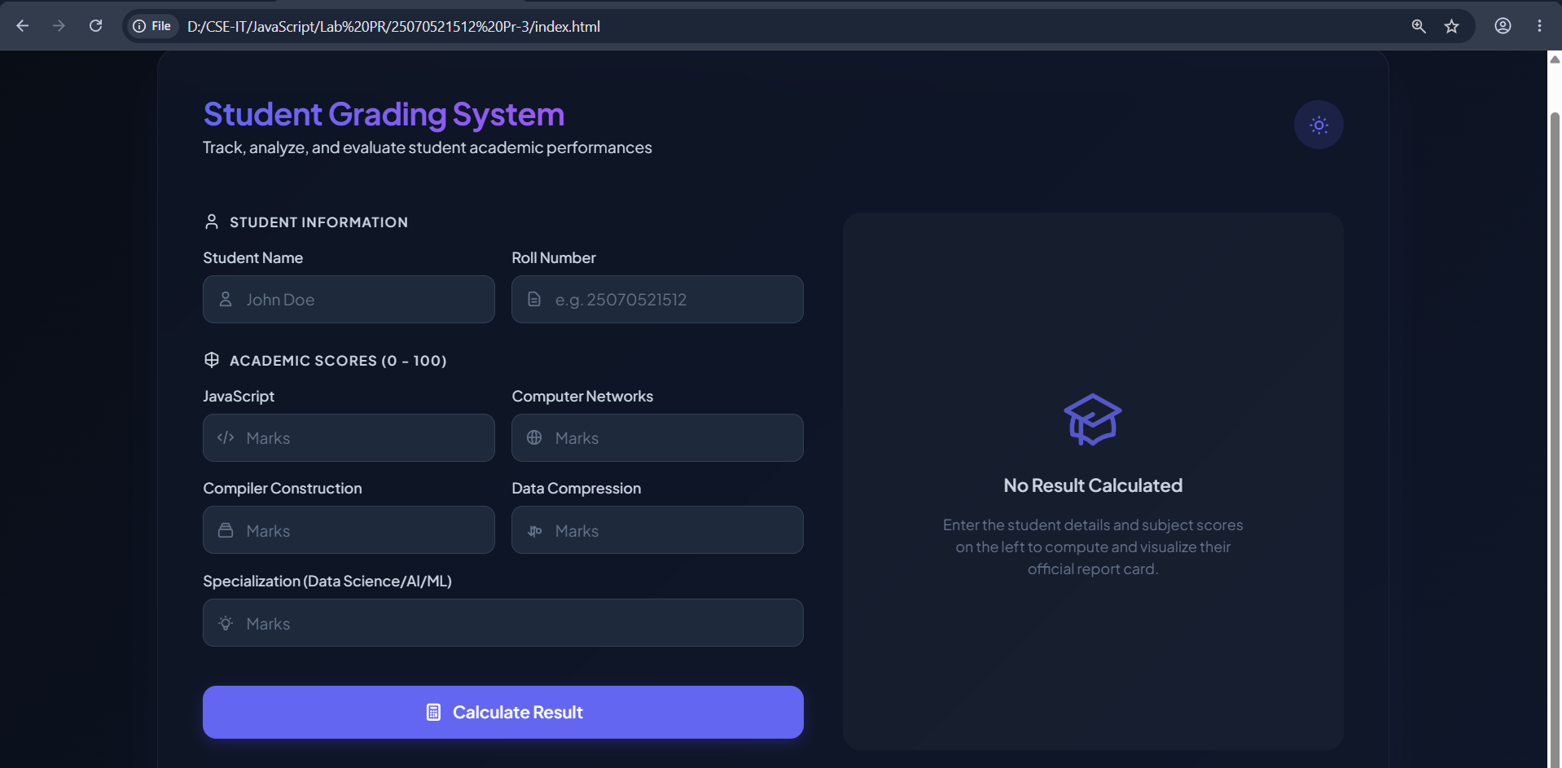
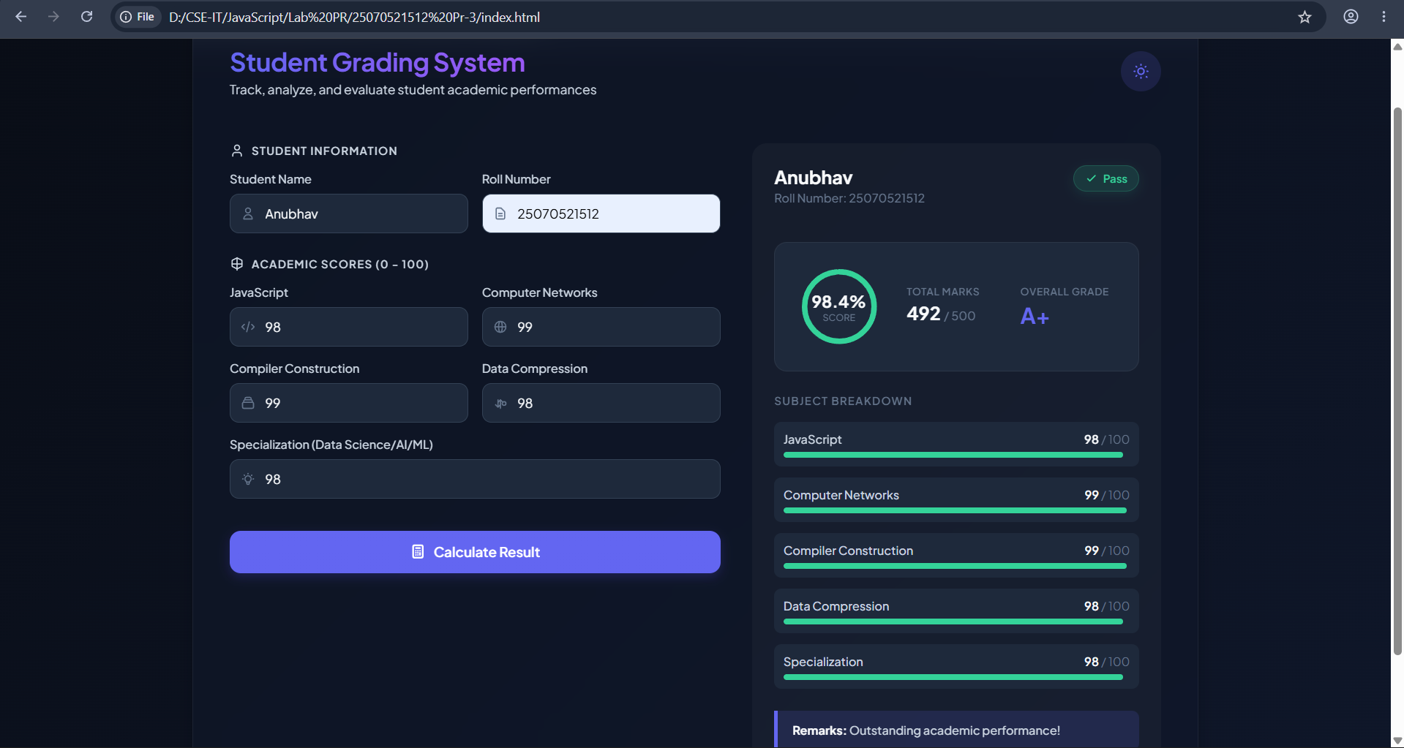

Result: The Student Grading System was successfully implemented using HTML, CSS, and JavaScript. It validates user input, calculates the percentage, assigns grades using control structures, and displays the result accurately on a separate result page.
Conclusion: The Student Grading System successfully demonstrates the use of HTML, CSS, and JavaScript to create an interactive web application. It implements form validation, control structures, loops, and Local Storage to process user input and generate an accurate student result. The project provides a professional and user-friendly interface while reinforcing fundamental concepts of client-side web development.

Case Study No.: 3
Title: Student Grading System with Login Authentication and Form Validation using HTML, CSS, and JavaScript
Software/Tools Required: HTML5 , CSS3 , JavaScript , Visual Studio Code , Google Chrome
Index.html:
<!DOCTYPE html>
<html lang="en">
<head>
<meta charset="UTF-8">
<meta name="viewport" content="width=device-width, initial-scale=1.0">
<title>Student Grading System</title>
<link rel="stylesheet" href="style.css">
</head>
<body>
<div class="container">
<h1>Enter Subject Marks</h1>
<form id="gradeForm">
<div class="input-group">
<label>JavaScript</label>
<input
type="number"
id="javascript"
placeholder="Enter Marks"
min="0"
max="100"
required
>
</div>
<div class="input-group">
<label>Computer Networks</label>
<input
type="number"
id="computer-networks"
placeholder="Enter Marks"
min="0"
max="100"
required
>
</div>
<div class="input-group">
<label>Compiler Construction</label>
<input
type="number"
id="compiler-construction"
placeholder="Enter Marks"
min="0"
max="100"
required
>
</div>
<div class="input-group">
<label>Data Compression</label>
<input
type="number"
id="data-compression"
placeholder="Enter Marks"
min="0"
max="100"
required
>
</div>
<div class="input-group">
<label>Specialization (AI / ML / Data Science)</label>
<input
type="number"
id="specialization"
placeholder="Enter Marks"
min="0"
max="100"
required
>
</div>
<button type="submit">
Generate Result
</button>
<button type="reset" class="reset-btn">
Reset
</button>
</form>
</div>
<script src="script.js"></script>
</body>
</html>
Login.html:
<!DOCTYPE html>
<html lang="en">
<head>
<meta charset="UTF-8">
<meta name="viewport" content="width=device-width, initial-scale=1.0">
<title>Student Login</title>
<link rel="stylesheet" href="style.css">
</head>
<body>
<div class="container">
<h1>Student Login</h1>
<form id="loginForm">
<div class="input-group">
<label>Student Name</label>
<input
type="text"
id="studentName"
placeholder="Enter Student Name"
required
>
</div>
<div class="input-group">
<label>PRN Number</label>
<input
type="text"
id="prn"
placeholder="Enter PRN Number"
required
>
</div>
<div class="input-group">
<label>Password</label>
<input
type="password"
id="password"
placeholder="Enter Password"
required
>
</div>
<button type="submit">
Login
</button>
</form>
<p
id="message"
style="
text-align:center;
margin-top:20px;
color:red;
font-weight:bold;">
</p>
</div>
<script src="login.js"></script>
</body>
</html>

Login.js:
const loginForm = document.getElementById("loginForm");
loginForm.addEventListener("submit", function(event){
event.preventDefault();
const studentName = document.getElementById("studentName").value.trim();
const prn = document.getElementById("prn").value.trim();
const password = document.getElementById("password").value;
const message = document.getElementById("message");
message.innerHTML = "";

if(studentName === ""){
message.innerHTML = "Please enter Student Name.";
return;
}
if(prn === ""){
message.innerHTML = "Please enter PRN Number.";
return;
}

if(!/^[0-9]+$/.test(prn)){
message.innerHTML = "PRN should contain only digits.";
return;
}
if(password.length < 8){
message.innerHTML =
"Password must contain at least 8 characters.";
return;
}
if(!/[A-Z]/.test(password)){
message.innerHTML =
"Password must contain at least one uppercase letter.";
return;
}
if(!/[a-z]/.test(password)){
message.innerHTML =
"Password must contain at least one lowercase letter.";
return;
}
if(!/[0-9]/.test(password)){
message.innerHTML =
"Password must contain at least one number.";
return;
}
if(!/[!@#$%^&*(),.?":{}|<>]/.test(password)){
message.innerHTML =
"Password must contain at least one special character.";
return;
}
const student = {
name: studentName,
prn: prn
};
localStorage.setItem(
"loggedInStudent",
JSON.stringify(student)
);
window.location.href = "index.html";
});

Result.html:
<!DOCTYPE html>
<html lang="en">
<head>
<meta charset="UTF-8">
<meta name="viewport"
content="width=device-width, initial-scale=1.0">
<title>Student Result</title>
<link rel="stylesheet" href="style.css">
</head>
<body>
<div class="container result-container">
<h1>Student Grade Report</h1>
<div id="resultCard">
<!-- Result will be loaded here -->
</div>
<div class="button-group">
<button onclick="goBack()">
Back
</button>
</div>
</div>
<script src="result.js"></script>
</body>
</html>

Result.js:
const student = JSON.parse(localStorage.getItem("studentResult"));
const resultCard = document.getElementById("resultCard");
if (student === null) {
resultCard.innerHTML = `
<h2 style="color:red;text-align:center;">
No Student Data Found
</h2>
<p style="text-align:center;">
Please enter student details first.
</p>
`;
}
else {
resultCard.innerHTML = `
<table>
<tr>
<th colspan="2">
Student Information
</th>
</tr>
<tr>
<td><strong>Student Name</strong></td>
<td>${student.studentName}</td>
</tr>
<tr>
<td><strong>Roll Number</strong></td>
<td>${student.rollNumber}</td>
</tr>
</table>
<br>
<table>
<tr>
<th>Subject</th>
<th>Marks</th>
</tr>
<tr>
<td>JavaScript</td>
<td>${student.javascript}</td>
</tr>
<tr>
<td>Computer Networks</td>
<td>${student.computerNetworks}</td>
</tr>
<tr>
<td>Compiler Construction</td>
<td>${student.compilerConstruction}</td>
</tr>
<tr>
<td>Data Compression</td>
<td>${student.dataCompression}</td>
</tr>
<tr>
<td>Specialization</td>
<td>${student.specialization}</td>
</tr>
</table>
<br>
<table>
<tr>
<th colspan="2">
Result Summary
</th>
</tr>
<tr>
<td><strong>Total Marks</strong></td>
<td>${student.total} / 500</td>
</tr>
<tr>
<td><strong>Percentage</strong></td>
<td>${student.percentage}%</td>
</tr>
<tr>
<td><strong>Grade</strong></td>
<td class="grade">${student.grade}</td>
</tr>
<tr>
<td><strong>Status</strong></td>
<td class="${student.status === "Pass" ? "success" : "fail"}">
${student.status}
</td>
</tr>
<tr>
<td><strong>Remarks</strong></td>
<td>${student.remarks}</td>
</tr>
</table>
`;
}
function goBack() {
window.location.href = "index.html";
}

Script.js:
const loginStudent = JSON.parse(localStorage.getItem("loggedInStudent"));
if (!loginStudent) {
window.location.href = "login.html";
}
const gradeForm = document.getElementById("gradeForm");
gradeForm.addEventListener("submit", function (event) {
event.preventDefault();
const studentName = loginStudent.name;
const rollNumber = loginStudent.prn;
const javascript = Number(document.getElementById("javascript").value);
const computerNetworks = Number(document.getElementById("computer-networks").value);
const compilerConstruction = Number(document.getElementById("compiler-construction").value);
const dataCompression = Number(document.getElementById("data-compression").value);
const specialization = Number(document.getElementById("specialization").value);
const marks = [
javascript,
computerNetworks,
compilerConstruction,
dataCompression,
specialization
];
const subjectNames = [
"JavaScript",
"Computer Networks",
"Compiler Construction",
"Data Compression",
"Specialization"
];
for (let i = 0; i < marks.length; i++) {
if (isNaN(marks[i])) {
alert("Please enter " + subjectNames[i] + " marks.");
return;
}
if (marks[i] < 0 || marks[i] > 100) {
alert(subjectNames[i] + " marks should be between 0 and 100.");
return;
}
}
let total = 0;
for (let mark of marks) {
total += mark;
}
const percentage = (total / 500) * 100;
let status = "Pass";
for (let mark of marks) {
if (mark < 35) {
status = "Fail";
break;
}
}
let grade = "";
if (status === "Fail") {
grade = "F";
}
else if (percentage >= 90) {
grade = "A+";
}
else if (percentage >= 80) {
grade = "A";
}
else if (percentage >= 70) {
grade = "B";
}
else if (percentage >= 60) {
grade = "C";
}
else if (percentage >= 50) {
grade = "D";
}
else {
grade = "F";
}
let remarks = "";
switch (grade) {
case "A+":
remarks = "Outstanding";
break;
case "A":
remarks = "Excellent";
break;
case "B":
remarks = "Very Good";
break;
case "C":
remarks = "Good";
break;
case "D":
remarks = "Needs Improvement";
break;
default:
remarks = "Better Luck Next Time";
}
const studentResult = {
studentName,
rollNumber,
javascript,
computerNetworks,
compilerConstruction,
dataCompression,
specialization,
total,
percentage: percentage.toFixed(2),
grade,
status,
remarks
};
localStorage.setItem(
"studentResult",
JSON.stringify(studentResult)
);
window.location.href = "result.html";
});

Style.css:
*{
margin:0;
padding:0;
box-sizing:border-box;
font-family: Ballance;
}

body{
background:linear-gradient(135deg,#99c6ee,#a4e5f0);
display:flex;
justify-content:center;
align-items:center;
min-height:100vh;
}

.container{
width: 1000px;
background:#c7e0f4;
padding:30px;
border-radius:15px;
box-shadow:0 10px 25px rgba(0,0,0,.2);
}

h1{
text-align:center;
margin-bottom:25px;
color:#0e0e0f;
}

.input-group{
margin-bottom:15px;
}

label{
display:block;
margin-bottom:6px;
font-weight:bold;
}

input{
width:100%;
padding:10px;
border:1px solid #d2e4fd;
border-radius:8px;
font-size:15px;
}

input:focus{
outline:none;
border-color:#0d6efd;
}

button{
width:100%;
padding:12px;
background:#0c48a1;
color:white;
border:none;
border-radius:8px;
font-size:16px;
cursor:pointer;
}

button:hover{
background:#084298;
}

#result{
margin-top:20px;
display:none;
padding:15px;
background:#f5f8ff;
border-radius:10px;
}

table{
width:100%;
border-collapse:collapse;
}

td{
padding:10px;
border-bottom:1px solid #ddd;
}

.success{
color:green;
font-weight:bold;
}
.fail{
color:red;
font-weight:bold;
}

Output:
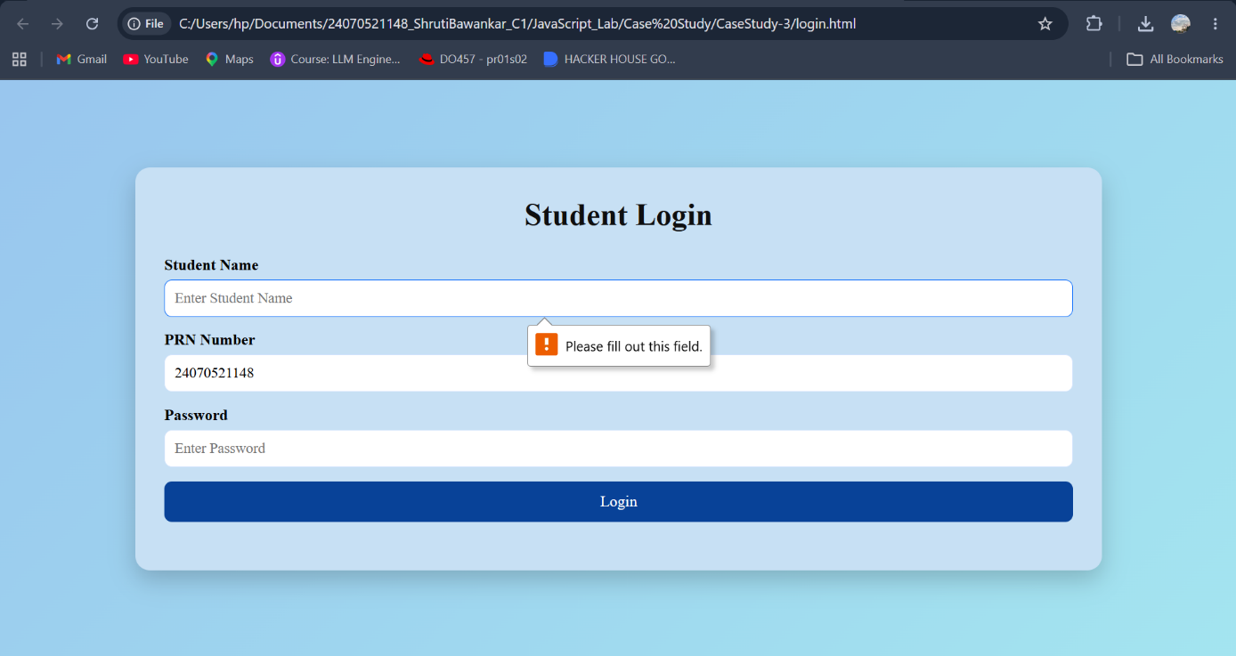
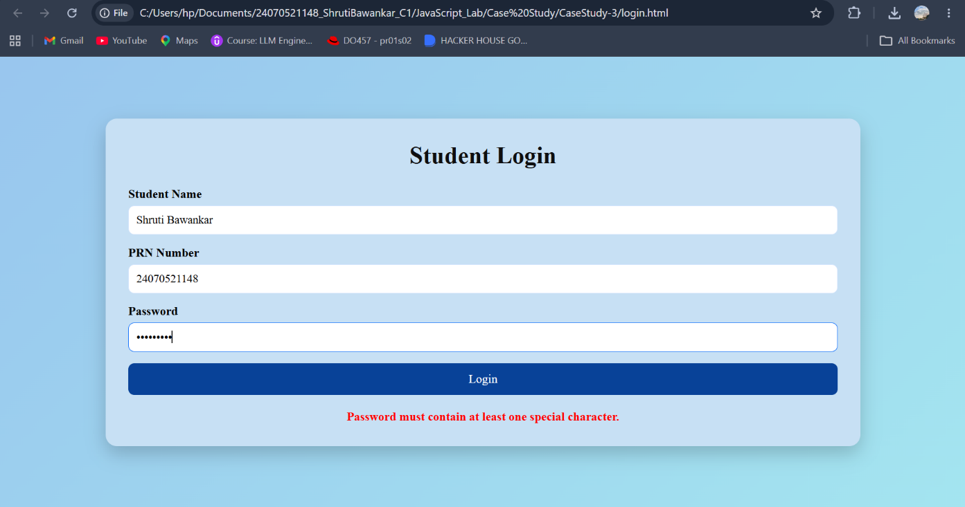
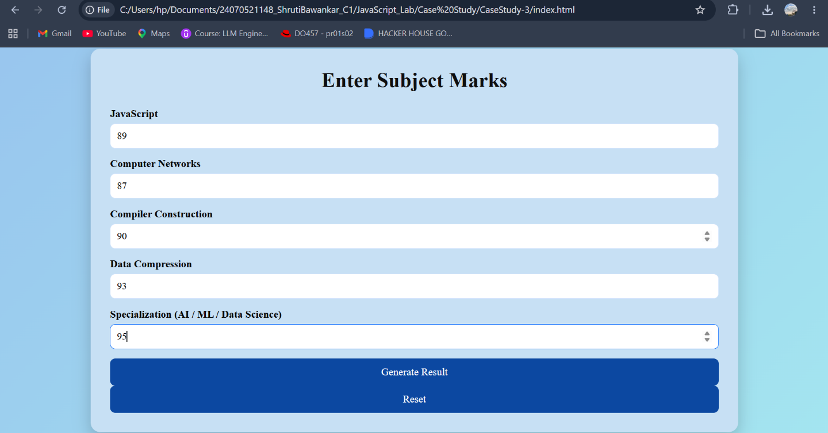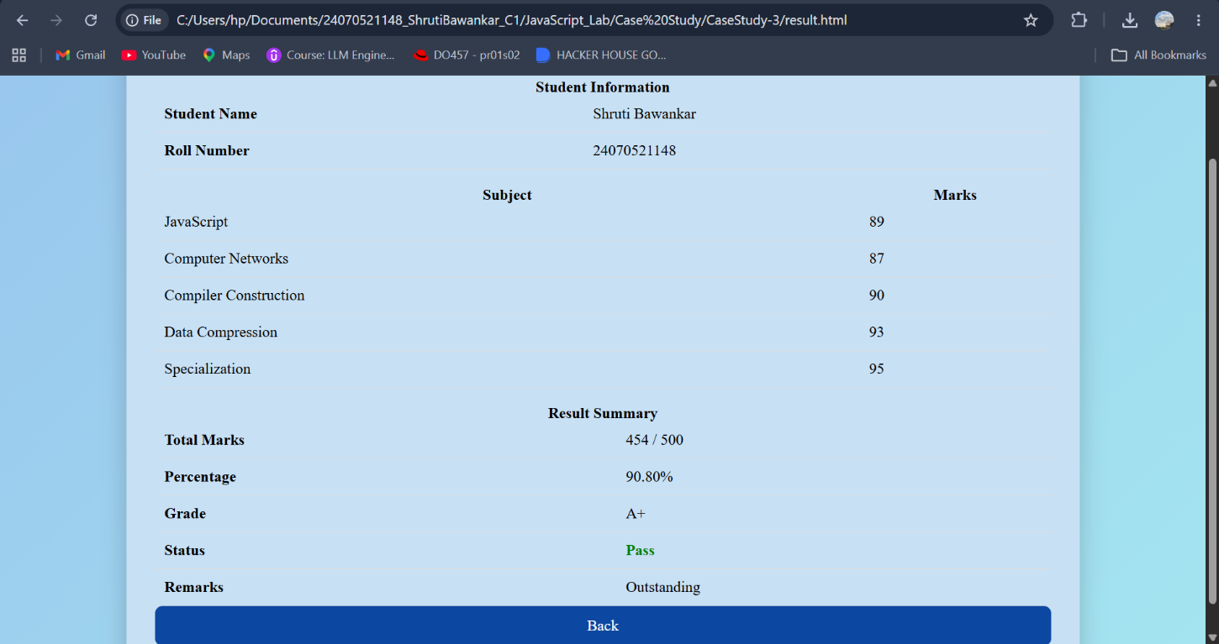
Result: The Student Grading System was successfully developed to validate user credentials, process student marks, calculate grades, and display the results accurately on a separate result page.
Conclusion: This project successfully demonstrates the implementation of JavaScript form validation and control structures, providing a simple, secure, and user-friendly web application for student result management.
Experiment No.: 4
Title: Use function types, scope, and closures; apply try-catch; build a palindrome checker.
Software/Tools Required: HTML5, CSS3, JavaScript, VS Code, Google Chrome
Index.html:
<!DOCTYPE html>
<html lang="en">
<head>
<meta charset="UTF-8">
<meta name="viewport" content="width=device-width, initial-scale=1.0">
<title>Palindrome Checker</title>
<style>
body {
font-family: Georgia, sans-serif;
background: #f8f2d9;
display: flex;
justify-content: center;
align-items: center;
height: 100vh;
}
.container {
background: white;
padding: 25px;
border-radius: 10px;
width: 350px;
box-shadow: 0px 0px 10px rgb(27, 21, 21);
text-align: center;
}
input {
width: 90%;
padding: 10px;
margin: 10px 0;
font-size: 16px;
}
button {
padding: 10px 20px;
background: royalblue;
color: white;
border: none;
border-radius: 5px;
cursor: pointer;
}
button:hover {
background: darkblue;
}
#result {
margin-top: 20px;
font-size: 18px;
font-weight: bold;
}
#counter {
color: green;
margin-top: 10px;
}
</style>
</head>
<body>
<div class="container">
<h2>Palindrome Checker</h2>
<input type="text" id="word" placeholder="Enter a word">
<br>
<button onclick="checkPalindrome()">Check</button>
<p id="result"></p>
<p id="counter"></p>
</div>
<script src="script.js"></script>
</body>
</html>

Script.js:
let appName = "Palindrome Checker";
function visitCounter() {
let count = 0;
return function () {
count++;
return count;
};
}
const counter = visitCounter();
function isPalindrome(text) {
let cleaned = text.toLowerCase().replace(/[^a-z0-9]/g, "");
let reversed = cleaned.split("").reverse().join("");
return cleaned === reversed;
}
const displayMessage = function(message, color) {
const result = document.getElementById("result");
result.innerHTML = message;
result.style.color = color;

};
const updateCounter = () => {
document.getElementById("counter").innerHTML =
"Checked " + counter() + " time(s)";
};
function checkPalindrome() {
try {
let input = document.getElementById("word").value;
if (input.trim() === "") {
throw "Input cannot be empty.";
}
if (isPalindrome(input)) {
displayMessage(
`"${input}" is a Palindrome`,
"green"
);
} else {
displayMessage(
`"${input}" is NOT a Palindrome`,
"red"
);
}
updateCounter();
}
catch(error) {
displayMessage(error, "orange");
}
}

Output:
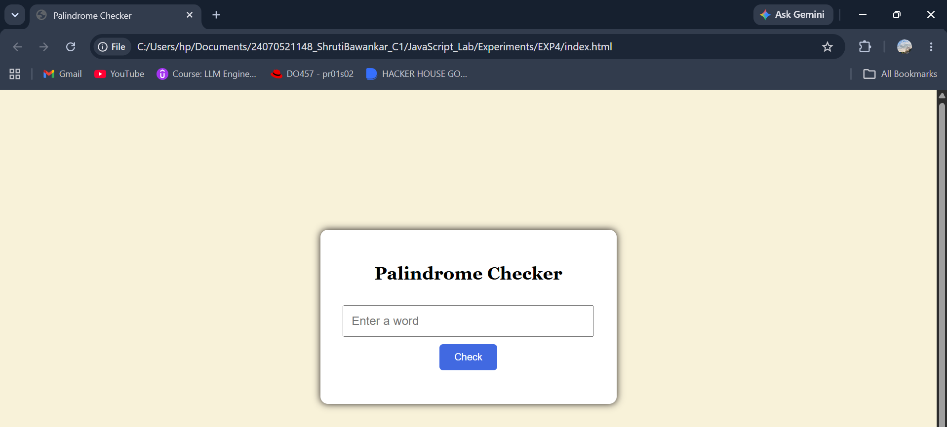
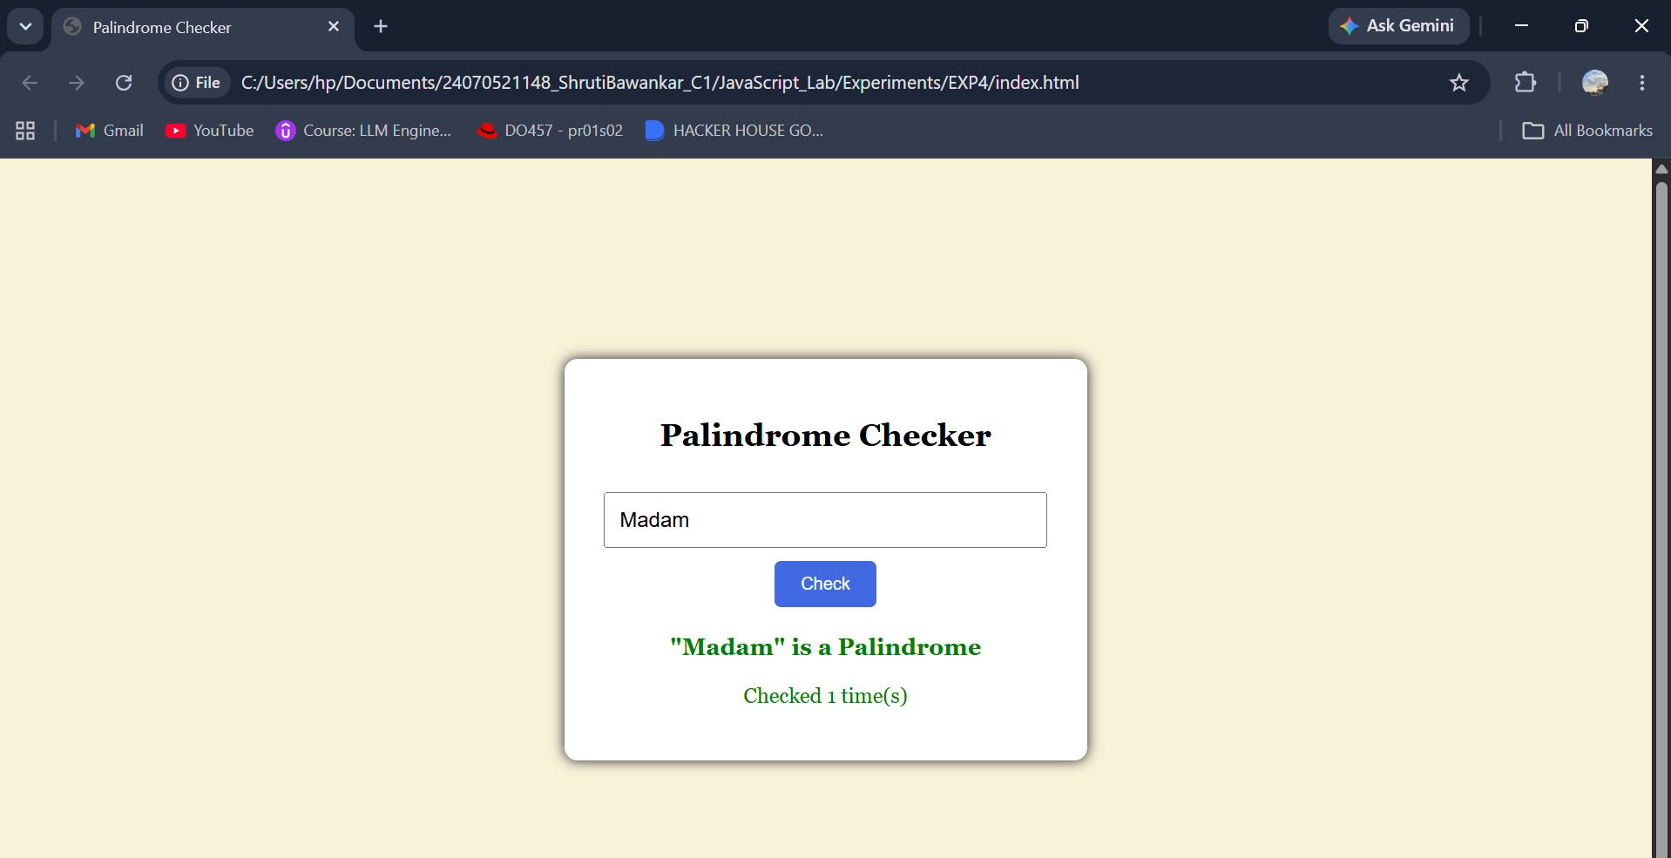
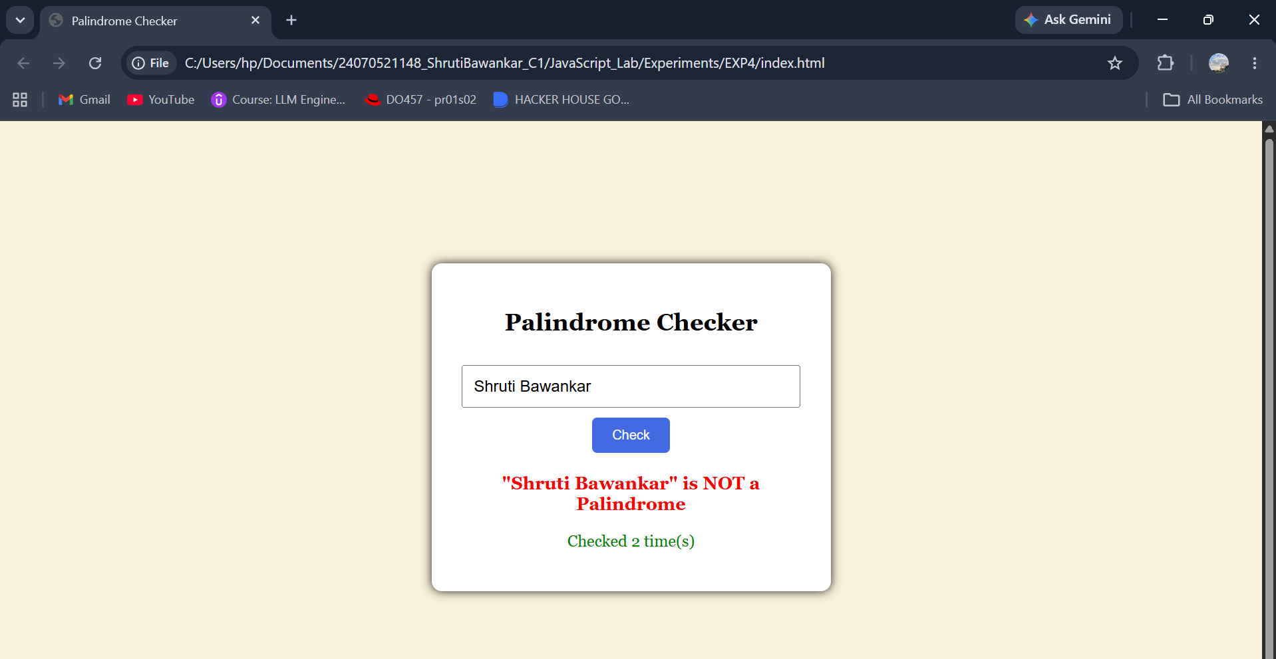
Result: The palindrome checker successfully identifies whether the entered text is a palindrome or not and displays the result while handling invalid input using try...catch.
Conclusion: The program effectively demonstrates JavaScript function types, scope, closures, and exception handling through a simple and user-friendly palindrome checking application.

Experiment No.: 4
Title: Use function types, scope, and closures; apply try-catch; build a password strength checker using palindrome then display strong or weak password and generate a html and js code.
Software/Tools Required: HTML5, CSS3, JavaScript, VS Code, Google Chrome
Index.html:
<!DOCTYPE html>
<html lang="en">
<head>
<meta charset="UTF-8">
<meta name="viewport" content="width=device-width, initial-scale=1.0">
<title>Password Strength Checker</title>
<style>
*{
margin:0;
padding:0;
box-sizing:border-box;
font-family:'Lucida Console', 'Monaco', monospace;
}
body{
height:100vh;
display:flex;
justify-content:center;
align-items:center;
background:linear-gradient(135deg,#89949810,#84b2da);
}
.container{
width:400px;
background:white;
border-radius:18px;
padding:35px;
text-align:center;
box-shadow:
0 15px 35px rgba(0,0,0,0.2);
}
.icon{
font-size:55px;
margin-bottom:10px;
}
h2{
color:#333;
margin-bottom:8px;
}
p.subtitle{
color:#777;
margin-bottom:25px;
font-size:14px;
}
.input-box{
position:relative;
}
input{
width:100%;
padding:14px 16px;
border:2px solid #ddd;
border-radius:10px;
outline:none;
font-size:16px;
transition:.3s;
}
input:focus{
border-color:#33a060;
}
button{
width:100%;
margin-top:18px;
padding:14px;
border:none;
border-radius:10px;
background:#667eea;
color:white;
font-size:16px;
font-weight:600;
cursor:pointer;
transition:.3s;
}
button:hover{
background:#4f61d8;
transform:translateY(-2px);
}
#result{
margin-top:22px;
padding:14px;
border-radius:10px;
background:#f7f7f7;
font-size:17px;
font-weight:600;
min-height:55px;
display:flex;
justify-content:center;
align-items:center;
}
#count{
margin-top:15px;
color:#555;
font-size:14px;
}
.footer{
margin-top:20px;
font-size:12px;
color:#999;
}
</style>
</head>
<body>
<div class="container">
<div class="icon">🔐</div>
<h2>Password Strength Checker</h2>
<p class="subtitle">
A palindrome password is considered <b>Weak</b>.
Any other password is considered <b>Strong</b>.
</p>
<div class="input-box">
<input
type="password"
id="password"
placeholder="Enter your password">
</div>
<button onclick="checkPassword()">
Check Password
</button>
<div id="result">
Result will appear here...
</div>
<div id="count">
</div>
</div>
<script src="script.js"></script>
</body>
</html>
Script.js:
let appName = "Password Strength Checker";
function passwordCounter(){
let count = 0;
return function(){
count++;
return count;
};
}
const counter = passwordCounter();
function isPalindrome(password){
let reverse = password.split("").reverse().join("");
return password === reverse;
}
const displayResult = function(message, color){
const result = document.getElementById("result");
result.innerHTML = message;
result.style.color = color;
if(color === "green"){
result.style.background = "#e8f9ee";
result.style.border = "2px solid #28a745";
}
else if(color === "red"){
result.style.background = "#ffe8e8";
result.style.border = "2px solid #dc3545";
}
else{
result.style.background = "#fff4d6";
result.style.border = "2px solid #ff9800";
}
};
const updateCount = ()=>{
document.getElementById("count").innerHTML =
"Passwords Checked : " + counter();
};
function checkPassword(){
try{
let password = document.getElementById("password").value;
if(password.trim()==""){
throw "Password cannot be empty.";
}
if(password.length < 4){
throw "Password must contain at least 4 characters.";
}
if(isPalindrome(password)){
displayResult(
"Weak Password (Palindrome Password)",
"red"
);
}
else{
displayResult(
"Strong Password (Not a Palindrome)",
"green"
);
}
updateCount();
}
catch(error){
displayResult(error,"orange");
}
}

Output:

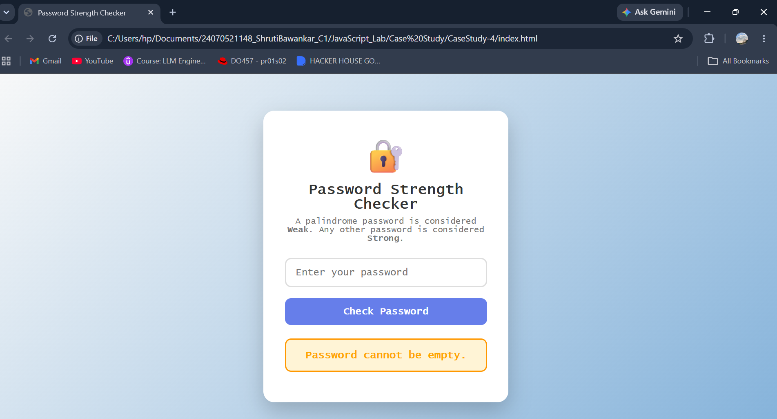
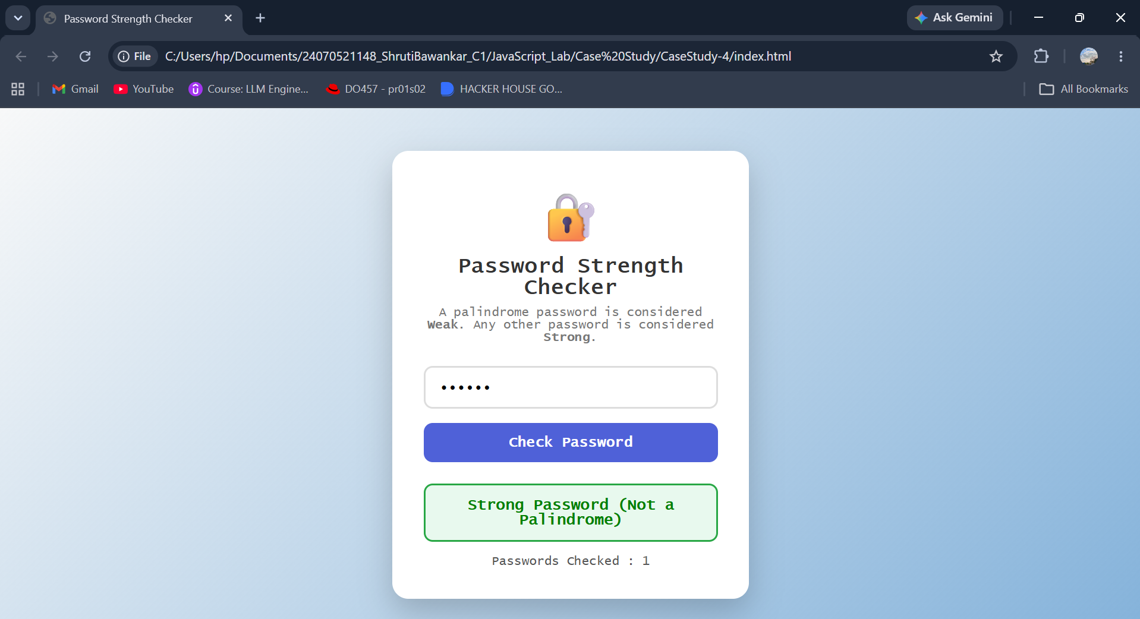
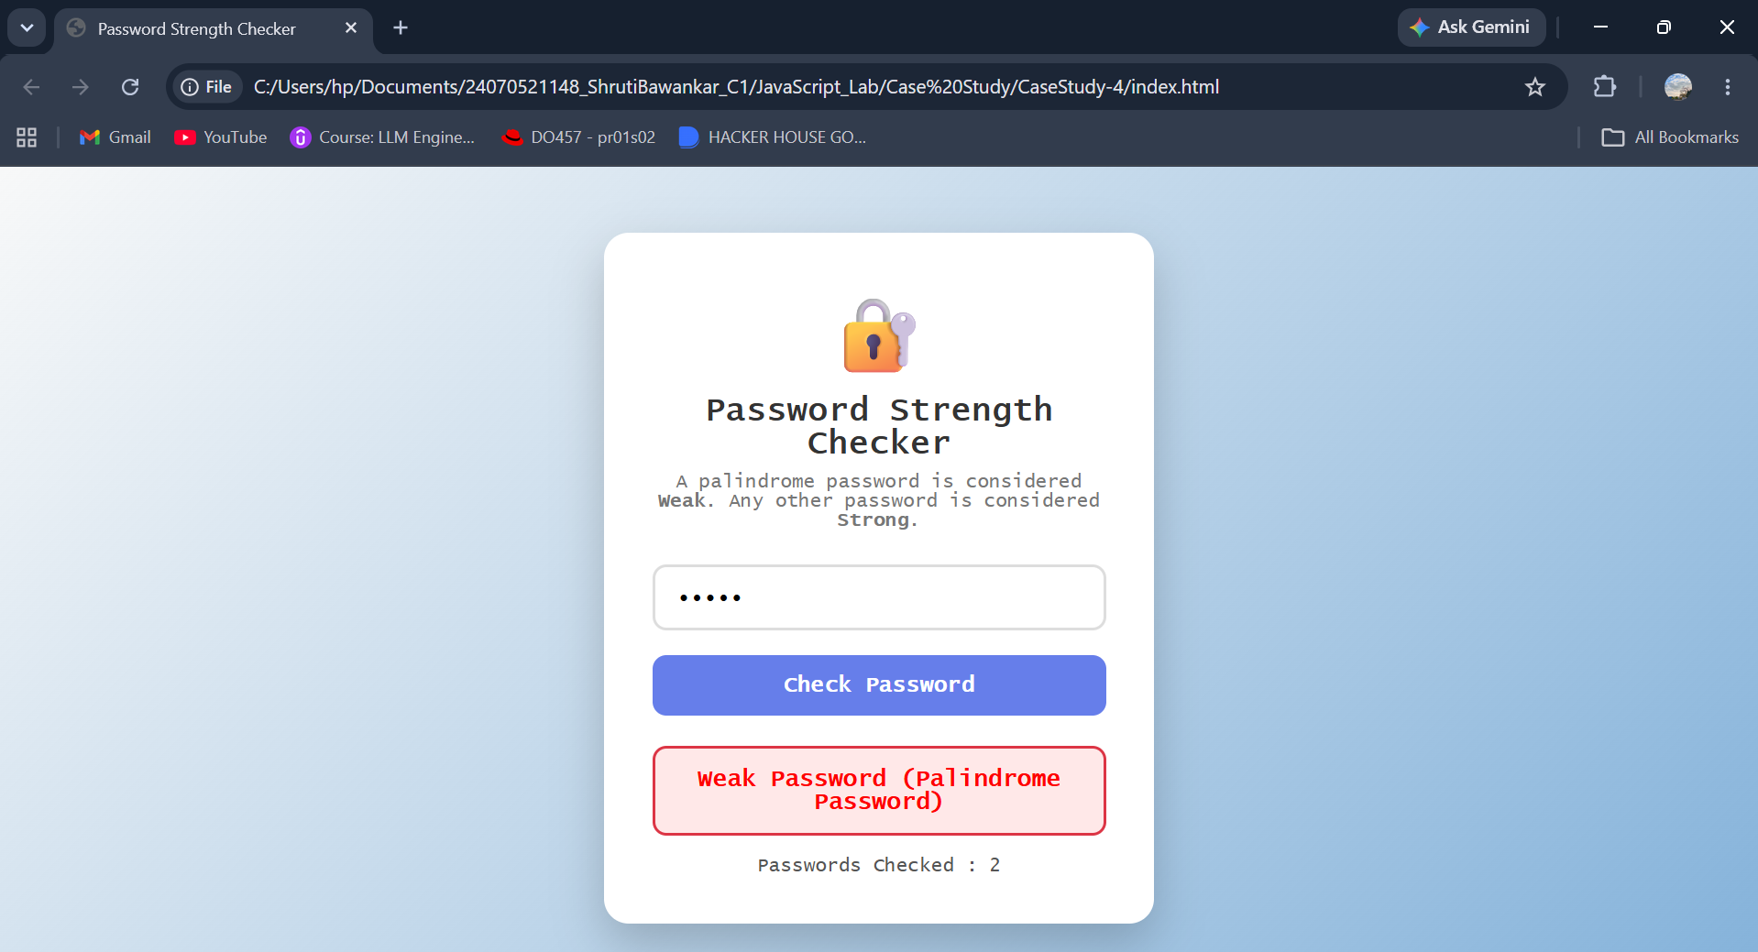

Result: The password checker successfully identifies whether a password is a palindrome and classifies it as Weak or Strong while handling invalid inputs using try...catch.
Conclusion: The program effectively demonstrates JavaScript function types, scope, closures, and exception handling through a simple and interactive password validation application.

