**IMPLEMENTING CRYPTOSYSTEMS**

**Description:-**

**This project implements a diverse range of cryptographic systems for private and public-key scenarios. The user-friendly interface ensures a seamless user experience. Private-key systems include the historically significant Caesar and Substituting Ciphers, enhancing security. Public-key features Diffie-Hellman for secure key exchange and RSA Encryption for communication security. The tech stack employs widely-used programming languages, ensuring reliability and security throughout the project.**

**Features:-**

**1. Variety of Cryptography Methods:**

• **Caesar Cipher**

• **Substitution Cipher**

• **Homophonic Substitution**

• **Vigenere Cipher**

• **Diffie-Hellman Key Exchange**

• **RSA Encryption**

• **XOR Encryption**

**2. Communication Channel for Different Users:**

•  **A communication channel to facilitate interaction among different users, fostering collaboration and knowledge sharing.**

**3. Encrypting and Decrypting Tool:**

• **A tool that enables users to both encrypt and decrypt data using the listed cryptographic methods.**

**4. A feature to store and access data:**

• **The system will also feature a functionality to store public and private keys.**

**5. Info Page for All Methods:**

• **Informative pages providing details on each cryptography method to educate users about their characteristics and applications.**

**Technology stack:- Python**

**Implementation Details:**

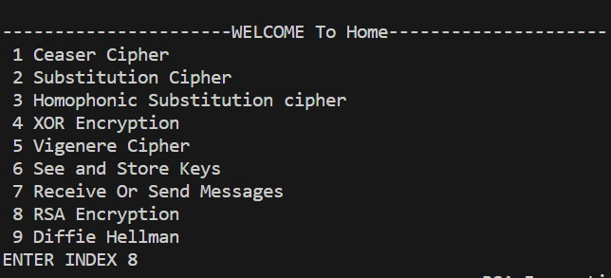**First the users will inter a main screen containing a list of cryptographic systems and some tools .**

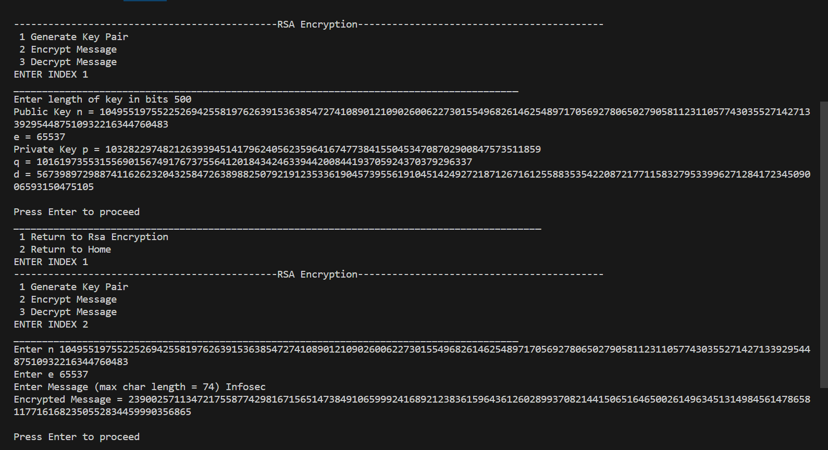**Upon selecting a specific cryptography tool from the list, users will be directed to a dedicated interface where they can seamlessly encode or decode data using the chosen tool.**

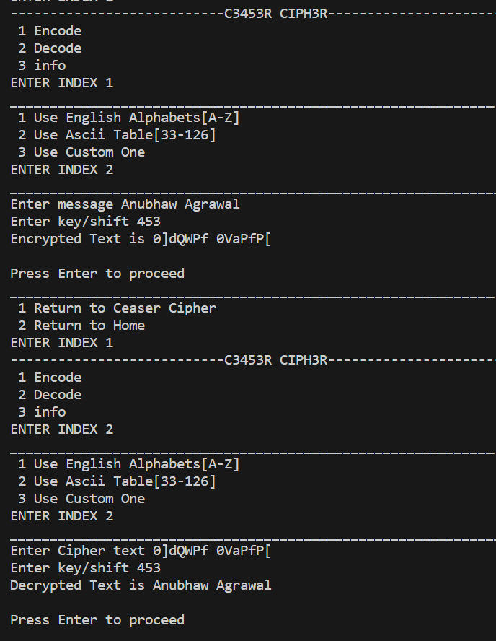

**The system also feature a functionality to store public and private keys.**

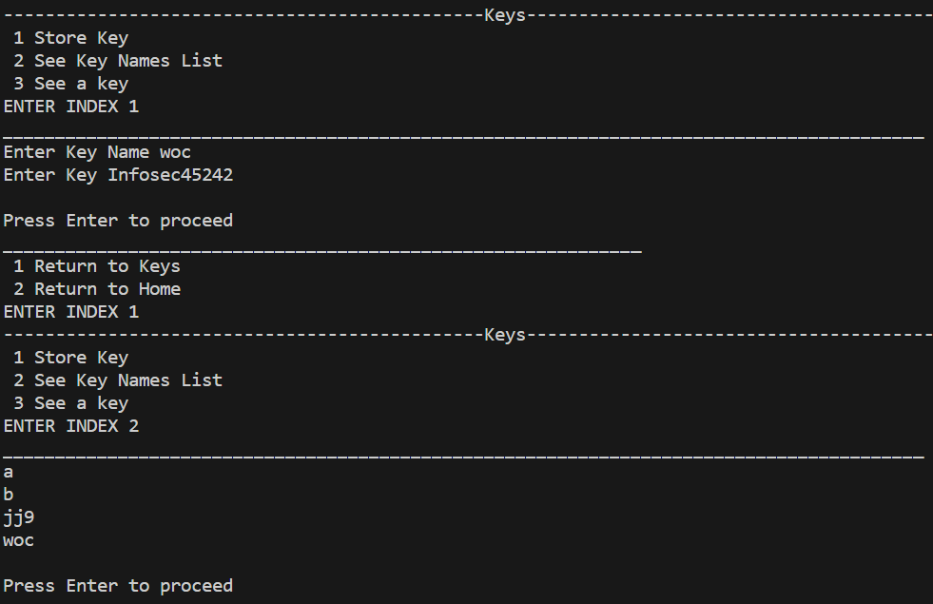

**Also different users can communicate using this.**

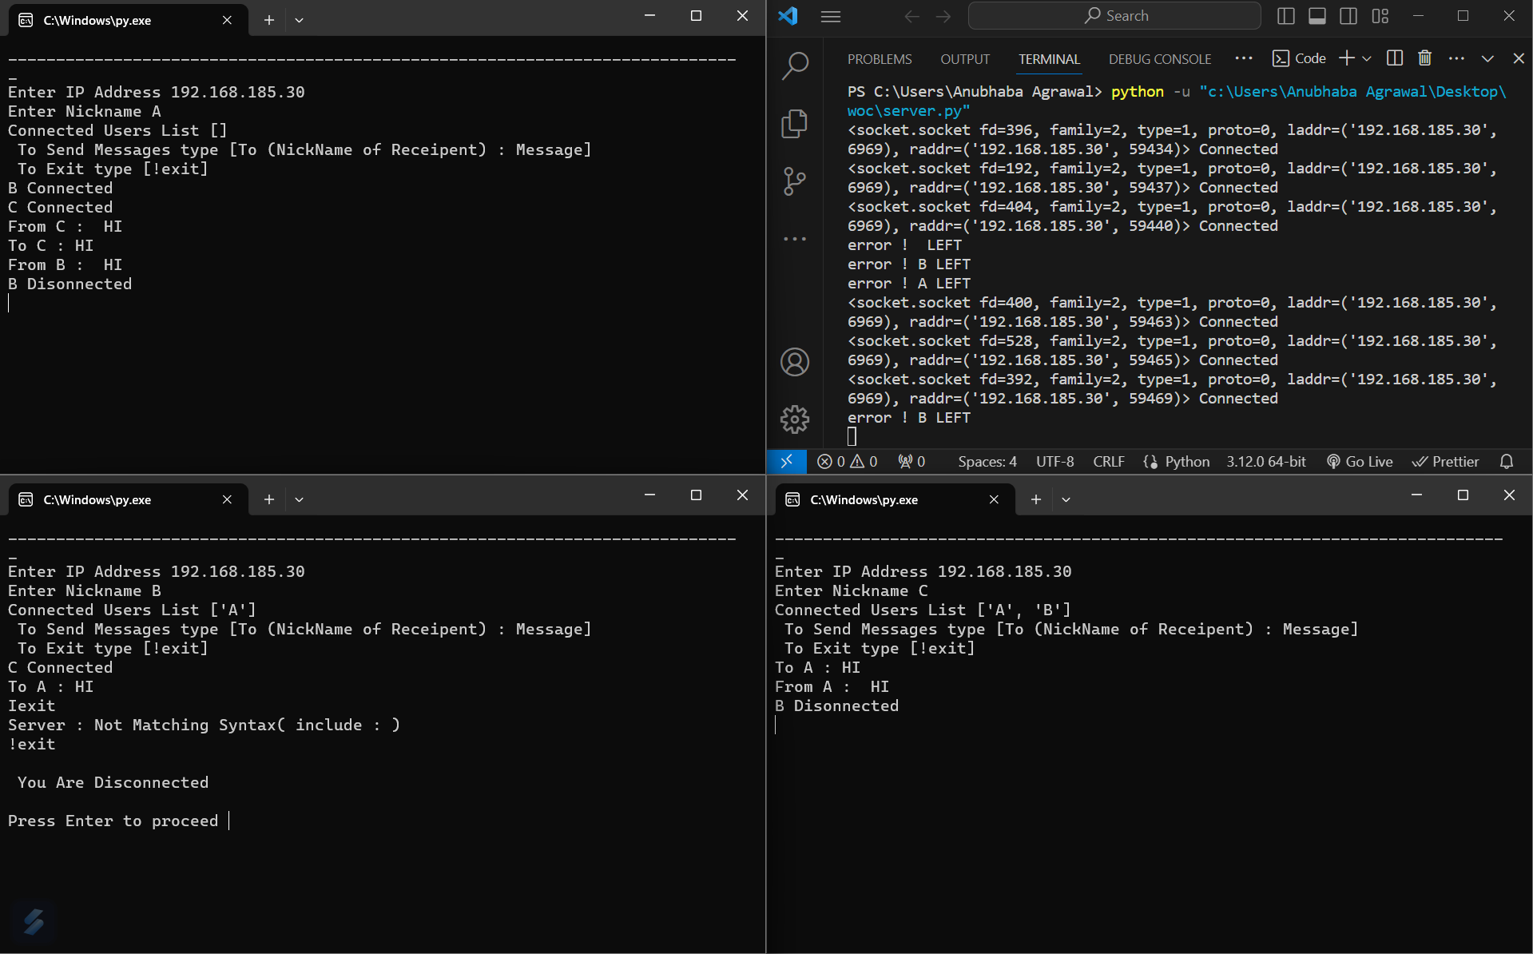

**There is a input validation system also.**

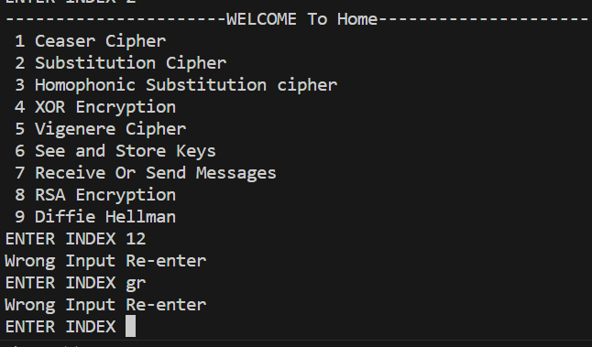

**This implementation aims to provide a seamless and secure environment for users to explore various cryptography tools, communicate with others, and effectively manage their encrypted data.**