**Table Of Content:**

1. Introduction to Machine Learning.
2. Types Of Machine Learning Algorithms.
3. Using Data to Answer Question
4. 7 Steps in Machine Learning
5. Application Of Machine Learning

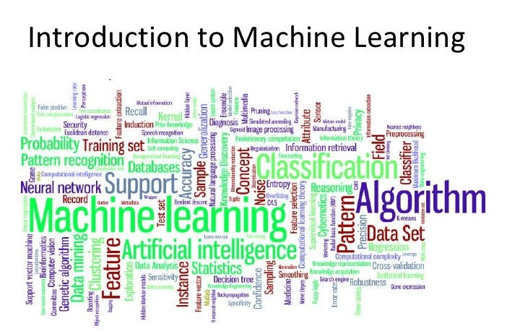

* *”Machine Learning is the study of Computer Algorithms that improve automatically through experience.”*
* “A computer program is said to learn from experience E with respect to some task T and some performance measure P, if its performance on T, as measured by P, improves with experience E.”

**-Tom Mitchell, Carnegie Mellon University**

Machine Learning (ML) is coming into its own, with a growing recognition that ML can play a key role in a wide range of critical applications, such as ***data mining, natural language processing, image recognition, and expert systems***. ML provides potential solutions in all these domains and more, and is set to be a pillar of our future civilization.

Machine learning is an application of artificial intelligence (AI) that provides systems the ability to automatically learn and improve from experience without being explicitly programmed. **Machine learning focuses on the development of computer programs** that can access data and use it learn for themselves.

The process of learning begins with observations or data, such as examples, direct experience, or instruction, in order to look for patterns in data and make better decisions in the future based on the examples that we provide. **The primary aim is to allow the computers learn automatically** without human intervention or assistance and adjust actions accordingly.

**Some Machine Learning Algorithms :**

Machine learning algorithms are often categorized as supervised or unsupervised.

* **Supervised machine learning algorithms** can apply what has been learned in the past to new data using labeled examples to predict future events. Starting from the analysis of a known training dataset, the learning algorithm produces an inferred function to make predictions about the output values. The system is able to provide targets for any new input after sufficient training. The learning algorithm can also compare its output with the correct, intended output and find errors in order to modify the model accordingly.
* In contrast, **unsupervised machine learning algorithms** are used when the information used to train is neither classified nor labeled. Unsupervised learning studies how systems can infer a function to describe a hidden structure from unlabeled data. The system doesn’t figure out the right output, but it explores the data and can draw inferences from datasets to describe hidden structures from unlabeled data.
* **Semi-supervised machine learning algorithms** fall somewhere in between supervised and unsupervised learning, since they use both labeled and unlabeled data for training – typically a small amount of labeled data and a large amount of unlabeled data. The systems that use this method are able to considerably improve learning accuracy. Usually, semi-supervised learning is chosen when the acquired labeled data requires skilled and relevant resources in order to train it / learn from it. Otherwise, acquiringunlabeled data generally doesn’t require additional resources.
* **Reinforcement machine learning algorithms** is a learning method that interacts with its environment by producing actions and discovers errors or rewards. Trial and error search and delayed reward are the most relevant characteristics of reinforcement learning. This method allows machines and software agents to automatically determine the ideal behavior within a specific context in order to maximize its performance. Simple reward feedback is required for the agent to learn which action is best; this is known as the reinforcement signal.

**Using data to answer questions**

For our purposes, we can shorten the definition of machine learning down to just five words:

***“Using data to answer questions”***

This is, of course, an oversimplification, but it can still serve a useful purpose.

In particular, we can split the definition into two parts: “using data”, and “answer questions”. These two pieces broadly outline the two sides of machine learning, both of them equally important.

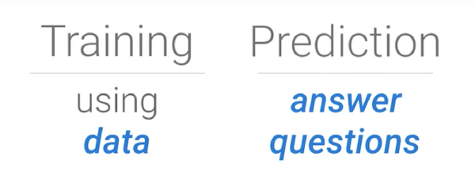

“Using data” is what is typically referred to as “training”, while “answering questions” is referred to as “making predictions”, or “inference”.

What connects these two parts together is the model. We train the model to make increasingly better and more useful predictions, using the our datasets. This predictive model can then be deployed to serve up predictions on previously unseen data.

***Data is the key***

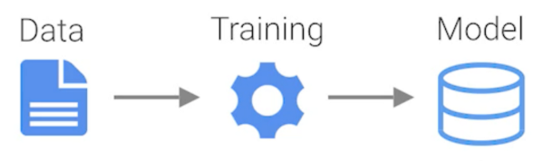

As you may have noticed, the key component of this process is data. Data is the key to unlocking machine learning, as much as machine learning is the key to unlocking the insight hidden in data.

This question answering system called a model is created via a process termed as training. The main goal of training is to create an accurate model that answers our questions correctly, at least for most of the times. But in order to train a model, you also need to collect data on what you'd want to train on. This is where you start and then the rest follows. The detailed information to the next steps is given below:

**7 Steps Of Machine Learning:**

Machine learning is a field of computer science that gives computers the ability to learn without being programmed explicitly. The power of machine learning is that you can determine how to differentiate using models, rather than using human judgment. The basic steps that lead to machine learning and will teach you how it works are described below in a big picture:

1. Gathering data
2. Preparing that data
3. Choosing a model
4. Training
5. Evaluation
6. Hyper parameter tuning
7. Prediction.

**1. Gathering Data:**

Once you know exactly what you want and the equipments are in hand, it takes you to the first real step of machine learning- Gathering Data. This step is very crucial as the quality and quantity of data gathered will directly determine how good the predictive model will turn out to be. The data collected is then tabulated and called as Training Data.

**2. Data Preparation:**

After the training data is gathered, you move on to the next step of machine learning: Data preparation, where the data is loaded into a suitable place and then prepared for use in machine learning training. Here, the data is first put all together and then the order is randomized as the order of data should not affect what is learned.

This is also a good enough time to do any visualizations of the data, as that will help you see if there are any relevant relationships between the different variables, how you can take their advantage and as well as show you if there are any data imbalances present. Also, the data now has to be split into two parts. The first part that is used in training our model, will be the majority of the dataset and the second will be used for the evaluation of the trained model’s performance. The other forms of adjusting and manipulation like normalization, error correction, and more take place at this step.

1. **3. Choosing a model:**

The next step that follows in the workflow is choosing a model among the many that researchers and data scientists have created over the years. Make the choice of the right one that should get the job done.

**4. Training:**

After the before steps are completed, you then move onto what is often considered the bulk of machine learning called training where the data is used to incrementally improve the model’s ability to predict.

The training process involves initializing some random values for say A and B of our model, predict the output with those values, then compare it with the model's prediction and then adjust the values so that they match the predictions that were made previously.

This process then repeats and each cycle of updating is called one training step.

**5. Evaluation:**

Once training is complete, you now check if it is good enough using this step. This is where that dataset you set aside earlier comes into play. Evaluation allows the testing of the model against data that has never been seen and used for training and is meant to be representative of how the model might perform when in the real world.

**6. Parameter Tuning:**

Once the evaluation is over, any further improvement in your training can be possible by tuning the parameters. There were a few parameters that were implicitly assumed when the training was done. Another parameter included is the learning rate that defines how far the line is shifted during each step, based on the information from the previous training step. These values all play a role in the accuracy of the training model, and how long the training will take.

For models that are more complex, initial conditions play a significant role in the determination of the outcome of training. Differences can be seen depending on whether a model starts off training with values initialized to zeroes versus some distribution of values, which then leads to the question of which distribution is to be used. Since there are many considerations at this phase of training, it’s important that you define what makes a model good. These parameters are referred to as Hyper parameters. The adjustment or tuning of these parameters depends on the dataset, model, and the training process. Once you are done with these parameters and are satisfied you can move on to the last step.

**7. Prediction:**

Machine learning is basically using data to answer questions. So this is the final step where you get to answer few questions. This is the point where the value of machine learning is realized. Here you can Finally use your model to predict the outcome of what you want.

The above-mentioned steps take you from where you create a model to where you Predict its output and thus acts as a learning path.

Machine Learning Applications:

We see machine learning all around us in the products we use today, but it isn’t always apparent to us that machine learning is behind it all. While tagging objects and people in pictures is clearly machine learning, you may not realize that features like video recommendation systems are also often powered by machine learning.

Today, machine learning’s immediate applications are already quite wide-ranging, including [image recognition](https://cloud.google.com/vision/), [fraud detection](https://cloud.google.com/blog/big-data/2017/08/how-wepay-uses-stream-analytics-for-real-time-fraud-detection-using-gcp-and-apache-kafka), [recommendation engines](https://cloud.google.com/solutions/recommendations-using-machine-learning-on-compute-engine), as well as [text](https://cloud.google.com/natural-language/) and [speech](https://deepmind.com/blog/wavenet-generative-model-raw-audio/) systems. These powerful capabilities can be applied to a wide range of fields, from [diabetic retinopathy](https://blog.google/topics/machine-learning/detecting-diabetic-eye-disease-machine-learning/) and [skin cancer detection](http://cs.stanford.edu/people/esteva/nature/) to retail, and of course transportation, in the form of self-parking and [self-driving vehicles](https://waymo.com/)

Machine learning is the science of getting computers to act without being explicitly programmed. In the past decade, machine learning has given us self-driving cars, practical speech recognition, effective web search, and a vastly improved understanding of the human genome. Machine learning is so pervasive today that you probably use it dozens of times a day without knowing it.

NOTE:

Machine learning enables analysis of massive quantities of data. While it generally delivers faster, more accurate results in order to identify profitable opportunities or dangerous risks, it may also require additional time and resources to train it properly. Combining machine learning with AI and cognitive technologies can make it even more effective in processing large volumes of information