**Sales Trend Analysis Using Aggregations  
(Result table)**

DATASET: Online Sales Data  
NAME:ANUBHUTI ANURAG  
EMAIL: [anubhutianurag216@gmail.com](mailto:anubhutianurag216@gmail.com)  
  
**Query1:**  
SELECT EXTRACT(MONTH FROM `Date`) AS order_month FROM online_sales LIMIT 10;

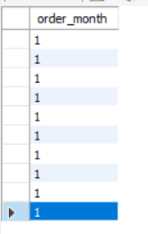  
  
**QUERY2:(Group by year/month)**SELECT  
 EXTRACT(YEAR FROM `Date`) AS order_year,   
 EXTRACT(MONTH FROM `Date`) AS order_month   
FROM online_sales GROUP BY EXTRACT(YEAR FROM `Date`), EXTRACT(MONTH FROM `Date`);  
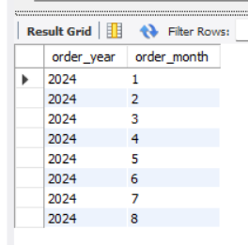  
  
  
  
**Query3**: **(use sum() for revenue)**  
SELECT

EXTRACT(YEAR FROM `Date`) AS order_year,

EXTRACT(MONTH FROM `Date`) AS order_month,

SUM(`Total Revenue`) AS monthly_revenue

FROM online_sales GROUP BY EXTRACT(YEAR FROM `Date`), EXTRACT(MONTH FROM `Date`);  
  
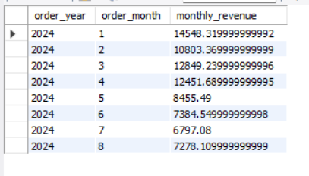  
  
**Query4: (COUNT(DISTINCT order_id) for volume.)**SELECT

EXTRACT(YEAR FROM `Date`) AS order_year,

EXTRACT(MONTH FROM `Date`) AS order_month,

COUNT(DISTINCT `Transaction ID`) AS order_volume

FROM online_sales GROUP BY EXTRACT(YEAR FROM `Date`), EXTRACT(MONTH FROM `Date`);  
  
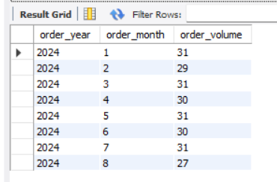

**Query5:( Use ORDER BY for sorting.)**SELECT

EXTRACT(YEAR FROM `Date`) AS order_year,

EXTRACT(MONTH FROM `Date`) AS order_month,

SUM(`Total Revenue`) AS monthly_revenue

FROM online_sales GROUP BY EXTRACT(YEAR FROM `Date`), EXTRACT(MONTH FROM `Date`)

ORDER BY monthly_revenue DESC**;  
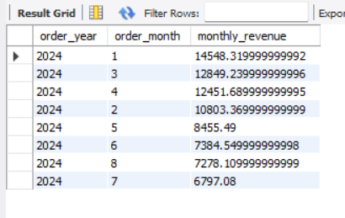  
  
Query6:(** **Limit results for specific time periods.)**SELECT

EXTRACT(YEAR FROM `Date`) AS order_year,

EXTRACT(MONTH FROM `Date`) AS order_month,

SUM(`Total Revenue`) AS monthly_revenue

FROM online_sales

GROUP BY EXTRACT(YEAR FROM `Date`), EXTRACT(MONTH FROM `Date`)

ORDER BY monthly_revenue DESC

LIMIT 6;  
  
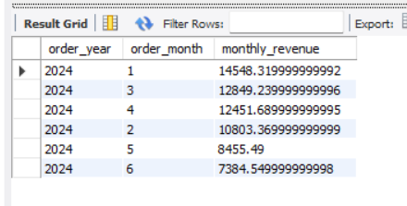

**Query7:(combining all)**

SELECT

EXTRACT(YEAR FROM `Date`) AS order_year,

EXTRACT(MONTH FROM `Date`) AS order_month,

SUM(`Total Revenue`) AS monthly_revenue,

COUNT(DISTINCT `Transaction ID`) AS order_volume

FROM online_sales GROUP BY EXTRACT(YEAR FROM `Date`), EXTRACT(MONTH FROM `Date`)ORDER BY EXTRACT(YEAR FROM `Date`), EXTRACT(MONTH FROM `Date`);  
  
