**3. Maven**

1. Why do we need a build tool like maven?

It is making the build process easier. Provide a uniform build system and gives quality project information

1. Install maven
2. Display output of maven version

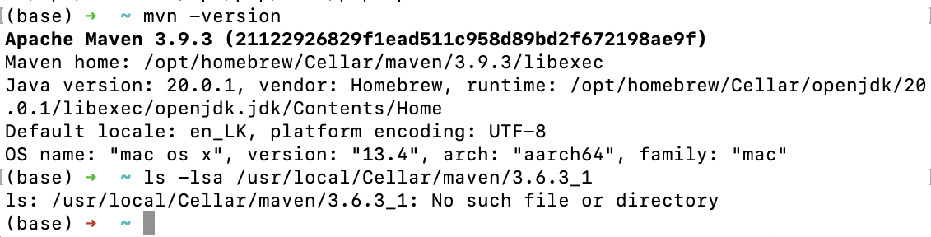

1. What is the pom.xml file?

POM means Project Object Model. It contains the project information and configuration information which are needed by the maven to build project such as dependencies, build directory, source directory

1. Explain these tags found in pom.xml files?

|  |  |
| --- | --- |
| groupId | It is the sub element of the project. It specifies the id for the project group. |
| artifactId | It specifies the id for the project. Artifact is something that is produced or used by projects. JAR’s, source and binary distribution are some of the artifacts produced by maven for the projects. |
| version | It specify the version of the artifact under the given group |
| packaging | Defines the packaging type like jar, war etc |
| dependencies | Defines dependencies for the project |
| dependency | Defines dependency. It is used inside of the dependencies |
| properties | Properties are placeholders. And they can be used anywhere in the pom.xml file |

1. Create a method which accept an integer as parameter and returns the square of it
2. Add junit (v5) dependency
3. Add a unit test to test the method
4. Run unit tests with maven. What is the command you used? mvn test
5. Create a Student class with following attributes and add getters/setters

* id: intn
* name: String
* age: int
* subjects: List<String>

1. In your main method create and student object and set these values

id: 1

name: “john”

age: 20

subjects: [“Maths”, “English”, “History”]

1. Then print these student values using getters (e.g: s.getName())
2. Add lombok dependency and remove getter/setter methods from Student class
3. Explain the usage of these commands

|  |  |
| --- | --- |
| mvn clean | Cleaning the maven project by deleting the target directory |
| mvn install | Build the maven project and install the project files |
| mvn package | Use to execute all the maven phases until the package phase |

1. Explain 3 types of maven repositories

Local repository

Central repository

Remote repository

1. Add your codes and answer sheet to a directory named “maven-basic-training” and push it to your training github repository.