**LSDS Assignment 3**

**Command for running Problem A : srun homework_3 1 human.txt human_reads_trimmed.fa**

**Command for running Problem B : srun homework_3 2 human.txt human_reads_trimmed.fa**

1. **Assess the impact of the hash table size :**
   1. For each of your 4 hash table sizes, how many collisions did you observe while populating the hash?

**Number of collisions observed while populating the hash table are mentioned in the screenshot below.**

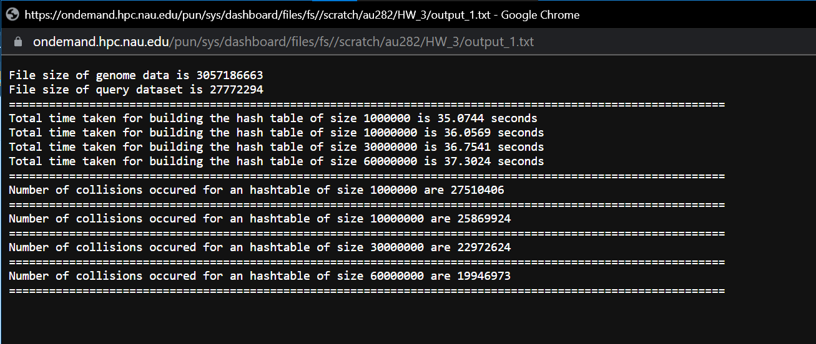

* 1. For each of your 4 hash table sizes, how long did it take you to populate the hash table? Do the timing results make sense? Explain.

**There is no major difference here in time for populating the hash table of sizes 1 M till 60 M. This is because while populating the hash table I am inserting the nodes at the beginning of the linked list which optimizes things. As attached in the above screenshot, the time taken for populating the hash table are as follows:**

**For 1 Million : 35.0744 seconds**

**For 10 Million : 36.0569 seconds**

**For 30 Million : 36.7541 seconds**

**For 60 Million : 37.3024 seconds**

1. **Searching speed:**
   1. How long did it take to search for every possible 16-character long fragment of the subject dataset within the query dataset?

**Total time taken for searching every fragment of the subject dataset in the query dataset is 4882.16 seconds.**

* 1. How many such fragments did you find?

**Total number of fragment hits are : 542456454**

* 1. Print the first 10 fragments of the subject dataset that you found within the Query_HT.

**The first 10 fragments of the subject dataset found in Query_HT is mentioned in the below screenshot.**

