**LSDS Assignment 2**

**Command for running Problem A : srun homework_2 1 human.txt human_reads.fa**

**Command for running Problem B : srun homework_2 2 human.txt human_reads.fa**

1. **Unsorted Linear search :**
   1. How long did it take you to search for the first 10K, 100K, and 1M 32-character long fragments of the subject dataset within the query dataset?

**Time taken for searching 10k fragments of the subject dataset is : 12190.066 seconds**

**Time taken for searching 100k fragments of the subject dataset is : 117431.09 seconds**

**Time taken for searching 1M fragments of the subject dataset is : 1210354.93 seconds**

* 1. How long would it take to search for every possible 32-character long fragment of the subject dataset within the query dataset?

**Time taken for searching 3B fragments of the subject dataset is : 3614457925.939 seconds**

* 1. Print the first 10 fragments of the subject dataset that you found within the Query AR object (if any)?

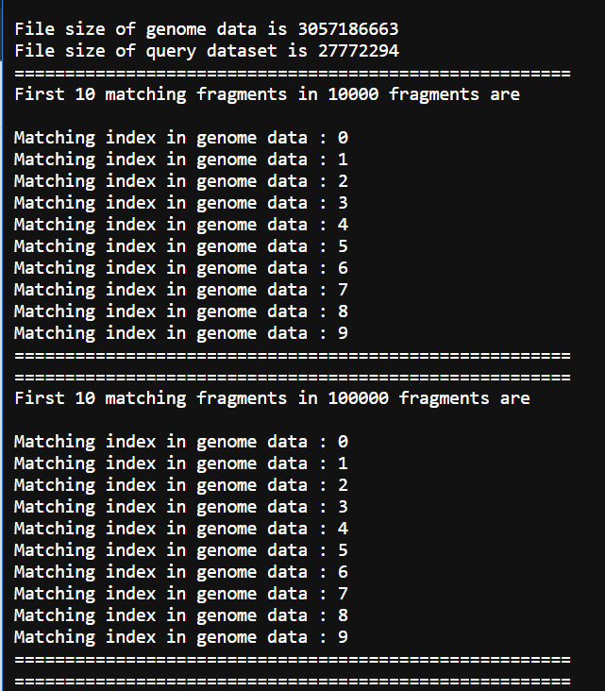

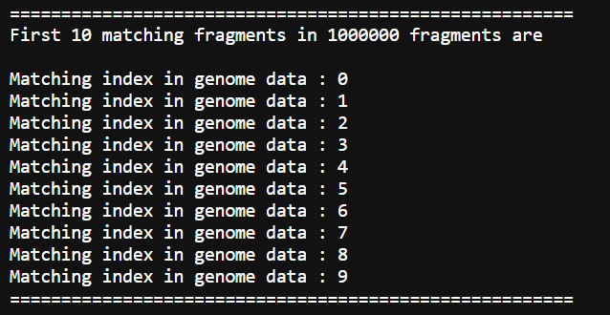

1. **Sorted Binary search:**
   1. How long did it take you to search for the first 10K, 100K, and 1M 32-character long fragments of the subject dataset within the query dataset?

**Time taken for searching 10k fragments of the subject dataset is : 0.04 seconds**

**Time taken for searching 100k fragments of the subject dataset is : 0.51 seconds**

**Time taken for searching 1M fragments of the subject dataset is : 4.87 seconds**

* 1. How long would it take to search for every possible 32-character long fragment of the subject dataset within the query dataset?

**Time taken for searching 3B fragments of the subject dataset is : 14533.358 seconds**

* 1. Print the first 10 fragments of the subject dataset that you found within the Query AR object (if any)?

