**Report: Project 3**

**Name: Anudeep Balagam  
UBID: 50442091**

**PART A**

* First the images path is read from the command line. This image path is set with the help of “os” and the images in this are sorted in ascending order of the image name.
* For face detection I used Haar cascade(frontalface-default) which is feature based cascade classifier proposed by Paul Viola and Michael Jones.
* In this method a window of 24x24 pixels is used to slide over the original image there by allowing it to detect the exact feature from each image.
* Then is used a function from face_recognition library that returns the exact coordinates of the detecting face in each image there by giving us the height and width of each face detected.
* Then returned he boxes of faces detected in result_list as per the requirement.
* The F1 score after running the validation folder I got a score of:  
  
* I then ran the code for test images and got a set of faces recognized into results.json file.

**PART B**

* I initially calculated the encodings of each image as mentioned in the step 2 of project pdf.
* After that I used sklearn library for using the K-Means clustering algorithm.
* The clusters are calculated by using the encoded images from the face_recognition library (face_encodings).
* Then I used the labels of clusters and used the face_recongnition to get the bbox of each image and crop it by iterating the images.
* The images are iterated based on the number of clusters and labels then matching the images of the set to each cluster.
* I have concatenated all the images and returned it to result_list as per the requirement.
* I used hconcat from cv2 for the images to stack horizontally one after another.
* Below are the clusters I obtained:

1. **Cluster_0:**

1. **Cluster_1:**

1. **Cluster_2:**

1. **Cluster_3:**

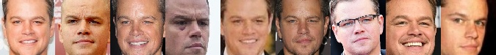

1. **Cluster_4:**

