**VELAGAPUDI RAMAKRISHNA SIDDHARTHA ENGINEERING**

**COLLEGE KANURU , VIJAYAWADA**

**A Project Report On**

**‘AMPLITUDE MODULATION AND DEMODULATION’**

**For The Course**

**ANALOG AND DIGITAL COMMUNICATIONS**



**SUBMITTED BY**

**GANGU BHARATH KUMAR [208W1A04E3]**

**GANTA ANUDEEP [208W1A04E4]**

**GEDALA VINAY SAI [208W1A04E5]**

**SECOND YEAR ELECTRONICS AND COMMUNICATION ENGINEERING**

UNDER THE ESTEEMED GUIDANCE OF

DR.B.LAKSHMI SIRISHA , Associate Professor

MRS.K.V RATNA PRABHA, Associate Professor

**SUBMITTED TO**

**VELAGAPUDI RAMAKRISHNA SIDDHARTHA ENGINEERING COLLEGE**

**FOR THE ACADEMIC YEAR 2021- 2022**

TABLE OF CONTENTS

|  |  |
| --- | --- |
| 1.1 | OBJECTIVE |
| 1.2 | HARDWARE REQUIRED |
| 1.3 | THEORY |
| 1.4 | AM MODUALTION CIRCUIT DIAGRAM |
| 1.5 | MODEL GRAPH |
| 1.6 | AM DEMODUALTION CIRCUIT DIAGRAM |
| 1.7 | LAB PROCEDURE |
| 1.8 | LAB RESULT |

1.1 OBJECTIVE:

To construct an amplitude modulator circuit using transistor with Vc=50mv , Vm=8v to satisfy under modulation condition and generate amplitude modulated signal.Calculate the modulation index and also demodulate using envelope detector and reconstruct the modulating signal.

1.2 HARDWARE REQUIRED:

|  |  |  |  |
| --- | --- | --- | --- |
| **S.NO** | **EQUIPMENT / COMPONENT NAME** | **SPECIFICATIONS** | **QUANTITY** |
| 1. | Cathode ray Oscilloscope | (0-20MHZ) | 1 |
| 2. | Audio frequency Oscilloscope | (0-2MHZ) | 2 |
| 3. | Regulated power supply | (0-30V),1A | 1 |
| 4. | Resistors | 1.5K Ohm  10K Ohm  20K Ohm  100K Ohm | 2  3  1  2 |
| 5. | Conductors | 0.1 µf  0.01 µf  0.001 µf  22 µf | 1  1  3  1 |
| 6. | Semiconductor Device (Transistor) | BC108 | 1 |
| 7. | Semiconductor  Device (Diode) | OA79 | 1 |

1.3 THEORY:

Modulation is defined as the process by which some characteristics of a carrier signal is varied in accordance with a modulating signal. The base band signal is referred to as the modulating signal and the output of the modulation process is called as the modulation signal.

**1.3.1 AMPLITUDE MODULATION** :

Amplitude modulation is defined as the process in which amplitude of the carrier wave is varied in accordance with the instantaneous values of the modulating signal. The envelope of the modulating wave has the same shape as the base band signal provided the following two requirements are satisfied 1. The carrier frequency fc must be much greater, then the highest frequency components fm of the message signal m (t) i.e.  fc >>fm.

2. The modulation index must be less than unity. If the modulation index is greater than unity, the carrier wave becomes over modulated.

**1.3.2 AMPLITUDE DEMODULATION**:

The process of detection provides a means of recovering the modulating Signal from modulating signal. Demodulation is the reverse process of modulation. The envelope detector circuit is employed to separate the carrier wave and eliminate the side bands. Since the envelope of an AM wave has the same shape as the message, independent of the carrier frequency and phase, demodulation can be accomplished by extracting envelope. An increased time constant RC results in a marginal output follows the modulation envelope. A further increase in time constant the discharge curve become horizontal if the rate of modulation envelope during negative half cycle of the modulation voltage is faster than the rate of voltage RC combination ,the output fails to follow the modulation resulting distorted output is called as  diagonal clipping this will occur even high modulation index. The depth of modulation at the detector output greater than unity and circuit impedance is less than circuit load (Rl > Zm) results in clipping of negative peaks of modulating signal. It is called “negative clipping “.

**SPECIFICATIONS** : R1 = R2 = R5 = 10KΩ; R3 = 1.5KΩ; R4 = 20KΩ; C1 = 0.01µF; C2 = 0.001µF;   C3 = 0.1 µf; Vc = 50mV; fc = 500KHZ; Vm = 8V; fm = 1KHZ; VCC = 30V;

1.4 AM MODULATION CIRCUIT DIAGRAM:

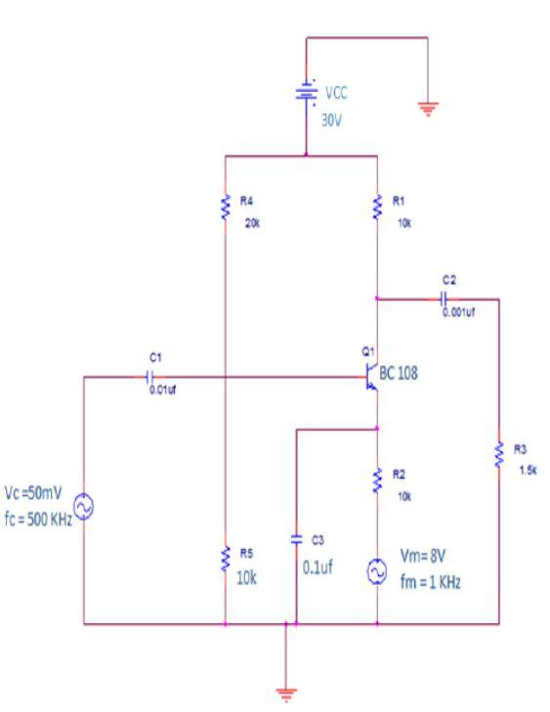

Fig. 1.1 AM Modulator Circuit

1.5 MODEL GRAPH :

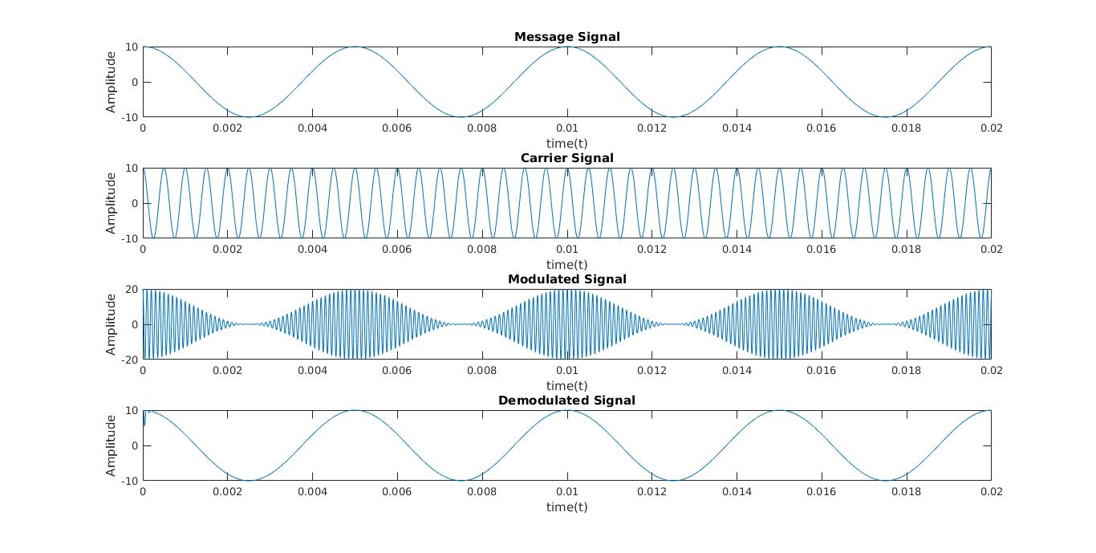

**SPECIFICATIONS :**       C1=0.001μf, C2=22μf, C3=0.001μf, R1=100KΩ and R2=100KΩ.

1.6 AM DEMODULATION CIRCUIT DIAGRAM:

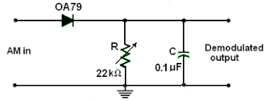

Fig 1.2 : AM Demodulator circuit

1.7 LAB PROCEDURE:

I) AMPLITUDE MODULATION:

1. The circuit connection is made as shown in the circuit.

2. The power supply is connected to the collector of the transistor.

3. Set the input signal fm as 1KHz and 8volt sinusoidal signal in AFO

4. Set the carrier signal fc as 500KHz and 50 millivolt sinusoidal signal in AFO.

5. The Amplitude Modulated Output is taken from the collector of the Transistor.

6. Calculate Emax and Emin from the Output waveform.

7. Calculate modulation index using the formula. Emax – Emin Modulation index (m)% =    ‐‐‐‐‐‐‐‐‐‐‐‐‐‐‐‐‐‐  X  100     Emax + Emin.

8. Plot the input signals and obtained AM output waveforms in the graph sheet.

OBSERVATION :

|  |  |  |
| --- | --- | --- |
| SIGNAL | MODULATING SIGNAL | CARRIER SIGNAL |
| TYPE OF SIGNAL | SINE | SINE |
| AMPLITUDE |  |  |
| FREQUENCY |  |  |
| TIME PERIOD |  |  |

MODULATED OUTPUT :

|  |  |  |  |
| --- | --- | --- | --- |
| SIGNAL TYPE | E MIN | E MAX | MODULATION INDEX |
| AM |  |  |  |

II ) AMPLITUDE DEMODULATION :

1. The circuit connections are made as shown in the circuit diagram.

2. The amplitude modulated signal from AM generator is given as input to the demodulator circuit.

3. The demodulated output is observed  on the CRO

4.   Plot the obtained AM demodulated  output waveforms in the graph sheet

OBSERVATION :

DEMODULATED OUTPUT

|  |  |  |  |
| --- | --- | --- | --- |
| SIGNAL TYPE | TIME PERIOD | FREQUENCY | AMPLITUDE |
| SINE TYPE |  |  |  |

1.8 LAB RESULT:

Thus, the amplitude modulation and demodulation were performed and the modulation index for various modulating voltage were calculated.