1>
*
* *
* * *
* * * *
* * * * *
package com.day4;

public class Main {

public static void main(String[] args){

int i, j, row = 6;
//Outer loop work for rows
for (i=0; i<row; i++)
{
//inner loop work for space
for (j=row-i; j>1; j--)
{
//prints space between two stars
System.out.print(" ");
}
//inner loop for columns
for (j=0; j<=i; j++ )
{
//prints star
System.out.print("* ");
}
//throws the cursor in a new line after printing each line
System.out.println();
}
}
}

2>
*
* *
* * *
* * * *
* * * * *
package com.day4;

public class Star1 {

public static void main(String[] args) {
int i, j, row = 6;
for (i = 0; i < row; i++) {
for (j = row - 1; j > 1; j--) {
System.out.print("");
}
for (j = 0; j <= i; j++) {
System.out.print("* ");

}
System.out.println();
}
}
}

3>
*
* *
* * *
* * * *
* * * * *
4>

*
***
*****
*******
*********
*******
*****
***
*

5>
* * * * *
* * * *
* * *
* *
*

package com.day4;

public class Star2 {
public static void main(String[] args) {

int i, j, row = 5;
for (i = row; i > 0; i--) {
for (j = row ; j > 0; j--) {

System.out.print("");
}
for (j = 0; j <= i-1; j++) {
System.out.print("* ");

}

System.out.println();
}
}
}

6>
*
**
***
****
*****
******

7>
* * * * *
* * * *
* * *
* *
*
8>
*****
****
***
**
*
9>
*
* *
* * *
* * * *
* * * * *
* * * *
* * *
* *
*

10>

*
**
***
****
*****
****
***
**
*

11>

* * * * *
* * * *
* * *
* *
*
*
* *
* * *
* * * *
* * * * *

12>

*
* *
* *
* *
*********

13>

1
1 2
1 2 3
1 2 3 4
1 2 3 4 5
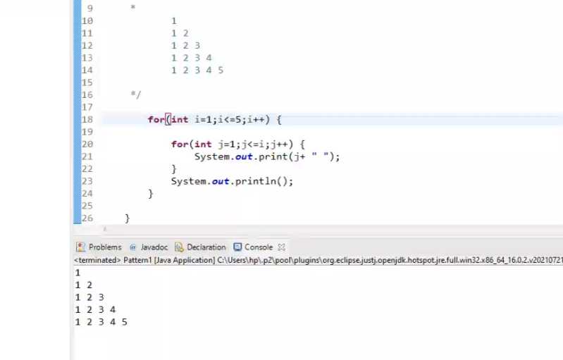

14>

1
2 3
4 5 6
7 8 9 10
11 12 13 14 15

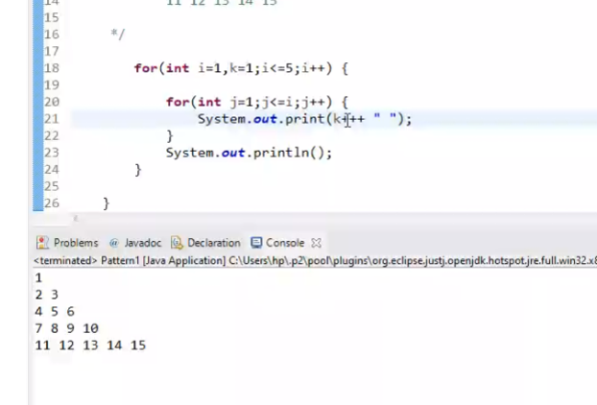
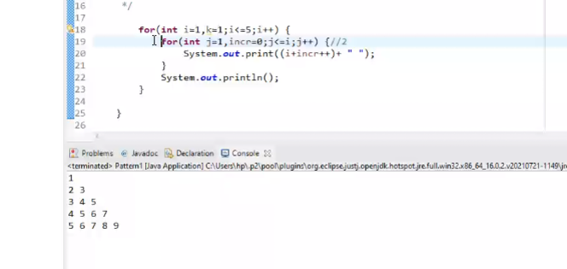

15>

1
1 1
1 2 1
1 3 3 1
1 4 6 4 1
16>

1
212
32123
4321234
32123
212
1

17>

1
2 2
3 3 3
4 4 4 4
5 5 5 5 5

18>
5
5 4
5 4 3
5 4 3 2
5 4 3 2 1

19>
1
2 1
3 2 1
4 3 2 1
5 4 3 2 1

20>
10101
01010
10101
01010
10101

public class twopattern {
public static void main(String[] args){
for(int i=1,k=1;i<=5;i++){
for(int j=1;j <=5;j++){
System.out.print(k++%2);
}
System.out.println();
}
}
}

21>
1
10
101
1010
10101

package com.day4;

public class patternThree {
public static void main(String[] args){
for(int i=1;i<=5;i++){
for(int j=1,k=1;j<=i;j++){
System.out.print(k++%2);
}
System.out.println();

}
}
}

22>
1 2 3 4 5
2 3 4 5
3 4 5
4 5
5
4 5
3 4 5
2 3 4 5
1 2 3 4 5

23>
A
A B
A B C
A B C D
A B C D E
A B C D E F
public class patternFour {
public static void main(String[] args) {
for (int i = 1, k = 64; i <= 6; i++) {
for (int j = 1; j <= i; j++) {
System.out.print((char) (k + j) + " ");
}
System.out.println();
}
}
}

24>
A
B C
D E F
G H I J
K L M N O
P Q R S T U

public class patternFour {
public static void main(String[] args) {
for (int i = 1, k = 65; i <= 6; i++) {
for (int j = 1; j <= i; j++) {
System.out.print((char) (k ++) + " ");
}
System.out.println();
}

}
}

https://stackoverflow.com/questions/3911966/how-to-convert-number-to-words-in-java

